Supplementary Information

GD2-specific Chimeric Antigen Receptor-modified T Cells for the Treatment of
Refractory and/or Recurrent Neuroblastoma in Pediatric Patients
Lihua Yu^{1†}, Lulu Huang^{1†}, Danna Lin¹, Xiaorong Lai¹, Li Wu¹, Xu Liao¹, Jiale Liu¹, Yinghua Zeng¹, Lichan Liang¹, Guanmei Zhang¹ Bin Wang¹, Zhu Wu¹, Shaohua Tao¹, Yuchen Liu², Cheng Jiao², Lung-Ji Chang^{2*}, Lihua Yang^{1*}

Table S1. Clinical characteristics of the NB patients before enrolled in this study
No. | Age at Dx  (years) | Previous therapy*
 |  | Surgery | Chemotherapy  (cycle) | XRT | Auto-HSCT
1 | 3 | GTR | 20 | Y | N
2 | 5 | GTR | 8 | Y | N
3 | 5 | GTR | 8 | Y | N
4 | 4 | STR | 16 | Y | N
5 | 1.2 | STR | 8 | N | N
6 | 1 | STR | 10 | Y | N
7 | 3 | GTR | 7 | Y | Y
8 | 1.3 | STR | 10 | Y | N
9 | 1.7 | GTR | 10 | Y | Y
10 | 5 | STR | 11 | Y | N
*MIBG and GD2 monoclonal antibody treatment are not accessible in China. Abbreviations: NB, neuroblastoma; Dx, diagnosis; XRT, radiation therapy; GTR, gross total resection; STR, subtotal resection.

Table S2. T Cell products phenotype
No. | phenotype (%) |  |  |  | CD4:CD8  ratio
 | CD3⁺ | CD4⁺ | CD8⁺ | CD56⁺
1 | 6 | 2 | 3 | 1 | 0.67
 | 82 | 21 | 54 | 15 | 0.39
 | 98 | 59 | 35 | 1 | 1.69
2 | 78 | 9 | 62 | 18 | 0.15
 | 96 | 44 | 43 | 5 | 1.02
3 | 90 | 41 | 46 | 13 | 0.89
4 | 58 | 9 | 42 | 34 | 0.21
5 | 90 | 27 | 57 | 12 | 0.47
6 | 91 | 39 | 53 | 9 | 0.73
7 | 97 | 53 | 37 | 1 | 1.43
 | 100 | 67 | 33 | 1 | 2.03
8 | 98 | 57 | 33 | 5 | 1.72
9 | 96 | 64 | 15 | 5 | 4.27
10 | 98 | 34 | 51 | 9 | 0.67

Table S3. 4SCAR-GD2 T cells hematologic toxicities, ferritin, IL-6 and IL-10
No. | Hematologic toxicities |  | Ferritin  (ug/L) |  | IL-6  (pg/mL) |  | IL-10  (pg/mL)
 | Neutrophil count (× 109/liter) | Platelet count (× 109/liter)
 | Min | Min | Min | Max | Min | Max | Min | Max
1 | 0.17 | 11 | 853.3 | 1108 | 2.7 | 3.5 | <5 | -
 | 0.52 | 114 | ND | ND | <2 | - | <5 | -
 | 0.34 | 114 | ND | ND | ND | ND | ND | ND
2 | 1.1 | 134 | 18.4 | 56.6 | <2 | 11 | <5 | 6.79
 | 1.45 | 149 | ND | ND | ND | ND | ND | ND
3 | 0.49 | 70 | 695.8 | 1348 | <2 | 8.08 | <5 | 15.7
4 | 0.51 | 97 | 1300 | 1538 | <2 | 10.4 | <5 | 11.9
5 | 0.19 | 90 | 535.9 | 1534 | <2 | 52.7 | <5 | 34.3
6 | 1.49 | 136 | 434.8 | 802 | 2.19 | 58.4 | <5 | 13.1
7 | 0.48 | 170 | 534.4 | 887.2 | 7.99 | 60.7 | 5.35 | 8.63
 | 0.87 | 211 | 455.4 | 574.7 | ND | ND | ND | ND
8 | 0.72 | 124 | 789.5 | 2149 | <2 | 72.3 | <5 | 17.9
9 | 0.26 | 11 | 1480 | 3417 | 3.13 | 34.4 | <5 | 11.6
10 | 0.86 | 147 | 137.5 | 330.3 | 4.12 | 1000 | <5 | 8014
ND, Not detected.

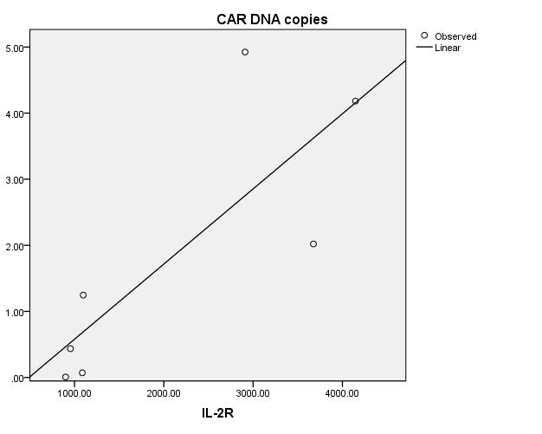
Fig. S1 The correlation between 4SGD2-CAR T cells expansion and IL-2R

