Supplementary Table 1 Diagnostic basis and treatment data of patients with infections
Patient No. | Symptoms | Diagnostic Basis | Infection Type | Pathogen (if identified) | Treatment Regimen | Outcomes
03 | Fever, cough, sputum production | Elevated CRP and PCT, chest CT showing multiple lung infections | Bacterial (suspected) | Not specified | Piperacillin (ineffective for 2 days), switched to Imipenem | Improvement in fever and cough; infection markers normalized; chest CT showed resolution
06 | Fever, diarrhea, vomiting | Elevated WBC, CRP, and PCT; suspected bacterial infection with viral prophylaxis | Bacterial and viral (suspected) | Not specified | Cefoperazone-sulbactam + Oseltamivir | Improvement in fever, vomiting, and diarrhea; infection markers normalized
04 | Fever, cough, sputum production | Chest CT showing bilateral lung infection | Bacterial | Pseudomonas aeruginosa (sputum culture) | Levofloxacin + Tazocin | Improvement in fever; recurrent ventilator-associated pneumonia due to mechanical ventilation
CRP C-Reactive Protein, PCT Procalcitonin, CT Computed Tomography, WBC White Blood Cell

Supplementary Table 2 Delayed adverse events in six patients after GD2+PSMA CAR-T infusion
Event | Number of patients
 | Grade1 | Grade2 | Grade3 | Grade4
Cytokine release syndrome | 0 | 0 | 0 | 0
Central neurotoxic effects | 0 | 0 | 0 | 0
Hematologic toxic effects
Anemia | 0 | 0 | 0 | 0
Neutropenia | 0 | 0 | 0 | 0
Thrombocytopenia | 0 | 0 | 0 | 0
leukocytopenia | 0 | 0 | 0 | 0
Nervous system
epilepsy | 0 | 0 | 0 | 0
encephalalgia | 1 | 0 | 0 | 0
respiratory system
pneumonia | 0 | 1 | 0 | 0
dyspnea | 1 | 0 | 0 | 0
Abnormal laboratory values
Elevated alanine aminotransferase level, aspartate aminotransferase level, or both | 0 | 0 | 0 | 0
Elevated bilirubin level | 0 | 0 | 0 | 0
Electrolyte abnormalities | 0 | 0 | 0 | 0
Miscellaneous
Infection | 1 | 0 | 0 | 0
Fever | 1 | 0 | 0 | 0
nausea | 0 | 0 | 0 | 0
diarrhea | 0 | 0 | 0 | 0
bellyache | 0 | 0 | 0 | 0
Hematologic toxic effects, anomalies caused by the disease or by previous treatments were not included. Delayed adverse events were documented >1-6 months (or until disease progression) after the first infusion.

Supplementary Table 3 Monitoring of GD2 and PSMA CAR-T expansion in patients after infusion over time
Patient 01 | D1 | D7 | D14 | D21 | D28 | D56 | D63 | D76 | D407
GD2 CAR-T copy | 0.00% | 0.00% | 1.24% | 2.69% | 17.56% | 0.08% | 0.03% | 0.19% | 0.77%
PSMA CAR-T copy | 0.00% | 0.00% | 0.68% | 0.00% | 0.00% | 0.00% | 0.11% | 0.19% | 0.00%
Patient 02 | D1 | D7 | D14 | D21 | D28
GD2 CAR-T copy | 0.00% | 0.64% | 2.21% | 3.03% | 1.99%
PSMA CAR-T copy | 0.00% | 1.55% | 4.91% | 1.20% | 0.49%
Patient 03 | D1 | D7 | D14 | D21 | D28 | D92 | D142 | D183 | D202
GD2 CAR-T copy | 0.00% | 1.37% | 0.70% | 0.80% | 0.17% | 0.00% | 1.14% | 1.20% | 0.05%
PSMA CAR-T copy | 0.00% | 7.06% | 3.68% | 14.26% | 12.85% | 0.11% | 1.65% | 0.02% | 0.21%
Patient 04 | D1 | D7 | D14 | D21 | D28 | D61 | D68 | D75 | D82
GD2 CAR-T copy | 0.00% | 4.34% | 0.71% | 1.37% | 1.42% | 3.98% | 0.57% | 0.48% | 3.51%
PSMA CAR-T copy | 0.00% | 0.86% | 1.11% | 2.20% | 2.49% | 3.86% | 8.89% | 6.81% | 5.62%
Patient 04 | D159 | D196 | D215 | D239 | D257 | D264 | D271 | D285 | D292
GD2 CAR-T copy | 0.16% | 1.03% | 0.09% | 1.12% | 5.24% | 0.20% | 0.07% | 0.11% | 0.00%
PSMA CAR-T copy | 0.00% | 3.71% | 1.43% | 0.61% | 1.87% | 0.35% | 0.42% | 0.84% | 1.19%
Patient 05 | D1 | D7 | D14
GD2 CAR-T copy | 0.00% | 0.35% | 2.88%
PSMA CAR-T copy | 0.00% | 0.27% | 1.54%
Patient 06 | D1 | D7 | D14 | D21
GD2 CAR-T copy | 0.00% | 0.00% | 15.60% | 6.80%
PSMA CAR-T copy | 0.00% | 0.00% | 0.39% | 0.00%

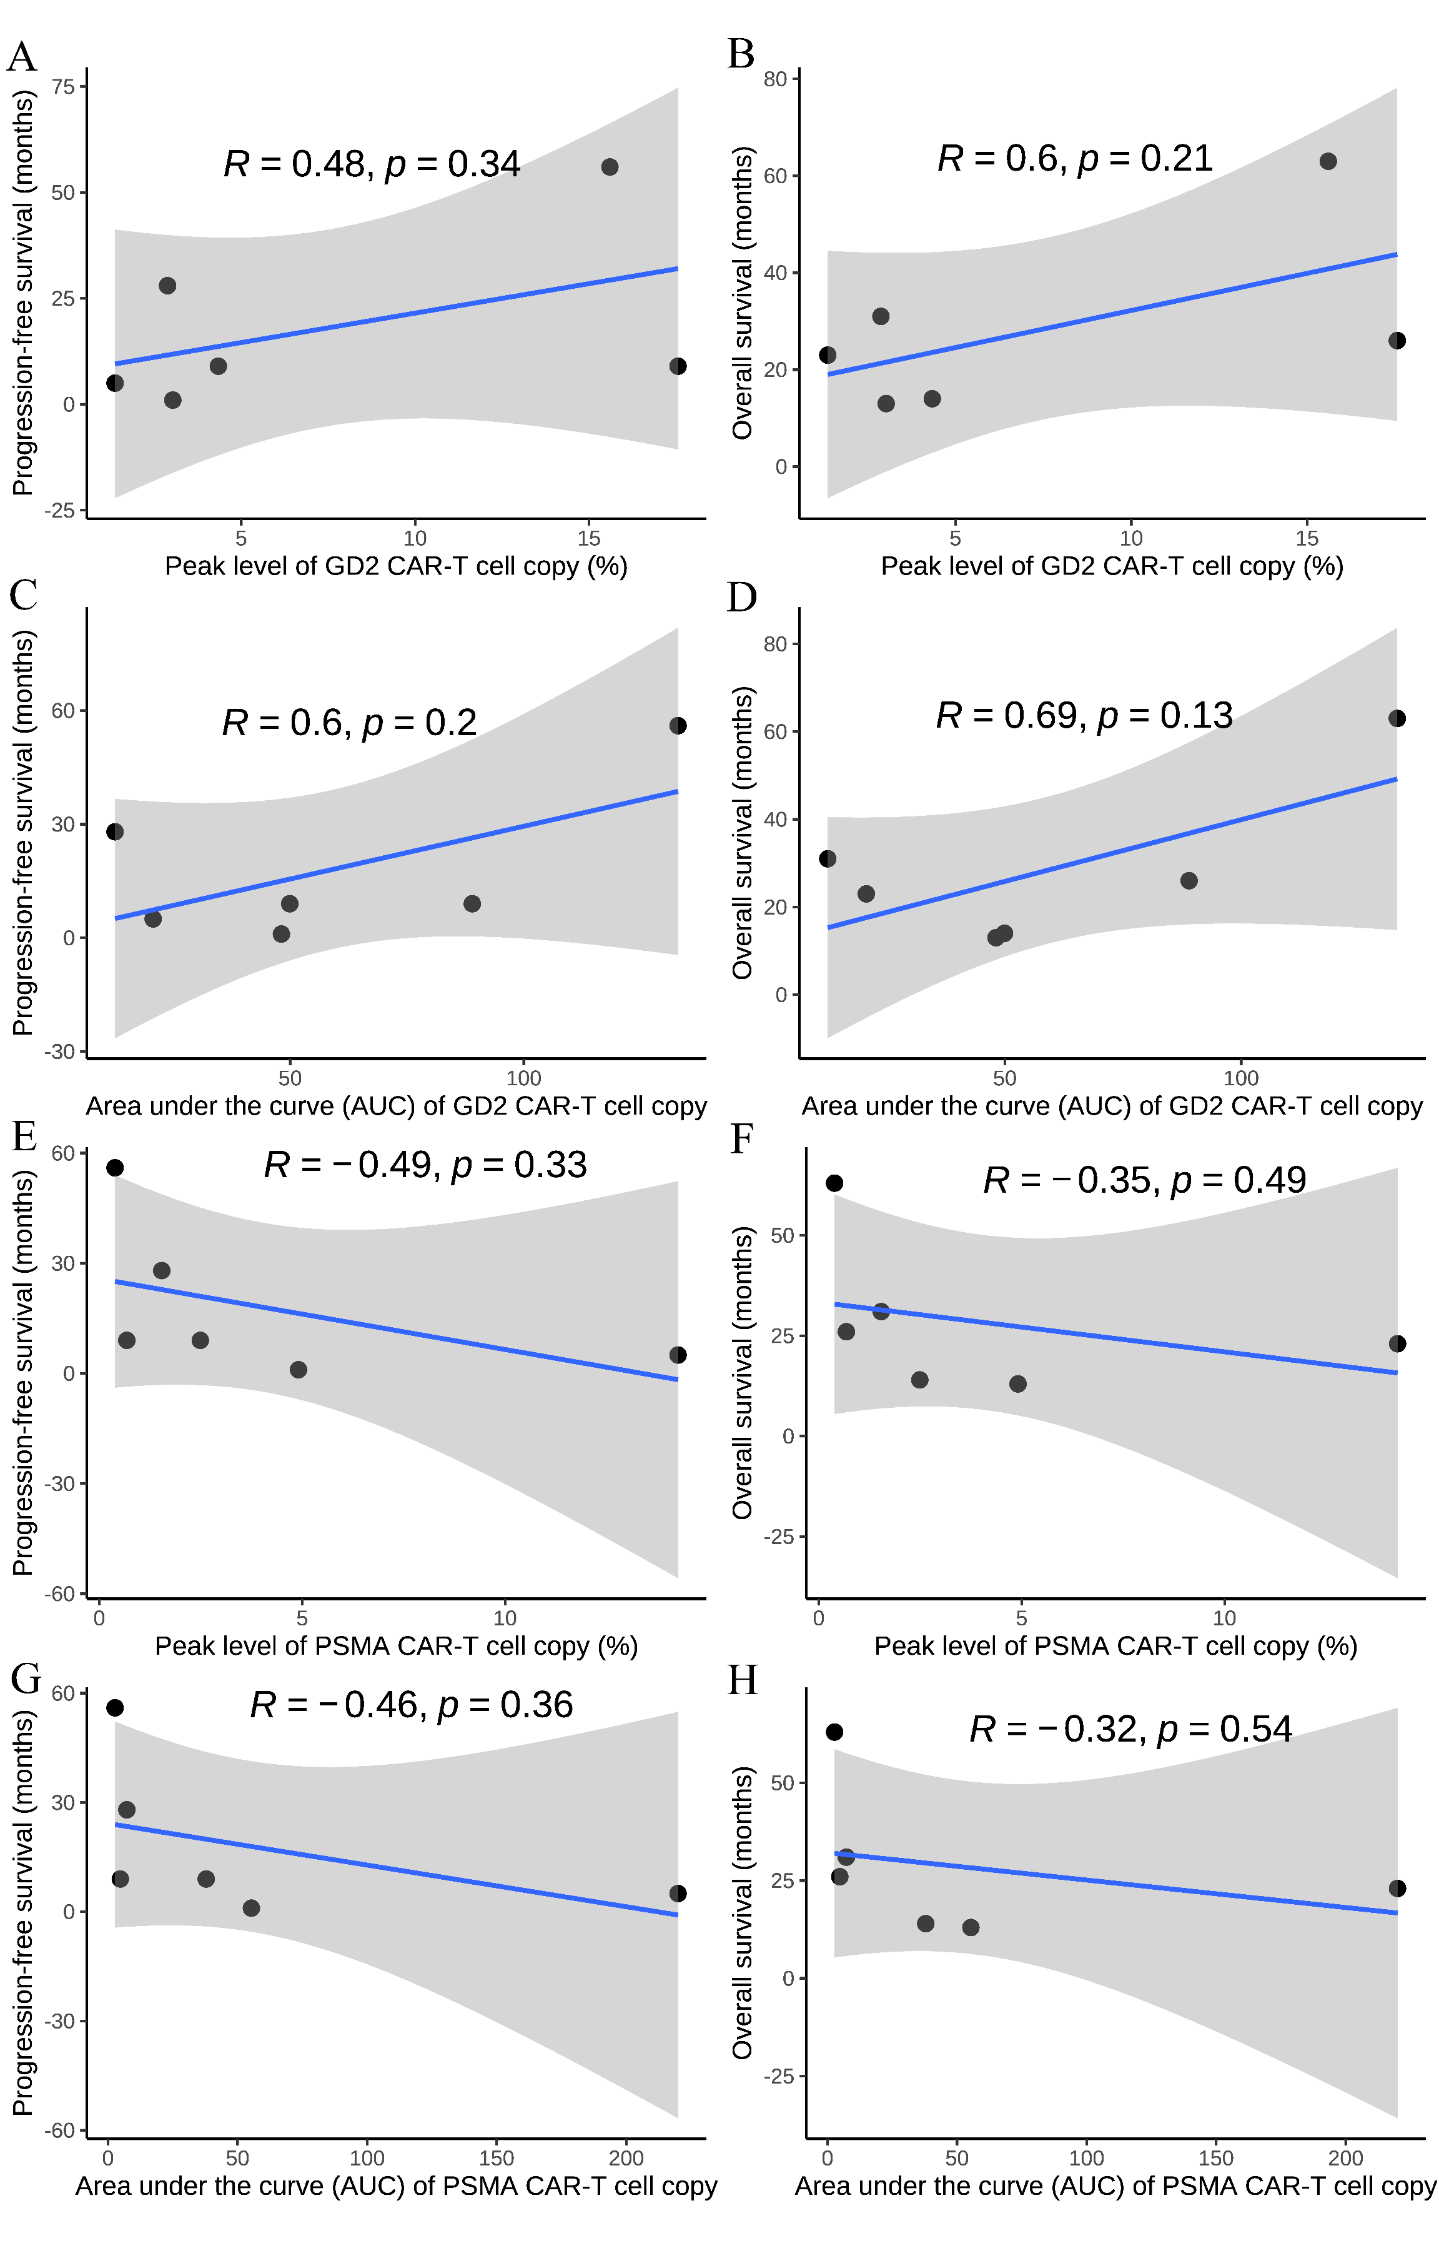
Supplementary Figure 1 Relationship between CAR-T cell expansion and clinical outcomes. Each scatter plot includes a linear regression line (blue), with shaded 95% confidence intervals (gray). The Pearson correlation coefficient (R) and p-value (p) are displayed in each plot. A-B Correlation of peak level of GD2 CAR-T cell copy with progression-free survival (PFS) and overall survival (OS). C-D Correlation of area under the curve (AUC) of GD2 CAR-T cell copy with PFS and OS. E-F Correlation of peak level of PSMA CAR-T cell copy with PFS and OS. G-H Correlation of AUC of PSMA CAR-T cell copy with PFS and OS.

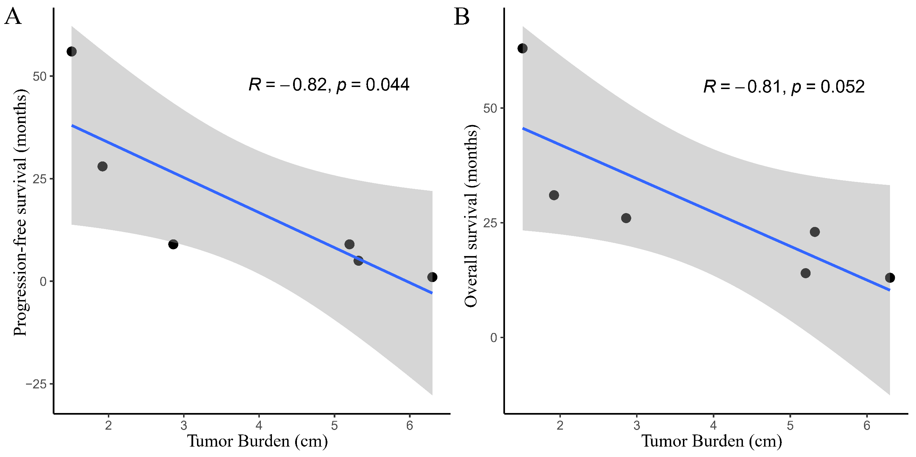
Supplementary Figure 2 Correlation between tumor burden and survival outcomes. The blue line represents the linear regression fit, and the shaded area indicates the 95% confidence interval. The Pearson correlation coefficient (R) and p-value (p) are displayed in each plot. A Correlation between tumor burden and progression-free survival (PFS). The negative correlation is statistically significant (R = -0.82, p = 0.044). B Correlation between tumor burden and overall survival (OS). A strong negative correlation is observed, though it does not reach statistical significance (R = -0.81, p = 0.052).

