Supplementary Data
Supplementary Figure 1
Flow cytometry panels
 |  | Cell composition | Phenotype | Subsets | Inhibitory
V1 | VioBlue | CD3 | δ1 | δ1 | δ1
V2 | VioGreen |  | HLA-DR |  | KIR2D
B1 | FITC |  | CD45RA | γ9
 | VioBright B515 | CD56 |  |  | TIM3
B2 | PE | PD-1 | CD27 | NKG2D | PD-1
B3 | PerCP | 7-AAD | 7-AAD | 7-AAD | 7-AAD
B4 | PE-Vio 770 | CD14 | CD69 |  | TIGIT
R1 | APC | γδ | γδ | γδ | γδ
R2 | APC-Vio 770 | CD19 | δ2 | δ2 | δ2

Supplementary Figure 2
Flow cytometry gating strategies for each panel.
Panel Cell Composition
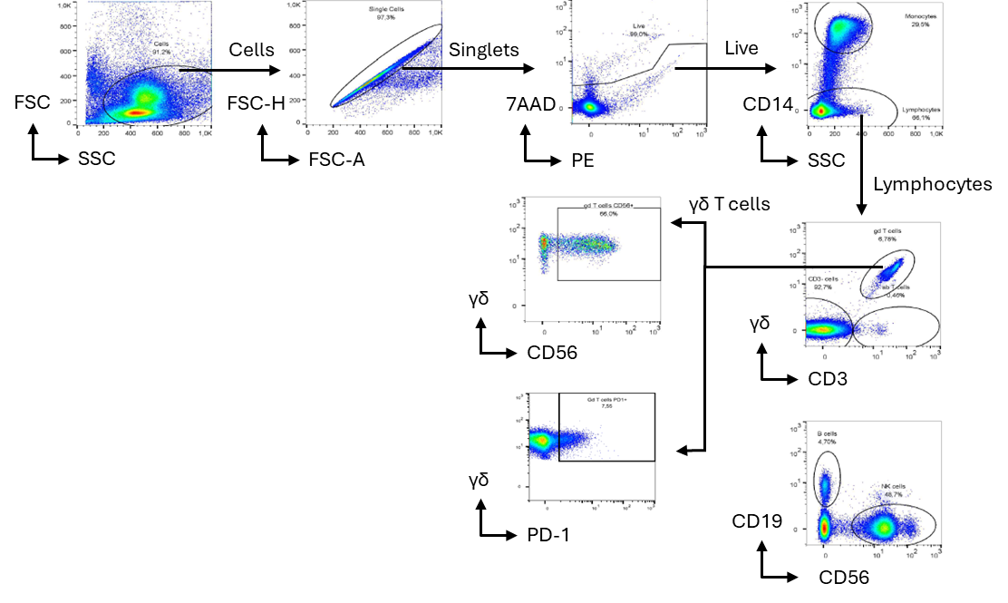
Panel Cell Phenotype
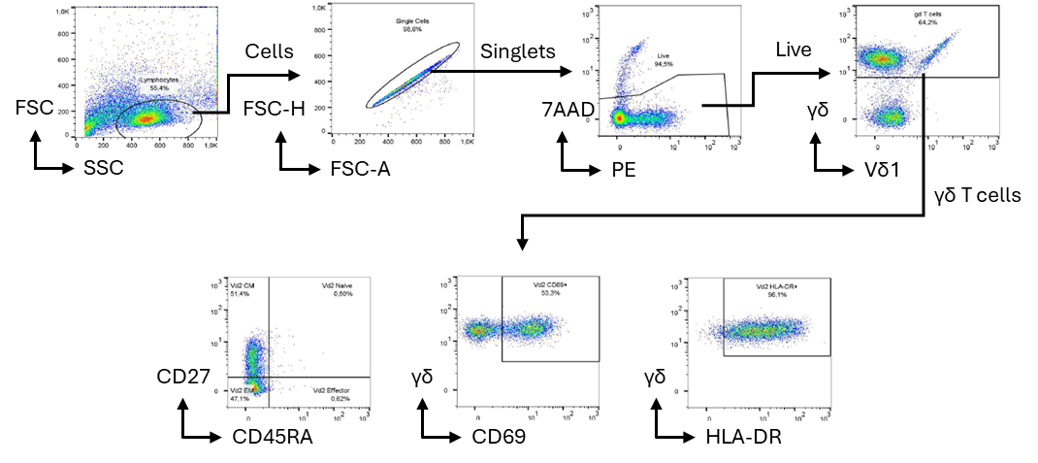
Panel Exhaustion
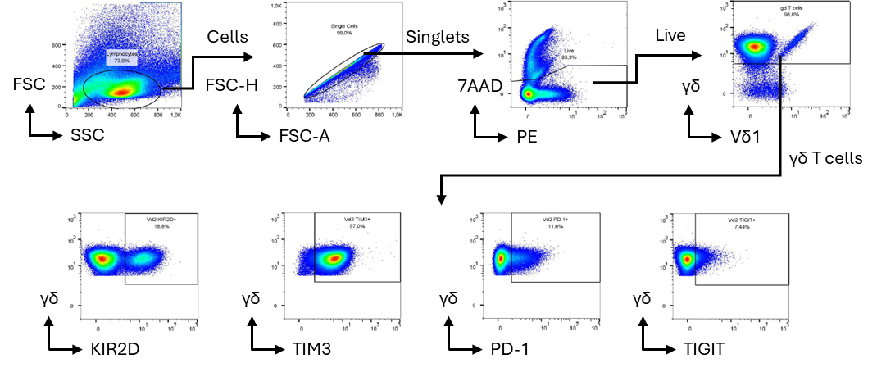
Panel Subsets
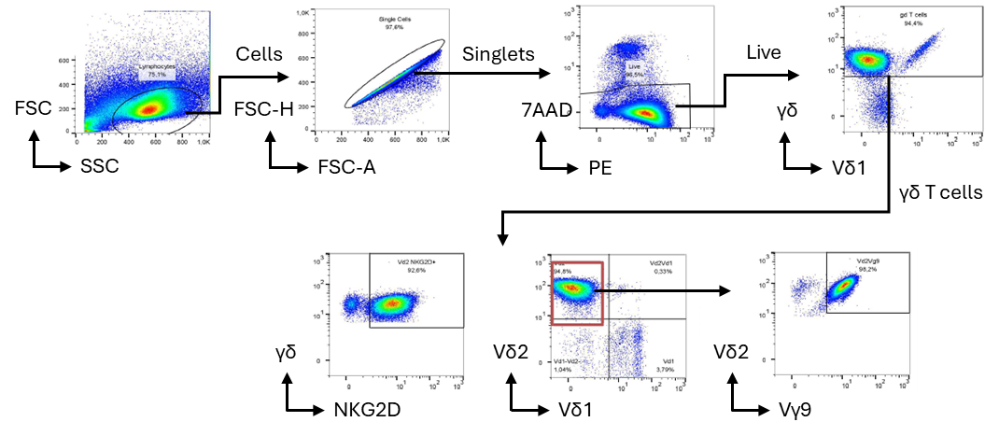

Supplementary Figure 3
 | Hashing antibody | Barcode | Reaction
donorA, day 0 | Separate reaction on another day (no hashtaging) |  | #1
donorA, day 7 -S | TotalSeq™-C0252 anti-human Hashtag 2 Antibody | TGATGGCCTATTGGG | #1
donorA, day 10 -S | TotalSeq™-C0253 anti-human Hashtag 3 Antibody | TTCCGCCTCTCTTTG
donorA, day 14 -S | TotalSeq™-C0254 anti-human Hashtag 4 Antibody | AGTAAGTTCAGCGTA
donorA, day 7 +S | TotalSeq™-C0255 anti-human Hashtag 5 Antibody | AAGTATCGTTTCGCA
donorA, day 10 +S | TotalSeq™-C0256 anti-human Hashtag 6 Antibody | GGTTGCCAGATGTCA
donorA, day 14 +S | TotalSeq™-C0257 anti-human Hashtag 7 Antibody | TGTCTTTCCTGCCAG
donorB, day 0 | TotalSeq™-C0251 anti-human Hashtag 1 Antibody | GTCAACTCTTTAGCG | #2
donorB, day 7 -S | TotalSeq™-C0252 anti-human Hashtag 2 Antibody | TGATGGCCTATTGGG
donorB, day 10 -S | TotalSeq™-C0253 anti-human Hashtag 3 Antibody | TTCCGCCTCTCTTTG
donorB, day 14 -S | TotalSeq™-C0254 anti-human Hashtag 4 Antibody | AGTAAGTTCAGCGTA
donorB, day 7 +S | TotalSeq™-C0255 anti-human Hashtag 5 Antibody | AAGTATCGTTTCGCA
donorB, day 10 +S | TotalSeq™-C0256 anti-human Hashtag 6 Antibody | GGTTGCCAGATGTCA
donorB, day 14 +S | TotalSeq™-C0257 anti-human Hashtag 7 Antibody | TGTCTTTCCTGCCAG
donorC, day 0 | TotalSeq™-C0251 anti-human Hashtag 1 Antibody | GTCAACTCTTTAGCG | #3
donorC, day 7 -S | TotalSeq™-C0252 anti-human Hashtag 2 Antibody | TGATGGCCTATTGGG
donorC, day 10 -S | TotalSeq™-C0253 anti-human Hashtag 3 Antibody | TTCCGCCTCTCTTTG
donorC, day 14 -S | TotalSeq™-C0254 anti-human Hashtag 4 Antibody | AGTAAGTTCAGCGTA
donorC, day 7 +S | TotalSeq™-C0255 anti-human Hashtag 5 Antibody | AAGTATCGTTTCGCA
donorC, day 10 +S | TotalSeq™-C0256 anti-human Hashtag 6 Antibody | GGTTGCCAGATGTCA
donorC, day 14 +S | TotalSeq™-C0257 anti-human Hashtag 7 Antibody | TGTCTTTCCTGCCAG

Table listing hashing antibodies used to multiplex the samples.

Supplementary Figure 4
Cellular composition assessed by flow cytometry after expansion: (A) Vδ2 population and (B) NK cell population. Paired Wilcoxon comparisons test, n=12. ***p < 0.001.

Supplementary Figure 5
Cellular viability assessed by flow cytometry after expansion. Paired Wilcoxon comparisons test, n=12. ns=non-significant.

Supplementary Figure 6
γδ T cell phenotype determined by flow cytometry based on CD27 and CD45RA expression. Paired Šídák's multiple comparisons test, n=12. *p < 0.05, ns = non-significant.

Supplementary Figure 7
 | + Serum | - Serum
CD69 (n=15) | 67.49 [57.36 – 77.62] | 81.20 [74.97 – 87.43]
CD56 (n=15) | 68.46 [61.04 – 75.88] | 86.08 [80.57 – 91.59]
HLA-DR (n=15) | 88.71 [82.65 – 94.77] | 97.61 [96.66 – 98.57]
NKG2D (n=6) | 78.87 [67.41 – 90.33] | 93.08 [84.91 – 101.3]
KIR2D (n=6) | 20.44 [9.245 – 31.63] | 16.28 [10.49 – 22.08]
PD-1 (n=6) | 34.23 [19.61 – 48.86] | 9.510 [-1.73 – 20.75]
TIM3 (n=6) | 90.90 [82.14 – 99.66] | 94.45 [90.31 – 98.59]
TIGIT (n=6) | 18.24 [8.64 – 27.83] | 7.08 [2.80 – 11.37]
Mean and confidence intervals of activation and inhibitory/exhaustion markers determined by flow cytometry after expansion.

Supplementary Figure 8
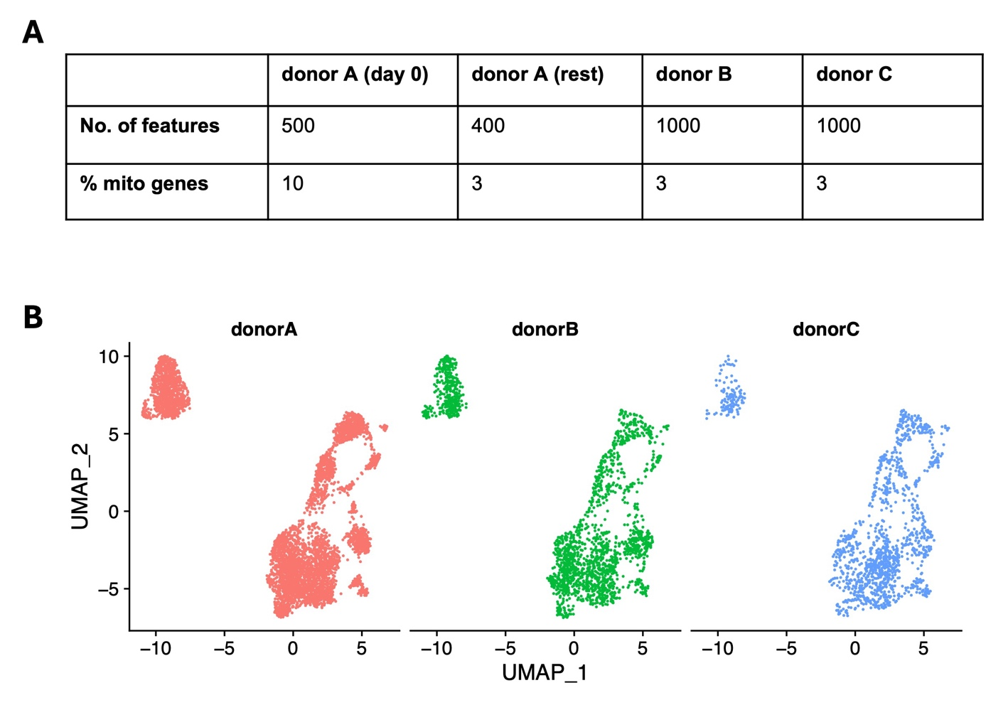
Quality control analysis of the scRNA-seq data. (A) Table listing the cut-offs used to remove low-quality cells for scRNA-seq analysis. (B) UMAP representation showing the origin of cells across different donors in different colors.

