Supplementary figures and figure legends
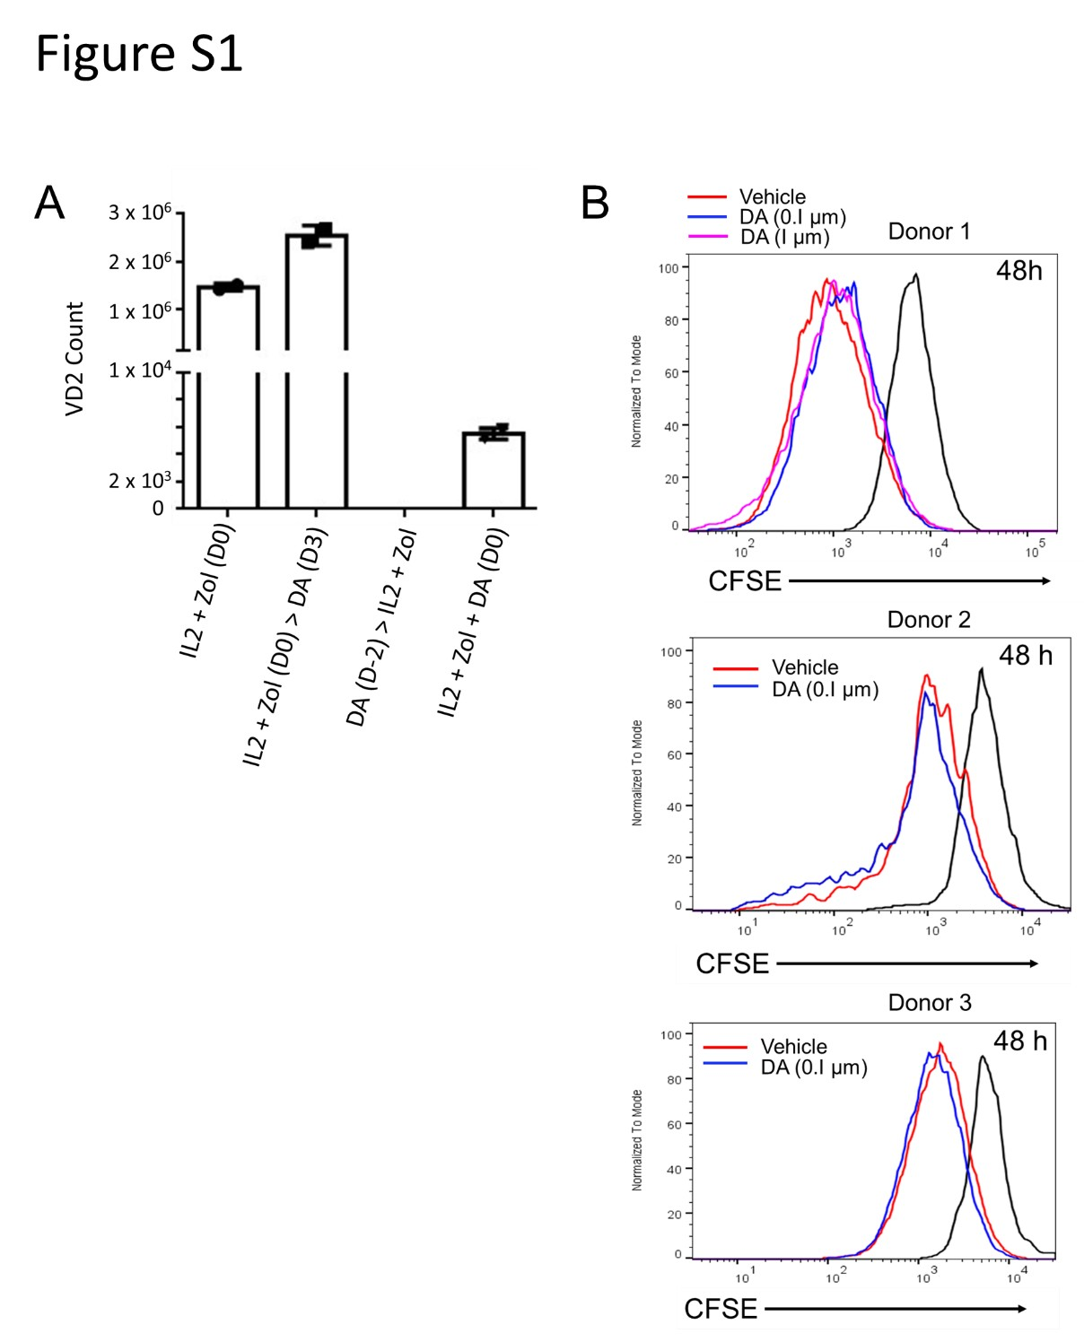
Figure S1. Timing of dasatinib addition affects γδ2 T cell expansion and proliferation.
(A) γδ2 T cell expansion under different dasatinib treatment schedules: pretreatment (before culture initiation), co-treatment (added at day 0), and standard treatment (added at day 3). Data from representative donors show that only day 3 addition enhances γδ2 T cell expansion, while earlier treatments offer no significant benefit. (B) CFSE-based proliferation assay comparing vehicle- and dasatinib-treated γδ2 T cells over a 48-h period (day 5 to day 7 of culture).
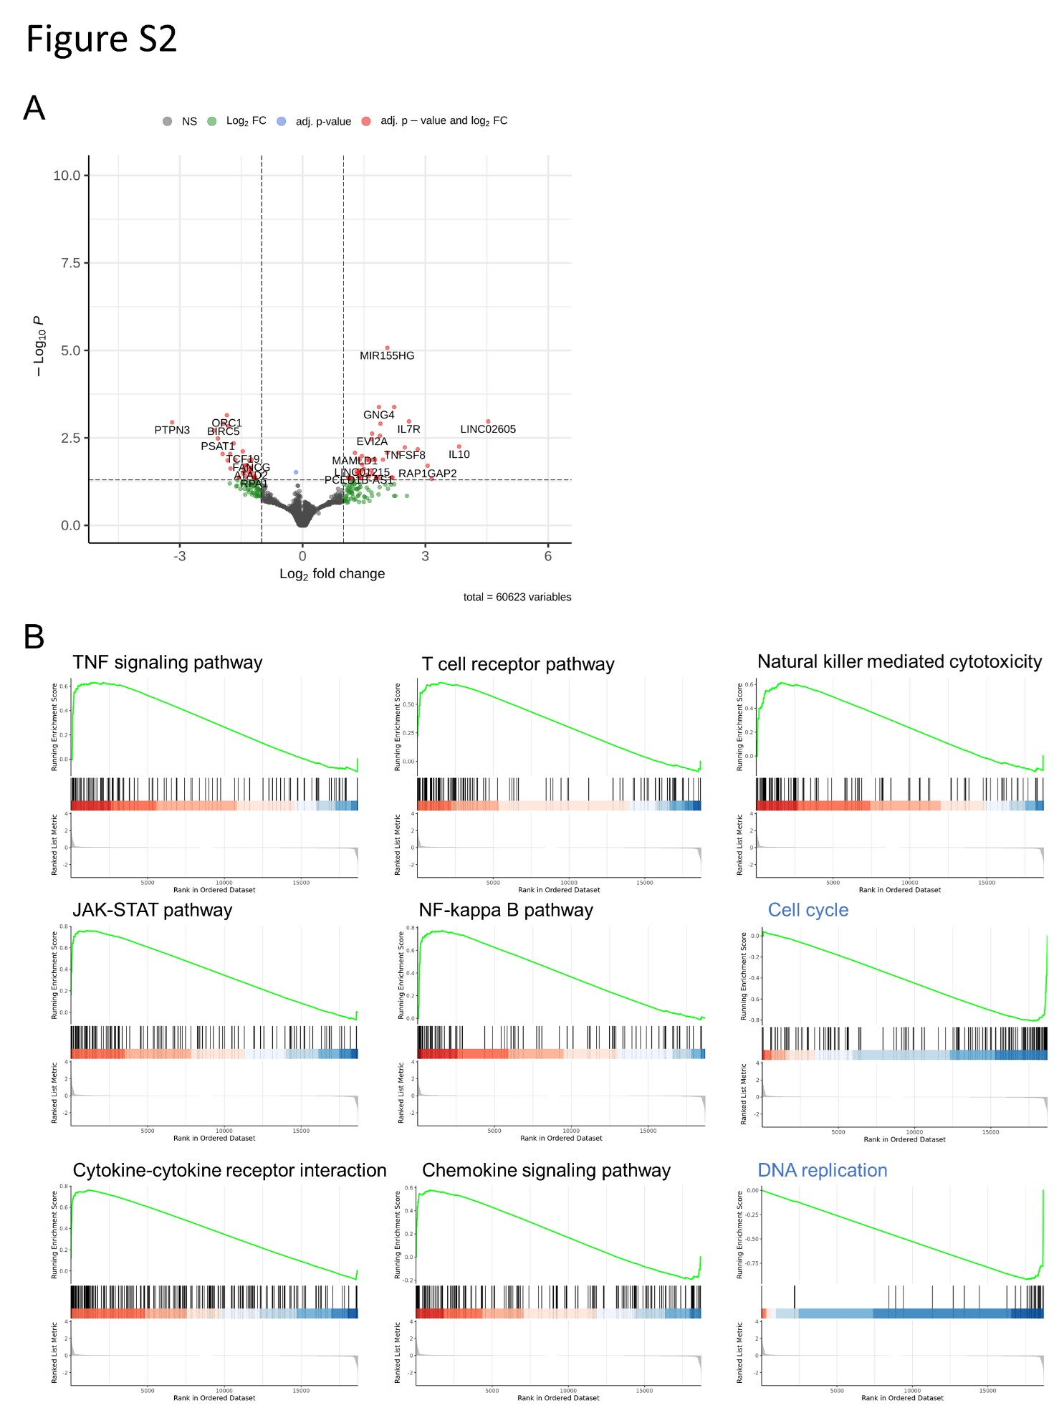
Figure S2. Transcriptomic analysis reveals dasatinib-induced gene expression changes.
(A) Volcano plot of differentially expressed genes between dasatinib-treated and vehicle-treated γδ2 T cells. MIR155HG is the most significantly upregulated transcript. (B) Gene Set Enrichment Analysis (GSEA) shows positive enrichment of immune-related pathways and negative enrichment of mitotic and cell cycle pathways.

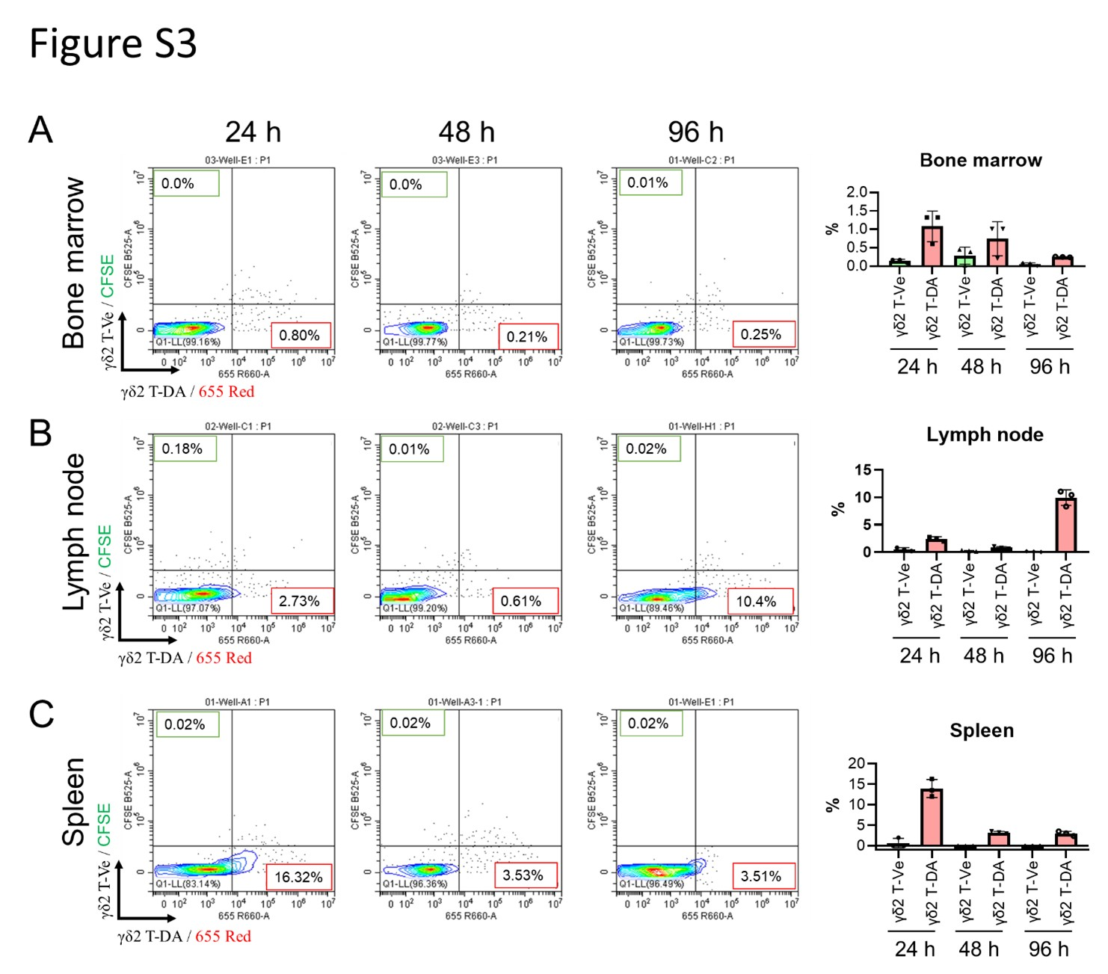
Figure S3. Tissue distribution of γδ2 T-Da and γδ2 T-Ve cells in GBM-bearing mice.
Representative flow cytometry plots and summary data showing higher abundance of γδ2 T-Da cells in the bone marrow, spleen, and lymph nodes at 24-h to 96-h post-infusion. γδ2 T-Ve cells are rarely detected. Tracers: BioTracker™ 655 (T-Da) and CFSE (T-Ve).

