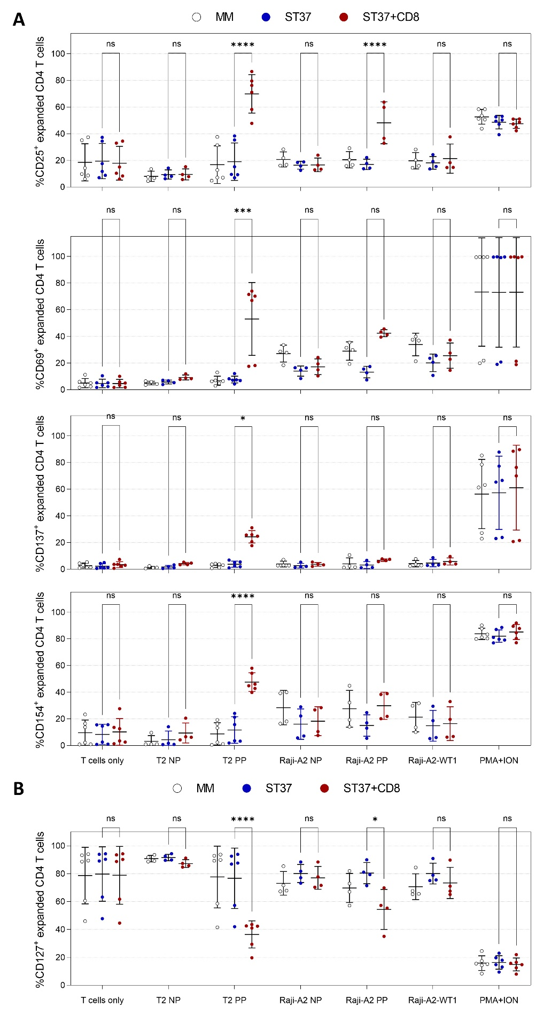
Figure S1. Expression of activation markers in response to WT1-specific recognition in expanded primary CD4 T-cells. Upregulation of CD25, CD69, CD137 and CD154 expression (A) and downregulation of CD127 expression (B) in T37 TCR-redirected CD4 T-cells were measured 24 hr after co-culture with tumor cell lines that were pulsed (PP) with WT1₃₇₋₄₅ peptide or left unpulsed (NP). As a negative control, T-cells were cultured in the absence of target cells (‘T cells only’ condition). As a positive control, T-cells were cultured in the presence of phorbol 12-myristate 13-acetate and ionomycin (PMA+ION). Graphs represent mean ± SD values for 4-6 independent donors and were analyzed using two-way ANOVA followed by Tukey’s multiple comparison test (ns, not significant; *, 0.01 < P < 0.05; ***, P ≤ 0.001; ****, P ≤ 0.0001). MM, control double sequential mock electroporation; ST37, double sequential electroporation, first with DsiRNA directed against TRAC and against TRBC mRNA, followed by WT1₃₇₋₄₅ TCR mRNA electroporation; +CD8, CD8 mRNA co-electroporated with TCR mRNA.
There was a significant increase in CD25 expression in ST37+CD8-engineered CD4 T-cells against HLA-A*02-positive WT1₃₇₋₄₅ peptide-pulsed T2 and Raji-A2 cells (69.9 ± 14.4% and 48.2 ± 15.7%, respectively), compared to their ST37 counterpart (19.1 ± 14.0% and 17.0 ± 3.9%, respectively). A significantly higher expression of CD69, CD137 and CD154 was found in co-cultures with WT1₃₇₋₄₅ peptide-pulsed T2 cells in ST37+CD8- (53.1 ± 27.3%, 24.3 ± 4.6% and 47.6 ± 7.0%, respectively), compared to ST37-engineered CD4 T-cells (7.7 ± 2.5%, 3.8 ± 2.3% and 11.6 ± 10.0%, respectively). There was a significant downregulation of CD127 in ST37+CD8-redirected CD4 T-cells in response to WT1₃₇₋₄₅ peptide-pulsed T2 and Raji-A2 cells (36.4 ± 9.7 % and 54.4 ± 14.4 %, respectively) versus ST37-engineered CD4 T-cells (76.7 ± 21.7 % and 80.4 ± 7.6 %, respectively).

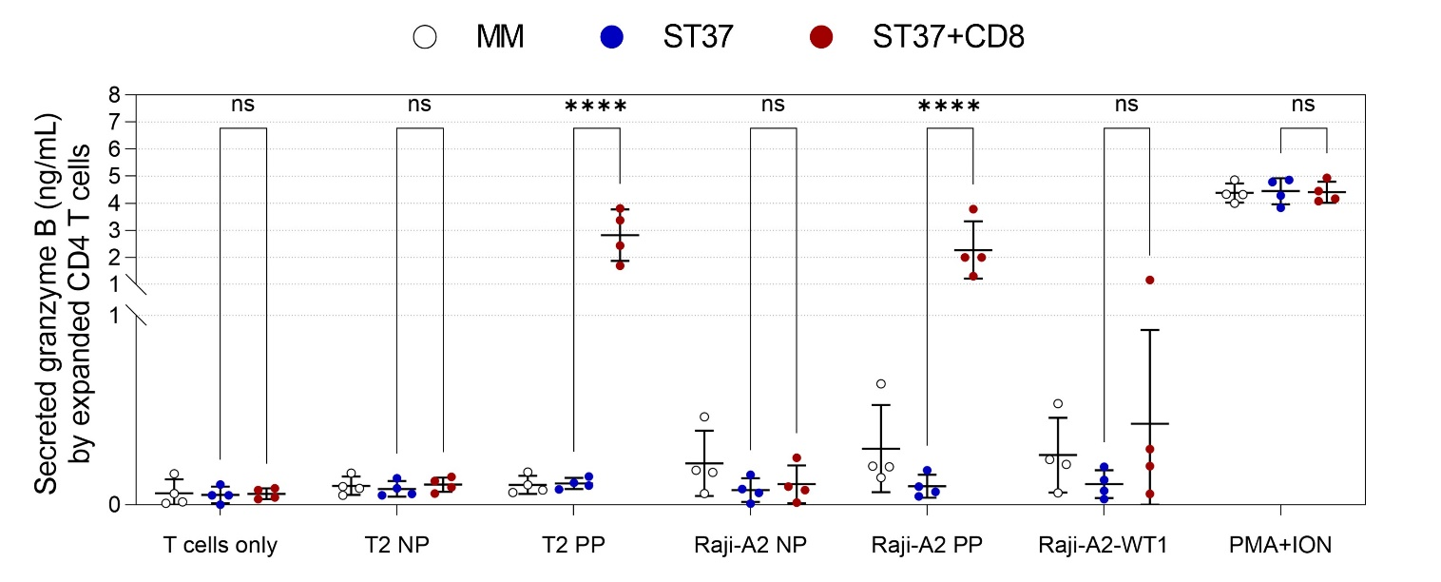
Figure S2. Secretion of granzyme B in expanded primary T37 TCR-redirected CD4 T-cells in response to WT1-specific recognition. Supernatants from 24 hr co-cultures of T37 TCR-redirected CD4 T-cells and tumor cell lines that were pulsed with WT1₃₇₋₄₅ peptide (PP) or left unpulsed (NP), were harvested and analyzed for granzyme B using ELISA. As a negative control, T-cells were cultured in the absence of target cells (‘T cells only’ condition). As a positive control, T-cells were cultured in the presence of phorbol 12-myristate 13-acetate and ionomycin (PMA+ION). Graphs represent mean ± SD values for 4 independent donors and were analyzed using two-way ANOVA followed by Tukey’s multiple comparison test (ns, not significant; ****, P ≤ 0.0001). MM, control double sequential mock electroporation; ST37, double sequential electroporation, first with DsiRNA directed against TRAC and against TRBC mRNA, followed by WT1₃₇₋₄₅ TCR mRNA electroporation; +CD8, CD8 mRNA co-electroporated with TCR mRNA.
ST37+CD8-engineered CD4 T-cells, but not ST37-redirected CD4 T-cells secreted granzyme B in the presence of WT1₃₇₋₄₅ peptide-pulsed T2 (2.8 ± 0.9 ng/mL versus 0.1 ± 0.03 ng/mL) and of WT1₃₇₋₄₅ peptide-pulsed Raji-A2 cells (2.3 ± 1.1 ng/mL versus 0.1 ± 0.1 ng/mL); these differences were significant.

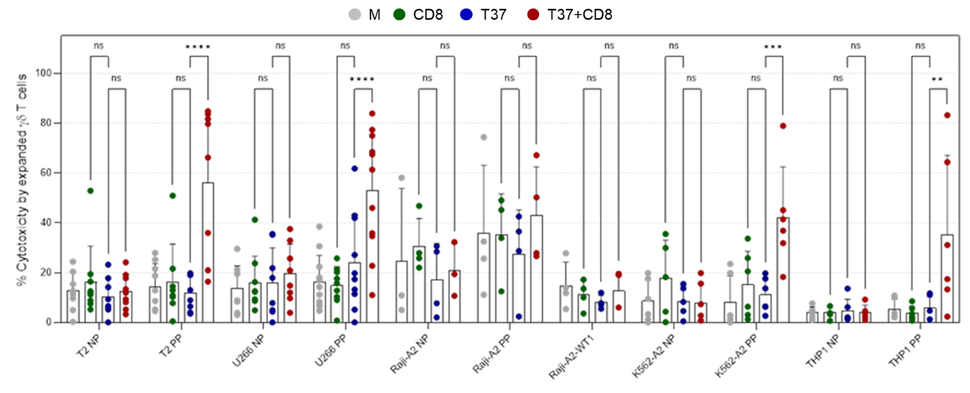
Figure S3. Antigen-specific activity of T37 TCR-redirected γδ T-cells against WT1₃₇₋₄₅ epitope presented by tumor cells. WT1-specific cytotoxic activity of T37 TCR-redirected γδ T-cells was measured 4 hr after co-culture with tumor cell lines that were pulsed with WT1₃₇₋₄₅ peptide (PP) or left unpulsed (NP). Graphs represent mean ± SD values for 3-11 independent donors and were analyzed using two-way ANOVA followed by Tukey’s multiple comparison test (ns, not significant; **, P ≤ 0.01; ***, P ≤ 0.001; ****, P ≤ 0.0001). M, mock electroporation; CD8, CD8 mRNA electroporation only; T37, WT1₃₇₋₄₅ TCR mRNA electroporation only; T37+CD8, co-electroporation of WT1₃₇₋₄₅ TCR + CD8 mRNAs.
Compared to T37-engineered γδ T-cells, T37+CD8-redirected γδ T-cells were significantly able to specifically kill HLA-A*02-positive WT1₃₇₋₄₅ peptide-pulsed T2 (56.1 ± 28.5 %), U266 (53.0 ± 24.3 %), K562-A2 (42.0 ± 20.3 %) and THP1 (35.3 ± 31.8 %) tumor cells.

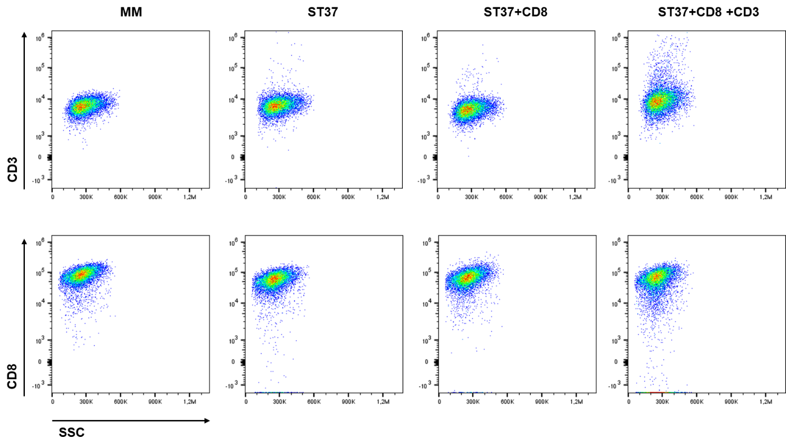
Figure S4. Representative flow cytometry plot showing CD3 and CD8 expression in ST37+CD8 and ST37+CD8+CD3 T37 TCR-redirected CD8 T-cells. CD3 and CD8 surface expression was assessed 24 hours after electroporation of CD8 T-cells with CD3 and CD8 mRNA. Representative flow cytometry plots illustrate membrane expression levels following gating on viable cells. MM, control double sequential mock electroporation; ST37, double sequential electroporation, first with DsiRNA directed against TRAC and against TRBC mRNA, followed by WT1₃₇₋₄₅ TCR mRNA electroporation; +CD8, CD8 mRNA co-electroporated with TCR mRNA; +CD3, CD3 mRNA co-electroporated with TCR and CD8 mRNA.
No visual differences were observed in membrane expression of CD3 or CD8 following electroporation with the respective mRNAs.

