**Jim’s Gym Supplies**

General outlook: **Strong**

Strengths:

* ~2.5M in revenue from inception to end of data set (Feb 2018 -> Jan 2021) .
* ~1.2M in revenue in the last year of business (Jan 2020 -> Jan 2021).
* ~36k customers
* 21.75% year-over-year revenue growth
* 33% repeat customer rate (up from 29% year-over-year)
* 56% churn rate (down from 63% year-over-year)
* $16.18 in customer lifetime value (up from $6.89 year-over-year)
* Overall we observe strong linear growth patterns in both revenue and customer acquisition with fairly good and improving customer retention metrics.

Weaknesses:

* From Sep 2019 through Feb 2020 we see a complete stoppage of both revenue and customer growth. It seems as if the business suddenly stopped functioning for this period of time and there should be due diligence of what the cause of this was.
* Sales seem to commence again in March 2020, which marks the start of the COVID-19 pandemic. There may be risk associated with policy changes regarding the pandemic and their effect on both online customer activity and the home improvement market (home gyms).

Seasonality:

* Weekly seasonality data suggests order activity peaks mid-week (Wed) and falls during the weekend. (see below)
* Yearly seasonality data suggests that the strongest performing months of the year in terms of revenue generation are March and August. (see below)

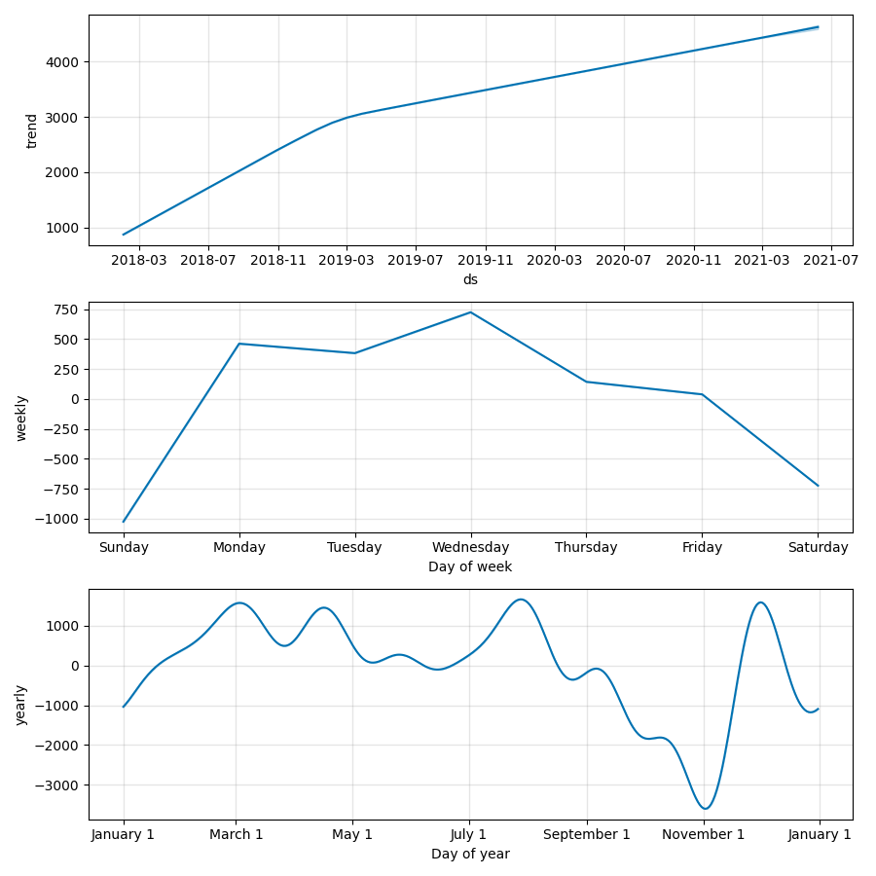

Forecasted Revenue:

* Forecasted revenue for next 150 days: $811,982.10 ($750,177.57, $873,088.98) 80% confidence interval.
* Generated utilizing time-series forecasting model which includes linear growth function and seasonality function (fournier series as a function of time).

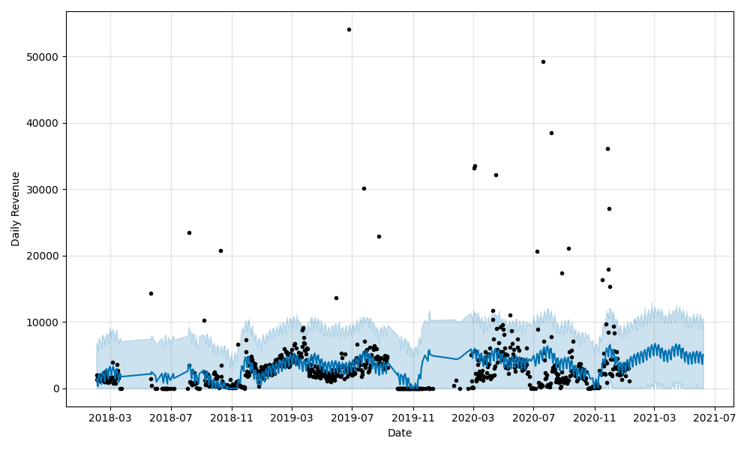

**John’s Boardgame Shop**

General outlook**: Weak**

Strengths:

* ~1.3M in revenue from inception to end of data set (Feb 2018 -> Sep 2021) .
* ~.8M in revenue in the last year of business (Sep 2020 -> Sep 2021).
* 52.06% year-over-year revenue growth
* ~35k customers
* Strong linear growth curve in revenue and customer acquisition from May 2020 to May 2021

Weaknesses:

* 15% repeat customer rate (down from 16% year-over-year)
* 75% churn rate (down from 76% year-over-year)
* $2.02 in customer lifetime value (down from $2.42 year-over-year)
* From May 2021 forward we see a large decrease in revenue and customer acquisition growth.
* ~175k in revenue with 1371 newly acquired during the latest quarter compared with the previous quarter of ~350k done in revenue and 20k new customers. ~50% decrease in revenue from previous quarter and astounding ~93% decrease in customer acquisition.
* Aggressive drops in customer acquisition compounded with poor customer retention statistics makes the outlook poor for this company.

Seasonality:

* Weekly seasonality data suggests order activity peaks at the beginning of the week (Sun-Mon) and falls linearly throughout the rest of week. (see below)
* Yearly seasonality data suggests that the strongest performing months of the year in terms of revenue generation are March, Apri, and Mayl. (see below)

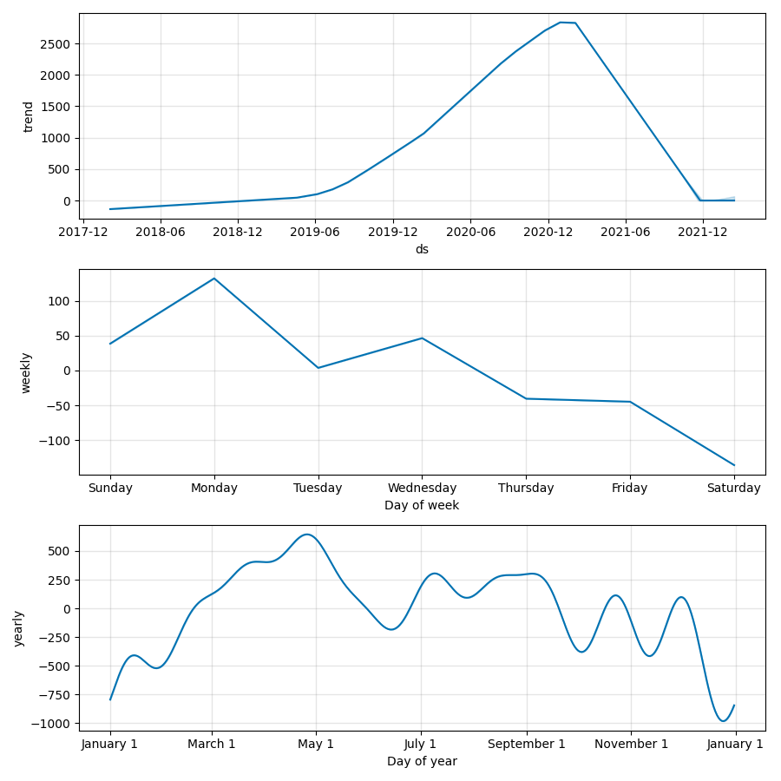

Forecasted Revenue:

* Forecasted revenue for next 150 days: $39,180.15 ($32,916.43, $45,695.49) 80% confidence interval
* Generated utilizing time-series forecasting model which includes linear growth function and seasonality function (fournier series as a function of time).

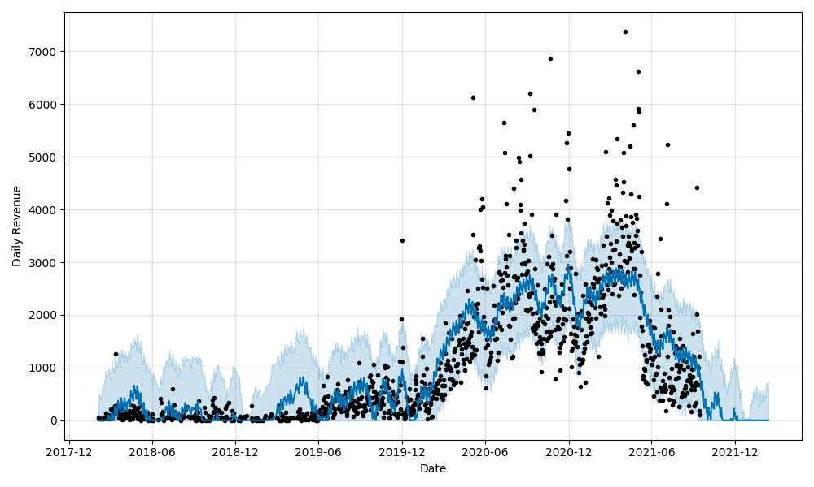

**Mary’s Christmas Shop**

General Outlook: **Fair**

Strengths:

* ~2.3M in revenue from inception to end of data set (Feb 2018 -> Aug 2021) .
* ~1.6M in revenue in the last year of business (Aug 2020 -> Aug 2021).
* ~35k customers
* 172% year-over-year revenue growth
* 21% repeat customer rate (up from 12% year-over-year)
* 71% churn rate (down from 84% year-over-year)
* $6.75 in customer lifetime value (up from $2.41 year-over-year)
* Overall we observe strong linear growth patterns in both revenue and customer acquisition with improving customer retention metrics since the beginning of June 2020.

Weaknesses:

* From inception to beginning of June 2020, we see a very slow linear growth rate associated with both revenue and customer acquisition. During that period, we observe average monthly revenue of ~8k and monthly customer acquisition of ~141. This pales in comparison to an average monthly revenue of ~140k and monthly customer acquisition of ~2163 from June 2020 onward.
* Sales seem to grow much faster starting in June 2020, which is a few months after the start of the COVID-19 pandemic. There may be risk associated with policy changes regarding the pandemic and their effect on both online customer activity and the online holiday shopping market.
* Customer retention statistics are growing. However, low LTV and repeat customer rates signify a risk in terms of customer retention.

Seasonality:

* Weekly seasonality data suggests order activity is strongest during the weekdays and falls during the weekend. (see below)
* Yearly seasonality data suggests that the strongest performing months of the year in terms of revenue generation are around June and then also the months leading up to the Christmas season (November and December). (see below)
* This trend falls in line with what we would expect considering consumer activity jumps during large christmas sales in the summer and also before the holiday itself.

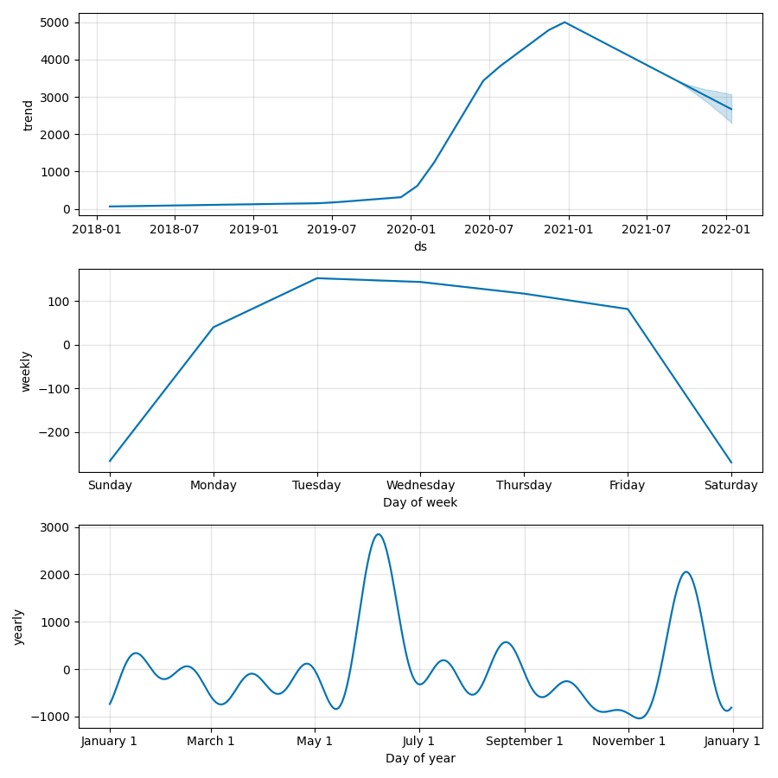

Forecasted Revenue:

* Forecasted revenue for next 150 days: $463,321.97 ($425,432.31, $502,078.65) 80% confidence interval
* Generated utilizing time-series forecasting model which includes linear growth function and seasonality function (fournier series as a function of time).

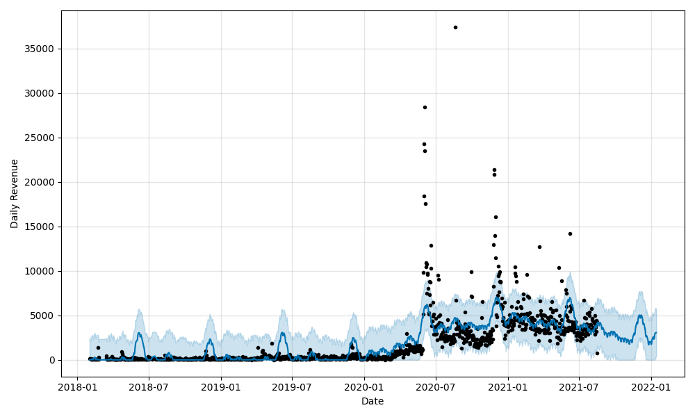

**Conclusion:**

The general outlook of each company is based on a combination of analysis surrounding revenue and customer acquisition growth patterns, seasonality, and customer retention statistics. Since all three companies seem to have changes in growth patterns surrounding the time period of the pandemic, it is important to do due diligence in assessing the cause of these changes in growth and whether they are in line with the general ecommerce market. There should be cause for concern that these companies may be sensitive to changes in lockdown policies.