FIT5032 eFolio Week 11: Hosting
Student: czen0018 (jordandmc666@gmail.com)
Hosting platform: Cloudflare (account Jordandmc666@gmail.com's Account)

Links to deployed projects
Deployment from Git (GitHub czen0018/fit5032-week1): https://fit5032-week1.jordandmc666.workers.dev
Get Weather page on the Git deployment (Task 11.2): https://fit5032-week1.jordandmc666.workers.dev/WeatherCheck
Deployment directly from IDE using C3 (czen0018-library): https://czen0018-library.pages.dev

Contents
Task 11.1 Screenshot 1: Cloudflare Workers & Pages list showing both deployed projects
Task 11.1 Screenshot 2: Deployment from Git, successful build of czen0018/fit5032-week1
Task 11.1 Screenshot 3: Deployment from Git, deployed site in the browser
Task 11.1 Screenshot 4: Deployment from IDE using C3, npm run deploy in VS Code
Task 11.1 Screenshot 5: Deployment from IDE using C3, Cloudflare deployments page
Task 11.2 Screenshot 1: Get Weather working on the Cloudflare deployment (address bar visible)
Task 11.2 Screenshot 2: Fix applied, build variable VITE_OPENWEATHER_API_KEY

Task 11.1 Screenshot 1: Cloudflare Workers & Pages (both deployed projects)
File: Cloudflare dashboard > Compute > Workers & Pages. fit5032-week1 is connected to the GitHub repository czen0018/fit5032-week1 (deployment from Git), and czen0018-library has no Git connection because it was deployed directly from the IDE with the C3 tool. The account Jordandmc666@gmail.com is shown at the top left.
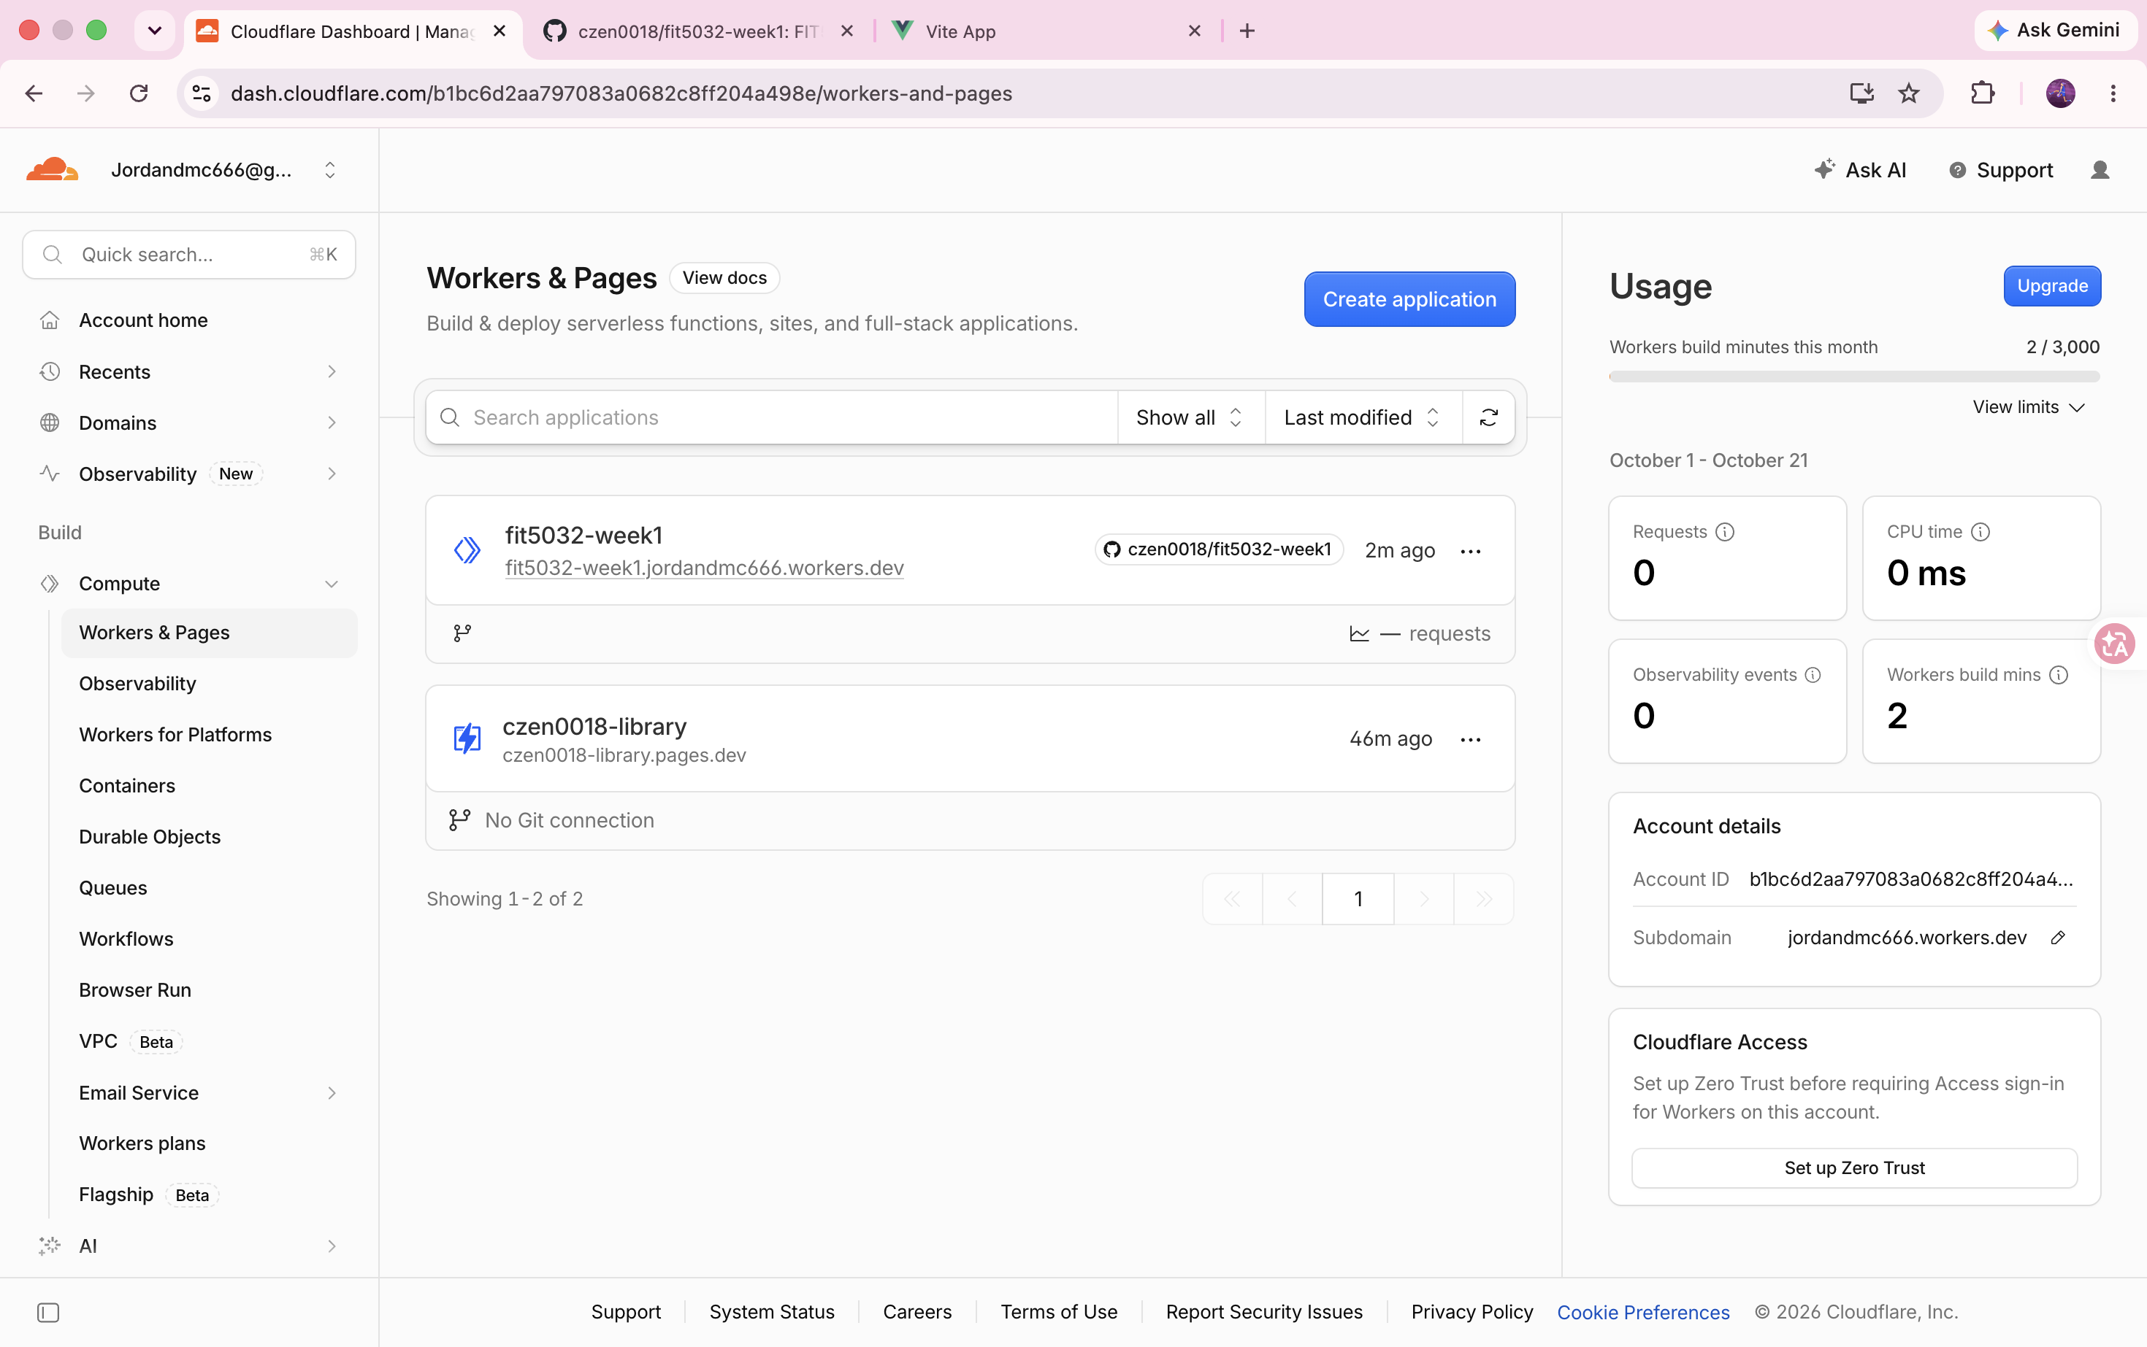

Task 11.1 Screenshot 2: Deployment from Git, build log
File: Cloudflare dashboard > fit5032-week1 > Deployments > build details. Every stage (Initializing, Cloning, Installing, Building, Deploying) succeeded after pushing to GitHub, and the log ends with the deployed URL https://fit5032-week1.jordandmc666.workers.dev. A wrangler.jsonc file serving ./dist as static assets with single-page-application fallback was added to the repository so that the Vue build deploys correctly.
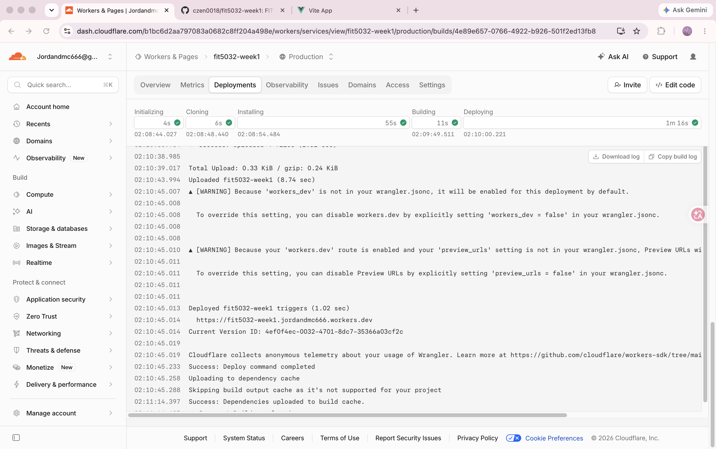

Task 11.1 Screenshot 3: Deployment from Git, live site
File: Browser, https://fit5032-week1.jordandmc666.workers.dev. The eFolio Vue application built from the GitHub repository is live on Cloudflare.
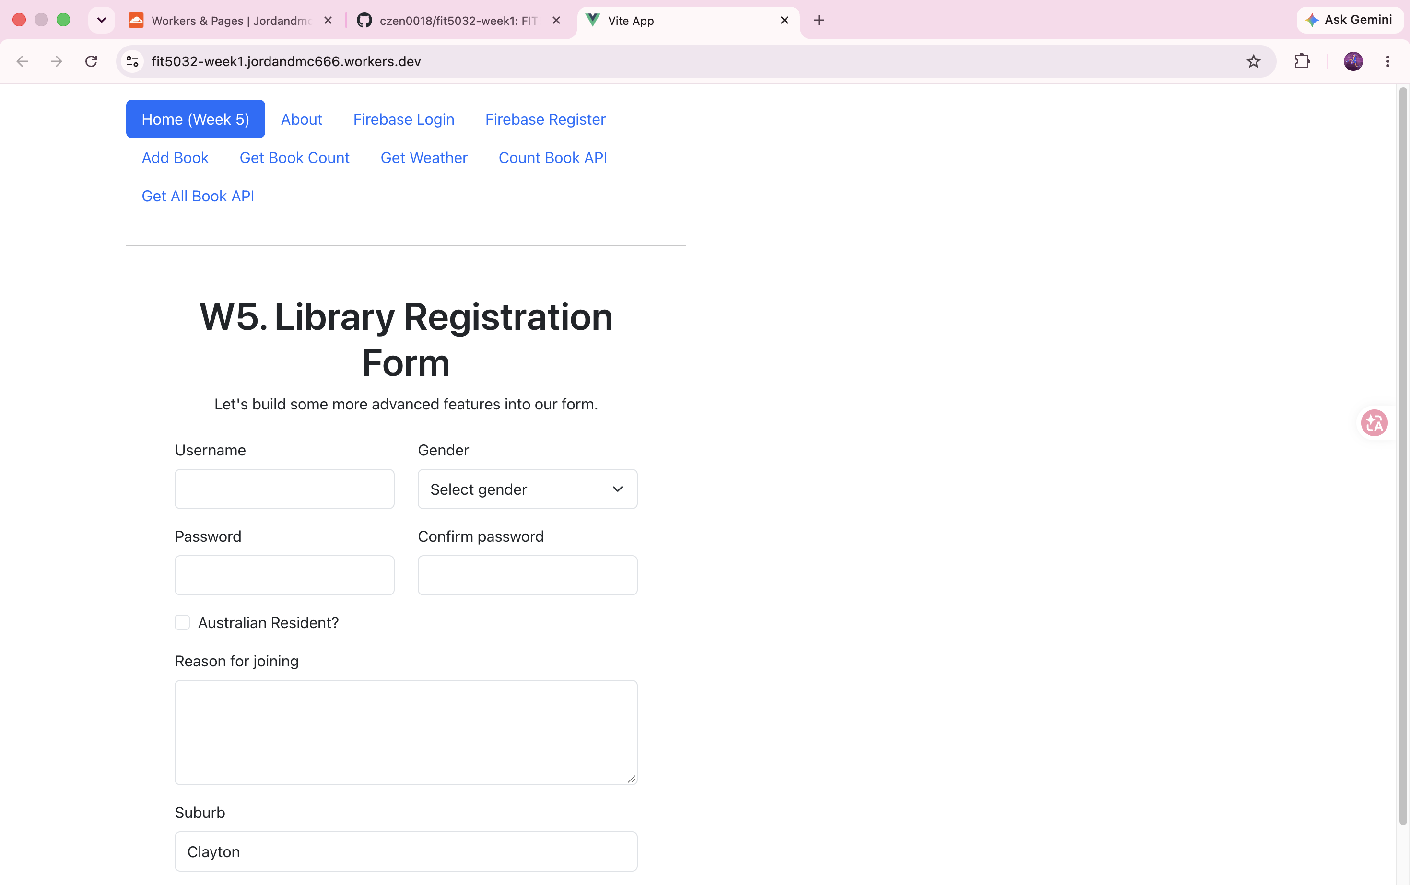

Task 11.1 Screenshot 4: Deployment directly from IDE using C3
File: Visual Studio Code, project czen0018-library created with "npm create cloudflare@latest -- czen0018-library --framework=vue --platform=pages". The terminal shows npm run deploy building the app with Vite, uploading with wrangler and "Deployment complete!" with the czen0018-library.pages.dev URL; wrangler.jsonc generated by C3 is open in the editor.
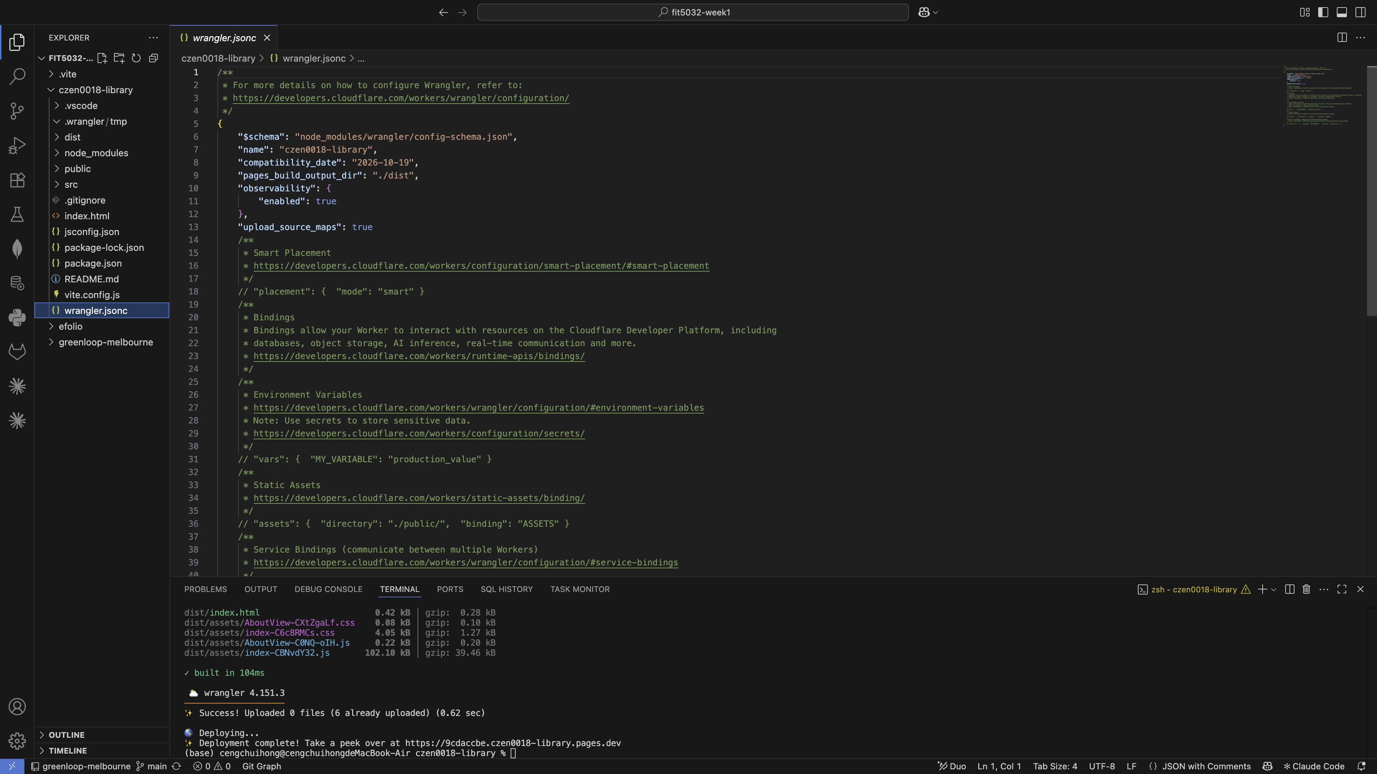

Task 11.1 Screenshot 5: C3 project deployments in Cloudflare
File: Cloudflare dashboard > Workers & Pages > czen0018-library > Deployments. The production domain czen0018-library.pages.dev and all successful deployments made from the IDE are listed.
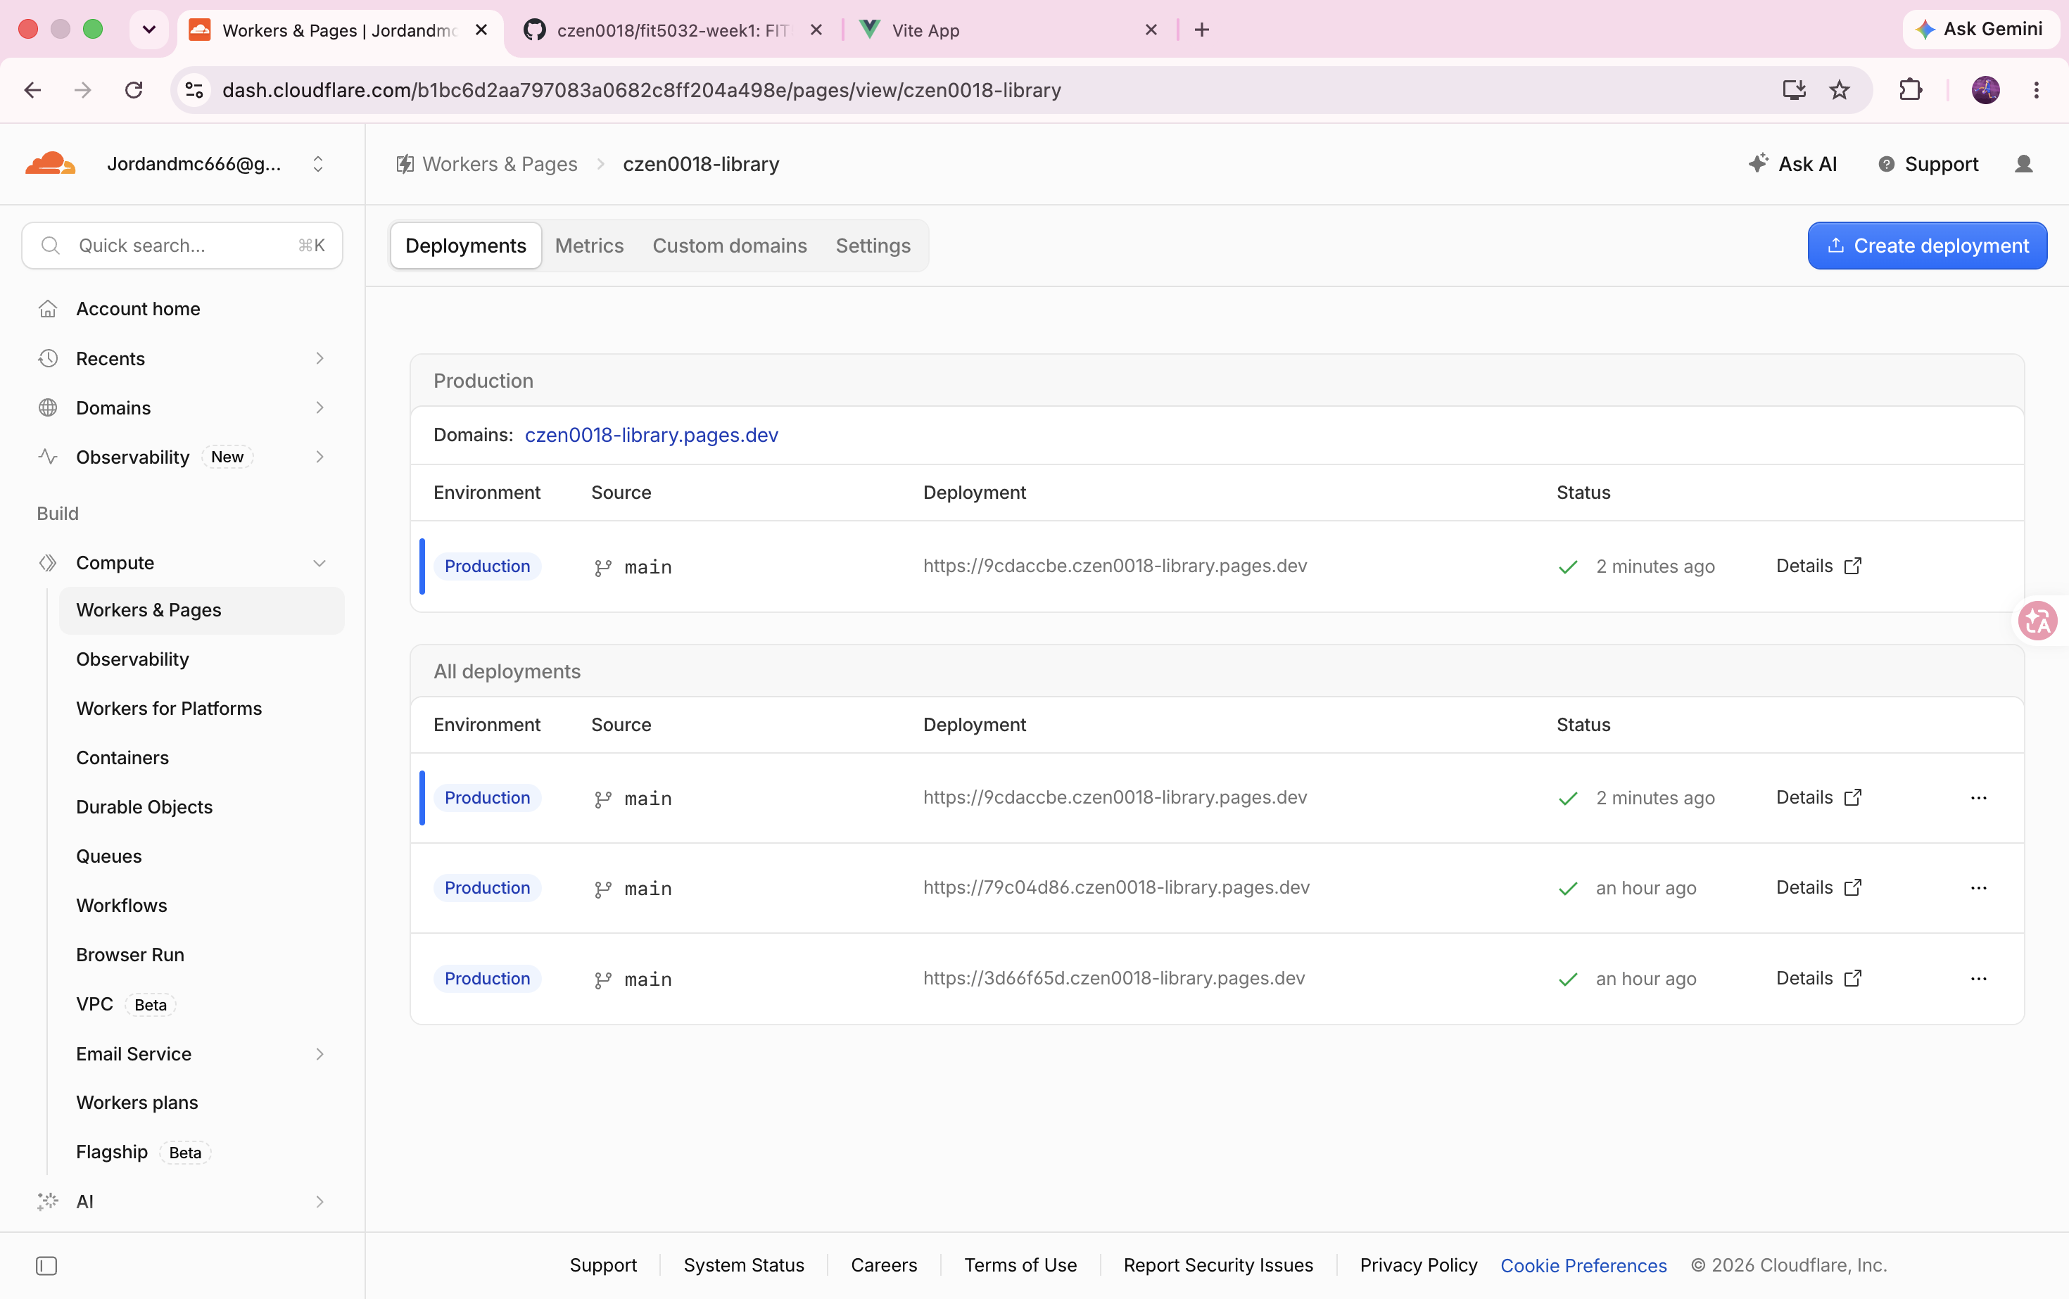

Task 11.2 Screenshot 1: Get Weather working on Cloudflare
File: Browser, https://fit5032-week1.jordandmc666.workers.dev/WeatherCheck (address bar visible). The deployed Get Weather page shows the current location weather (Notting Hill, AU, 16 °C, Clear Sky) with its icon.
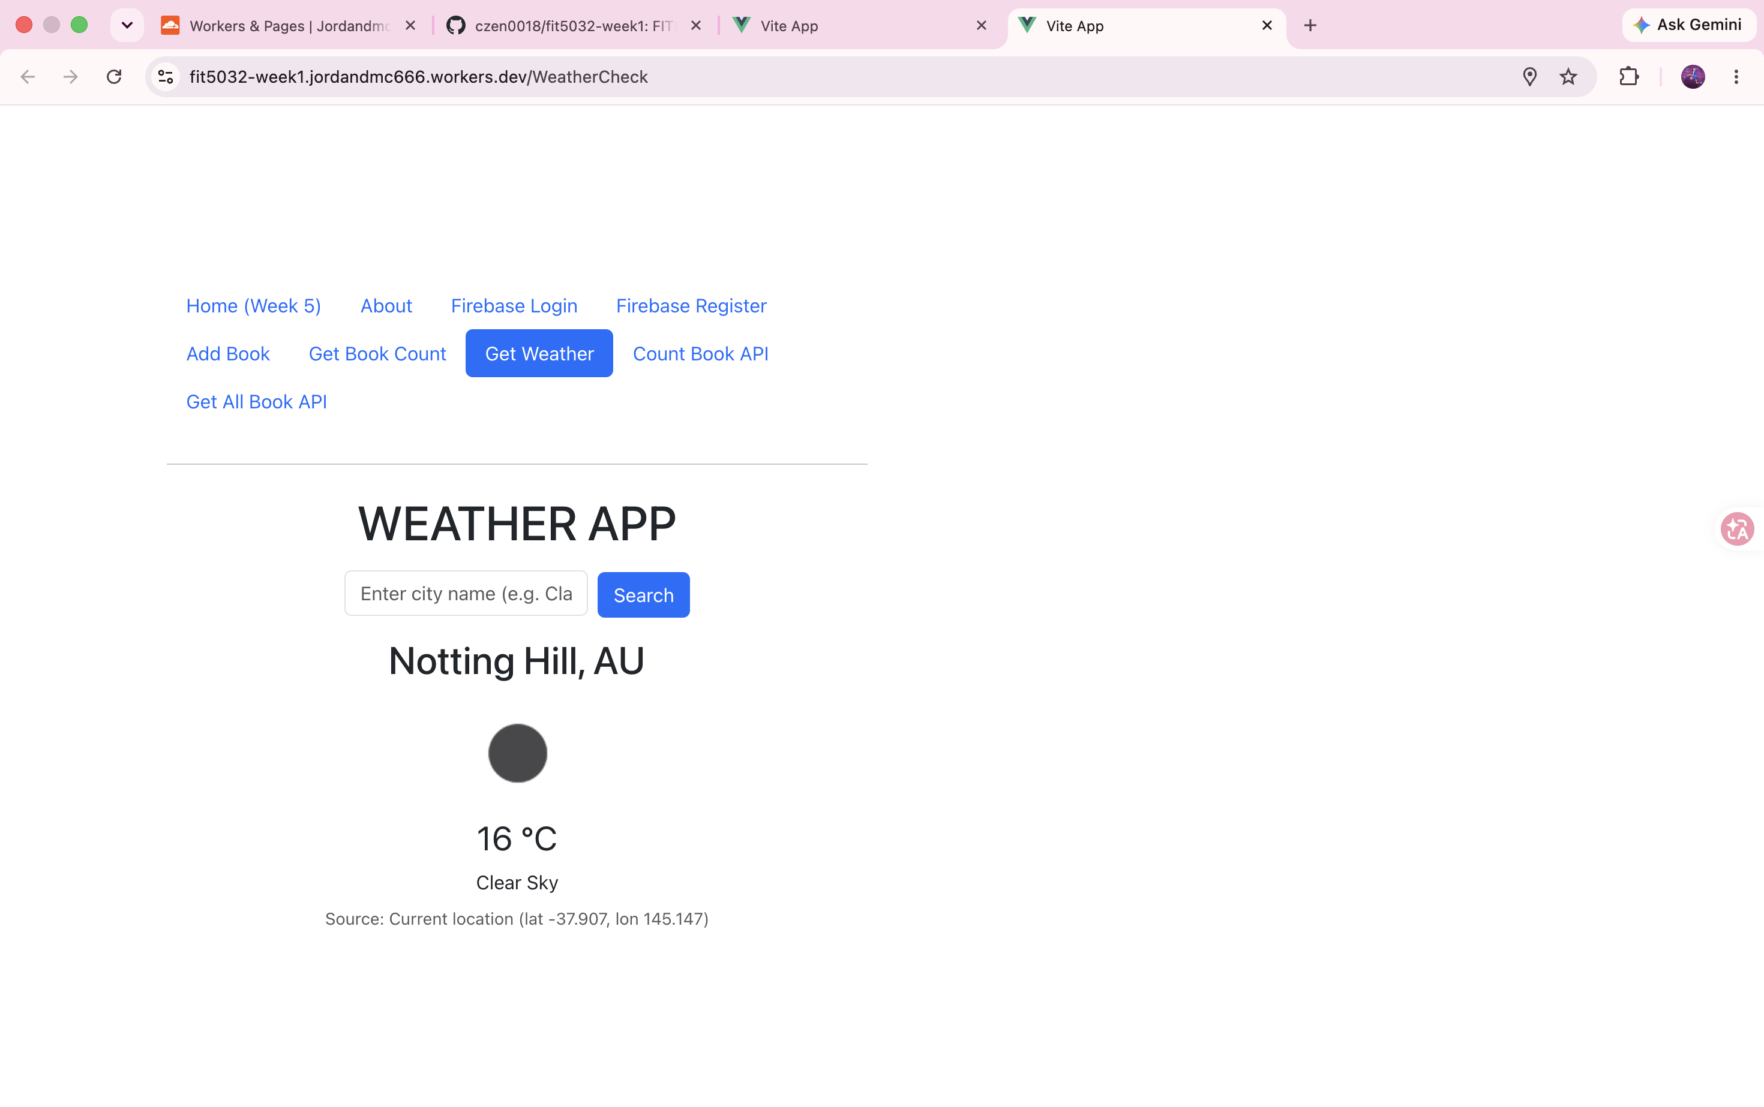

Task 11.2 Screenshot 2: How the Get Weather issue was fixed
File: Cloudflare dashboard > fit5032-week1 > Settings > Builds > Variables and secrets. After the first deployment the weather page failed because the OpenWeatherMap key lives in the local .env file, which is git-ignored and therefore not in the repository. Vite reads VITE_ variables at build time, so the key was added as the build variable VITE_OPENWEATHER_API_KEY and the project was rebuilt. Direct visits to /WeatherCheck are served by the single-page-application fallback in wrangler.jsonc.
