FIT5032 eFolio Week 10: API
Student: czen0018 (jordandmc666@gmail.com)
Firebase project: FIT5032 (fit5032-4a2ec). Weather data: OpenWeatherMap Current Weather API (free student plan).
Local project: fit5032-week1 (Vue 3 + Vite + axios + Firebase Cloud Functions 2nd gen)

Contents
Task 10.1 Screenshot set 1: Code and browser showing the current location weather
Task 10.1 Screenshot set 2: Code and browser of the CountBookAPI page showing the number of books
Task 10.2 Screenshot set 1: Code and browser searching weather by city ("Clayton, AU") with Celsius temperature and weather icon
Task 10.2 Screenshot set 2: Code and browser of the GetAllBookAPI page showing all books in JSON format

Task 10.1 Screenshot set 1a: Current location weather (browser)
File: Browser, http://localhost:5174/WeatherCheck. When the page loads, the browser Geolocation API provides the latitude and longitude, the app calls the OpenWeatherMap Current Weather API and shows the location (Notting Hill, AU), the weather icon, the temperature in Celsius and the description.
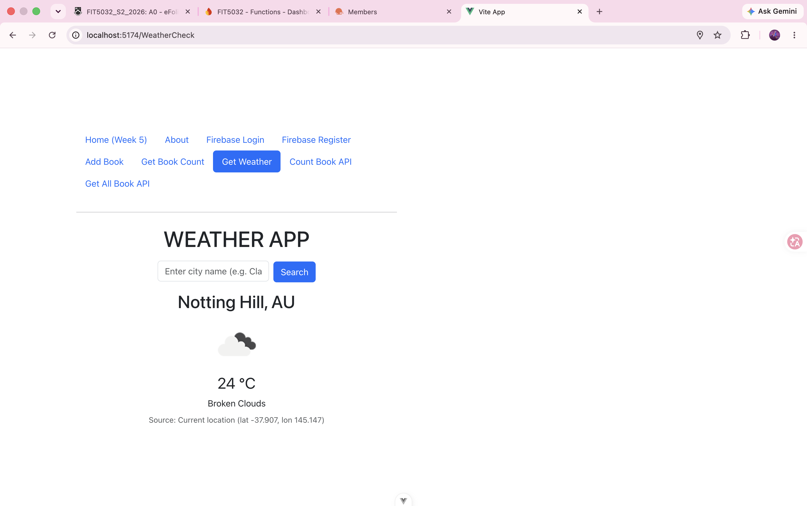

Task 10.1 Screenshot set 1b: Code of src/views/WeatherView.vue (template)
File: src/views/WeatherView.vue in Visual Studio Code. The template contains the city text field bound with v-model, the Search button with the searchByCity click handler, and the <main> section that renders weatherData.name, weatherData.sys.country, the icon (iconUrl), the temperature in °C and weather[0].description.
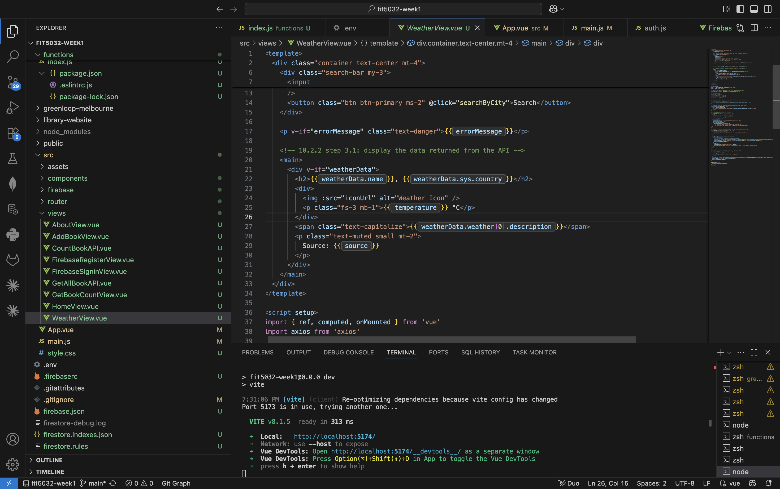

Task 10.1 Screenshot set 1c: Code of src/views/WeatherView.vue (script)
File: src/views/WeatherView.vue in Visual Studio Code, <script setup> section: the apikey from .env, the computed temperature and iconUrl, fetchWeatherData with axios inside try / catch, fetchCurrentLocationWeather using navigator.geolocation, searchByCity, and onMounted.
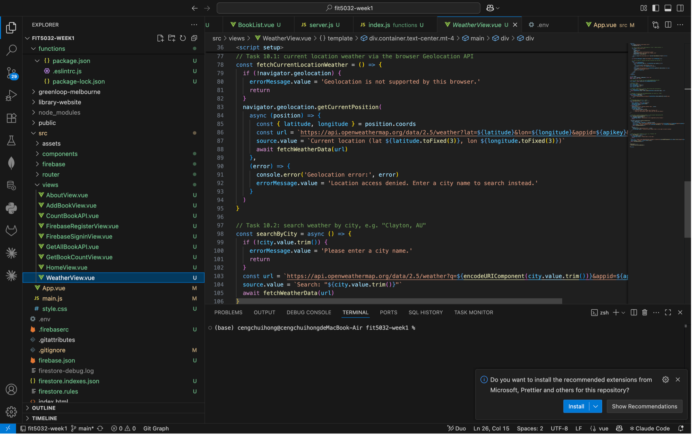

Task 10.1 Screenshot set 2a: CountBookAPI page showing the number of books (browser)
File: Browser, http://localhost:5174/CountBookAPI. The page calls the countBooks Cloud Function on mount and displays the JSON response { "count": 3 } in a <pre> tag. The navigation header is hidden on API pages by the showHeader computed property in App.vue.
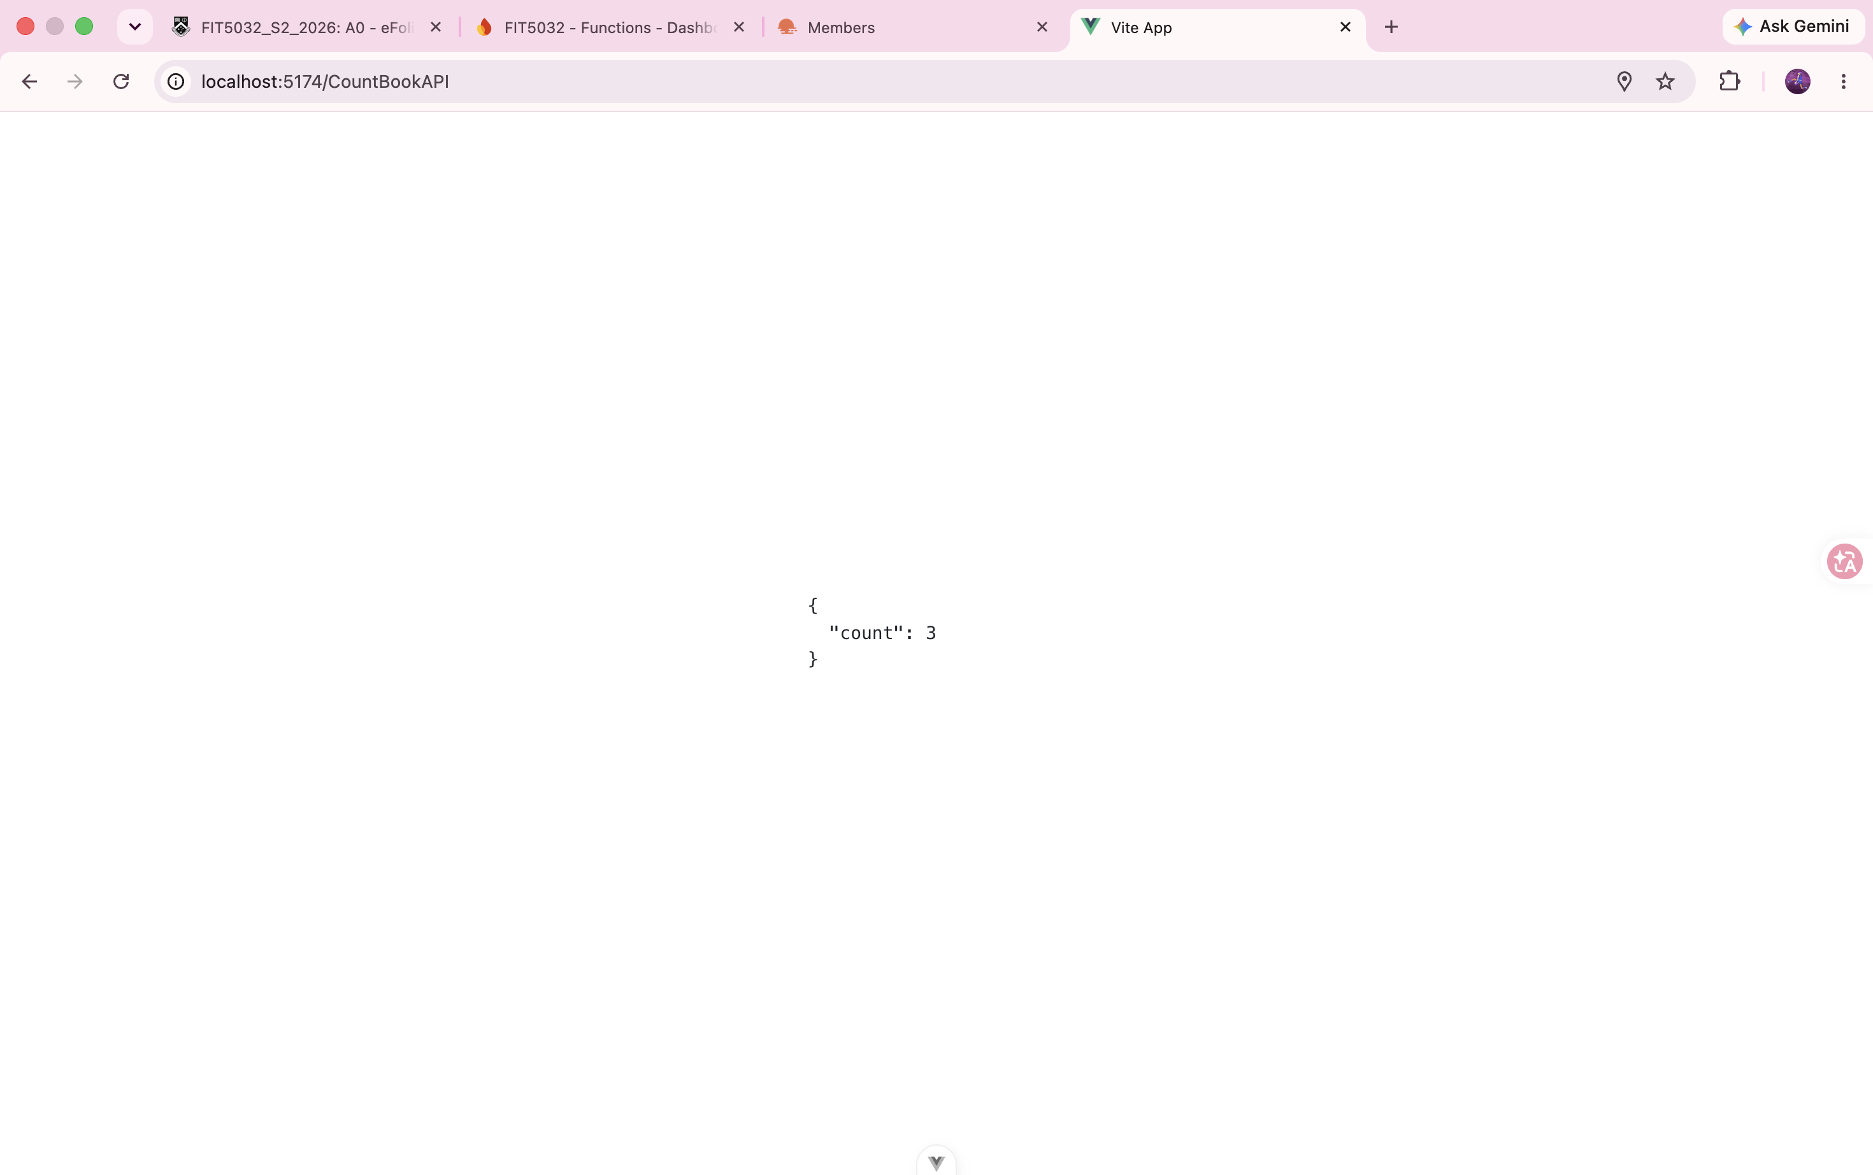

Task 10.1 Screenshot set 2b: Code of src/views/CountBookAPI.vue
File: src/views/CountBookAPI.vue in Visual Studio Code. getBookCountAPI returns only response.data from axios, it is called from onMounted() so no button is needed, and the template shows the JSON inside <pre>{{ jsondata }}</pre>.
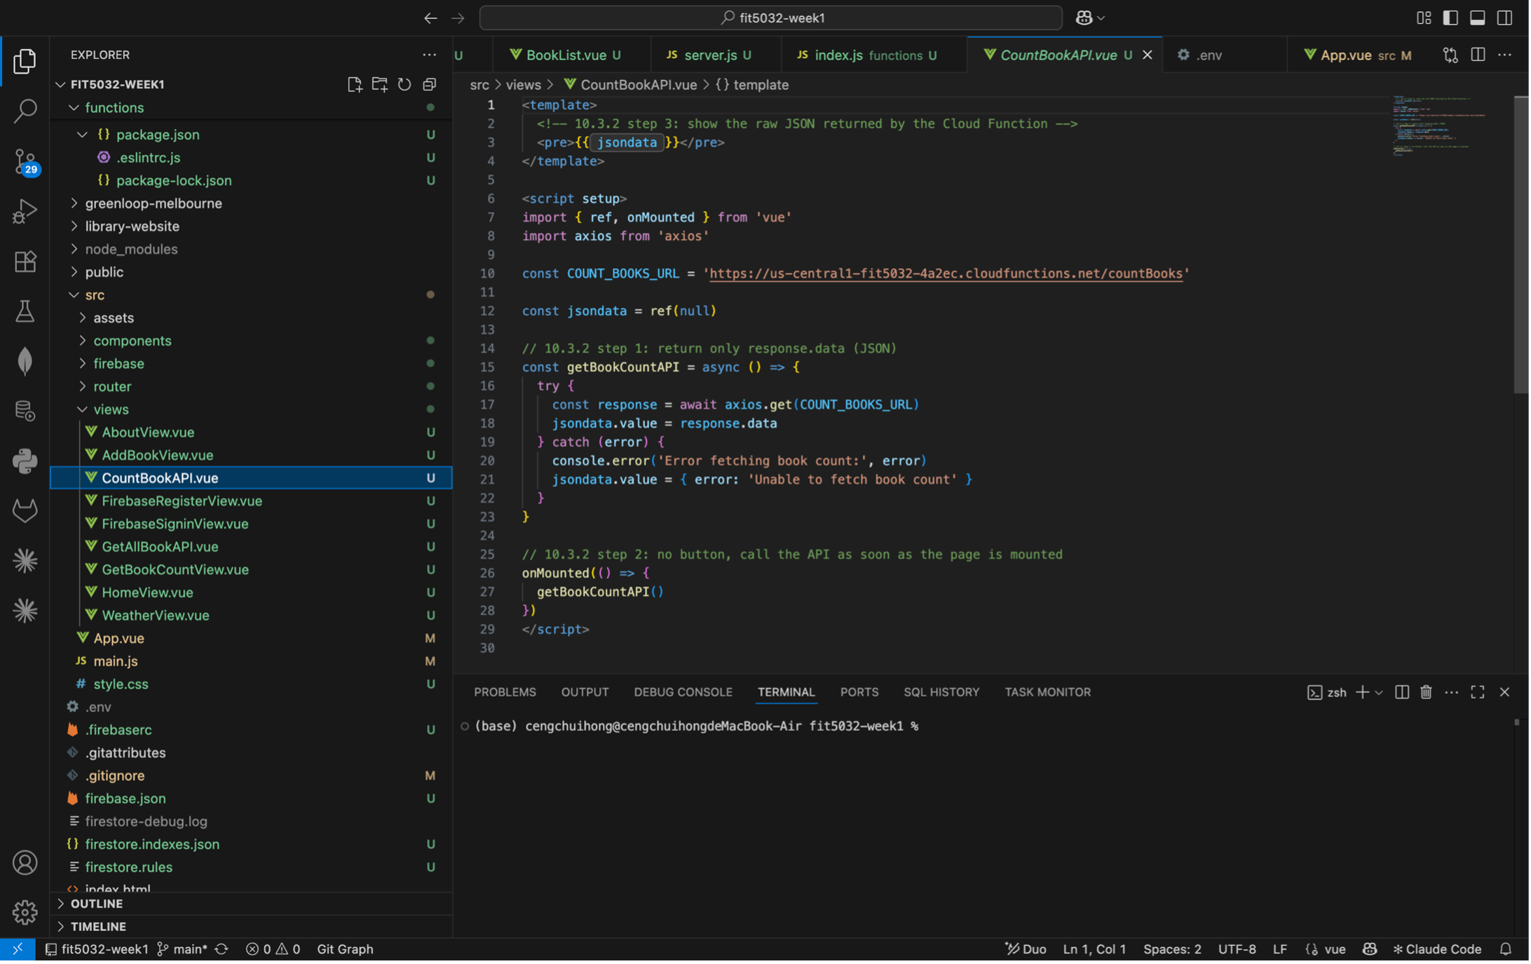

Task 10.2 Screenshot set 1: Search weather by city "Clayton, AU" (browser)
File: Browser, http://localhost:5174/WeatherCheck. After typing "Clayton,AU" and clicking Search, the app requests the Current Weather API with q=Clayton,AU&units=metric and shows Clayton, AU, the corresponding weather icon, the temperature in Celsius (23 °C) and the description (Broken Clouds). The code for this is in WeatherView.vue shown in Task 10.1 set 1b and 1c.
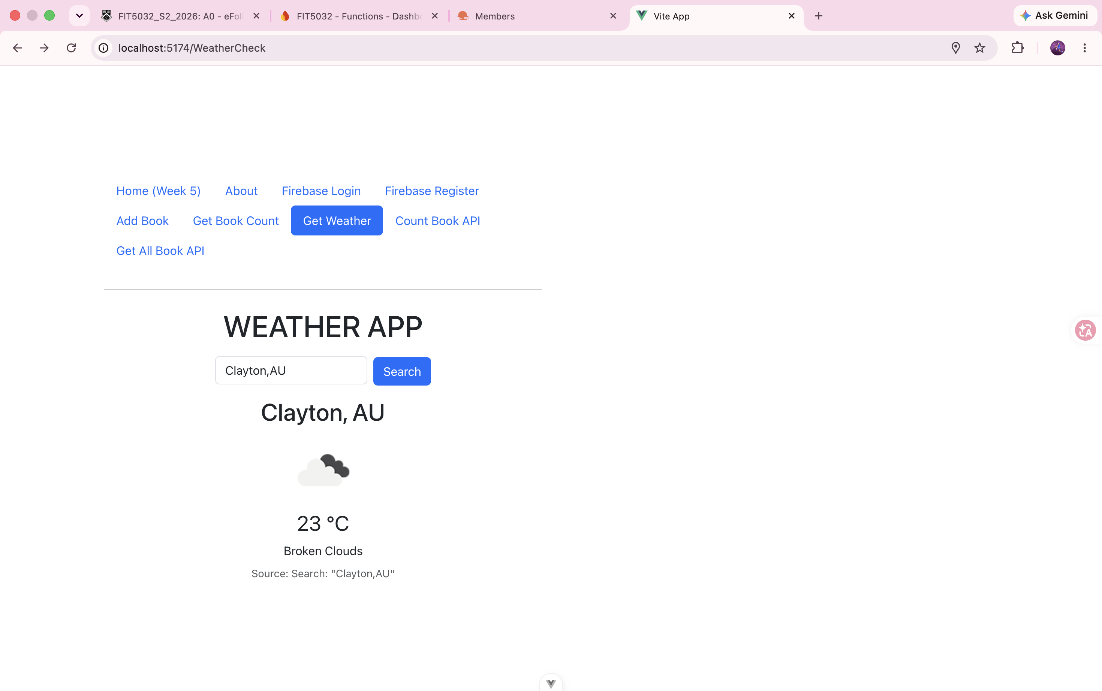

Task 10.2 Screenshot set 2a: GetAllBookAPI page showing all books in JSON (browser)
File: Browser, http://localhost:5174/GetAllBookAPI. The page calls the getAllBooks Cloud Function on mount and displays every document of the "books" collection as JSON, including the book capitalised by the Week 9 capitalizeBook trigger.
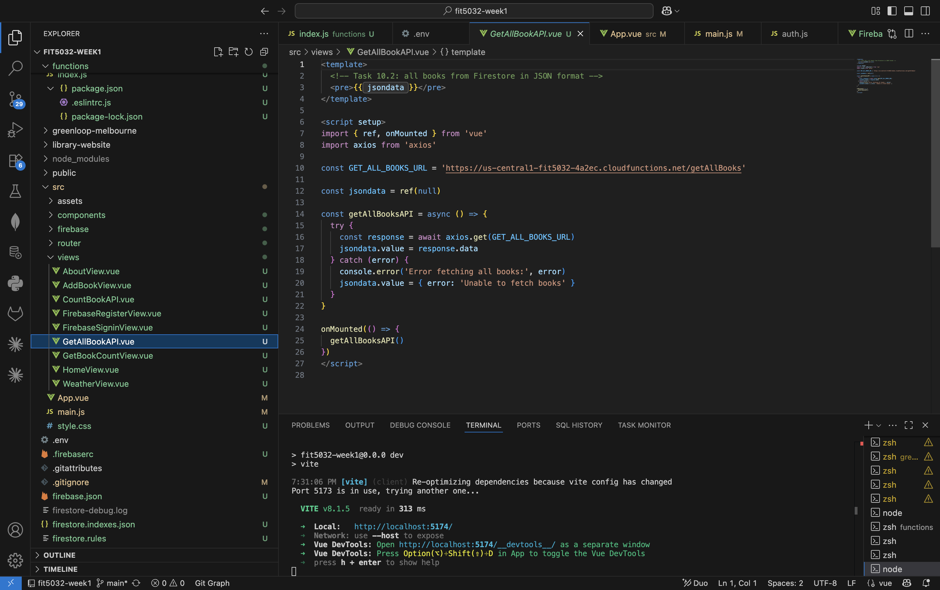

Task 10.2 Screenshot set 2b: Code of src/views/GetAllBookAPI.vue
File: src/views/GetAllBookAPI.vue in Visual Studio Code. axios.get() calls the deployed getAllBooks function, response.data is stored in jsondata and rendered in a <pre> tag; the request runs automatically in onMounted().
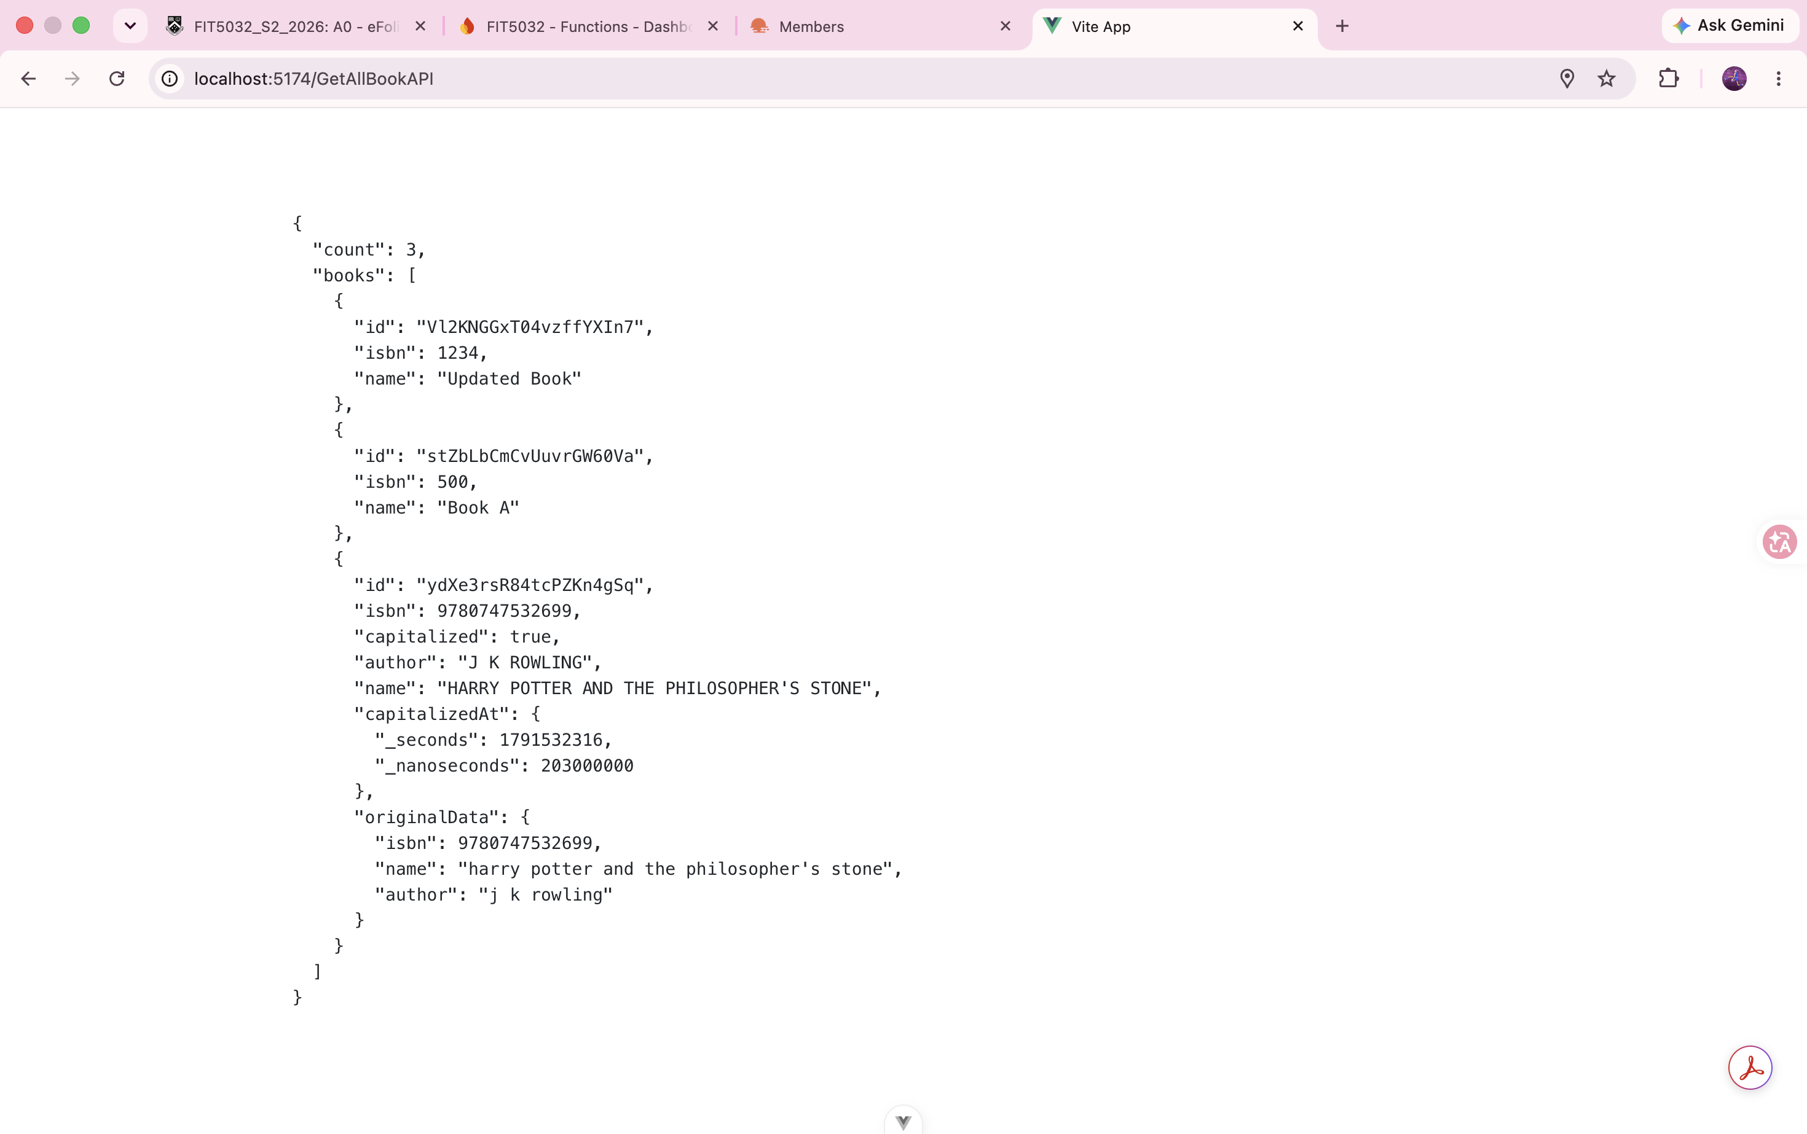

Task 10.2 Screenshot set 2c: Code of functions/index.js (getAllBooks Cloud Function)
File: functions/index.js in Visual Studio Code. getAllBooks is an onRequest HTTPS function wrapped with cors; it reads the whole "books" collection with the Firebase Admin SDK, maps each document to { id, ...data } and returns { count, books } as JSON inside try / catch.
