I. INTRODUCTION

- Background of the Problem
Cryptography is science that uses the mathematics to encrypt and decrypt data, it lets you keep your files and documents safe even on insecure networks like the Internet. Cryptography is also defined as the science that makes all the possible mathematical calculations and formulations in order to guarantee the secrecy of the data encrypted.
Encryption is applying an algorithm to a message, which scrambles the data on it – making it difficult and time consuming to deduce the original data, given only the data encoded. Input to the encryption algorithm typically involves additional secret data called key, which prevents the message from being decoded – even if the algorithm is publicly known. The output is usually garbled text, which is useless unless you decrypt it. This term can always be associated with the Internet where the great advancement in technology lies. Internet serves as a virtual place where businessmen meet for their transactions, and serves as a medium of communications for everyone.
Keys are additional secret data inputted along the plain text, which is used in the algorithm to encode data in a pattern specific to the key. It has two types namely: (a) Secret key – Symmetric Cryptography, where the encryption algorithm requires the same secret key to be used for both encryption and decryption. Because of the type of key, this is sometimes called secret key encryption, (b) Public/Private Keys – Asymmetric Cryptography. This uses two keys that are mathematically related. One key is called the private key and is never revealed, and the other is called the public key and is freely given out to all potential correspondents. The complexity of the relationship between the public key and the private key means that provided the keys are long enough, it is practically impossible to determine one from the other.
A secret sharing scheme is a method for sharing a secret among a set p of p participants. The secret is encoded into n pieces called shares each of which is given to a distinct participant. Certain qualified subsets of participants can recover the secret by pooling together their information, whereas forbidden subsets of participants have information on the secret. The specification of the qualified sets and the forbidden sets is called access structure. A special kind of secret sharing scheme are visual cryptography schemes (VCSs), that is, schemes where the secret to share is an image and the shares consist of Xeroxed transparencies which are stacked to recover the shared image.
Visual Cryptography is a secret sharing scheme which uses the human visual system to perform computations. The basic principle behind visual cryptography is the use of superimposed images to reveal the secret. Each individual image can be considered as a cipher, and the corresponding image may be regarded as a key. The basic idea in secret sharing is to divide the secret key into pieces and distribute the pieces to different persons so that certain subsets of the persons can get together to recover the key. From this came the new concept about Visual Secret Sharing Scheme which is an interesting visual variant of the ordinary secret sharing schemes. Roughly speaking the problem can be formulated as follows: There is a secret picture to be shared among n participants. The picture is divided into n transparencies (shares) such that if any m transparencies are placed together, the picture becomes visible, but if fewer than m transparencies are placed together, nothing can be seen. Visual cryptography is a new area of research in secret sharing schemes.

B. Statement of the Problem
Currently there are lots of freely available encryption algorithms, just search the net and you will find some. However, technology is rapidly changing from time to time, so the once secure way algorithm for encryption through time has now become predictable and proves to be easy to decipher. If we will go back in time the first encryption algorithm implemented was that of Julius Caesar, to safeguard military and diplomatic communications (Alconis, 1996). These algorithm uses the shift by three rules, for example an ‘a’ becomes ‘d’, ‘b’ becomes ‘e’ and so on, through history this algorithm has proven its value. But with the abundance of cryptographic knowledge and more complex mathematical analysis these kind of algorithm is considered obsolete. To cope up security with increasing technology, encryption algorithms have now incorporated complex mathematical formulas that are quite hard to comprehend and also require intensive CPU power.
Also consider the situation wherein there is only one secret key that provides access to many important files, which is the case for Symmetric Cryptosystem. How about if the key is lost or the computer that stores the key is destroyed, then all your precious documents, files, etc. are now inaccessible and for symmetric encryption it is just a document with a garbled text written on it. So in doing encryption we also have to consider Secure Key Management.
Moreover, consider this question; can you manually decrypt a cipher text encrypted in a very complex manner? I mean without the aid of a computer. Probably, but the follow up question is how long?

C. Significance of the Study
“Although transaction security on the internet is a hot topic, it is only a part of the colorful story of digital cryptography” (Nanda, 2002). In today’s world of Electronic Commerce on the internet, the need for secure communications is obviously crucial. The fact that many companies are spending millions just to avail the newest algorithm for digital data encryption is enough to explain that there is a pressing need for a strong encryption technology.
This paper proposed an alternative encryption algorithm developed by Naor and Shamir, which uses the concept of Visual Secret Sharing Scheme. The new algorithm offers advantages considered valuable by the end users. First is the isolation of complex mathematical functions associated to the existing encryption technologies. Secondly, the algorithm can be performed without the use of a computer; so even if you are on a mountain side of the world you can still perform decryption.
James Bond carries a special "key" which is in fact a transparency with lots of random dots on it; when M faxes Bond a secret message, it too consisting of lots of random dots; Bond simply places his transparency over the cipher text and reads out the plaintext (Stejano, 2005)! Finally, this paper addresses the problem of using a symmetric encryption that uses single key for encryption. The problem is if the key is lost, so as the data encrypted or stored. The proposed encryption method uses at least two keys/shares from a subset of n keys/shares that are allowed to encipher the original message.
Although no new algorithm is developed, the system provides the implementation and a little improvement of various Visual Cryptographic Schemes that the author considered because the algorithm implements an unbreakable (in the information-theoretical sense) cryptosystem rather similar to the one time pad, with the additional twist that decryption does not require any computing equipment.

D. Objective of the Study
The general objective of the study is to develop a package that implements various Visual Cryptographic Algorithms.
Specifically the study aims:
- to develop a class package that will provide the implementation of:
- 2x2 Visual Cryptographic Scheme,
- 2xn Visual Cryptographic Scheme,
c. nxn Visual Cryptographic Scheme;
2. to develop a class package which is designed so that it may be extended to implement advanced features;
3. to implement the proposed package in Java Programming Language with the aide of image libraries from sourceforge community and the Sun Company; http://www.sourceforge.net, http://www.java.sun.com respectively; and
4. to develop documentation on how to use the package libraries and its functionalities.

II. REVIEW OF RELATED LITERATURE

The concept of securing messages through cryptography has a long history.
Indeed, Julius Caesar is credited with creating one of the earliest Cryptographic
systems to send military messages to his Generals. (When Julius Caesar sent
messages to his trusted Acquaintances, he didn't trust the messengers.
So he replaced every A by a D, every B by an E, and so on through the alphabet.
Only someone who knew the shift by 3 rules could decipher his messages.)
Throughout history, however, there has been one central problem limiting widespread
use of Cryptography. That problem is key management. In Cryptographic systems,
the term key refers to a numerical value used by an Algorithm to alter information,
making that information secure and visible only to individuals who have the corresponding key to recover the information. Consequently, the term key management refers to the secure administration of keys to provide them to users where and when they are required (Sedgewick, 1988).
We have not mentioned what is popularly supposed to be the purpose of coding: security. We have only considered coding as a mechanism for improving the integrity of the communication system in the presence of noise. The use of coding for security has a different name: encryption. The use of digital computers has made highly secure communication a normal occurrence. It is very much easier to encrypt than it is to decipher. The principle is just that of a combination lock. With a computer, the number of the digits in the lock can be very large. Of course, one still has to keep the combination secure!
Encryption is the name given to the process of applying an algorithm to a message, which scrambles the data in it – making it very difficult and time consuming, (but not practically impossible), to deduce the original data, given only the encoded data. Inputs to the algorithm typically involve additional secret data called keys, which prevents the message from being decoded – even if the algorithm is publicly known. The output is usually garbled text, which is useless unless you decrypt it. These arguments are extracted from (Sedgewick, 1988).
Generally, there are two types of approach to encryption. One is by substitution: an encryption key is used to determine, for each character of the plain text, a cipher text character to be substituted for that character; the other is by permutation, in which plaintext characters are simply rearranged into some different sequence. Good cryptographic systems should always be designed so that they are as difficult to break as possible. Governments have always had concerns with strong encryption fearing that criminals could use it against their countries. Sophisticated technology is used by law enforcement agencies to decipher encrypted information that might contain incriminating evidence. In theory one can break any encryption algorithm by exhausting every key in a sequence. This brute force method requires vast amounts of computing power as length of the key increase. For example a 32-bit key takes 2^32 (4294967296) steps. A system with 40 bit keys (e.g. US-exportable version of RC4) takes 2^40 steps - this kind of computing power is available in most universities and even small companies (Nanda, 2002).
According to Schneier, the very popular encryptions in used today are the ones that employ a key. This is for real security. This can be a very large value. The range of possible values of a key is called a keyspace. Belonging to these is the precursor and the simplest of its kind the Caesar’s Cipher, which is used by the Great Roman Emperor himself Julius Caesar (Sedgewick, 1988). It’s just a plain substitution of a defined displacement of a fixed number of positions which is three to the right modulo 26 (the number of characters in the English alphabet), A is replaced by D, B is replaced by E, Z is replaced by C, and so on. In general if the character is at location N^{th} then it is replaced by a (N + K)^{th} letter from the same alphabet, where K is a fixed number.
The encryption algorithms that uses keys depends on the safe keeping of keys, in other words, their generation, storage and exchange, is of paramount importance to ensure the security of the data. There is no point applying the strongest levels of cryptographic algorithms, if your keys are stored on a scrap of paper in your in-tray. The strength of the encryption is dependent on two basic items: the nature of the mathematical algorithm and the size of the keys involved. The term message is used to refer to any piece of data. This message can consist of ASCII text, a database file, or any data you want to store or transmit securely. Plaintext is used to refer to data that has not been encrypted, while cipher text refers to data that has been.
Keys are additional secret data inputted along with the plain text, which is used in the algorithm to encode data in a pattern specific to the key. One of the vital roots of the strength of the encryption is the size/length of the keys involved, generally expressed in bits. The key is generally a long number produced by multiplying two much larger prime numbers using the algorithm of Factoring.
Key-based algorithms can be classified into two categories: Symmetric Cryptography (secret keys) and Asymmetric Cryptography (public/private keys). In symmetric cryptography, the encryption algorithm requires the same secret key to be used for both encryption and decryption. Because of the type of key, this is sometimes called secret key encryption.
The advantage of these algorithms is that they are fast and efficient. However, the problem is that of key exchange - it is the mechanism for safely ensuring both parties, the sender and the receiver, have the secret key. This is one of the weakest areas of symmetric cryptography. How do you send the key to your partners? You cannot just send it in an email message, because it could be intercepted and, possibly unknowingly, compromise your security. Furthermore, how can you be sure that your partners will keep your key secure (Schneier, 1995)?
One solution to the problem of key security is asymmetric cryptography. This uses two keys that are mathematically related. One key is called the private key and is never revealed, and the other is called the public key and is freely given out to all potential correspondents. The complexity of the relationship between the public key and the private key means that provided the keys are long enough, it is practically impossible to determine one from the other. The one problem with asymmetric cryptography is that the processing required is very CPU intensive and this can cause potential performance problems when many simultaneous sessions are required.
And in addition like the combination of a lock, the system is only secure if the key is secure. If the key is changed often, the security of the key becomes a problem, because the transfer of the key between sender and receiver may not be secure. This is avoided by the use of matched keys. In a matched key scheme, the encryption is not reversible with the same key. The message is encrypted using one key, and decrypted with a second, matched key. The receiver makes available the first, public key. The sender to encrypt the message uses this key. This message is unintelligible to anyone not in possession of the second, private key. In this way the private key need not be transferred.
Secret sharing scheme were discovered independently by Blakley and Shamir. The motivation for secret sharing is Secure Key Management. In some situations, there is usually one secret key that provides access to many important files. If such a key is lost
(E.G., the person who knows the key becomes unavailable, or the computer which stores the key is destroyed), then all the important files become inaccessible. The basic idea in secret sharing is to divide the secret key into pieces and distribute the pieces to different persons so that certain Subsets of the persons can get together to recover the key. The general model for secret sharing is called an m-out-of-n scheme (OR (M, N) – Threshold Scheme) for Integers. In the scheme, there is a sender (or dealer) and n participants. The sender divides the secret into n parts and gives each participant one part so that any m parts can be put together to recover the secret, but any m–1 parts reveal no information about the secret. The pieces are usually called shares or shadows. Different choices for the values of m and n reflect the trade-off between Security and Reliability. A secret sharing scheme is perfect if any group of at most m–1 participants (Insiders) has no advantage in guessing the secret over the outsiders. Both Shamir’s scheme and Blakley’s scheme are m-out-of-n secret sharing schemes. They represent two different ways of constructing such schemes, based on which more advanced secret sharing schemes can be designed.
Shamir Secret Sharing Scheme is an Interpolating scheme based on Polynomial Interpolation. An (M - 1) - degree polynomial over the finite field GF(q) is constructed such that the coefficient a0 is the secret and all other coefficients are random elements in the field. (The field is known to all participants) Each of the n shares is a point (XI, VI) on the curve defined by the polynomial, where, given any m shares, the polynomial is uniquely determined and hence the secret a0 can be computed. However, given m–1 or fewer shares, the secret can be any element in the field. Therefore, Shamir’s scheme is a perfect secret sharing scheme. The polynomial is a line and the secret is the point where the line intersects with the y-axis. Each share is a point on the line. Any two shares (two points) determine the line and hence the secret. With just a single share (point), the line can be any line that passes the point, and hence the secret can be any point on the y-axis. (Naor and Shamir, 1994)
Blakley’s Secret Sharing Scheme is geometric in nature. The secret is a point in an m-dimensional space. n shares are constructed with each share defining a hyperplane in this space. By finding the intersection of any m of these planes, the secret (or point of intersection) can be obtained. This scheme is not perfect, as the person with a share of the secret knows that the secret is a point on his hyperplane. Nevertheless, this scheme can be modified to achieve perfect security. A special case of Blakley’s scheme is shown in the above figure. This is based on the scenario where two shares are required to recover the secret. A two-dimensional plane is used as only two shares are required to recover the secret. The secret is a point in the plane. Each share is a line that passes through the point. If any two of the shares are put together, the point of intersection, which is the secret, can be easily derived.
Naor and Shamir developed what they called Visual Secret Sharing schemes,
which are an interesting Visual variant of the ordinary secret sharing schemes. Roughly speaking the problem can be formulated as follows: There is a secret picture to be shared among n participants. The picture is divided into n transparencies (shares) such that if any m transparencies are placed together, the picture becomes visible, but if fewer than m transparencies are placed together, nothing can be seen. Such a scheme is constructed by viewing the secret picture as a set of black and white pixels and handling each pixel separately. The schemes are perfectly secure and easily implemented without any Cryptographic computation. A further improvement allows each transparency (share) to be an innocent picture (e.g. a picture of a landscape or a picture of a building), thus concealing the fact that secret sharing is taking place (Naor and Shamir, 1994).
Visual threshold schemes are based on visual cryptography. Compared with common threshold schemes, visual threshold themes use an image as the information source of the secret. The secret is reconstructed by simply superimposing enough share images, and no computation is needed. Unless more than a certain number of share images are obtained, it is impossible to disclose the secret image. This feature enables visual threshold schemes to be used conveniently in highly confidential cases where the secret is shared by several members. Information hiding (steganography) is the art of masking the existence of the message. By concealing a secret image with several innocent-looking shares, information hiding can be achieved (Xiao and Robinson, 2000). This paper discusses visual cryptography in two main areas: threshold schemes and information hiding. The details of specific threshold schemes, their application in information hiding, and the relationship of visual cryptography and steganography are presented.
Visual Cryptographic Schemes are new algorithms that offer many advantages and distinct features. So it has captured the eyes of many computer scientists. The stroke of genius here is the technique, explained by Naor and Shamir, by which the Boolean operation of "xor" is implemented by means of a visual "or". Since the point here was not so much using the cryptosystem but communicating to others the intellectual excitement of the invention (Stejano, 2005), there have been studies that were intended to display the algorithm in the graphical. Some packages were already developed.
The Visual Cryptographic Kit project started on 2005 developed by Stejano, was one that implements the 2x2 algorithm. It is written using Python and an additional library PIL (Python Imaging Library) and provides source codes for the application.
The Applet Visual Cryptography which is free and open, was developed on 2000 by Holger Schmidt. Being an applet it was developed using Java Platform 1.4.1. Like that of Stejano’s the package focus on implementing the 2x2 algorithm alone, using the various libraries available from java, like its support for image manipulations.

III. THEORETICAL FRAMEWORK

A. General Encryption
The Encryption is very old. Even Julius Caesar used it when he was sending messages because he didn't trust to his messengers. You see encryption is everywhere, when you watch some spy film you see there's always a computer with encrypted files or some film about hackers when the feds busted the hacker and they see all of the hacker's files are encrypted.
The process of encryption hides data or the contents of a message in such a way that the original information can be recovered through a corresponding decryption process. Encryption and decryption are common techniques in cryptography, the scientific discipline behind secure communications. Many different encryption / decryption processes or algorithms exist. It turns out that in cryptography, it's very difficult to keep the logic of an algorithm truly secret. Especially on the Internet, it's generally much easier to use well-known public algorithms, and rely on alternative forms of protection.
When you have simple .txt file that you can read this is called "plain text". But when you use encryption and encrypt the file it will become unreadable by the time you don't enter the password. This text is called cipher text. The process of converting a cipher text into plain text is called decryption.
Here's a little example:
Plaintext==>Encryption==>Cipher text==>Decryption==>Plaintext

Figure 1. The Process of Symmetric Encryption.
- Visual Cryptography
The image stored in the computer system can be considered a composition of pixels. Let each pixels be stored in d bits. Then, a 2^{d} gray-leveled image can be shown using a set of pixels. The visual cryptography is suitable for encryption and distribution of secret information that is available as a black and white pixel image. It splits the information into several transparent foils, that have to be overlayed to retrive the information. Different versions with k out of n foils are possible, which means the k of the n foils are needed to regain the information. Variants of these method are (2, 2), (2, n), (n, n), and the general case in which you will be the one to supply the set that would be needed to regain the original image.
Therefore every single pixel ist split into subpixels, lying so close together, that the human eye can only see them as one pixel. The information is stored in a m x n Matrix S=[s_{ij}], where s_{ij}=1 means, that subpixel j in foil i is black, otherwise is s_{ij}=0. The overlay of the foils corresponds with a OR combination of the m vectors of the matrix.
The subpixel matrix for one black or white pixel is randomly selected during encryption form a set of possible matrices C₀ for white pixels and C₁ for black pixels. The sets C₀ and C₁ contain all matrices build by permutation of the columns of one start matrix for black respectively white pixels. The start matrix depends on the the number of foils needed to regain the information (k) and the number of foils at all (n). The matrix for the white pixels has to be choosen in a way, that any OR combination results in a gray value, that the human eye can easily distinguish from black. The matrix for black pixels must meet two conditions. At first any combination of k or more foils must result in black and second every combination of less then k foils has to result in a gray value, that does not differ from that of the white pixels. This means that any combination of less than k foils, does not reveal any information.
In 2x2, 2xn and nxn visual cryptography the right value/variables: (2x2), 2; (2xn), 2; (nxn), 2 are the number of foils or shares produced. While the left values/variable are the number of qualified shares/foils/participants needed to regain the encrypted image when stacked together. Any (left values/variable – 1) set of shares/foils/participants reveals absolutely no information about the secret image when stacked together. Let us take the following 2 out of two method us example:
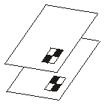 | The 2 out of 2 method uses:  2 foils, 1 pixel with 4 sub pixels.  The overlay results in black, so the original pixel is also black.
Figure 2. A Graphical Representation of 2x2 Visual Cryptography.
The following matrices would be suitable for this method:
C0 = all column permutaions of 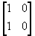
C1 = all column permutaions of 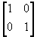
But this means only two subpixels per pixel, which would result in a distorted image. To compensate that, the following matrices with 4 subpixels are used: C0 = all column permutaions of 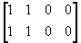 C1 = all column permutaions of 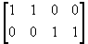(Schmidt, 2000), which according to Stinson is the pixel expansion method of writing shares. This method produces same height/width ratio as the original image by copying the subpixel expansion, m, over m times for the source image pixel on each share, the final subpixel is now a square.
For illustration let us take more visuals from Mr. Stinson’s page about visual cryptogprahy:
Stinson devised the following scheme, illustrated in the figure below. The algorithm specifies how to encode a single pixel, and it would be applied for every pixel in the image to be shared.
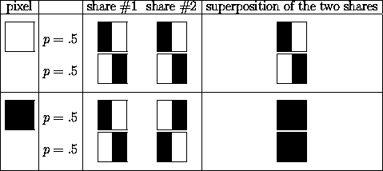
Figure 3. Basis Matrices for Encrypting White or Black Pixel.
Each pixel P in the shared image is divided into two subpixels in each of these two shadows. If P is black, then the dealer randomly selects one of the first two rows in Figure 3. If P is white, then the dealer randomly selects one of the last two rows in Figure 3. Then the dealer puts the two sub-pixels blocks from columns 3 and 4, respectively.
Suppose we look at a pixel P in the first share. One of the two sub pixels in P is black and the other is white. Moreover, each of the two possibilities "black-white" and "white-black" is equally likely to occur, independent of whether the corresponding pixel in the secret image is black or white. Thus the first share gives no clue as to whether the pixel is black or white. The same argument applies to the second share. Since all the pixels in the secret image were encrypted using randomly, there is no information to be gained by looking at any group of pixels on a share, either. This demonstrates the security of the scheme. In writing the shares this algorithm uses a random number in determining which basis column to be used in encrypting the i^{th} pixel on the n^{th} share so it is known according to Stinson as the Random Basis Column.
Now let's consider what happens when we superimpose the two shares (here we refer to the last column of the figure). Consider one pixel P in the image. If P is black, then we get two black sub pixels when we superimpose the two shares; if P is white, then we get one black sub pixel and one white sub pixel when we superimpose the two shares. Thus, we could say that the reconstructed pixel (consisting of two sub pixels and are printed in close proximity to each other that the human visual system averages their individual black and white contributions) has a grey level of 1 if P is black and will be recognized as a black dot; and grey level of 1/2 if P is white and will be recognized as a white dot. There will be a 50% loss of contrast in the reconstructed image, but it should still be visible (Stinson, 2003).
The 2xn and nxn are but expansion of the 2x2 algorithm discussed above. In case of 2xn Visual Cryptography instead of producing just 2 shares it produce a maximum of n shares but allows a minimum of 2 shares to get the encrypted image. On the other hand nxn produces a maximum of n shares but only allows exactly all n of them to regain the encrypted image by stacking the shares together.

  - The Zero-One Matrix
A matrix with entries that are either 0 or 1.The zero-one matrix is often used to represent structures in graph theory. But in visual cryptography this matrix is used as the basis matrices for encrypting the shares on the participants. These basis matrices are constructed using the Hadamard Matrix Conjecture Algorithms.
D. The Hadamard Matrix as BIBDs
A Hadamard Matrix is an nxn matrix H with entries in {-1, 1} such that any two distinct rows or columns of H have inner product 0. A binary Hadamard Matrix is an nxn matrix M (where n is 1 or even) with entries {0, 1} such that any two distinct rows or columns of M have Hamming distance n/2. The Hamming distance between two vectors is simply the number of entries in which they differ.
A Block Design (sometimes simply design) is a pair (X, A) such that:
1.) X is a set of elements (points), and
2.) A is a collection of subsets of X (blocks).
The most common of these are the balanced incomplete block design (BIBD).
BIBDs blocks cannot contain all points and because this design is balanced. Let ν, k, λ є N with ν > k ≥ 2. A (ν, k, λ)-balanced incomplete blocked design ((ν, k, λ) - BIBD) is a design (X, A) such that
- |X| = ν,
- each blocks contains exactly k points, and
- every distinct points is contained in exactly λ blocks.
In a (ν, k, λ)-BIBD, every point occurs in exactly
λ(ν - 1)
k - 1
νr
k
λ(ν² - 1)
k² - k
r = blocks, and has exactly b = = blocks.
These two theorems indicate that no (ν, k, λ) - BIBD can exist unless (k-1) | (λ (ν -1)) and (k² - k) | ((λ (ν² - v)). In fact, determining necessary and sufficient conditions for the existence of a (ν, k, λ) - BIBD is a well known problem in design theory. A BIBD in which b = ν (or, equivalently, r = k or λ (ν - 1) = k² - k) is called a symmetric BIBD. If m > 2 then there exists an Hadamard matrix of order 4m if and only if there exists a (symmetric) (4m - 1, 2m - 1, m - 1)-BIBD. Also there exists a Hadamard matrix of order 4m if 4m - 1 is a prime power. (Stinson, 2004).
An example of this is the (7, 3, 1) – BIBD, which is known as the Fano plane and the incidence matrix is given by:
1 1 1 0 0 0 0
1 0 0 0 1 1 0
1 0 0 1 0 0 1
0 1 0 1 0 1 0
0 1 0 0 1 0 1
0 0 1 1 1 0 0
0 0 1 0 0 1 1

The incidence matrix of a BIBD is simply its adjacency matrix when its blocks are considered as edges of a hypergraph.

  - The GIF File Format
The Graphics Interchangeable Format of commonly known as GIF file was popularized by CompuServe Information Services in 1980s as an efficient means to transmit images across data networks. Gif files incorporate a compression scheme to keep file sizes at a minimum, and they are limited to 8-bit (256 or fewer colors) color palettes. Several slight variants of the basic GIF format add support for transparent color and for the interlaced GIF graphics popularized by Netscape Navigator (Lynch and Horton, 2002). The World Wide Web adopted Gif for its efficiency and widespread familiarity. Nowadays, many images that we can surf from the internet are in the GIF file format, and virtually all the web browsers that support graphics can display GIF files.
IV. METHODOLOGY

In writing the shares it requires basis zero-one matrices c0 and c1 for encrypting white and black pixel respectively, where n is the number of participants and m is the pixel expansion. The basis matrices are constructed using the Hadamard Matrix Conjecture. The algorithm in performing the above operation over a secret image is described as follows:
for each pixel p in source image
if(p) is white then
let permuteCols = a random permutation of the columns of c0
else
let permuteCols = a random permutation of the columns of c1

Figure 4. The Algorithm Used to Implement Using the Basis Matrices.
for i = 0 to height of source image
for j = 0 to width of source image
for each participant k, where 1 <= k < = n
if the pixel value at (i, j) of participant k is 1
set the pixel value at (i, j) of the coalesce image to 1
set the pixel value at (i, j) of the coalesce image to 0

Figure 5. The Algorithm for Retrieving the Source Image with Noise.
for i = 0 to height of source image
for j = 0 to width of source image
int ctr = 0
for each participant k, where 1 <= k < = n
if the pixel value at (i, j) of participant k is 1
ctr++
if((ctr % 2) == 0)
set the pixel value at (i, j) of the coalesce image to 0
else
set the pixel value at (i, j) of the coalesce image to 1

Figure 5a. The Algorithm for Retrieving the Source Image without Noise.
2 x 2 Visual Cryptographic Scheme Construction.
- Construct 2 basis zero-one matrices c0 and c1 as follows:
c0 = 1 0 1 0 c1 = 1 0 0 1
0 1 0 1 1 0 0 1
2.) Before encoding each pixel from the source image randomly permutes the basis matrices c0 and c1 respectively.
3.) Using the permuted basis matrices each pixel p from the source image will be encrypted as follows:
a.) A black pixel from the source image will be encrypted on the i^{th} participant’s share as the i^{th} row of matrix c1, where 0 represents a white pixel and 1 represents black respectively. The same process is done in case of white pixel on the source image.
4.) The 2x2 Visual Cryptographic Scheme divides each pixel from the source image into m=4 subpixels.
2 x n Visual Cryptographic Scheme Construction.
- Construct an n x m zero-one matrix c1 by considering all the binary n-vectors of weight [n / 2]. Hence m = Combination(n, [n / 2]) and any row in c1 has weight equal to Combination((n - 1), [n / 2] - 1). This matrix is known as a Hadamard BIBD matrix.
- Construct an n x m zero-one matrix c0 as Combination(n – 1, [n / 2]) columns of weight 0 zero and Combination(n – 1, [n - 1] - 1) columns of weight n.
- This 2xn-threshold scheme produces a Visual Cryptographic Scheme with optimal contrast with respect to relative contrast proven by Doug Stinson himself. For instance: Construct a (2, 6)-threshold Visual Cryptographic Scheme.
0 0 0 0 0 0 0 0 0 0 1 1 1 1 1 1 1 1 1 1
0 0 0 0 0 0 0 0 0 0 1 1 1 1 1 1 1 1 1 1
0 0 0 0 0 0 0 0 0 0 1 1 1 1 1 1 1 1 1 1
0 0 0 0 0 0 0 0 0 0 1 1 1 1 1 1 1 1 1 1
0 0 0 0 0 0 0 0 0 0 1 1 1 1 1 1 1 1 1 1
0 0 0 0 0 0 0 0 0 0 1 1 1 1 1 1 1 1 1 1

c0 =

Figure 6. The Basis Matrix for Encrypting a White Pixel in a 2x6- threshold.
The number of ‘0’ columns =
n – 1
[n / 2]
6 – 1
[6 / 2]
5
3
5!__
2!*3!
= = = = 10

The number of ‘1’ columns =
n – 1
[n / 2] - 1
6 – 1
[6 / 2] - 1
5
2
5!__
3!*2!
= = = = 10
1 1 1 0 1 1 0 1 0 0 1 1 0 1 0 0 1 0 0 0
1 1 0 1 1 0 1 0 1 0 1 0 1 0 1 0 0 1 0 0
1 0 1 1 0 1 1 0 0 1 0 1 1 0 0 1 0 0 1 0
0 1 1 1 0 0 0 1 1 1 0 0 0 1 1 1 0 0 0 1
0 0 0 0 1 1 1 1 1 1 0 0 0 0 0 0 1 1 1 1
0 0 0 0 0 0 0 0 0 0 1 1 1 1 1 1 1 1 1 1

c1 =

Figure 7. The Basis Matrix for Encrypting a Black Pixel in a 2x6-threshold.
The columns has a distinct n-vectors of weight (n / 2) = (6 / 2) = 3.
The number of columns or m =
n
[n / 2]
6
[6 / 2]
6
3
6!__
3!*3!
= = = = 20.

n x n Visual Cryptographic Scheme Construction.
1.) Construct the basis BIBD zero-one matrix for c0 as a matrix whose columns are all of distinct n-vectors having an even number of ones.
2.) Construct the basis BIBD zero-one matrix for c1 as a matrix whose columns are all of distinct n-vectors having an odd number of ones. So the number of columns or m = 2^{n – 1}.
3.) The scheme is a Visual Cryptographic Scheme with parameters pixel expansion m = 2^{n – 1}, relative contrast α(m) = 1 / 2^{n - 1}, order 2^{n – 1}! and contrast m = 1 (Stinson, 1996).
4.) The scheme is optimal in terms of relative contrast α(m), and contrast m. (Stinson)

For instance: Construct a (6, 6)-threshold Visual Cryptographic Scheme.
The basis matrices are produced as follows:
0 1 1 0 1 0 0 1 1 0 0 1 0 1 1 0 1 0 0 1 0 1 1 0 0 1 1 0 1 0 0 1
0 1 0 1 0 1 0 1 0 1 0 1 0 1 0 1 0 1 0 1 0 1 0 1 0 1 0 1 0 1 0 1
0 0 1 1 0 0 1 1 0 0 1 1 0 0 1 1 0 0 1 1 0 0 1 1 0 0 1 1 0 0 1 1
0 0 0 0 1 1 1 1 0 0 0 0 1 1 1 1 0 0 0 0 1 1 1 1 0 0 0 0 1 1 1 1
0 0 0 0 0 0 0 0 1 1 1 1 1 1 1 1 0 0 0 0 0 0 0 0 1 1 1 1 1 1 1 1
0 0 0 0 0 0 0 0 0 0 0 0 0 0 0 0 1 1 1 1 1 1 1 1 1 1 1 1 1 1 1 1

c0 =

Figure 8. The Basis Matrix for Encrypting a White Pixel in a 6x6- threshold.
1 0 0 1 0 1 1 0 0 1 1 0 1 0 0 1 0 1 1 0 1 0 0 1 1 0 0 1 0 1 1 0
0 1 0 1 0 1 0 1 0 1 0 1 0 1 0 1 0 1 0 1 0 1 0 1 0 1 0 1 0 1 0 1
0 0 1 1 0 0 1 1 0 0 1 1 0 0 1 1 0 0 1 1 0 0 1 1 0 0 1 1 0 0 1 1
0 0 0 0 1 1 1 1 0 0 0 0 1 1 1 1 0 0 0 0 1 1 1 1 0 0 0 0 1 1 1 1
0 0 0 0 0 0 0 0 1 1 1 1 1 1 1 1 0 0 0 0 0 0 0 0 1 1 1 1 1 1 1 1
0 0 0 0 0 0 0 0 0 0 0 0 0 0 0 0 1 1 1 1 1 1 1 1 1 1 1 1 1 1 1 1

c1 =

Figure 9. The Basis Matrix for Encrypting a Black Pixel in a 6x6- threshold.

- RESULTS AND DISCUSSION

The developed system is efficient because the ciphers can de decrypted even without the aid of any computing machine. The ciphers which are in the form of transparency simply need to be stacked together to regain the secret image. This can be done by any person without prior knowledge to any complex mathematical functions.
The visual cryptography assumes that the image consists of black and white pixels. Each original pixel appears in n modified shares, one for each transparency. Each share is a collection of m black and white subpixels, which are printed in close proximity to each other so that the human visual system averages their individual black and white contributions. The resulting structure is an n x m Boolean matrix S[i][j] if the j^{th} subpixel in the i^{th} transparency is black; white otherwise. When all the transparencies are stacked together in a way which properly aligns the subpixels, we see a combined share whose black subpixels are represented by the Boolean “or” of rows of i₁… i_{n} in S. According to Stinson the grey level of this combined share is proportional to the Hamming weight H(V) of the “or” m-vector V. This grey level is interpreted by the visual system of the user as black if H(V) >= d and as white if H(V) < d – αm for some fixed threshold 1 <= d <= m and relative difference α > 0.
It is hard to evaluate the outputs of the visual encryption theoretically so some experimental results concerning the proposed method are presented here. All the images used are black and white gif images. The experiments were performed on a personal computer with Intel Pentium 600.
To test the effectivity of the developed system it was tested using different font sizes that range from 8 to 24 all of which are Times New Roman font. The sensitivity of the participants to image dimension manipulation is also considered by resizing the sizes of each participants. The participants are resized smaller and larger than the original image before obtaining their respective secret images

- 2x2 VCS Using Different Font Sizes.
Font Size
8 | 
10
12
14
16
18
20
22
24
Figure 10. The Coalesce Image of 2x2 VCS Using Different Font Sizes.
As observed by the coalesce image smaller fonts proved to be unperceivable by the human visual system. The acceptable font size using 2x2 VCS is 18 and above. The bigger the font size the more black pixel the algorithm considers the more the secret in the coalesce image becomes perceivable because of the increase in the grey value of the image.
- 2xn VCS Using Different Font Sizes.
Font Size
8 | 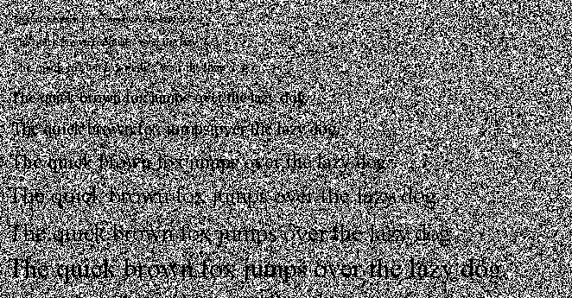
10
12
14
16
18
20
22
24
Figure 11. The Coalesce Image of 2xn VCS Using Different Font Sizes.
The 2xn VCS, where n=4, results are just like the 2x2 VCS but this time with a little increase in noise. The secret is visible using 18 and above font sizes.
- nxn VCS Using Different Font Sizes.
The nxn VCS security is high considering you have to get all the n parts before you can obtain the secret however, there is a trade off in contrast this means that this scheme’s font size must be greater than those that are previously defined. For this scheme the minimum font size that is accepted by the human visual system is 36.
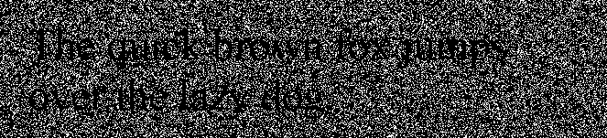

Figure 12. The Coalesce Image of nxn VCS Using 36 Font Size.

The different VCS studied have their own draw backs. The author in case of nxn limits the number of participants to 5 for better results. Because study shows that during encryption the greater the number of participants produced, results in the loss of contrast of the coalesce image. The opposite is true using 2xn VCS; it has been found out that the number of participants is proportional to coalesce image contrast. So the greater the participants the less black pixel we could see to the coalesce image, for both case, making the secret image unperceivable by the human eyes. The 2x2 VCS produced the most desirable results, the coalesce image has enough black and white pixels to make the image perceivable by the human visual system.
Furthermore, resizing the participants distorts the pixel components of the image, making the decryption process fail. The participants therefore, must have the same dimensions as the secret image. The following coalesce images were obtained in resizing the participants:

Consider hitler.gif as the secret image to be encrypted, which has a dimension 300x300 pixel.

The coalesce images produced were resized to fit the page.
2x2 VCS
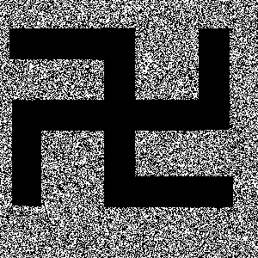
400x400 pixel
200x200 pixel
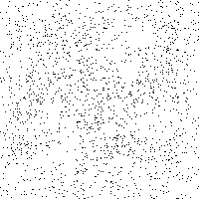
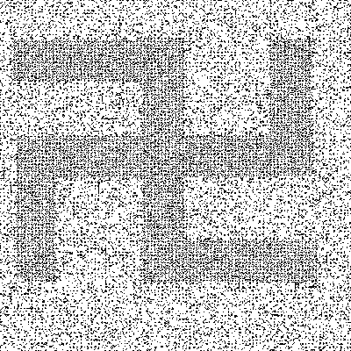
300x300 pixel.
2xn VCS where n = 3.

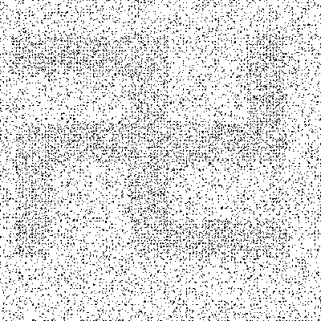
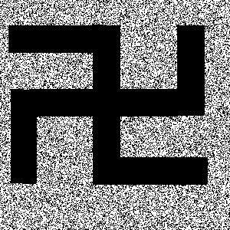
300x300 pixel
200x200 pixel
400x400 pixel

nxn VCS, where n = 3.

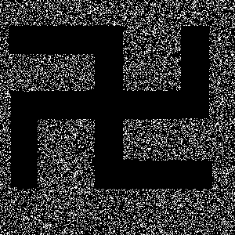
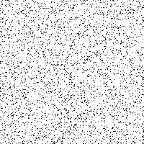
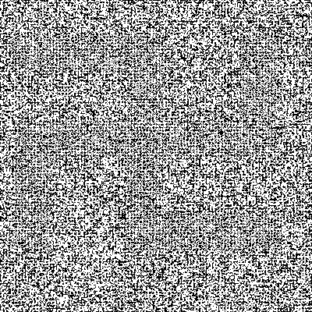
300x300 pixel
200x200 pixel
400x400 pixel

Every pixel encrypted in each participant is a part of a bigger key that holds the lock to the secret image. Therefore, every pixel is a vital component, and resizing the participants makes the coalesce image void.
Enlarging the participants produced large gaps between the black pixels, while reducing its dimension also reduced the grey levels of the black pixels; for both cases the coalesce image becomes less perceptible to the human visual system.
VI. CONCLUSION AND RECOMMENDATION

This system considers the problem of encrypting gif image in a perfectly secure way which can be decoded directly by the human visual system. The model is consists of a gif file of cipher (which can be sent by mail, fax or even LBC) and another gif file now as a key both printed in transparency. The original image encrypted is revealed by stacking the cipher and the key together, even though they are composed of random dots the original image or message is revealed. It is consider as a one time pad because each cipher text is decrypted using different key or transparency. Due to the simplicity of the algorithm the system can be performed by anyone without prior knowledge to cryptography and without performing any cryptographic computations.
The result of the study is a Java TM module that performs the various Visual Cryptographic Schemes specifically 2x2, 2xn and nxn, a jar file of the application for the ease of running and an API that describes all the classes, variables and methods used. The specific versions of java compiler used are Java 1.4.2_06/1.5.0_05 which is freely downloadable at http://www.java.sun.com.
The system was found to be functional and stable. The core class package was developed using Java TM compiler that provides the core functionalities for encryption and decryption of source images.
The study has certain limitations: the participants must have the same dimensions as the secret image to be able to perform the coalesce operation and produced the secret image. Furthermore the application only accepts and performs its operations on a black and white gif file: encryption, coalesce, save etc.
A lot of extension can be done to the module and since it is open for extension simple, flexible, extensible and easy to understand I think those students who share the same interests as mine can innovate something from the system produced. An obvious extension is using a color source image for encryption. Moreover, is the construction of a module for image type support like jpeg and bitmap.
VII. BIBLIOGRAPHY
Alconis, M. Virtual-One Way Cryptosystem. (An Instructional Tool), UPLB, March 1996. Unpublished Undergraduate Thesis.

Ateniese G., Blundo C., De Santis A., Stinson D. Construction and Bound for Visual Cryptography [Online], 1996. Available at: http://www.cacr.math.uwaterloo.ca/~dstinson/papers/ICALP96.ps [Accessed February 15, 2005].

Ateniese G., Blundo C., De Santis A., Stinson D. Visual Cryptography for General Access Structures [Online], 1996. Available at: http://www.cacr.math.uwaterloo.ca/~dstinson/papers/IC.ps [Accessed February 15, 2005].

Ateniese G., Blundo C., De Santis A., Stinson D. On Contrast in Visual Cryptography Schemes [Online], 1996. Available at: http://www.cacr.math.uwaterloo.ca/~dstinson/papers/contrast.ps [Accessed February 15, 2005].

Ateniese G., Blundo C., De Santis A., Stinson D. Extended Schemes for Visual Cryptography [Online], 1996. Available at: http://www.cacr.math.uwaterloo.ca/~dstinson/papers/j-evcs.ps [Accessed February 15, 2005].

Baird, L. Visual Cryptography [Online], 2004. Available at: http://www.leemon.com/crypto/VisualCrypto.html [Accessed April 6, 2005].

Blundo C., D’Arco P., De Santis A., Stinson D. Contrast Optimal Threshold Visual Cryptography Schemes [Online], 1998. Available at: http://www.cacr.math.uwaterloo.ca/~dstinson/papers/COTVCS.ps [Accessed February 15, 2005].

Dutch. Visual Cryptography Project [Online], 1996. Available at: http://www.esat.kuleuven.ac.be/~rijmen/vc/ [Accessed November 21, 2004].

Eckel, B. Thinking in Java 2nd Edition [Online], 2001. Available at: http://www.sunpack.com/ [Accessed June 24, 2005]

Eisen P., Stinson D. Threshold Visual Cryptography Schemes With Specified Whiteness Levels of Reconstructed Pixels [Online], 1999. Available at: http://www.cacr.math.uwaterloo.ca/~dstinson/papers/tvcs.ps [Accessed February 15, 2005].

Huy, T. Encryption for Data Security. UPLB, May 1994. Unpublished
Undergraduate Thesis.
IFIP. Secret Sharing and Visual Cryptographic Schemes [Online], 2001. Available at: http://portal.acm.org [Accesssed August 18, 2005].

Lynch and Horton. Gif Files [Online], 2002. Available at: http://www.webstyleguide.com/graphics/gifs.html [Accessed September 9, 2005].

Macgyver Liaw, W. 1995, ‘Reading GIF Files’, Dr. Dobb’s Journal, vol 20, issue 2, pp. 56 – 60.

Mohit N. Cryptography Split Wide Open [Online], 2002. Available at http://www.google.com [Accessed July 17, 2002].

Naor M., Shamir A. Visual Cryptography [Online], 1994. Available at: http://www.cacr.math.uwaterloo.ca/~dstinson/ [Accessed February 15, 2005].

Potdar V., Chang E. Disguising Text Cryptography using Image Cryptography [Online], [No date]. Available at: http://www.google.com [Accessed April 1, 2005].

Schmid, H. Visual [Online], 2000. Available at: http://www.-fs.informatik.uni-tuebingen.de/~reinhard/krypto/ [Accessed February 15, 2005].

Schmidt, M. Java Imaging Utilities [Online], 2004. Available at: http://jiu.sourceforge.net/ [Accessed February 14, 2005].

Schneier, B. “The Gost Encryption Algorithm.” Dr. Dobb’s Journal. Vol 20
Issue #1. January 1995. pp 143.

Sedgewick, R. Algorithms. Addison-Wesley Publishing Company. 1988.

Stejano, F. Visual Cryptography Kit [Online], 2005. Available at: http://www-lce.eng.cam.ac.uk/~fms27/vck/ [Accessed July 4, 2004].

Stinson D. Tutorials [Online], 2003. Available at: http://www.cacr.math.uwaterloo.ca/~dstinson/visual.html [Accessed February 15, 2005].

Tressler, E. A Survey of the Hadamard Conjecture [Online], 2004. Available at: http://www.google.com [Accessed February 15, 2005].

The Maniac [2002], “The Basics of Cryptography”, Available at: Hackers Matrix CD.

Weisstein, E. Hadamard Matrix [Online], 2005. Available at: http://mathworld.wolfram.com/HadamardMatrix.html [Accessed February 15, 2005].
APPENDIX A. Sample Encrypted Participants Using 2x2 Visual Cryptographic Scheme.

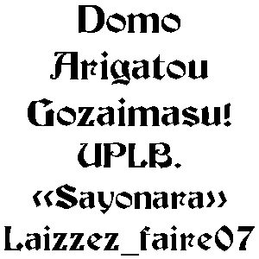

The Secret Image to be Encrypted

Share of Participant 1. Share of the Participant 2.
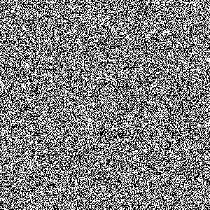
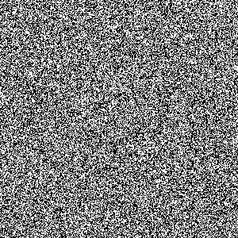

The Coalesce Image of Participant 1 and 2
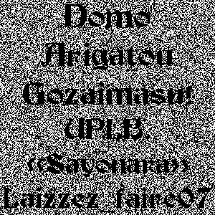
APPENDIX B. The Main Interface with an Image already opened.

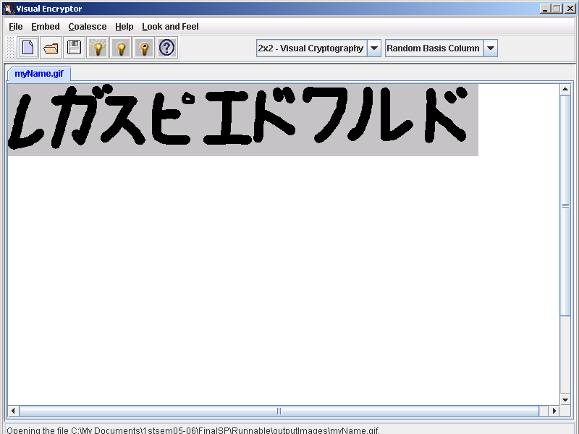
APPENDIX C: The Coalesce Image.

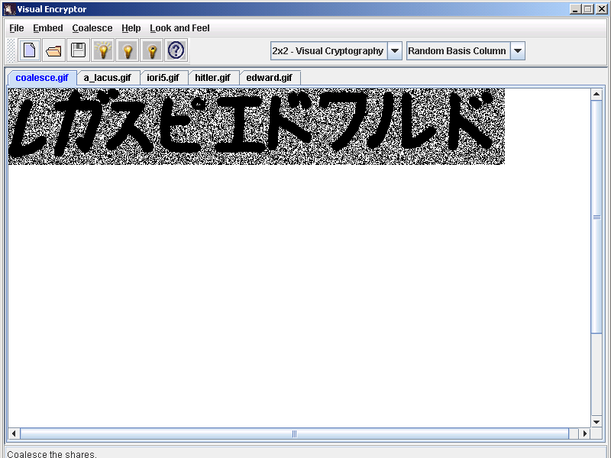
APPENDIX D: The Main Interface with Most of the Available Operations.

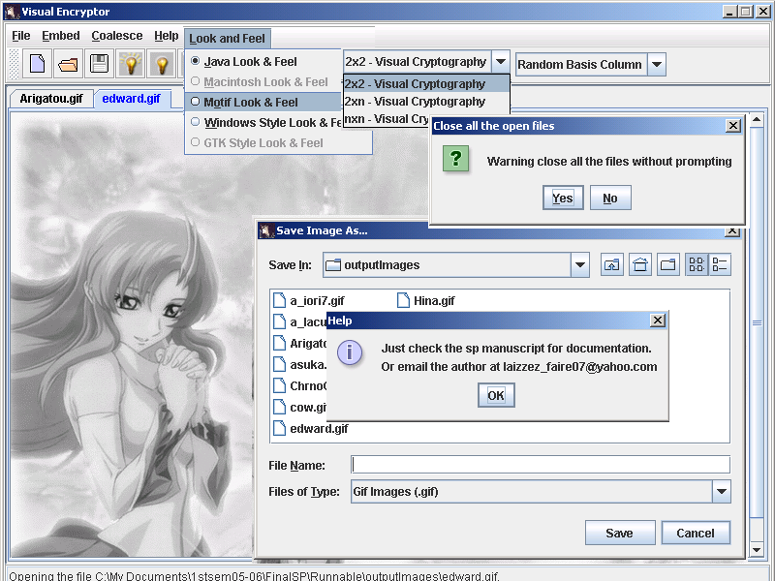
APPENDIX E: The Visual Cryptography Schemes JavaTM API.

