

CAS: [30363-03-2](http://www.ichemistry.cn/chemistry/30363-03-2.htm)

bis(dibenzylideneacetone)dipalladium, 三(二亚苄基丙酮)二钯, C34H28O2Pd, M: 575, CAS: 52409-22-0.

2-dicyclohexylphosphino-2',4',6'-tri-i-propyl-1,1'-biphenyl, X-PHOS, C33H49P, M: 476.72, CAS: 564483-18-7.

NaOtBu, M: 96.1, CAS: 865-48-5.

xx (xx g, 11.0 mmol), A~2.5

A mixture of 9,9-dimethyl-acridan (0.42 g, 2.0 mmol), B~1

bis(dibenzylideneacetone)dipalladium (0.015 g, 0.02 mmol), ~0.01

NaOtBu (0.2 g, 2.0 mmol), ~1

2-dicyclohexylphosphino-2',4',6'-tri-i-propyl-1,1'-biphenyl (0.05g, 0.06 mmol), ~0.03

in toluene (20 mL) was stirred at 85 oC under argon for 2 h.

2019-2-27 16.00 start-

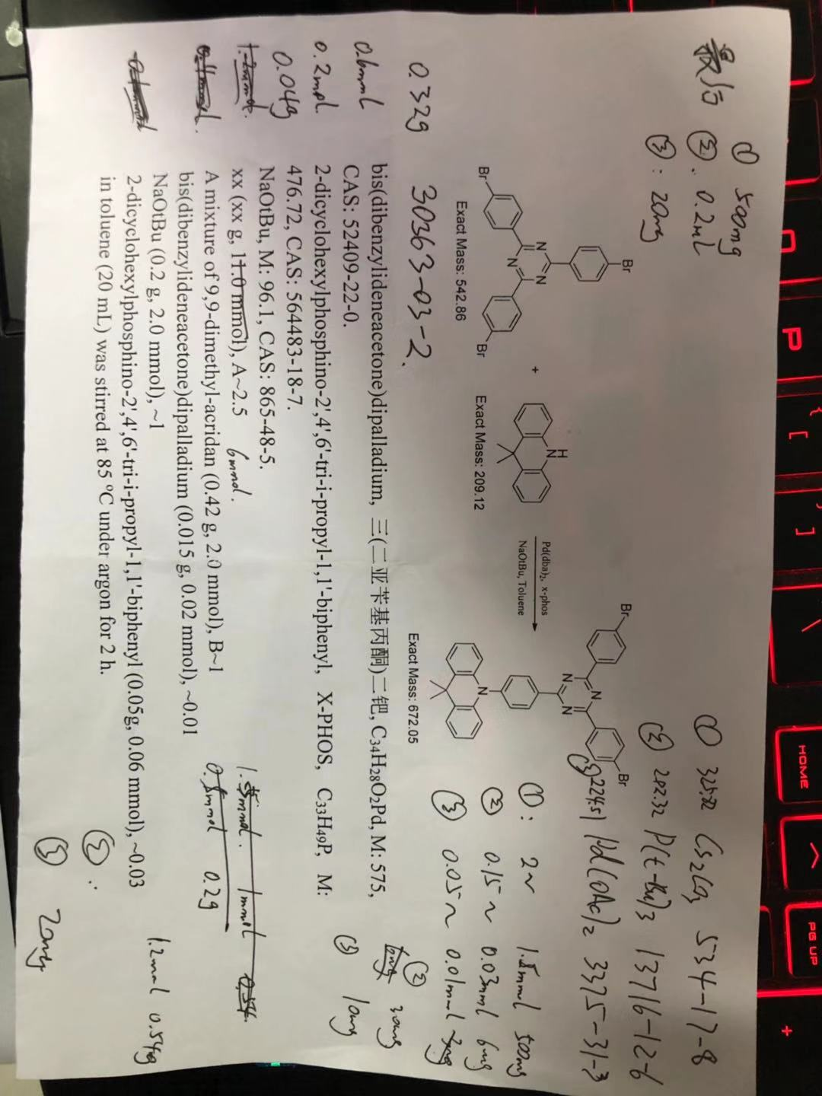

reaction overnight orange-color in DCM

0.32g~A+0.04g~B→(85℃)40mg product bright green power (2019.02.28)

2019.03.04



A~0.03mmol 163mg ~1 CAS: 30363-03-2

B~0.025mmol 86.5mg ~0.8 CAS: 7486-35-3 1.085 g/mL at 25 °C

[Pd(PPh3)4] (10 mg, 0.01 mmol), M:1155.56, CAS: 14221-01-3 ~0.01

DMF:toluene=1/4 20ml 85℃ **In the absence of light**



A~ CAS: 30363-03-2

(3-vinylphenyl)boronic acid, M: 147.97, CAS: 15016-43-0.

tetrakis(triphenylphosphine)platinum, 四(三苯基膦)铂, M:1244.2, CAS: 14221-02-4.

K2CO3, M: 138.21, CAS: 584-08-7.

toluene (12 mL), ethanol (6 mL), and 2 M aqueous Na2CO3 (9 mL)