2020. 12. 18

Electrode:

AgNW (concentration:1mL + 19mL IPA)+ PEIE(10uL)

Condition: $75℃$. Thick?/thin?

Then, spin coat TPU-1185A10V (from BASF) (C:_20mg/mL in THF). Vacuum overnight

Then 7g PDMS (15:1) on top on the TPU, curing at 80 $℃$ for 4 h.

Medium 3 layers (in sequence):

1st PEDOT:PSS-8000 + PFI + IPA = 2:1:1.5 (solution volume ratio)

Rpm: 3000, time: 60s 🡪 annealing: 160 $℃$, 25 min

2nd PDKC27H45 (C: 8 mg/ml in CB?)

Rpm: 3000, time: 30s 🡪 annealing: 120 $℃$, 25 min

3rd PEIE (0.4wt% ) + PFN (0.4wt% ) in methonal 2:1

Rpm: 5000, time: 60s 🡪 annealing: 120 $℃$, 25 min

Assembling: Transfer the entire 3 layers together to electrode directly

Device works, tun on around 5V, can be stretched to 30%-40% by eye at 7V.

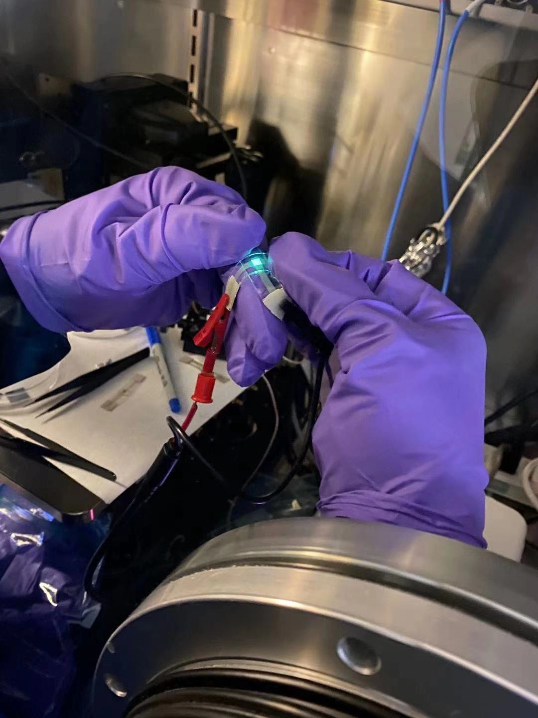

2020.08.11

PEIE in IPA 2.5% (0.67mL 37% to 10mL IPA) + 5% crossing linking agent (3-glycidyloxypropyl)trimethoxysilane (GOPTS), 12.5 uL

PEIE in IPA 2.5% (0.67mL 37% to 10mL IPA) + 1% crossing linking agent (3-glycidyloxypropyl)trimethoxysilane (GOPTS), 2.5 uL

Then use the solution mix with 2.5% ZnO in IPA with 1:1 ratio

20200729 thickness measurement:

PEDOT:PSS(8000)-PFI=1:1 on OTS, thickness: center(edge)

Standing 2min, 1000 a, 3000 rpm, 1min: 332.5(408)nm

Polymer (PDKC27H45) 10mg/mL in CB on PEDOT:PSS(8000)-PFI

1000 a, 1000 rpm:411.2(442.8)nm, 78.7(34.8)nm

1000 a, 2000 rpm:380.5(424.7)nm, 48(16.7)

1000 a, 3000 rpm:352.0(350.8)nm, 19.5(not accurate)

Polymer (PDKC27H45) 10mg/mL in CB on OTS

1000 a, 3000 rpm, 1min: 37.2(40)nm

TmPyPB in 2-methoxyethanol 10mg/mL on Polymer (PDKC27H45)

1000 a, 1000 rpm:107.5(109.8)nm, 70.3(69.8)nm

1000 a, 2000 rpm:118.6(91.6)nm, 81.2(51.6)

1000 a, 3000 rpm:81.8(100.8)nm, 40.9(60.8)

Device structure:

ITO/PEDOT:PSS/EML/TPBI or TmPyPb (45 nm)/LiF/Al

ITO/PEDOT:PSS-PFI/EML/TPBI or TmPyPb (45 nm)/LiF/Al

EML: P1, P2, P3 in chlorobenzene 10mg/mL 3000 rpm, annealing 120oC 15 min

* CV curve measurement:

Product Comparison Guide Tetrabutylammonium hexafluorophosphate, CAS: 3109-63-5. M= 387.43 0.1M: 0.58g/15mL 0.387g/10mL

20200620

MPTS modified wafer, 160o for 30 min, can be used to transfer PEDOT:PSS with surfactant(triton X100).

20200523

MPTS modify the wafer: wafer UV-O3 plasma for 5min and annealed with MPTS vapor for 3min. Followed by the toluene ultrasonic for 5 min, than washed with IPA.

MPTS modified Wafer can be used as the substrate for transfer the PDKC27H,PTRZF, but not for the PTDC6(maybe because of the OH group in the end of the polymer), not work for PEDOT:PSS(1000 or 8000) no matter with ipa or surfactant(triton X100).

2019.08.31

ITO/PEDOT:PSS/P-2/PEIE/AgNWs

ITO/PEDOT:PSS/P-2/PEIE & PFN-Br/AgNWs

PEDOT:PSS: 2-ethoxyethanol=40:1, 4500 r.p.m. 1min, 145oC, 30min

P-2: 10mg/mL in CB, 3000 r.p.m. 1min, 100 oC, 15min

EIL: 0.4mg/mL in 2-ethoxyethanol 5000 r.p.m. 30s, 100 oC, 15min

AgNWs spray coating on glass, SEBS 1051

2019.08.18

The elastomer of the AgNWs/elastomer really matters: the SEBS 1051 WORK, but the SEBS 1052 and PDMS don’t.

2019.08.17

PEIE from Sigma dilute from 35~40% into 0.4% in 2-propanol

TmPyPb 10mg/mL in DMF

PO-T2T 10mg/mL in DMF

ITO/PEDOT:PSS/P-2/PO-T2T (or TmPyPb)/PEIE/AgNWs(SEBS 1052)

ITO/PEDOT:PSS/P-2/TmPyPb/PEIE/AgNWs

ITO/PEDOT:PSS/P-2/PEIE/AgNWs

2019.08.13

The PEDOT can be directly spin coating onto the AgNWs/SEBS (1051) composite, but not work on AgNWs/PDMS composite.

2019.08.02:

PEIE from Sigma dilute from 35~40% into 2.5%: 1mL/17mL, 2-propanol backed 100oC

PEIE: from Sigma 0.8w/v

Cs2CO3: from Sigma 0.5mg/mL

2019.08.05

SEBS 1051 60mg/mL

CNT 20mg/mL in 2-propanol with two drops of water,

3-h bath sonication, 10min tip sonication, and then centrifugation

For the device with PEIE as EIL, polyethylenimine, 80% ethoxylated (PEIE) (Mw = 70 000 g mol−1), was dissolved in H2O with a concentration of 35–40 wt% as received from Aldrich. [1] Then it was further diluted with 2-methoxyethanol to a weight concentration of 0.025%. The solution was spin coated on top of the substrates at a speed of 5000 rpm for 1 min and an acceleration of 1000 rpm s−1. Spin-coated PEIE films were annealed at 100 °C for 10 min on a hotplate in ambient air. The thickness of these PEIE layers was determined to be ≈1 nm by combining atomic force microscopy (AFM).[2]

PEIE in 2-propanol was spin-coated onto the ZnO NP layer and baked at 100 oC. PMA in acetonitrile was spin-coated onto the PEIE layer and baked at 150 oC.[1]

Polyethylenimine ethoxylated (PEIE) (1 wt % in 2-methoxyethanol, Sigma-Aldrich)

filtered (0.45 μm poly tetra fluoroethylene membrane) PEDOT:PSS (BAYTRON®P VP CH 4083) was spin coated to make a 30 nm hole-injection layer on the ITO glass and annealed at 120 °C for 30 min to remove residual water.

poly [(9,9‐bis(30‐(N,N‐dimethylamino)propyl)‐2,7‐fluorene)‐alt‐2,7‐(9,9‐ioctylfluorene)] (PFN) is dissolved in methanol and spin casted on the patterned ITO (cathode)

An ultrathin Cs2CO3 interfacial layer was spin-coated from a 0.5 mg/ml 2-ethoxyethanol solution. The Cs2CO3:PFN layer was obtained using Cs2CO3:PFN solutions in a 2:1 weight ratio.

octadecyltrimethoxysilane (OTS) molecules to increase the hydrophobicity, through consecutive processes of O2 plasma treatment, spin-coating of OTS solution (3 m M in hexane) at 3,000 r.p.m., and finally vapour annealing in a desiccator with a small vial containing a few millimetres of ammonium hydroxide solution (28–30% in water) for 10 h at room temperature.

OTS solution: 20uL/20mL in trichloroethylene, 30s standing 30s spin-coating 3000 r. p. m.

[1] S. Ohisa; T. Takahashi; M. Igarashi; H. Fukuda; T. Hikichi; R. Komatsu; E. Ueki; Y. J. Pu; T. Chiba; J. Kido, *Adv. Funct. Mater.* **2019**, *29,* 1808022.

[2] J. P. Prieto-Ruiz; S. G. Miralles; H. Prima-Garcia; A. Lopez-Munoz; A. Riminucci; P. Graziosi; M. Aeschlimann; M. Cinchetti; V. A. Dediu; E. Coronado, *Advanced materials.* **2019**, *31,* e1806817.