2021.01.21 reaction 106-1



A~1.5mmol, 0.3g, CAS: 27060-75-9, 1.424 g/mL, 0.21mL

B~0.6mmol, 0.48g

C~ Tris(dibenzylideneacetone)dipalladium, Pd2(dba)3, M=915, CAS:60748-47-2

D~2-Dicyclohexylphosphino-2’,6’-dimethoxybiphenyl, SPhos, M=410.53, CAS: 657408-07-6,

E~one drop of Aliquat 336 (~50 mg)

F~ Potassium carbonate solution (8 mL, 2 mol/L in H2O), CAS: 584-08-7, M=138.21, 2.2g

Tris(dibenzylideneacetone)dipalladium ( 3 mg) and 2-Dicyclohexylphosphino-2',6'-dimethoxybiphenyl (10 mg)

Named as 0123-1

2020.10.23 reaction 105-1



A~0.7mmol, 0.2688g

B~0.7mmol, 0.5659g

C~ Tris(dibenzylideneacetone)dipalladium, Pd2(dba)3, M=915, CAS:60748-47-2

D~2-Dicyclohexylphosphino-2’,6’-dimethoxybiphenyl, SPhos, M=410.53, CAS: 657408-07-6,

E~one drop of Aliquat 336 (~50 mg)

F~ Potassium carbonate solution (8 mL, 2 mol/L in H2O), CAS: 584-08-7, M=138.21, 2.2g

Pinacolato-boron monomer (0.5 mmol), bromine monomer (0.5 mmol), one drop of Aliquat 336 (~50 mg), Tris(dibenzylideneacetone)dipalladium (1.5 mg) and 2-Dicyclohexylphosphino-2',6'-dimethoxybiphenyl (5.3 mg) were charged into a flask with a magnetic bar, and the system was vacuumed and aerated with nitrogen for five times.. Degassed toluene (20 mL) was added and the mixture was heated to 80 oC under vigorous stirring. Potassium carbonate solution (8 mL, 2 mol/L in H2O) was added and the temperature was risen 88 oC for 2 days to 93 oC 5 days.

Phenylboronic acid (50 mg in 5 mL toluene) was added. After 8 hours, Bromobenzene (0.5 mL) was added. After another 8 hours, the mixture was cooled down to 80 oC, then sodium diethyldithiocarbamate trihydrate (1 g in 10ml in H2O) was added. After 12 hours, the system was cooled down to room temperature. The mixture is poured into 100 mL DCM and washed by 100 mL saturated sodium chloride solution for five times.

Named as PDKC27H(g) Mn=60.3k

2020.10.22 reaction 69-3



A~0.75mmol, 0.3405g

B~0.75mmol, 0.6045g

C~ Tris(dibenzylideneacetone)dipalladium, Pd2(dba)3, M=915, CAS:60748-47-2

D~2-Dicyclohexylphosphino-2’,6’-dimethoxybiphenyl, SPhos, M=410.53, CAS: 657408-07-6,

E~one drop of Aliquat 336 (~50 mg)

F~ Potassium carbonate solution (8 mL, 2 mol/L in H2O), CAS: 584-08-7, M=138.21, 2.2g

Pinacolato-boron monomer (0.5 mmol), bromine monomer (0.5 mmol), one drop of Aliquat 336 (~50 mg), Tris(dibenzylideneacetone)dipalladium (1.5 mg) and 2-Dicyclohexylphosphino-2',6'-dimethoxybiphenyl (5.3 mg) were charged into a flask with a magnetic bar, and the system was vacuumed and aerated with nitrogen for five times.. Degassed toluene (20 mL) was added and the mixture was heated to 80 oC under vigorous stirring. Potassium carbonate solution (8 mL, 2 mol/L in H2O) was added and the temperature was risen 88 oC for 2 days to 93 oC 5 days.

Phenylboronic acid (50 mg in 5 mL toluene) was added. After 8 hours, Bromobenzene (0.5 mL) was added. After another 8 hours, the mixture was cooled down to 80 oC, then sodium diethyldithiocarbamate trihydrate (1 g in 10ml in H2O) was added. After 12 hours, the system was cooled down to room temperature. The mixture is poured into 100 mL DCM and washed by 100 mL saturated sodium chloride solution for five times.

Named as PDKCH(g)

2020.09.02 reaction 104-2



A~

B~1: Diiodomethane, CAS: 75-11-6, 3.325 g/mL

C~2, K2CO3, M: 138.21, CAS: 584-08-7

Acetonitrile 30 mL 95o over night

A, 10 mmol, 1.86g

B, 4mmol, g, 1.07g, 0.32 mL

C, 12mmol, 1.66g.1

After finished, poured the solution into water.

0.6g (39%) Named as 1022-1 and 1022-2

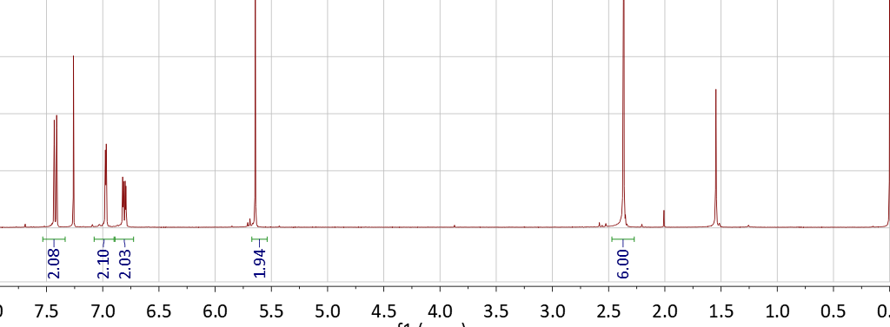

2020.09.02 reaction 104-1



A~

B~1: Diiodomethane, CAS: 75-11-6, 3.325 g/mL

C:~2.5 NaOH, CAS: 1310-73-2, C (M=40)

D:~0.01, Tetrabutylammonium Bromide (TBAB), CAS: 1643-19-2, M=322.37

THF 10mL 65o over night

A, 10 mmol, 1.86g

B, 4mmol, g, 1.07g, 0.32 mL

C, 12mmol, 0.48g

D, 0.15mmol, 48mg

Low yield

2020.10.20 reaction 103-1



A, 4-Bromo-3-methylphenol, CAS: 14472-14-1, M=186

B, 2-Bromo-5-fluorotoluene, CAS: 452-63-1, M= 189.02, 1.495 g/mL

C~2, K2CO3, M: 138.21, CAS: 584-08-7

A, 5mmol, 0.93g

B, 5mmol, 0.94g, 0.63mL

C, 10mmol, 1.38g

DMF 10mL

2020.10.19 reaction 102-1



A, 4-Bromo-3-methylphenol, CAS: 14472-14-1, M=186

B, 2-Bromo-5-fluorotoluene, CAS: 452-63-1, M= 189.02, 1.495 g/mL

C~2, K2CO3, M: 138.21, CAS: 584-08-7

A, 5mmol, 0.93g

B, 5mmol, 0.94g, 0.63mL

C, 10mmol, 1.38g

MDSO 10mL

Fail

2020.09.25 reaction 65-3



A~1, 4-BROMO-4'-FLUOROBENZOPHENONE, CAS: 2069-41-2, 4mmol, 1.1g

B~1, 9,9-DIMETHYLACRIDAN , CAS: 6267-02-3, 4mmol, 0.81g

C~0.05, bis(dibenzylideneacetone)dipalladium Pd(dba)2, C34H28O2Pd, M:575, CAS: 32005-36-0, 0.2mmol, 0.115g

D~0.15,dicyclohexylphosphino-2',4',6'-tri-i-propyl-1,1'-biphenyl, X-PHOS, C33H49P, M: 476.72, CAS: 564483-18-7,0.6mmol, 0.28g

E~NaOtBu, M: 96.1, CAS: 865-48-5, 10mmol, 0.96g

A, 9mmol, 2.5g

B, 9mmol, 1.88g

C, 0.3mmol, 0.1725g

D, 0.9mmol, 0.44g

E, 20mmol, 1.92g

Toluene, 35mL, 85oC

2020.09.09 reaction 101-1



A-1~0.075mmol, 0.0381g

A-2~0.425mmol, 0.19295g

B~0.5mmol, 0.4042g

C~ Tris(dibenzylideneacetone)dipalladium, Pd2(dba)3, M=915, CAS:60748-47-2

D~2-Dicyclohexylphosphino-2’,6’-dimethoxybiphenyl, SPhos, M=410.53, CAS: 657408-07-6,

E~one drop of Aliquat 336 (~50 mg)

F~ Potassium carbonate solution (8 mL, 2 mol/L in H2O), CAS: 584-08-7, M=138.21, 2.2g

Pinacolato-boron monomer (0.5 mmol), bromine monomer (0.5 mmol), one drop of Aliquat 336 (~50 mg), Tris(dibenzylideneacetone)dipalladium (1.5 mg) and 2-Dicyclohexylphosphino-2',6'-dimethoxybiphenyl (5.3 mg) were charged into a flask with a magnetic bar, and the system was vacuumed and aerated with nitrogen for five times.. Degassed toluene (20 mL) was added and the mixture was heated to 80 oC under vigorous stirring. Potassium carbonate solution (8 mL, 2 mol/L in H2O) was added and the temperature was risen 88 oC for 2 days to 93 oC 5 days.

Phenylboronic acid (50 mg in 5 mL toluene) was added. After 8 hours, Bromobenzene (0.5 mL) was added. After another 8 hours, the mixture was cooled down to 80 oC, then sodium diethyldithiocarbamate trihydrate (1 g in 10ml in H2O) was added. After 12 hours, the system was cooled down to room temperature. The mixture is poured into 100 mL DCM and washed by 100 mL saturated sodium chloride solution for five times.

2020.09.06 reaction 100-1



A~0.8mmol, 0.408g

B~0.8mmol, 0.6451g

C~ Tris(dibenzylideneacetone)dipalladium, Pd2(dba)3, M=915, CAS:60748-47-2

D~2-Dicyclohexylphosphino-2’,6’-dimethoxybiphenyl, SPhos, M=410.53, CAS: 657408-07-6,

E~one drop of Aliquat 336 (~50 mg)

F~ Potassium carbonate solution (12 mL, 2 mol/L in H2O), CAS: 584-08-7, M=138.21, 3.3g

Pinacolato-boron monomer (0.5 mmol), bromine monomer (0.5 mmol), one drop of Aliquat 336 (~50 mg), Tris(dibenzylideneacetone)dipalladium (1.5 mg) and 2-Dicyclohexylphosphino-2',6'-dimethoxybiphenyl (5.3 mg) were charged into a flask with a magnetic bar, and the system was vacuumed and aerated with nitrogen for five times.. Degassed toluene (30 mL) was added and the mixture was heated to 80 oC under vigorous stirring. Potassium carbonate solution (15 mL, 2 mol/L in H2O) was added and the temperature was risen 88 oC for 2 days to 93 oC 5 days.

Phenylboronic acid (50 mg in 5 mL toluene) was added. After 8 hours, Bromobenzene (0.5 mL) was added. After another 8 hours, the mixture was cooled down to 80 oC, then sodium diethyldithiocarbamate trihydrate (1 g in 10ml in H2O) was added. After 12 hours, the system was cooled down to room temperature. The mixture is poured into 100 mL DCM and washed by 100 mL saturated sodium chloride solution for five times.

2020.08.23 reaction 67-4



A, 2mmol, 1.42g

B, 6mmol, bis(pinacolato)diboron, CAS: 73183-34-3, M=254, 1.524g

C, [1,1'-Bis(diphenylphosphino)ferrocene]dichloropalladium(II), Pd(dppf)Cl2, CAS: 72287-26-4, M=731, 0.1mmol, 73mg

D, potassium acetate, KOAc, M=98, 6mmol, 0.588g

1,4-dioxane 24mL

2020.09.02 reaction 99-1



A~

B~1: 1,10-Diiododecane, CAS: 16355-92-3, 2.35 g/mL

C:~2.5 NaOH, CAS: 1310-73-2, C (M=40)

D:~0.01, Tetrabutylammonium Bromide (TBAB), CAS: 1643-19-2, M=322.37

THF 15mL 65o over night

A, 15mmol, 2.79g

B, 6mmol, g, 2.364g, 1.00 mL

C, 15mmol, 0.6g

D, 0.15mmol, 48mg

Obtained 1g, 32.7% NAMED AS 0903-1

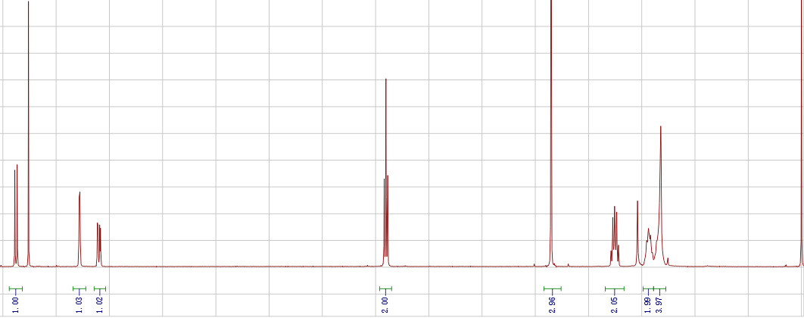

2020.08.30 reaction 98-1



A~0.6mmol, 0.3048g

B~0.6mmol, 0.4838g

C~ Tris(dibenzylideneacetone)dipalladium, Pd2(dba)3, M=915, CAS:60748-47-2

D~2-Dicyclohexylphosphino-2’,6’-dimethoxybiphenyl, SPhos, M=410.53, CAS: 657408-07-6,

E~one drop of Aliquat 336 (~50 mg)

F~ Potassium carbonate solution (8 mL, 2 mol/L in H2O), CAS: 584-08-7, M=138.21, 2.2g

Pinacolato-boron monomer (0.5 mmol), bromine monomer (0.5 mmol), one drop of Aliquat 336 (~50 mg), Tris(dibenzylideneacetone)dipalladium (1.5 mg) and 2-Dicyclohexylphosphino-2',6'-dimethoxybiphenyl (5.3 mg) were charged into a flask with a magnetic bar, and the system was vacuumed and aerated with nitrogen for five times.. Degassed toluene (20 mL) was added and the mixture was heated to 80 oC under vigorous stirring. Potassium carbonate solution (8 mL, 2 mol/L in H2O) was added and the temperature was risen 88 oC for 2 days to 93 oC 5 days.

Phenylboronic acid (50 mg in 5 mL toluene) was added. After 8 hours, Bromobenzene (0.5 mL) was added. After another 8 hours, the mixture was cooled down to 80 oC, then sodium diethyldithiocarbamate trihydrate (1 g in 10ml in H2O) was added. After 12 hours, the system was cooled down to room temperature. The mixture is poured into 100 mL DCM and washed by 100 mL saturated sodium chloride solution for five times.

Fail!

2020.08.27 reaction 97-1



A: CAS1.574g/cm3, 8mmol, 1.868g, 1.187mL, dissolved in 18mL DCM

B: CAS, 124-09-4, M,116.21, 2mmol, 0.23g

B and Et3N 3mL in 18mL DCM

A round-bottom flask equipped with a magnetic stir bar was charged with 2,6Pyridinedicarbonyl chloride (3.00 g, 14.7 mmol) and CH2Cl2 (36 mL). A solution of 2Thiopheneethylamine (4.10 g, 3.78 mmol) and Et3N (6 mL) in CH2Cl2 (36 mL) was then added dropwise to the previous solution. The mixture was stirred overnight at room temperature and was diluted with CH2Cl2. Upon completion of the reaction, the organic layer was extracted with H2O and was washed with a brine solution. The organic layer was then dried with Na2SO4 and the solvents were removed under reduced pressure. The mixture was purified by flash chromatography on silica gel using hexanes to 30% acetone/hexanes to afford compound as a white solid.

NAMED as 0829-1:

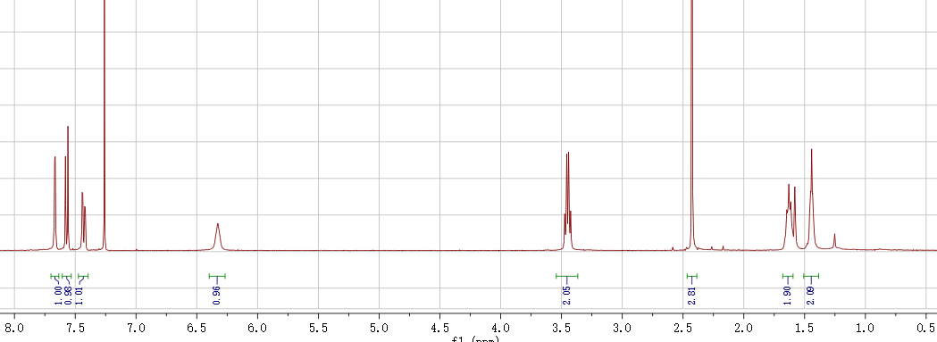

2020.08.25 reaction 96-1



A~0.7mmol, 0.2884g

B~0.7mmol, 0.5645g

C~ Tris(dibenzylideneacetone)dipalladium, Pd2(dba)3, M=915, CAS:60748-47-2

D~2-Dicyclohexylphosphino-2’,6’-dimethoxybiphenyl, SPhos, M=410.53, CAS: 657408-07-6,

E~one drop of Aliquat 336 (~50 mg)

F~ Potassium carbonate solution (8 mL, 2 mol/L in H2O), CAS: 584-08-7, M=138.21, 2.2g

Pinacolato-boron monomer (0.5 mmol), bromine monomer (0.5 mmol), one drop of Aliquat 336 (~50 mg), Tris(dibenzylideneacetone)dipalladium (1.5 mg) and 2-Dicyclohexylphosphino-2',6'-dimethoxybiphenyl (5.3 mg) were charged into a flask with a magnetic bar, and the system was vacuumed and aerated with nitrogen for five times.. Degassed toluene (20 mL) was added and the mixture was heated to 80 oC under vigorous stirring. Potassium carbonate solution (8 mL, 2 mol/L in H2O) was added and the temperature was risen 88 oC for 2 days to 93 oC 5 days.

Phenylboronic acid (50 mg in 5 mL toluene) was added. After 8 hours, Bromobenzene (0.5 mL) was added. After another 8 hours, the mixture was cooled down to 80 oC, then sodium diethyldithiocarbamate trihydrate (1 g in 10ml in H2O) was added. After 12 hours, the system was cooled down to room temperature. The mixture is poured into 100 mL DCM and washed by 100 mL saturated sodium chloride solution for five times.

Obtained 0.51g 90.7% Named as

2020.08.23 reaction 67-3



A, 2mmol, 1.42g

B, 6mmol, bis(pinacolato)diboron, CAS: 73183-34-3, M=254, 1.524g

C, [1,1'-Bis(diphenylphosphino)ferrocene]dichloropalladium(II), Pd(dppf)Cl2, CAS: 72287-26-4, M=731, 0.1mmol, 73mg

D, potassium acetate, KOAc, M=98, 6mmol, 0.588g

~~DMF 15mL /~~ 1,4-diox 35ml

mixed in a flask, vacuumed and aerated with nitrogen for three times. Degassed DMF (10 mL) was added and the system was heated to 100 oC overnight. When the temperature was down to room temperature, the mixture was precipitated into 150 mL saturated sodium chloride solution, filtered by vacuum to obtain the crude product, purified by column chromatography on silica gel (short ~7cm) using (DCM/He= 3:1), then DCM as eluent (don’t use THF). give the product (bright yellow powder, 0.58g, yield 36.0%).

2020.08.21 reaction 95-1



A~

B~1: 1,3-Diiodopropane, CAS: 627-31-6, 2.576 g/mL

C:~2.5 NaOH, CAS: 1310-73-2, C (M=40)

D:~0.01, Tetrabutylammonium Bromide (TBAB), CAS: 1643-19-2, M=322.37

THF 15mL 65o over night

A, 15mmol, 2.79g

B, 6mmol, g, 1.776g, 0.69mL

C, 15mmol, 0.6g

D, 0.15mmol, 48mg

18h, Low yield 0.23g

Named as 0822-1:

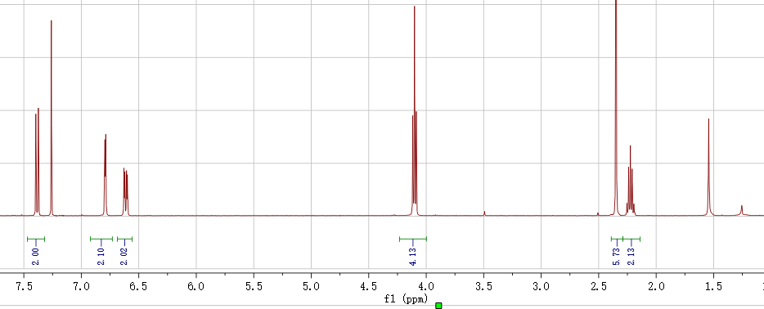

2020.08.20 reaction 66-2



A~1

B~1.2

C~ t-BuOK, CAS: 865-47-4, C (M=112)

A, 6mmol, 2.442g

B, 6.4mmol, 2.067g,

C, 6.2mmol, 0.6944g

DMF 30mL 120o, 10h

2020.08.18 reaction 65-2



A~1, 4-BROMO-4'-FLUOROBENZOPHENONE, CAS: 2069-41-2, 4mmol, 1.1g

B~1, 9,9-DIMETHYLACRIDAN , CAS: 6267-02-3, 4mmol, 0.81g

C~0.05, bis(dibenzylideneacetone)dipalladium Pd(dba)2, C34H28O2Pd, M:575, CAS: 32005-36-0, 0.2mmol, 0.115g

D~0.15,dicyclohexylphosphino-2',4',6'-tri-i-propyl-1,1'-biphenyl, X-PHOS, C33H49P, M: 476.72, CAS: 564483-18-7,0.6mmol, 0.28g

E~NaOtBu, M: 96.1, CAS: 865-48-5, 10mmol, 0.96g

A, 8mmol, 2.2g

B, 8mmol, 1.62g

C, 0.3mmol, 0.1725g

D, 0.9mmol, 0.44g

E, 20mmol, 1.92g

Toluene, 35mL, 85oC

Abotained 2.79g, 87%