67-1

2020.08.11 reaction 94-1



A~1

B~1

C~2, K2CO3, M: 138.21, CAS: 584-08-7

The semi-flexible copolymer was synthesized via a typical polycondensation reaction [*ChemSusChem* 2012, 5, 843-8.]. A (g, 10 mmol), B (g, 10 mmol), K2CO3 (g, 20 mmol) were placed in a three-necked round bottom flask equipped with a nitrogen inlet/outlet and a DeaneStark trap. Then, DMSO/toluene=2:1 was added and the reaction mixture was initially kept at 135 oC for 2 h under constant nitrogen flow to remove the water and toluene. (precipitation formed), then add 8mL NMP, the reaction was subsequently carried out at 165 oC for another 48 h. Then the product was cooled to room temperature (the product was precipitated) and precipitated in the ice water. Finally, the yellow fibrous polymer, was obtained by washing several times with ethanol, followed by drying under vacuum at 60 oC for 24 h.

A, 0.8 mmol, 0.384g

B, 0.8 mmol, 0.2704g

C, 2 mmol, 0.276g

DMSO/toluene=8mL/4mL

The molecular weight might be low

2020.06.26 reaction 93-1



A,

B, Diethylphosphite, CAS: 762-04-9, M=138.10, d= 1.072 g/mL

A, 30mmol, 30mL (1M in THF)

B, 15mmol, 2.07g, 1.93mL

The mixture was aged for 30 minutes at 0 oC, then stirred at 25 oC for 16 hours. After the mixture was cooled again to 0 oC, 100 mL aqueous 1N HCl was added slowly. The mixture was extracted with diethyl ether and the organic phase was washed with brine, which was then dried over Na2SO4. After the solvent was completely removed, the residue was purified by column chromatography on silica gel using petroleum ether/ethyl acetate = 1/1 as eluent to give the product as a white powder in 1.72g (42.4%)

2020.08.11 reaction 92-1



A~1

B~1

C~2, K2CO3, M: 138.21, CAS: 584-08-7

The semi-flexible copolymer was synthesized via a typical polycondensation reaction [*ChemSusChem* 2012, 5, 843-8.]. A (g, 10 mmol), B (g, 10 mmol), K2CO3 (g, 20 mmol) were placed in a three-necked round bottom flask equipped with a nitrogen inlet/outlet and a DeaneStark trap. Then, DMSO/toluene=2:1 was added and the reaction mixture was initially kept at 135 oC for 2 h under constant nitrogen flow to remove the water and toluene. (precipitation formed), then add 8mL NMP, the reaction was subsequently carried out at 165 oC for another 48 h. Then the product was cooled to room temperature (the product was precipitated) and precipitated in the ice water. Finally, the yellow fibrous polymer, was obtained by washing several times with ethanol, followed by drying under vacuum at 60 oC for 24 h.

A, 0.8 mmol, 0.384g

B, 0.8 mmol, 0.2416g

C, 2 mmol, 0.276g

DMSO/toluene=8mL/4mL

Thrice by dissolution/precipitation method (the rude product was dissolved in NMP, filtrated, and precipitated in a large amount of methanol) and once by Soxhlet extraction (methanol, 1d).

Without adding the capping agent, so OH group are still in the polymer, so it will adhere to the MPTS layer.

2020.08.07 reaction 71-3



A~6mmol, 2.56g

B~ Tris(dibenzylideneacetone)dipalladium, Pd2(dba)3, M=915, CAS:60748-47-2, 0.12mmol, 110 mg

C~ 2-Di-tert-butylphosphino-3,4,5,6-tetramethyl-2’, 4’, 6’ -triisopropyl-1,1’-biphenyl, Tetramethyl di-tBuXPhos, Me4tButylXphos, 0.48 mmol,CAS: 857356-94-6, M= 480.756, 231 mg

D~ KOH (1.68 g, M=56, 30.0 mmol)

1,4-dioxane (25 mL) and degassed water (25 mL), 100 oC for 24 h

The reaction mixture was cooled to room temperature, carefully acidified with dilute aqueous HCl. The resulting mixture was extracted with mixture of ethyl acetate/DCM.

by column chromatography using HEX/ethyl acetate (1:1) as eluent to afford a white-yellow solid 1.39g (76.7%)

NMR named as 0810-1:

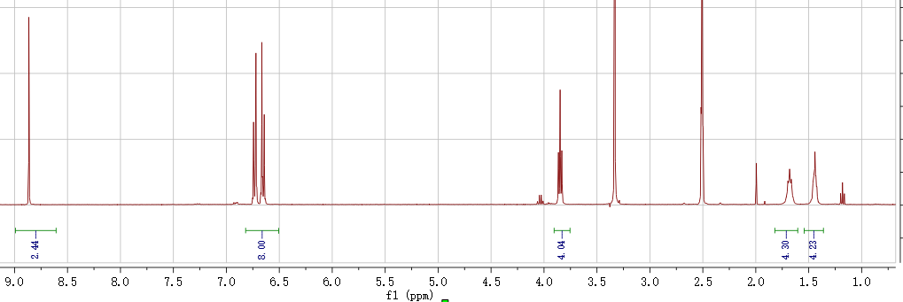

2020.08.06 reaction 84-2



A, 1,3,5-Tris(4-bromophenyl)benzene, 1 mmol , 0.54g;

B, Diphenylphosphine Oxide, 5 mmol , 1.01 g;

C, Pd(OAc)2, M=224.5, (44.8 mg, 0.2 mmol)

D, 1,4bis(diphenylphosphino)butane (dppb), CAS: 7688-25-7, M=426 (84.6 mg, 0.2mmol)

E, (i-Pr)2NEt, CAS: 7087-68-5, M=129, d=0.782g/mL (1.32 ml, 8 mmol)

Toluene, 10mL, 100oC overnight

After cooling to room temperature, the mixture was poured into water, extracted with

CH2Cl2, washed with water completely and dried with Na2SO4. The pure product (260

mg) was obtained by column chromatography using methanol/ethyl acetate (1:10) as eluent to afford a white-yellow solid, 0.21 g (23%)

NMR named as 0808-1 (H1) and 0808-2 (P31)

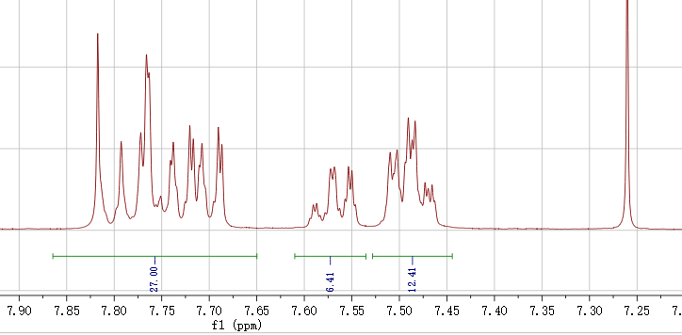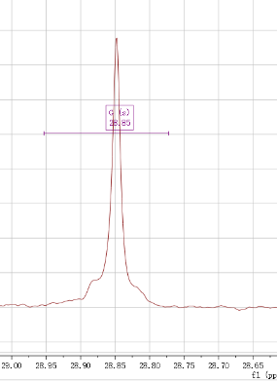

2020.08.05 reaction 42-3



A~2.2: 4-Bromophenol, CAS: 106-41-2

B~1: 1,6-Diiodohexane, CAS: 629-09-4, d=2.05g/mL

C:~2.5 NaOH, CAS: 1310-73-2, C (M=40)

D:~0.01, Tetrabutylammonium Bromide, CAS: 1643-19-2, M=322.37

THF 15mL 60o over night

A, 20mmol, 3.4g; 30mmol, 5.1g

B, 8mmol, g, 2.7g, 1.3mL; 12mmol, 2mL

C, 24mmol, 0.96g; 48mmol, 1.44gde

D, 0.1mmol, 32mg; 50mg

After the reaction, add water into it to precipitate the product and washed wish methanol to the product, 58%。

2020.07.27 reaction 91-1



A: CAS: 500-22-1, M=107, d=1.14G/mL, 2.14g, 1.87mL; 15mmol, 1.4mL

4'-FLUORO-3'-(TRIFLUOROMETHYL)ACETOPHENONE B: , CAS: 99-90-1, M= 206.1, 1.299 g/mL, 30 mmol, 6.18 g, 4.757mL

NaOH, 0.6g, 15mmol

aqueous NH4OH (75 mL of a 28 wt% solution, 60 mmol),

Ethanol 90Ml

NAMED AS 0805-1:

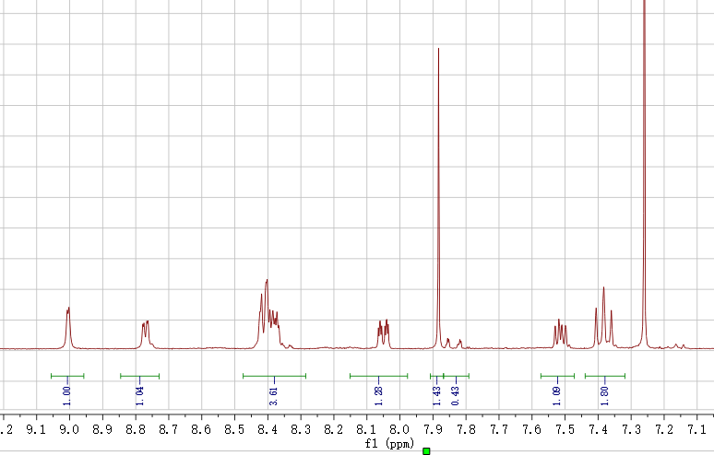

2020.07.27 reaction 82-3



A, 2mmol, 0.54g;

B, 2mmol, 0.774g;

C, Pd(OAc)2, M=224.5, (22.4 mg, 0.1 mmol)

D, 1,4bis(diphenylphosphino)butane (dppb), CAS: 7688-25-7, M=426 (42.3mg, 0.1mmol)

E, (i-Pr)2NEt, CAS: 7087-68-5, M=129, d=0.782g/mL (0.66 ml, 4 mmol)

Toluene, 10mL, 100oC overnight

A, B, Pd(OAc)2, 1,4bis(diphenylphosphino)butane (dppb), and (i-Pr)2NEt was added consecutively to 20 mL toluene under argon. The mixture was then heated at 100 oC for 18 h. After cooling to room temperature, the obtained suspension was directly applied to a silica gel column using petroleum XX as eluent to give the crude product.

2020.07.30 reaction 90-1



A~ 2-Bromo-3-(trifluoromethy)phenol, CAS: 320-49-0, M=241,

B~1: 1,6-Diiodohexane, CAS: 629-09-4, d=2.05g/mL

C:~2.5 NaOH, CAS: 1310-73-2, C (M=40)

D:~0.01, Tetrabutylammonium Bromide, CAS: 1643-19-2, M=322.37

THF 15mL 60o over night

A, 10mmol, 2.41 g;

B, 4mmol, g, 2.7g, 0.65mL

C, 13mmol, 0.52g, in (10mL THF)

D, 0.05mmol, 16mg

Silicone gel: HEX:DCM=5:1, two spot are very close, the second one

White solid, Low yield

Named as 08-3-1

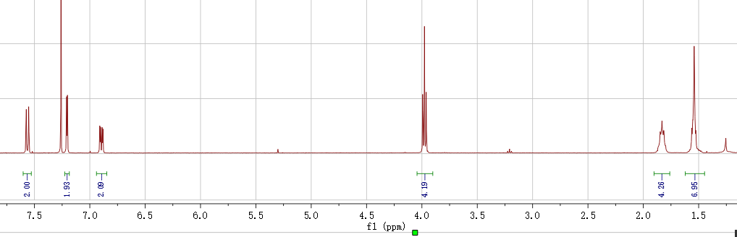

2020.07.30 reaction 89-1



A: CAS: 500-22-1, M=107, d=1.14G/mL, 2.14g, 1.87mL; 15mmol, 1.4mL

B: 4'-Fluoracetophenone, CAS: 99-90-1, M= 138.14, 1.143 g/mL,

30 mmol, 4.14g, 3.625mL

NaOH, 0.6g, 15mmol

aqueous NH4OH (75 mL of a 28 wt% solution, 60 mmol),

Ethanol 90Ml

Overnight washed with DI water and ethanol, obtained ~1.3g, 25%

NMR named as 0731-1

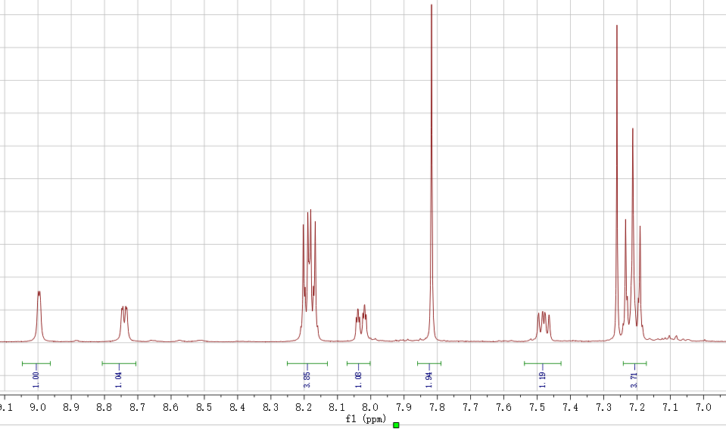

2020.07.27 reaction 82-3



A, 2mmol, 0.54g;

B, 2mmol, 0.314g;

C, Pd(OAc)2, M=224.5, (22.4 mg, 0.1 mmol)

D, 1,4bis(diphenylphosphino)butane (dppb), CAS: 7688-25-7, M=426 (42.3mg, 0.1mmol)

E, (i-Pr)2NEt, CAS: 7087-68-5, M=129, d=0.782g/mL (0.66 ml, 4 mmol)

Toluene, 10mL, 100oC overnight

A, B, Pd(OAc)2, 1,4bis(diphenylphosphino)butane (dppb), and (i-Pr)2NEt was added consecutively to 20 mL toluene under argon. The mixture was then heated at 100 oC for 18 h. After cooling to room temperature, the obtained suspension was directly applied to a silica gel column using petroleum XX as eluent to give the crude product.

2020.07.27 reaction 88-1



A, 3mmol, 1.39g

B, 10 mmol, bis(pinacolato)diboron, CAS: 73183-34-3, M=254, 2.54g

C, [1,1'-Bis(diphenylphosphino)ferrocene]dichloropalladium(II), Pd(dppf)Cl2, CAS: 72287-26-4, M=731, 0.2mmol, 0.146g

D, potassium acetate, KOAc, M=98, 15mmol, 1.47g

1,4 dioxane 35mL

mixed in a flask, vacuumed and aerated with nitrogen for three times. Degassed 1,4 dioxane was added and the system was heated to 90 oC overnight. Yellow Liquid

by column chromatography using EA: hexane= 2:3 as eluent

NMR named as 0730-1:

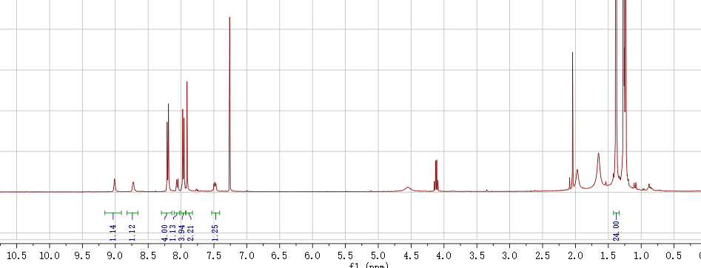

2020.XX.XX reaction XX-1



A: CAS: 500-22-1, M=107, 20 mmol, d=1.14G/mL, 2.14g, 1.87mL; 10mmol, 1.07g, 0.938mL

B: 4'-Bromoacetophenone, CAS: 99-90-1, M= 199, 20 mmol, 3.96g

KOH, 10mmol, M=56, 0.56g in 5mL MeOH

To a stirred mixture of 3-pyridinecarboxaldehyde (10 mmol) and the appropriately substituted acetophenone (20 mmol) in MeOH cooled to 0—5 oC, a 10% solution of KOH in MeOH (5 mL) was slowly added dropwise. The mixture was kept at room temperature for 18 h, poured into water, and acidified with 10% HCl to рH ~7. The crystals formed were collected by filtration, washed with water, dried in air, and crystallized from EtOH.

2020.07.25 reaction 86-2



A mixture of A (~1) B(~2) NaOH ~KOH, 25% NH3 (5mL/~1) ethanol 7mL/~1 room temperature at N2 atmosphere @0oC

Washed with water and ethanol

Abtained 5g (59.5%)

Named as 0726-2

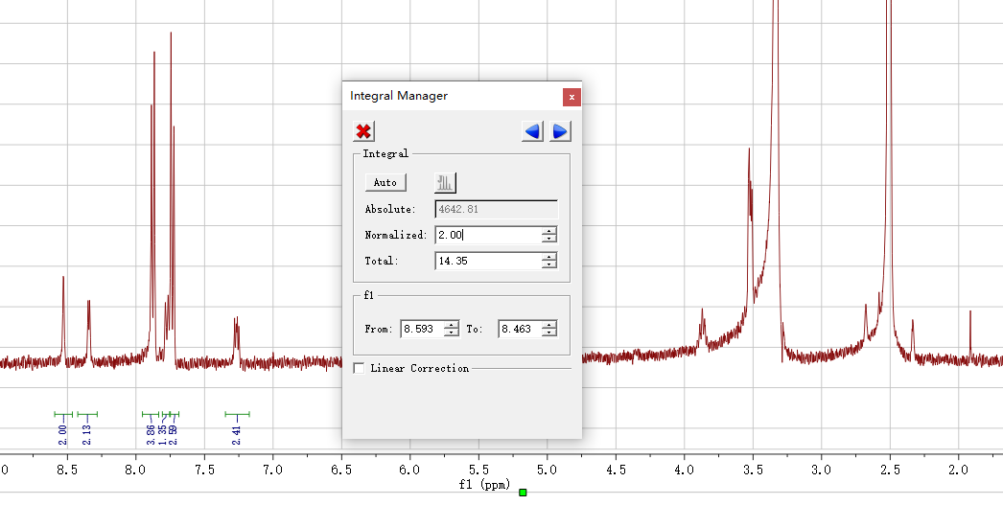

2020.07.24 reaction 87-1



A~ 2-Bromo-5-hydroxypyridine, CAS: 55717-45-8, M=174,

B~1: 1,6-Diiodohexane, CAS: 629-09-4, d=2.05g/mL

C:~2.5 NaOH, CAS: 1310-73-2, C (M=40)

D:~0.01, Tetrabutylammonium Bromide, CAS: 1643-19-2, M=322.37

THF 1mL 60o over night

A, 10mmol, 1.74g;

B, 4mmol, g, 2.7g, 0.65mL

C, 13mmol, 0.52g

D, 0.05mmol, 16mg

A, 20mmol, 3.76g;

B, 8mmol, g, 2.7g, 1.3mL

C, 24mmol, 0.96g

D, 0.1mmol, 32mg

Fail to go through the silicon gel

2020.07.24 reaction 86-1



A: CAS: 500-22-1, M=107, 20 mmol, d=1.14G/mL, 2.14g, 1.87mL; 15mmol, 1.4mL

B: 4'-Bromoacetophenone, CAS: 99-90-1, M= 199, 30mmol, 5.97g

NaOH, 0.6g, 15mmol

aqueous NH4OH (75 mL of a 28 wt% solution, 60 mmol),

Ethanol 90mL

A mixture of A (~1) B(~2) NaOH ~KOH, 25% NH3 (5mL/~1) ethanol 7mL/~1 room temperature at N2 atmosphere

Fail

2020.07.16 reaction 85-1



A~ 5-Bromo-2-hydroxy-4-methylpyridine, CAS: 164513-38-6,M=188,

A~2.2: 4-Bromophenol, CAS: 106-41-2

B~1: 1,6-Diiodohexane, CAS: 629-09-4, d=2.05g/mL

C:~2.5 NaOH, CAS: 1310-73-2, C (M=40)

D:~0.01, Tetrabutylammonium Bromide, CAS: 1643-19-2, M=322.37

THF 15mL 60o over night

A, 20mmol, 3.76g

B, 8mmol, g, 2.7g, 1.3mL

C, 24mmol, 0.96g

D, 0.1mmol, 32mg

Fail！

2020.07.15 reaction 84-1



A, 1,3,5-Tris(4-bromophenyl)benzene, M=543.1, 3mmol, 0.81g;

B, Diphenylphosphine Oxide, M=202, 3mmol, 0.471g;

C, N-methylmorpholine, CAS: 109-02-4, M=101.15, 25mmol, 2.5g, 3mL d=0.82g/mL,

D, tetrakis(triphenylphosphine)platinum, Pd(PPh3)4 M:1244.2, CAS: 14221-02-4, 0.6mmol, 0.74g

Toluene, 30mL, 110oC overnight

After cooling to room temperature, the mixture was poured into water, extracted with

CH2Cl2, washed with water completely and dried with Na2SO4. The pure product (260

mg) was obtained by column chromatography using CH2Cl2: hexane= 1:3 as

eluent in a yield of methanol/ethyl acetate (1:3) as eluent to afford a white solid

FAIL

2020.07.15 reaction 83-1



A, 0.5mmol, 0.17g

B, 1.5mmol, bis(pinacolato)diboron, CAS: 73183-34-3, M=254, 0.381g

C, [1,1'-Bis(diphenylphosphino)ferrocene]dichloropalladium(II), Pd(dppf)Cl2, CAS: 72287-26-4, M=731, 0.025mmol, 19mg

D, potassium acetate, KOAc, M=98, 1.5mmol, 0.147g

DMF 8mL

mixed in a flask, vacuumed and aerated with nitrogen for three times. Degassed DMF (8 mL) was added and the system was heated to 100 oC overnight.

FAIL

2020.07.08 reaction 82-1



A, 3mmol, 0.81g;

B, 3mmol, 0.471g;

C, N-methylmorpholine, CAS: 109-02-4, M=101.15, 5mmol, 0.5g, d=0.82g/mL, 0.61mL

D, tetrakis(triphenylphosphine)platinum, Pd(PPh3)4 M:1244.2, CAS: 14221-02-4, 0.6mmol, 0.74g

Toluene, 10mL, 100oC overnight

After cooling to room temperature, the mixture was poured into water, extracted with

CH2Cl2, washed with water completely and dried with Na2SO4. The pure product (260

mg) was obtained by column chromatography using CH2Cl2: hexane= 1:3 as

eluent in a yield of 0.25g, 24%

NMR named as 200711: in DMSO (the peaks in CDCl3 cannot be recognized)

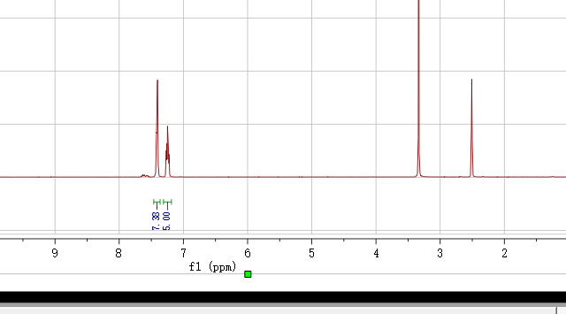

2020.07.XX reaction 81-1



A, 3mmol, 0.81g; 1.5mmol, 0.405g

B, 3mmol, 0.615g; 1.5mmol, 0.307g

C, N-methylmorpholine, CAS: 109-02-4, M=101.15, 2.5mmol, 0.25g, d=0.82g/mL, 0.3mL

D, tetrakis(triphenylphosphine)platinum, Pd(PPh3)4 M:1244.2, CAS: 14221-02-4, 0.3mmol, 0.37g

Toluene, 10mL, 100oC overnight

After cooling to room temperature, the mixture was poured into water, extracted with

CH2Cl2, washed with water completely and dried with Na2SO4. The pure product (260

mg) was obtained by column chromatography using CH2Cl2: methanol = 50:1 as

eluent in a yield of 80%.

2020.06.26 reaction 79-2



A, 4-Chlorophenylmagnesium bromide, CAS: 873-77-8

B, Diethylphosphite, CAS: 762-04-9, M=138.10, d= 1.072 g/mL

A, 30mmol, 30mL (1M in 2-methyltetrahydrofuran)

C, 15mmol, 2.07g, 1.93mL

The mixture was aged for 30 minutes at 0 oC, then stirred at 25 oC for 16 hours. After the mixture was cooled again to 0 oC, 100 mL aqueous 1N HCl was added slowly. The mixture was extracted with diethyl ether and the organic phase was washed with brine, which was then dried over Na2SO4. After the solvent was completely removed, the residue was purified by column chromatography on silica gel using petroleum ether/ethyl acetate = 1/1 as eluent to give the product as a white powder in 1.72g (42.4%)

NMR named as 200628-1:

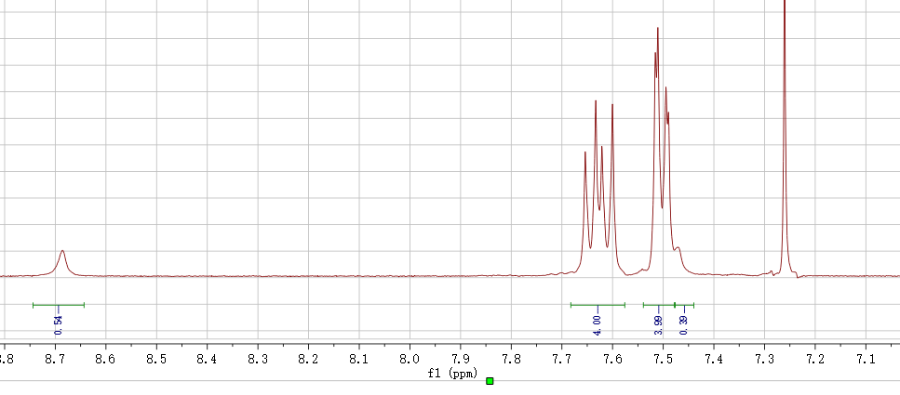

2020.06.xx reaction 79-1



A, 4-Chlorophenylmagnesium bromide, CAS: 873-77-8

B, Diethylphosphite, CAS: 762-04-9, M=138.10, d= 1.072 g/mL

A, 10mmol, 10mL (1M in 2-methyltetrahydrofuran)

C, 5mmol, 0.69g, 0.644mL

THF 10mL

Diethylphosphite (1.5 mL, 11.7 mmol) was added dropwise to a solution of 4-bromophenylmagnesium iodide in tetrahydrofuran which was prepared from *p*-bromoiodobenzene (4.5 mL, 35.3 mmol) and magnesium (0.85 g, 35.3 mmol) at 0 oC. The mixture was aged for 30 minutes at 0 oC, then stirred at 25 oC for 16 hours. After the mixture was cooled again to 0 oC, 75 mL aqueous NH4Cl (1 mol/L) was added slowly. The mixture was extracted with diethyl ether and the organic phase was washed with brine, which was then dried over Na2SO4. After the solvent was completely removed, the residue was purified by column chromatography on silica gel using petroleum ether/ethyl acetate = 1/1 as eluent to give the product as a white powder in 65% yield.

Obtained 0.3g, 22%, NMR:wang-0625-1

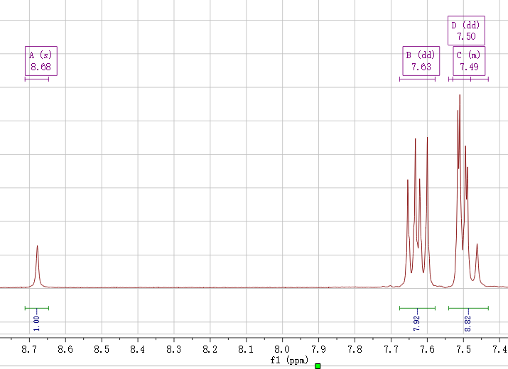

2020.06.17 reaction 78-1





A, 1-Bromo-4-iodobenzene, CAS: 589-87-7

B, magnesium, CAS: 7439-95-4

C, Diethylphosphite, CAS: 762-04-9, M=138.10, d= 1.072 g/mL

A, 5mmol, 1.4g

B, 5mmol, 0.12g

C, 2.5mmol, 0.345g, 0.322mL

Diethylphosphite (1.5 mL, 11.7 mmol) was added dropwise to a solution of 4-bromophenylmagnesium iodide in tetrahydrofuran which was prepared from *p*-bromoiodobenzene (4.5 mL, 35.3 mmol) and magnesium (0.85 g, 35.3 mmol) at 0 oC. The mixture was aged for 30 minutes at 0 oC, then stirred at 25 oC for 16 hours. After the mixture was cooled again to 0 oC, 75 mL aqueous NH4Cl (1 mol/L) was added slowly. The mixture was extracted with diethyl ether and the organic phase was washed with brine, which was then dried over Na2SO4. After the solvent was completely removed, the residue was purified by column chromatography on silica gel using petroleum ether/ethyl acetate = 1/1 as eluent to give the product as a white powder in 65% yield. 1H NMR (300 MHz, CDCl3, δ) 8.02 (d, *J* = 487 Hz, 1H), 7.65 (dd, *J* = 8.3, 2.2 Hz, 4H), 7.53 (dd, *J* = 13.2, 8.3 Hz, 4H).

Failed to prepare the 4-bromophenylmagnesium iodide.

2020.06.13 reaction 74-3



A~0.7mmol, 0.3178g

B1~0.21mmol, 0.169g

B2~0.49mmol, 0.260g

C~ Tris(dibenzylideneacetone)dipalladium, Pd2(dba)3, M=915, CAS:60748-47-2

D~2-Dicyclohexylphosphino-2’,6’-dimethoxybiphenyl, SPhos, M=410.53, CAS: 657408-07-6,

E~one drop of Aliquat 336 (~50 mg)

F~ Potassium carbonate solution (8 mL, 2 mol/L in H2O), CAS: 584-08-7, M=138.21, 2.2g (5mL)

Pinacolato-boron monomer (0.5 mmol), bromine monomer (0.5 mmol), one drop of Aliquat 336 (~50 mg), Tris(dibenzylideneacetone)dipalladium (1.5 mg) and 2-Dicyclohexylphosphino-2',6'-dimethoxybiphenyl (5.3 mg) were charged into a flask with a magnetic bar, and the system was vacuumed and aerated with nitrogen for five times.. Degassed toluene (20 mL) was added and the mixture was heated to 80 oC under vigorous stirring. Potassium carbonate solution (8 mL, 2 mol/L in H2O) was added and the temperature was risen 88 oC for 2 days to 93 oC 4 days.

Phenylboronic acid (50 mg in 5 mL toluene) was added. After 8 hours, Bromobenzene (0.5 mL) was added. After another 8 hours, the mixture was cooled down to 80 oC, then sodium diethyldithiocarbamate trihydrate (1 g in 10ml in H2O) was added. After 12 hours, the system was cooled down to room temperature. The mixture is poured into 100 mL DCM and washed by 100 mL saturated sodium chloride solution for five times.

Named as PDKC27CH30(0.41g) 83% Mn=32.2k

2020.05.08 reaction 74-2



A~0.7mmol, 0.3178g

B1~0.315mmol, 0.2540g

B2~0.385mmol, 0.2046g

C~ Tris(dibenzylideneacetone)dipalladium, Pd2(dba)3, M=915, CAS:60748-47-2

D~2-Dicyclohexylphosphino-2’,6’-dimethoxybiphenyl, SPhos, M=410.53, CAS: 657408-07-6,

E~one drop of Aliquat 336 (~50 mg)

F~ Potassium carbonate solution (8 mL, 2 mol/L in H2O), CAS: 584-08-7, M=138.21, 2.2g (5mL)

Pinacolato-boron monomer (0.5 mmol), bromine monomer (0.5 mmol), one drop of Aliquat 336 (~50 mg), Tris(dibenzylideneacetone)dipalladium (1.5 mg) and 2-Dicyclohexylphosphino-2',6'-dimethoxybiphenyl (5.3 mg) were charged into a flask with a magnetic bar, and the system was vacuumed and aerated with nitrogen for five times.. Degassed toluene (20 mL) was added and the mixture was heated to 80 oC under vigorous stirring. Potassium carbonate solution (8 mL, 2 mol/L in H2O) was added and the temperature was risen 88 oC for 2 days to 93 oC 4 days.

Phenylboronic acid (50 mg in 5 mL toluene) was added. After 8 hours, Bromobenzene (0.5 mL) was added. After another 8 hours, the mixture was cooled down to 80 oC, then sodium diethyldithiocarbamate trihydrate (1 g in 10ml in H2O) was added. After 12 hours, the system was cooled down to room temperature. The mixture is poured into 100 mL DCM and washed by 100 mL saturated sodium chloride solution for five times.

Named as PDKC27CH45(0.41g) 83% Mn=32.2k

2020.03.04 reaction 77-1



A~0.6mmol, 0.2724g

B~0.6mmol, 0.3474g

C~ Tris(dibenzylideneacetone)dipalladium, Pd2(dba)3, M=915, CAS:60748-47-2

D~2-Dicyclohexylphosphino-2’,6’-dimethoxybiphenyl, SPhos, M=410.53, CAS: 657408-07-6,

E~one drop of Aliquat 336 (~50 mg)

F~ Potassium carbonate solution (8 mL, 2 mol/L in H2O), CAS: 584-08-7, M=138.21, 2.2g(5mL)

Pinacolato-boron monomer (0.5 mmol), bromine monomer (0.5 mmol), one drop of Aliquat 336 (~50 mg), Tris(dibenzylideneacetone)dipalladium (1.5 mg) and 2-Dicyclohexylphosphino-2',6'-dimethoxybiphenyl (5.3 mg) were charged into a flask with a magnetic bar, and the system was vacuumed and aerated with nitrogen for five times.. Degassed toluene (20 mL) was added and the mixture was heated to 80 oC under vigorous stirring. Potassium carbonate solution (8 mL, 2 mol/L in H2O) was added and the temperature was risen 85 oC for 2 days to 93 oC 5 days.

Phenylboronic acid (50 mg in 5 mL toluene) was added. A fter 8 hours, Bromobenzene (0.5 mL) was added. After another 8 hours, the mixture was cooled down to 80 oC, then sodium diethyldithiocarbamate trihydrate (1 g in 10ml in H2O) was added. After 12 hours, the system was cooled down to room temperature. The mixture is poured into 100 mL DCM and washed by 100 mL saturated sodium chloride solution for five times.

Obtained 0.35g (93.6%), Mn-32.5k. (PTRZ-F)

2020.03.02 reaction 76-1



A, 2mmol, 0.966g

B, 6mmol, bis(pinacolato)diboron, CAS: 73183-34-3, M=254, 1.524g

C, [1,1'-Bis(diphenylphosphino)ferrocene]dichloropalladium(II), Pd(dppf)Cl2, CAS: 72287-26-4, M=731, 0.1mmol, 73mg

D, potassium acetate, KOAc, M=98, 6mmol, 0.588g

DMF 15mL

mixed in a flask, vacuumed and aerated with nitrogen for three times. Degassed DMF (10 mL) was added and the system was heated to 100 oC overnight. When the temperature was down to room temperature, the mixture was precipitated into 150 mL saturated sodium chloride solution, filtered by vacuum to obtain the crude product, purified by column chromatography on silica gel using (DCM/He= 3:1), then DCM as eluent (don’t use THF). give the product (white powder, 0.53g, yield 45.7%).

In CH3Cl3 named as 0303-1:

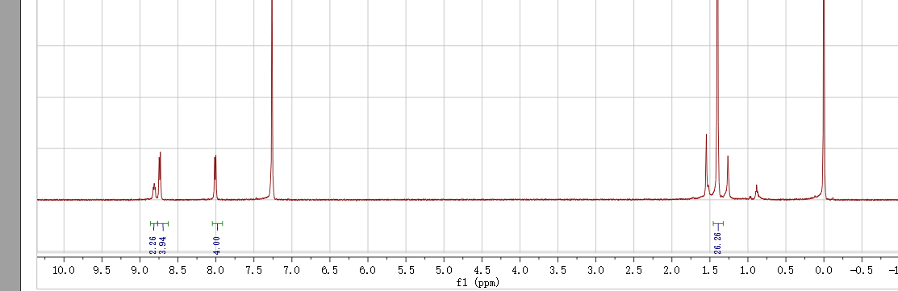

In DMSO named as 0303-2:

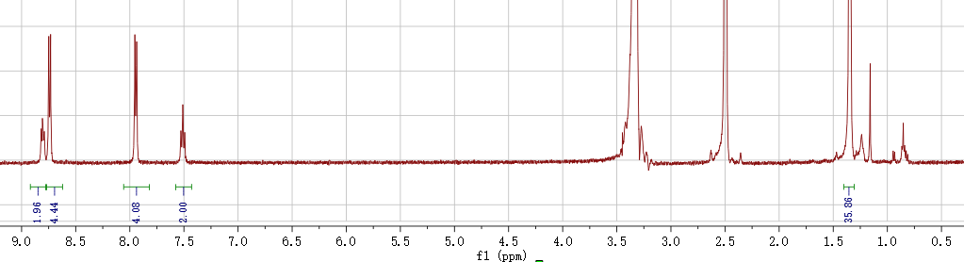

2020.03.01 reaction 75-1



A~0.6mmol, 0.2724g

B~0.6mmol, 0.3186g

C~ Tris(dibenzylideneacetone)dipalladium, Pd2(dba)3, M=915, CAS:60748-47-2

D~2-Dicyclohexylphosphino-2’,6’-dimethoxybiphenyl, SPhos, M=410.53, CAS: 657408-07-6,

E~one drop of Aliquat 336 (~50 mg)

F~ Potassium carbonate solution (8 mL, 2 mol/L in H2O), CAS: 584-08-7, M=138.21, 2.2g(5mL)

Pinacolato-boron monomer (0.5 mmol), bromine monomer (0.5 mmol), one drop of Aliquat 336 (~50 mg), Tris(dibenzylideneacetone)dipalladium (1.5 mg) and 2-Dicyclohexylphosphino-2',6'-dimethoxybiphenyl (5.3 mg) were charged into a flask with a magnetic bar, and the system was vacuumed and aerated with nitrogen for five times.. Degassed toluene (20 mL) was added and the mixture was heated to 80 oC under vigorous stirring. Potassium carbonate solution (8 mL, 2 mol/L in H2O) was added and the temperature was risen 88 oC for 2 days to 93 oC 5 days.

Phenylboronic acid (50 mg in 5 mL toluene) was added. After 8 hours, Bromobenzene (0.5 mL) was added. After another 8 hours, the mixture was cooled down to 80 oC, then sodium diethyldithiocarbamate trihydrate (1 g in 10ml in H2O) was added. After 12 hours, the system was cooled down to room temperature. The mixture is poured into 100 mL DCM and washed by 100 mL saturated sodium chloride solution for five times.

Obtained 0.31g (89.8%), Mn-32.7k. (PCZH)

2020.02.26 reaction 74-1



A~0.7mmol, 0.3178g

B1~0.105mmol, 0.08484g

B2~0.595mmol, 0.3159g

C~ Tris(dibenzylideneacetone)dipalladium, Pd2(dba)3, M=915, CAS:60748-47-2

D~2-Dicyclohexylphosphino-2’,6’-dimethoxybiphenyl, SPhos, M=410.53, CAS: 657408-07-6,

E~one drop of Aliquat 336 (~50 mg)

F~ Potassium carbonate solution (8 mL, 2 mol/L in H2O), CAS: 584-08-7, M=138.21, 2.2g (5mL)

Pinacolato-boron monomer (0.5 mmol), bromine monomer (0.5 mmol), one drop of Aliquat 336 (~50 mg), Tris(dibenzylideneacetone)dipalladium (1.5 mg) and 2-Dicyclohexylphosphino-2',6'-dimethoxybiphenyl (5.3 mg) were charged into a flask with a magnetic bar, and the system was vacuumed and aerated with nitrogen for five times.. Degassed toluene (20 mL) was added and the mixture was heated to 80 oC under vigorous stirring. Potassium carbonate solution (8 mL, 2 mol/L in H2O) was added and the temperature was risen 88 oC for 2 days to 93 oC 4 days.

Phenylboronic acid (50 mg in 5 mL toluene) was added. After 8 hours, Bromobenzene (0.5 mL) was added. After another 8 hours, the mixture was cooled down to 80 oC, then sodium diethyldithiocarbamate trihydrate (1 g in 10ml in H2O) was added. After 12 hours, the system was cooled down to room temperature. The mixture is poured into 100 mL DCM and washed by 100 mL saturated sodium chloride solution for five times.

Named as PDKC27CH15(0.41g) 83% Mn=32.2k

2020.02.09 reaction 73-2



A~1, 1mmol, 0.483g

B~1, 1mmol, 0.209g

C~ Cs2CO3, CAS: 534-17-8, C (M=325.82), 1.2mmol, 0.39g

DMSO 10mL 80 oC(not react for 2h) then increase to 100oC

LOW YEILD maybe because of the inpurity of A.

2020.02.09 reaction 73-1



A~1, 4mmol, 1.93g

B~1.2, 4.5mmol, 0.94g

C~ t-BuOK, CAS: 865-47-4, C (M=112), 4.3mmol, 0.4816g

DMF 20mL 120o

LOW YEILD maybe because of the inpurity of A.

2020.02.12, reaction 72-1



4-Fluorobenzoyl Chloride, CAS: 403-43-0, A~1, d=1.342 g/mL

4-Bromobenzonitrile, CAS: 623-00-7, B~2

Antimony(v) chloride, CAS:7647-18-9, C, M=299.02, 2.36g/mL,

Ammonia solution, CAS: 1336-21-6, M=35.05

A~1, 20mmol, 3.16g, 2.35mL

B~2, 40mmol, 7.24g

C~1, 20mmol, 5.98g, 2.5mL

A and B in 30mL chlorobenzene was cooled at 0-5℃To the solution , antimony(V) chloride was added drop-wise at 0 °C. The mixture was stirred for 20 min at room temperature, then heated at 100 °C for 2 h, and the resulting red slurry of the oxadiazinium salt was cooled to –20 °C. With vigorous stirring, 28% NH3 aqueous solution (40 mL) was added to the slurry, and a white precipitate of desired compound was immediately formed, and the become white slurry. Then, the obtained white solid was added into a 250 mL of three-necked flask, and stirred with 200 mL methanol. The suspension was filtered, and the crude product was dried at 100 C under vacuum for 24 h.

Named as 0213-1:

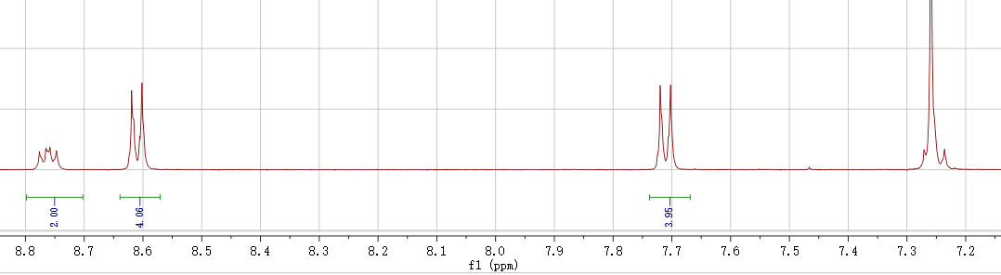

2020.02.11

PLQY measurement sample preparation:

1. TDC0

2. PPKCH28

3. PPKCH

4. PDKCH19

5. PDKC27H

6. PTC6

2020.02.11 reaction 28-4



A~1

B~1

C~2, K2CO3, M: 138.21, CAS: 584-08-7

The semi-flexible copolymer was synthesized via a typical polycondensation reaction [*ChemSusChem* 2012, 5, 843-8.]. A (g, 10 mmol), B (g, 10 mmol), K2CO3 (g, 20 mmol) were placed in a three-necked round bottom flask equipped with a nitrogen inlet/outlet and a DeaneStark trap. Then, DMSO/toluene=2:1 were added and the reaction mixture was initially kept at 135 oC for 2 h under constant nitrogen flow to remove the water and toluene. (precipitation formed), then add 8mL NMP, the reaction was subsequently carried out at 165 oC for another 48 h. Then the product was cooled to room temperature (the product was precipitated) and precipitated in the ice water. Finally, the yellow fibrous polymer, was obtained by washing several times with ethanol, followed by drying under vacuum at 60 oC for 24 h.

A, 1mmol, 0.552g

B, 1mmol, 0.302g

C, 2.2mmol, 0.304g

DMSO/toluene=8mL/4mL

Thrice by dissolution/precipitation method (the rude product was dissolved in NMP, filtrated, and precipitated in a large amount of methanol) and once by Soxhlet extraction (methanol, 1d).

Without adding the capping agent, so OH group are still in the polymer, so it will adhere to the MPTS layer.

2020.02.09 reaction 23-9



A~1, 2F-TRZ-Br, 4mmol, 1.69g

B~0.9, DMAC, 4mmol, 0.836g

C~0.05, bis(dibenzylideneacetone)dipalladium Pd(dba)2, C34H28O2Pd, M:575, CAS: 32005-36-0, 0.2mmol, 0.115g

D~0.15,dicyclohexylphosphino-2',4',6'-tri-i-propyl-1,1'-biphenyl, X-PHOS, C33H49P, M: 476.72, CAS: 564483-18-7,0.6mmol, 0.28g

E~NaOtBu, M: 96.1, CAS: 865-48-5, 10mmol, 0.96g

Toluene, 20mL, 85oC

A mixture of A B, C, D, and E in toluene (10 mL) was stirred at 90oC under argon for 20 h. After cooling to room temperature, the mixture was washed with brine and the organic phase was dried with anhydrous sodium sulfate. After removing of the solvent, the mixture was applied to a silica gel column using cyclohexane/dichloromethane = 3/1 as eluent to give the crude product as white power. The powder was further crystallized from a mixture of hexane and CH2Cl2 to afford the pure product

1.2g, 54%, Named as 0210-2: (the low yield is due to the miss use of KOtBu)

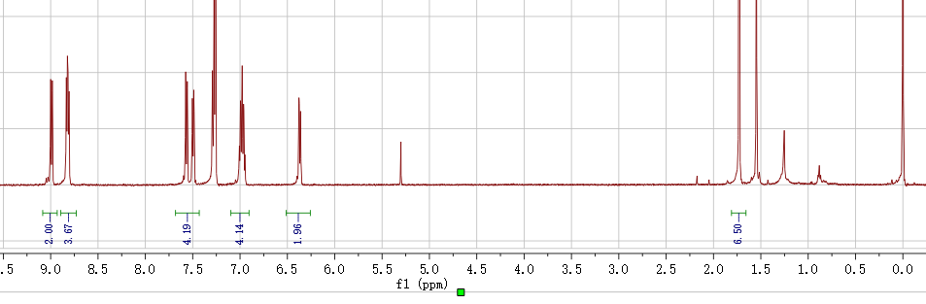

2020.02.09 reaction 69-2



A~0.6mmol, 0.2724g

B~0.6mmol, 0.4836g

C~ Tris(dibenzylideneacetone)dipalladium, Pd2(dba)3, M=915, CAS:60748-47-2

D~2-Dicyclohexylphosphino-2’,6’-dimethoxybiphenyl, SPhos, M=410.53, CAS: 657408-07-6,

E~one drop of Aliquat 336 (~50 mg)

F~ Potassium carbonate solution (8 mL, 2 mol/L in H2O), CAS: 584-08-7, M=138.21, 2.2g(5mL)

Pinacolato-boron monomer (0.5 mmol), bromine monomer (0.5 mmol), one drop of Aliquat 336 (~50 mg), Tris(dibenzylideneacetone)dipalladium (1.5 mg) and 2-Dicyclohexylphosphino-2',6'-dimethoxybiphenyl (5.3 mg) were charged into a flask with a magnetic bar, and the system was vacuumed and aerated with nitrogen for five times.. Degassed toluene (20 mL) was added and the mixture was heated to 80 oC under vigorous stirring. Potassium carbonate solution (8 mL, 2 mol/L in H2O) was added and the temperature was risen 88 oC for 2 days to 93 oC 5 days.

Phenylboronic acid (50 mg in 5 mL toluene) was added. After 8 hours, Bromobenzene (0.5 mL) was added. After another 8 hours, the mixture was cooled down to 80 oC, then sodium diethyldithiocarbamate trihydrate (1 g in 10ml in H2O) was added. After 12 hours, the system was cooled down to room temperature. The mixture is poured into 100 mL DCM and washed by 100 mL saturated sodium chloride solution for five times.

Named as PDKC27H(g) Mn=60.3k

2020.02.05 reaction 71-3



A~4mmol, 1.7g

B~ Tris(dibenzylideneacetone)dipalladium, Pd2(dba)3, M=915, CAS:60748-47-2, 0.08mmol, 73mg

C~ 2-Di-tert-butylphosphino-3,4,5,6-tetramethyl-2’, 4’, 6’ -triisopropyl-1,1’-biphenyl, Tetramethyl di-tBuXPhos, Me4tButylXphos, 0.32mmol,CAS: 857356-94-6, M= 480.756, 154mg

D~ KOH (1.344 g, M=56, 24.0 mmol)

1,4-dioxane (10 mL) and degassed water (10 mL), 100 oC for 24 h

NH4Cl, M= 53.49, 1.28g

The reaction mixture was cooled to room temperature, carefully acidified with dilute aqueous HCl. The resulting mixture was extracted with mixture of ethyl acetate/DCM.

0.4g

Named as 0207-1：

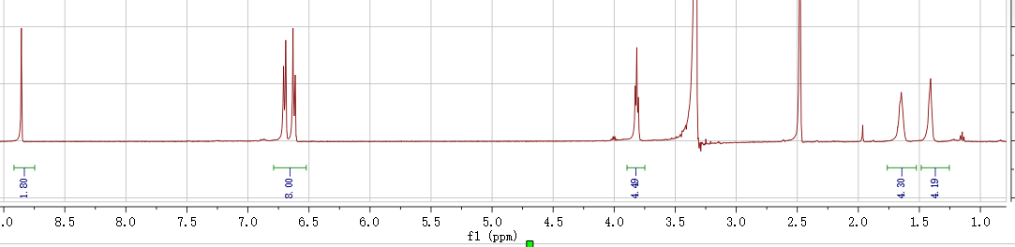

2020.02.03 reaction 42-2



A~2.2: 4-Bromophenol, CAS: 106-41-2

B~1: 1,6-Diiodohexane, CAS: 629-09-4, d=2.05g/mL

C:~2.5 NaOH, CAS: 1310-73-2, C (M=40)

D:~0.01, Tetrabutylammonium Bromide, CAS: 1643-19-2, M=322.37

THF 15mL 60o over night

A, 20mmol, 3.4g

B, 8mmol, g, 2.7g, 1.3mL

C, 24mmol, 0.96g

D, 0.1mmol, 32mg

After the reaction, add water into it to precipitate the product and washed wish methanol to the product, 58%。

2020.01.31 reaction 71-2



A~1mmol, 0.426g

B~ Tris(dibenzylideneacetone)dipalladium, Pd2(dba)3, M=915, CAS:60748-47-2, 0.04mmol, 36.6mg

C~ 2-Di-tert-butylphosphino-3,4,5,6-tetramethyl-2’, 4’, 6’ -triisopropyl-1,1’-biphenyl, Tetramethyl di-tBuXPhos, Me4tButylXphos, 0.16mmol, M= 480.756, 77mg

D~ KOH (330 mg, 6.0 mmol)

1,4-dioxane (2 mL) and degassed water (2 mL), 100 oC for 12 h

HCl: 37%, 6mmol, M=36, 0.585mL

The reaction mixture was cooled to room temperature, carefully acidified with dilute aqueous HCl. The resulting mixture was extracted with mixture of ethyl acetate/DCM.

After evoporation crude product without purification named as 0201-1:

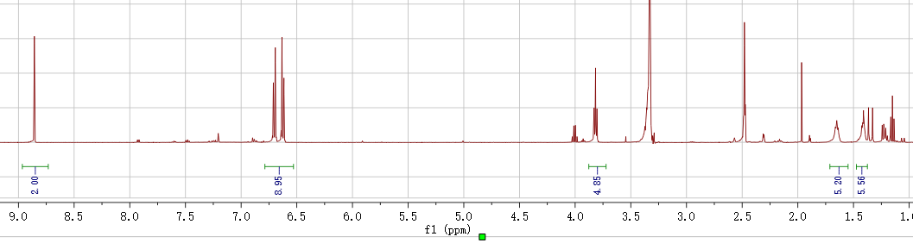

After purification, some of the product maybe oxidized(without dry): named as 0201-2

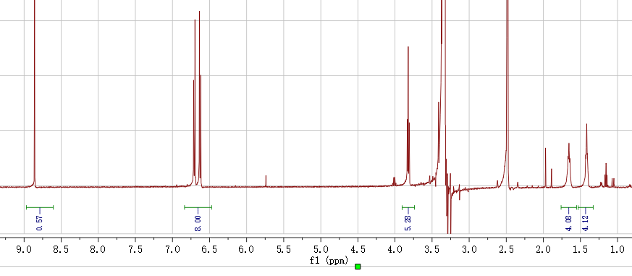

After dry named as 0202-1 (50mg)

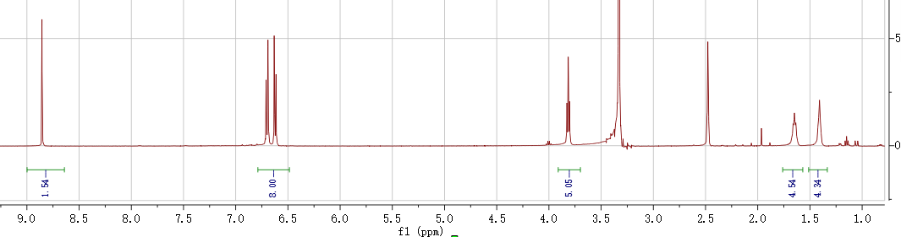

2020.01.23 reaction 71-1



A~1mmol, 0.426g

B~Cu2O,CAS: 1317-39-1, M=143.09, 0.2mmol, 28.6mg

C~4,7-Dihydroxy-1,10-phenanthroline, CSA: 3922-40-5, M=212.2, 0.4mmol, 84.8mg

D~Tetrabutylammonium hydroxide, 40% solution in water, CAS: 2052-49-5, M=259.47, 8mmol, 5.2mL

H2O, 110oC, 4mL+6mL 1,4dioxane

HCl: 37%, 8mmol, M=36, 0.78mL

Fail. did not react

2020.01.20 reaction 70-1



A~0.4mmol, 0.1816g

B~0.4mmol, 0.1981g

C~ tetrakis(triphenylphosphine)platinum, Pd(PPh3)4 M:1244.2, CAS: 14221-02-4, 0.02mmol, 24.9mg

D~three drop of Aliquat 336 (~50 mg)

F~ Potassium carbonate solution (1 mL, 2 mol/L in H2O), CAS: 584-08-7, M=138.21, 0.276g 1.5mL+ 12mL toluene

2020.01.20 reaction 69-1



A~0.3mmol, 0.136g

B~0.3mmol, 0.2416g

C~ Tris(dibenzylideneacetone)dipalladium, Pd2(dba)3, M=915, CAS:60748-47-2

D~2-Dicyclohexylphosphino-2’,6’-dimethoxybiphenyl, SPhos, M=410.53, CAS: 657408-07-6,

E~one drop of Aliquat 336 (~50 mg)

F~ Potassium carbonate solution (4 mL, 2 mol/L in H2O), CAS: 584-08-7, M=138.21, 1.1g(5mL)

Pinacolato-boron monomer (0.5 mmol), bromine monomer (0.5 mmol), one drop of Aliquat 336 (~50 mg), Tris(dibenzylideneacetone)dipalladium (1.5 mg) and 2-Dicyclohexylphosphino-2',6'-dimethoxybiphenyl (5.3 mg) were charged into a flask with a magnetic bar, and the system was vacuumed and aerated with nitrogen for five times.. Degassed toluene (12 mL) was added and the mixture was heated to 80 oC under vigorous stirring. Potassium carbonate solution (4 mL, 2 mol/L in H2O) was added and the temperature was risen to 95 oC.

~~Phenylboronic acid (50 mg in 5 mL toluene) was added. After 8 hours, Bromobenzene (0.5 mL) was added. After another 8 hours, the mixture was cooled down to 80~~ ~~o~~~~C, then sodium diethyldithiocarbamate trihydrate (1 g in 10ml in H2O) was added. After 12 hours, the system was cooled down to room temperature.~~ The mixture is poured into 100 mL DCM and washed by 100 mL saturated sodium chloride solution for five times.

Named as PDKC27H (0.2g) Mn=

2020.01.13 reaction 68-1



A~0.5mmol, 0.227g

B~0.1mmol, 0.078g

C~0.4mmol, 0.198g

D~ Tris(dibenzylideneacetone)dipalladium, Pd2(dba)3, M=915, CAS:60748-47-2

E~2-Dicyclohexylphosphino-2’,6’-dimethoxybiphenyl, SPhos, M=410.53, CAS: 657408-07-6,

~~F~one drop of Aliquat 336 (~50 mg) (NO)~~

G~ Potassium carbonate solution (4 mL, 2 mol/L in H2O), CAS: 584-08-7, M=138.21, 1.1g add 2mL water more due to the water always hang on the flask.

4-Bromostyrene, CAS: 2039-82-9

4-Vinylphenylboronic acid, CAS: 2156-04-9

Pinacolato-boron monomer (0.5 mmol), bromine monomer (0.5 mmol), one drop of Aliquat 336 (~50 mg), Tris(dibenzylideneacetone)dipalladium (1.5 mg) and 2-Dicyclohexylphosphino-2',6'-dimethoxybiphenyl (5.3 mg) were charged into a flask with a magnetic bar, and the system was vacuumed and aerated with nitrogen for five times. Degassed toluene (10 mL) was added and the mixture was heated to 80 oC under vigorous stirring. Potassium carbonate solution (4 mL, 2 mol/L in H2O) was added and the temperature was risen to 95 oC.

Phenylboronic acid (50 mg in 5 mL toluene) was added. After 8 hours, Bromobenzene (0.5 mL) was added. After another 8 hours, the mixture was cooled down to 80 oC, then sodium diethyldithiocarbamate trihydrate (1 g in 10ml in H2O) was added. After 12 hours, the system was cooled down to room temperature. The mixture is poured into 100 mL DCM and washed by 100 mL saturated sodium chloride solution for five times.

2020.01.17 reaction 56-2



A~

B~1: 1,6-Diiodohexane, CAS: 629-09-4, d=2.05g/mL

C:~2.5 NaOH, CAS: 1310-73-2, C (M=40)

D:~0.01, Tetrabutylammonium Bromide (TBAB), CAS: 1643-19-2, M=322.37

THF 15mL 65o over night

A, 15mmol, 2.79g

B, 6mmol, g, 1.352g, 0.99mL

C, 15mmol, 0.6g

D, 0.15mmol, 48mg

After the reaction completing, add DI water to precipitate produce (light yellow)

Obtained 1.9g, 69.75% named as 0118-1

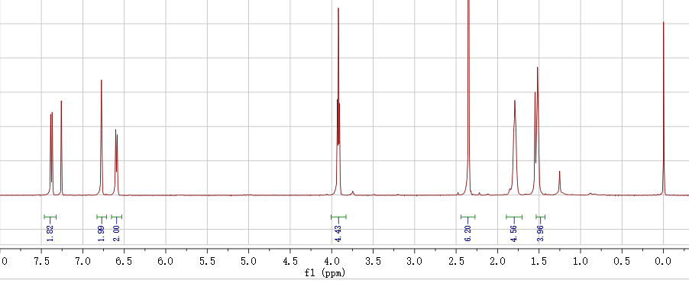

2020.01.17 reaction 67-1



A, 2mmol, 1.42g

B, 6mmol, bis(pinacolato)diboron, CAS: 73183-34-3, M=254, 1.524g

C, [1,1'-Bis(diphenylphosphino)ferrocene]dichloropalladium(II), Pd(dppf)Cl2, CAS: 72287-26-4, M=731, 0.1mmol, 73mg

D, potassium acetate, KOAc, M=98, 6mmol, 0.588g

DMF 15mL

mixed in a flask, vacuumed and aerated with nitrogen for three times. Degassed DMF (10 mL) was added and the system was heated to 100 oC overnight. When the temperature was down to room temperature, the mixture was precipitated into 150 mL saturated sodium chloride solution, filtered by vacuum to obtain the crude product, purified by column chromatography on silica gel (short ~7cm) using (DCM/He= 3:1), then DCM as eluent (don’t use THF). give the product (bright yellow powder, 0.81g, yield 50.1%).

Named as 0120-1:

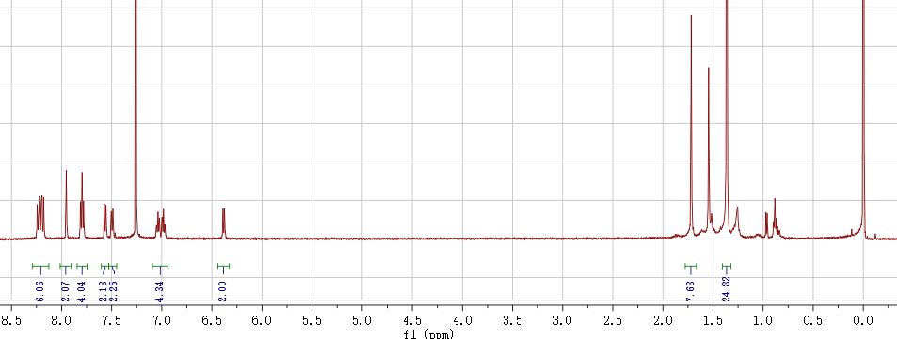

2020.01.16 reaction 66-1



A~1

B~1.2, CAS: 136630-39-2

C~ t-BuOK, CAS: 865-47-4, C (M=112)

DMF 15mL 120o, 10h

A, 3mmol, 1.22g

B, 3.2mmol, 1.033g,

C, 3.1mmol, 0.347g

2g, 90%, Named as 0116-2：

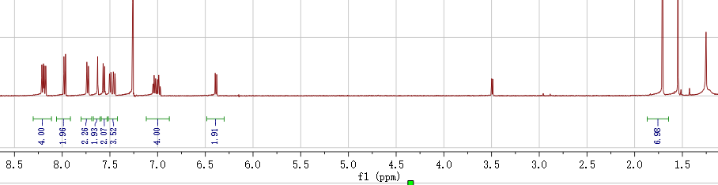

2019.12.03 reaction 65-1



A~1, 4-BROMO-4'-FLUOROBENZOPHENONE, CAS: 2069-41-2, 4mmol, 1.1g

B~1, 9,9-DIMETHYLACRIDAN , CAS: 6267-02-3, 4mmol, 0.81g

C~0.05, bis(dibenzylideneacetone)dipalladium Pd(dba)2, C34H28O2Pd, M:575, CAS: 32005-36-0, 0.2mmol, 0.115g

D~0.15,dicyclohexylphosphino-2',4',6'-tri-i-propyl-1,1'-biphenyl, X-PHOS, C33H49P, M: 476.72, CAS: 564483-18-7,0.6mmol, 0.28g

E~NaOtBu, M: 96.1, CAS: 865-48-5, 10mmol, 0.96g

Toluene, 20mL, 85oC

Abotained 1.28g, 81%

Named as 0116-1, DMAC-K-F

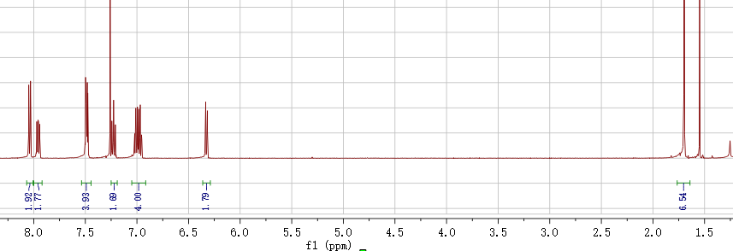

2020.01.09 reaction 61-3



A~1,

B~1.2,

C~1.05, t-BuOK, CAS: 865-47-4, C (M=112)

DMF 15mL 120o,

Base is added after the mix @110 o

A 3mmol, 1.5628g

B, 3.2mmol, 0.669g,

C, 3.1mmol,0.3472g

2020.01.09 reaction 64-2



A~3,

B~1

C~ t-BuOK, CAS: 865-47-4, C (M=112)

DMF 10mL 110o, 4h

A, 6mmol, 1.3083g

B, 2mmol, 0.646g,

C, 2mmol, 0.224g (add after 100o)

2020.01.09 reaction 63-3



A~0.5mmol, 0.227g

B~0.1mmol, 0.078g

C~0.4mmol, 0.198g

D~ Tris(dibenzylideneacetone)dipalladium, Pd2(dba)3, M=915, CAS:60748-47-2

E~2-Dicyclohexylphosphino-2’,6’-dimethoxybiphenyl, SPhos, M=410.53, CAS: 657408-07-6,

F~one drop of Aliquat 336 (~50 mg)

G~ Potassium carbonate solution (4 mL, 2 mol/L in H2O), CAS: 584-08-7, M=138.21, 1.1g

Pinacolato-boron monomer (0.5 mmol), bromine monomer (0.5 mmol), one drop of Aliquat 336 (~50 mg), Tris(dibenzylideneacetone)dipalladium (1.5 mg) and 2-Dicyclohexylphosphino-2',6'-dimethoxybiphenyl (5.3 mg) were charged into a flask with a magnetic bar, and the system was vacuumed and aerated with nitrogen for five times.. Degassed toluene (10 mL) was added and the mixture was heated to 80 oC under vigorous stirring. Potassium carbonate solution (4 mL, 2 mol/L in H2O) was added and the temperature was risen to 95 oC.

Phenylboronic acid (50 mg in 5 mL toluene) was added. After 8 hours, Bromobenzene (0.5 mL) was added. After another 8 hours, the mixture was cooled down to 80 oC, then sodium diethyldithiocarbamate trihydrate (1 g in 10ml in H2O) was added. After 12 hours, the system was cooled down to room temperature. The mixture is poured into 100 mL DCM and washed by 100 mL saturated sodium chloride solution for five times.

2020.01.07 reaction 44-4



A~3,

B~1

C~ t-BuOK, CAS: 865-47-4, C (M=112)

DMF 20mL 110o, 4h (participated after reaction for 1h)

A, 7mmol, 1.526g

B, 5mmol, 1.61g,

C, 5mmol, 0.56g

Fail maybe both side with the Donor

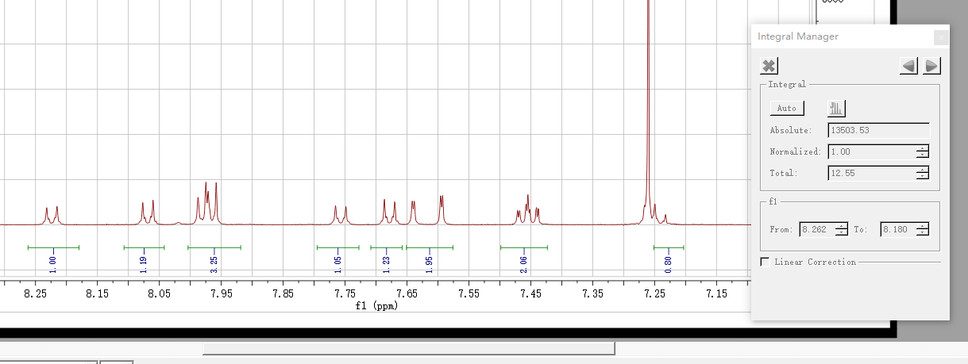

NMR named as 0109-4

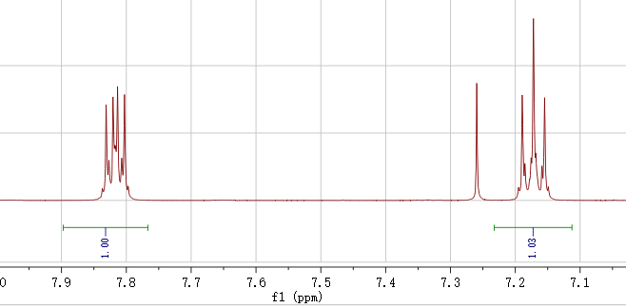

2020.01.07 reaction



A~3,

B~1

C~ t-BuOK, CAS: 865-47-4, C (M=112)

DMF 20mL 110o, 4h (participated after reaction for 1h)

A, 7mmol, 1.526g

B, 5mmol, 1.61g,

C, 5mmol, 0.56g

Named as 1217-1, ~1.15g (73.6%):

2020.01.02 reaction 62-2



A, 0.65mmol, 0.4615g

B, 1.8mmol, bis(pinacolato)diboron, CAS: 73183-34-3, M=254, 0.457g

C, [1,1'-Bis(diphenylphosphino)ferrocene]dichloropalladium(II), Pd(dppf)Cl2, CAS: 72287-26-4, M=731, 60mg

D, potassium acetate, KOAc, M=98, 1.8mmol, 0.1764g

DMF 10mL

mixed in a flask, vacuumed and aerated with nitrogen for three times. Degassed DMF (10 mL) was added and the system was heated to 100 oC overnight. When the temperature was down to room temperature, the mixture was precipitated into 150 mL saturated sodium chloride solution, filtered by vacuum to obtain the crude product, purified by column chromatography on silica gel (short ~7cm) using (DCM/He= 3:1), then DCM as eluent (don’t use THF).

2019.01.02 reaction 60-2



A~, 0.4mmol, 0.1816g

B~, 0.4mmol, 0.312g

D~ Tris(dibenzylideneacetone)dipalladium, Pd2(dba)3, M=915, CAS:60748-47-2

E~2-Dicyclohexylphosphino-2’,6’-dimethoxybiphenyl, SPhos, M=410.53, CAS: 657408-07-6,

F~one drop of Aliquat 336 (~50 mg)

G~ Potassium carbonate solution 4 mL, 2 mol/L in H2O, CAS: 584-08-7, M=138.21, 1.1g

Toluene 10mL

Pinacolato-boron monomer (0.5 mmol), bromine monomer (0.5 mmol), one drop of Aliquat 336 (~50 mg), Tris(dibenzylideneacetone)dipalladium (1.5 mg) and 2-Dicyclohexylphosphino-2',6'-dimethoxybiphenyl (5.3 mg) were charged into a flask with a magnetic bar, and the system was vacuumed and aerated with nitrogen for five times.. Degassed toluene was added and the mixture was heated to 80 oC under vigorous stirring. Potassium carbonate solution was added and the temperature was risen to 95 oC.

Phenylboronic acid (50 mg in 5 mL toluene) was added. After 8 hours, Bromobenzene (0.5 mL) was added. After another 8 hours, the mixture was cooled down to 80 oC, then sodium diethyldithiocarbamate trihydrate (1 g in 10ml in H2O) was added. After 12 hours, the system was cooled down to room temperature. The mixture is poured into 100 mL DCM and washed by 100 mL saturated sodium chloride solution for five times.