2020.03.07 reaction 111-1



A~0.7mmol, 0.357g

B1~0.07mmol, 0.056g

B2~0.63mmol, 0.312g

C~ Tris(dibenzylideneacetone)dipalladium, Pd2(dba)3, M=915, CAS:60748-47-2

D~2-Dicyclohexylphosphino-2’,6’-dimethoxybiphenyl, SPhos, M=410.53, CAS: 657408-07-6,

E~one drop of Aliquat 336 (~50 mg)

F~ Potassium carbonate solution (8 mL, 2 mol/L in H2O), CAS: 584-08-7, M=138.21, 2.2g (5mL)

Pinacolato-boron monomer (0.5 mmol), bromine monomer (0.5 mmol), one drop of Aliquat 336 (~50 mg), Tris(dibenzylideneacetone)dipalladium (1.5 mg) and 2-Dicyclohexylphosphino-2',6'-dimethoxybiphenyl (5.3 mg) were charged into a flask with a magnetic bar, and the system was vacuumed and aerated with nitrogen for five times.. Degassed toluene (20 mL) was added and the mixture was heated to 80 oC under vigorous stirring. Potassium carbonate solution (8 mL, 2 mol/L in H2O) was added and the temperature was risen 88 oC for 2 days to 93 oC 4 days.

Phenylboronic acid (50 mg in 5 mL toluene) was added. After 8 hours, Bromobenzene (0.5 mL) was added. After another 8 hours, the mixture was cooled down to 80 oC, then sodium diethyldithiocarbamate trihydrate (1 g in 10ml in H2O) was added. After 12 hours, the system was cooled down to room temperature. The mixture is poured into 100 mL DCM and washed by 100 mL saturated sodium chloride solution for five times.

Acetone, Methanol, Chloroform Soxhlet extraction

2021.02.26 reaction 110-1



A~0.7mmol, 0.357g

B1~0.14mmol, 0.113g

B2~0.56mmol, 0.277g

C~ Tris(dibenzylideneacetone)dipalladium, Pd2(dba)3, M=915, CAS:60748-47-2

D~2-Dicyclohexylphosphino-2’,6’-dimethoxybiphenyl, SPhos, M=410.53, CAS: 657408-07-6,

E~one drop of Aliquat 336 (~50 mg)

F~ Potassium carbonate solution (8 mL, 2 mol/L in H2O), CAS: 584-08-7, M=138.21, 2.2g (5mL)

Pinacolato-boron monomer (0.5 mmol), bromine monomer (0.5 mmol), one drop of Aliquat 336 (~50 mg), Tris(dibenzylideneacetone)dipalladium (1.5 mg) and 2-Dicyclohexylphosphino-2',6'-dimethoxybiphenyl (5.3 mg) were charged into a flask with a magnetic bar, and the system was vacuumed and aerated with nitrogen for five times.. Degassed toluene (20 mL) was added and the mixture was heated to 80 oC under vigorous stirring. Potassium carbonate solution (8 mL, 2 mol/L in H2O) was added and the temperature was risen 88 oC for 2 days to 93 oC 4 days.

Phenylboronic acid (50 mg in 5 mL toluene) was added. After 8 hours, Bromobenzene (0.5 mL) was added. After another 8 hours, the mixture was cooled down to 80 oC, then sodium diethyldithiocarbamate trihydrate (1 g in 10ml in H2O) was added. After 12 hours, the system was cooled down to room temperature. The mixture is poured into 100 mL DCM and washed by 100 mL saturated sodium chloride solution for five times.

2021.02.24 reaction 108-1



A~

B~1: 1,10-Diiododecane, CAS: 16355-92-3, 2.35 g/mL

C~2, K2CO3, M: 138.21, CAS: 584-08-7

Acetonitrile 45 mL 95o over night

A, 15 mmol, 2.79g

B, 5mmol, g, 1.97g, 0.84 mL

C, 15mmol, 2.07g

After finished, poured the solution into water.

2021.02. reaction 107-1



A~5mmol, 1.135g, CAS: 17202-49-2

B~2mmol, 0.4g, 1,12-Dodecanediol, 5675-51-4

C~ DIMETHYL-PYRIDIN-4-YL-AMINE, DMAP, M=122.17, CAS: 1122-58-3, 1mmol, 122mg

D~({[3-(DIMETHYLAMINO)PROPYL]IMINOMETHYLIDENE)(ETHYL)AMINE, EDC, M=155.24, CAS: 1892-57-5, 0.877 g/mL at 20 °C, 12mmol, 1.86g, 2.12mL

**A** (5 mmol), DMAP (122 mg, 1 mmol), EDC (1.86 g, 12 mmol) and **B** were added to a 200 mL round bottom flask of 100 mL anhydrous dichloromethane at 0 °C. After stirring for 18 h, the reaction mixture was diluted with 100 mL deionized water, extracted twice with 70 mL diethyl ether, dried over anhydrous MgSO4 and concentrated under reduced pressure. The product was purified by column chromatography (silica gel, hexanes/ ethyl acetate, 8:2, v/v) to afford **6** as a white powder in 0.27g.

Named as 0203-1:

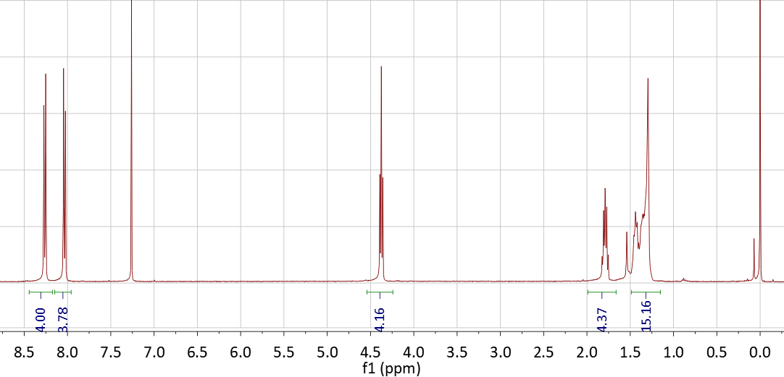

2021.02.14 reaction 109-1



A~0.7mmol, 0.357g

B1~0.21mmol, 0.169g

B2~0.49mmol, 0.243g

C~ Tris(dibenzylideneacetone)dipalladium, Pd2(dba)3, M=915, CAS:60748-47-2

D~2-Dicyclohexylphosphino-2’,6’-dimethoxybiphenyl, SPhos, M=410.53, CAS: 657408-07-6,

E~one drop of Aliquat 336 (~50 mg)

F~ Potassium carbonate solution (8 mL, 2 mol/L in H2O), CAS: 584-08-7, M=138.21, 2.2g (5mL)

Pinacolato-boron monomer (0.5 mmol), bromine monomer (0.5 mmol), one drop of Aliquat 336 (~50 mg), Tris(dibenzylideneacetone)dipalladium (1.5 mg) and 2-Dicyclohexylphosphino-2',6'-dimethoxybiphenyl (5.3 mg) were charged into a flask with a magnetic bar, and the system was vacuumed and aerated with nitrogen for five times.. Degassed toluene (20 mL) was added and the mixture was heated to 80 oC under vigorous stirring. Potassium carbonate solution (8 mL, 2 mol/L in H2O) was added and the temperature was risen 88 oC for 2 days to 93 oC 4 days.

Phenylboronic acid (50 mg in 5 mL toluene) was added. After 8 hours, Bromobenzene (0.5 mL) was added. After another 8 hours, the mixture was cooled down to 80 oC, then sodium diethyldithiocarbamate trihydrate (1 g in 10ml in H2O) was added. After 12 hours, the system was cooled down to room temperature. The mixture is poured into 100 mL DCM and washed by 100 mL saturated sodium chloride solution for five times.