Routes

Host1:

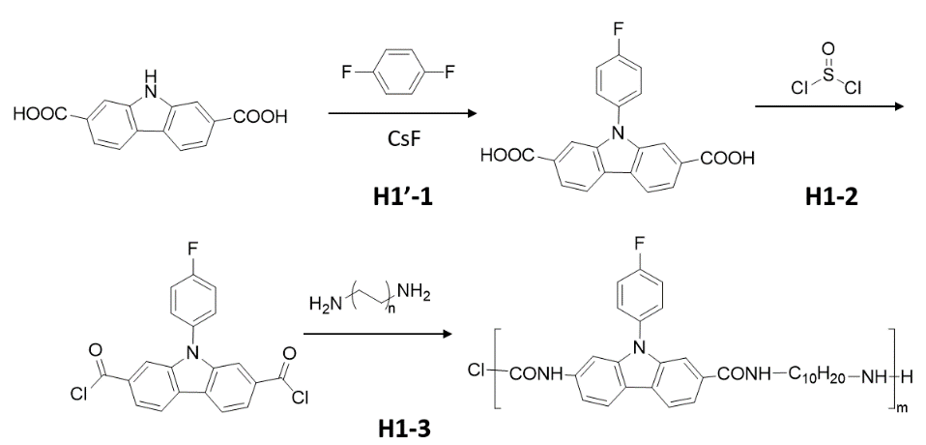

Host2 (H2):

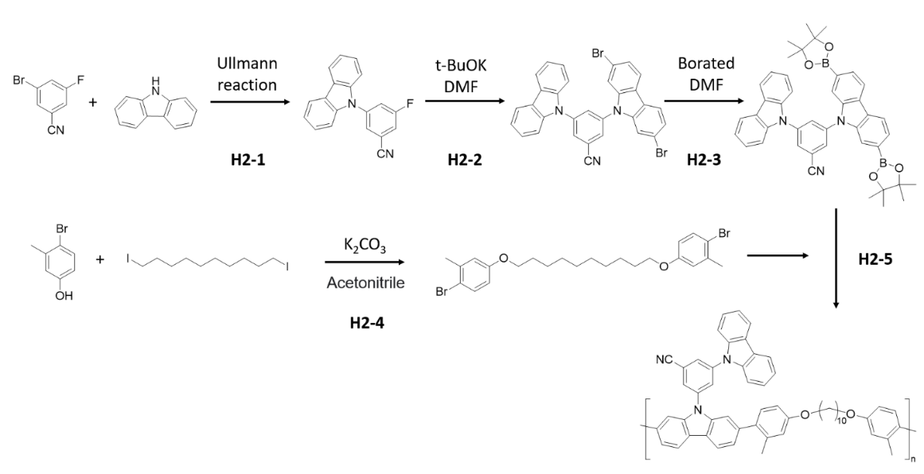

Host3 (H3):

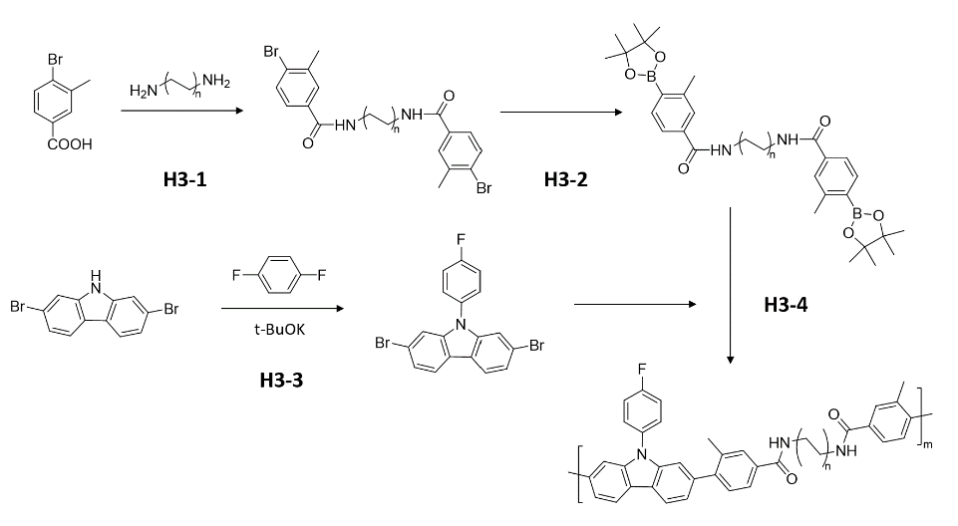

2022.02.22

Reaction H1-1:



t-BuOK

A - CAS 1409971-87-4; Mn = 255.23; Density = 1.583 g/cm3;

B - CAS 540-36-3; Mn = 114.09; Density = 1.1725 g/cm3;

C - CAS 865-47-4; Mn = 112.21;

Solution - N,N-dimethylformamide

A – 1 mmol = 255.23 mg

B – 3 mmol = 342.27 mg

C - ~~1mmol = 112.21 mg~~ 3.5 mmol = 392.74 mg

Solution – 15mL

A mixture of A (255.23 mg, 1 mmol) and B (342.27 mg, 3 mmol) in N,N-dimethylformamide (15 mL) was stirred for 15 min under argon at room temperature, and then the reaction mixture was heated up to 110 °C and potassium tert-butoxide (~~112.21 mg, 1 mmol~~ 392.74 mg, 3.5 mmol) was added and stirred for 12 h. The reaction was quenched with water (20 mL), and precipitated in ~~methanol~~ dilute HCl, and washed with DI water three times to remove DMF. Use column chromatography to get the pure product.

Yield = ____ %

2022.02.22 (tiral1) - low yield – C should be at least 3 times higher than A.

2022.02.25 (trial 2) - low yield – A wasn’t deprotonated well.

2022.02.03

Reaction H2-4

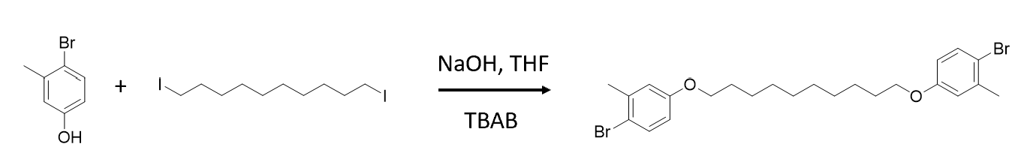

A – CAS 14472-14-1; Mn = 187.03;

B – CAS 16355-92-3; Mn = 394.08;

C – CAS 584-08-7; Mn = 138.21;

Solution – Acetonitrile

Product – Mn = 510.08;

A – 15 mmol = 2.805 g

B – 5 mmol = 1.970 g

C – 15 mmol = 2.073 g

Solution - 45 mL

A solution of A, B and C in 45 mL Acetonitrile under nitrogen at 95 for 12h. After cooling to room temperature, the solution was poured into DI water. The precipitate was collected by filtration and washed with water (light yellow). Finally, it was purified by column chromatography on silica gel using hexane/DCM (v/v = 4:1) as eluent to give white solid products.

Notes:

1. The filtration is slow. Needs to switch filter paper.
2. Use Hexane to wash the final product.

Yield = ___/2.5504 = ~ 43 %

2022-02-21

Reaction H2-1

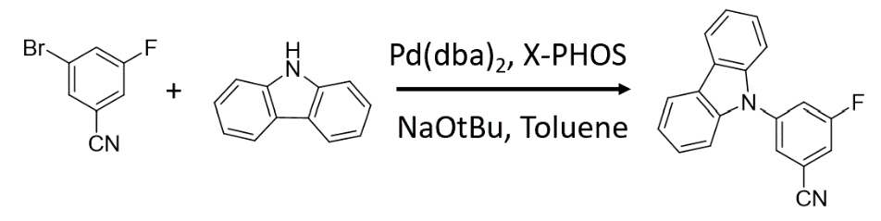

A – CAS 179898-34-1; Mn = 200.01

B – CAS 86-74-8; Mn = 167.21

C – CAS 32005-36-0; Mn = 575.00

D – CAS 564483-18-7; Mn = 476.72

E – CAS 865-48-5; Mn = 97.11

Solution – Toluene

Product – Mn = 286.09

A – 16 mmol = 3.200 g

B – ~~8 mmol = 1.338 g~~ 12 mmol = 2.007 g

C – 0.3 mmol = 0.1725 g

D – 0.9 mmol = 0.429 g

E – 20 mmol = 1.942 g

Solution – ~~35mL~~ 40mL

A solution of A,B,C,D and E in 35 mL toluene under N2 at 85 for 12h.

2022.02.24 (trial 1) – low yield – F was replaced by carbazole, reacted for too long time.

2022.02.28 (trial 2) -

2022.02.14

Reaction H2-s1

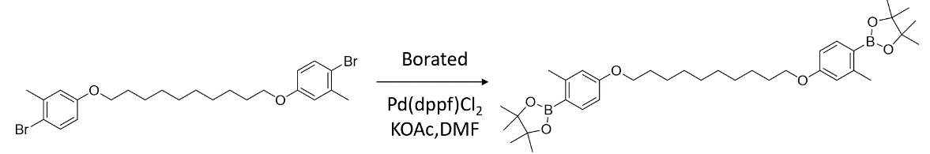

A – CAS NA; Mn = 510.08;

B – CAS 73183-34-3; Mn = 253.94;

C – CAS 72287-26-4; Mn = 731.72;

D – CAS 127-08-2; Mn = 98.15;

Solution – ~~DMF~~ 1,4-dioxane

Product – Mn = 606.46

A – 2mmol = 1.020 g

B – 6mmol = 1.524 g

C – 0.1mmol = 0.073 g

D – 6mmol = 0.5889 g

Solution – 15 mL

A solution of A,B,C,D and E in 15 mL degassed DMF under N2 at 100 for 12h. After cooling to room temperature, the solution was poured into 150 mL saturated sodium chloride solution and filtered by vacuum to obtain the crude product, purified by column chromatography on silica gel (short ~7cm) using (DCM/Hex= 3:1), then DCM as eluent (don’t use THF). give the product (bright yellow powder, 0.58g, yield 36.0%).

Yield = Low!

Notes:

1. Use 1,4-dioxane as the solvent.

2022.02.28

Reaction H3-1

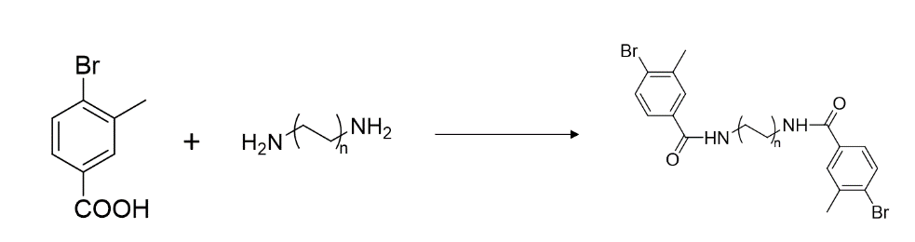

A – CAS 7697-28-1; Mn = 215.04;

B – CAS 646-25-3; Mn = 172.31;