**Document Versioning Table**

|  |  |  |  |
| --- | --- | --- | --- |
| **Rev No.** | **Change Description** | **Rev Date – dd/mm/yyyy** | **Effective Date - dd/mm/yyyy** |
| Version 1.0 | Created end to end provisioning BKM | 19/11/2020 | 20/11/2020 |
|  |  |  |  |
|  |  |  |  |
|  |  |  |  |
|  |  |  |  |
|  |  |  |  |
|  |  |  |  |
|  |  |  |  |
|  |  |  |  |
|  |  |  |  |
|  |  |  |  |
|  |  |  |  |
|  |  |  |  |
|  |  |  |  |
|  |  |  |  |
|  |  |  |  |

**E2E Provisioning**

E2E provisioning supports following things for the user,

* CPLD Flashing, refer the below BKM.
  + \\bdcspiec010.gar.corp.intel.com\File_Transfer\Automation_status\EGS\usbblaster_cpld_flashing_BKM.pdf
* IFWI Flashing.
* BMC Flashing.
  + Via Banino
  + Via Redfish

To configure the system_configuration.xml file with the above flashing configurations, please refer the below mentioned BKM,

\\bdcspiec010\File_Transfer\Automation_status\EGS\Flashing provider configuration BKM.docx

A system_configuration.xml file from my host machine has been placed under the below path for your reference,

\\bdcspiec010.gar.corp.intel.com\File_Transfer\Automation_status\EGS\system_configuration.xml

* USBBlaster - Post code Reading, refer the below BKM,
  + \\bdcspiec010\File_Transfer\Automation_status\EGS\usbblaster_postcode_read_BKM.pdf
* OS Installation.
  + RHEL
  + Windows
  + ESXi
  + CentOS
* BKM on how to use the above provisioning are mentioned in the below mentioned path,
  + \\bdcspiec010.gar.corp.intel.com\File_Transfer\Automation_status\EGS\EgS_Provisioning_one_liner2.3.pdf

**Hardware Setups:**

* Get PDU Credentials and its power outlet number / Rpi IP address for power cycling.
* Banino (SX State and all other connections.
* Connect a USB pen-drive on Banino village board.
  + 16 GB or 32 GB pendrive for Linux OS installation. Preferred Models – HP, PNY, TRANSCEND and SANDISK.
* Connect USB Blaster and Install Quartus Application (contact lab support) and click on Auto Detect button and you should see the below chip information.



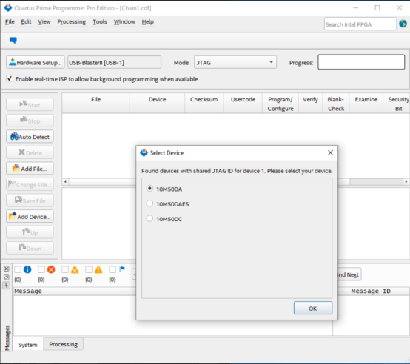



* BMC Serial COM port configuration (port will get differ platform to platform).

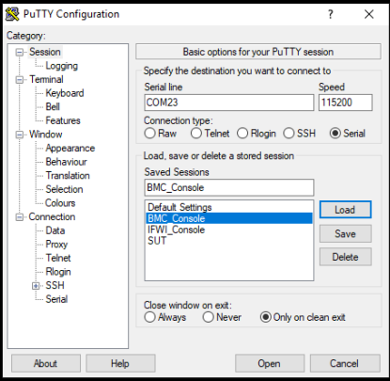



* IFWI Serial COM port configuration (port will get differ platform to platform).

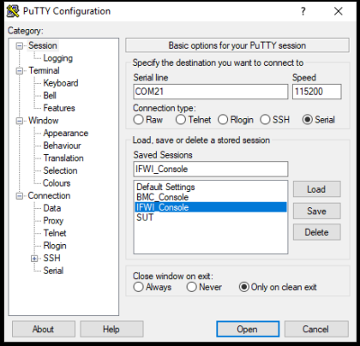



* Ethernet connectivity to platform and platform BMC.
* Connect ITP to use the Auto mode of OS installation.
* KVM and Camera if necessary.

**Pre-requisites: (Must to Follow)**



* Install python 3.6 from the below path,



* + \\bdcspiec010\File_Transfer\Automation_status\EGS\python-3.6.0-amd64.exe
* Install python dependency packages from dtaf_content and dtaf_core Frameworks, the packages can be installed by giving the direct path of the requirements file that can be found under the below paths highlighted in yellow, the path will change as per where you clone the framework.
* Just by substituting the correct path in place of xxxx, the below command will install the packages for you.
* **dtaf_core -** pip install --proxy=http://proxy01.iind.intel.com:911 -r C:\xxxx\dtaf_core\requirements\requirements_ut_py37.txt



* **dtaf_content -** pip install --proxy=http://proxy01.iind.intel.com:911 -r C:\xxxx\dtaf_content\requirements_py3.txt
* Setup Cscripts and pythonSV, refer the below BKM on how to set up.
  + \\bdcspiec010\File_Transfer\Automation_status\EGS\PythonSv_Cscripts_BKM.docx
* Install Command Center Sprinter from the below link,
  + <https://commandcenter.iind.intel.com/SprinterBuilds/Download>

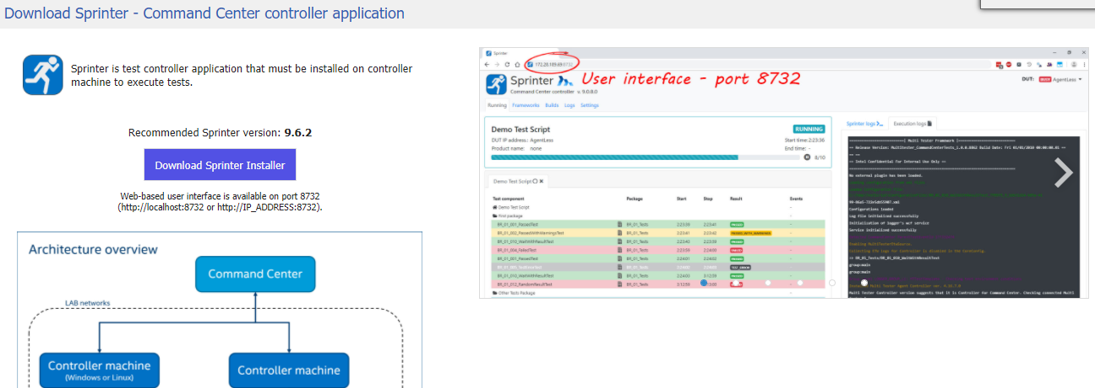

* Add appropriate environment variables under the name – PYTHONPATH, in the system variables rather than user variables.
  + For dtaf_content Framework – “C:\EGS_Automation\dtaf_content”
  + For dtaf_core Framework – “C:\EGS_Automation\dtaf_core\src”
  + For cscripts – “C:\cscripts“
  + For PythonSv - “C:\PythonSV“
  + For Python – “C:\Program Files\Python36\Scripts” – wherever the python installed.

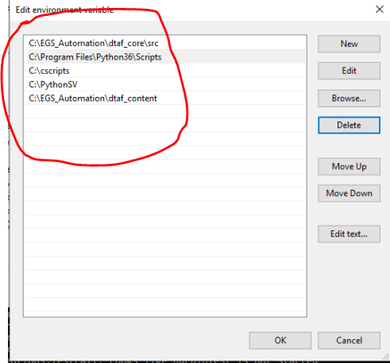

* Copy Banino zip and extract to host under C: drive.
  + \\bdcspiec010\File_Transfer\Automation_status\EGS\banino.zip
  + Refer the below path on how to setup banino dc power and Sx State configuration post hardware connection, configure it as per the below BKM,
    - \\bdcspiec010\File_Transfer\Automation_status\EGS\Banino_bkm.docx
* **DDI** Request – For static IP configuration for both BMC and the Platform – (Send a request mail to “**M, EswarareddyX**”)
* Check for BMC IP address change every time post flashing the full stack .ROM image on BMC, if the IP changed, please update the new ip in system_configuration.xml file.

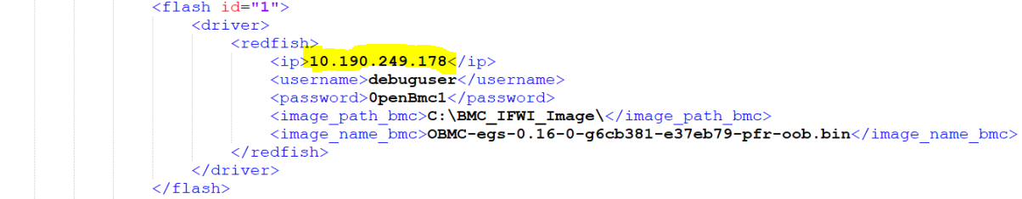

* Create **debuguser** every time post flashing the full stack .ROM image on BMC, for creating the user, open putty and load the BMC_CONSOLE as per the com port configuration you have and log in as **root** user, then run the commands which are in the below BKM file,
  + \\bdcspiec010\File_Transfer\Automation_status\EGS\BMC_create_debuguser_BKM.txt

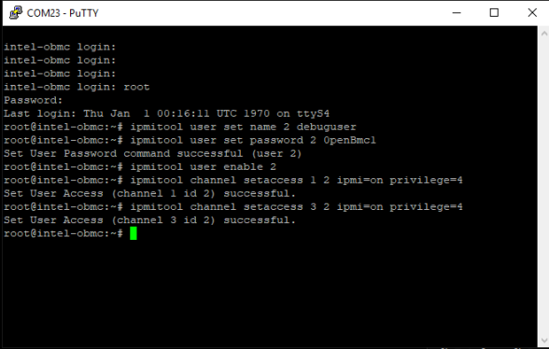

* Putty should always be closed before running the provisioning.

**Issues faced: -**

ITP failure: General checks:

1. Check for proper cable connections on host and SUT.
2. Check PythonSv and Cscripts path set correctly in the environment path.
3. Check PythonSv folder is update to date under C: drive.
4. Check latest Cscripts is placed under C: drive
5. After above checks are performed, still problem persists, restart the host and sut once and then check ITP again.
6. Still persists, cross verify the ITP configuration again by using the below mentioned BKM,
   1. \\bdcspiec010\File_Transfer\Automation_status\EGS\PythonSv_Cscripts_BKM.docx
7. If all are good in terms of configuration, but the problem still there, open terminal and manually start the PythonSV from the below folder and see the error message for your issue.
   1. C:\PythonSV\sapphirerapids
8. If none of the above resolves your issue, please contact the person who configured the ITP device.

Successful OS installation – Result failed:

* This happens when the SUT IP address is not static, after installation OS, IP address might have been changed that resulted in ping failed and the result also failed. Please set the SUT IP static and trigger the installation.

Successful IFWI Flashing – Result failed:

* This happens when the BIOS entry menu is not detected, to resolve this, please restart the host once and try again.
* Flush the serial port and verify serial port number is same as before (mentioned in the sys_configuration.)

PDU did not do power on / off:

* Check the PDU information in the system_configuration.xml
* Provided all the PDU information are correct in the system_configuration.xml, this problem occurs randomly, which we have no control over, so manually open PDU controller from browser and do the power cycle once and start the script again.

BMC flashing failing via Redfish:

* Verify whether **debuguser** has been created or not.
* Check for all the python modules are installed and environment path as set correctly.

Error: Could not find the manifest path:

* Please select the latest framework build and run the test setup again.
* Even after selecting the latest build, the error persists, please contact [blazej.stanisz@intel.com](mailto:blazej.stanisz@intel.com) and command center team.

Error: Due to Software and File Size Limitation FAT32 Format Connect only 32gb or less For Linux OS Installation:

* Connect only 16 or 32 GB USB drive for RHEL OS installation and trigger again.

Sprinter Client Error: Unable to establish communication on port (ex:12344):

* Raise an IT ticket to unblock the port on host device, so that the communication can happen from sprinter to command center.

Sprinter Client Error: Exception occurred while executing test package in EEC:

* Restart the sprinter client, still same exception, restart the host and try again.

SPI BMC/BIOS chip detection issue:

* Flash the latest firmware version and physical connection check.

Spi chip verification fail issue with BMC chip:

* After erase and write, the verification fails, but the flashing happens, so you can ignore this fail.

Banino Usb Switch to SUT Not Happening:

* Physical connection check (probably faulty USB cable)

Banino is not responding after long idle time:

* Banino power adapter unplug and plug it back.

AC power off is not happening but says performed ac power off:

* This is a random issue, please try again.

USB Blaster loses its power after an idle time:

* USB cable unplug and plug it back.

ITP not responding loose power and physical intervention required:

* Remove the ITP power adapter and plug it back.

Host USB port are not powering the instrumentations and other hardwares connected:

* USB powered hub to be connected.

KVM issue Keyboard and mouse not working in SUT:

* Remove the KVM power adapter and plug it back.
* If the problem araise frequently, replace the KVM USB cable or the KVM hardware itself.

CC Timeout – Terminated by Timeout:

* This will happen if you give a shorter timeout for the Test setup execution, so give a maximum timeout that you feel suitable, for example (one day)

SUT did not boot after Flashing:

* Wait for some 30 minutes maximum, still the platform does not boot, probably the platform got stuck in some post code, using usb blaster read the post code and take necessary action.
* If unable to read the post code, and the platform still did not boot, please use PDU and do a power cycle.