Chuan X. Zheng (Tommy)

September 14, 2018

HWK #2

CS591 E2

Chapter 1:

1. Android Virtual Device
2. eXtensible Markup Language
3. valid, invalid, valid, invalid, invalid, invalid, invalid, valid, invalid, invalid
4. abc
5. Hello
6. @string/hi
7. android.support.v7.app
8. true

Chapter 2:

1. Model View Controller
2. Display data to the user, let the user interact with the app, let the user input data
3. RelativeLayout
4. android.view
5. parent
6. android.textColor
7. android.theme
8. android.background=”@color/myColor”
9. android.onClick
10. TextWatcher

25.

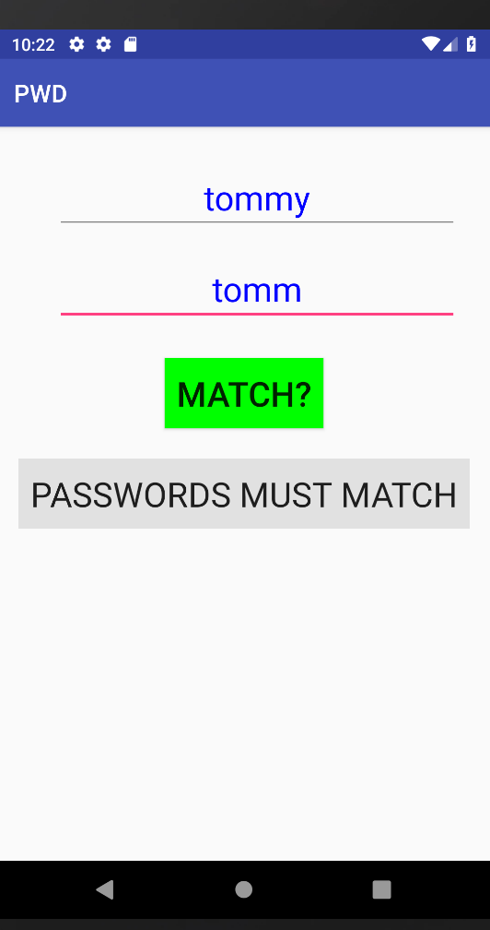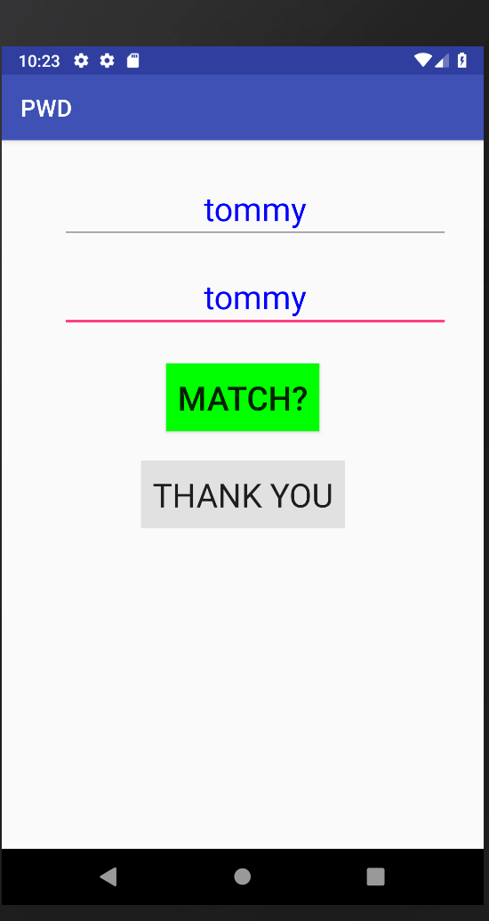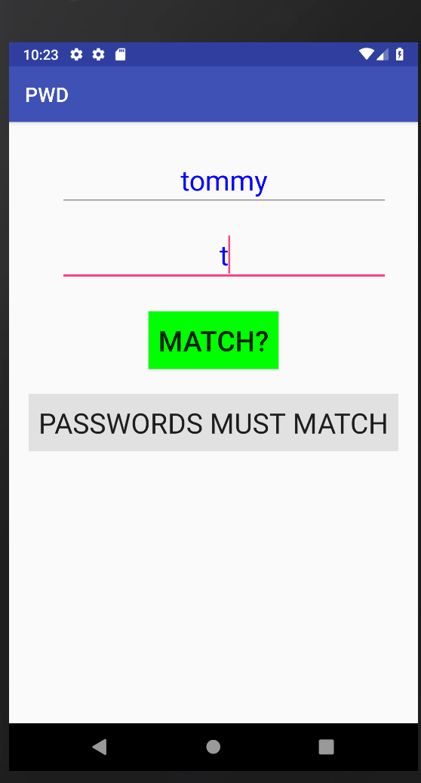

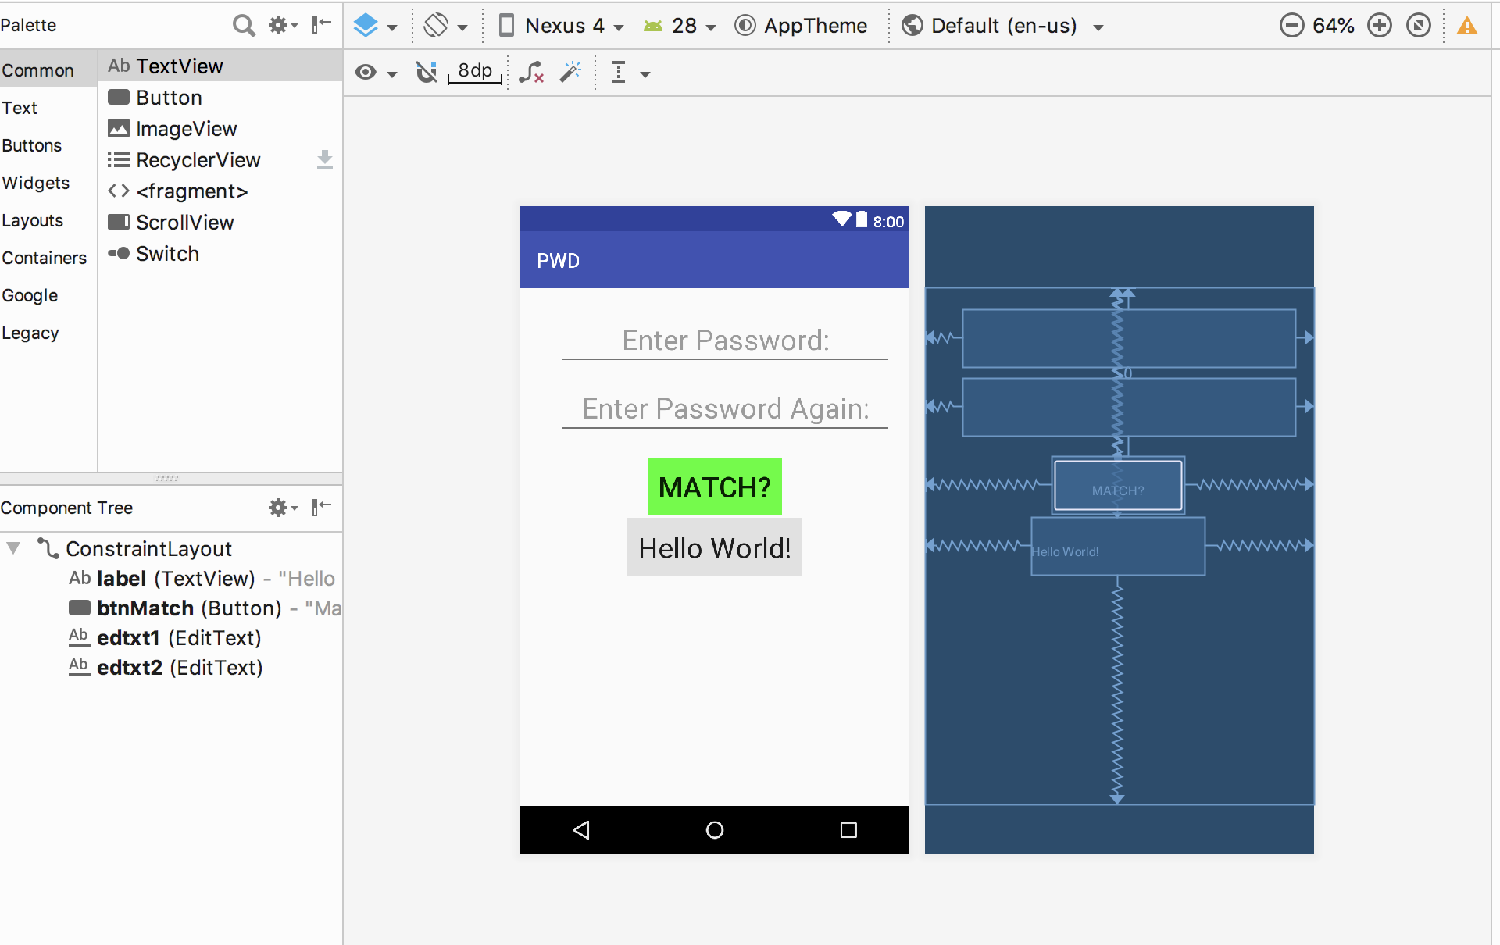

26.

