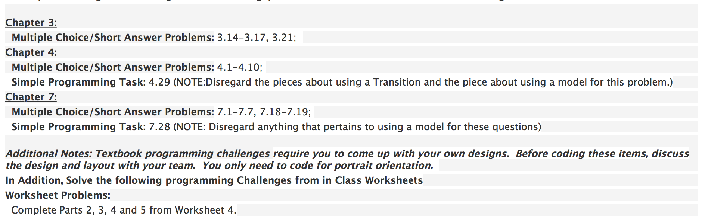

**need to be completed:**

**C4_P29 - done**

**C7 multiple choice - done**

**C7_P28 - done by Judy (got a problem need to be fixed)**

**W4_P2 - done**

**W4_P3 - done**

**W4_P4 - done**

**W4_P5 - done**

Chapter 3

3.14

GridLayout gridLayout = new GridLayout(this);

gridLayout.setRowCount(4);

gridLayout.setColumnCount(2);

3.15

private Button btn = new Button(this);

3.16

private Button btns = new Button[5][2];

for (int row = 0; row < 5; row++) {

for (int col = 0; col < 2; col++) {

btns[row][col] = new Button(this);

}

}

3.17

private Button b = new Button(this);

GridLayout g1 = new GridLayout(this);

gl.addView(b, 200, 200);

3.21

if (v == findViewById(R.id.b)) {

Log.i(“Msg”, “YES”);

}else {

Log.i(“Msg”m “NO”);

}

Chapter 4

4.1 A

4.2 B

4.3 A

4.4 B

4.5 D

4.6 A

4.7 C

4.8 B

4.9 B

4.10 D

Chapter 7

7.1 A

7.2 B

7.3 C

7.4 B

7.5 C

7.6 D

7.7 B

7.18

private GestureDetector detector;

protected void onCreate (Bundle savedInstanceState) {

super.onCreate(savedInstanceState);

GestureAndTapHandler gth = new GestureAndTapHandler();

detector = new GestureDetector(this, gth);

detector.setOnDoubleTapListener(gth);

}

public boolean onTouchEvent(MotionEvent event) {

detector.onTouchEvent(MotionEvent event);

return super.onTouchEvent(event);

}

private class GestureAndTapHandler implements GestureDetector.OnGestureListener,

GestureDetector.OnDoubleTapListener {

// override all 9 methods

}

7.19

private GestureDetector detector;

public boolean onTouchEvent(MotionEvent event) {

detector.onTouchEvent(MotionEvent event);

return super.onTouchEvent(event);

}