## Nano 266

## Lab 2 Report

## Chen Zheng

## A53048780

Q1:

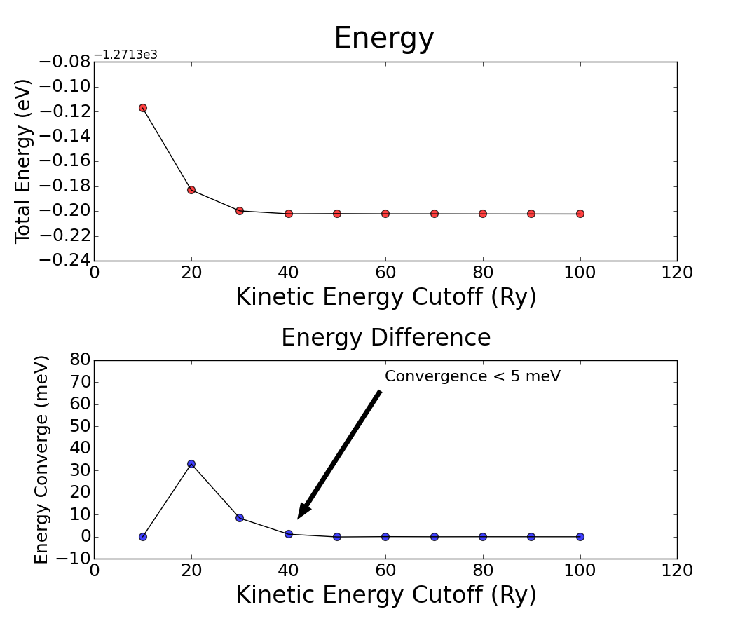

When the energy cutoff increases to higher than 40 Ry, we reached the level of convergence below 5 meV/atom. We see the calculated energy difference drops rapidly initially with increasing of kinetic energy cutoff and than flattened after the energy cut off passes 40 Ry.

Q2

b) With increasing of k-points number, the total energy decreases rapidly at the beginning, and then become stable when the unique K-point number reach 29 (8*8*8 K-point grid setting in input file). Since K-points number is related to number of integrals we need to consider during evaluating the energy in the space, higher density of K-points means we have more points for sampling, and have more accurate results.

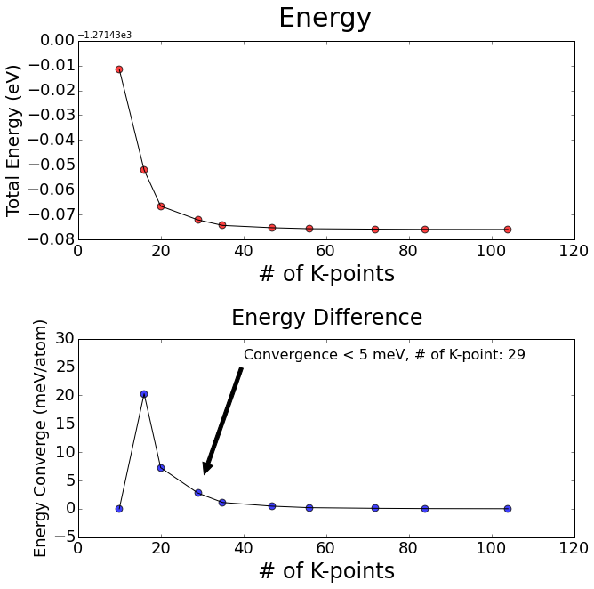

c) The relationship between number of K-points and calculation time is linear as we could see from the below plot, and linear regression model fit their relationship pretty well with slope equals to 0.28 and intercept equals 2.38.

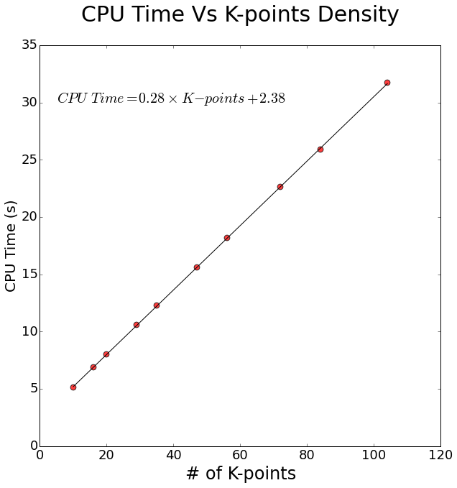

Q3: Convergence of Forces with respect to cutoff energies

From the below graph, with 30 Ry as cutoff energy, we could converged to a good force value within ~10 meV/Angstrom.

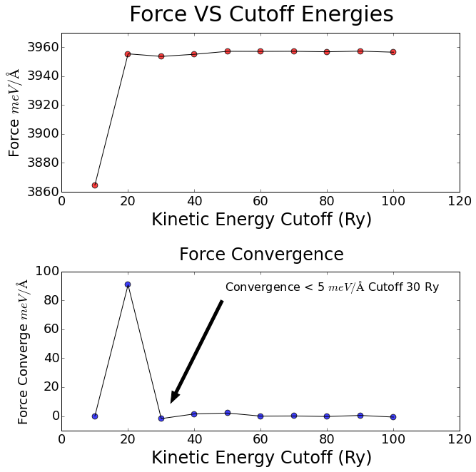

Q4: Convergence of Forces with respect to K-points

To get relative good force convergence, we need K-point grid larger than 9*9*9, with 205 unique K-points. Compared with previous energy convergence, force convergence need more unique K-point for sampling.

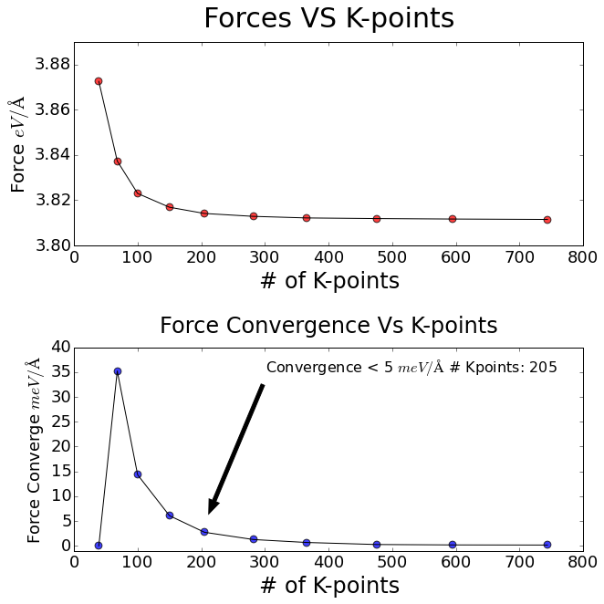

Q5: Convergence of Energy Differences with respect to energy cutoff and K-points.

1. From the below plot, we could conclude that, if we use energy cutoff as 10 Ry, the energy difference will be larger than 30 meV/atom and impossible to converge to lower than 5 meV/atom. While after we increase the energy cutoff to 20 meV/atom, the energy difference convergence much faster than the convergence of absolute energy (e.g. Q3). Low density of K-point (i.e. 6*6*6) is enough for energy difference convergence. In general, the energy difference converges much faster compared with convergence of absolute energy.

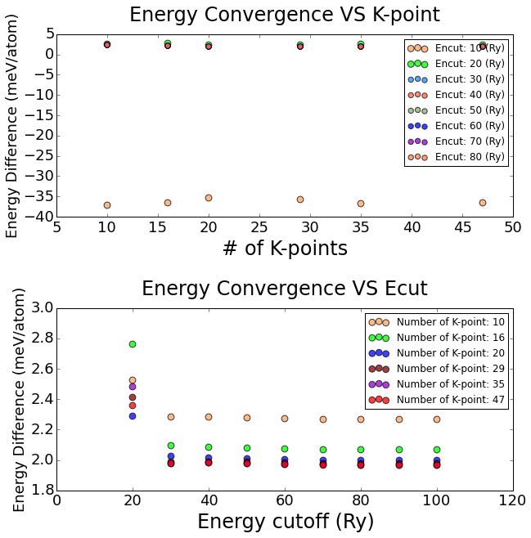

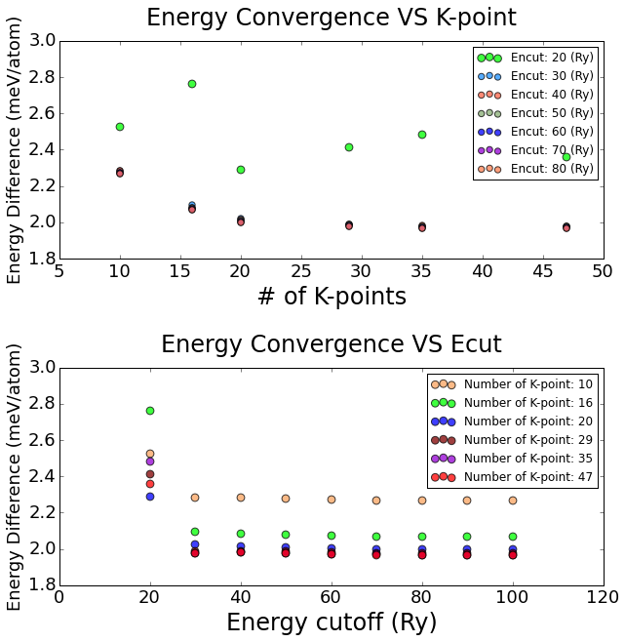

Q6:

Based on preceding question’s result, for absolute energies, forces calculation, 50 Ry as kinetic energy cutoff, 9*9*9 K-points grid size might be the best parameter combinations considering both efficiency and accuracy.

For energy difference calculation, lower energy cutoff and K-point density are enough since the energy difference calculation cancelled out part of DFT systematic error.

Q7: Equilibrium structure

Using 50 Ry as energy cut off, 9*9*9 as K-point density, we obtain the below plot with difference lattice parameter in static calculation. We found that 10.33 a.u is the equilibrium structure lattice parameter which gives us the lowest total energy per primitive cell.

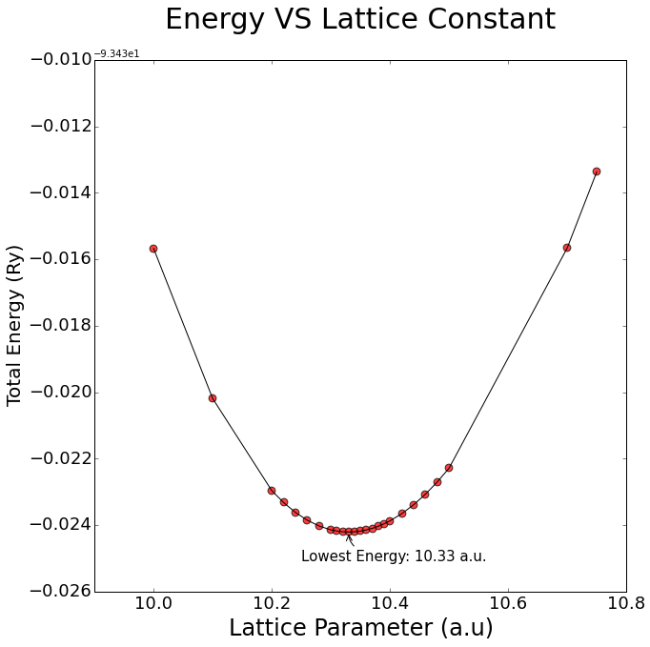

Q8:

Using data we got in Q7, we could use Birch Murnaghan EOS (3rd order) to find the bulk modulus of silicon at the equilibrium lattice constant.

The bulk modulus we got of silicon cell is 89.0 GPa, which is ~8.8% lower than experimental value of 97.6 GPa.

# equation of state: birch 3rd order. chisq = 0.8073D-12

# a0 = 10.3303 a.u., k0 = 890 kbar, dk0 = 4.31 d2k0 = -0.007 emin = -93.45421

# a0 = 5.46655 Ang, k0 = 89.0 GPa, V0 = 275.598 (a.u.)^3, V0 = 40.839 A^3

#########################################################################

# Lat.Par E_calc E_fit E_diff Pressure Enthalpy

# a.u. Ry Ry Ry GPa Ry

#########################################################################

9.50000 -93.39081 -93.39081 0.00000 37.64 -92.84238

10.00000 -93.44567 -93.44567 -0.00000 10.68 -93.26423

10.10000 -93.45019 -93.45019 0.00000 6.96 -93.32839

10.20000 -93.45296 -93.45296 0.00000 3.68 -93.38663

10.22000 -93.45332 -93.45332 0.00000 3.07 -93.39760

10.24000 -93.45362 -93.45362 -0.00000 2.48 -93.40835

10.26000 -93.45385 -93.45385 -0.00000 1.91 -93.41888

10.28000 -93.45403 -93.45403 0.00000 1.34 -93.42920

10.30000 -93.45414 -93.45414 -0.00000 0.80 -93.43931

10.31000 -93.45418 -93.45418 -0.00000 0.53 -93.44428

10.32000 -93.45420 -93.45420 -0.00000 0.27 -93.44920

10.33000 -93.45421 -93.45421 -0.00000 0.01 -93.45407

10.34000 -93.45420 -93.45420 -0.00000 -0.25 -93.45889

10.35000 -93.45418 -93.45418 -0.00000 -0.50 -93.46366

10.36000 -93.45415 -93.45415 -0.00000 -0.75 -93.46838

10.37000 -93.45410 -93.45410 -0.00000 -1.00 -93.47305

10.38000 -93.45404 -93.45404 -0.00000 -1.24 -93.47766

10.39000 -93.45396 -93.45396 0.00000 -1.48 -93.48223

10.40000 -93.45387 -93.45387 -0.00000 -1.72 -93.48675

10.42000 -93.45366 -93.45366 0.00000 -2.18 -93.49564

10.44000 -93.45339 -93.45339 0.00000 -2.63 -93.50434

10.46000 -93.45307 -93.45307 0.00000 -3.07 -93.51284

10.48000 -93.45270 -93.45271 0.00000 -3.50 -93.52116

10.50000 -93.45229 -93.45229 0.00000 -3.91 -93.52929

10.70000 -93.44566 -93.44566 0.00000 -7.46 -93.60091

10.75000 -93.44337 -93.44337 -0.00000 -8.19 -93.61623

Q9:

Using LDA pseudopotential and redo the equilibrium calculation Q7, we found that the equilibrium lattice parameter changed with lower overall total energy. The equilibrium lattice parameter now becomes 10.21 a.u. The equilibrium lattice parameter predicted to be lower than in GGA due to LDA’s well-known overbinding problem with lead to lower bond length, lattice parameter and atomization energies prediction. The overbinding also leads to an energy overestimating by 4% compared with GGA.

While we could conclude that evaluating bulk modulus using LDA give better agreement with experimental data.

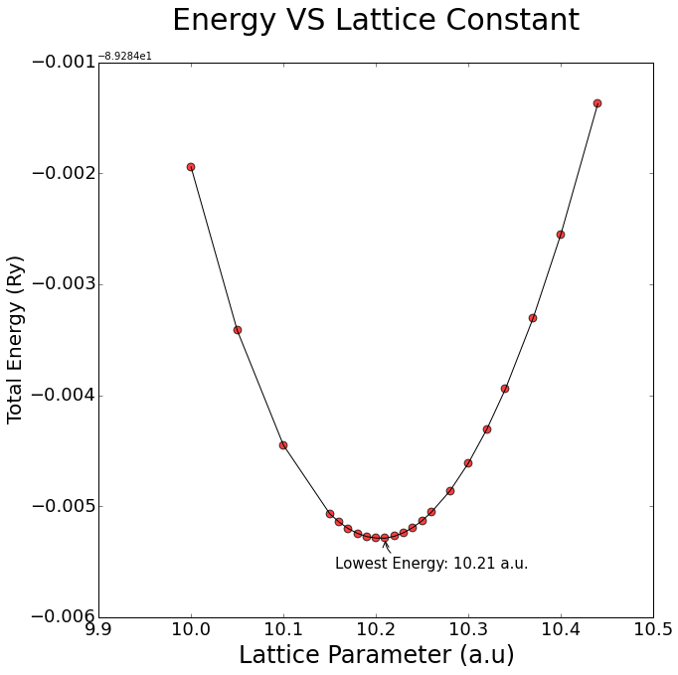

We could use Birch Murnaghan EOS (3rd order) to fit the data. The bulk modulus of silicon at the equilibrium lattice constant.

The bulk modulus we got of silicon cell is 96.9 GPa and very close to the experimental value 97.6 GPa, and is only ~0.72% lower.

# equation of state: birch 3rd order. chisq = 0.1586D-11

# a0 = 10.2037 a.u., k0 = 968 kbar, dk0 = 4.23 d2k0 = -0.006 emin = -89.28929

# a0 = 5.39957 Ang, k0 = 96.9 GPa, V0 = 265.592 (a.u.)^3, V0 = 39.357 A^3

#########################################################################

# Lat.Par E_calc E_fit E_diff Pressure Enthalpy

# a.u. Ry Ry Ry GPa Ry

#########################################################################

9.50000 -89.24235 -89.24235 0.00000 32.32 -88.77149

10.00000 -89.28594 -89.28594 0.00000 6.66 -89.17284

10.05000 -89.28742 -89.28741 -0.00000 4.85 -89.20367

10.10000 -89.28845 -89.28845 -0.00000 3.17 -89.23300

10.15000 -89.28907 -89.28907 0.00000 1.59 -89.26088

10.16000 -89.28914 -89.28914 0.00000 1.28 -89.26629

10.17000 -89.28920 -89.28920 0.00000 0.98 -89.27164

10.18000 -89.28924 -89.28925 0.00000 0.69 -89.27694

10.19000 -89.28927 -89.28928 0.00000 0.39 -89.28218

10.20000 -89.28929 -89.28929 0.00000 0.11 -89.28737

10.21000 -89.28929 -89.28929 -0.00000 -0.18 -89.29251

10.22000 -89.28927 -89.28927 -0.00000 -0.46 -89.29759

10.23000 -89.28924 -89.28924 -0.00000 -0.74 -89.30262

10.24000 -89.28919 -89.28919 -0.00000 -1.01 -89.30759

10.25000 -89.28913 -89.28913 0.00000 -1.28 -89.31252

10.26000 -89.28905 -89.28905 0.00000 -1.54 -89.31738

10.28000 -89.28886 -89.28886 -0.00000 -2.06 -89.32697

10.30000 -89.28861 -89.28861 -0.00000 -2.57 -89.33635

10.32000 -89.28831 -89.28830 -0.00000 -3.06 -89.34553

10.34000 -89.28794 -89.28794 -0.00000 -3.54 -89.35451

10.37000 -89.28731 -89.28731 0.00000 -4.24 -89.36761

10.40000 -89.28655 -89.28655 0.00000 -4.90 -89.38027

10.44000 -89.28537 -89.28537 0.00000 -5.75 -89.39651

10.48000 -89.28400 -89.28400 0.00000 -6.54 -89.41201

10.50000 -89.28324 -89.28324 -0.00000 -6.93 -89.41949