COMSW4111_003_2024_3 - INTRODUCTION TO DATABASES

Homework 2A

Submission Instructions
Please see Ed discussions.

Understanding Concepts
- Brieﬂy explain the concepts of “top-down” and “bottom-up” data modeling.

- What are two reasons it is necessary to use an associative entity to implement a relationship set/relationship between entities.

- Brieﬂy explain the concepts of the degree of a relationship/relationship set, and the cardinality of a relationship.

- A theta-join is of the form 𝑟⋈𝜃 𝑠, where r and s are relations (tables). What is an equivalent relational algebra statement that only uses π, σ, ⨯, 𝖴, -, ρ. Your answer may not need to use all the operators.

- Consider a domain for an attribute/column in which the possible values are in the range 0.00 to 99.99, and there can only be two digits after the decimal point. What SǪL data type would you use?

- Consider the create table statement below, which columns could be the primary key in a MySǪL database and why?

create table if not exists course_management.students_ﬁxed (
CU_id int not null, uni varchar(12) null,

email | text | not null,
ﬁrst_name | text | null,
last_name | text | null,
middle_name | text | null
);

- Why does using a natural join sometimes produce incorrect results or results that do not make any sense?

- Some SǪL database management systems do not implement the full outer join operation. Describe how to write an equivalent query to a full outer join using other SǪL capabilities.

- SELECT statements and UNION statements behavior diberently with respect to duplicates in a result set. Brieﬂy explain the diberences. How can you make SELECT and UNION behave the same with respect to duplicates.

- Explain the concept of “arity” in SǪL statements.

- Explain the concepts of overlapping, disjoint, complete and incomplete when modeling inheritance/specialization in ER-modeling.

- Consider the diagram from the lectures slides for our course.

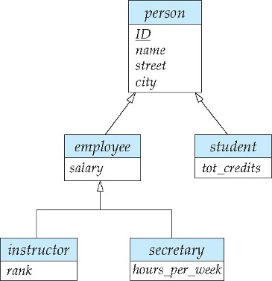
Draw the equivalent Crow’s Foot Notation diagram. You may have to add/extend

Crow’s Foot for your diagram. You can use notes or text to explain your extensions.

- For the sample data associated with course textbook, the relational expression
course ▷ prereq returns courses without prereqs.
  - Provide an equivalent query that does not use anti-join.
  - Provide a query that uses anti-join to return courses that are not prereqs.

You can just provide the statements. You do not need to execute them.

- In the lecture, we discussed three motivations for using views. List and brieﬂy explain the motivations/use cases.

- What is a materialized view? What is one advantage, and one disadvantage of a materialized view compared to a non-materialized view.

