GCtfFind User Manual

Written by: Shawn Zheng, Biohub
Email: szheng@czii.org
Date: July 10, 2026
Version: 1.1.8 and 1.2.0
GCtfFind is a GPU accelerated software application for fast and accurate CTF estimation of cryoEM micrographs and cryoET tilt series. Inspired by the widely adopted CTFFind software developed in the Grigorieff lab, GCtfFind has been developed with a significant effort dedicated to CTF estimation of cryoET tilt series, where individual tilt images typically exhibit substantially lower SNRs than cryoEM single-particle micrographs. Fig. 1 illustrates the CTF estimation on three tilt images of a cryoET tilt series collected from a cryoFIB lamella approximately 200 nm thick.
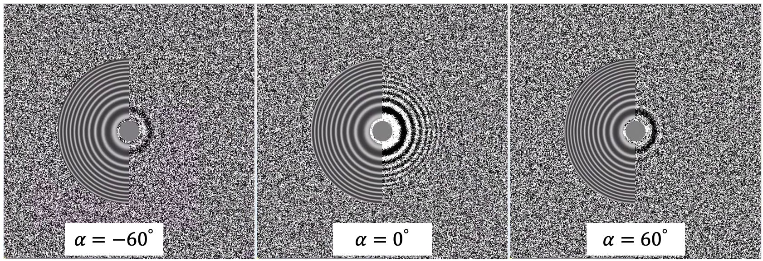
Fig. 1 CTF estimation for three representative tilt images from a tilt series collected with a total electron dose of 130 $e/{Å^{2}}$. The electron dose per tilt was 2.13 $e/{Å^{2}}$.
GCtfFind provides a batch processing mode for automated estimation over a large set of cryoEM micrographs. This functionality exempts users from writing scripts, facilitating convenient and fast processing large sets of micrographs. A Imod compatible file is generated when GCtfFind is applied to a cryoET tilt series and can be imported into RELION subtomo averaging pipeline without any modification.
GCtfFind does not require initial input to determine defocus and astigmatism. It automatically determines search ranges based upon user input at the command line.
GCtfFind 1.1.8 and later versions added options to let users specify the search ranges for defocus, astigmatism, and extra phase shift, and can estimate CTF parameters for overfocused micrographs.
It is important to note that the command line options in versions 1.1.8 and 1.2.0 are significantly different from those in the earlier versions. Please refer to the earlier user manuals if you are use earlier versions.

1 System Requirement and Installation
GCtfFind is a Linux application written in C++/CUDA. It runs on a Linux platform equipped with a state-of-art Nvidia GPU. GCtfFind is open source and can be downloaded from Github using the following command at the prompt in a terminal window:
git clone https://github.com/czimaginginstitute/GCtfFind.git
This command creates the GCtfFind directory containing the downloaded source code. This directory contains two make files, makefile12 and makefile12 for Cuda 12.x and Cuda 13.x separately. Users can use nvcc --version to find out the version installed on your system. The following is the result displayed by this command:
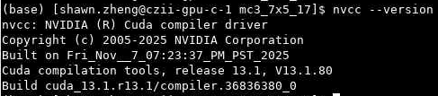
If the toolkit is not installed or the PATH environment variable is not properly configured, “nvcc: command not found” will be displayed. When this happens, try run “module load cuda/12” or “module load cuda/13” first if you install the package on a HPC cluster. If you install it on a Linux workstation, the path variable can be configured in .bashrc or .cshrc files.
Users need to revise the path variables defined these two makefiles. The following screenshot shows the settings of these variables based on my system setup:
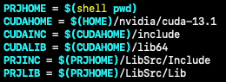
Users need to change the settings for CUDAHOME, CUDAINC, and CUDALIB. Once you find the path of the installed CUDA toolkit, check the CUDA directory for include and lib64 directories. If they are there, you do not need to change CUDAINC and CUDALIB.
Users need to make sure g++ compiler is installed. This can be checked by running “g++ --version” at the command line.
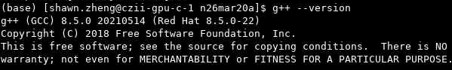
To generate the executable file of GCtfFind, run “make exe -f makefile12” for CUDA 12.x installation or “make exe -f makefile13” for CUDA 13.x. If you want to clean up or recompile, run “make clean -f makefile12” or “make clean -f makefile13”.
You may encounter a compiler error “can not be used when making a PIE object; recompile with -fPIE.” This is because the provided libmrcfile.a and libutil.a are not compatible with your system setting. Recompiling them should solve the problem. The source code of these two modules are Mrcfile and Util directories, respectively, in GCtfFind/LibSrc directory. In each directory, run “make clean” followed by “make all”. Once completed, recompile GCtfFind one more time as described earlier.
To test whether the compilation is successful, run “GCtfFind --version” and the following screenshot is what should be displayed.
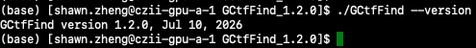
To display the online help information, run “GCtfFind --help” and the following information snippet should be displayed.
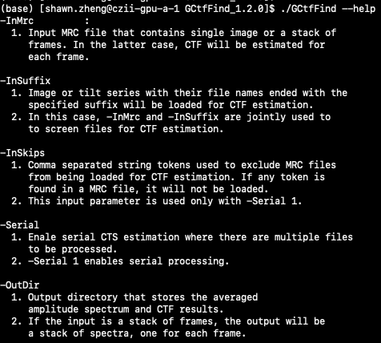

2 Processing A Single Micrograph
The following screenshot shows the command-line parameters for CTF estimation on a micrograph collected with a dual-cavity laser phase plate. The micrograph is stored in MRC format, which is currently the only input format supported by GCtfFind.
In this example, -InMrc specifies the path to the input MRC file. -OutDir specifies the output directory, where GCtfFind saves a text file containing the estimated CTF parameters and a diagnostic MRC file for visual inspection of the CTF fitting results.
-PixSize specifies the pixel size of the input micrograph in angstrom. -Kv provides the microscope acceleration voltage in kV, and -Cs specifies the spherical aberrartion constant.
-Defocus requires two values to define the defocus search range. The first one specifies the central defocus, and the second specifies the search range around the central value. Both values are expressed in angstrom. Note that the search is limited with this range and will go beyond it. In the following example, GCtfFind searches from -25,000 $Å$ (overfocus) to +25,000 $Å$ (underfocus) for the best defocus value.
-AstRatio also requires two values to define the search range for the astigmatic ratio. The first value specifies the central value, and the second is the range around that central value. “-AstRatio 0.05 0.1” means to search from 0 to 0.1 for the astigmatic ratio, which is defined as follows. Note that ${|f}_{max}|$ > |$f_{min}|$ regardless of whether the defocus is overdefocus or underdefocus.
$$ast_{ratio}=\left|\frac{f_{max}-f_{min}}{f_{max}+f_{min}}\right|$$
-AstAngle uses the central value and the span to define the search range for the azimuth angle of the astigmatism.
-ExtPhase requires two values to define the search range for the extra phase shift induced by the phase plate. These values are expressed in degree. In this example, “-ExtPhase 70 140” means to search the optimal phase shift within the range of 0° to 140°.
Note: if the second value for -Defocus, -AstRatio, -AstAngle, or -ExtPhase is set to zero, GCtfFind uses the first value as a fixed parameter without performing a search for that parameter.
The output files include CTF.txt and a diagnosis MRC file named after the input MRC file with _CTF inserted immediately before the input file name extension (.mrc). The three diagnostic images shown in Fig. 2 suggest that GCtfFind can deliver reliable CTF estimation for micrographs collected at low and overfocus settings and different phase shift.
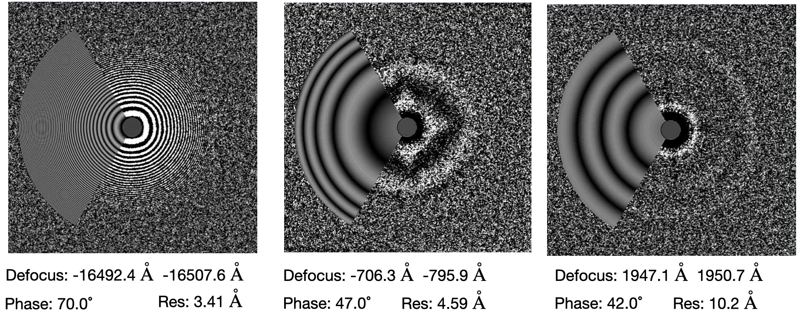
Fig. 2 Diagnostic images showing that GCtfFind delivered reliable CTF estimation from micrographs collected with overfocus and low defocus settings and different extra phase shifts.

3 Batch Processing Mode
GCtfFind can process all the micrographs in a directory in a single run provided they are collected at the same magnification. This mode is enabled by setting -Serial 1. In this mode, GCtfFind loads all the file names from the specified directory provided after -InMrc. Since the provided directory may contain files that are not micrographs, GCtfFind provides -InSuffix and -InSkips to help screen for the micrograph files. The following screenshot illustrates a batch processing example.
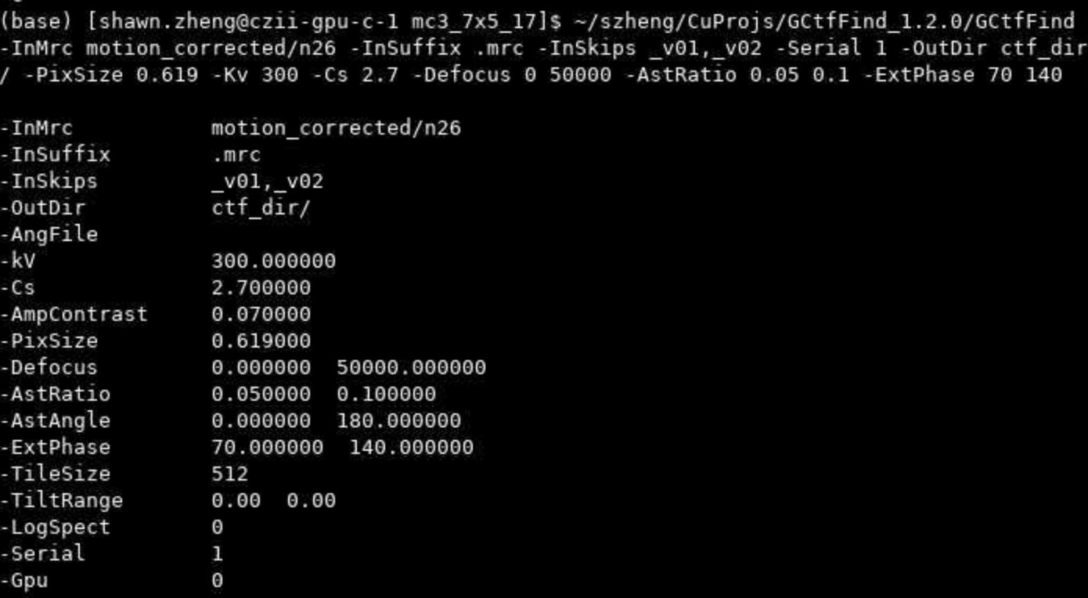
The combination of -InMrc, -InSuffix, and -InSkips in this command instructs the program to load only MRC files from motion_corrected directory whose filenames begin with n26, while excluding any files whose names contain either _v01 or _v02. Note that the tokens behind -InSkips are separated by commas not whitespaces.

4 Processing MRC Tilt Series
Given a MRC file, GCtfFind reads its header first. If there are multiple images in that file, GCtfFind starts tilt series processing mode. the estimation starts from the zero-tilt image if the tilt angles can be found in the MRC file extended header. Otherwise, the middle image will be estimated first.
GCtfFind estimates the per-tilt defocus, astigmatism, and phase shift only for images collected within a low-tilt range. For images beyond this range, where the SNR decreases, GCtfFind estimates only the defocus. The astigmatisms and phase shifts for these high-tilt images are assigned with the values estimated from the nearest low tilt image.
Users can pass the tilt angles to GCtfFind using a single column text file using -AngFile.

5 Plots of CTF estimation score versus tilt angle
We have found the plot of CTF estimation score versus tilt angle is quite informative. The plot can reveal what the data collection scheme is used if such information is lost for some reason. Fig.2 shows a pair of plots, one for dose-symmetry scheme, one for two-branch scheme.
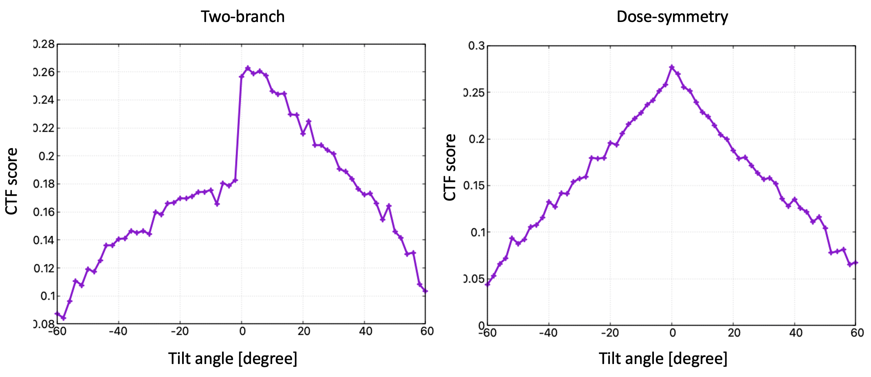
Fig. 3 Plots of CTF estimation score versus tilt angle can reveal data collection scheme.

