GMSr Pipeline

Contracts:
- Main: search & navigation (cfr. screenshot)
- possibility to search directly in 'Framework Contracts', 'Amendments', 'Specific Contracts' and 'Orders'
- possibility to retrieve the other linked data from a selection in one of the search results

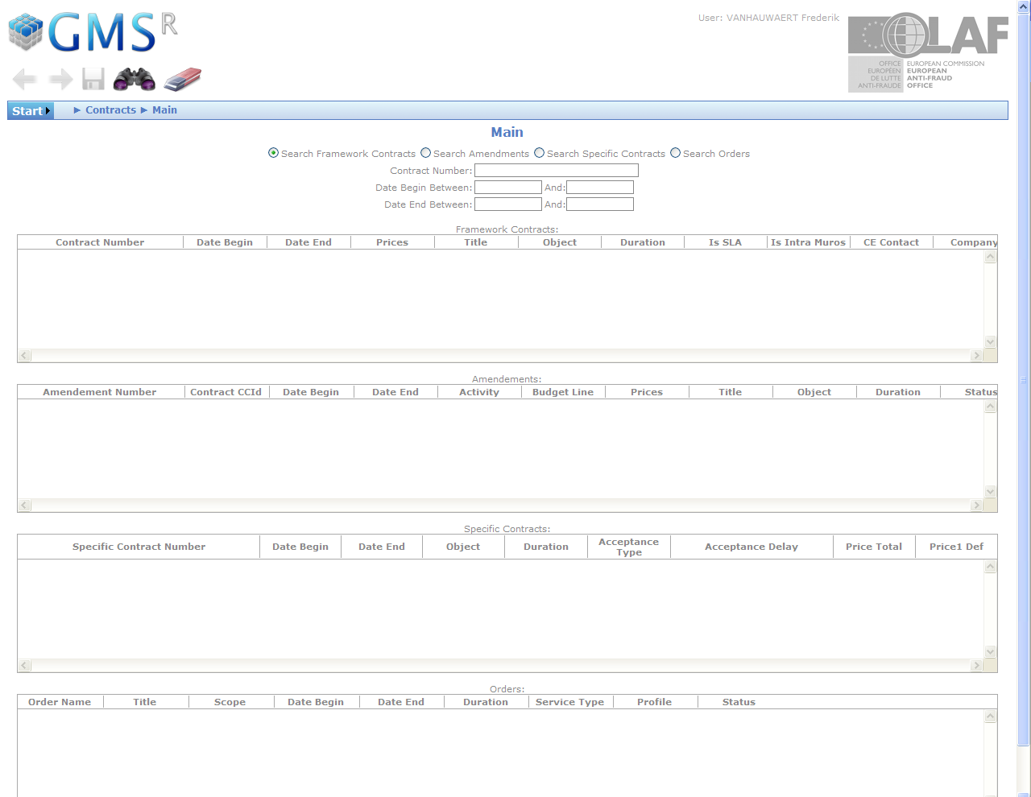

Software:
- improve 'In Use' because the comboboxes have to many items to be used fluently with IE7
- add an easy way to retrieve the available licenses of a certain product to 'Main'
- add search possibilities to retrieve licenses by user and filter by whether the licenses are available or not

Users:
- add useful linked data:
- to be discussed with Ramon's team and other end users of that section
- add export to excel of all related data so there is a printer friendly layout

Hardware:
- add useful linked data:
- to be discussed with Ramon's team and other end users of that section

Services:
- to be discussed & analyzed

General
- create Unit Tests for the Business Logic Layer to improve stability and monitoring
- refactoring to improve maintainability

