

Technical Documentation

August 2011

About this document

This document is intended for (.NET) software developers & engineers. It describes the GMSr application in a top down fashion. Focus is on high-level and relatively time independent aspects. More low level documentation is part of the code base.

Table of Contents

Technical Documentation 1
About this document 2
Table of Contents 2
1. Tools & Technologies 3
2. Application Architecture 3
3. Methodology 4
4. GMSr directory structure 5
5. Visual Studio Solution structure 6
5.1. Gmsr project 6
5.2. GmsrBLL project 7
5.3. GmsrDAL project 9
5.4. GmsrServices project 10
5.5. GmsrTest project 10
6. Closer Look 11
6.1. Naming conventions 11
6.2. Role Based Security 11
6.3. GUI Layout & Styling Principles 11
6.4. Event Logging 12
6.5. Audit Trailing 13
6.6. Open Sessions 13
6.7. Session Logging 14
6.8. Generic Repository 14
6.9. Unit Testing (with Fake Repository) 15
6.10. Other 15
7. Data Models 16
7.1. DataModel mapped to GMS 16
7.2. DataModel mapped to GetSmc 16
8. Database 17
8.1. Menu 18
8.2. Software 19
8.3. Product Backlog 19
8.4. Audit Trailing 20
8.5. Error Logging 20
9. Web Server 21
10. Deployment 22
10.1. Manual Deployment 22
10.2. Automated Deployment 23
11. Monitoring 23

Tools & Technologies
The development environment consists of the following tools and technologies:

- Visual Studio 2010 (Ultimate)
- C#
- ASP.NET 4.0
- ADO.NET 4.0 Entity Framework
- WCF
- AjaxControlToolkit
- Subversion
- TortoiseSVN
- AnkhSVN
- SQL Server (2000)/ 2005 / 2008
- OpenXml
- (Visual Studio) Unit Testing Framework

- Additional / Optional:
- Gimp
- Fiddler Web Debugger

The web application targets Internet Explorer 7/8/9.

Application Architecture
GMSr has a typical n-layered application architecture with a presentation layer (PL), business logic layer (BLL), data access layer (DAL) and data layer.

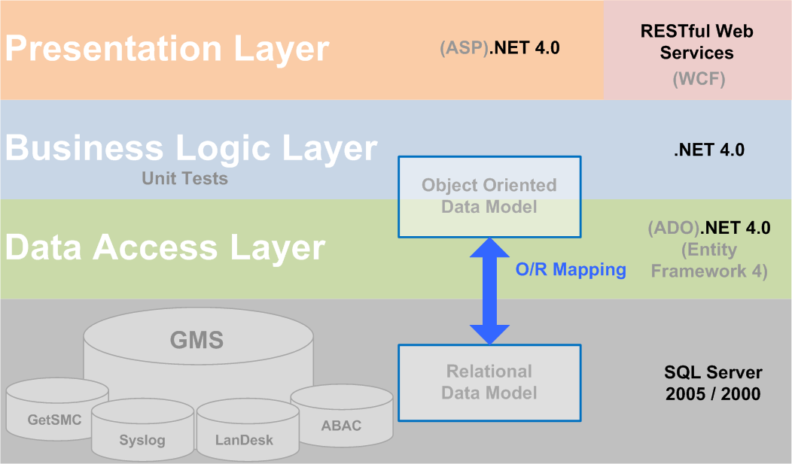

The 'GMS' sql server database plays the main part in the data layer. It contains the GMSr users, groups, menu elements, event logging, audit trailing, session logging and (scrum) backlog. In the DAL the entity framework takes care of the object relational mapping. The object oriented data model is exposed to the business logic layer via a generic repository. The unit tests focus on the BLL and use a fake generic repository from the DAL. In the PL, visual stuff like layout, styling and presentation logic is build with ASP.NET webforms. GMSr also exposes business logic through RESTful Web Services, implemented with Windows Communication Foundation (WCF). Up until the moment of writing, the webservices have not reached production.

Methodology
GMSr is build following an agile methodology. This lightweight incremental iterative method helps responding to unpredictable circumstances.

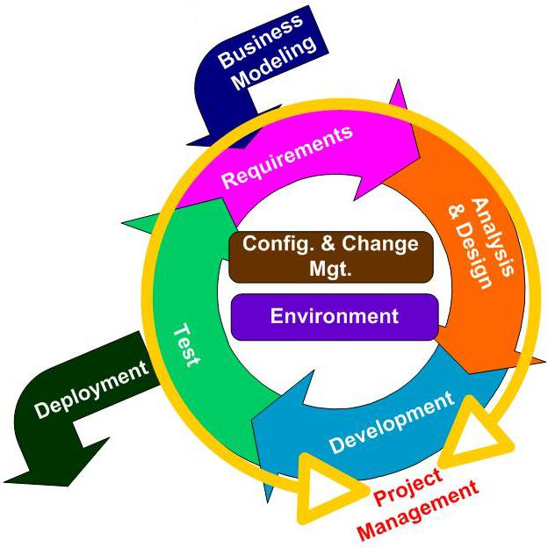

The agile methodology is applied following the scrum approach. We have a backlog and sprints of about 30 days.

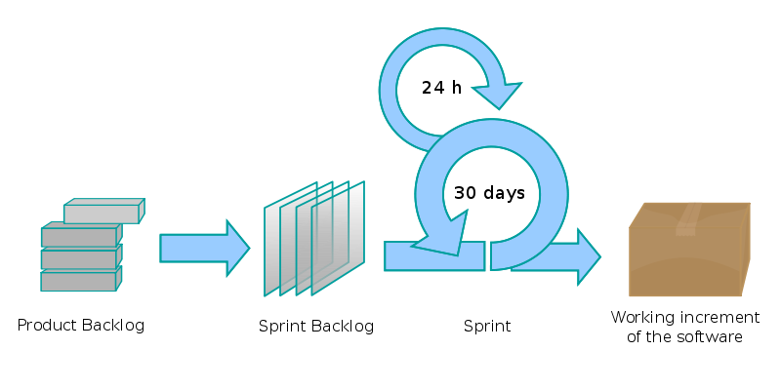

GMSr directory structure
All GMSr sources (including code base, documentation, downloads, tools, …) are organised in one folder structure which is under version control (Subversion).

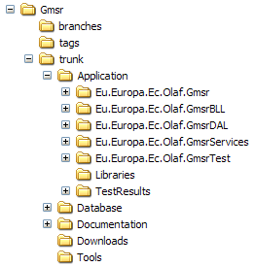

Let's walk through the structure:
- branches, tags and trunk represent the typical subversion folders.
- Application contains the VS2010 Solution with the project folders.
- Libraries contains the external dll's that are used by GMSr.
- Database contains T-SQL scripts and other database related stuff.
- Documentation contains all GMSr related documents including the one you are reading now.
- Downloads contains the downloaded installation files of e.g. toolkits that are used by the code base.
- Tools contains tools like e.g. a configured performance monitor (GMSrMonitor.msc).

Visual Studio Solution structure
If you open the solution in Visual Studio, you will see that it contains five projects: Gmsr, GmsrBLL, GmsrDAL, GmsrServices and GmsrTest.

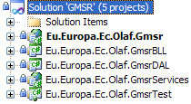

Gmsr project
This project represents the presentation layer.

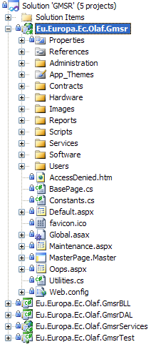

Let's walk through this project structure:
- Administration contains the GMSr administration webforms.
- App_Themes contains the common styling of the site like fonts, colours, default control widths, borders, …
- Contracts contains the contracts related webforms.
- Hardware contains the hardware related webforms.
- Images contains all images used by the website.
- Reports contains the report webforms.
- Scripts contains the jquery javascript libraries.
- Services contains the services related webforms.
- Software contains the software related webforms.
- Users contains the olaf users related webforms.
- AccessDenied.htm is displayed when the user tries to access a part of the site without permission.
- BasePage.cs is the base class for most of the webform classes.
- Constants.cs contains constant declarations.
- Default.aspx(.cs) is the default web form (home) that is displayed when no specific menu item has been selected.
- favicon.ico defines the GMSr icon that's displayed on e.g. the address bar and the tab of the browser.
- Maintenance.aspx(.cs) replaces web forms that are not accessible due to maintenance.
- MasterPage.Master(.cs) is the asp.net master page that provides the GMSr standardized look (e.g. header, menu and footer) across all pages. The code behind takes care of the authentication, menu content and authorization. It also contains the javascript for e.g. client-side sorting, loading animation, modal popup, cube animation, …
- Oops.aspx(.cs) is displayed when an unexpected error occurs.
- Utilities.cs contains several handy site wide methods like e.g. the export to excel.
- Web.config is the typical configuration file with e.g. the connection strings and the asp.net health monitoring configuration.

GmsrBLL project
This project represents the business logic layer.
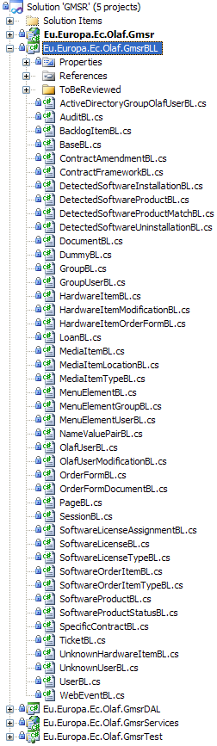

This project contains the business logic classes (***BL.cs). In many cases such a class is mapped to a certain (entity framework) entity of one of the datamodels (.edmx files) in the DAL. But it can also be mapped to multiple different entities of multiple different datamodels. Or it can even have no mapping with an entity at all. Typically it contains Save, Delete and Select methods to manipulate its data. Getxxx static methods retrieve data of the type xxxBL. These methods are implemented via (object oriented) queries that make use of the generic repository. Whether it's the real or fake repository that is used depends on which repository factory is being used. The RepositoryFactory is a property that all business logic classes inherit from their base class BaseBL.cs. The ***BL classes also typically contain mapping methods to map their properties with properties of one or more entities. The ToBeReviewed folder contains business logic classes that first have to be reviewed (e.g. is the design inline with object oriented principles and inline with the naming conventions) before they become part of the root of the BLL project.

GmsrDAL project
This project represents the data access layer.

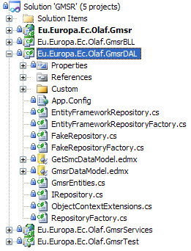

Let's walk through this project structure:
- Custom contains all DAL code that does not use the entity framework.
- App.Config contains the connectionstrings needed to synchronise the data models with the corresponding databases.
- EntityFrameworkRepository.cs contains the implementation of the (real) generic repository.
- EntityFrameworkRepositoryFactory.cs is the factory of the (real) generic repository.
- FakeRepository.cs contains the implementation of the fake generic repository.
- FakeRepositoryFactory.cs is the factory of the fake generic repository.
- GetSmcDataModel.edmx is the data model mapped to the GetSmc database.
- GmsrDataModel.edmx is the data model mapped to the GMS database.
- GmsrEntities.cs is the partial class of the one that is generated by the Entity Framework. It's here that we implement the audit trailing.
- IRepository.cs is the interface of the generic repository.

- ObjectContextExtensions.cs is just used by EntityFrameworkRepository.cs.
- RepositoryFactory.cs is the abstract base class for both EntityFrameworkRepositoryFactory.cs and FakeRepositoryFactory.cs.

GmsrServices project
This project contains the RESTful web services.

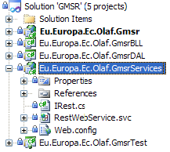

Let's walk through this project structure:
- IRest.cs contains the service and data contract of the (ticket) services.
- RestWebService.svc(.cs) uses the BL (just as the PL) to implement the IRest interface.
- Web.config is the typical configuration file with the endpoint settings like address, binding and contract.

GmsrTest project
This project contains the unit tests.

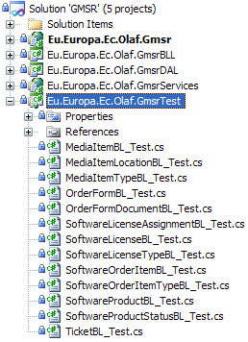

- Every ***BL_Test.cs file represents a test class for the corresponding ***BL.cs business logic class.

Closer Look

Naming conventions
We follow the industry-accepted standard naming conventions for C#.

Role Based Security
The content of the menu for a certain user determines the access level. The menu content is defined by a set of menu elements. This set of menu elements is composed based on the groups the user belongs to combined with the menu elements assigned directly to the user. Assigning menu elements directly to a user should only be done for exceptions because it's less maintainable.
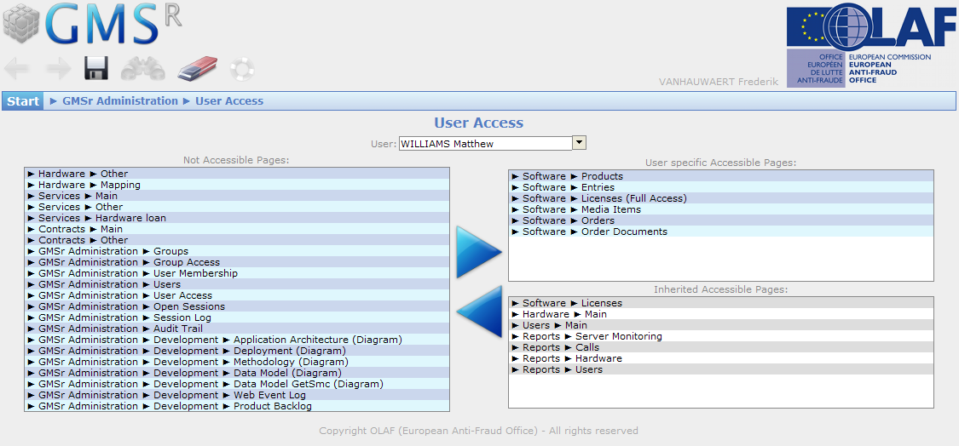

GUI Layout & Styling Principles
When you resize the browser window, you will see that all controls (except the header) are centered horizontally. Stuff that's clickable or important in the current context, is displayed in a way that catches the attention, e.g. in full colour instead of grayed out. For example normal labels are displayed in gray since these only provide some extra information. The data itself however is in the more contrasting black or blue. Multiple grids with data on the same page are presented each with their own background colors. That makes it easier to recognize the different meanings of data.
Only the relevant icons in the header on the left (we call them 'ActionButtons') are in full color. The OLAF logo can be blue, red or gray depending on whether you are looking at the production, test or development GMSr application.
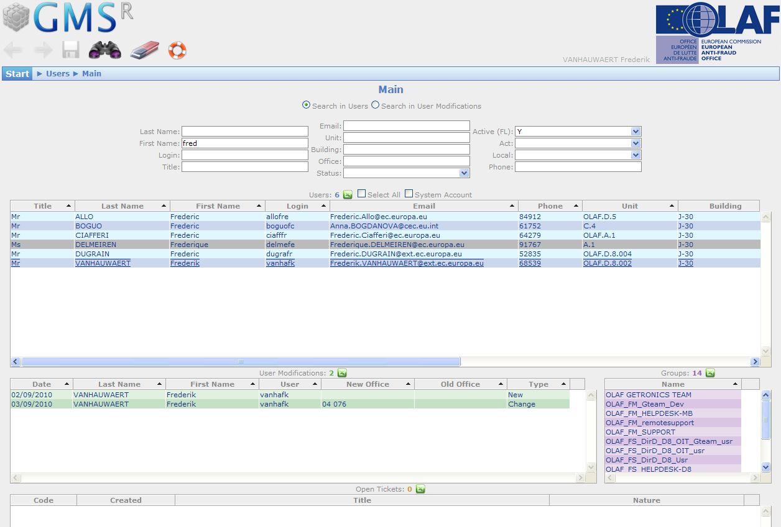

Event Logging
We use the asp.net health monitoring. The event mappings, providers, rules,… are defined in the web.config.
Under GMSr Administration > Development > Web Event Log, you can explore this logging. Click any item to retrieve its details. The errors are displayed in red. 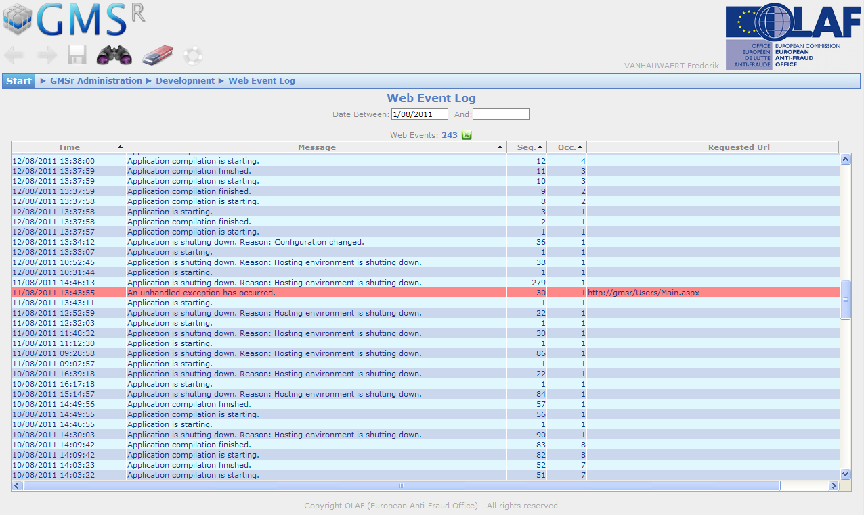

Audit Trailing
The audit trailing data is created generically for all entities of the GmsrDataModel.
Under GMSr Administration > Audit Trail you can find the audit trail. It contains the modifications done in GMSr. Green audit items represent additions to the database, the red items are removes and the blue ones are updates. By clicking an item you will find further details.

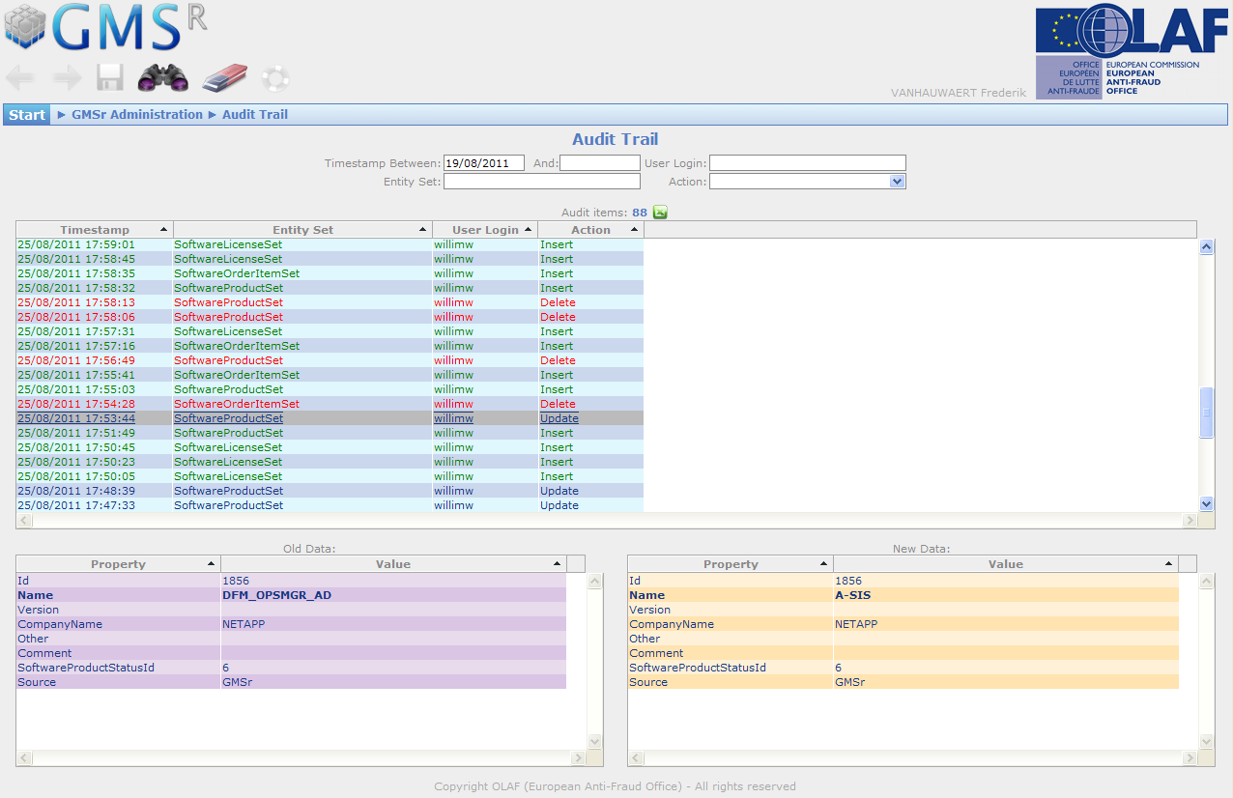

Open Sessions
Under GMSr Administration > Open Sessions you can find the current open sessions. Especially before executing a deployment, this can be very useful.

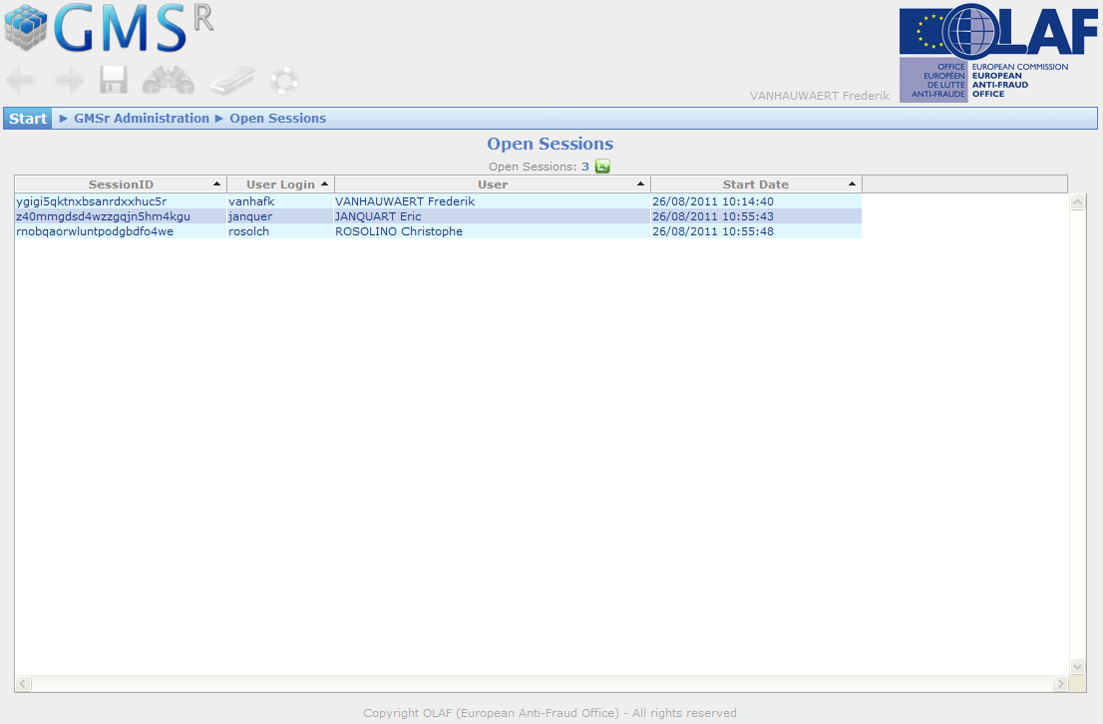

Session Logging
Under GMSr Administration > Session Log you will find the logging of the sessions.

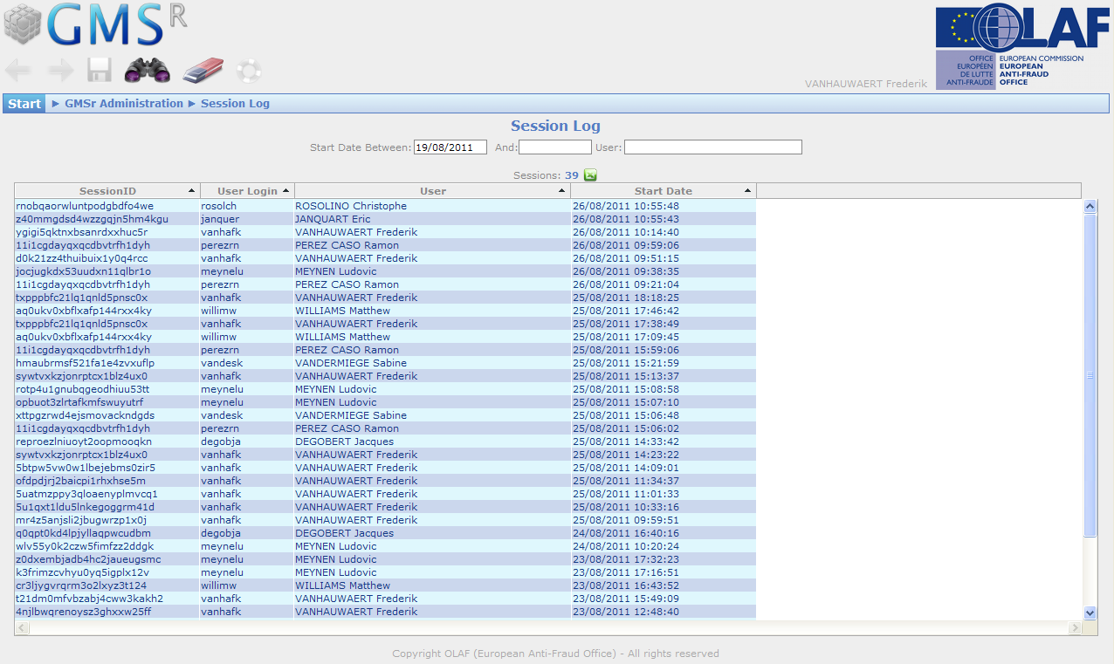

Generic Repository
All business logic GMS database operations should use the generic repository. Below you will find the interface of the generic repository.
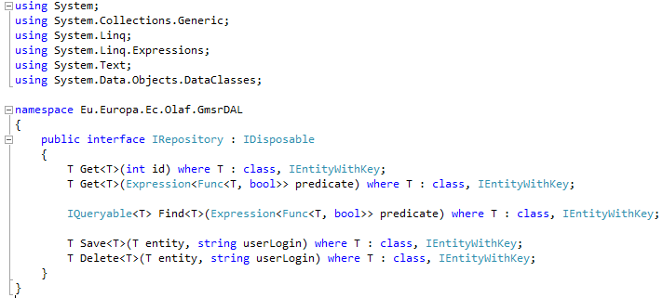

Unit Testing (with Fake Repository)

Other

- baseclass: previouspage, …
- …
Masterpage:
- contains the common markup, javascript and codebehind logic
- markup
- modalPopup
- GmsrLogo (with animated cube)
- User
- OlafLogo
- ActionButtons
- Menu
- (Error)Messages
- Copyright
- javascript
- animation of Cube
- modal popup
- to make sure the button can only be pressed once
- to allow the enter key to point to the correct button to click
- to synchronize the scrolling of the gridview and the corresponding header
- to provide the client-side sorting for the corresponding gridviews
- codebehind logic
- Session start
- Authentication
- Build menu based on authentication
- Non-Postback Page Load
- Authorization: verify whether the requested url is allowed
- Enable / Disable Actionbuttons
- SetGridviewProperties: Is needed for every gridview with the "static header"
- Show / Clear Error & Validation Messages
- Pass the ActionButton click events
- AdditionalPageList Property: contains the additional urls the user has access to

Data Models

DataModel mapped to GMS

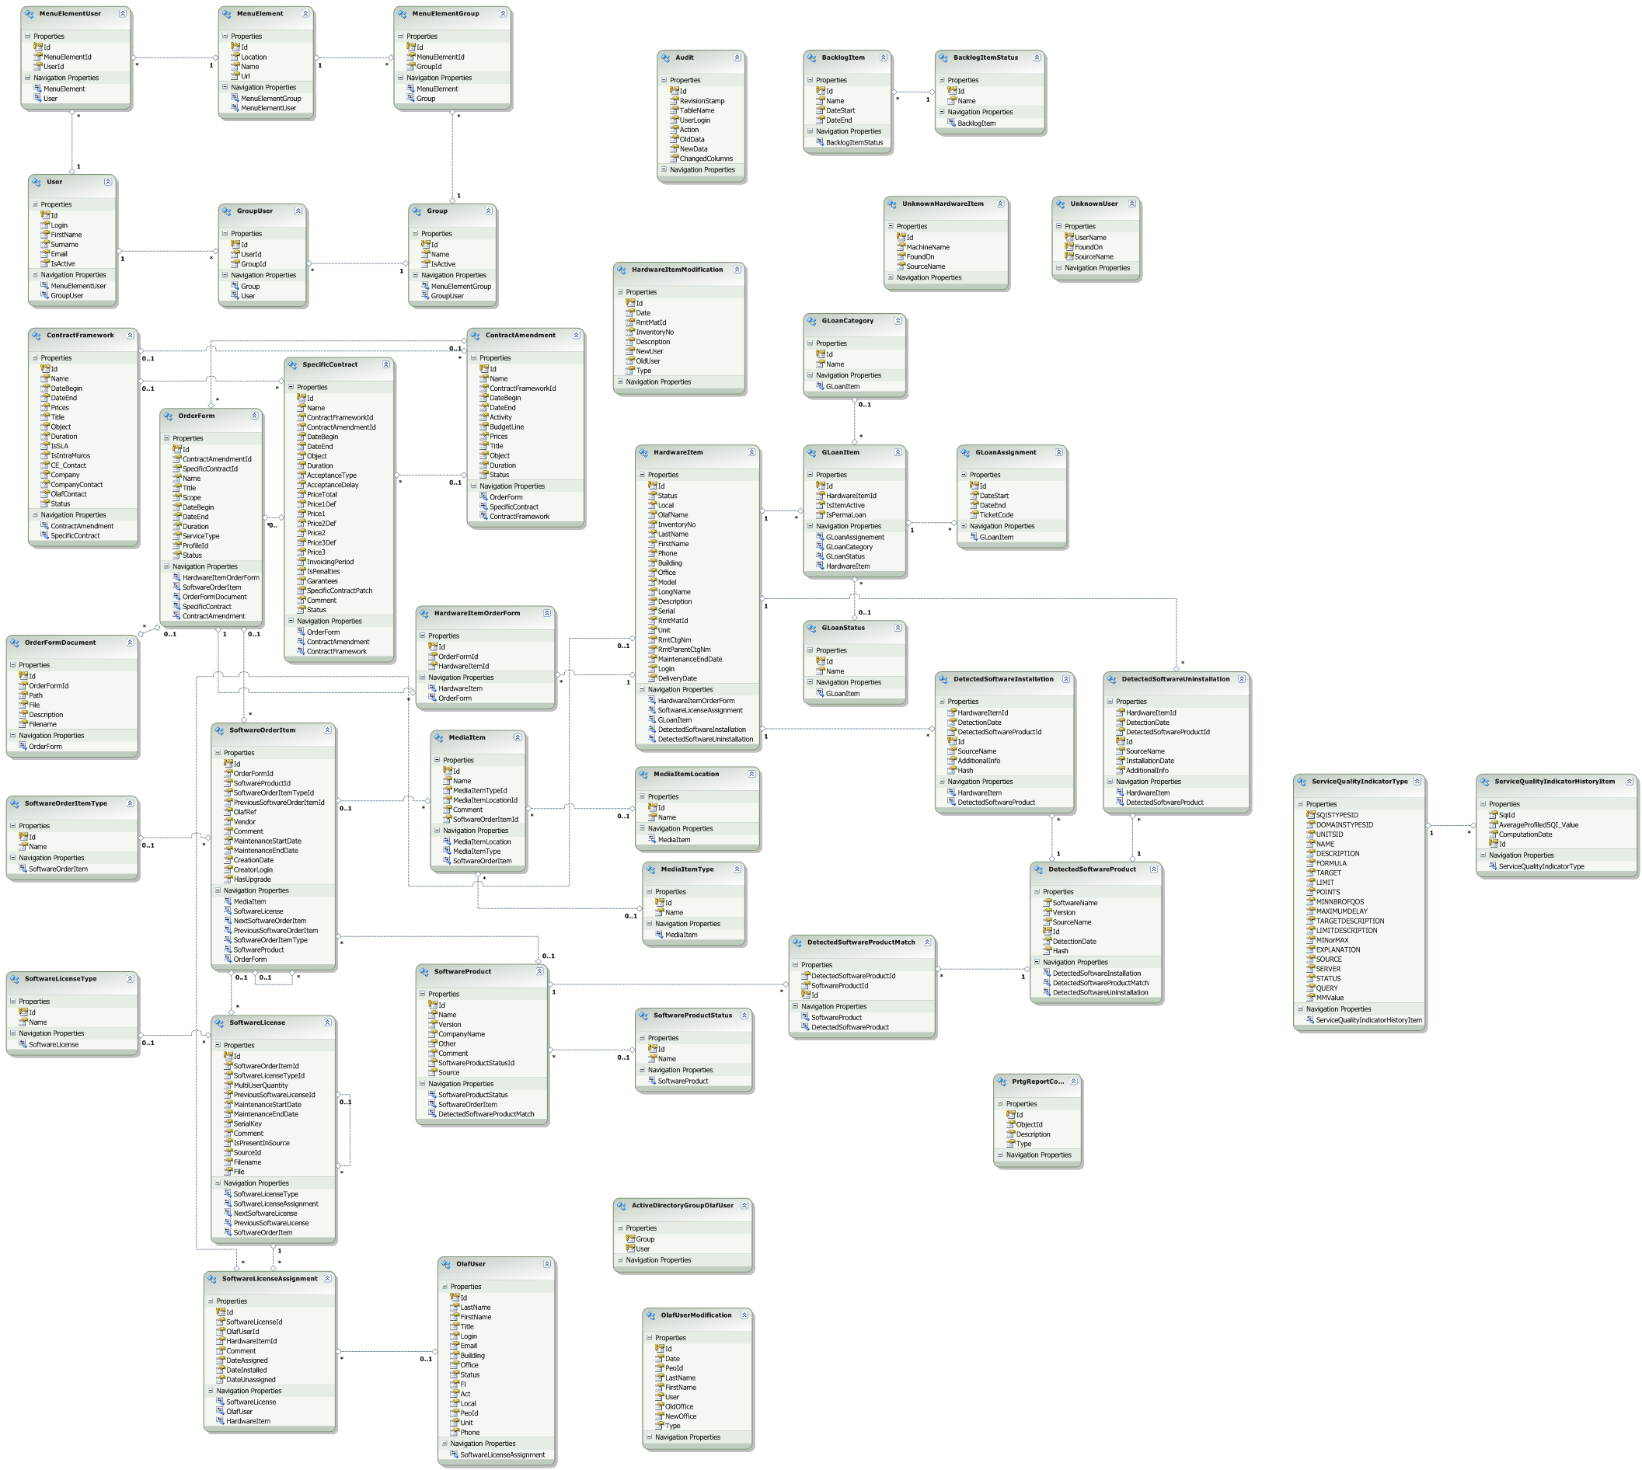

DataModel mapped to GetSmc

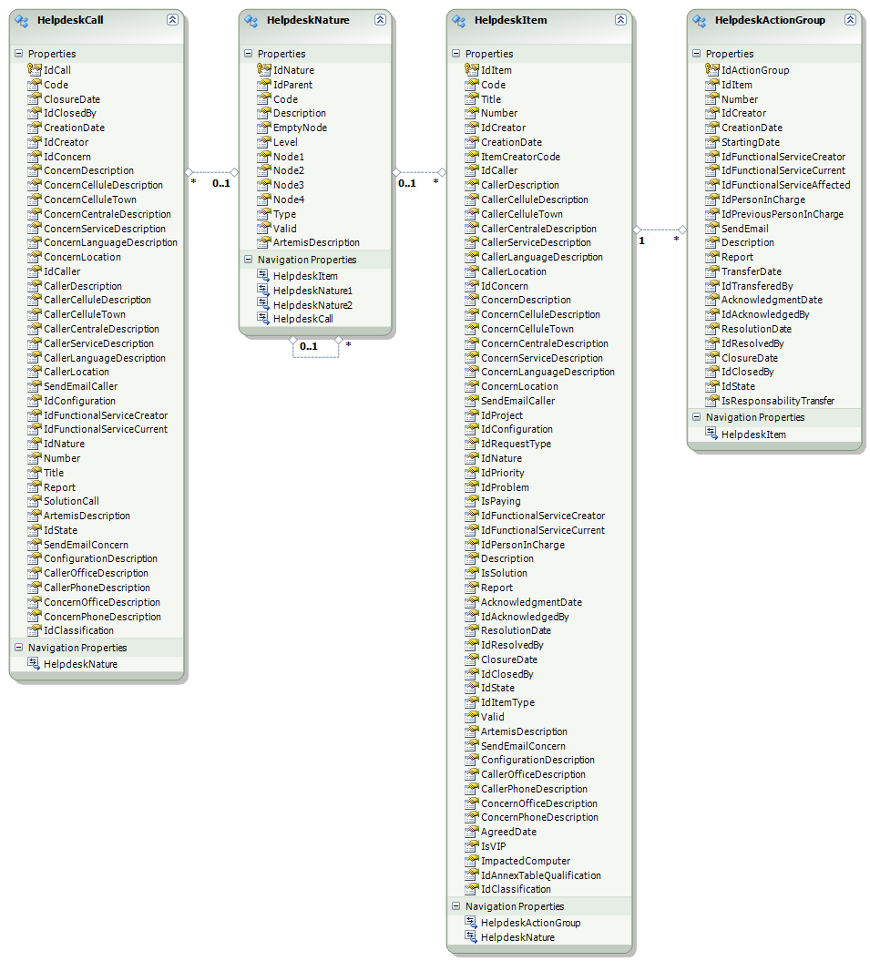

Database

Menu
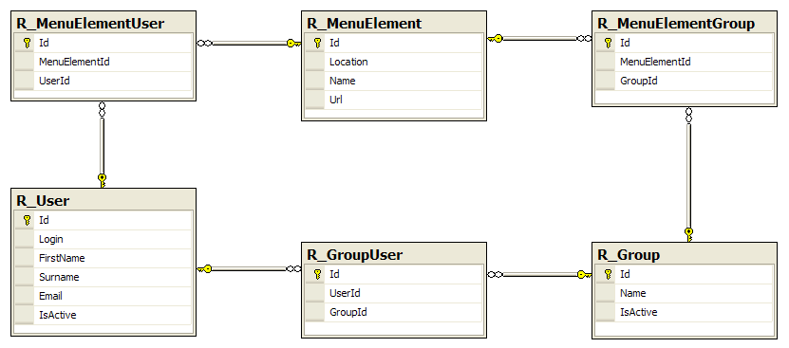

Software
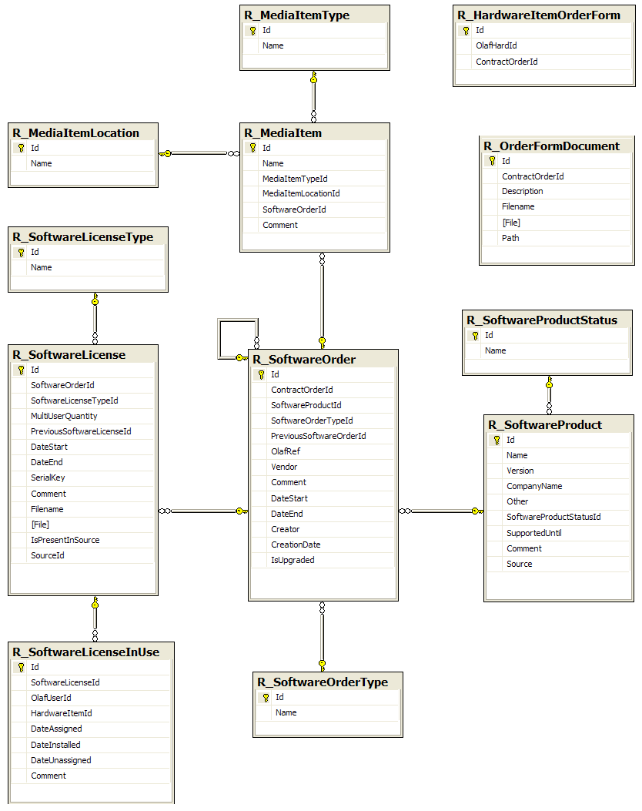

Product Backlog

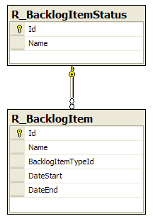

Audit Trailing

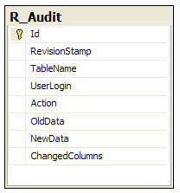

Error Logging

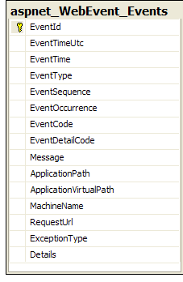

Web Server
- IIS configuration
- stored in xml files under documentation

Deployment
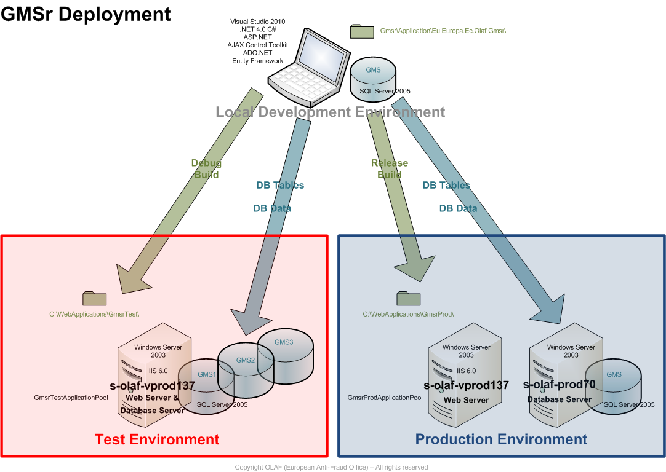

Manual Deployment

- Update Action Plans (e.g. masterpage doesn't have to be modified anymore)
Action Plans:
- Deployment to Test Environment:

1) rebuild the code in 'Debug' mode

2) make a temporary backup copy of '\\s-olaf-vprod137\WebApplications\GmsrTest'

3) copy (overwrite) the new/updated files (don't forget the updated dll's):
from the local '...\Application\Eu.Europa.Ec.Olaf.Gmsr'
to '\\s-olaf-vprod137\WebApplications\GmsrTest'

- if the web.config is updated:
- check that the connectionString is set to the one with 's-olaf-vprod137'
- check that 'compilation debug' is 'true'
- check that 'customErrors mode' is 'Off'

- if the MasterPage.Master is updated:
- check that the test OLAF logo is referenced

- if necessary delete the old files that are not used anymore on '\\s-olaf- vprod137\WebApplications\GmsrTest'

4) verify if everything is OK on 'http://s-olaf-vprod137:8080/'

5) - if there is a problem, restore the original situation from the backup copy
- if everything is OK, remove the temporary backup copy

- Deployment to Production Environment:
1) rebuild the code in 'Release' mode

2) make a temporary backup copy of '\\s-olaf-vprod137\WebApplications\GmsrProd'

3) copy (overwrite) the new/updated files (don't forget the updated dll's):
from the local '...\Application\Eu.Europa.Ec.Olaf.Gmsr'
to '\\s-olaf-vprod137\WebApplications\GmsrProd'

- if the web.config is updated:
- check that the connectionString is set to the one with 's-olaf-vprod70'
- check that 'compilation debug' is 'false'
- check that 'customErrors mode' is 'On'

- if the MasterPage.Master is updated:
- check that the normal OLAF logo is referenced

- if necessary delete the old files that are not used anymore on '\\s-olaf- vprod137\WebApplications\GmsrProd'

4) verify if everything is OK on 'http://s-olaf-vprod137/'

5) - if there is a problem, restore the original situation from the backup copy
- if everything is OK, remove the temporary backup copy

Automated Deployment
An automated deployment can be done easily inside Visual Studio by selecting the appropriate publish option: GmsrTest or GmsrProd and then Publish Web. Make sure that the corresponding build configuration (Debug, Release(Test), Release(Prod)) is applied.

Monitoring
Performance Monitor (perfmon.exe) is used to monitor GMSr.

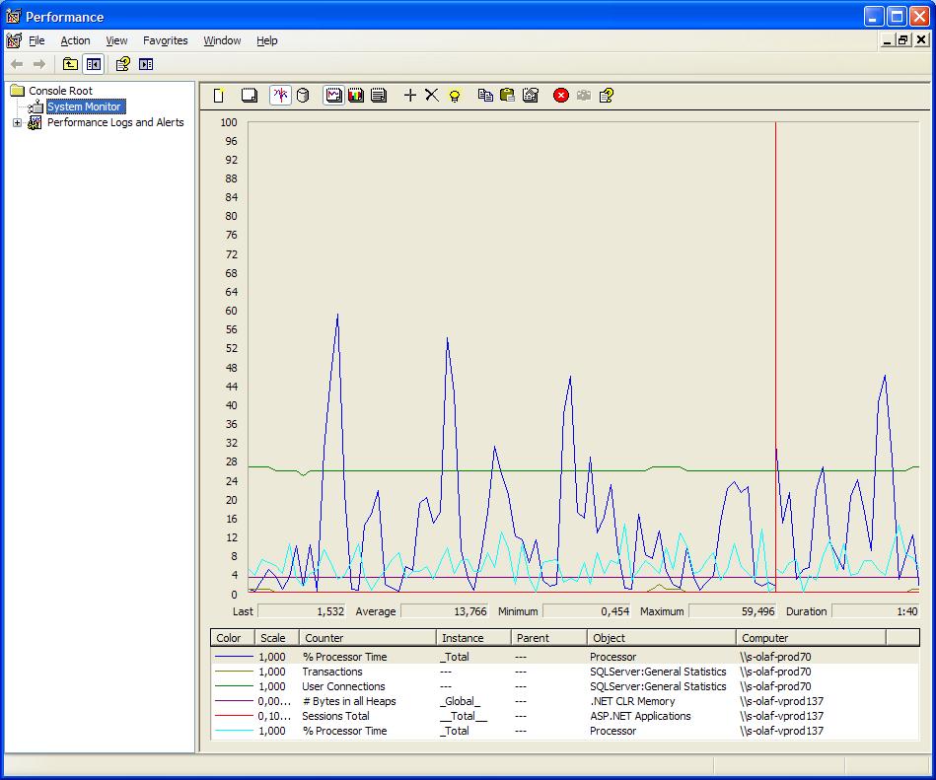

- Counters are used on s-olaf-prod70:
- Processor > % Processor Time:
This counter is the primary indicator of processor activity.

- SQLServer:General Statistics > Transactions:
Number of transaction enlistments (local, DTC, bound all combined).

- SQLServer:General Statisics > User Connections:
Counts the number of users currently connected to SQL Server.

- Counters are used on s-olaf-vprod137:
- .NET CLR Memory > # Bytes in all Heaps:
Displays the sum of the Gen 1 Heap Size, Gen 2 Heap Size, and the Large Object Heap Size counters. This counter indicates the current memory allocated in bytes on the garbage collection heaps.

- ASP.NET Applications > Sessions Total:
The total number of sessions. This counter is supported only with in-memory session state.

- Processor > % Processor Time:
This counter is the primary indicator of processor activity.

