
DRAFT

GMSr User Documentation

Menu & Sitepath

Action Buttons

Modules

Software

Core Terminology
- SoftwareProduct
- SoftwareEntry
- SoftwareLicense

SoftwareProduct
- Examples of SoftwareProducts:
- Photoshop CS4
- Photoshop CS
- JRebel Standard 4.0

- The following do NOT represent SoftwareProducts:
- UPG from Photoshop CS4 to CS5
- MNT (2 y) for Photoshop CS4
- MNT RNW (1 y) for Photoshop CS4

- So in a way a software product is ‘independent’:
(A UPG or MNT are NOT independent à e.g. when you buy a UPG for PhotoShop CS4 to PhotoShop CS5 and you did not already bought PhotoShop CS4 then the UPG is useless. The same is true for an MNT for PhotoShop CS4)

- The list of software products says NOTHING about what we have purchased and what not.

- In theory this list could contain all software products in the world.

- The list of software products is just a catalog that we can refer to when we are adding licenses.

- The more complete this list is à the more convenient it is when we are adding licenses.

- Properties:
- Name
- Version
- Company
- Other Info
- Status
- Operational (Evaluation)
- Operational
- Not-Operational (Phase-Out)
- Not-Operational (Decommissioned)
- N/A
- Comment
- (Detected Product)

SoftwareEntry
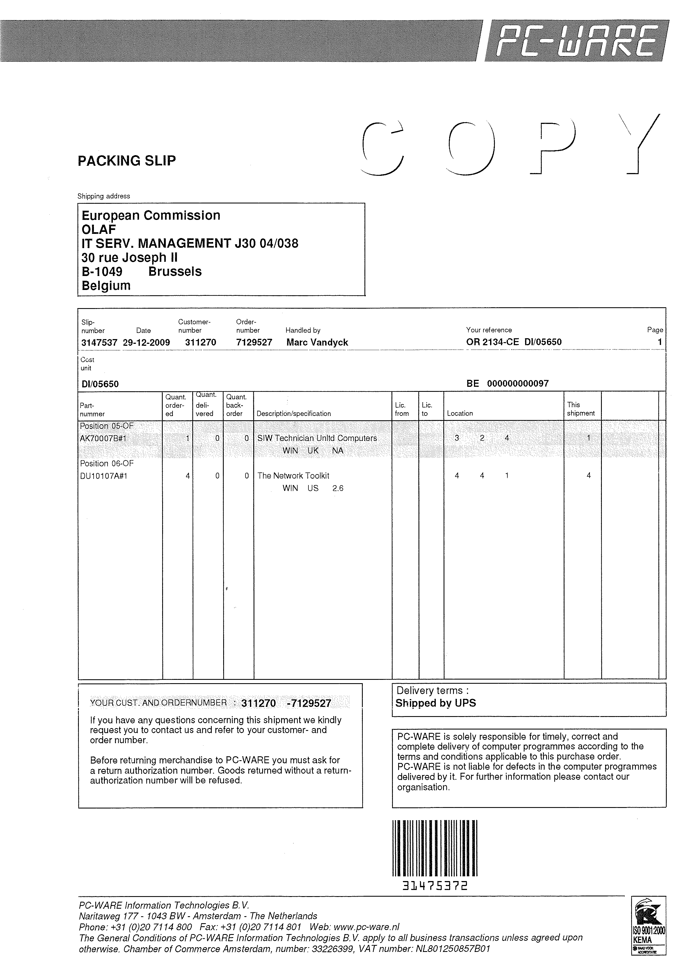
Order
SoftwareEntry
SoftwareEntry
Type: License(s)
Type: Maintenance
Type:License(s)
SoftwareEntry

- What and How acquired:
- The entries represent what softwareproducts we have acquired.
- But more importantly they also say how we have acquired them.

- Example:
Let’s assume the following:
We apparently have 6 licenses for PhotoShop CS5.
2 of them have a maintenance of 2 years and the other 4 a maintenance of 1 year.

How did we acquire this stuff?
- pack of 4 and pack of 2?
- was the maintenance included or did we order it seperately at a later date?
- did we order a maintenance of 2 years? Or was it 1 year + a renewal of 1 year?
- which ones are upgrades from PhotoShop CS4?
- what orders are involved here?

- Three types of entries:
- License(s)
- Upgrade License(s)
- Maintenance
- Properties:
- Type
- License(s)
- Upgrade License(s)
- Maintenance
- Olaf Ref
- Comment

SoftwareLicense
- Represents only what we have on the level of the ‘smallest unit’ (=license level)

- The assigning is done on the license level.

- E.g.: Suppose we bought a pack of 60 licenses of PhotoShop CS4 with MNT(1yr). And a pack of 25 licenses of PhotoShop CS4 without MNT.
- This results in:
à 3 software entries (2 packs and 1 maintenance)
à 120 software licenses

- Properties:
- Serial No
- Type
- Enterprise License
- Free License
- Multi User License
- Network Dongle License
- Server License
- Single User License
- Volume License
- File
- Comment

Example

SoftwareProducts
SoftwareEntries
SoftwareLicenses
Orders
1
2
3
4
5
6
7
8
9
10
1) Maintenance renewal for one license
2) Maintenance for one license
3) One license (maintenance (2) was included ((2) and (3) point to the same order))
4) Maintenance for five licenses (=pack)
5) Five upgrade licenses (=pack) for five licenses (=pack)
6) One upgrade license for one license
7) One license ((5), (6) and (7) were ordered together)
8) One license that has an upgrade license
9) Five licenses (=pack) that has five upgrade licenses (=pack)
10) One license that does not have an order. E.g.: FireFox

Use Cases
A) Add license(s) for FireFox 3.6
B) Add license(s) for PhotoShop CS4
C) Add maintenance (2y) for (B)
D) Add upgrade license(s) for (B) to PhotoShop CS5
E) Add license(s) for PhotoShop CS5
F) Add maintenance (1y) for (E)
G) Add maintenance renewal (1y) for (F)
H) Add maintenance (1y) for (D) (this is actually a maintenance renewal because it already has a maintenance that it has inherited from PhotoShop CS4)

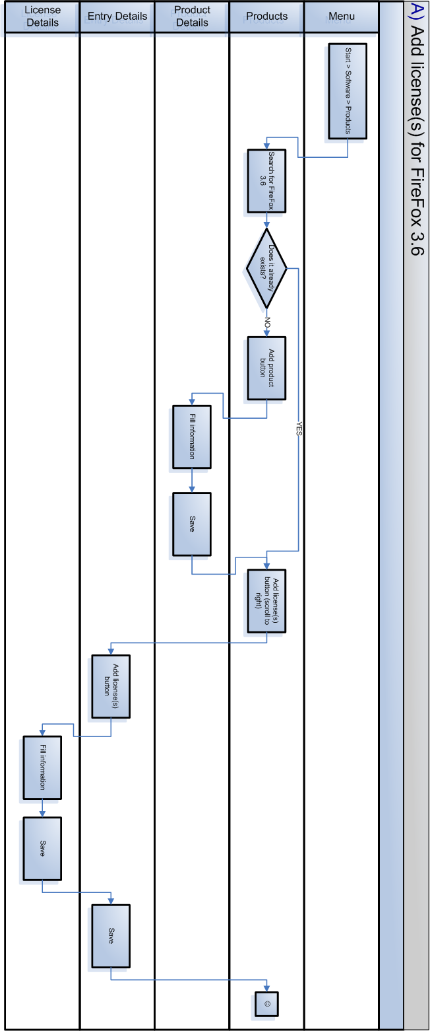
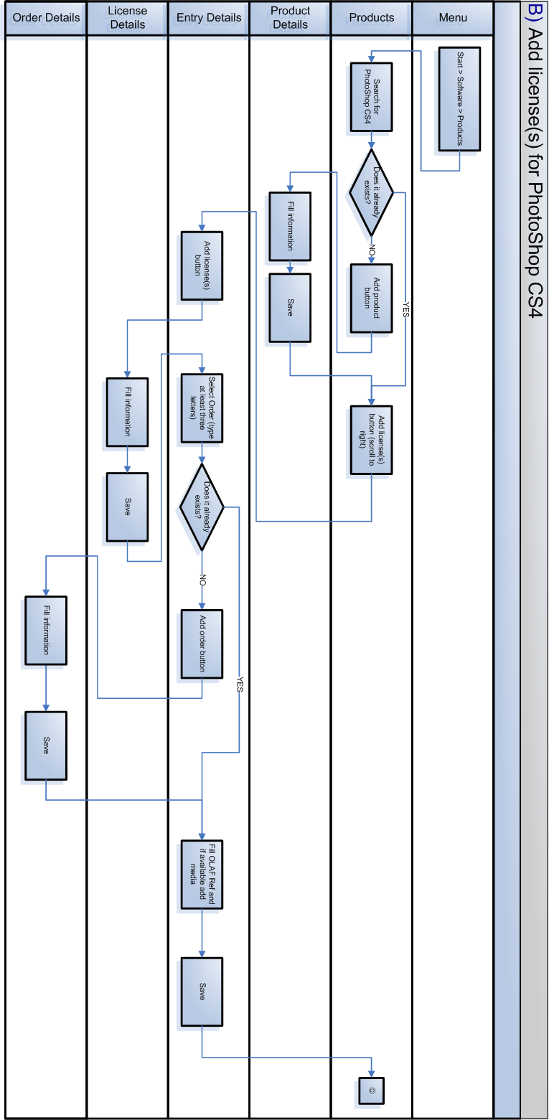
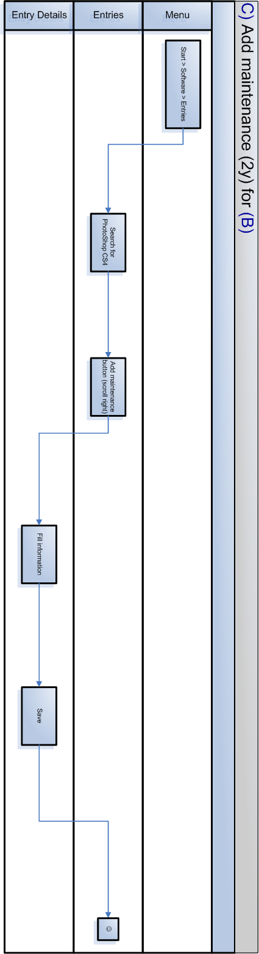
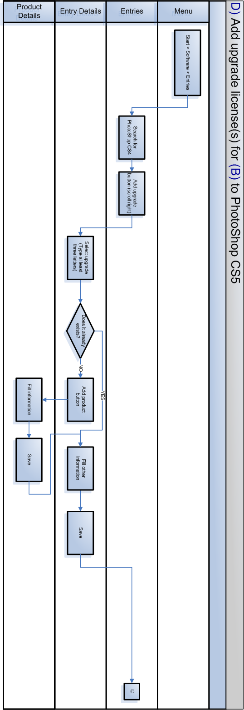
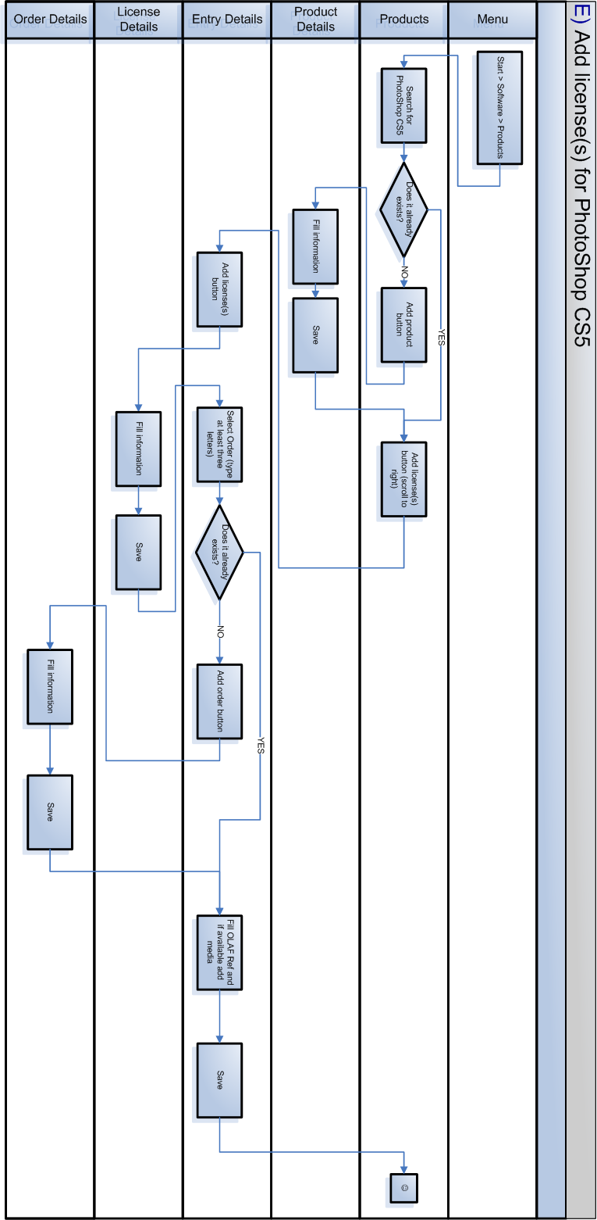
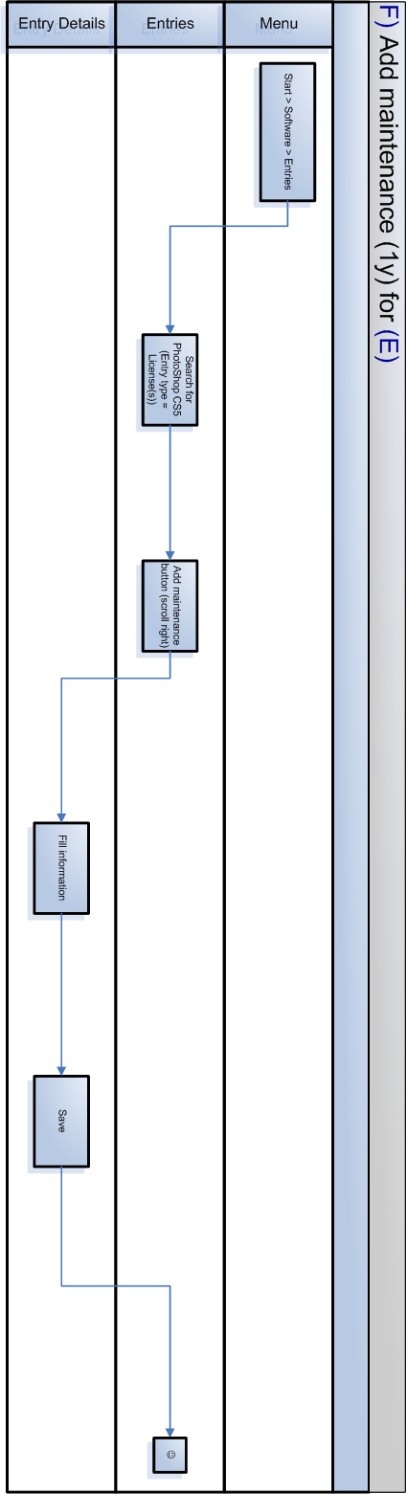
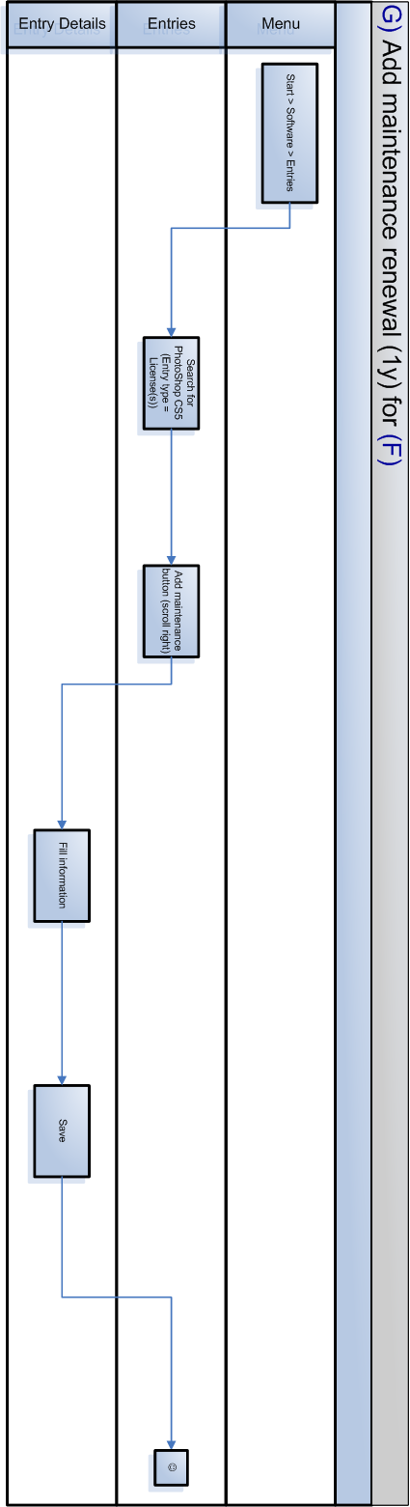
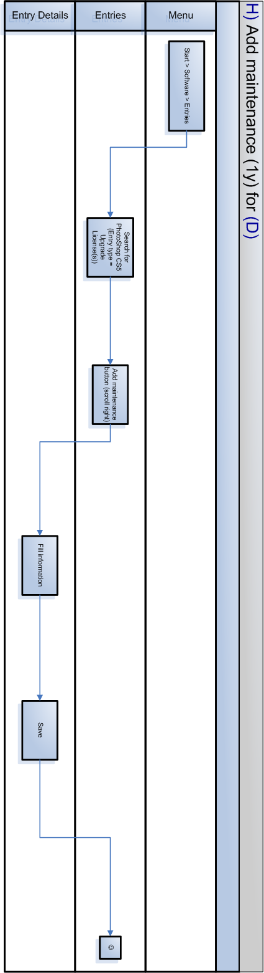

Hardware

Services

Contracts

Users

Reports

GMSr Administration

