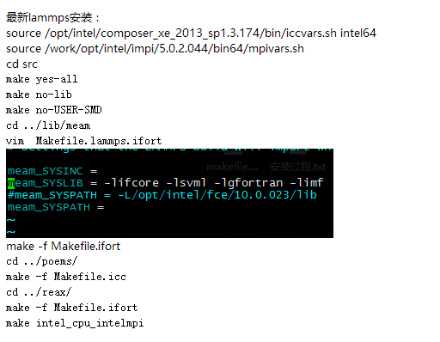

备注：source /opt/intel/composer_xe_2013_sp1.3.174/bin/iccvars.sh intel64

source /work/opt/intel/impi/5.0.2.044/bin64/mpivars.sh

最后一行前面加上cd ../../src

安装完以后，在.bashrc里面改下：

export LD_LIBRARY_PATH=/work/opt/intel/composer_xe_2013_sp1.3.174/tbb/lib/intel64/gcc4.4:/work/opt/intel/impi/5.0.2.044/intel64/lib:$LD_LIBRARY_PATH

PS:如果有人需要USER-SMD模块

在lib/smd目录下解压eigen-eigen-67e894c6cd8f.tar.gz

tar -xvzf eigen-eigen-67e894c6cd8f.tar.gz

ln -s eigen-eigen-67e894c6cd8f includelink

cd ../../src

make yes-all

make no-lib

make mpi-stubs

make yes-user-smd

那么就近src下面执行make yes-USER-SMD

重新make：make –j 8 intel_cpu_intelmpi (-j　多核编译)