CA1 Report

EE5731 Visual Computing

Name

Student ID

9 October 2020

Q1

1. Sobel Kernel: gx:

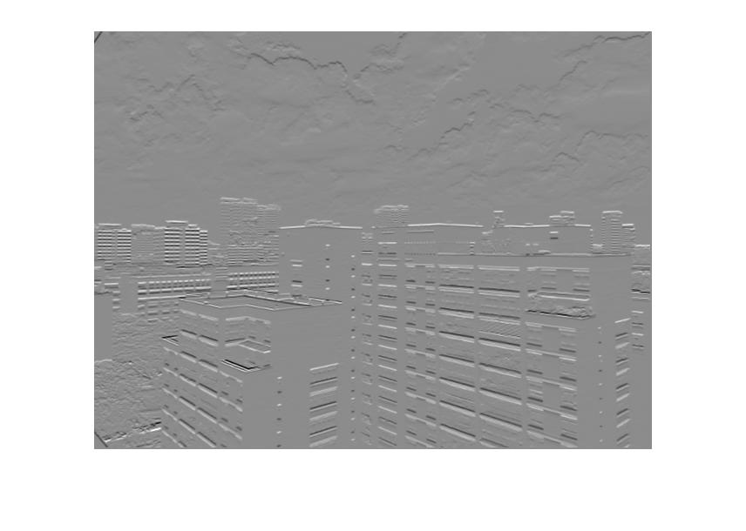

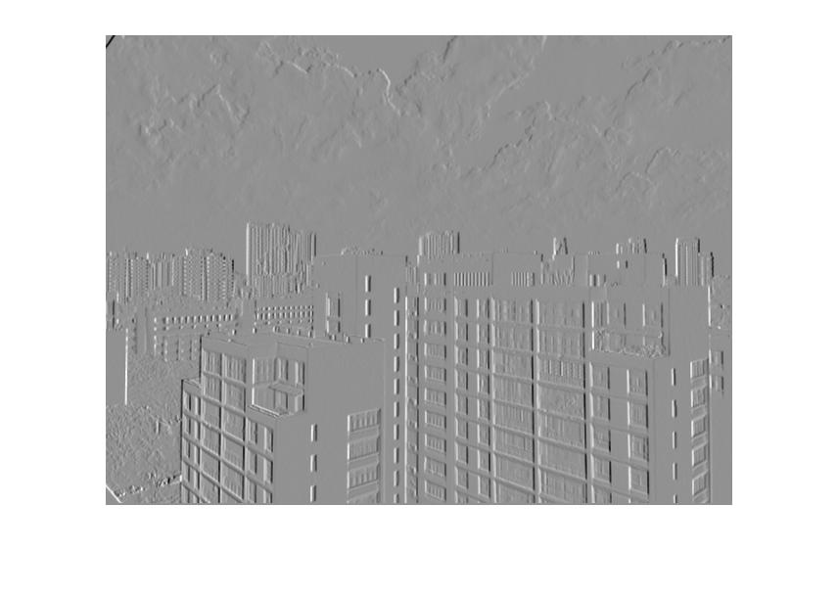

gy:

gxy:

2. Gaussian kernel:

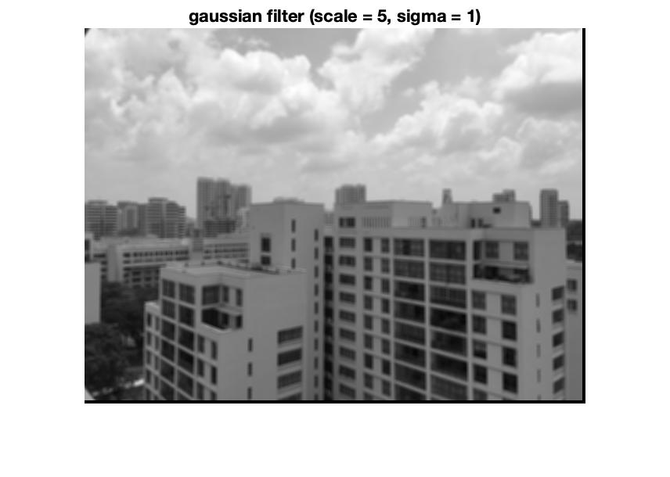

3. Haar-lik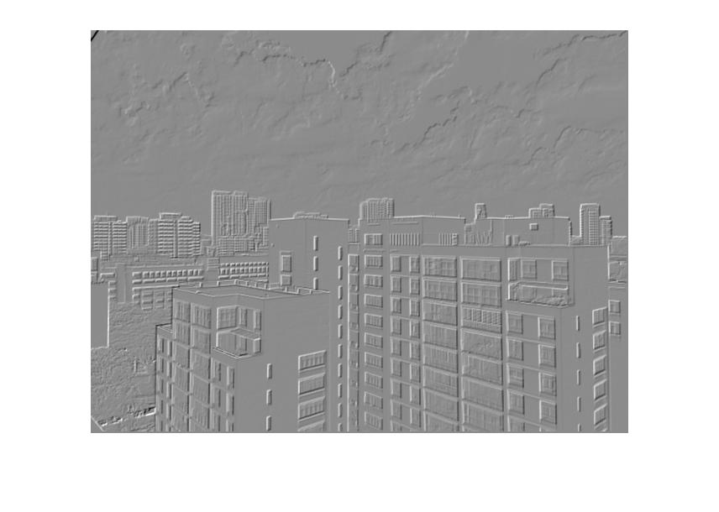e mask: Example - Kernel B [-1;1] - Scale 3:

Kernel B: Scale 5:

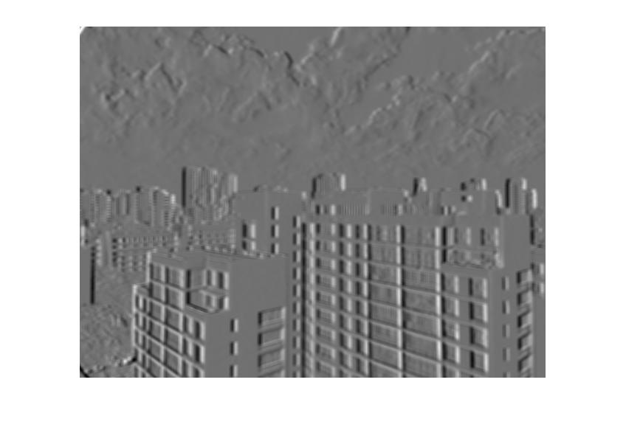

The effect of mask scale on image output: T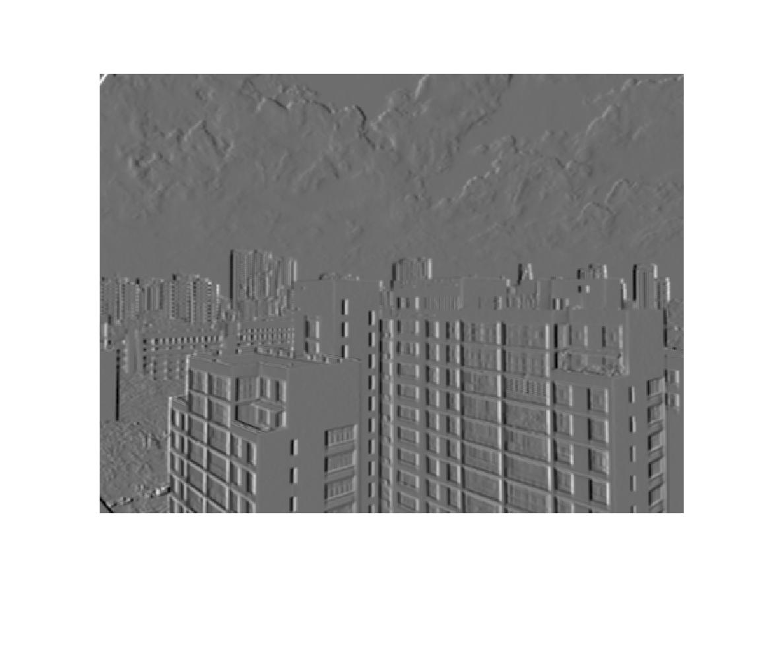he bigger the scale, the burrer the image is.

Q2

Extract key points: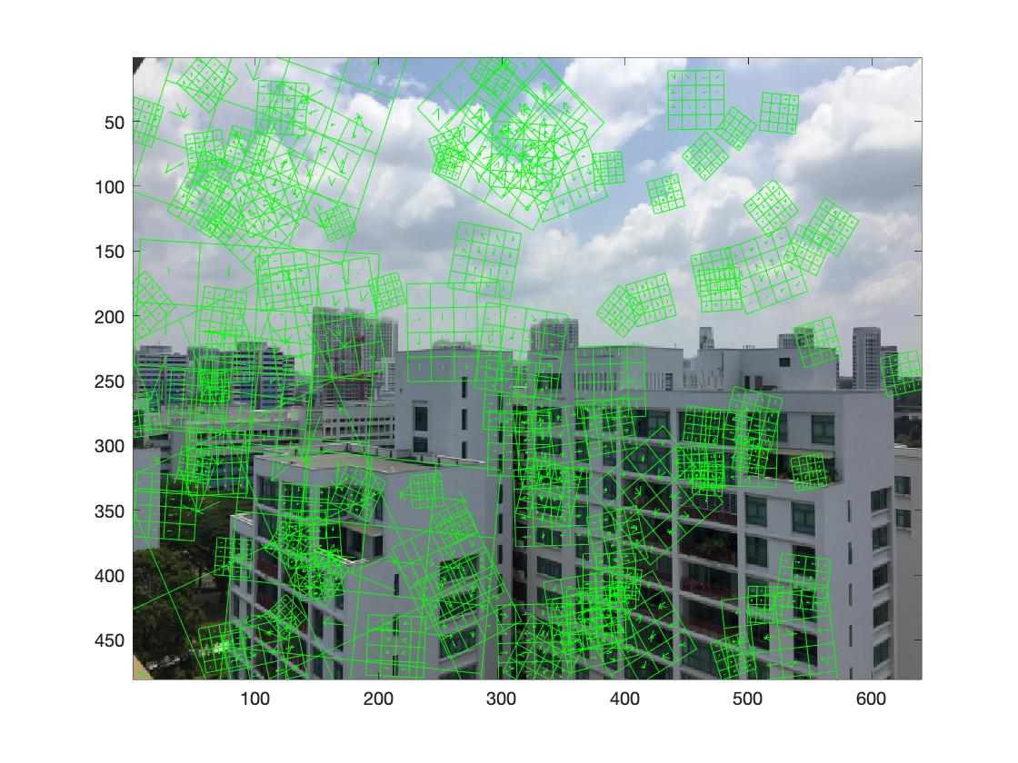

Q3

H1 to H2:

Homography matrix:

0.0019 0.0012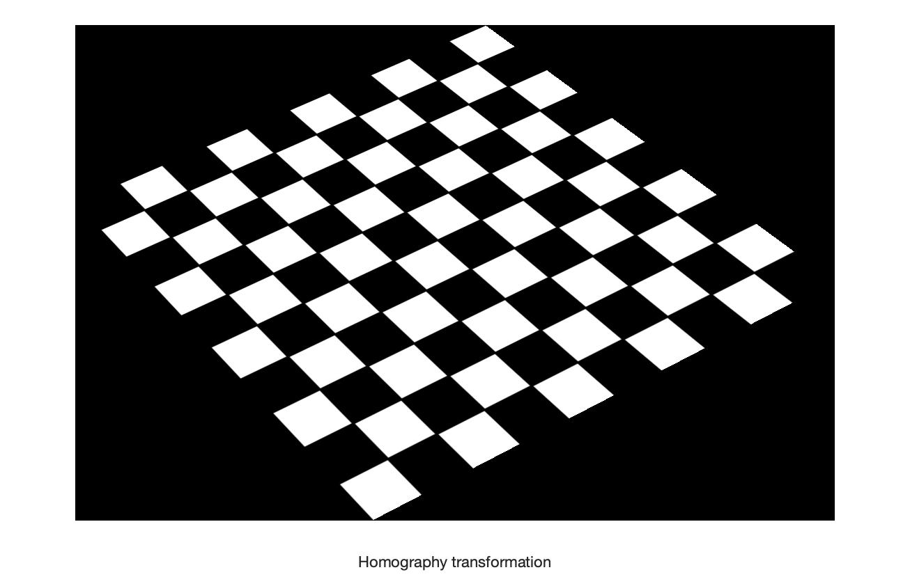 -0.5803

-0.0008 0.0010 0.8144

0.0000 -0.0000 0.0037

H2 to H1:

Homography matrix:

-0.0026 0.0023 -0.3616

-0.0019 -0.0041 0.9323

-0.0000 -0.0000 -0.0015

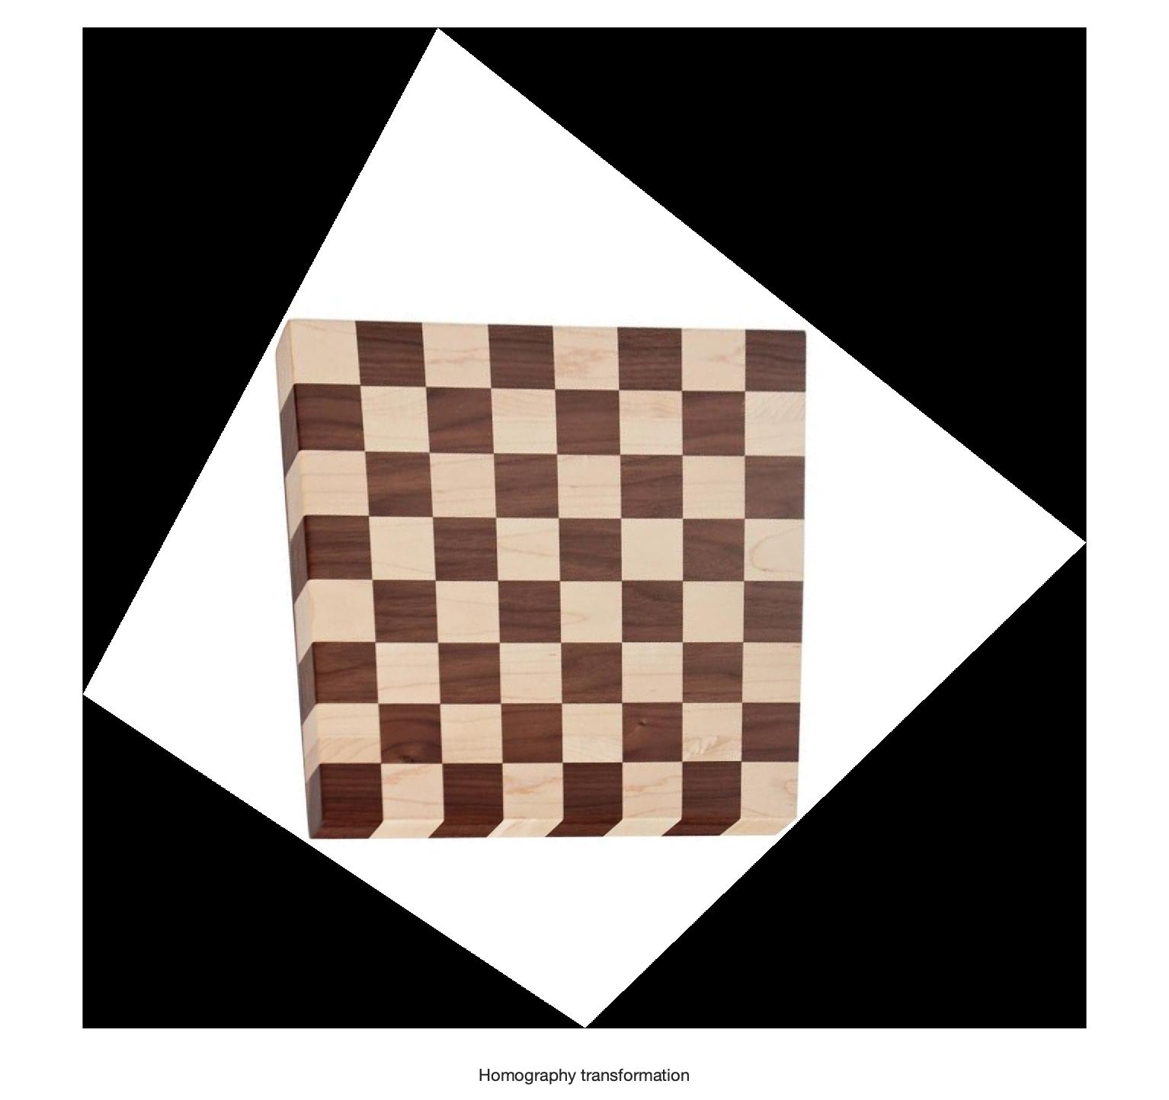

Q4

Why there is a double image effect:

To stitch the two images, the algorithm uses average displacement to deduce the position of the images and do homography on one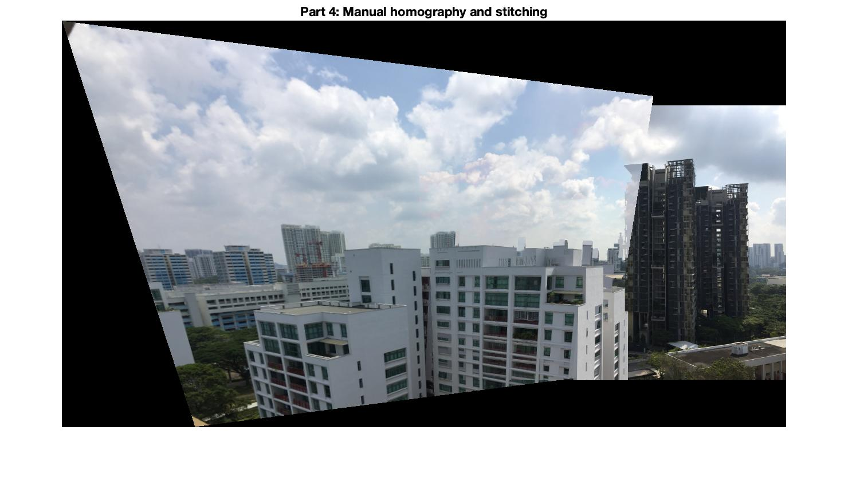 of the images to get the final result. The reason why there is a double image effect is that after homography the image is distorted while the other image is not.

Q5

