Speech Sentiment Analysis System

Product Design

Speech Sentiment Analysis System

Team Members: Chenzhanglin, Lixingliang,
Yeya
Creation Date: 4/21/2021
Last Revised: 4/29/2021
Version: 1.0

INTRODUCTION

Purpose of this Designing

The document was written for the following purpose:
- Provide a basis and specification for the developers in development
- Provide a basis for project testing, modification and maintenance
- Facilitate project manager (project manager) to perform task assignment and development process control
- Provide a basis for quality inspection of the final delivery project
- Provide a basis for the test and scoring of the project sponsor (teacher)

Overview

Project Name:
- Speech Sentiment Analysis System
Project Sponsor:
- Jin Liu
Project member:
- Speech team of SCM course
End User:
- all students participated in SCM course

Architecture

Overall

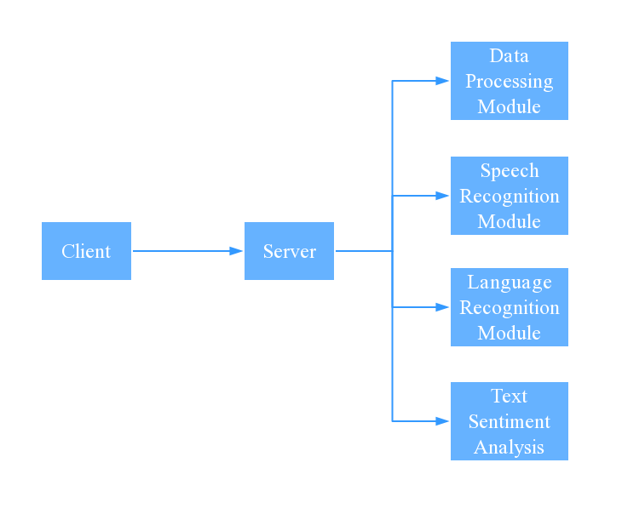

There are four modules in our project plan
- Data Process Module
- Speech Recognition Module
- Language Recognition Module
- Text Sentiment Analysis Module

Process

Flow graph

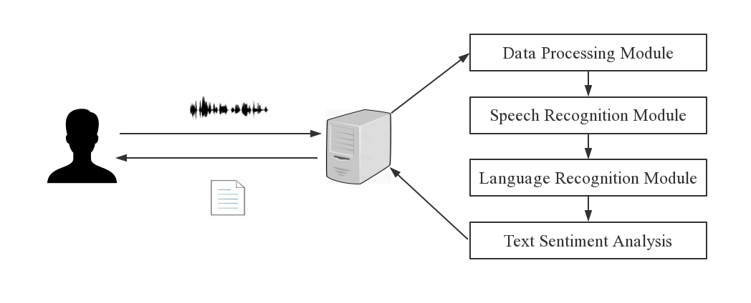

Description

- The users select and upload audio files to the server through web

- The server receives and processes the audio，reducing the interference of environmental noise

- The server translates denoised audio into Chinese Pinyin, converts them into corresponding Chinese character text and analyzes the sentiment of text.

- The server sends result back to web, which can be separated into ‘positive’, ‘negative’ and ‘neutral’

Data Process Module

- This module is used for reducing the interference of environmental noise
. Functions and interfaces in the module will be developed by Chen zhanglin.

Main Functions

There will be two main functions in the module:
divide_frame(file_type, file_data) - >ndarry
According to the stability of the voice signal in a short time, the audio sequence is divided into frames. These frames should be processed further more.
Input:
- file_type (str) – the format of file (eg:wav)
- file_data (str) – data in bytes contain the audio sequence
- user_id(str) – the only representation to the user
Output:
- audio_list (ndarry) – a list of a audio divided into small segments will be returned

denoising_process (audio_list)-> ndarry:
The Hamming window is established by spectral subtraction to transform the speech sequence, the fast Fourier transform is used to extract the speech features, and the noise power spectrum is smoothed with a triangular filter
Input:
- audio_list (ndarray) – a list of a audio divided into small segments
Output:
- denoise_result(ndarray) – denosied audio will be returned for further editing

Interface
Interface for client
Look outside the module, the module provides the service of speech denoising. Actually many other modules will be imported. This is because this module provides an interface for client.
- Type of interface: Post request supported by HTTP protocol
- Interface port: 8080
- Encoding: UTF-8
- Request content: a json file –
{
“file_type”: “”,
“file_data”: “”,
“user_id”: “”
}
The input of the interface is a sequence of audio and is in wav format.

- Response content: a json file –
{
“sent_result”: “”
}
The output of the interface is a sentiment classification result of the audio uploaded.

Work Estimate

The duration of the development of this module will be last for 22 days. But the real work time is 14 days and the extra one day is used for coping with emergencies

Deliverables

Code in this module will be delivered as a function in web server (flask) as an interface for client to call. What else, the development document will record the details of this module.

Speech Recognition Module

This module is used to convert audio into Chinese Pinyin for further editing and processing. Functions and interfaces in the module will be developed by Ye ya.

Main Functions

There will be three main functions in the module:
TrainModel(text_wav,text) - >model
This function trains the established model using the generated dataset (include text_wav and text). When the training ends, it will return the model file.
Input:
- text_wav (wave) – the set of wav for training
- text (str) – the set of texts corresponding to the above images
Output:
- model (h5) – trained model file

Predict(data_input, input_len) - >text
This function will predict audio results and return the list of pinyin text.

Input:
- Data_input(wave) – the set of wav for predicting audio
- Input_len(str) – the length of wav data
Output:
- text (str) – audio to pinyin

RecognizeSpeech(wavsignal) - >text
This function is a function for speech recognition, recognizing a wav sequence of speech.
Input:
- wavsignal(wave) – a wav sequence of speech
Output:
- text (str) – form a pinyin list

Interface
Interface for speech recognition module (module of server)
After receiving the sequence of audio, this module will translate the audio into Chinese pinyin and return the pinyin list.
- Type of interface: Function call
- Inputs: A sequence of audio
- Outputs: A pinyin list

Work Estimate

The duration of the development of this module will be last for 22 days. But the real work time is 14 days and the extra one day is used for coping with emergencies

Deliverables

Code in this module will be delivered as a complete package that can be imported in server. The data process module can call it by the interface function name. What else, the development document will record the details of this module.

Language Recognition Module

This module is used to convert Chinese Pinyin into corresponding Chinese character text. Functions and interfaces in the module will be developed by Li xingliang.

Main Functions
There will be four main functions in the module:
SpeechToText(list_syllable) - >text
This function is a speech recognition processing function,which realize the conversion from phonetic pinyin symbols to the final text.
Input:
- list_syllable(str) – a list of phonetic symbols
Output:
- text (str) – final text

Decode(list_syllable, yuzhi = 0.0001) - >text
This function is based on Markov chain and can realize the conversion of pinyin to text.
Input:
- list_syllable(str) – a list of phonetic symbols
- yuzhi = 0.0001(str) – a threshold set by yourself
Output:
- text (str) – final text

GetSymbolDict(dictfilename) - >dic_symbol
This function will read the dictionary file of pinyin Chinese characters and return the read dictionary.
Input:
- dictfilename(getcwd) – a dictionary file of pinyin Chinese characters
Output:
- dic_symbol(str) – a dictionary file of pinyin Chinese characters

GetLanguageModel(modelLanFilename) - >model
This function will read the language model file and return the read model.
Input:
- modelLanFilename(getcwd) – a file of language model
Output:
- model(h5) – a language model

Interface
Interface for language recognition module (module of server)
After receiving the list of pinyin , this module will translate the list of pinyin into corresponding Chinese character text
- Type of interface: Function call
- Inputs: A list of pinyin
- Outputs: A Chinese character text

Work Estimate

The duration of the development of this module will be last for 22 days. But the real work time is 14 days and the extra one day is used for coping with emergencies

Deliverables

Code in this module will be delivered as a complete package that can be imported in server. The data process module can call it by the interface function name. What else, the development document will record the details of this module.

Text Sentiment Analysis

This module contributes to analyze the sentiment of text converted from speech. The sentiments can be separated into ‘positive’, ‘negative’ and ‘neutral’. Functions and interfaces in this module will be developed by Li xingliang.

Main Functions

There will be three main functions in the module:
Text_preprocess (text) - >text
This function judges the format and type of input text and convert into the expected format that can be addressed by our model.
Input:
- text (Unknown) – an input text in and format and type
Output:
- text (str) – a string with standard format will be returned

Data_reading (path) - >train_data, val_data
This function reads data from path and split them into training data and validation data. Then this function prepares data by dataloader.
Input:
- path
Output:
- train_data (torch.DataLoader) – training data used to train our model
- val_data (torch.DataLoader) – validation data used to evaluate our model

Model_train (train_data, val_data) - >model
This function trains the established model by the generated dataset (include training data and validation data). When the training ends, it will return the model file.
Input:
- train_data (torch.DataLoader) – training data used to train our model
- val_data (torch.DataLoader) – validation data used to evaluate our model
Output:
- model (bin) – trained model file

Model_test (text) - > sentiment
This function receives the input text and uses trained model to predicted the sentiment of text. It will return a string that denotes the sentiment.
Input:
- text (string) – input text
Output:
- sentiment (string) – predicted sentiment of target text

Interface
Interface for text sentiment module (module of server)
After receiving the text, the text is preprocessed to the standart format that can be inputted into the model. After that, trained model will be loaded and predicts the sentiment of target text.
- Type of interface: Function call
- Inputs: A string
- Outputs: A sentiment result

Work Estimate

The duration of the development of this module will be last for 14 days. But the real work time is 13 days and the extra one day is used for coping with emergencies

Deliverables

Code in this module will be delivered as a complete package that can be imported in server. The data process module can call it by the interface function name. What else, the development document will record the details of this module.

