Speech Sentiment Analysis System

Test Document

Speech Sentiment Analysis System
Team Members: Lixingliang , Chenzhanglin,
Yeya
Creation Date: 5/15/2021
Last Revised: 5/18/2021
Version: 1.0

Speech Sentiment Analysis System
Contents

INTRODUCTION 2
Purpose of Plan 2
GOALS AND OBJECTIVES 2
Project Goals and Objectives 2
TEST PLAN 3
Test Approach 3
UNIT TEST 3
Process Module 3
Speech Recognition Module 5
Text Sentiment Analysis Module 6
SYSTEM TEST 7
ACCEPTANCE TEST 7

INTRODUCTION

Purpose of Plan

The Speech Sentiment Analysis System Plan will provide a definition of the project, including the system’s goals and objectives. The users select and upload audio files to the server through web.The server receives and processes the audio，reducing the interference of environmental noise.The server translates denoised audio into Chinese Pinyin, converts them into corresponding Chinese character text and analyzes the sentiment of text.The server sends result back to web, which can be separated into ‘positive’, ‘negative’ and ‘neutral’.

The Project Plan defines the following:

- Goals and Objectives
- Scope
- SPMP

GOALS AND OBJECTIVES

Project Goals and Objectives

- The goal of whole system is to translates denoised audio into Chinese Pinyin, then converts them into corresponding Chinese character text and analyzes the sentiment of text.And the goal of our project is to realize the speech recognition system reach 80% on the performance of accuracy and the text sentiment analysis system can separate the text sentiment into ‘positive’, ‘negative’ and ‘neutral’.

The objectives of project are listed as follow:
- Ensure that audio can be uploaded in 2 second.
- Ensure that Chinese Pinyin can be recognized at 90% accuracy.
- Ensure that Chinese character text can be recognized at 80% accuracy.
- Ensure that text sentiment can be separated into ‘positive’, ‘negative’ and ‘neutral’
- Ensure that end users have a conception of the design process.
- Accomplish project goals and objectives within defined budget and time parameters.
- Ensure the final quality of products can be accepted

TEST PLAN

Test Approach

- Unit Test
- Performance Test
- System Test
- Acceptance Test

UNIT TEST

We have tested our modules in unit test to check the feasibility of each module.
And we will list the test detail and test case in next section.

Process Module

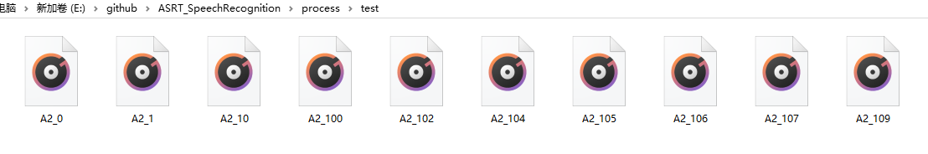

In the processing module, it includes loading the phonetic symbol list and calculating the voice features. By reading the audio file under the test folder, we can get their frame number, channel number, frame rate and other features, and then we can get the final feature data by adding time window and translation to the read voice features.
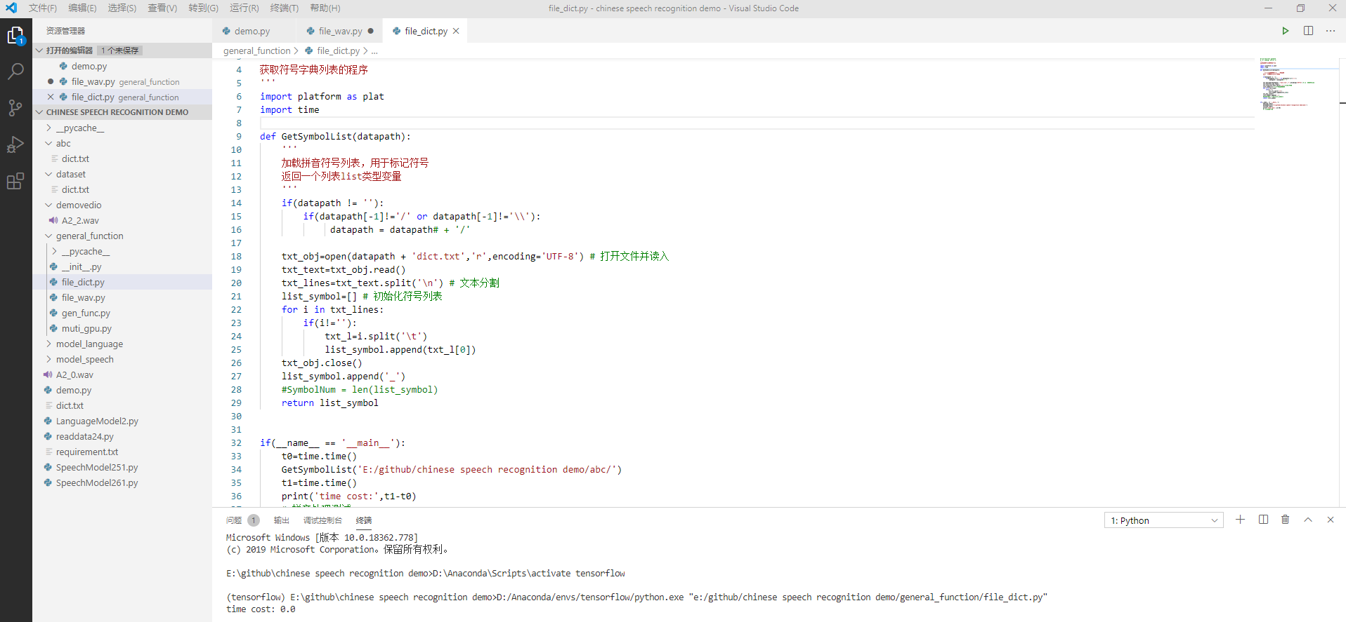
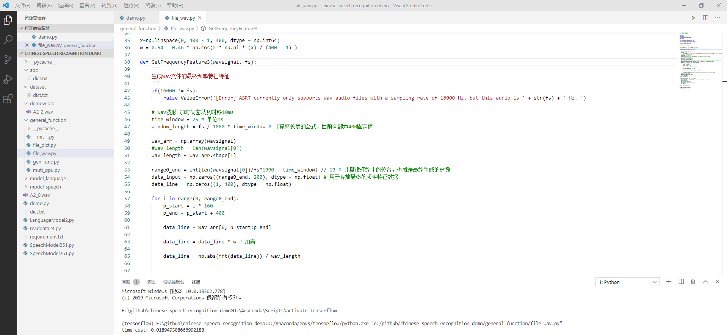

Speech Recognition Module

Test for speech recognition module can be divided into two parts:audio to Pinyin and Pinyin to Chinese character text.
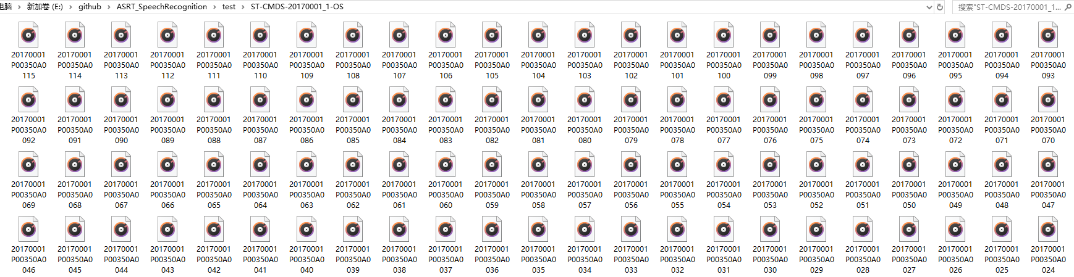
The test of two parts can be seen as follows:
audio to Pinyin:

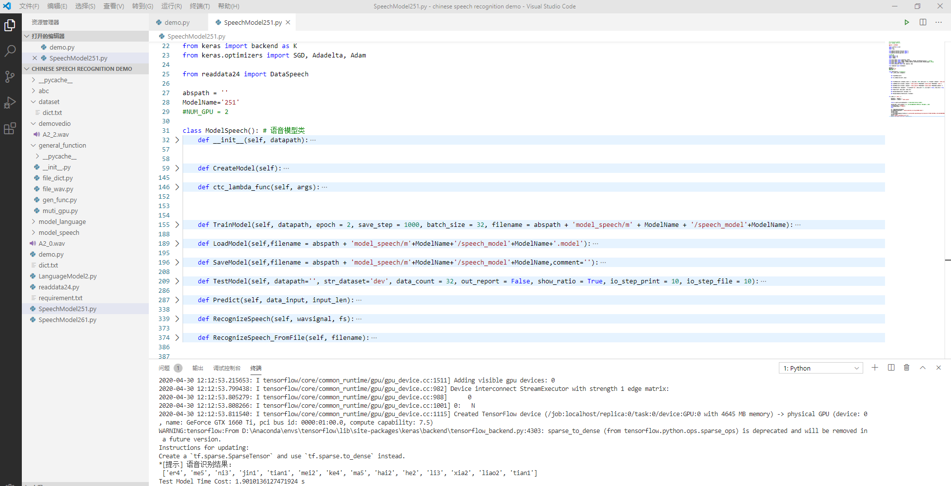

Pinyin to Chinese character text:

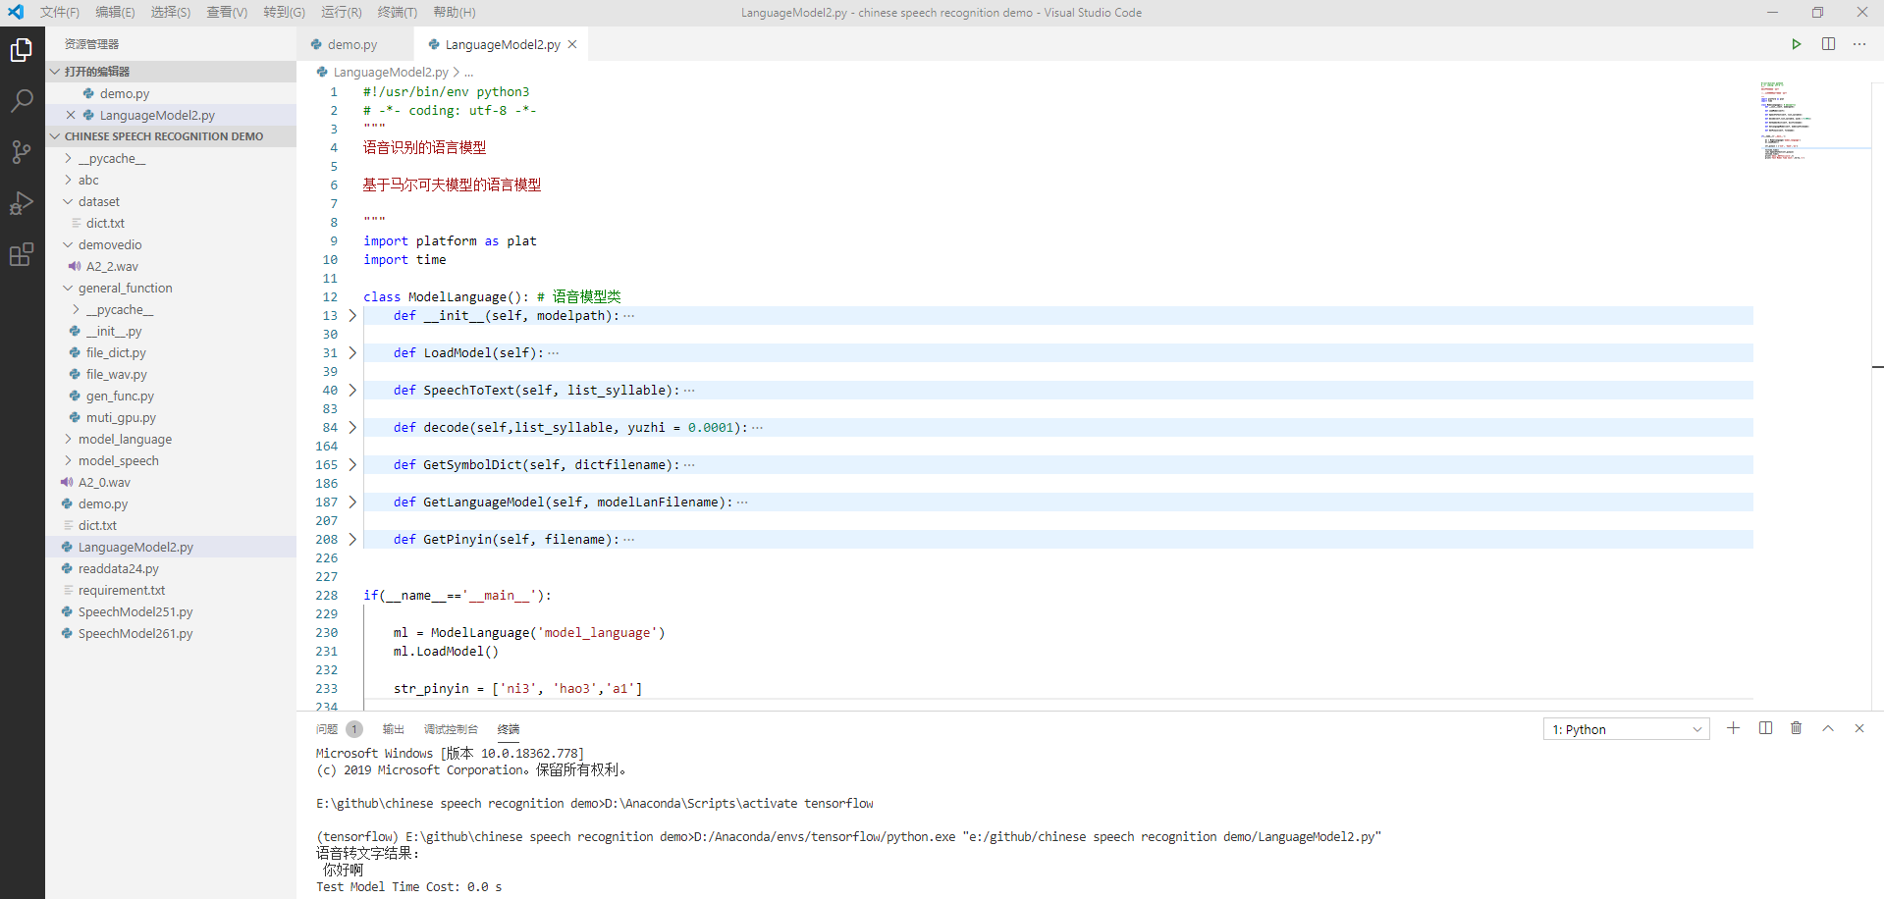

Text Sentiment Analysis Module

Test cases for text sentiment analysis module can be divided sentiment into three parts: ‘positive’, ‘negative’ and ‘neutral’.By analyzing the scores of three kinds of sentiments, we can give the final classification.
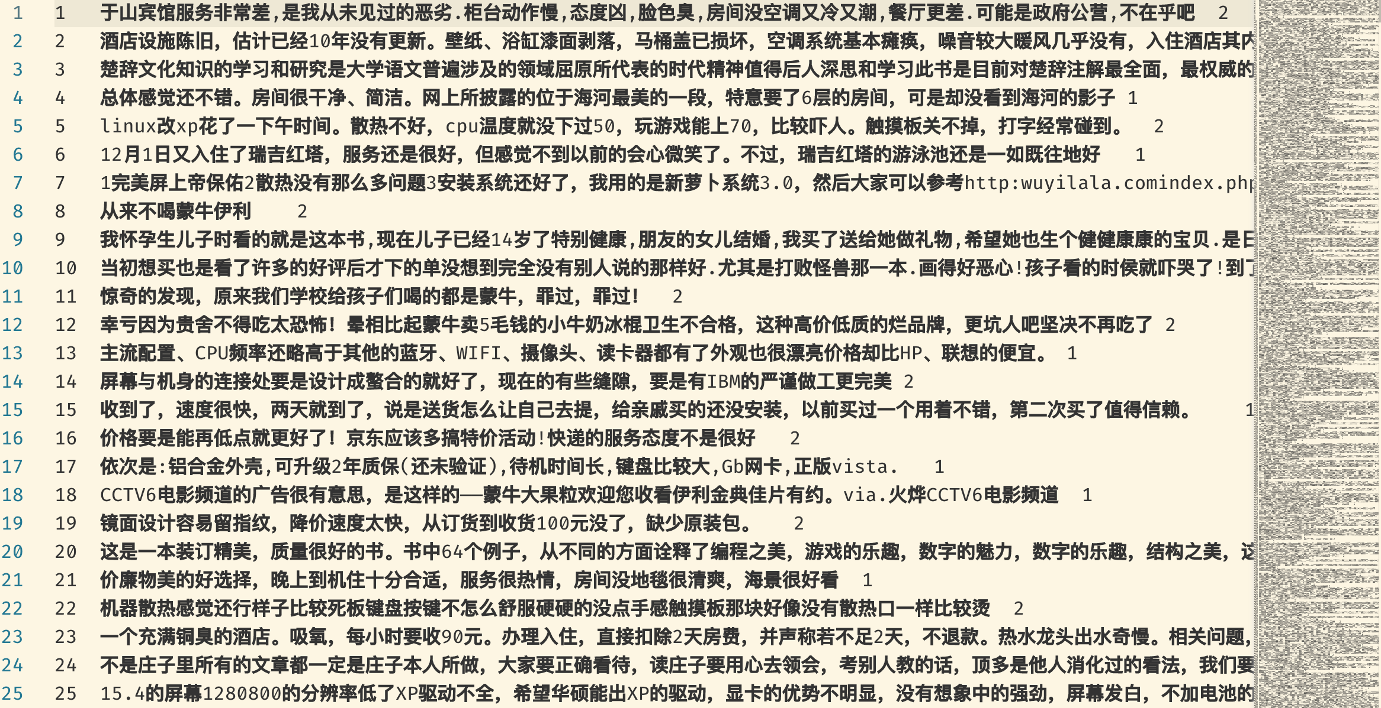

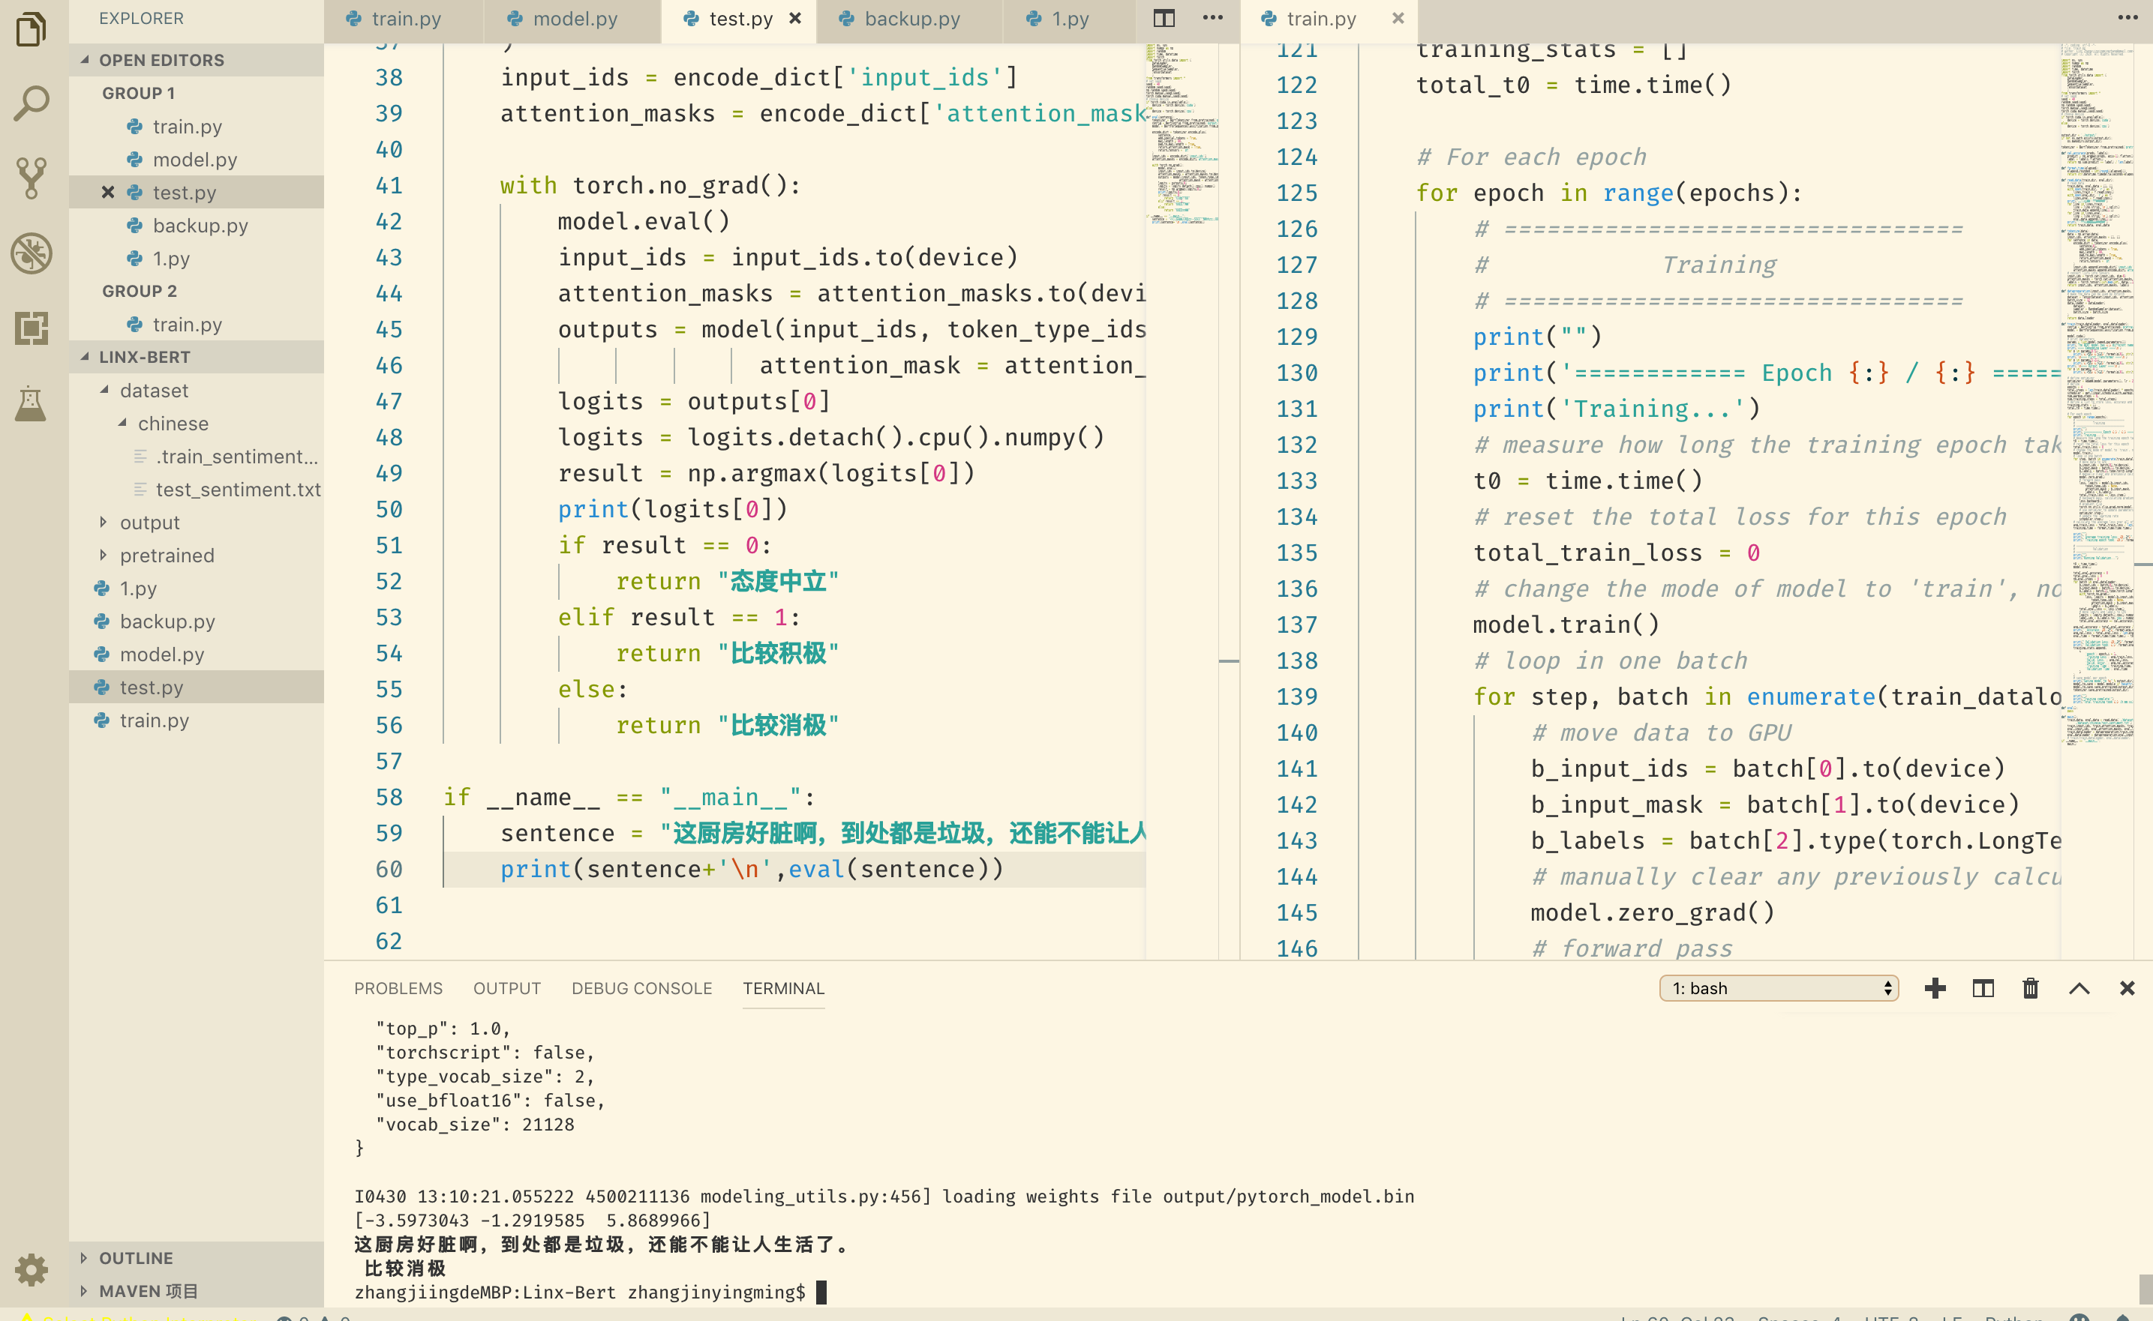

SYSTEM TEST

After testing by the local server, the entire system is confirmed to be able to run normally and provide a complete speech sentiment analysis service to the users.

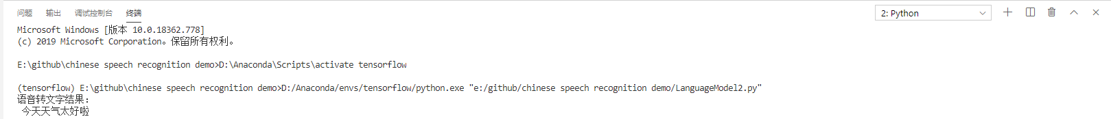
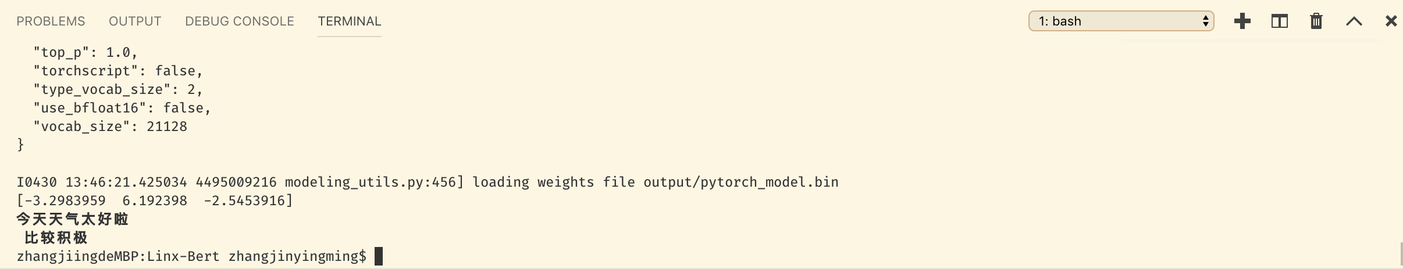

ACCEPTANCE TEST

Our purpose is to reach 80% on the performance of accuracy of speech recognition, ensure that audio can be uploaded in 2 second , ensure that Chinese Pinyin can be recognized at 90% accuracy ,ensure that Chinese character text can be recognized at 80% accuracy and ensure that text sentiment can be separated into ‘positive’, ‘negative’ and ‘neutral’
According to our test, upload time was less than 2 seconds and the recognize accuracy achieve 92%. Besides the final analysis performance reach 0.35604851901473483 in BLEU score, which is good among the other Speech Sentiment Analysis System.

