|  |  |  |
| --- | --- | --- |
| HTL_Logo | HTBLuVA Wien XXReife- und Diplomprüfung / Diplomprüfung |  |
| Prüfungsgebiet  **ENGLISCH** | | |
| Themenbereich 5 | | |
| 1 TECHNOLOGY & SCIENCE  2 CULTURE & LIFESTYLE  3 BUSINESS  4 JOBS & WORK EXPERIENCE  5 **VR AND THE METAVERSE**  6 ENVIRONMENT & ENERGY  **Frage 1: VR AND THE METAVERSE** | | |
| Bitte nicht auf die Angabe schreiben!  Der Angabe ist bei der Prüfung wieder abzugeben! | | |

VR AND THE METAVERSE

**Situation:**

You are working at a company that focuses on creating a Metaverse. You have been invited to your former school to talk in front of students and teachers.

**Individual long turn (4-6 minutes):**

In your presentation you should

- Explain the concept of a Metaverse  
- Describe the current status of VR and a Metaverse (Material 1)  
- Highlight the possible risks involved (Material 2)

**Interaction (6-8 minutes):**

After your speech, you start a conversation with another participant.

In your conversation you should

- evaluate how VR affects you

- suggest good ways to use a Metaverse (Material 3)

- argue how a Metaverse could affect society (Material 4)

You may want to use the materials given below.

Material 1:

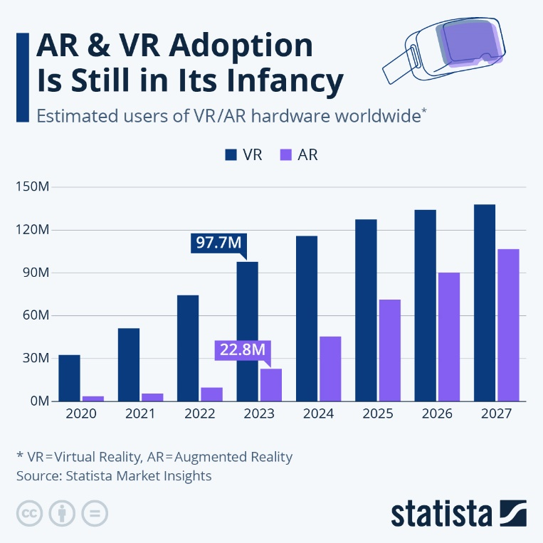

Source: https://www.statista.com/chart/28467/virtual-and-augmented-reality-adoption-forecast/

|  |  |
| --- | --- |
| Material 2: | Material 3: |
|  | Must-Know Metaverse Statistics and Predictions for 2023 |
| Source: https://www.thedigitalspeaker.com/what-are-the-dangers-of-the-metaverse/ | Source: https://www.tidio.com/blog/metaverse/ |

Material 4:

**5 Ways Meraverse affects society**

von Melendez Ken

1. At Work

As the world slowly recovers from the COVID-19 pandemic, many businesses and organizations have adopted a “work from home” strategy, either completely or partially. Because of this change in workplace culture, many routine events that used to take place in the office are being replaced by virtual ones.

Platforms such as Zoom, Google Meet, Discord, and many others have taken care of this so far, but still, leave much to be desired in terms of personal and connected interactions. By providing a 3D environment, the metaverse aspires to fill this gap. With the simple use of a VR headset or AR glasses, employees of a company will be able to enter a “virtual office” and brainstorm ideas with their coworkers while remaining in the comfort of their own homes.

And with AI, they will be able to be productive while taking time off, without having to worry about a piled-up workload when they return to work. Moreover, it will be easier for companies to pitch their ideas to potential investors all over the world. Surely, the possibilities for virtual offices are limitless.

2. Shopping

Major brands have already begun to integrate Metaverse technology into their operations to provide a more immersive shopping experience for their customers. Imagine being able to see how a piece of furniture will look in your space before making a purchase. Or how a dress fits you without physically trying it on. Or even walking through a virtual store to choose the items you want before checking out. Exciting, right?

Well, that’s the experience of shopping in the metaverse. Brands have made efforts to create integrated augmented reality to enhance the online shopping experience. For example, you can virtually try on makeup from brands such as L’Oréal and Avon via their website or app to find the perfect shade. Or use IKEA’s Place app that uses augmented reality to place furniture in your rooms so you can see how it will look in your home or office. And this is all in its early stages.

3. Entertainment and Gaming

Many live shows were canceled during the pandemic and artists had to come up with new ways to reach their fans. Rapper Travis Scott, for example, held a concert inside the popular video game “Fortnite,” which drew over 27 million people who entered using their avatars. While in the metaverse, the audience could purchase skins for their avatars as well as other kinds of virtual items. Post-pandemic, artists have continued to dabble in the plethora of opportunities that the metaverse presents to the media and entertainment industries.

In gaming, virtual reality is set to transform gaming platforms by creating the illusion of a realistic experience through the use of VR headsets, 3D images, spaces with sensory features and scents, and full display screens, allowing gamers a fully immersive experience.

4. Education

The metaverse will impact practical learning by allowing students to experience the process as part of their training, which will transform education into a more all-encompassing endeavor.

In some parts of the world, students can already take lessons by connecting with their teachers through immersive VR and AR technology from the comfort of their own homes. We’ve already seen this in Poland, where teachers are teaching science using the VR game Half-Life: Alyx. Immersive learning can have a longer-lasting impact on learners by making concepts clearer and more practical.

5. Travel

The most sought-after experience by many people is unquestionably the impact of the metaverse on travel. Most people have little time in their busy schedules to travel, and sometimes travel is simply too expensive. However, with the metaverse, you will be able to travel virtually anywhere in the world simply by strapping on a headset. In addition, when you physically visit a destination, you will have access to guided augmented reality tours that will enhance your travel experiences and help you learn more about the destination.

The metaverse is still in its early stages and newer ways for the technology to impact society will emerge as time goes by, eventually revolutionizing virtually all aspects of human life.

Source: https://blog.cindicator.com/5-effects-of-the-metaverse-on-society/