综合案例 & 阶段总结

案例展示与分析
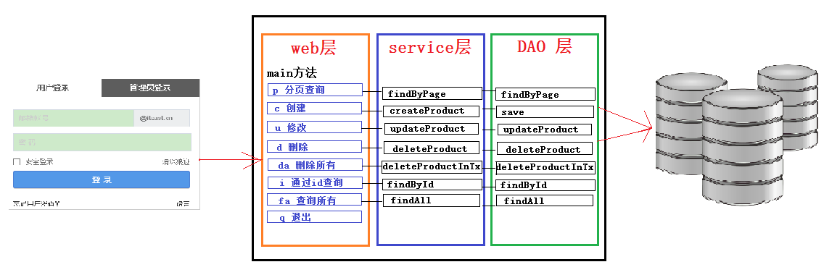

- 程序将划分层次
  - com.itheima.domain javaBean
  - com.itheima.utils 工具类
  - com.itheima.dao dao层
  - com.itheima.service service层（业务层，今天的情况内容非常少，直接调用dao，只有与业务挂钩时才能体现出来的）

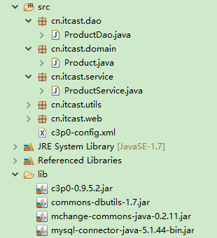

代码实现

准备数据

-- 创建数据库
create database day07;
-- 切换数据库
use day07;
-- 创建产品表
create table products (
pid int primary key auto_increment,
pname varchar(30),
price int,
category varchar(30)
);
-- 添加数据
insert into products(pid,pname,price,category) values(null,'联想',5000,'电脑办公');
insert into products(pid,pname,price,category) values(null,'海尔',3000,'家用电器');
insert into products(pid,pname,price,category) values(null,'雷神',7000,'电脑办公');
insert into products(pid,pname,price,category) values(null,'Jack Jones',500,'服装饰品');
insert into products(pid,pname,price,category) values(null,'真维斯',300,'服装饰品');
insert into products(pid,pname,price,category) values(null,'花花公子',1000,'服装饰品');
insert into products(pid,pname,price,category) values(null,'劲霸男装',3000,'服装饰品');
insert into products(pid,pname,price,category) values(null,'香奈儿',8000,'香水有毒');

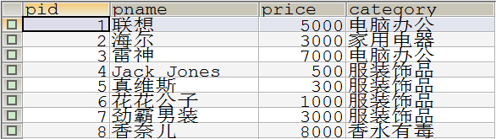

查询所有

public class WebDemo {
private static Scanner sc = new Scanner(System.in);

public static void main(String[] args) {
while (true) {
System.out.println("请输入操作码: ");
System.out.println("p:分页查询\tc:创建\tu:修改\td:删除\tda:批量删除\ti:通过id查询\tfa:查询所有\tq:退出\t");
String choice = sc.nextLine();
switch (choice) {
case "p":
findByPage();
break;
case "c":
createProduct();
break;
case "u":
updateProduct();
break;
case "d":
deleteProduct();
break;
case "da":
deleteByIdInTransaction();
break;
case "i":
findById();
break;
case "fa":
findAll();
break;
case "q":
System.out.println("感谢您的使用, 欢迎下次再来.");
System.exit(0);
break;
default :
System.out.println("输入有误, 请重新输入.");
break;
}
}
}

public class Product {
private int pid;
private String pname;
private int price;
private String category;
public int getPid() {
return pid;
}
public String getPname() {
return pname;
}
public int getPrice() {
return price;
}
public String getCategory() {
return category;
}
public void setPid(int pid) {
this.pid = pid;
}
public void setPname(String pname) {
this.pname = pname;
}
public void setPrice(int price) {
this.price = price;
}
public void setCategory(String category) {
this.category = category;
}
@Override
public String toString() {
return "Product [pid=" + pid + ", pname=" + pname + ", price=" + price + ", category=" + category + "]";
}
}

<?xml version="1.0" encoding="UTF-8"?>
<c3p0-config>
<!-- 默认配置, c3p0框架默认架子啊这段默认配置 -->
<default-config>
<!-- 配置 JDBC 四个基本属性 -->
<property name="driverClass">com.mysql.jdbc.Driver</property>
<property name="jdbcUrl">jdbc:mysql:///day04</property>
<property name="user">root</property>
<property name="password">123</property>
</default-config>
<!-- 可以自定义配置, 为这段配置起一个名字, c3p0指定该名称加载配置 -->
<named-config name="day07">
<property name="driverClass">com.mysql.jdbc.Driver</property>
<property name="jdbcUrl">jdbc:mysql:///day07</property>
<property name="user">root</property>
<property name="password">123</property>
</named-config>
</c3p0-config>

public class JDBCUtils {

// c3p0 数据库连接池对象属性
private static final ComboPooledDataSource dataSource = new ComboPooledDataSource("day07");
// 创建一个 ThreadLocal 对象
private static final ThreadLocal<Connection> local = new ThreadLocal<Connection>();

// 获取连接
public static Connection getConnection() throws SQLException {
Connection conn = null;

// Connection 对象优先从 ThreadLocal 中获取
conn = local.get();
// 如果 conn 为 null
if (conn == null) {
// 说明当前线程是第一次获取连接对象, 所以需要从数据库连接池中获取连接对象
conn = dataSource.getConnection();
// 然后将该连接对象存储到 local 中
local.set(conn);
}

// 返回连接
return conn;
}

// 获取数据库连接池对象
public static DataSource getDataSource() {
return dataSource;
}

// 提交
public static void commitAndCloseQuietly(Connection conn) {
// 调用 DBUtils 框架的方法
DbUtils.commitAndCloseQuietly(conn);
}

// 回滚
public static void rollbackAndCloseQuietly(Connection conn) {
// 调用 DBUtils 框架的方法
DbUtils.rollbackAndCloseQuietly(conn);
}

// 释放资源
public static void release(Connection conn, Statement stmt, ResultSet rs) {
if (rs != null) {
try {
rs.close();
} catch (SQLException e) {
e.printStackTrace();
}
rs = null;
}
release(conn, stmt);
}

public static void release(Connection conn, Statement stmt) {
if (stmt != null) {
try {
stmt.close();
} catch (SQLException e) {
e.printStackTrace();
}
stmt = null;
}
if (conn != null) {
try {
conn.close();
// 如果当前线程关闭连接时, 将 ThreadLocal 中存储的连接清除
local.remove();
} catch (SQLException e) {
e.printStackTrace();
}
conn = null;
}
}
}

dao层

// 查询所有
public List<Product> findAll() throws SQLException {
// 1. 创建一个 QueryRunner 对象, 将连接池作为参数传入
QueryRunner queryRunner = new QueryRunner(JDBCUtils.getDataSource());
String sql = "select * from products;";
List<Product> list = queryRunner.query(sql, new BeanListHandler<Product>(Product.class));
return list;
}

service层

public List<Product> findAll() {
ProductDao productDao = new ProductDao();
try {
List<Product> list = productDao.findAll();
return list;
} catch (SQLException e) {
e.printStackTrace();
return null;
}
}

web层入口

// 查看所有
private static void findAll() {
ProductService productService = new ProductService();
List<Product> list = productService.findAll();
if (list != null) {
for (Product product : list) {
System.out.println(product);
}
} else {
System.out.println("没有任何数据内容!");
}
}
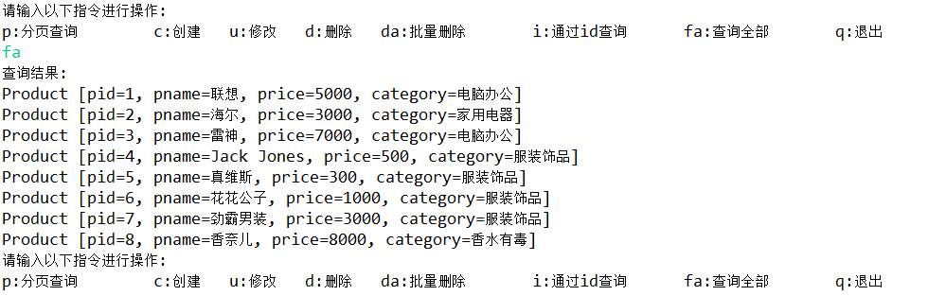

通过id查询详情

dao层

// 根据 id 查询
public Product findById(int pid) throws SQLException {
QueryRunner queryRunner = new QueryRunner(JDBCUtils.getDataSource());
String sql = "select * from products where pid = ?;";
Product product = queryRunner.query(sql, new BeanHandler<Product>(Product.class), pid);
return product;
}

service层

public Product findById(int pid) {
ProductDao productDao = new ProductDao();
try {
Product product = productDao.findById(pid);
return product;
} catch (SQLException e) {
e.printStackTrace();
return null;
}
}

web层入口

// 根据 id 查询
private static void findById() {
System.out.println("请输入要查询的商品 id : ");
String pid_str = sc.nextLine();
int pid = Integer.parseInt(pid_str);

ProductService productService = new ProductService();
Product product = productService.findById(pid);
if (product != null) {
System.out.println("商品信息: " + product);
} else {
System.out.println("该编号的商品不存在!");
}
}

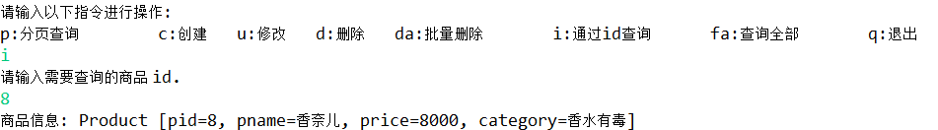

添加

dao层

// 保存
public void save(Product product) throws SQLException {
QueryRunner queryRunner = new QueryRunner(JDBCUtils.getDataSource());
String sql = "insert into products values(null,?,?,?);";
Object[] params = {product.getPname(), product.getPrice(), product.getCategory()};
queryRunner.update(sql, params);
}

service层

// 创建商品, 并将商品的信息保存到数据库中
public boolean createProduct(Product product) {
boolean flag = false;

ProductDao productDao = new ProductDao();
try {
productDao.save(product);
flag = true;
} catch (SQLException e) {
e.printStackTrace();
}

return flag;
}

web层入口

// 创建用户
private static void createProduct() {
System.out.println("请输入商品的名称: ");
String pname = sc.nextLine();
System.out.println("请输入商品的价格 : ");
String price_str = sc.nextLine();
int price = Integer.parseInt(price_str);
System.out.println("请输入商品的分类 :");
String category = sc.nextLine();

Product product = new Product();
product.setPname(pname);
product.setPrice(price);
product.setCategory(category);

ProductService productService = new ProductService();
boolean result = productService.createProduct(product);

if (result == true) {
System.out.println("商品保存成功!");
} else {
System.out.println("商品保存失败!");
}
}

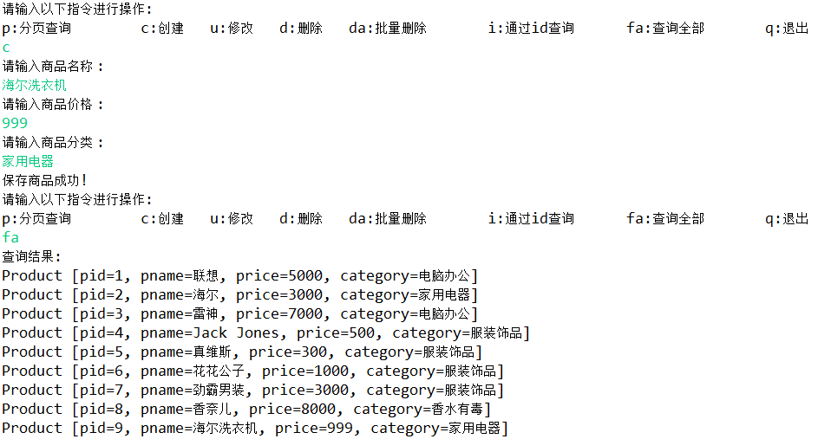

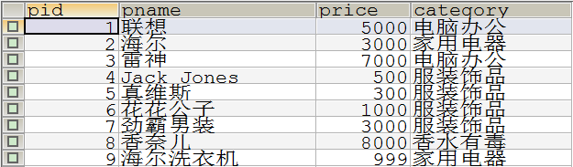

修改

dao层

// 更新数据库中对应编号的商品
public void updateProduct(Product product) throws SQLException {
QueryRunner queryRunner = new QueryRunner(JDBCUtils.getDataSource());
String sql = "update products set pname=?,price=?,category=? where pid=?;";
Object[] params = {product.getPname(), product.getPrice(), product.getCategory(), product.getPid()};
queryRunner.update(sql, params);
}

service层

// 更新商品信息
public boolean updateProduct(Product product2) {
boolean flag = false;

ProductDao productDao = new ProductDao();
try {
productDao.updateProduct(product2);
flag = true;
} catch (SQLException e) {
e.printStackTrace();
}

return flag;
}

web层入口

// 更新用户
private static void updateProduct() {
System.out.println("请输入需要修改的商品编号 : ");
String pid_str = sc.nextLine();
int pid = Integer.parseInt(pid_str);

// 先查询该 pid 是否存在
ProductService productService = new ProductService();
Product product = productService.findById(pid);
if (product == null) {
System.out.println("该编号的商品不存在!");
return;
}

// 存在, 显示信息
System.out.println("商品信息为: " + product);

System.out.println("请输入修改后商品的名称 : ");
String pname = sc.nextLine();
System.out.println("请输入修改后商品的价格 : ");
String price_str = sc.nextLine();
int price = Integer.parseInt(price_str);
System.out.println("请输入修改后商品的分类 : ");
String category = sc.nextLine();

Product product2 = new Product();
product2.setPid(pid);
product2.setPname(pname);
product2.setPrice(price);
product2.setCategory(category);

// 调用更新方法
boolean result = productService.updateProduct(product2);
if (result == false) {
System.out.println("商品更新失败!");
} else {
System.out.println("商品更新成功!");
}
}

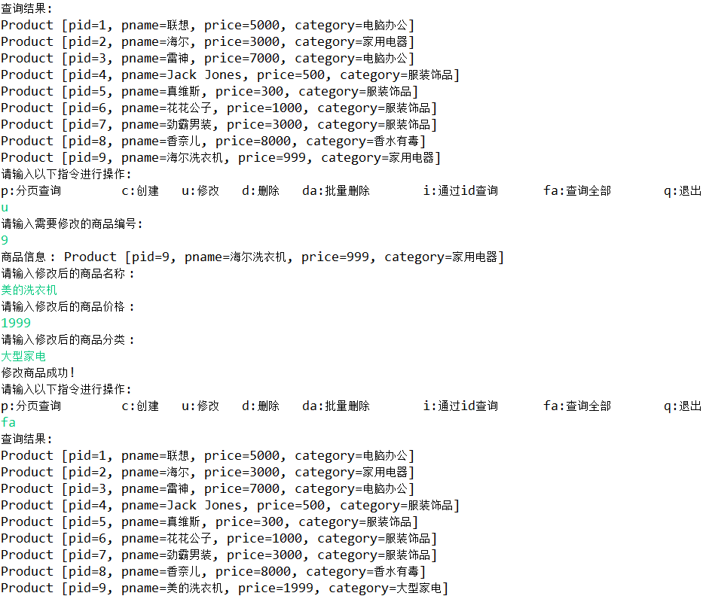

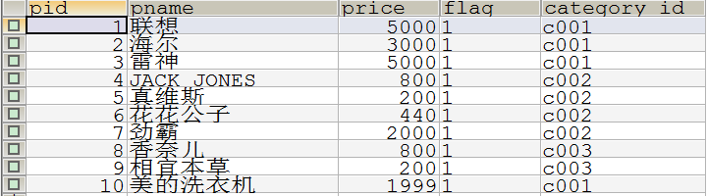

通过id删除

dao层

// 删除商品
public void deleteProduct(int pid) throws SQLException {
QueryRunner queryRunner = new QueryRunner(JDBCUtils.getDataSource());
String sql = "delete from products where pid = ?;";
queryRunner.update(sql, pid);
}

service层

// 根据商品 pid 删除商品
public boolean deleteProduct(int pid) {
boolean flag = false;

ProductDao productDao = new ProductDao();
try {
productDao.deleteProduct(pid);
flag = true;
} catch (SQLException e) {
e.printStackTrace();
}

return flag;
}

入口

// 删除用户
private static void deleteProduct() {
System.out.println("请输入需要删除的商品编号 :");
String pid_str = sc.nextLine();
int pid = Integer.parseInt(pid_str);

ProductService productService = new ProductService();
Product product = productService.findById(pid);

if (product == null) {
System.out.println("该编号的商品不存在!");
} else {
System.out.println("商品信息 : " + product);
System.out.println("请再次确认是否真的要删除 y (确认) / n (取消) :");
String choice = sc.nextLine();
if ("y".equalsIgnoreCase(choice)) {
boolean flag = productService.deleteProduct(pid);
if (flag == true) {
System.out.println("商品删除成功!");
} else {
System.out.println("商品删除失败!");
}
} else {
System.out.println("该操作已取消!");
}
}
}

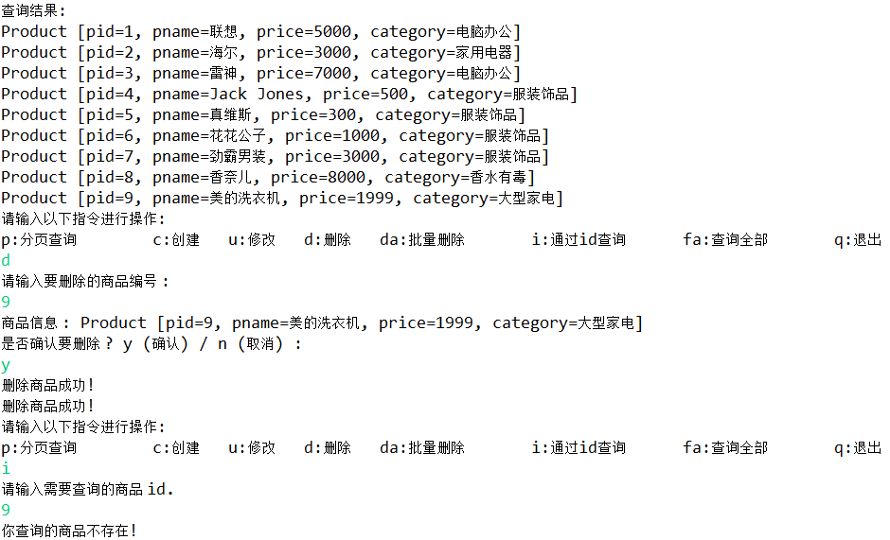

批量删除

Dao层：

// 带事务的删除方法
public void deleteProductInTransaction(int pid) throws SQLException {
// 创建一个 QueryRunner 对象, 不要传入连接池对象
QueryRunner queryRunner = new QueryRunner();
Connection conn = JDBCUtils.getConnection();
String sql = "delete from products where pid=?;";
queryRunner.update(conn, sql, pid);
}

service层

// 带事务的删除
public boolean deleteProductInTransaction(List<Integer> pidList) {
boolean flag = false;
Connection conn = null;
try {
// 开启事务
conn = JDBCUtils.getConnection();
conn.setAutoCommit(false);
// 调用删除方法
ProductDao productDao = new ProductDao();

// 循环调用删除
for (Integer pid : pidList) {
productDao.deleteProductInTransaction(pid);
}

// 提交事务
JDBCUtils.commitAndCloseQuietly(conn);
flag = true;
} catch (SQLException e) {
e.printStackTrace();
// 回滚事务
JDBCUtils.rollbackAndCloseQuietly(conn);
return flag;
}

return flag;
}

web层入口

// 批量删除
private static void deleteByIdInTransaction() {
System.out.println("进入批量删除模式,请输入要删除商品的编号, -1 表示退出 :");

ArrayList<Integer> pidList = new ArrayList<Integer>();
ProductService productService = new ProductService();

while (true) {
String pid_str = sc.nextLine();
int pid = Integer.parseInt(pid_str);

if (pid == -1) {
break;
}

Product product = productService.findById(pid);
if (product == null) {
System.out.println("该编号的商品不存在, 请继续输入, -1 表示退出 :");
continue;
} else {
System.out.println("商品信息: " + product);
}

// 将 pid 加入到集合中
pidList.add(pid);
}

System.out.println("请确认要删除共 " + pidList.size() + " 件商品吗 ? y (确认) / n (取消) :");
String choice = sc.nextLine();

if ("y".equalsIgnoreCase(choice)) {
boolean flag = productService.deleteProductInTransaction(pidList);
if (flag == true) {
System.out.println("商品删除成功!");
} else {
System.out.println("商品删除失败!");
return;
}
} else {
// 取消
System.out.println("操作已取消.");
}
}

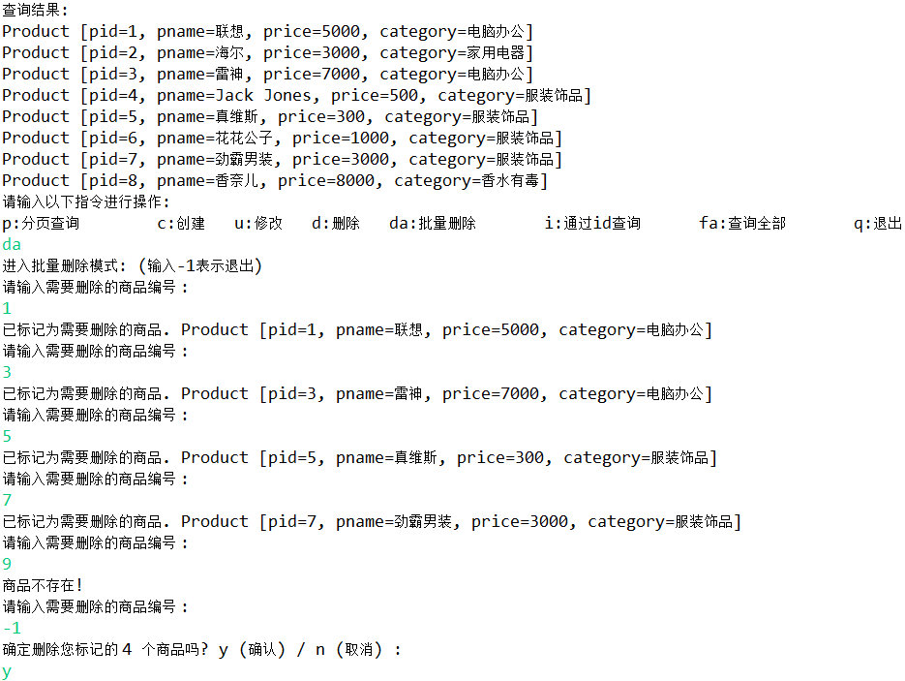
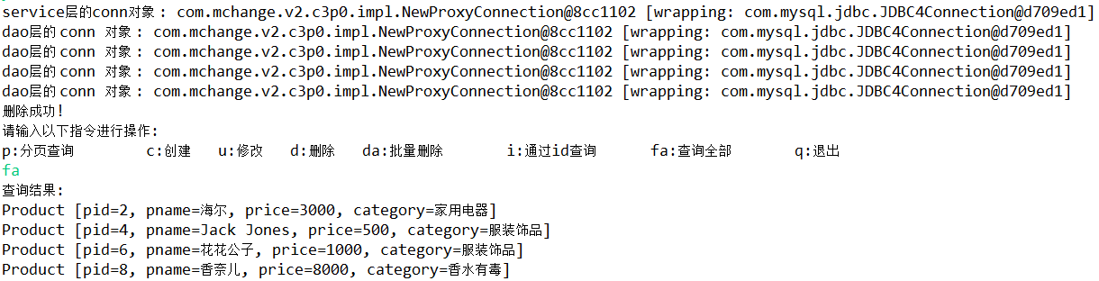
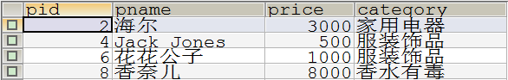

分页查询

truncate table products;

insert into products(pid,pname,price,category) values(null,'联想1',5000,'电脑办公');
insert into products(pid,pname,price,category) values(null,'海尔1',3000,'家用电器');
insert into products(pid,pname,price,category) values(null,'雷神1',7000,'电脑办公');
insert into products(pid,pname,price,category) values(null,'Jack Jones1',500,'服装饰品');
insert into products(pid,pname,price,category) values(null,'真维斯1',300,'服装饰品');
insert into products(pid,pname,price,category) values(null,'花花公子1',1000,'服装饰品');
insert into products(pid,pname,price,category) values(null,'劲霸男装1',3000,'服装饰品');
insert into products(pid,pname,price,category) values(null,'香奈儿1',8000,'香水有毒');

insert into products(pid,pname,price,category) values(null,'联想2',5000,'电脑办公');
insert into products(pid,pname,price,category) values(null,'海尔2',3000,'家用电器');
insert into products(pid,pname,price,category) values(null,'雷神2',7000,'电脑办公');
insert into products(pid,pname,price,category) values(null,'Jack Jones2',500,'服装饰品');
insert into products(pid,pname,price,category) values(null,'真维斯2',300,'服装饰品');
insert into products(pid,pname,price,category) values(null,'花花公子2',1000,'服装饰品');
insert into products(pid,pname,price,category) values(null,'劲霸男装2',3000,'服装饰品');
insert into products(pid,pname,price,category) values(null,'香奈儿2',8000,'香水有毒');

insert into products(pid,pname,price,category) values(null,'联想3',5000,'电脑办公');
insert into products(pid,pname,price,category) values(null,'海尔3',3000,'家用电器');
insert into products(pid,pname,price,category) values(null,'雷神3',7000,'电脑办公');
insert into products(pid,pname,price,category) values(null,'Jack Jones3',500,'服装饰品');
insert into products(pid,pname,price,category) values(null,'真维斯3',300,'服装饰品');
insert into products(pid,pname,price,category) values(null,'花花公子3',1000,'服装饰品');
insert into products(pid,pname,price,category) values(null,'劲霸男装3',3000,'服装饰品');
insert into products(pid,pname,price,category) values(null,'香奈儿3',8000,'香水有毒');

Dao层

// 根据页码返回对应条数的数据
public List<Product> findByPage(int index, int count) throws SQLException {
// 1. QueryRunner 对象
QueryRunner queryRunner = new QueryRunner(JDBCUtils.getDataSource());
// 2. query 方法
String sql = "select * from products limit ?, ?;";
Object[] params = {index, count};
List<Product> list = queryRunner.query(sql, new BeanListHandler<Product>(Product.class), params);

return list;
}

Service层

// 分页查询
public List<Product> findByPage(int page) {

List<Product> list = new ArrayList<Product>();

// page -> 1, 2, 3, 4, ....
// index 0, 8, 16, 24 ...

int count = 8;
int index = (page - 1) * 8;

// dao 层
ProductDao productDao = new ProductDao();
try {
list = productDao.findByPage(index, count);
} catch (SQLException e) {
e.printStackTrace();
}

return list;
}

Web层入口

// 分页查询
private static void findByPage() {
// 1. 提示用户需要查询的页码
System.out.println("请输入需要查询商品的页码 :");
int page = Integer.parseInt(sc.nextLine());

// 2. 创建一个 service 层对象
ProductService productService = new ProductService();
List<Product> list = productService.findByPage(page);

// 3. 判断返回的 list 结果
if (list.isEmpty()) {
System.out.println("该页码没有对应的商品信息.");
} else {
// 有数据
for (Product product : list) {
System.out.println(product);
}
}
}

