**HAPTICS**

|  |  |
| --- | --- |
| **Type** | Encyclopedia Article |
| **Date Added** | Wednesday, March 27, 2013 4:44:45 PM |
| **Modified** | Wednesday, March 27, 2013 4:44:45 PM |

### Attachments

* + Microsoft Word - DCPMM_basics.DOC - dcpmm_basics.pdf
  + _.html

### Tags:

* + - Andre-Marie Ampere
    - commutator
    - direct current rotating machines
    - electric motors
    - Hippolyte Pixii
    - rotary electrical switch

## Rock Paper Scissors Playing Glove – Grathio Labs

|  |  |
| --- | --- |
| **Type** | Web Page |
| **URL** | <http://grathio.com/2010/03/rock_paper_scissors_training_glove/> |
| **Accessed** | Wednesday, March 27, 2013 9:43:50 PM |
| **Date Added** | Wednesday, March 27, 2013 9:43:50 PM |
| **Modified** | Wednesday, March 27, 2013 9:43:50 PM |

### Attachments

* + Rock Paper Scissors Playing Glove – Grathio Labs

## Project Proposal.pdf

|  |  |
| --- | --- |
| **Type** | Attachment |
| **Date Added** | Wednesday, March 27, 2013 4:16:30 PM |
| **Modified** | Wednesday, March 27, 2013 4:16:30 PM |

### Tags:

* + goal
  + haptic
  + proposal
  + timeline

## Meet The Tacit Project. It’s Sonar For The Blind. – Grathio Labs

|  |  |
| --- | --- |
| **Type** | Web Page |
| **URL** | <http://grathio.com/2011/08/meet-the-tacit-project-its-sonar-for-the-blind/> |
| **Accessed** | Wednesday, March 27, 2013 7:11:07 PM |
| **Date Added** | Wednesday, March 27, 2013 7:11:07 PM |
| **Modified** | Wednesday, March 27, 2013 7:11:07 PM |

### Tags:

* + diy
  + haptic
  + ultrasonic sensors

### Notes:

* + More importantly even small vibrations, if they’re constant, can cause nerve damage.

experimental muscle materials

use some small servomotors with cushions on the ends, these can be quickly and precisely positioned in a lot of positions and give higher fidelity than solenoids

three different types of touch-sensitive nerves, Merkel cells which detect pressure, Pacinian and Messiner’s which sense the start and finish of touches

middle finger loop to support

velcro wrist strap

Shapelock or other Polycaprolactone plastic to build solid mounts for the sensors and servos. (It’s plastic that melts in hot water and can be formed by hand.)

The gauntlet is made from:   
  
    (1) 12″x12″ (30cmx30cm) piece of 3mm neoprene.   
    12″ (30cm) of hook and loop fastener (Velcro)   
    4″ (10cm) of bias tape.

Warning: Neoprene is a big challenge to sew. It likes to drop stitches like crazy on a sewing machine.  Use the biggest needle you can, thick thread, and if possible place a non-neoprene strip where you sew.

1) Don’t attach the electronics permanently to the neoprene. Use snaps or velcro or something so that it can be easily removed and laundered.

When attaching velcro to the electronics or plastic supports, super glue worked better than any other adhesive or epoxy.

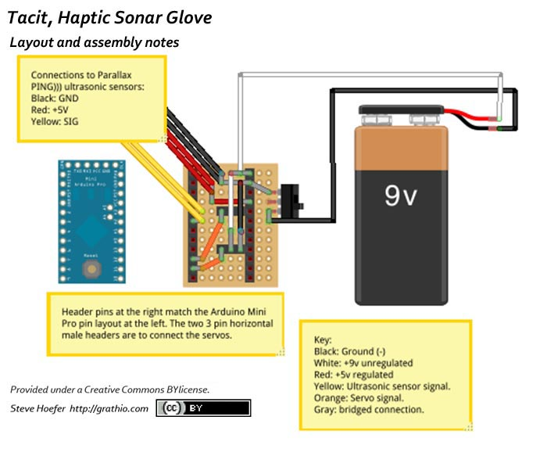

### Attachments

* + Meet The Tacit Project. It’s Sonar For The Blind. – Grathio Labs
  + haptic glove gauntlet outlines_p1 - haptic_glove_gauntlet_outlines.pdf

## Make your own instrumented glove

|  |  |
| --- | --- |
| **Type** | Web Page |
| **URL** | <http://xspasm.com/x/sfu/vmi/PCVR.html> |
| **Accessed** | Wednesday, March 27, 2013 9:58:51 PM |
| **Date Added** | Wednesday, March 27, 2013 9:58:51 PM |
| **Modified** | Wednesday, March 27, 2013 9:58:51 PM |

### Notes:

* + have the sensor flexed, although the joint is actually straight.

For bidirectional joint movements it is necessary to join two PG sensors back to back

It is recommendable to cover the lead-sensor interface with some heat-shrink tube

it is good practice to shield the sensor, as it is a high impedant device, from the ever present electromagnetic interference by attaching or perhaps spraying a highly conductive layer on both sides of the sensor and (virtually) grounding this layer, i.e. keeping it at zero potential.

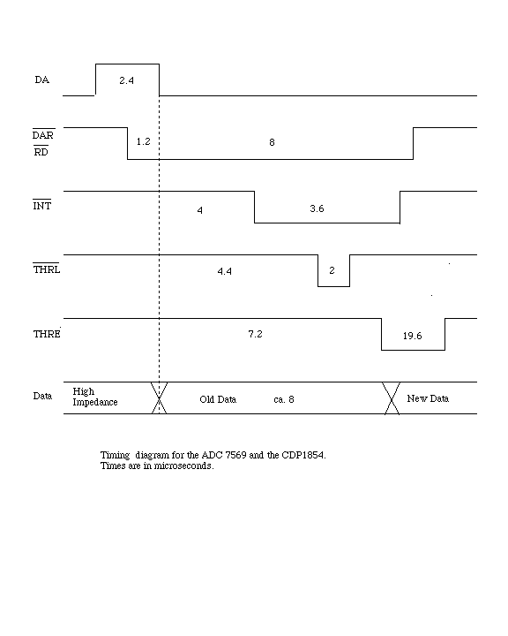

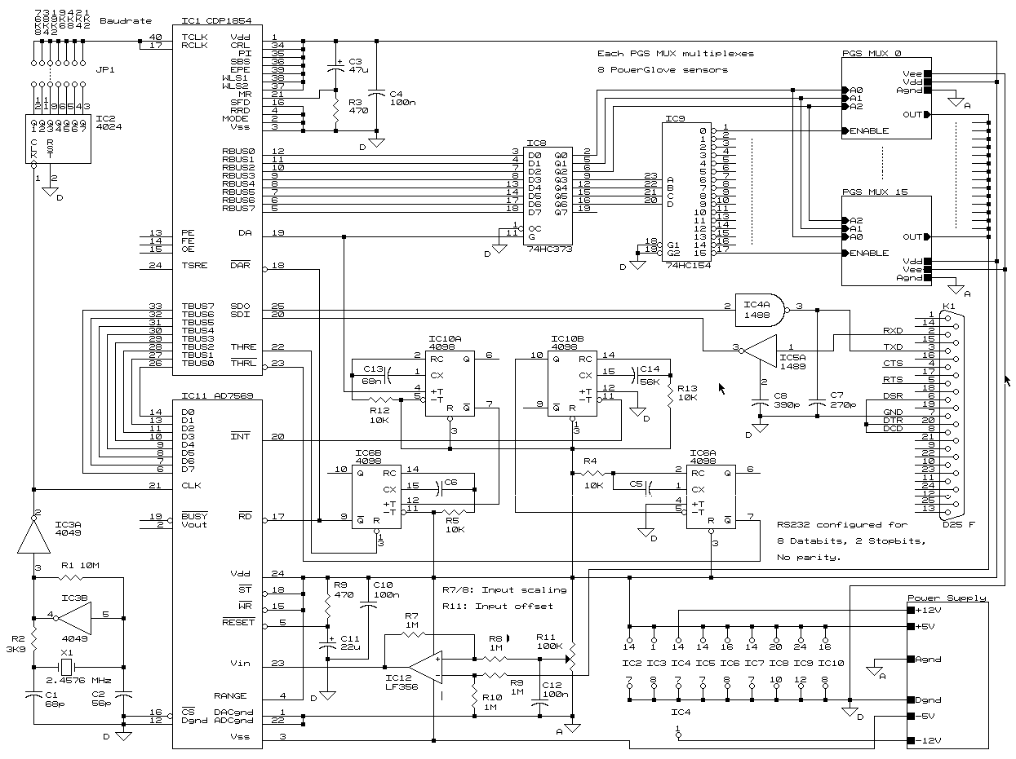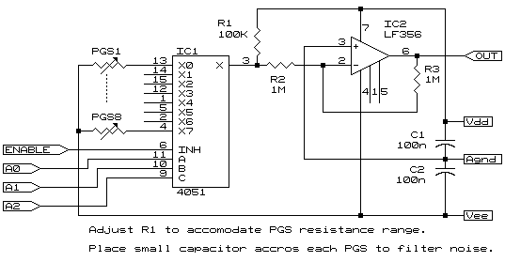

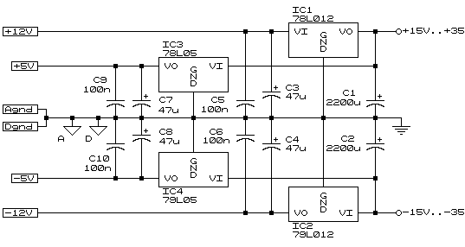

### Attachments

* + Make your own instrumented glove

## Haptics-in-Touchscreen-Hand-Held-Devices.pdf

|  |  |
| --- | --- |
| **Type** | Attachment |
| **Date Added** | Wednesday, March 27, 2013 4:17:05 PM |
| **Modified** | Wednesday, March 27, 2013 4:17:05 PM |

### Tags:

* + hand-held
  + haptic
  + immersion
  + touch
  + touchscreen

## Enhancing-Device-Design-Through-Tactile-Feedback.pdf

|  |  |
| --- | --- |
| **Type** | Attachment |
| **Date Added** | Wednesday, March 27, 2013 4:18:15 PM |
| **Modified** | Wednesday, March 27, 2013 4:18:15 PM |

### Tags:

* + feedback
  + haptic
  + immersion
  + tactile

## Changing Vibration Alerting Signal | Application Bulletin

|  |  |
| --- | --- |
| **Type** | Web Page |
| **URL** | <http://www.precisionmicrodrives.com/application-notes-technical-guides/application-bulletins/ab-013-advanced-vibration-alerting-waveforms> |
| **Accessed** | Wednesday, March 27, 2013 6:48:57 PM |
| **Date Added** | Wednesday, March 27, 2013 6:48:57 PM |
| **Modified** | Wednesday, March 27, 2013 6:48:57 PM |

### Attachments

* + Changing Vibration Alerting Signal | Application Bulletin

## Bryan Cera's 3D-Printed Glove Doubles as a Cellphone (Video) | Ecouterre

|  |  |
| --- | --- |
| **Type** | Web Page |
| **URL** | <http://www.ecouterre.com/bryan-ceras-3d-printed-glove-doubles-as-a-cellphone-video/> |
| **Accessed** | Wednesday, March 27, 2013 8:10:24 PM |
| **Date Added** | Wednesday, March 27, 2013 8:10:24 PM |
| **Modified** | Wednesday, March 27, 2013 8:10:24 PM |

### Notes:

* + the functionality of the device depends on the dysfunctionality of the wearer

### Attachments

* + Bryan Cera's 3D-Printed Glove Doubles as a Cellphone (Video) | Ecouterre

### Tags:

* + - 3d printable

## Brainstorming.docx

|  |  |
| --- | --- |
| **Type** | Attachment |
| **Date Added** | Wednesday, March 27, 2013 4:20:11 PM |
| **Modified** | Wednesday, March 27, 2013 4:20:11 PM |

### Tags:

* + actuator
  + crisping techniques
  + haptic driver
  + precision microdrives
  + pulse width modulation
  + pwm
  + system level

## biphenyl.org » Blog Archive » Make the Future You Imagined: The Power Glove — 20th Anniversary Edition

|  |  |
| --- | --- |
| **Type** | Web Page |
| **URL** | <http://biphenyl.org/blog/2009/04/03/the-power-glove-20th-anniversary-edition/> |
| **Accessed** | Thursday, March 28, 2013 12:12:27 PM |
| **Date Added** | Thursday, March 28, 2013 12:12:27 PM |
| **Modified** | Thursday, March 28, 2013 12:12:27 PM |

### Notes:

* + Java program that takes the input and dumps it directly to a text file.

### Attachments

* + Power Glove 20th Anniversary Edition - a set on Flickr
  + PGSchematic.pdf

### Tags:

* + - interface
    - java
    - power glove
    - schematic
  + CD74HC4067, CD74HCT4067 (Rev. C) - cd74hc4067.pdf
  + biphenyl.org » Blog Archive » Make the Future You Imagined: The Power Glove — 20th Anniversary Edition
  + ADXL330 Small, Low Power, 3-Axis ±3 g i MEMS® Accelerometer Data Sheet (Rev. A) - ADXL330.pdf
  + 3985361

### Tags:

* + - instructions
    - power glove
    - video

**INTERFACES**

## USB Low Pin Kit

|  |  |
| --- | --- |
| **Type** | Web Page |
| **URL** | <http://electronics-lab.com/projects/mcu/016/index.html> |
| **Accessed** | Wednesday, March 27, 2013 8:38:06 PM |
| **Date Added** | Wednesday, March 27, 2013 8:38:06 PM |
| **Modified** | Wednesday, March 27, 2013 8:38:06 PM |

### Attachments

* + USB Low Pin Kit

**MOTORS**

## Vibration Motor Experiment | Waterproofing / Overmoulding

|  |  |
| --- | --- |
| **Type** | Web Page |
| **URL** | <http://www.precisionmicrodrives.com/application-notes-technical-guides/application-bulletins/ab-016-experiments-in-waterproofing-and-overmoulding-vibration-motors> |
| **Accessed** | Wednesday, March 27, 2013 6:49:12 PM |
| **Date Added** | Wednesday, March 27, 2013 6:49:12 PM |
| **Modified** | Wednesday, March 27, 2013 6:49:12 PM |

### Attachments

* + Vibration Motor Experiment | Waterproofing / Overmoulding

## Mobile / Cell Phone | Vibration Motors | Best Practices

|  |  |
| --- | --- |
| **Type** | Web Page |
| **URL** | <http://www.precisionmicrodrives.com/application-notes-technical-guides/application-bulletins/ab-008-vibration-motor-best-practices-from-the-mobile-cell-phone-industry> |
| **Accessed** | Wednesday, March 27, 2013 6:48:21 PM |
| **Date Added** | Wednesday, March 27, 2013 6:48:21 PM |
| **Modified** | Wednesday, March 27, 2013 6:48:21 PM |

### Attachments

* + Mobile / Cell Phone | Vibration Motors | Best Practices

## Miniature Vibration Motor | User-Interfaces & Controls

|  |  |
| --- | --- |
| **Type** | Web Page |
| **URL** | <http://www.precisionmicrodrives.com/application-notes-technical-guides/application-bulletins/ab-014-mechanical-layout-of-vibration-motors-for-typical-user-interfaces-and-controls> |
| **Accessed** | Wednesday, March 27, 2013 6:49:04 PM |
| **Date Added** | Wednesday, March 27, 2013 6:49:04 PM |
| **Modified** | Wednesday, March 27, 2013 6:49:04 PM |

### Attachments

* + Miniature Vibration Motor | User-Interfaces & Controls

## Electromagnetic Compatibility (EMC / EMI) | Vibrating Motors

|  |  |
| --- | --- |
| **Type** | Web Page |
| **URL** | <http://www.precisionmicrodrives.com/application-notes-technical-guides/application-bulletins/ab-005-electromagnetic-compatibility-with-vibration-motors> |
| **Accessed** | Wednesday, March 27, 2013 6:47:33 PM |
| **Date Added** | Wednesday, March 27, 2013 6:47:33 PM |
| **Modified** | Wednesday, March 27, 2013 6:47:33 PM |

### Attachments

* + Electromagnetic Compatibility (EMC / EMI) | Vibrating Motors

## Discrete H-bridge For Enhanced Vibration Control | Guide

|  |  |
| --- | --- |
| **Type** | Web Page |
| **URL** | <http://www.precisionmicrodrives.com/application-notes-technical-guides/application-bulletins/ab-002-discrete-h-bridge-circuit-for-enhanced-vibration-motor-control-haptic-feedback> |
| **Accessed** | Wednesday, March 27, 2013 6:46:28 PM |
| **Date Added** | Wednesday, March 27, 2013 6:46:28 PM |
| **Modified** | Wednesday, March 27, 2013 6:46:28 PM |

### Attachments

* + Discrete H-bridge For Enhanced Vibration Control | Guide

## DC Vibration Motor | Lifetime | MTTF |FIT

|  |  |
| --- | --- |
| **Type** | Web Page |
| **URL** | <http://www.precisionmicrodrives.com/application-notes-technical-guides/application-bulletins/ab-019-lifetime-of-vibration-motors> |
| **Accessed** | Wednesday, March 27, 2013 6:49:30 PM |
| **Date Added** | Wednesday, March 27, 2013 6:49:30 PM |
| **Modified** | Wednesday, March 27, 2013 6:49:30 PM |

### Attachments

* + DC Vibration Motor | Lifetime | MTTF |FIT

**DRIVERS**

## Driving Brushless Vibration Motors | Long-Life Motor | Guide

|  |  |
| --- | --- |
| **Type** | Web Page |
| **URL** | <http://www.precisionmicrodrives.com/application-notes-technical-guides/application-bulletins/ab-018-driving-brushless-vibration-motors> |
| **Accessed** | Wednesday, March 27, 2013 6:49:28 PM |
| **Date Added** | Wednesday, March 27, 2013 6:49:28 PM |
| **Modified** | Wednesday, March 27, 2013 6:49:28 PM |

### Attachments

* + Driving Brushless Vibration Motors | Long-Life Motor | Guide

## Driver Circuits for Vibration Motors with MOSFET Guide

|  |  |
| --- | --- |
| **Type** | Web Page |
| **URL** | <http://www.precisionmicrodrives.com/application-notes-technical-guides/application-bulletins/ab-001-discrete-driver-circuits-for-vibration-motors> |
| **Accessed** | Wednesday, March 27, 2013 6:45:36 PM |
| **Date Added** | Wednesday, March 27, 2013 6:45:36 PM |
| **Modified** | Wednesday, March 27, 2013 6:45:36 PM |

### Attachments

* + Driver Circuits for Vibration Motors with MOSFET Guide

**ICs**

## Mini Vibrating Motors | Integrated Driver Circuits | Guide

|  |  |
| --- | --- |
| **Type** | Web Page |
| **URL** | <http://www.precisionmicrodrives.com/application-notes-technical-guides/application-bulletins/ab-017-integrated-driver-circuits-for-vibration-motors> |
| **Accessed** | Wednesday, March 27, 2013 6:49:18 PM |
| **Date Added** | Wednesday, March 27, 2013 6:49:18 PM |
| **Modified** | Wednesday, March 27, 2013 6:49:18 PM |

### Attachments

* + Mini Vibrating Motors | Integrated Driver Circuits | Guide

**POWERSOURCE**

## Electrical Techniques for Using Different Power Sources

|  |  |
| --- | --- |
| **Type** | Web Page |
| **URL** | <http://www.precisionmicrodrives.com/application-notes-technical-guides/application-bulletins/ab-011-electrical-techniques-for-using-different-power-sources> |
| **Accessed** | Wednesday, March 27, 2013 6:48:45 PM |
| **Date Added** | Wednesday, March 27, 2013 6:48:45 PM |
| **Modified** | Wednesday, March 27, 2013 6:48:45 PM |

### Attachments

* + Electrical Techniques for Using Different Power Sources

**PULSE WIDTH MODULATION**

## Simple DC motor PWM speed control

|  |  |
| --- | --- |
| **Type** | Web Page |
| **URL** | <http://electronics-lab.com/projects/motor_light/005/index.html> |
| **Accessed** | Wednesday, March 27, 2013 8:29:42 PM |
| **Date Added** | Wednesday, March 27, 2013 8:29:42 PM |
| **Modified** | Wednesday, March 27, 2013 8:29:42 PM |

### Attachments

* + Simple DC motor PWM speed control

## Pulse generator

|  |  |
| --- | --- |
| **Type** | Web Page |
| **URL** | <http://electronics-lab.com/projects/oscillators_timers/007/index.html> |
| **Accessed** | Wednesday, March 27, 2013 8:33:53 PM |
| **Date Added** | Wednesday, March 27, 2013 8:33:53 PM |
| **Modified** | Wednesday, March 27, 2013 8:33:53 PM |

### Attachments

* + Pulse generator

## Driving Vibration Motors with Pulse Width Modulation | PWM

|  |  |
| --- | --- |
| **Type** | Web Page |
| **URL** | <http://www.precisionmicrodrives.com/application-notes-technical-guides/application-bulletins/ab-012-driving-vibration-motors-with-pwm> |
| **Accessed** | Wednesday, March 27, 2013 6:48:50 PM |
| **Date Added** | Wednesday, March 27, 2013 6:48:50 PM |
| **Modified** | Wednesday, March 27, 2013 6:48:50 PM |

### Attachments

* + Driving Vibration Motors with Pulse Width Modulation | PWM

## Adjustable High/Low Frequency Sine wave generator

|  |  |
| --- | --- |
| **Type** | Web Page |
| **URL** | <http://electronics-lab.com/projects/oscillators_timers/003/index.html> |
| **Accessed** | Wednesday, March 27, 2013 8:32:12 PM |
| **Date Added** | Wednesday, March 27, 2013 8:32:12 PM |
| **Modified** | Wednesday, March 27, 2013 8:32:12 PM |

### Attachments

* + Adjustable High/Low Frequency Sine wave generator

**ECCENTRIC ROTATING MASS (ERM) VIBRATION MOTOR**

## Understanding Eccentric Rotating Mass (ERM) Vibration Motor

|  |  |
| --- | --- |
| **Type** | Web Page |
| **URL** | <http://www.precisionmicrodrives.com/application-notes-technical-guides/application-bulletins/ab-004-understanding-erm-characteristics-for-vibration-applications> |
| **Accessed** | Wednesday, March 27, 2013 6:47:10 PM |
| **Date Added** | Wednesday, March 27, 2013 6:47:10 PM |
| **Modified** | Wednesday, March 27, 2013 6:47:10 PM |

### Attachments

* + Understanding Eccentric Rotating Mass (ERM) Vibration Motor

## Linear Resonant Actuator Vibration Motor

## lra-linear-vibrator-construction.690.510.r.s.jpg (JPEG Image, 690 × 510 pixels) - Scaled (0%)

|  |  |
| --- | --- |
| **Type** | Artwork |
| **URL** | <http://www.precisionmicrodrives.com/uploads/media_items/lra-linear-vibrator-construction.690.510.r.s.jpg> |
| **Accessed** | Wednesday, March 27, 2013 4:25:36 PM |
| **Date Added** | Wednesday, March 27, 2013 4:25:36 PM |
| **Modified** | Wednesday, March 27, 2013 4:25:36 PM |

## Linear Resonant Actuator Vibration Motor | LRA for Haptic Feedback

|  |  |
| --- | --- |
| **Type** | Web Page |
| **URL** | <http://www.precisionmicrodrives.com/vibrating-vibrator-vibration-motors/linear-resonant-actuator-lra-haptic-vibration-motors> |
| **Accessed** | Wednesday, March 27, 2013 4:22:35 PM |
| **Date Added** | Wednesday, March 27, 2013 4:22:35 PM |
| **Modified** | Wednesday, March 27, 2013 4:22:35 PM |

### Notes:

* + 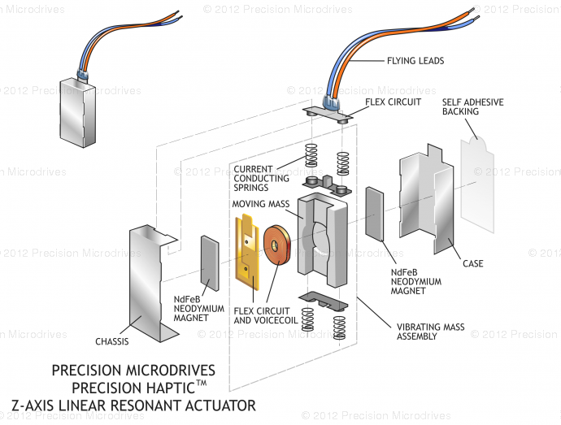

A magnetic field is generated by the voice coil which interacts with the magnet & mass, which are suspended on a spring. As the magnetic field varies with the applied drive signal, the magnet & mass are moved up and down as they interact with the spring.

### Tags:

* + - current conducting springs
    - Flex Circuit
    - flying leads
    - moving mass
    - NdFeB Neodymium Magnet
    - Voicecoil
    - z-axis linear resonant actuator
  + 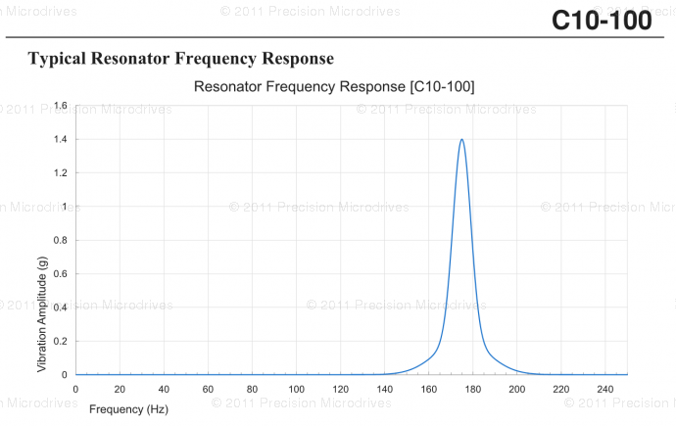

attaching a mass to a spring causes a resonance effect.

spring stiffness, mass and magnet / coil size will cause the linear vibrator to have a natural resonant frequency

### Tags:

* + - Bode Plot
    - Resonant Frequency of Operation
    - Resonator Frequency Response
  + the voice coil drive is very similar to that loud speaker
  + Linear Resonant Actuator (LRA) vibration motors, which are also known as linear vibrators.

Linear Resonant Actuator vibration motors as an alternative to long life brushless vibration motors

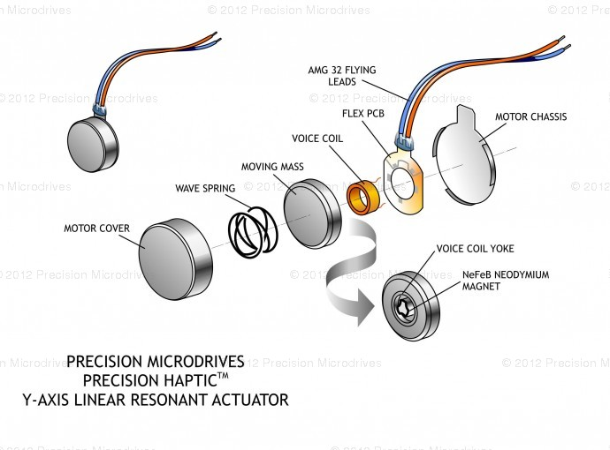

### Tags:

* + - actuator
    - linear vibrators
    - LRA
  + instead of a cone that generates sound pressure waves, there is a mass that generates vibrations.

### Attachments

* + Linear Resonant Actuator Vibration Motor | LRA for Haptic Feedback

### Tags:

* + - Eccentric Rotating Mass (ERM)
    - Linear Resonant Actuator (LRA) Vibration Motors
    - linear vibrators
    - precision microdrives
  + Linear Resonant Actuator Vibration Motor | LRA for Haptic Feedback
  + Linear Resonant Actuator Vibration Motor LRA for.jpg

### Tags:

* + - AMG 32 Flying Leads
    - Flex PCB
    - moving mass
    - NeFeB Neodymium Magnet
    - voice coil
    - voice coil yoke
    - wave spring
    - y-axis linear resonant actuator

Y-axis vibrators resonant frequencies are around 175 Hz

## Linear Resonant Actuator Vibration Motor | LRA for Haptic Feedback

|  |  |
| --- | --- |
| **Type** | Web Page |
| **URL** | <http://www.precisionmicrodrives.com/vibrating-vibrator-vibration-motors/linear-resonant-actuator-lra-haptic-vibration-motors> |
| **Accessed** | Wednesday, March 27, 2013 4:23:50 PM |
| **Date Added** | Wednesday, March 27, 2013 4:23:50 PM |
| **Modified** | Wednesday, March 27, 2013 4:23:50 PM |

## Linear Resonant Actuator Vibration Motor | LRA for Haptic Feedback

|  |  |
| --- | --- |
| **Type** | Web Page |
| **URL** | <http://www.precisionmicrodrives.com/vibrating-vibrator-vibration-motors/linear-resonant-actuator-lra-haptic-vibration-motors> |
| **Accessed** | Wednesday, March 27, 2013 4:29:52 PM |
| **Date Added** | Wednesday, March 27, 2013 4:29:52 PM |
| **Modified** | Wednesday, March 27, 2013 4:29:52 PM |

### Attachments

* + Linear Resonant Actuator Vibration Motor | LRA for Haptic Feedback

## Linear Resonant Actuator Vibration Motor | LRA for Haptic Feedback

|  |  |
| --- | --- |
| **Type** | Web Page |
| **URL** | <http://www.precisionmicrodrives.com/vibrating-vibrator-vibration-motors/linear-resonant-actuator-lra-haptic-vibration-motors> |
| **Accessed** | Wednesday, March 27, 2013 4:30:28 PM |
| **Date Added** | Wednesday, March 27, 2013 4:30:28 PM |
| **Modified** | Wednesday, March 27, 2013 4:30:28 PM |

### Attachments

* + Linear Resonant Actuator Vibration Motor | LRA for Haptic Feedback

## Linear Resonant Actuator Vibration Motor | LRA for Haptic Feedback

|  |  |
| --- | --- |
| **Type** | Web Page |
| **URL** | <http://www.precisionmicrodrives.com/vibrating-vibrator-vibration-motors/linear-resonant-actuator-lra-haptic-vibration-motors> |
| **Accessed** | Wednesday, March 27, 2013 4:52:06 PM |
| **Date Added** | Wednesday, March 27, 2013 4:52:06 PM |
| **Modified** | Wednesday, March 27, 2013 4:52:06 PM |

### Notes:

* + LRA vibration motors are effectively brushless

commutation being via a voice-coil

springs are modelled with finite element analysis (FEA)

failure modes are restricted to aging of internal components

LRA are single plane vibrators, ERMs can have two planes (or more?)

### Tags:

* + - brushless
    - commutator
    - finite element analysis
    - voice coil

### Attachments

* + Linear Resonant Actuator Vibration Motor | LRA for Haptic Feedback

## Linear Resonant Actuator Vibration Motor | LRA for Haptic Feedback

|  |  |
| --- | --- |
| **Type** | Web Page |
| **URL** | <http://www.precisionmicrodrives.com/vibrating-vibrator-vibration-motors/linear-resonant-actuator-lra-haptic-vibration-motors> |
| **Accessed** | Wednesday, March 27, 2013 4:55:01 PM |
| **Date Added** | Wednesday, March 27, 2013 4:55:01 PM |
| **Modified** | Wednesday, March 27, 2013 4:55:01 PM |

### Attachments

* + Linear Resonant Actuator Vibration Motor | LRA for Haptic Feedback

## Linear Resonant Actuator | What is an LRA?

|  |  |
| --- | --- |
| **Type** | Web Page |
| **URL** | <http://www.precisionmicrodrives.com/application-notes-technical-guides/application-bulletins/ab-020-understanding-linear-resonant-actuator-characteristics> |
| **Accessed** | Wednesday, March 27, 2013 6:49:34 PM |
| **Date Added** | Wednesday, March 27, 2013 6:49:34 PM |
| **Modified** | Wednesday, March 27, 2013 6:49:34 PM |

### Attachments

* + Linear Resonant Actuator | What is an LRA?

## How To Drive A Linear Resonance Vibration Actuators

|  |  |
| --- | --- |
| **Type** | Web Page |
| **URL** | <http://www.precisionmicrodrives.com/application-notes-technical-guides/application-bulletins/ab-003-how-to-drive-linear-resonance-actuators-lra-vibrating-motors> |
| **Accessed** | Wednesday, March 27, 2013 4:56:56 PM |
| **Date Added** | Wednesday, March 27, 2013 4:56:56 PM |
| **Modified** | Wednesday, March 27, 2013 4:56:56 PM |

### Notes:

* + DC Eccentric Rotating Mass (ERM) motors which are produced with a offset weight attached to the shaft.

commutated pager motor form factors

brushless, and ‘coin’ types

When the weight rotates the centripetal force of the weight causes a vibration

LRA: The drive signal needs to alternate the direction of current (i.e. it's an AC signal) and hence the magnetic field to make the permanent magnet oscillate back and forth with the spring.

it is the moving of the mass back and forth that generates the vibration.

springs will fatigue over time,

short lag and rise times

lower power

Size matters:  Compact size may not be desired as it is relates to maximum vibration amplitude

amplitude and frequency are independent of each other

can produce a 'richer' user haptic experience

it is not possible to directly swap an ERM motor with an LRA vibrator

the input signal to the LRA has to alternate, i.e. it needs an AC drive signal.

Vibration performance drops off significantly when the input signal frequency is moved too far from the resonant frequency

POTENTIAL LIMITING FACTOR:  the LRA the easiest option is to use a dedicated driver IC

* + Stand-alone LRA drivers

Texas Instruments - DRV8601

typical driver schematic

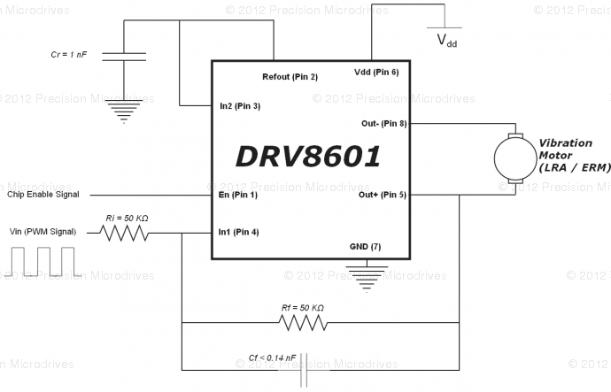

Need to find analog equivalent.

Texas Instruments suggest resistors in the range of 20 kΩ to 100 kΩ for stable operation, we’ve chosen 50 kΩ

capacitor Cf:  allows you to control the amplitude of vibration by adjusting the PWM duty signal

Cr  This capacitor is to remove any unwanted noise from the internal regulator, although larger values increase the turn-on time

The (optional) feedback capacitor in parallel with Rf forms a first order low-pass RC filter.

the cutoff frequency must be higher than the resonant frequency of the LRA

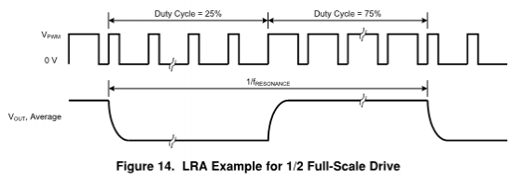

DRV8601 PWM Input

LRAs must be driven at their resonant frequency - even a few hertz off will dramatically reduce performance  (this limitation isn't a design killer w.r.t. wave form complexity.  The frequency does not necessarily limit the complexity of the wave form so diverse surfaces could still be considered.)

Nothing is written in stone:  The resonant frequency will change depending on what it is mounted to, the climate, age of the product, and will even be slightly different between different LRAs from the same manufacturing batch

processor code is LRA dependant

With auto resonance detection The LRA will always be driven right on its resonant frequency regardless of its environment.

RingCore210 chips

for LRAs, the frequency of the output is determined by the value of a capacitor between the negative output pin and the GAIN pin

### Tags:

* + - component values
    - configuration
    - driver schematic
    - lra drivers
  + Semtec

Integrated LRA Drivers

The major difference between models is the inclusion of a proximity sensor system, or the ability to handle multitouch inputs

* + Maxim - MAX11810/MAX11811 - Capacitive Touch IC with Haptic Driver

capacitive touch screen interfaces with integrated proximity sensors and haptic controller and driver

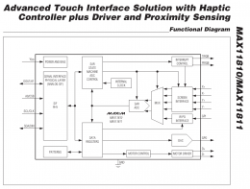

### Attachments

* + How To Drive A Linear Resonance Vibration Actuators

**MOUNTING**

## Vibrator Motor | Mounting | Flexible Materials & Clothing

|  |  |
| --- | --- |
| **Type** | Web Page |
| **URL** | <http://www.precisionmicrodrives.com/application-notes-technical-guides/application-bulletins/ab-010-mounting-vibration-motors-to-flexible-materials-clothing> |
| **Accessed** | Wednesday, March 27, 2013 6:48:40 PM |
| **Date Added** | Wednesday, March 27, 2013 6:48:40 PM |
| **Modified** | Wednesday, March 27, 2013 6:48:40 PM |

### Attachments

* + Vibrator Motor | Mounting | Flexible Materials & Clothing

## Vibrating Motor | Mounting | Moulded & Machined Enclosure

|  |  |
| --- | --- |
| **Type** | Web Page |
| **URL** | <http://www.precisionmicrodrives.com/application-notes-technical-guides/application-bulletins/ab-015-mechanical-mounting-for-vibration-motors-moulded-and-machined-enclosures> |
| **Accessed** | Wednesday, March 27, 2013 6:49:06 PM |
| **Date Added** | Wednesday, March 27, 2013 6:49:06 PM |
| **Modified** | Wednesday, March 27, 2013 6:49:06 PM |

### Attachments

* + Vibrating Motor | Mounting | Moulded & Machined Enclosure

## Securing Vibrating Motor | Leads & Wires | Common Problems

|  |  |
| --- | --- |
| **Type** | Web Page |
| **URL** | <http://www.precisionmicrodrives.com/application-notes-technical-guides/application-bulletins/ab-009-securing-vibration-motor-leads-and-wires> |
| **Accessed** | Wednesday, March 27, 2013 6:48:27 PM |
| **Date Added** | Wednesday, March 27, 2013 6:48:27 PM |
| **Modified** | Wednesday, March 27, 2013 6:48:27 PM |

### Attachments

* + Securing Vibrating Motor | Leads & Wires | Common Problems

## How To Mount Vibration Motors To PCBs

|  |  |
| --- | --- |
| **Type** | Web Page |
| **URL** | <http://www.precisionmicrodrives.com/application-notes-technical-guides/application-bulletins/ab-006-mechanical-mounting-for-vibration-motors-to-pcbs> |
| **Accessed** | Wednesday, March 27, 2013 6:47:56 PM |
| **Date Added** | Wednesday, March 27, 2013 6:47:56 PM |
| **Modified** | Wednesday, March 27, 2013 6:47:56 PM |

### Attachments

* + How To Mount Vibration Motors To PCBs

## How To Mount Vibrating Motors To Bulkheads

|  |  |
| --- | --- |
| **Type** | Web Page |
| **URL** | <http://www.precisionmicrodrives.com/application-notes-technical-guides/application-bulletins/ab-007-mechanical-mounting-for-vibration-motors-to-bulkheads> |
| **Accessed** | Wednesday, March 27, 2013 6:48:12 PM |
| **Date Added** | Wednesday, March 27, 2013 6:48:12 PM |
| **Modified** | Wednesday, March 27, 2013 6:48:12 PM |

### Attachments

* + How To Mount Vibrating Motors To Bulkheads

**NEUROLOGY**

**MECHANORECEPTORS**

## Tactile corpuscle - Wikipedia, the free encyclopedia

|  |  |
| --- | --- |
| **Type** | Web Page |
| **URL** | <http://en.wikipedia.org/wiki/Tactile_corpuscle> |
| **Accessed** | Wednesday, March 27, 2013 7:18:34 PM |
| **Date Added** | Wednesday, March 27, 2013 7:18:34 PM |
| **Modified** | Wednesday, March 27, 2013 7:18:34 PM |

### Tags:

* + mechanoreceptor
  + nerve
  + neurology
  + rapidly adaptive receptors
  + sensitivity
  + skin
  + touch

### Attachments

* + Tactile corpuscle - Wikipedia, the free encyclopedia

## Merkel cell - Wikipedia, the free encyclopedia

|  |  |
| --- | --- |
| **Type** | Web Page |
| **URL** | <http://en.wikipedia.org/wiki/Merkel_cell> |
| **Accessed** | Wednesday, March 27, 2013 7:26:06 PM |
| **Date Added** | Wednesday, March 27, 2013 7:26:06 PM |
| **Modified** | Wednesday, March 27, 2013 7:26:06 PM |

### Tags:

* + receptor cell
  + sense of light touch
  + shapes
  + somatosensory afferents
  + textures

### Notes:

* + afferent nerves resolve fine spatial details

### Attachments

* + Merkel cell - Wikipedia, the free encyclopedia

## Lamellar corpuscle - Wikipedia, the free encyclopedia

|  |  |
| --- | --- |
| **Type** | Web Page |
| **URL** | <http://en.wikipedia.org/wiki/Lamellar_corpuscle> |
| **Accessed** | Wednesday, March 27, 2013 7:19:58 PM |
| **Date Added** | Wednesday, March 27, 2013 7:19:58 PM |
| **Modified** | Wednesday, March 27, 2013 7:19:58 PM |

### Attachments

* + Lamellar corpuscle - Wikipedia, the free encyclopedia

**SCHEMATICS**

## Simple DC motor PWM speed control

|  |  |
| --- | --- |
| **Type** | Web Page |
| **URL** | <http://electronics-lab.com/projects/motor_light/005/index.html> |
| **Accessed** | Wednesday, March 27, 2013 8:30:18 PM |
| **Date Added** | Wednesday, March 27, 2013 8:30:18 PM |
| **Modified** | Wednesday, March 27, 2013 8:30:18 PM |

### Attachments

* + Simple DC motor PWM speed control

## Pulse generator

|  |  |
| --- | --- |
| **Type** | Web Page |
| **URL** | <http://electronics-lab.com/projects/oscillators_timers/007/index.html> |
| **Accessed** | Wednesday, March 27, 2013 8:34:05 PM |
| **Date Added** | Wednesday, March 27, 2013 8:34:05 PM |
| **Modified** | Wednesday, March 27, 2013 8:34:05 PM |

### Attachments

* + Pulse generator

## PCVR.vm.gif (GIF Image, 1245 × 931 pixels) - Scaled (63%)

|  |  |
| --- | --- |
| **Type** | Web Page |
| **URL** | <http://xspasm.com/x/sfu/vmi/PCVR.vm.gif> |
| **Accessed** | Wednesday, March 27, 2013 10:05:46 PM |
| **Date Added** | Wednesday, March 27, 2013 10:05:46 PM |
| **Modified** | Wednesday, March 27, 2013 10:05:46 PM |

### Attachments

* + PCVR.vm.gif (GIF Image, 1245 × 931 pixels) - Scaled (63%)

## Discrete H-bridge For Enhanced Vibration Control | Guide

|  |  |
| --- | --- |
| **Type** | Web Page |
| **URL** | zotero://attachment/40/ |
| **Accessed** | Wednesday, March 27, 2013 7:04:48 PM |
| **Date Added** | Wednesday, March 27, 2013 7:04:48 PM |
| **Modified** | Wednesday, March 27, 2013 7:04:48 PM |

### Attachments

* + Discrete H-bridge For Enhanced Vibration Control | Guide

## Adjustable High/Low Frequency Sine wave generator

|  |  |
| --- | --- |
| **Type** | Web Page |
| **URL** | <http://electronics-lab.com/projects/oscillators_timers/003/index.html> |
| **Accessed** | Wednesday, March 27, 2013 8:31:49 PM |
| **Date Added** | Wednesday, March 27, 2013 8:31:49 PM |
| **Modified** | Wednesday, March 27, 2013 8:31:49 PM |

### Attachments

* + Adjustable High/Low Frequency Sine wave generator

**SENSORS**

## XBee Accelerometer Demo - Wireless Tilt Mouse Application

|  |  |
| --- | --- |
| **Type** | Web Page |
| **URL** | <http://electronics-lab.com/projects/sensors/009/index.html> |
| **Accessed** | Wednesday, March 27, 2013 8:45:46 PM |
| **Date Added** | Wednesday, March 27, 2013 8:45:46 PM |
| **Modified** | Wednesday, March 27, 2013 8:45:46 PM |

### Attachments

* + XBee Accelerometer Demo - Wireless Tilt Mouse Application

## USB Biofeedback Game Controller

|  |  |
| --- | --- |
| **Type** | Web Page |
| **URL** | <http://www.instructables.com/id/USB-Biofeedback-Game-Controller/> |
| **Accessed** | Wednesday, March 27, 2013 9:26:52 PM |
| **Date Added** | Wednesday, March 27, 2013 9:26:52 PM |
| **Modified** | Wednesday, March 27, 2013 9:26:52 PM |

### Attachments

* + USB Biofeedback Game Controller

## Making flex sensors on the cheap

|  |  |
| --- | --- |
| **Type** | Web Page |
| **URL** | <http://hackaday.com/2012/06/04/making-flex-sensors-on-the-cheap/> |
| **Accessed** | Wednesday, March 27, 2013 9:22:19 PM |
| **Date Added** | Wednesday, March 27, 2013 9:22:19 PM |
| **Modified** | Wednesday, March 27, 2013 9:22:19 PM |

### Attachments

* + Making flex sensors on the cheap

## DIY Bend Sensor (Using only Conductive Bags and Masking Tape)

|  |  |
| --- | --- |
| **Type** | Web Page |
| **URL** | <http://www.instructables.com/id/DIY-Bend-Sensor-Using-only-Velostat-and-Masking-T/> |
| **Accessed** | Wednesday, March 27, 2013 9:22:53 PM |
| **Date Added** | Wednesday, March 27, 2013 9:22:53 PM |
| **Modified** | Wednesday, March 27, 2013 9:22:53 PM |

### Attachments

* + DIY Bend Sensor (Using only Conductive Bags and Masking Tape)

## Ben Krasnow: DIY 10-finger flex sensor gloves for possible VR or video game control

|  |  |
| --- | --- |
| **Type** | Web Page |
| **URL** | <http://benkrasnow.blogspot.com/2010/12/diy-10-finger-flex-sensor-gloves-for.html> |
| **Accessed** | Wednesday, March 27, 2013 9:19:31 PM |
| **Date Added** | Wednesday, March 27, 2013 9:19:31 PM |
| **Modified** | Wednesday, March 27, 2013 9:19:31 PM |

### Attachments

* + Ben Krasnow: DIY 10-finger flex sensor gloves for possible VR or video game control

**ACCELEROMETER**

## Rarely Asked Questions... | Analog Devices

|  |  |
| --- | --- |
| **Type** | Web Page |
| **URL** | <http://www.analog.com/en/content/RAQ_index/fca.html> |
| **Accessed** | Thursday, March 28, 2013 1:39:37 PM |
| **Date Added** | Thursday, March 28, 2013 1:39:37 PM |
| **Modified** | Thursday, March 28, 2013 1:39:37 PM |

### Attachments

* + Rarely Asked Questions... | Analog Devices

## Patient Respiration Measurement Using a 3-Axis Accelerometer | Technical Articles | ADXL330 | MEMS Inertial Sensors | MEMS and Sensors | Analog Devices

|  |  |
| --- | --- |
| **Type** | Web Page |
| **URL** | <http://www.analog.com/en/mems-sensors/mems-inertial-sensors/adxl330/products/technical-articles/ta_Patient_Respiration_Measure_Using_3-Axis_accel/resources/fca.html> |
| **Accessed** | Thursday, March 28, 2013 1:38:38 PM |
| **Date Added** | Thursday, March 28, 2013 1:38:38 PM |
| **Modified** | Thursday, March 28, 2013 1:38:38 PM |

### Attachments

* + Patient Respiration Measurement Using a 3-Axis Accelerometer | Technical Articles | ADXL330 | MEMS Inertial Sensors | MEMS and Sensors | Analog Devices

## MEMS Microphones: Analog Dialogue: Analog Devices

|  |  |
| --- | --- |
| **Type** | Web Page |
| **URL** | <http://www.analog.com/library/analogdialogue/archives/43-02/mems_microphones.html> |
| **Accessed** | Thursday, March 28, 2013 1:38:45 PM |
| **Date Added** | Thursday, March 28, 2013 1:38:45 PM |
| **Modified** | Thursday, March 28, 2013 1:38:45 PM |

### Attachments

* + MEMS Microphones: Analog Dialogue: Analog Devices

## Glossary_Terms.pdf

|  |  |
| --- | --- |
| **Type** | Attachment |
| **Date Added** | Thursday, March 28, 2013 1:37:46 PM |
| **Modified** | Thursday, March 28, 2013 1:37:46 PM |

## FAQs/RAQs | ADXL330 | MEMS Inertial Sensors | MEMS and Sensors | Analog Devices

|  |  |
| --- | --- |
| **Type** | Web Page |
| **URL** | [http://www.analog.com/en/mems-sensors/mems-inertial-sensors/adxl330/products/faqs/FAQ_iSensor_Shock/resources/faq.html? display=popup](http://www.analog.com/en/mems-sensors/mems-inertial-sensors/adxl330/products/faqs/FAQ_iSensor_Shock/resources/faq.html?display=popup) |
| **Accessed** | Thursday, March 28, 2013 1:38:57 PM |
| **Date Added** | Thursday, March 28, 2013 1:38:57 PM |
| **Modified** | Thursday, March 28, 2013 1:38:57 PM |

### Attachments

* + FAQs/RAQs | ADXL330 | MEMS Inertial Sensors | MEMS and Sensors | Analog Devices

## FAQs/RAQs | ADXL330 | MEMS Inertial Sensors | MEMS and Sensors | Analog Devices

|  |  |
| --- | --- |
| **Type** | Web Page |
| **URL** | [http://www.analog.com/en/mems-sensors/mems-inertial-sensors/adxl330/products/faqs/FAQ_What_is_an_inertial_sensor/resources/faq.html? display=popup](http://www.analog.com/en/mems-sensors/mems-inertial-sensors/adxl330/products/faqs/FAQ_What_is_an_inertial_sensor/resources/faq.html?display=popup) |
| **Accessed** | Thursday, March 28, 2013 1:39:02 PM |
| **Date Added** | Thursday, March 28, 2013 1:39:02 PM |
| **Modified** | Thursday, March 28, 2013 1:39:02 PM |

### Attachments

* + FAQs/RAQs | ADXL330 | MEMS Inertial Sensors | MEMS and Sensors | Analog Devices

## FAQs/RAQs | ADXL330 | MEMS Inertial Sensors | MEMS and Sensors | Analog Devices

|  |  |
| --- | --- |
| **Type** | Web Page |
| **URL** | [http://www.analog.com/en/mems-sensors/mems-inertial-sensors/adxl330/products/faqs/FAQ_What_is_an_accelerometer_and_a_gyroscope/resources/faq.html? display=popup](http://www.analog.com/en/mems-sensors/mems-inertial-sensors/adxl330/products/faqs/FAQ_What_is_an_accelerometer_and_a_gyroscope/resources/faq.html?display=popup) |
| **Accessed** | Thursday, March 28, 2013 1:39:06 PM |
| **Date Added** | Thursday, March 28, 2013 1:39:06 PM |
| **Modified** | Thursday, March 28, 2013 1:39:06 PM |

### Attachments

* + FAQs/RAQs | ADXL330 | MEMS Inertial Sensors | MEMS and Sensors | Analog Devices

## FAQs/RAQs | ADXL330 | MEMS Inertial Sensors | MEMS and Sensors | Analog Devices

|  |  |
| --- | --- |
| **Type** | Web Page |
| **URL** | [http://www.analog.com/en/mems-sensors/mems-inertial-sensors/adxl330/products/faqs/FAQ_Where_would_you_use_an_accelerometer/resources/faq.html? display=popup](http://www.analog.com/en/mems-sensors/mems-inertial-sensors/adxl330/products/faqs/FAQ_Where_would_you_use_an_accelerometer/resources/faq.html?display=popup) |
| **Accessed** | Thursday, March 28, 2013 1:39:11 PM |
| **Date Added** | Thursday, March 28, 2013 1:39:11 PM |
| **Modified** | Thursday, March 28, 2013 1:39:11 PM |

### Attachments

* + FAQs/RAQs | ADXL330 | MEMS Inertial Sensors | MEMS and Sensors | Analog Devices

## FAQs/RAQs | ADXL330 | MEMS Inertial Sensors | MEMS and Sensors | Analog Devices

|  |  |
| --- | --- |
| **Type** | Web Page |
| **URL** | [http://www.analog.com/en/mems-sensors/mems-inertial-sensors/adxl330/products/faqs/FAQ_Where_would_you_use_a_gyroscope/resources/faq.html? display=popup](http://www.analog.com/en/mems-sensors/mems-inertial-sensors/adxl330/products/faqs/FAQ_Where_would_you_use_a_gyroscope/resources/faq.html?display=popup) |
| **Accessed** | Thursday, March 28, 2013 1:39:16 PM |
| **Date Added** | Thursday, March 28, 2013 1:39:16 PM |
| **Modified** | Thursday, March 28, 2013 1:39:16 PM |

### Attachments

* + FAQs/RAQs | ADXL330 | MEMS Inertial Sensors | MEMS and Sensors | Analog Devices

## FAQs/RAQs | ADXL330 | MEMS Inertial Sensors | MEMS and Sensors | Analog Devices

|  |  |
| --- | --- |
| **Type** | Web Page |
| **URL** | [http://www.analog.com/en/mems-sensors/mems-inertial-sensors/adxl330/products/faqs/FAQ_What_are_the_major_error_sources_for_inertial/resources/faq.html? display=popup](http://www.analog.com/en/mems-sensors/mems-inertial-sensors/adxl330/products/faqs/FAQ_What_are_the_major_error_sources_for_inertial/resources/faq.html?display=popup) |
| **Accessed** | Thursday, March 28, 2013 1:39:20 PM |
| **Date Added** | Thursday, March 28, 2013 1:39:20 PM |
| **Modified** | Thursday, March 28, 2013 1:39:20 PM |

### Attachments

* + FAQs/RAQs | ADXL330 | MEMS Inertial Sensors | MEMS and Sensors | Analog Devices

## FAQs/RAQs | ADXL330 | MEMS Inertial Sensors | MEMS and Sensors | Analog Devices

|  |  |
| --- | --- |
| **Type** | Web Page |
| **URL** | [http://www.analog.com/en/mems-sensors/mems-inertial-sensors/adxl330/products/faqs/FAQ_What_is_the_limit_of_resolution_of_an_inertial/resources/faq.html? display=popup](http://www.analog.com/en/mems-sensors/mems-inertial-sensors/adxl330/products/faqs/FAQ_What_is_the_limit_of_resolution_of_an_inertial/resources/faq.html?display=popup) |
| **Accessed** | Thursday, March 28, 2013 1:39:26 PM |
| **Date Added** | Thursday, March 28, 2013 1:39:26 PM |
| **Modified** | Thursday, March 28, 2013 1:39:26 PM |

### Attachments

* + FAQs/RAQs | ADXL330 | MEMS Inertial Sensors | MEMS and Sensors | Analog Devices

## FAQs/RAQs | ADXL330 | MEMS Inertial Sensors | MEMS and Sensors | Analog Devices

|  |  |
| --- | --- |
| **Type** | Web Page |
| **URL** | [http://www.analog.com/en/mems-sensors/mems-inertial-sensors/adxl330/products/faqs/FAQ_I_need_finer_resolution_What_do_I_do/resources/faq.html? display=popup](http://www.analog.com/en/mems-sensors/mems-inertial-sensors/adxl330/products/faqs/FAQ_I_need_finer_resolution_What_do_I_do/resources/faq.html?display=popup) |
| **Accessed** | Thursday, March 28, 2013 1:39:32 PM |
| **Date Added** | Thursday, March 28, 2013 1:39:32 PM |
| **Modified** | Thursday, March 28, 2013 1:39:32 PM |

### Attachments

* + FAQs/RAQs | ADXL330 | MEMS Inertial Sensors | MEMS and Sensors | Analog Devices

## ADXL330.pdf

|  |  |
| --- | --- |
| **Type** | Attachment |
| **Date Added** | Thursday, March 28, 2013 1:37:41 PM |
| **Modified** | Thursday, March 28, 2013 1:37:41 PM |

## ADXL330 Small, Low Power, 3-Axis ±3 g i MEMS® Accelerometer Data Sheet (Rev. A) - ADXL330.pdf

|  |  |
| --- | --- |
| **Type** | Attachment |
| **Accessed** | Thursday, March 28, 2013 1:34:39 PM |
| **URL** | <http://www.analog.com/static/imported-files/data_sheets/ADXL330.pdf> |
| **Date Added** | Thursday, March 28, 2013 1:34:39 PM |
| **Modified** | Thursday, March 28, 2013 1:34:40 PM |

## Accelerometers and How they Work - Acceler1.pdf

|  |  |
| --- | --- |
| **Type** | Attachment |
| **Accessed** | Thursday, March 28, 2013 1:34:19 PM |
| **URL** | <http://www2.usfirst.org/2005comp/Manuals/Acceler1.pdf> |
| **Date Added** | Thursday, March 28, 2013 1:34:19 PM |
| **Modified** | Thursday, March 28, 2013 1:34:20 PM |

## 51880672750997AN668_0.pdf

|  |  |
| --- | --- |
| **Type** | Attachment |
| **Date Added** | Thursday, March 28, 2013 1:37:22 PM |
| **Modified** | Thursday, March 28, 2013 1:37:22 PM |

## 513772624AN602.pdf

|  |  |
| --- | --- |
| **Type** | Attachment |
| **Date Added** | Thursday, March 28, 2013 1:37:10 PM |
| **Modified** | Thursday, March 28, 2013 1:37:10 PM |

## 47076299220991AN_900.pdf

|  |  |
| --- | --- |
| **Type** | Attachment |
| **Date Added** | Thursday, March 28, 2013 1:37:16 PM |
| **Modified** | Thursday, March 28, 2013 1:37:16 PM |

## 45789401034275374892178CP_16_5a.pdf

|  |  |
| --- | --- |
| **Type** | Attachment |
| **Date Added** | Thursday, March 28, 2013 1:37:35 PM |
| **Modified** | Thursday, March 28, 2013 1:37:35 PM |

**SENSORY INPUT/DEVICE OUTPUT**

## DDS Function Generator

|  |  |
| --- | --- |
| **Type** | Web Page |
| **URL** | <http://electronics-lab.com/projects/test/013/index.html> |
| **Accessed** | Wednesday, March 27, 2013 8:47:47 PM |
| **Date Added** | Wednesday, March 27, 2013 8:47:47 PM |
| **Modified** | Wednesday, March 27, 2013 8:47:47 PM |

### Attachments

* + DDS Function Generator

**SOFTWARE DEVELOPMENT**

## Open Source Haptics - H3D.org

|  |  |
| --- | --- |
| **Type** | Web Page |
| **URL** | <http://www.h3dapi.org/> |
| **Accessed** | Wednesday, March 27, 2013 10:19:21 PM |
| **Date Added** | Wednesday, March 27, 2013 10:19:21 PM |
| **Modified** | Wednesday, March 27, 2013 10:19:21 PM |

### Attachments

* + Open Source Haptics - H3D.org