EDUC 641 Lab: Applied Statistics in Education and Human Services I
Lab 1: 10/1 and 10/2
This lab will start under the assumption that you all have downloaded R and RStudio. Support will be provided to those encountering issues.
Goals:
- Ensure everyone has R and RStudio downloaded
- Identify the four panes in RStudio
- Set up an R project file on your desktop with code, data, and output folders
- Save an R script to the code folder

Materials aligned with the lab: EDUC R Workshop - Modules 1 and 2

Remember to:
- Work in groups and discuss with your peers as you go.
- Write down your questions as and when they arise.
- Call for assistance.
- Sit near the GE.
Tasks:
- Install R and RStudio: R is a programming language used in the class to conduct statistical analysis. RStudio is the application or graphical interface we use to access R. You need both for coding purposes.
  - Download R from here based on your system: https://mirror.las.iastate.edu/CRAN/
  - Download RStudio from here based on your system: https://posit.co/download/rstudio-desktop/.
  - Once both are downloaded, open RStudio from the applications. If you see something like what is shown below, go on to task 2.
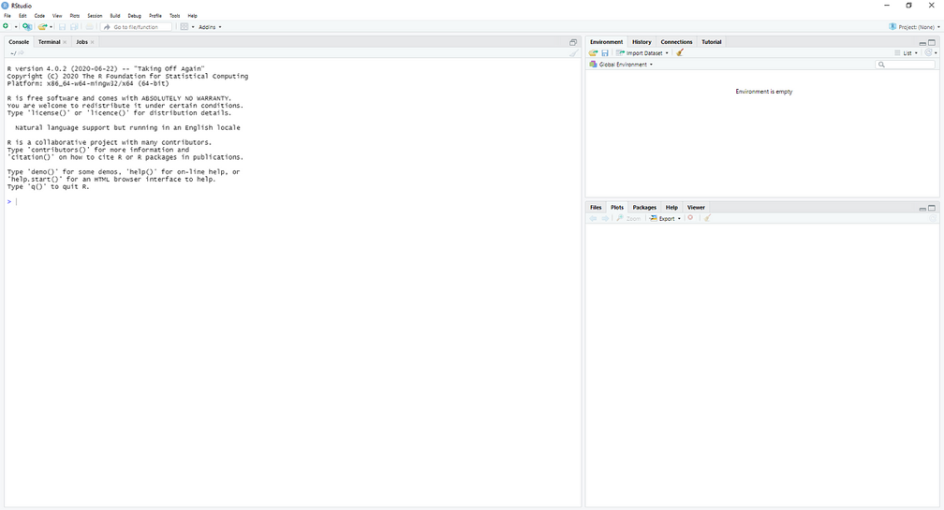
Note: R and RStudio keep frequent updates (on an annual basis). You should reinstall them to have the most up-to-date version.

- RStudio: RStudio is an interface for using the R programming language. Once you open RStudio, click on File -> New File -> R Script to see four panes. This interface is similar to Word, so file and save are intuitive to you.
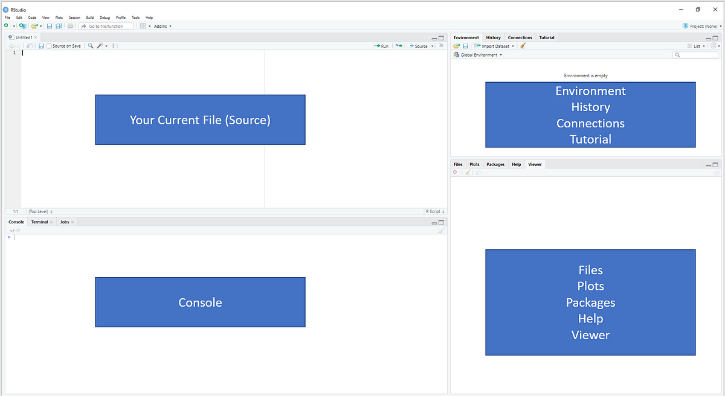

- R project: R projects organize your work on the device and will help your workflow throughout this sequence. They are a collection of documents, workspace, and history.
  - First, create a file (if not already) dedicated to the educ641 course. Then make a folder titled educ641_R. 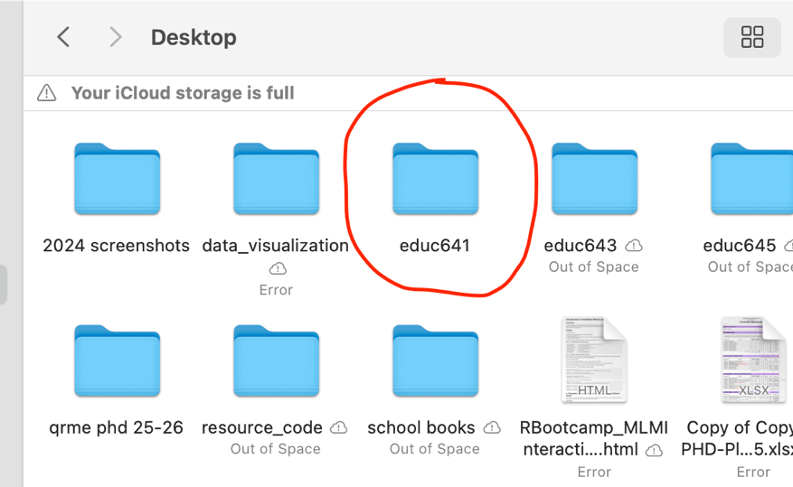

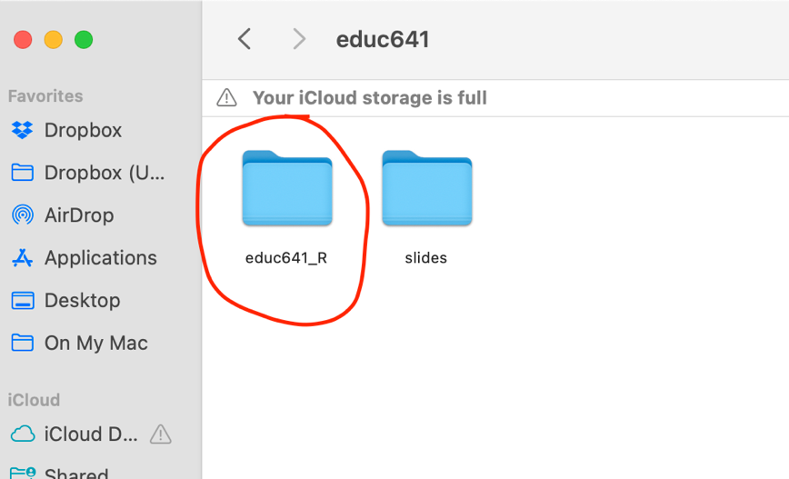

  - Then, inside your _R folder, add three more folders and label them 'code', 'data', and 'output'. Note: Keep everything lowercase and in one “string.” R doesn’t like spaces or capital letters.
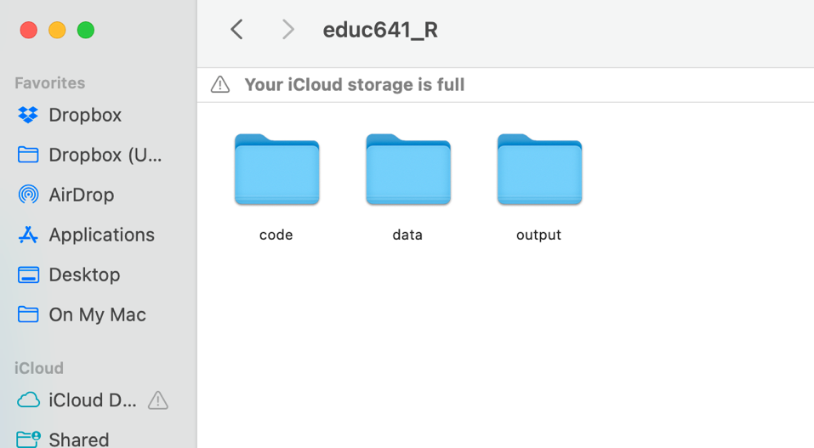
  - Next, open RStudio and click on Files -> New Project -> Existing Directory -> Browse -> select the Desktop/educ641/educ641_R file path. This will make the educ641_R folder your ‘R project!’
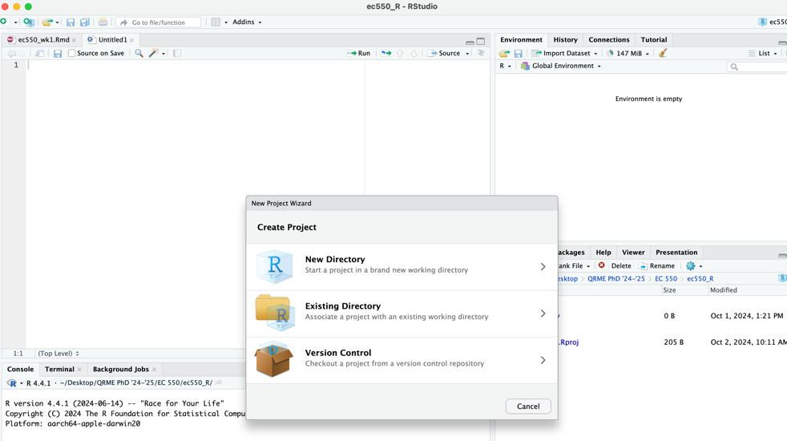
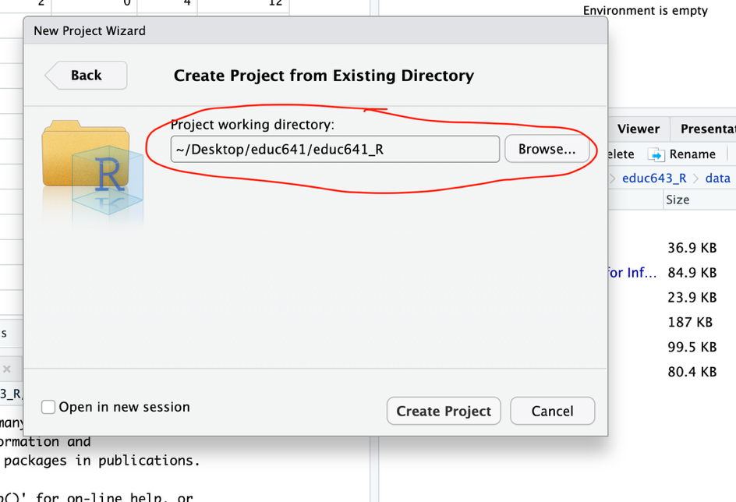
  - Close RStudio and open your newly created R project on your desktop location by checking if your Rproj (R ‘cube’) is in your educ641_R folder. Always open R projects by clicking the cube, not via your code folder. When RStudio reopens, make sure the three other folders are visible in your bottom right panel under the Files tab.
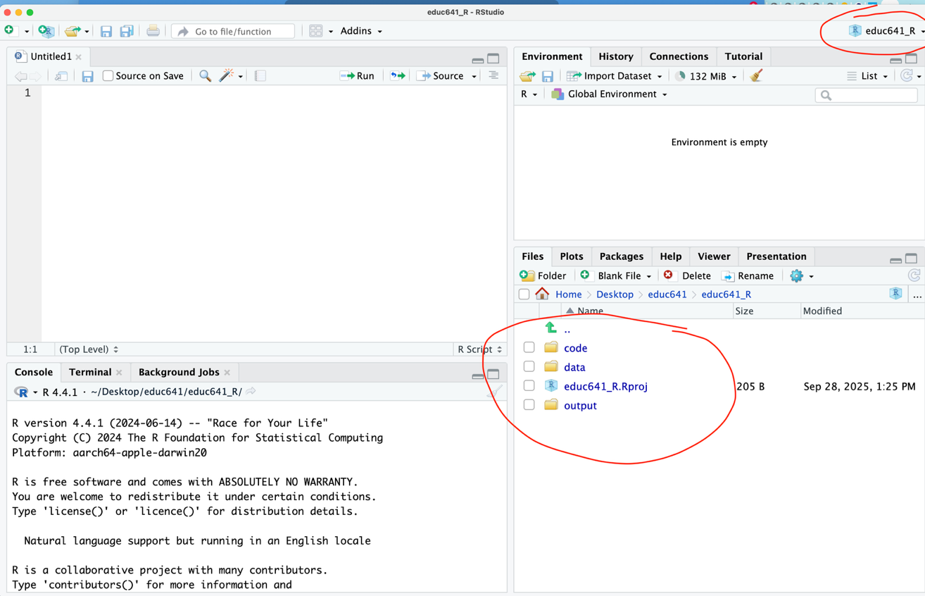
Note: If you realize that you created an R project in the wrong directory, it is easier to delete it and then go through the process again for the correct directory.
- Save R script: These “scripts” are used for writing and executing tasks in the R programming language, primarily designed for statistical computing and data analysis. While we haven’t utilized this function yet, we would like you to save the script you opened in task 2 to your code folder for Lab 2. File -> Save As… [give name to file] e.g., educ641_lab2 (and save in code folder). Please go to the file on your desktop and ensure your ‘.R’ script is there.
Checklist on desktop here:
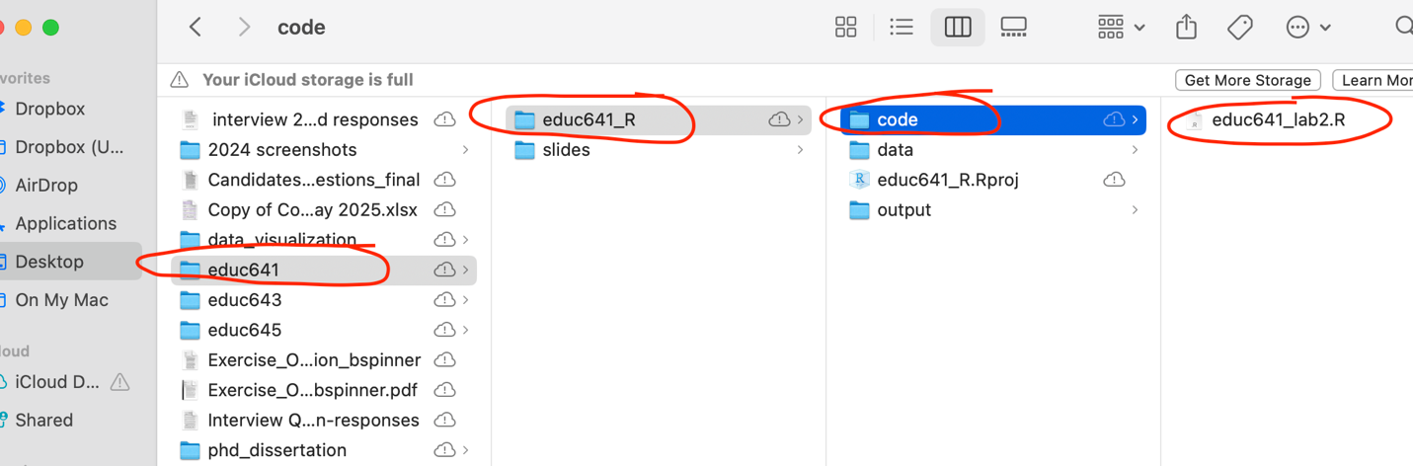
And checklist in R here:
