**EDUC 641 Lab: Applied Statistics in Education and Human Services I**

**Lab 1:** 10/2 and 10/3

*This lab will start under the assumption that you all have downloaded R and RStudio. Support will be provided to those encountering issues.*

**Goals**:

1. Ensure everyone has R and Rstudio downloaded
2. Identify the four panes in RStudio
3. Setup an R project file on your desktop with *code, data, tables, figures* folders
4. Save an R script to the code folder

**Remember to:**

1. Work in groups and discuss with your peers as you go.
2. Write down your questions as and when they arise.
3. Call for assistance.
4. Sit near the GE.

**Materials aligned with the lab:** [EDUC R Workshop](https://community.uoregon.edu/courses/18778) - Modules 1 and 2

Tasks:

1. **Install R and RStudio:** R is a programming language we use in the class to conduct statistical analysis. RStudio is the application or graphical interface we use to access R. You need both for coding purposes.
   1. Download R from *here* based on your system: <https://mirror.las.iastate.edu/CRAN/>
   2. Download RStudio from here based on your system: <https://posit.co/download/rstudio-desktop/>.
   3. Once both are downloaded, open RStudio from the applications. If you see something like what is shown below, go on to task 2.

Note: R and RStudio keep frequent updates (on an annual basis). You should re-install them to have the most up-to-date version.

1. **RStudio:** RStudio is an interface to use the R programming language. Once you open RStudio Click on File -> New File -> R Script to see four panes.

1. **R project:** R projects organize your work on the device and will help your workflow throughout this sequence. They are a collection of documents, workspace, and history.
   1. First, create a file (if not already) dedicated to the **educ641** course. Then create a folder titled **educ641_labs** and **educ641_hw**

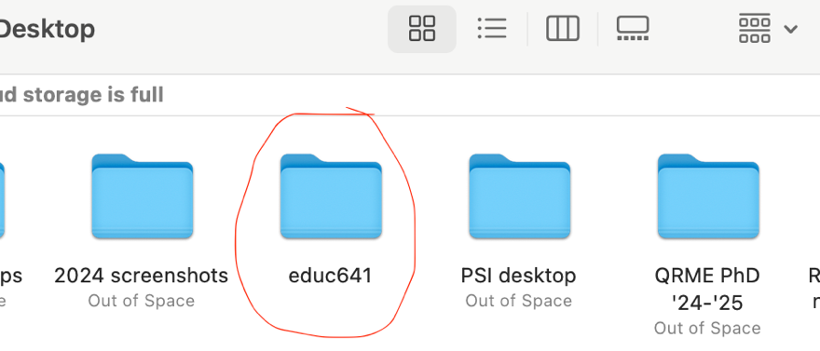

* 1. Add four more folders in the educ641_labs folder, label them *code, data, tables, figures* Note: try to keep everything lowercase and in one “string.” R doesn’t like spaces or capital letters.

* 1. Then, go to RStudio, click on Files -> New Project -> Existing Directory -> (select the educ641_labs file you created on your desktop in the educ641 folder) educ641_labs

* 1. Now go to the location on your device and check if your Rproj is in your educ641_labs folder with the four other folder you just created. It will look like a cube. Click on the Rproj cube and check in your bottom right panel under files tab to see if all your files are there. A screenshot of a computer

     Description automatically generated
  2. Try yourself: Make another R project for class assignments in your educ641_hw folder

Note: If you realize that you created an R project in the wrong directory, it is easier to delete it and then go through the process again for the correct directory.

1. **Save R script:** These “scripts” are used for writing and executing tasks in the **R programming language**, primarily designed for statistical computing and data analysis. While we haven’t utilized this function yet, we would like you to save the script you opened in task 2 to your code folder for Lab 2. File -> Save As… [give name to file] **educ641_lab2** (**save in code folder**). Please go to the file on your desktop and ensure your .R script is there. ☺

