MS Teplate

Cengiz Zopluoglu1 & Second author1,2

1 University of Oregon

2 Institution XYZ

Author note

A template for APA manuscript using papaja.

Correspondence concerning this article should be addressed to Cengiz Zopluoglu, Department of Educational Methodology, Policy, and Leadership, University of Oregon, Lokey Education Building, #102R, 1571 Alder Street, Eugene, OR 97403. E-mail: [cengiz@uoregon.edu](mailto:cengiz@uoregon.edu)

Abstract

One or two sentences providing a **basic introduction** to the field, comprehensible to a scientist in any discipline.

Two to three sentences of **more detailed background**, comprehensible to scientists in related disciplines.

One sentence clearly stating the **general problem** being addressed by this particular study.

One sentence summarizing the main result (with the words “**here we show**” or their equivalent).

Two or three sentences explaining what the **main result** reveals in direct comparison to what was thought to be the case previously, or how the main result adds to previous knowledge.

One or two sentences to put the results into a more **general context**.

Two or three sentences to provide a **broader perspective**, readily comprehensible to a scientist in any discipline.

*Keywords:* keywords

*Word count:* X

MS Teplate

# 1 Methods

We report how we determined our sample size, all data exclusions (if any), all manipulations, and all measures in the study.

## 1.1 Participants

## 1.2 Material

## 1.3 Procedure

## 1.4 Data analysis

# 2 Results

Table 1:

*Descriptive statistics of reading scores by race*

|  |  |  |  |  |
| --- | --- | --- | --- | --- |
| race | Mean | SD | Min | Max |
| A | 60.65 | 16.14 | 33.71 | 115.04 |
| AI | 51.29 | 9.68 | 33.78 | 102.66 |
| B | 52.63 | 10.37 | 33.41 | 113.45 |
| H | 50.44 | 9.68 | 33.14 | 107.71 |
| HPI | 54.58 | 12.52 | 34.30 | 104.81 |
| W | 55.72 | 11.20 | 33.22 | 164.33 |

*Note.* This table was created with apa_table()

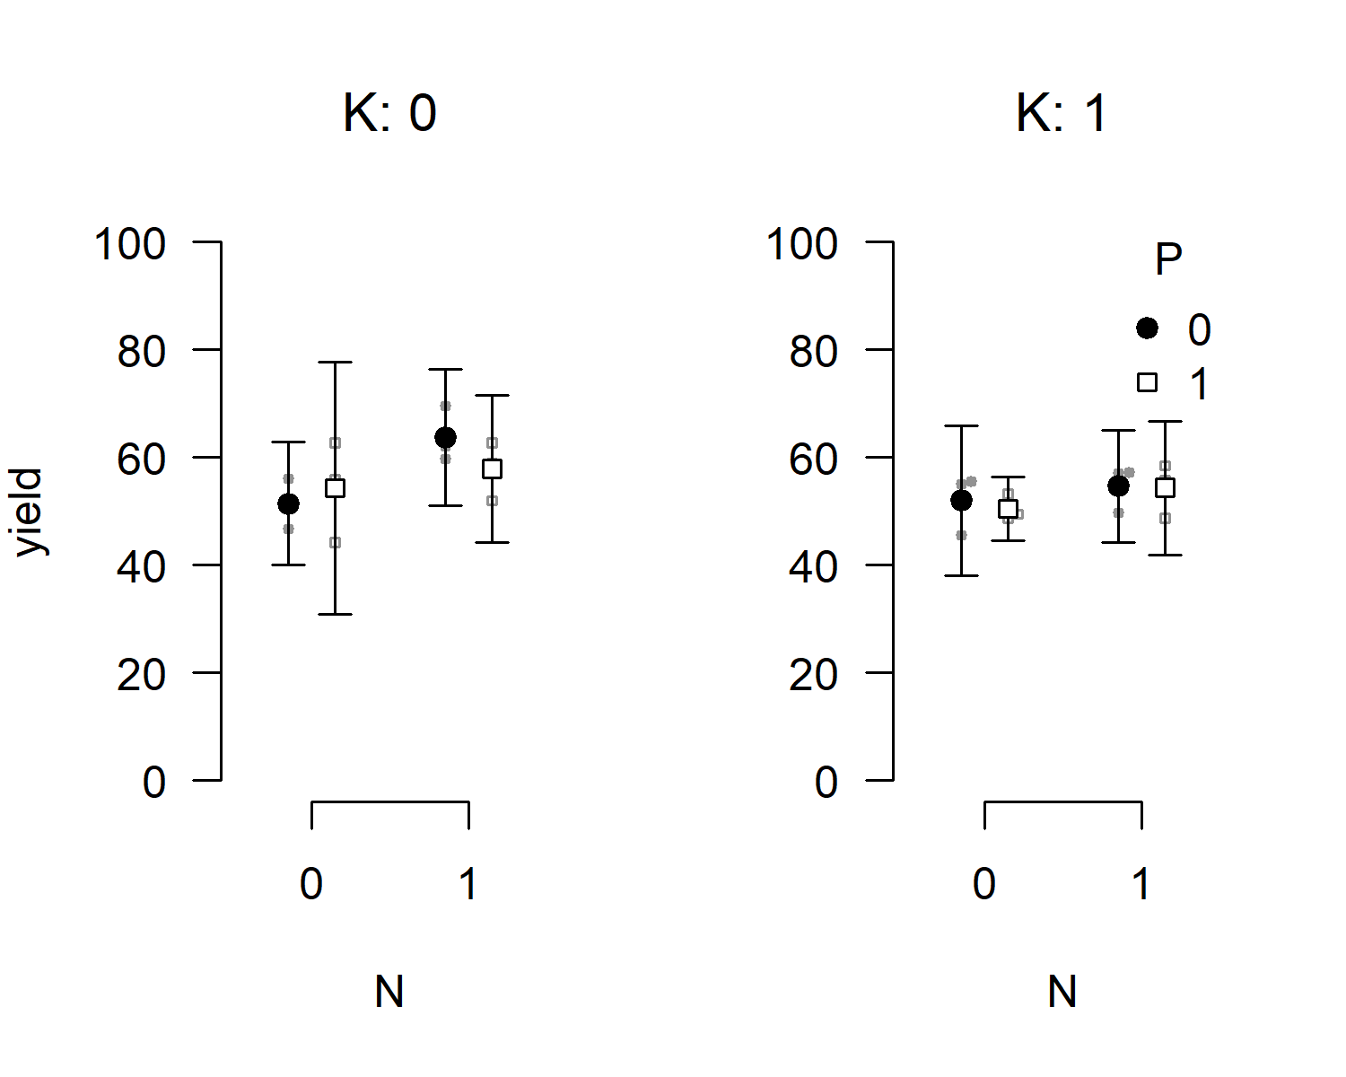

*Figure* *1.*  Bee plot of the example data set. Small points represent individual observations, large points represent means, and error bars represent 95% confidence intervals.

apa_print() will help you report the results of your statistical analyses. The function will format the contents of R objects and produce readily reportable text.

Now, you can report the results of your analyses like so:

Race is related to reading scores after accounting for SES, $F(5,14,063)=184.91$, $MSE=127.63$, $p<.001$, ${\hat{η}}_{p}^{2}=.062$.

What’s even more fun, you can easily create a complete ANOVA table using by passing mod_results$table to apa_table(), see Table 2.

Table 2:

*ANOVA table for the analyis of the example data set.*

|  |  |  |  |  |  |  |
| --- | --- | --- | --- | --- | --- | --- |
| Effect | $F$ | ${df}_{1}$ | ${df}_{2}$ | $MSE$ | $p$ | ${\hat{η}}_{p}^{2}$ |
| Race | 184.91 | 5 | 14,063 | 127.63 | < .001 | .062 |

*Note.* This is a table created using apa_print() and apa_table().

# 3 Discussion

# 4 References