3528 贴片LED规格书
3528 LED SMD SPECIFICATION

产品/Product : 贴片LED 3528白光
型号/Part Number : 3528W
客户/Customer :
日期/Date :

核准/APPROVED | 质检/Q.C. | 制作/Prepared

产品规格
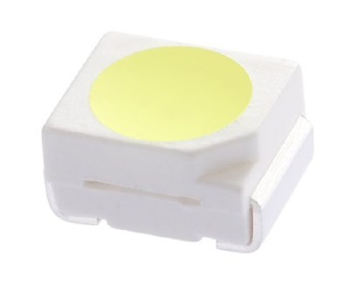

- 35mmx28mm SMD LED, 1.8mm THICKNESS.
（35mmx28mm SMD 发光二极管，总高1.2mm）
- VARIOUS COLORS AVAILABLE.（有各种颜色可供选择）

- WIDE SIDE VIEWING ANGLE.（宽角度发光)

- LOWPOWER CONSUMPTION. (低功率消耗)

Package Dimensions（封装尺寸）
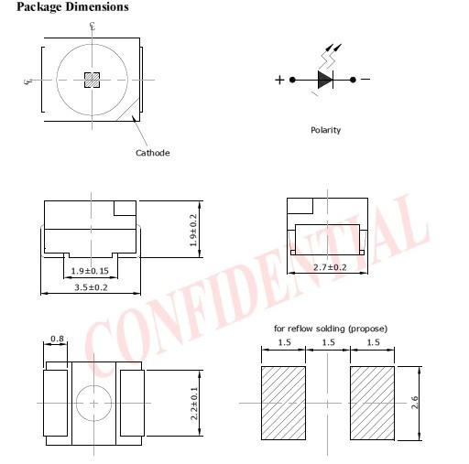
- All dimensions are in millimeters (inches). 所有单位是毫米（英寸）
- Tolerance is ± 0.25mm (.010”) unless otherwise noted. 允许误差为正负0.25mm,除非另行通知
- Specifications are subject to change without notice.规格可能随时有变化，不另行通知。
- This data-sheet only valid for six months.本数据有效期为六个月通量特征

Absolute Maximum Ratings at TA=25ºC(在25ºC环境下之绝对最大额定值)
Parameter(参数) | Maximum Rating（最大规定值） | Unit（单位）
Power Dissipation（消耗功率） | 60 | mW
Peak Forward Current（脉冲电流）  (1/10 Duty Cycle, 0.1ms Pulse width | 50 | mA
Continuous Forward Current（峰值电流） | 50 | mA
Derating Linear From 50℃（电流比例关系） | 0.2 | mA /℃
Operation Temperature Range（工作温度） | -40℃ to +80℃
Storage Temperature Range（储存温度） | -40℃ to +80℃
Lead Soldering Temperature  [4mm (.157”) From Body] （焊接温度） | 260℃ for 5 Seconds（260度下不超过5秒）

Electrical / Optical Characteristics at TA=25℃
Parameter（参数） | Symbol标志 | Min. 最小值 | Typ. 中间值 | Max. 最大值 | Unit单位 | Test Condition测试条件
Luminous Flux（光通量） | IV | 6 | 7 | 8 | lm | IF=20mA Note 1.4
Luminous Intensity（光强） | IV | 1800 | 2250 | 2500 | mcd | IF=20mA Note 1.4
Chromaticity Coordinate（R）色温 | CCT | 14000 | 15000 | 16000 |  | IF=20mA Note4
Viewing Angle（发光角度） | 2θ1/2 |  | 120 |  | deg | Note 2
Forward Voltage（正向电压） | VF | 3.0 | 3.1 | 3.3 | V | IF=20mA
Reverse Current（反向电流） | IR | - | - | 5 | μA | VR=5V
Note：1.Luminous intensity is measured with a light sensor and filter combination that approximates the CIE (Commission International De L’Eclairage) eye-response curve.
2.1/2 is the off-axis angle at which the luminous intensity is half the axial luminous and intensity.
3.The dominant wavelength, λd is derived from the CIE chromaticity diagram and represents the single wavelength which defines the color of the device.
4.The IV guarantee should be added ±15%.

其它参数图:
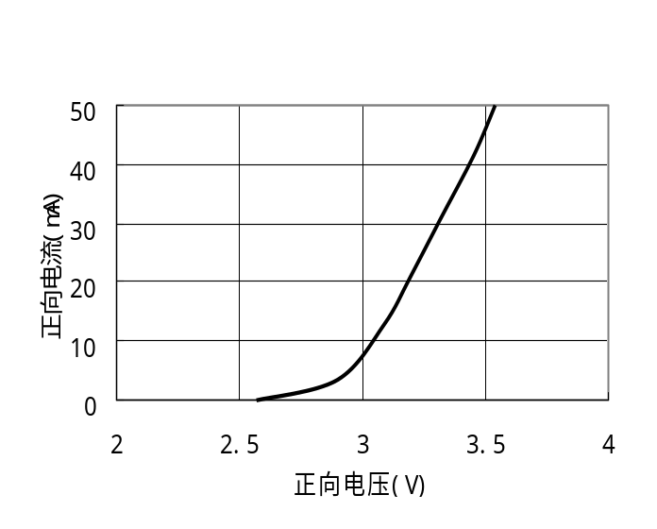
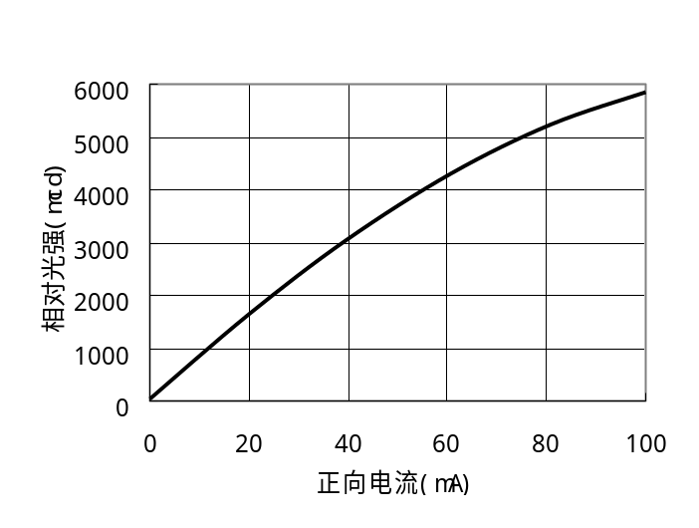

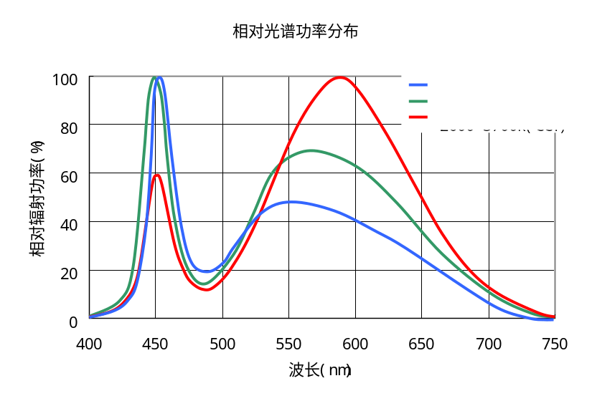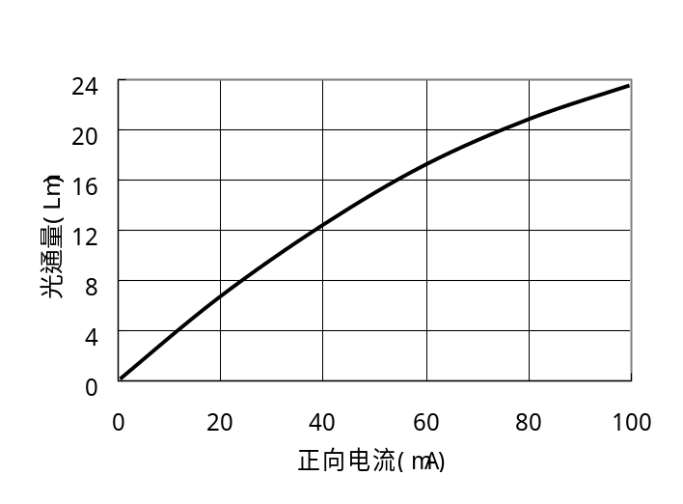

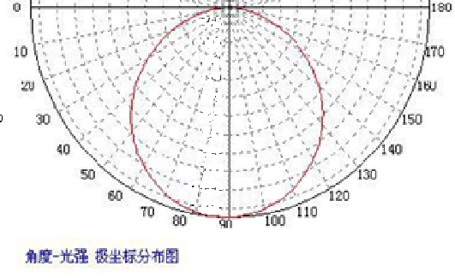

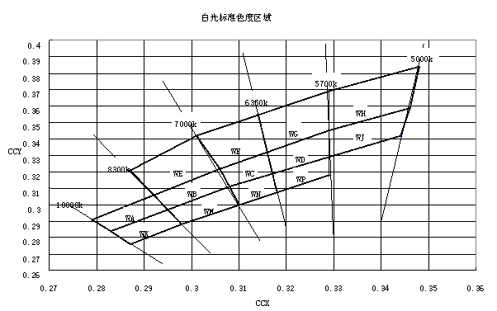
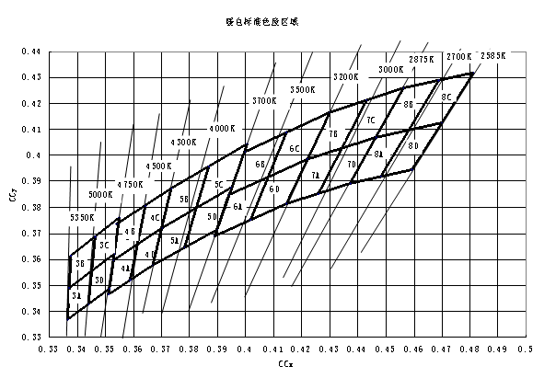

区域 | X Y | 区域 | X Y
WK | 0.283 0.284 | WF | 0.314 0.355
WK | 0.295 0.297 | WF | 0.316 0.332
WK | 0.298 0.288 | WF | 0.306 0.322
WK | 0.287 0.276 | WF | 0.301 0.342
WA | 0.292 0.306 | WP | 0.317 0.319
WA | 0.295 0.297 | WP | 0.329 0.330
WA | 0.283 0.284 | WP | 0.329 0.318
WA | 0.279 0.291 | WP | 0.318 0.308
WM | 0.295 0.297 | WD | 0.329 0.345
WM | 0.308 0.311 | WD | 0.329 0.330
WM | 0.310 0.300 | WD | 0.317 0.319
WM | 0.298 0.288 | WD | 0.316 0.332
WB | 0.306 0.322 | WG | 0.329 0.369
WB | 0.308 0.311 | WG | 0.329 0.345
WB | 0.295 0.297 | WG | 0.316 0.332
WB | 0.292 0.306 | WG | 0.314 0.355
WE | 0.301 0.342 | WJ | 0.329 0.330
WE | 0.306 0.322 | WJ | 0.329 0.345
WE | 0.292 0.306 | WJ | 0.346 0.359
WE | 0.287 0.321 | WJ | 0.344 0.342
WN | 0.308 0.311 | WH | 0.348 0.384
WN | 0.317 0.319 | WH | 0.346 0.359
WN | 0.318 0.308 | WH | 0.329 0.345
WN | 0.310 0.300 | WH | 0.329 0.369
WC | 0.316 0.332
WC | 0.317 0.319
WC | 0.308 0.311
WC | 0.306 0.322

白光色度区域限定坐标

暖白色度区域限定坐标
区域 | X | Y | 区域 | X | Y | 区域 | X | Y
 | 0.3371 | 0.349 |  | 0.367 | 0.3587 |  | 0.4147 | 0.3814
3A | 0.3451 | 0.3554 | 5A | 0.3702 | 0.3722 | 7A | 0.4221 | 0.3984
 | 0.344 | 0.3428 |  | 0.3825 | 0.3798 |  | 0.4342 | 0.4028
 | 0.3366 | 0.3369 |  | 0.3783 | 0.3646 |  | 0.4259 | 0.3853
 | 0.3376 | 0.3616 |  | 0.3702 | 0.3722 |  | 0.4221 | 0.3984
3B | 0.3463 | 0.3687 | 5B | 0.3736 | 0.3874 | 7B | 0.4299 | 0.4165
 | 0.3451 | 0.3554 |  | 0.3869 | 0.3958 |  | 0.443 | 0.4212
 | 0.3371 | 0.349 |  | 0.3825 | 0.3798 |  | 0.4342 | 0.4028
 | 0.3463 | 0.3687 |  | 0.3825 | 0.3798 |  | 0.4342 | 0.4028
3C | 0.3551 | 0.376 | 5C | 0.3869 | 0.3958 | 7C | 0.443 | 0.4212
 | 0.3533 | 0.362 |  | 0.4006 | 0.4044 |  | 0.4562 | 0.426
 | 0.3451 | 0.3554 |  | 0.395 | 0.3875 |  | 0.4465 | 0.4071
 | 0.3451 | 0.3554 |  | 0.3783 | 0.3646 |  | 0.4259 | 0.3853
3D | 0.3533 | 0.362 | 5D | 0.3825 | 0.3798 | 7D | 0.4342 | 0.4028
 | 0.3515 | 0.3487 |  | 0.395 | 0.3875 |  | 0.4465 | 0.4071
 | 0.344 | 0.3428 |  | 0.3898 | 0.3716 |  | 0.4373 | 0.3893
 | 0.3512 | 0.3465 |  | 0.3889 | 0.369 |  | 0.4373 | 0.3893
4A | 0.3529 | 0.3597 | 6A | 0.3941 | 0.3848 | 8A | 0.4465 | 0.4071
 | 0.3615 | 0.3659 |  | 0.408 | 0.3916 |  | 0.4582 | 0.4099
 | 0.359 | 0.3921 |  | 0.4017 | 0.3751 |  | 0.4483 | 0.3919
 | 0.3529 | 0.3597 |  | 0.3941 | 0.3848 |  | 0.4465 | 0.4071
4B | 0.3548 | 0.3736 | 6B | 0.3996 | 0.4015 | 8B | 0.4562 | 0.426
 | 0.3641 | 0.3804 |  | 0.4146 | 0.4089 |  | 0.4687 | 0.4289
 | 0.3615 | 0.3659 |  | 0.408 | 0.3616 |  | 0.4582 | 0.4099
 | 0.3615 | 0.3659 |  | 0.408 | 0.3916 |  | 0.4582 | 0.4099
4C | 0.3641 | 0.3804 | 6C | 0.4146 | 0.4089 | 8C | 0.4687 | 0.4289
 | 0.3736 | 0.3874 |  | 0.4299 | 0.4165 |  | 0.4813 | 0.4319
 | 0.3702 | 0.3722 |  | 0.4221 | 0.3984 |  | 0.47 | 0.4126
 | 0.359 | 0.3521 |  | 0.4017 | 0.3751 |  | 0.4483 | 0.3919
4D | 0.3615 | 0.3659 | 6D | 0.408 | 0.3916 | 8D | 0.4582 | 0.4099
 | 0.3702 | 0.3722 |  | 0.4221 | 0.3984 |  | 0.47 | 0.4126
 | 0.367 | 0.3578 |  | 0.4147 | 0.3814 |  | 0.4593 | 0.3944

Reflow Soldering Instructions (回流焊说明)
Number of reflow process shall be less than 2 times and cooling
process to normal temperature is required between first and Second soldering process.
(本产品最多只可回焊两次,且在首次回焊后须冷却至室温之后方可进行第二次回焊.)
1>Lead Solder（有铅回焊）
8 sex max
230℃
140~160℃
Over 120 sec
Time
4℃/sec
max
4℃/sec max
Temperature
2>Lead-Free Solder(无铅回焊)
6 sex max
260℃
180~200℃
Over 120 sec
Time
4℃/sec
max
4℃/sec max
Temperature

