NCCA logo | Want to learn  programming? | 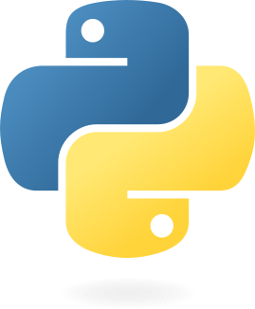
- Have you heard of the Python programming language? Want an introduction? A place to ask questions?
- Maybe you have heard of Javascript? You would like to see and build your own webpage or app?
- Perhaps someone said something about Java? Is it more than coffee? What is it and what is it used for?
- Have you heard of linux or Ubuntu? Come and see it!
- Finally, AI is all the rage, so come by and see chatbots/LLMs running on local laptops and maybe even setup your own laptop to run one!

Come by the library
Tuesdays/Thursdays
6-7pm
Bring your own laptop:
- We can set it up for programming
- We can set it up for AI
- We can create a learning plan

(If you don’t have a laptop, a couple running Ubuntu will be available to play and learn on!)

