



（ 2022 — 2023 学年第 一 学期 ）

课程名称： 面向对象程序设计
姓 名：
学 院： 工学院
专 业： 计算机科学与技术
年 级： 级
学 号：

实 验 报 告

20 年 12 月 13 日 第 3-4 节 勤学 楼 D323 号室 20 级 1 学期
进入实验室时间 | 同组者 | 离开实验室时间 | 实验项目名称
9:55 | 无 | 11:30 | C++基础（一）
一、实验目的
1、综合运用面向对象的程序设计方法，设计和定义链表类，实现链表中节点的管理及查询等功能。
2、理解和掌握模板的定义和使用方法；
3、通过定义的链表类实现基本的学生成绩管理功能；
4、实验八的内容均为综合型实验项目。
二、实验内容
1、将Student类作为基类，派生出本科生类（UnderGraduated）和研究生类（Graduated），
class UnderGraduated : public Student
{
public:
//请定义构造函数
//请定义析构函数
double tuition() { cout << “本科生学费” << endl; }

//重载运算符<<，实现本科生信息的输出，请定义。
friend ostream& operator<<(ostream& o, UnderGraduated& s);
};
class Graduated : public Student
{
private:
string tutor; //导师姓名
public:
//请定义构造函数
//请定义析构函数

void setTutor(string t) { tutoe = t; }
string getTutor() { return tutor; }

//重载运算符<<，实现研究生信息的输出，请定义。
friend ostream& operator<<(ostream& o, Graduated& s);
};
要求：
(1) 根据需要可以更改Student数据成员的访问属性；
(2) 考虑能否直接使用myList对本科生和研究生进行统一管理，若不能，分析原因，有无解决方法。
2、使用模板方法重新定义myList，实现相同的功能。
三、实验过程
1.
①题目：
将Student类作为基类，派生出本科生类（UnderGraduated）和研究生类（Graduated），
class UnderGraduated : public Student
{
public:
//请定义构造函数
//请定义析构函数
double tuition() { cout << “本科生学费” << endl; }

//重载运算符<<，实现本科生信息的输出，请定义。
friend ostream& operator<<(ostream& o, UnderGraduated& s);
};
class Graduated : public Student
{
private:
string tutor; //导师姓名
public:
//请定义构造函数
//请定义析构函数

void setTutor(string t) { tutoe = t; }
string getTutor() { return tutor; }

//重载运算符<<，实现研究生信息的输出，请定义。
friend ostream& operator<<(ostream& o, Graduated& s);
};
要求：
(1) 根据需要可以更改Student数据成员的访问属性；
(2) 考虑能否直接使用myList对本科生和研究生进行统一管理，若不能，分析原因，有无解决方法。

②代码：
完整代码:
#include <iostream>
using namespace std;

//---------------学生类部分-------------------
class Student
{
private:
string name; // 姓名
string sex; // 性别
string no; // 学号，每个学生的学号是唯一的
float Chinese; // 语文成绩
float math; // 数学成绩
float English; // 英语成绩
public:
Student(string _name, string _sex, string _no, float _chinese,
float _math, float _english) : name(_name), sex(_sex),
no(_no), Chinese(_chinese), math(_math), English(_english) {}
virtual ~Student() {}
string getName() { return name; }
void setName(string _name) { name = _name; }

string getSex() { return sex; }
void setSex(string _sex) { sex = _sex; }

string getNo() { return no; }
void setNo(string _no) { no = _no; }

float getChinese() { return Chinese; }
void setChinese(float _chinese) { Chinese = _chinese; }

float getMath() { return math; }
void setMath(float _math) { math = _math; }

float getEnglish() { return English; }
void setEnglish(float _english) { English = _english; }

// 做这些虚函数拓展student的多态性
virtual string getTutor() { return ""; }
virtual void setTutor(string t) { return; }
virtual double tuition() { return 0.0; }
virtual Student *getpartner() { return nullptr; }

friend ostream &operator<<(ostream &o, Student &s);
};

// 本科生
class UnderGraduated : public Student
{
// 添加了一个学伴字段和学费字段和GPA字段
private:
double tuition_;
Student *partner = nullptr;

public:
UnderGraduated(string name, string sex, string no, float chinese, float math, float english, bool isPartner) : Student(name, sex, no, chinese, math, english)
{
if (isPartner == true)
{
partner = new Student("ban", "female", "0000000", 0.0, 0.0, 0.0);
tuition_ = 4500.0 * 1.5;
}
else
{
tuition_ = 4500.0;
}
};
// 释放学伴，防止内存泄漏.
~UnderGraduated()
{
delete partner;
cout << "tip:undergraduate and her/his patrner are destructed now." << endl;
};

Student *getpartner()
{
return partner;
}

double tuition()
{
cout << "本科生学费:";
return tuition_;
}

friend ostream &operator<<(ostream &o, UnderGraduated &s);
};

// 研究生
class Graduated : public Student
{
private:
string tutor; // 导师姓名
public:
Graduated(string name, string sex, string no, string tutor, float chinese, float math, float english) : Student(name, sex, no, chinese, math, english), tutor(tutor) {}
~Graduated() { cout << "tip:Graduated is destructed now." << endl; }

void setTutor(string t)
{
tutor = t;
}
string getTutor() { return tutor; }
friend ostream &operator<<(ostream &o, Graduated &s);
};

ostream &operator<<(ostream &o, Student &s)
{
if (&s == NULL)
{
cout << "输出的学生不存在" << endl;
return o;
}
o << "姓名：" << s.name << "\n"
<< "性别：" << s.sex << "\n"
<< "学号：" << s.no;
return o;
}

ostream &operator<<(ostream &o, UnderGraduated &s)
{
string type_info = "本科生";
string part_info_null = "不存在";
if (&s == NULL)
{
cout << "输出的学生不存在" << endl;
return o;
}
o << "姓名：" << s.getName() << "\n"
<< "性别：" << s.getSex() << "\n"
<< "学号：" << s.getNo() << "\n"
<< "类别：" << type_info << "\n"
<< "学费：" << s.tuition_ << "\n";

if (s.partner != nullptr)
o << "学伴：" << s.partner->getName();
else
o << "学伴：" << part_info_null;

return o;
}

ostream &operator<<(ostream &o, Graduated &s)
{
string type_info = "研究生";
if (&s == NULL)
{
cout << "输出的学生不存在" << endl;
return o;
}
o << "姓名：" << s.getName() << "\n"
<< "性别：" << s.getSex() << "\n"
<< "学号：" << s.getNo() << "\n"
<< "类别：" << type_info << "\n"
<< "导师：" << s.tutor << "\n";

return o;
}

//-----------------------链表部分--------------------
// 链表节点
class Node
{
public:
Student *pStu;
Node *pNext; // 下一个节点指针

Node(Student *p) : pStu(p), pNext(NULL) {}
Node() : pStu(0), pNext(0) {}
virtual ~Node() {}
};

class myList
{
private:
Node *pHead; // 链表头指针
int nodeCount; // 链表中节点的个数
public:
myList() : pHead(0), nodeCount(0) {}
~myList(); // 删除所有的节点，请定义完整

// 以下函数需要定义
void add(Student *p); // 增加一个节点（链表尾）
Student *findByNo(string _no); // 按学号查找并定位学生（节点）

// 按姓名查找并定位学生（节点）
Student *findByName(string _name);

bool erase(string _no); // 按学号定位并删除学生（节点）

double averChinese(); // 计算所有的学生的语文平均成绩
double averMath(); // 计算所有的学生的数学平均成绩
double averEnglish(); // 计算所有的学生的英语平均成绩

// 计算指定学号的学生所有课程的平均成绩
double average(string _no);
};

myList::~myList(void)
{
for (int i = 0; i < nodeCount; i++)
{
Node *pn = pHead->pNext;
delete pHead->pStu;
delete pHead;
pHead = pn;
}
}

// 尾插法(没有做头节点)
void myList::add(Student *p)
{
nodeCount++;
Node *rear = pHead;
while (rear != NULL && rear->pNext != NULL)
{
rear = rear->pNext;
}
Node *newNode = new Node(p);
if (rear == NULL)
pHead = newNode;
else
rear->pNext = newNode;
}

Student *myList::findByNo(string _no)
{
Node *rear = pHead;
while (rear != NULL && rear->pStu->getNo() != _no)
{
rear = rear->pNext;
}
return rear->pStu;
}

Student *myList::findByName(string _name)
{
Node *rear = pHead;
while (rear != NULL && rear->pStu->getName() != _name)
{
rear = rear->pNext;
}
if (rear == NULL)
return NULL;

return rear->pStu;
}

bool myList::erase(string _no)
{
Node *rear = pHead;
Node *rbefore;
while (rear != NULL && rear->pStu->getNo() != _no)
{
rbefore = rear;
rear = rear->pNext;
}

if (rear != NULL)
{
rbefore->pNext = rear->pNext;
delete rear;
return true;
}
return false;
}

double myList::averChinese()
{
double sum = 0.0;
Node *rear = pHead;
while (rear != NULL)
{
sum += (double)(rear->pStu->getChinese());
rear = rear->pNext;
}
if (nodeCount != 0)
return sum / (double)nodeCount;

return 0.0;
}

double myList::averMath()
{
double sum = 0.0;
Node *rear = pHead;
while (rear != NULL)
{
sum += (double)(rear->pStu->getMath());
rear = rear->pNext;
}
if (nodeCount != 0)
return sum / (double)nodeCount;

return 0.0;
}

double myList::averEnglish()
{
double sum = 0.0;
Node *rear = pHead;
while (rear != NULL)
{
sum += (double)(rear->pStu->getEnglish());
rear = rear->pNext;
}
if (nodeCount != 0)
return sum / (double)nodeCount;

return 0.0;
}

double myList::average(string _no)
{
double sum = 0.0;
Student *s = findByNo(_no);
sum += (double)(s->getChinese() + s->getEnglish() + s->getMath());
return sum / 3.0;
}

int main()
{
// List test
myList *list1 = new myList();
list1->add(new UnderGraduated("张三", "male", "123456", 61, 95, 66, false));
list1->add(new UnderGraduated("李四", "male", "654321", 95, 65, 81, true));
list1->add(new Graduated("王五", "female", "415263", "王金祥", 53, 44, 63));
list1->add(new Graduated("马六", "female", "142536", "李政世", 87, 79, 85));
cout << "<<重载测试:" << endl;
cout << *((UnderGraduated *)(list1->findByName("张三"))) << endl
<< endl;
cout << *((Graduated *)(list1->findByName("马六"))) << endl;

cout << "功能成员测试:" << endl;
cout << list1->findByName("张三")->tuition() << endl;
cout << list1->findByName("李四")->tuition() << endl;
cout << "王五导师:" << list1->findByName("王五")->getTutor() << endl;

cout << endl
<< "释放测试:" << endl;
delete list1;

return 0;
}
③运行结果：
不可行报错展示
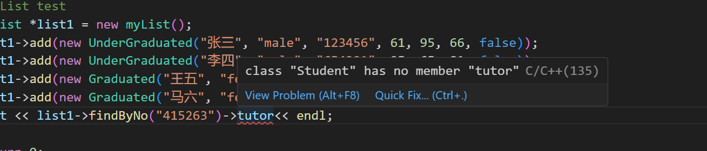
修正后测试结果(数据见完整代码):
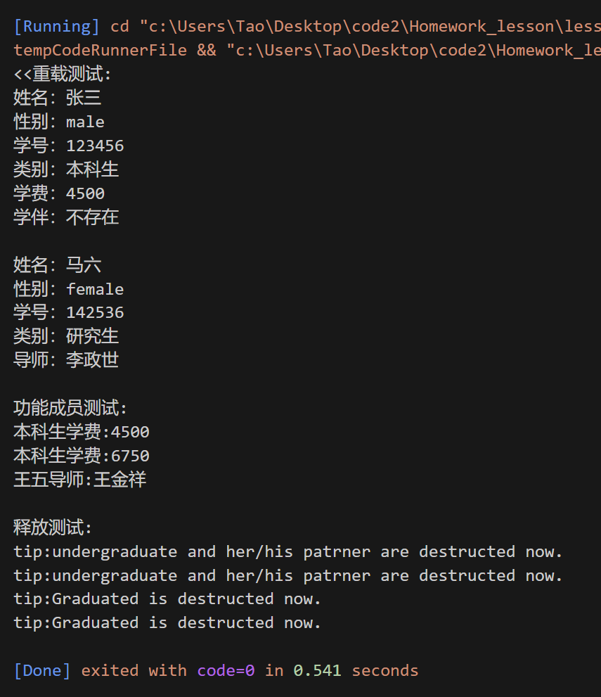

④分析：
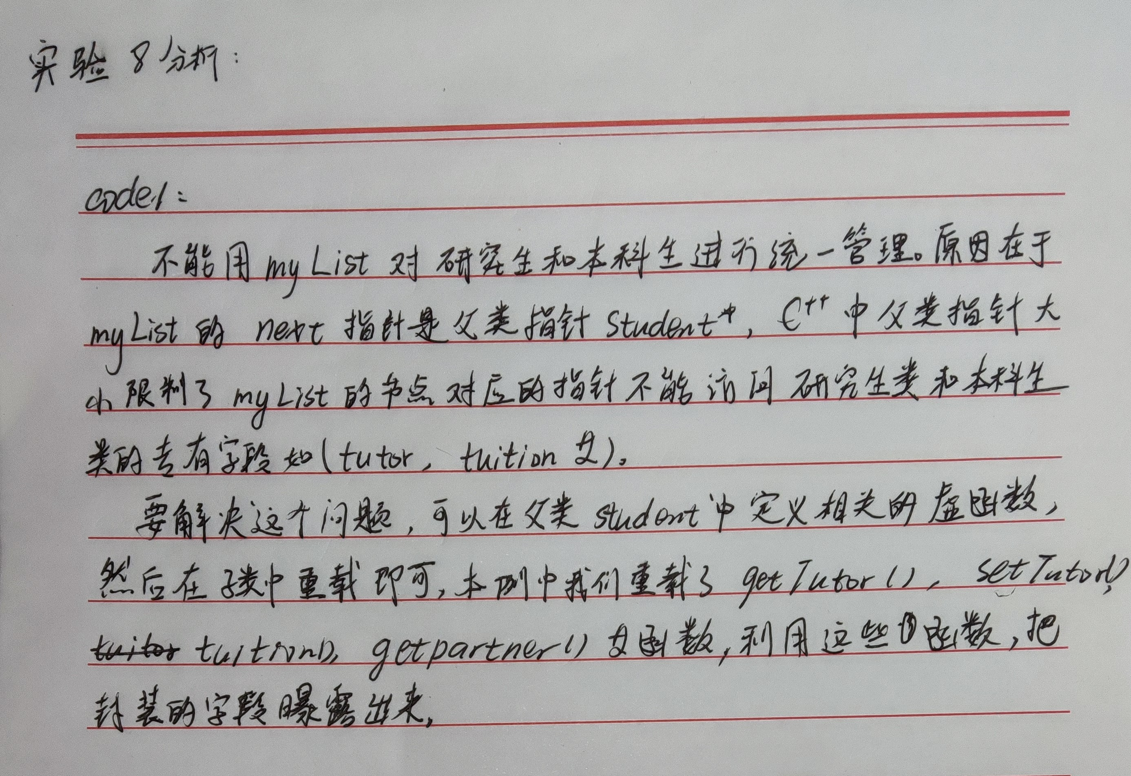
2.
①题目：
使用模板方法重新定义myList，实现相同的功能。
②代码：
#include <iostream>
using namespace std;

//---------------学生类部分-------------------
class Student
{
private:
string name; // 姓名
string sex; // 性别
string no; // 学号，每个学生的学号是唯一的
float Chinese; // 语文成绩
float math; // 数学成绩
float English; // 英语成绩
public:
Student(string _name, string _sex, string _no, float _chinese,
float _math, float _english) : name(_name), sex(_sex),
no(_no), Chinese(_chinese), math(_math), English(_english) {}
virtual ~Student() {}
string getName() { return name; }
void setName(string _name) { name = _name; }

string getSex() { return sex; }
void setSex(string _sex) { sex = _sex; }

string getNo() { return no; }
void setNo(string _no) { no = _no; }

float getChinese() { return Chinese; }
void setChinese(float _chinese) { Chinese = _chinese; }

float getMath() { return math; }
void setMath(float _math) { math = _math; }

float getEnglish() { return English; }
void setEnglish(float _english) { English = _english; }

// 做这些虚函数拓展student的多态性
virtual string getTutor() { return ""; }
virtual void setTutor(string t) { return; }
virtual double tuition() { return 0.0; }
virtual Student *getpartner() { return nullptr; }

friend ostream &operator<<(ostream &o, Student &s);
};

// 本科生
class UnderGraduated : public Student
{
// 添加了一个学伴字段和学费字段
private:
double tuition_;
Student *partner = nullptr;

public:
UnderGraduated(string name, string sex, string no, float chinese, float math, float english, bool isPartner) : Student(name, sex, no, chinese, math, english)
{
if (isPartner == true)
{
partner = new Student("ban", "female", "0000000", 0.0, 0.0, 0.0);
tuition_ = 4500.0 * 1.5;
}
else
{
tuition_ = 4500.0;
}
};
// 释放学伴，防止内存泄漏.
~UnderGraduated()
{
delete partner;
cout << "tip:undergraduate and her/his patrner are destructed now." << endl;
};

Student *getpartner()
{
return partner;
}

double tuition()
{
cout << "本科生学费:" << tuition_ << endl;
return tuition_;
}

friend ostream &operator<<(ostream &o, UnderGraduated &s);
};

// 研究生
class Graduated : public Student
{
private:
string tutor; // 导师姓名
public:
Graduated(string name, string sex, string no, string tutor, float chinese, float math, float english) : Student(name, sex, no, chinese, math, english), tutor(tutor) {}
~Graduated() { cout << "tip:Graduated is destructed now." << endl; }

void setTutor(string t)
{
tutor = t;
}
string getTutor() { return tutor; }
friend ostream &operator<<(ostream &o, Graduated &s);
};

ostream &operator<<(ostream &o, Student &s)
{
if (&s == NULL)
{
cout << "输出的学生不存在" << endl;
return o;
}
o << "姓名：" << s.name << "\n"
<< "性别：" << s.sex << "\n"
<< "学号：" << s.no;
return o;
}

ostream &operator<<(ostream &o, UnderGraduated &s)
{
string type_info = "本科生";
string part_info_null = "不存在";
if (&s == NULL)
{
cout << "输出的学生不存在" << endl;
return o;
}
o << "姓名：" << s.getName() << "\n"
<< "性别：" << s.getSex() << "\n"
<< "学号：" << s.getNo() << "\n"
<< "类别：" << type_info << "\n"
<< "学费：" << s.tuition_ << "\n";

if (s.partner != nullptr)
o << "学伴：" << s.partner->getName();
else
o << "学伴：" << part_info_null;

return o;
}

ostream &operator<<(ostream &o, Graduated &s)
{
string type_info = "研究生";
if (&s == NULL)
{
cout << "输出的学生不存在" << endl;
return o;
}
o << "姓名：" << s.getName() << "\n"
<< "性别：" << s.getSex() << "\n"
<< "学号：" << s.getNo() << "\n"
<< "类别：" << type_info << "\n"
<< "导师：" << s.tutor << "\n";

return o;
}

//-----------------------链表部分--------------------
// 链表节点
template <typename T>
class Node
{
public:
T *pStu;
Node *pNext; // 下一个节点指针

Node(T *p) : pStu(p), pNext(NULL) {}
Node() : pStu(0), pNext(0) {}
};

template <typename T>
class myList
{
private:
Node<T> *pHead; // 链表头指针
int nodeCount; // 链表中节点的个数
public:
myList() : pHead(0), nodeCount(0) {}
~myList(); // 删除所有的节点，请定义完整

// 以下函数需要定义
void add(T *p); // 增加一个节点（链表尾）
T *findByNo(string _no); // 按学号查找并定位学生（节点）

// 按姓名查找并定位学生（节点）
T *findByName(string _name);

bool erase(string _no); // 按学号定位并删除学生（节点）

double averChinese();
double averMath();
double averEnglish();

// 计算指定学号的学生所有课程的平均成绩
double average(string _no);
};

template <typename T>
myList<T>::~myList(void)
{
for (int i = 0; i < nodeCount; i++)
{
Node<T> *pn = pHead->pNext;
delete pHead->pStu;
delete pHead;
pHead = pn;
}
}

// 尾插法(没有做头节点)

template <typename T>
void myList<T>::add(T *p)
{
nodeCount++;
Node<T> *rear = pHead;
while (rear != NULL && rear->pNext != NULL)
{
rear = rear->pNext;
}
Node<T> *newNode = new Node<T>(p);
if (rear == NULL)
pHead = newNode;
else
rear->pNext = newNode;
}

template <typename T>
T *myList<T>::findByNo(string _no)
{
Node<T> *rear = pHead;
while (rear != NULL && rear->pStu->getNo() != _no)
{
rear = rear->pNext;
}
return rear->pStu;
}

template <typename T>
T *myList<T>::findByName(string _name)
{
Node<T> *rear = pHead;
while (rear != NULL && rear->pStu->getName() != _name)
{
rear = rear->pNext;
}
if (rear == NULL)
return NULL;

return rear->pStu;
}

template <typename T>
bool myList<T>::erase(string _no)
{
Node<T> *rear = pHead;
Node<T> *rbefore;
while (rear != NULL && rear->pStu->getNo() != _no)
{
rbefore = rear;
rear = rear->pNext;
}

if (rear != NULL)
{
rbefore->pNext = rear->pNext;
delete rear;
return true;
}
return false;
}

template <typename T>
double myList<T>::averChinese()
{
double sum = 0.0;
Node<T> *rear = pHead;
while (rear != NULL)
{
sum += (double)(rear->pStu->getChinese());
rear = rear->pNext;
}
if (nodeCount != 0)
return sum / (double)nodeCount;

return 0.0;
}

template <typename T>
double myList<T>::averMath()
{
double sum = 0.0;
Node<T> *rear = pHead;
while (rear != NULL)
{
sum += (double)(rear->pStu->getMath());
rear = rear->pNext;
}
if (nodeCount != 0)
return sum / (double)nodeCount;

return 0.0;
}

template <typename T>
double myList<T>::averEnglish()
{
double sum = 0.0;
Node<T> *rear = pHead;
while (rear != NULL)
{
sum += (double)(rear->pStu->getEnglish());
rear = rear->pNext;
}
if (nodeCount != 0)
return sum / (double)nodeCount;

return 0.0;
}

template <typename T>
double myList<T>::average(string _no)
{
double sum = 0.0;
Student *s = findByNo(_no);
sum += (double)(s->getChinese() + s->getEnglish() + s->getMath());
return sum / 3.0;
}

int main()
{
cout << "模板实现:" << endl;
// List test
myList<Student> *list1 = new myList<Student>();
list1->add(new UnderGraduated("张三", "male", "123456", 61, 95, 66, false));
list1->add(new UnderGraduated("李四", "male", "654321", 95, 65, 81, true));
list1->add(new Graduated("王五", "female", "415263", "王金祥", 53, 44, 63));
list1->add(new Graduated("马六", "female", "142536", "李政世", 87, 79, 85));

cout << "<<重载测试:" << endl;
cout << *((UnderGraduated *)(list1->findByName("张三"))) << endl
<< endl;
cout << *((Graduated *)(list1->findByName("马六"))) << endl;

cout << "功能成员测试:" << endl;
cout << list1->findByName("张三")->tuition() << endl;
cout << list1->findByName("李四")->tuition() << endl;
cout << "王五导师:" << list1->findByName("王五")->getTutor() << endl;

cout << endl
<< "释放测试:" << endl;
delete list1;

return 0;
}
③运行结果：
需求是实现相同的功能,于是与code1进行相同的测试:
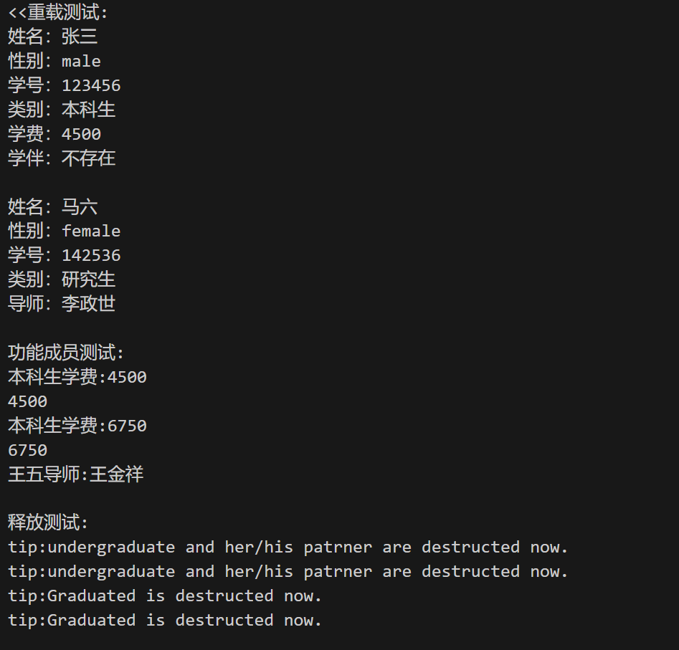
测试通过
④分析：
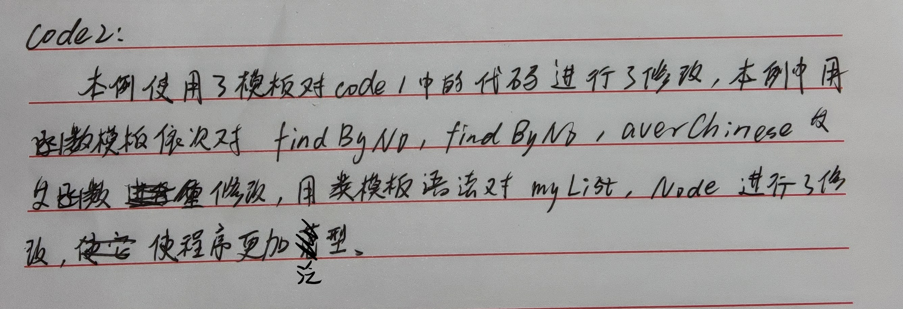
四、总结（存在问题、解决方法及实验收获）
通过本次实验,我有了以下收获心得:
1.模板（template）是实现代码重用机制的一种工具，它可以实现类型参数化，把类型定义为参数（模板元编程），从而实现了真正的代码可重用性。模板可以分为两类，一个是函数模板，另外一个是类模板。
2.函数模板允许定义一个通用的函数，可以在不同数据类型上进行操作。通过定义函数中的参数类型为模板参数，可以在函数调用时根据实际参数的类型来推断模板参数的类型。
3.类模板允许定义通用的类，可以在不同数据类型上进行实例化。与函数模板类似，通过在类中使用模板参数，可以在类的成员函数和成员变量中使用通用类型。
教师评语：
该生按时完成实验内容，实验步骤准确完整，实验总结全面，实验结果正确，实验思路创新，实验分析详细，实验态度认真。此次试验成绩为：优秀。

