1. dat<-read.table("subdat.txt")
2. > dim(dat)

[1] 10000 500

1. > range(dat)

0 2

1. dat.mat<-matrix(dat)> hist(dat.mat)
2. idp<-read.table("http://www2.unil.ch/popgen/teaching/R14/indpopsurv.txt",header=T)
3. table(idp$pop)

1A 1C 2A 2C 3A 3C 4A 4C 5A 5C

50 50 50 50 50 50 50 50 50 50

treat<-list("A"=0,"C"=0)

treat$A<-idp$id[grep(pattern="A",idp$pop)]

treat$C<-idp$id[grep(pattern="C",idp$pop)]

1. loc<-list("1"=0,"2"=0,"3"=0,"4"=0,"5"=0)

loc[[1]]<-idp$id[grep(pattern="1",idp$pop)]

loc[[2]]<-idp$id[grep(pattern="2",idp$pop)]

loc[[3]]<-idp$id[grep(pattern="3",idp$pop)]

loc[[4]]<-idp$id[grep(pattern="4",idp$pop)]

loc[[5]]<-idp$id[grep(pattern="5",idp$pop)]

1. table(idp$pop,idp$surv)

0 1

1A 34 16

1C 35 15

2A 35 15

2C 33 17

3A 43 7

3C 34 16

4A 42 8

4C 36 14

5A 27 23

5C 41 9

1. a<-idp$surv[grep(pattern="A",idp$pop)]

cc<-idp$surv[grep(pattern="C",idp$pop)]

Surviving, dead in A = c(length(a),length(a)-sum(a))

250 181

Surviving, dead in C = c(length(cc),length(a)-sum(cc))

[1] 250 179

1. loc1<-idp$surv[grep(pattern="1",idp$pop)]

loc2<-idp$surv[grep(pattern="2",idp$pop)]

loc3<-idp$surv[grep(pattern="3",idp$pop)]

loc4<-idp$surv[grep(pattern="4",idp$pop)]

loc5<-idp$surv[grep(pattern="5",idp$pop)]

c(length(loc1),length(loc1)-sum(loc1)) ;

c(length(loc2),length(loc2)-sum(loc2))

c(length(loc3),length(loc3)-sum(loc3))

c(length(loc4),length(loc4)-sum(loc4))

c(length(loc5),length(loc5)-sum(loc5))

1. names(dat)<-idp$id
2. datn<-matrix(nrow=nrow(dat), ncol=ncol(dat))
3. hist(datn)
4. row.sums<-c(rowSums(datn, na.rm=T))

hist(row.sums)

col.sums<- c(colSums(datn, na.rm=T))

hist(col.sums)

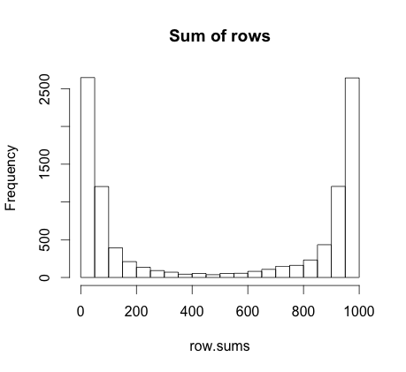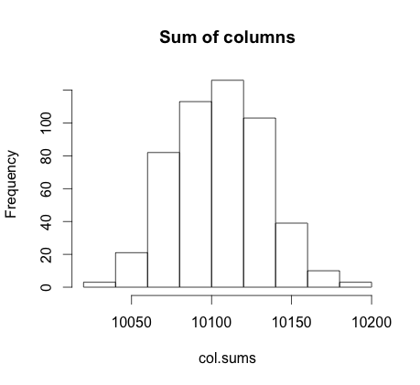

15.

16. tot.freq<-c(mean(row.sums)/2)

17. datn.C<-data.frame(dat[names(dat)==treat$C])

C.freq<- c(mean(rowSums(datn.C, na.rm=T))/2)