International Geomechanics Conference 2026 IGS-2026-206

An Interpretable Machine-Learning Framework for Pressure-Response Pattern Recognition and Frac-Hit Prediction in Deep Shale Gas Reservoirs
Zhao Cheng, Wendong Wang*, Yuxuan Deng, Wubin Yan & Yuliang Su
State Key Laboratory of Deep Oil and Gas, China University of Petroleum (East China), Qingdao, Shandong 266580, China
Wenfeng Yu
Shale Gas Research Institute, PetroChina Southwest Oil & Gasfield Company, Chengdu 610051, China
Sichuan Key Laboratory of Shale Gas Evaluation and Exploitation, Chengdu 610213, China
*Corresponding author: wwdong@upc.edu.cn
Copyright 2026 ARMA, American Rock Mechanics Association
This paper was prepared for presentation at the International Geomechanics Conference (IGS) on 16 -19 November 2026 in Chengdu, China. This paper was selected for presentation at the conference by an IGS Technical Program Committee based on a technical and critical review of the paper by a minimum of two technical reviewers. The material, as presented, does not necessarily reflect any position of the partner societies ARMA/DGS/SEG/CSRME/AAPG/SPWLA/InterPore/SPE/CSHE, its officers, or members. Electronic reproduction, distribution, or storage of any part of this paper for commercial purposes without the written consent of the partner societies is prohibited. Permission to reproduce in print is restricted to an abstract of not more than 200 words; illustrations may not be copied. The abstract must contain conspicuous acknowledgement of where and by whom the paper was presented.
ABSTRACT: Offset-well pressure responses during multi-well stimulation reflect coupled geological, mechanical, and operational influences, yet pressure increases alone do not establish hydraulic connectivity. This study develops an interpretable workflow for the L201H5 deep shale gas platform using raw treatment and offset-pressure records, well geometry, interpreted mechanical logs, seismic attributes, and microseismic observations. Quality control retained 229 stage–offset-well pairs from 78 stages. Sustained pressure increases of at least 1 MPa occurred in 27 pairs, all involving the same unordered well pair. Ward clustering favored four groups, but two groups contained only two samples each; removing two abrupt pressure steps favored three groups. In source-well-held-out evaluation, random forests using geometry, stage design, and pre-stage pressure achieved an average precision of 0.801, whereas adding mechanical and seismic attributes reduced it to 0.580. Holding out the sole responsive well pair left no positive training examples, precluding assessment of cross-pair transfer. Microseismic cases supported spatial comparisons without confirming direct hydraulic connection. The workflow therefore provides reproducible response characterization and exposes the validation limits of single-platform frac-hit prediction, motivating independent event adjudication and multi-platform testing.

1. INTRODUCTION
Multi-well stimulation perturbs stress and pore pressure in deep shale reservoirs. Offset-well pressure is a useful observation of this interaction, but its amplitude and timing depend on both subsurface processes and the monitored well’s boundary conditions. Field investigations at IGS have documented complex interference during Sichuan shale stimulation (Tang et al., 2023). Such complexity motivates a geomechanical interpretation that distinguishes measured pressure response from inferred fracture connection.
Machine learning has already been applied to pressure-based frac-hit detection and geological–engineering risk classification (Liu et al., 2024; Zeng et al., 2025). Accordingly, the contribution sought here is a traceable field workflow and a critical assessment of its transferability, rather than a claim that combining clustering and prediction is itself new. We separate retrospective morphology from pre-stage prediction, retain operational uncertainties, and test whether interpreted mechanical logs and seismic proxies add predictive information. In this paper, “frac-hit prediction” denotes an exploratory sustained-pressure-response surrogate; independently verified communication or damage is not the measured endpoint.

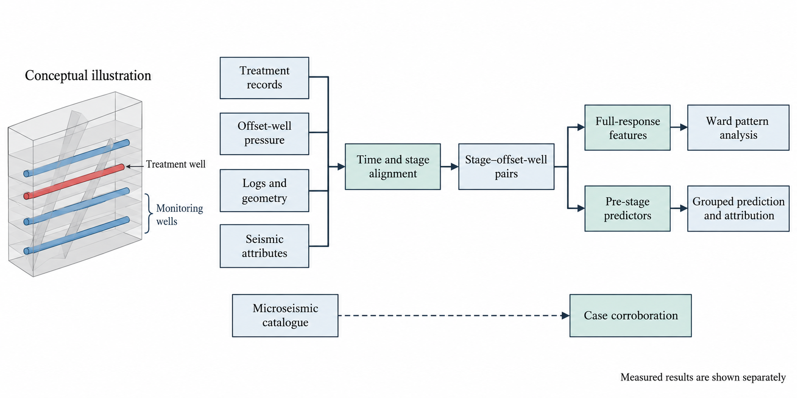
Fig. 1. Analysis workflow. The well and fracture illustration is conceptual and is not a reconstruction of the field. Full-response features are restricted to retrospective characterization; prediction uses pre-stage information. Microseismic observations provide separate case evidence.

2. FIELD DATA AND QUALITY CONTROL
The L201H5 package contains four wells, 98 designed stages, 578 distinct perforation clusters, 97 treatment files, 99 pressure-monitoring files covering 96 distinct stages, and four LAS files. Stage-center true vertical depths in the retained cohort are 4.18–4.29 km. Three duplicate perforation rows were removed. The microseismic catalogue contains 3235 records and 3232 after exact duplicate screening. The analytical unit is one treatment stage and one of its three platform offset wells, yielding 291 candidate pairs. All counts refer to supplied records, not independent geological realizations.
Treatment start and end are the first and last runs with rate at least 1 m³/min for 30 s. The resulting envelope can include internal shutdowns. Four files concatenate resumed operations on consecutive dates; date rollovers were reconstructed from documented clock resets and cross-checked against monitoring and event dates. No time shift was fitted to maximize pressure correlation. Independent instrument clock calibration was unavailable.
Pressure was screened within −0.1–200 MPa and reduced to 5 s medians. Retention required at least 95% treatment and pressure coverage, no treatment gap over 300 s or pressure gap over 30 s, a 20 min–8 h stage envelope, and at least 180 s of baseline measurements in the interval from 300 to 30 s before start. Recorded pumping by another well for over 60 s during the envelope caused exclusion. Baselines with absolute linear slope exceeding 0.1 MPa/min were excluded to avoid labeling pre-existing pressure ramps as new responses.
The coverage and timing criteria initially retained 233 pairs. Trace inspection motivated the baseline-stability refinement, removing four more pairs, and a smoothing safeguard described below. Thus, quality control was exploratory, not preregistered. The resulting 229 pairs cover 78 stages from August 2025 to January 2026. Exclusions overlap and are retained with explicit reasons; absent data are never assigned a negative response.

2.1. Mechanical and Seismic Descriptors
Stage averages of interpreted Young’s modulus, Poisson’s ratio, minimum horizontal stress, and horizontal stress difference were obtained by length-weighted integration of 0.125 m LAS supports over measured-depth stage intervals. These are log interpretations, not independently calibrated mechanical tests. The duplicated maximum-stress and breakdown-pressure columns in one layer table were not used as separate predictors. Geometry uses the minimum three-dimensional distance from treatment-cluster centers to the offset lateral trajectory, excluding shared surface locations. Vertical separation is the absolute elevation difference at that closest cluster–lateral point pair. Curvature was linearly interpolated to the reference horizon; discrete MCANT used its nearest vertical sample.

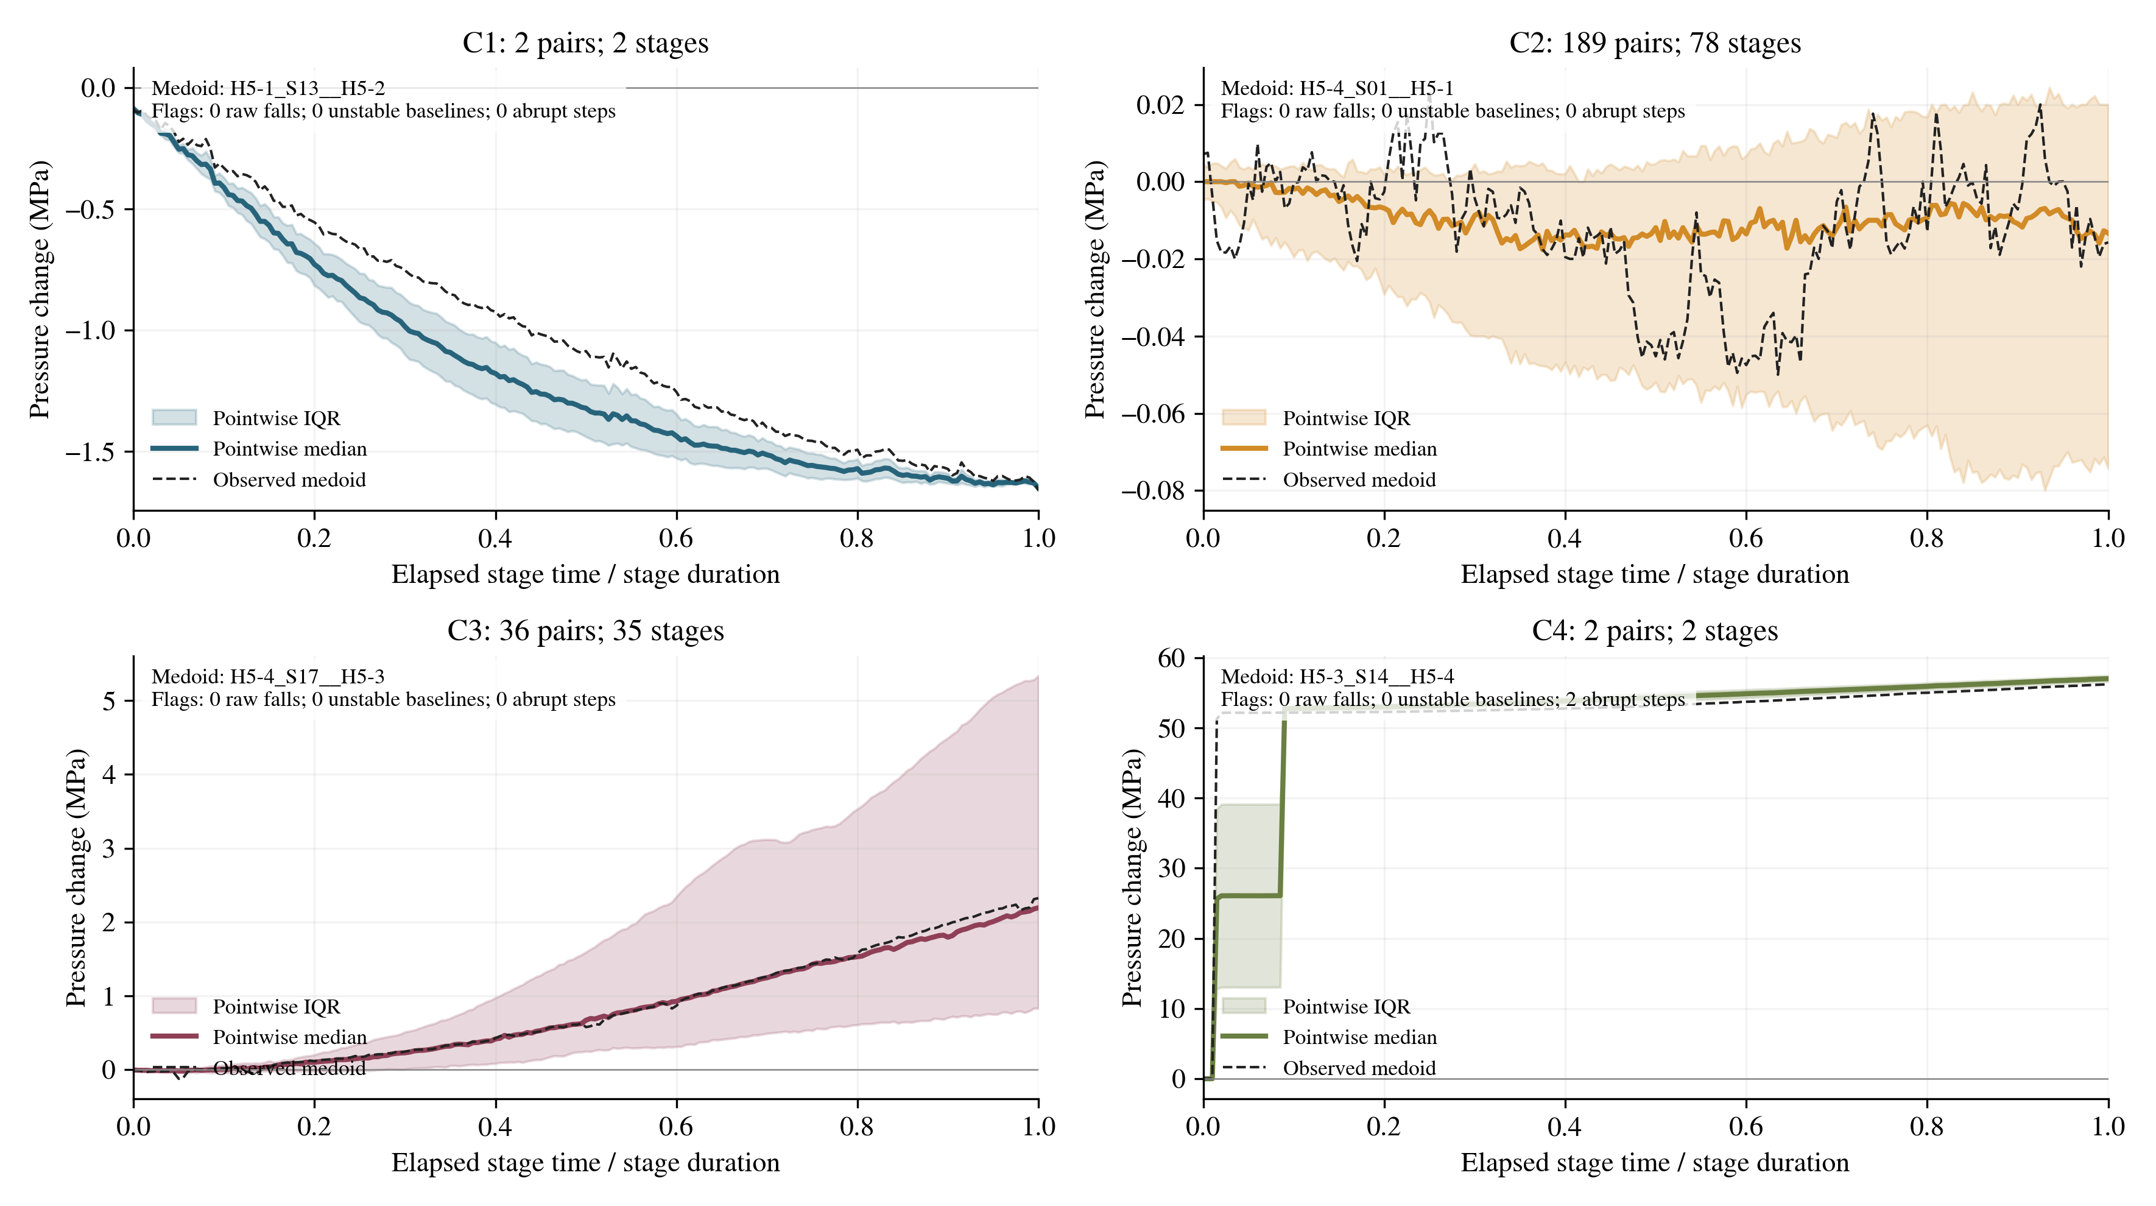
Fig. 2. Response groups from the four-cluster Ward solution. Curves are aligned by fractional treatment-envelope time; pressure amplitude remains in MPa. Pointwise interquartile ranges describe within-group variation. Small groups and abrupt-step flags limit interpretation as repeatable mechanisms.

Two supplied SEG-Y attributes, maximum curvature and MCANT, were sampled along the supplied O3w reference horizon in its recorded millisecond domain. Stage predictors are the 90th-percentile curvature and mean raw MCANT over the union of 50 m horizontal neighborhoods around perforation clusters. MCANT values of −1 were retained because their meaning is undocumented. These are reference-horizon structural proxies, not measured fracture density, approach angle, or attributes sampled at perforation depth. No time–depth conversion was assumed.
Engineering northing/easting columns were reordered to match the seismic grid. All perforation clusters fall within its horizontal extent, although the LU205H5 seismic filenames differ from the L201H5 engineering label and projection metadata remain unconfirmed. The survey’s explicit grid-azimuth convention defines the primary geometry. H5-1 LAS offsets differ by approximately 2.64°, shifting cluster positions by 51–106 m; an alternative-coordinate sensitivity analysis was therefore required.

3. RESPONSE AND PREDICTION METHODS

3.1. Pressure Features and Outcome
Let p₀ be the median raw pre-stage pressure and p̃(t) the filtered pressure. Their difference defines the observed response:
$Δp(t) = p̃(t) − p₀$ (1)
A seven-bin Hampel-type screen replaced isolated flagged runs of at most 10 s using a threshold equal to the larger of three scaled median absolute deviations and 0.05 MPa. A seven-bin quadratic Savitzky–Golay filter was then constrained to the local minimum and maximum of the Hampel series. This range constraint prevents artificial undershoot around large steps. Centered filtering is used only for retrospective targets and morphology, not online warning inputs.
The primary label is Δp ≥ 1 MPa for at least 60 s within the treatment envelope. The 2 and 5 MPa thresholds are sensitivities; none is a field-calibrated damage limit. Two changes between adjacent 5 s medians exceeding 10 MPa were flagged but retained in the primary cohort, avoiding outcome-dependent removal. Unfiltered and filtered 5 s median labels agree for all retained pairs.
Ward clustering (Ward, 1963) uses standardized log-transformed positive peak, mean positive response, mean negative response, fractional onset time, terminal-to-peak ratio, and positive duty fraction. Onset requires 60 s above max(0.2 MPa, 20% of positive peak); noncrossing responses receive onset fraction one. Terminal pressure change is the final five-minute median, normalized by max(peak, 0.2 MPa) and clipped to [−2, 2]. Duty fraction is the proportion of envelope bins above the same shape threshold. Log amplitudes use log(1 + amplitude/1 MPa). K = 2–6 was compared by silhouette. Stability used 100 refits, including scaling, on 62 of 78 stage groups without replacement (seed 20260913).

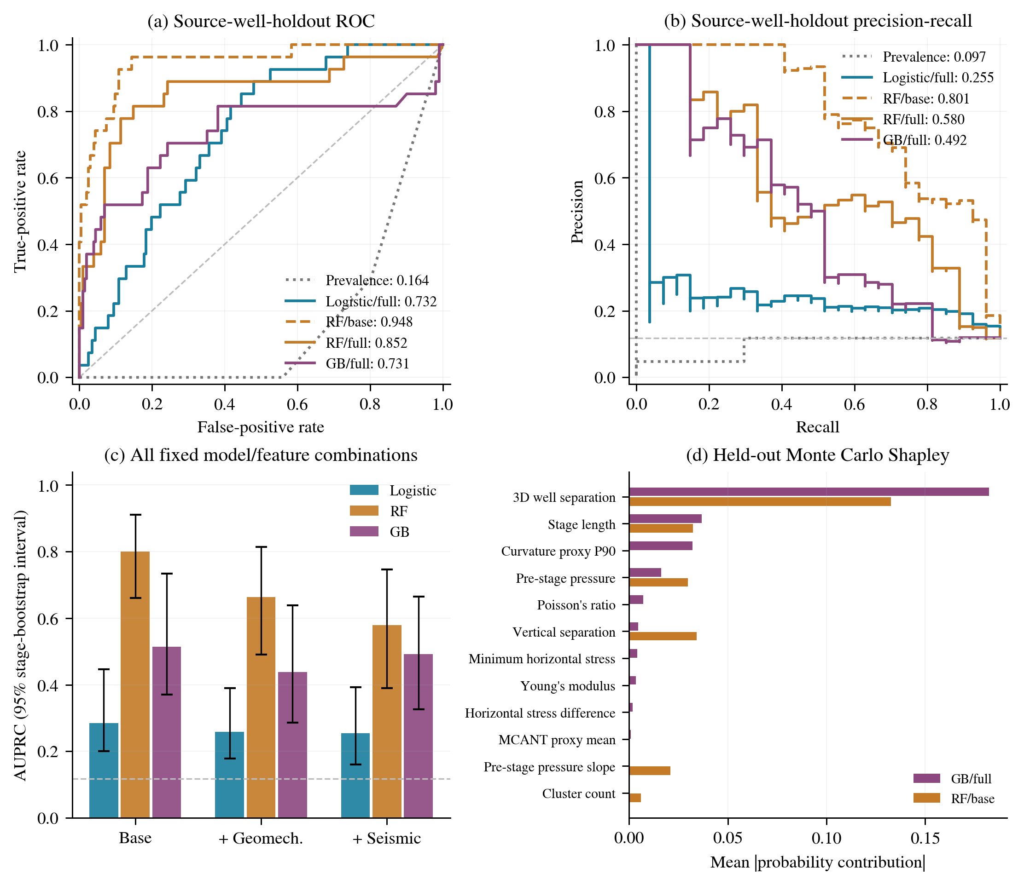
Fig. 3. Internal source-well-held-out prediction, feature-set comparison, and out-of-fold Monte Carlo Shapley attribution. Average precision summarizes the precision–recall curve. Base, mechanical, and full feature sets are nested. The horizontal PR reference is cohort prevalence; pooled fold-specific prevalence predictions can rank below chance. Missing RF/base attribution bars denote variables not supplied. Internal discrimination does not establish cross-pair transfer.

3.2. Prediction and Validation
Base predictors comprise minimum 3D distance, vertical separation, stage length, cluster count, pre-stage pressure median and slope. The mechanical set adds four LAS descriptors; the full set adds two seismic proxies. Full-response features and final fluid/proppant totals are excluded. Geometry and logs are assumed available before stimulation; interpretation delivery dates are undocumented.
Fixed models comprise balanced logistic regression (C = 1), balanced random forests (RF; 300 trees, depth 4, minimum leaf 6), and balanced-weight gradient boosting (GB; 200 trees, learning rate 0.05, depth 2, minimum leaf 8) (Breiman, 2001; Friedman, 2001). Training-fold median imputation is applied; logistic predictors are standardized. Hyperparameters and the 0.5 cutoff are not test-optimized. GB/full remains the integrated benchmark despite stronger comparator results.
Four source-well holdouts keep each stage’s neighbors together. Further checks use the latest quarter of stages, alternative H5-1 coordinates, and six unordered-pair holdouts combining reciprocal directions. All are retrospective within one platform. Pooled out-of-fold metrics are AUROC, average precision (AP), F1, and Brier score. Percentile intervals use 500 resamples of stage groups from fixed out-of-fold predictions, excluding model-refitting, between-platform uncertainty, and residual cross-stage dependence.
Monte Carlo Shapley contributions use 64 feature-order/background paths per held-out sample with training-only backgrounds (Štrumbelj and Kononenko, 2014). They explain predicted probabilities, not causal effects; correlated-feature substitutions can also create unrealistic combinations.

4. RESULTS
There are 27 positives (11.8%): eight for treatment H5-3→monitor H5-4 and 19 in reverse. H5-1/H5-2 holdouts lack positives, so fold AUROC/AP are undefined. The 2/5 MPa definitions yield 22/13 positives. All positives belong to one unordered well pair, limiting performance interpretation.

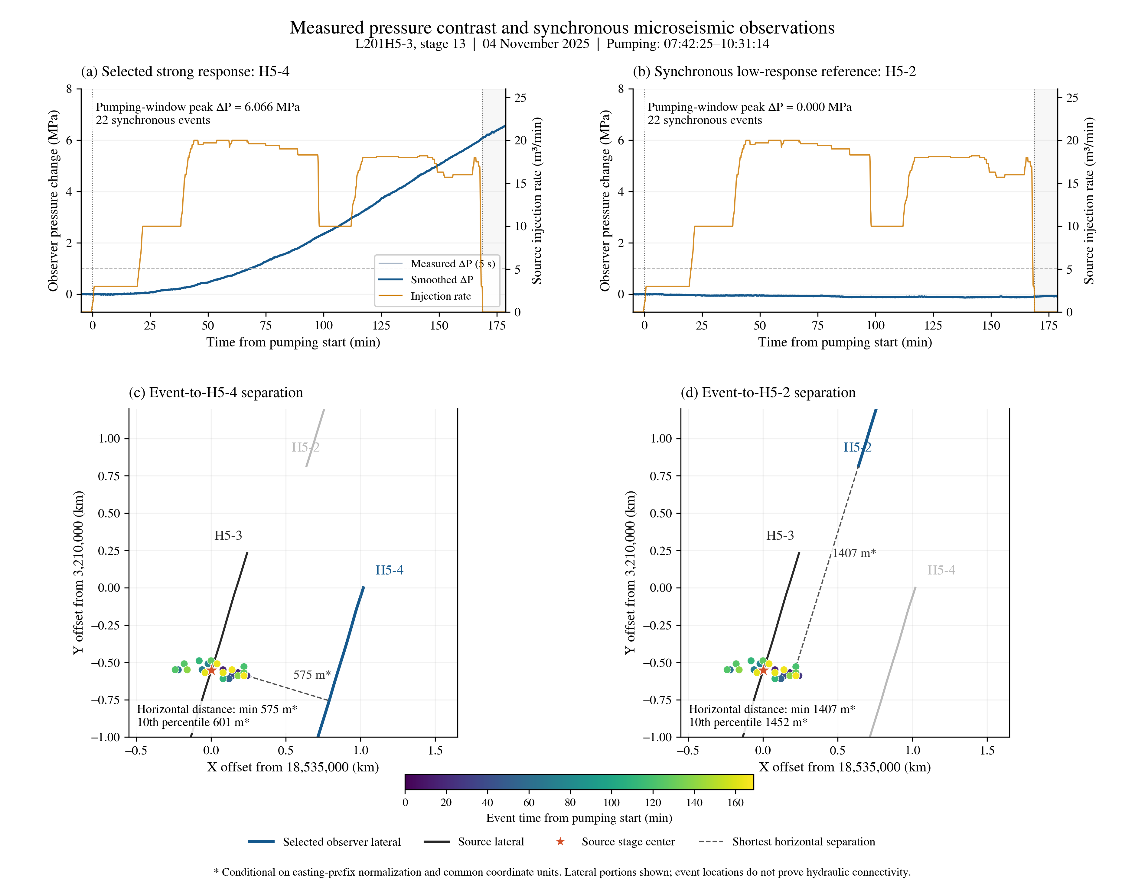
Fig. 4. H5-3 stage 13 treatment and two synchronous offset responses, with 22 catalogue events. H5-4 shows a 6.07 MPa peak rise; H5-2 shows no positive rise. Distances are horizontal and conditional on coordinate normalization. Event locations are observations, not mapped hydraulic-fracture surfaces.

4.1. Patterns and Model Comparisons
The maximum silhouette is 0.738 at K = 4, only 0.003 above K = 3. Ordered by median peak, the groups contain 2 declining, 189 weak, 36 positive-buildup, and 2 abrupt-step responses (Fig. 2). Their median peaks are −0.074, 0.020, 2.203, and 57.000 MPa. The two abrupt-step records are flagged. Four-cluster stability has mean adjusted Rand index 0.853 and fifth percentile 0.443; excluding the two steps selects K = 3 (silhouette 0.747). These results do not establish four stable geomechanical mechanisms.
Table 1. Pooled source-well-held-out results for 229 pairs.
Model / set | AUROC | AP | Brier
Logistic / full | 0.732 | 0.255 | 0.134
RF / base | 0.948 | 0.801 | 0.054
RF / full | 0.852 | 0.580 | 0.075
GB / base | 0.922 | 0.515 | 0.106
GB / full | 0.731 | 0.492 | 0.131
RF/base has the highest descriptive AP, with 95% stage-bootstrap interval 0.661–0.910; its AUROC interval is 0.898–0.984. It detects 18 of 27 positives with six false positives (F1 = 0.706). GB/full detects 14 with 18 false positives (F1 = 0.475); its AP interval is 0.327–0.665 and its Brier score exceeds the training-prevalence baseline of 0.118. Neither expanded feature set exceeds base-set AP in any classifier family. The data therefore provide no positive evidence of incremental predictive benefit from these descriptors.
Minimum 3D distance has the largest mean absolute Shapley contribution in both GB/full (0.182 probability units) and RF/base (0.133). RF without the two pre-stage pressure variables has AP = 0.671, below 0.801 with them; the paired bootstrap AP difference is −0.130 [−0.219, −0.052]. Geometry and pressure state both carry internal predictive information, but their contributions cannot distinguish causal controls from well-pair and sequence effects.

4.2. Transfer and Monitoring Evidence
The latest-quarter check contains 60 pairs and 17 positives; GB/full achieves AUROC = 0.967 and AP = 0.917, sharing platform and responsive-pair context with training. Holding out H5-3/H5-4 instead leaves 191 training observations without positives. A constant-probability fallback misses all 27 held-out positives. Cross-pair transfer is therefore unassessable with these event labels.
Results also depend on measurement interpretation. Substituting the alternative H5-1 geometry and associated horizon samples reduces GB/full AP from 0.492 to 0.326 (paired difference −0.166, interval −0.271 to −0.064). GB/full AP is 0.178 and 0.110 under the 2 and 5 MPa labels, respectively. Thus neither coordinate choice nor response threshold is a negligible uncertainty.
All retained stages have synchronous catalogue events. Conditional normalization of mixed easting prefixes to 18,000,000 m permits horizontal comparisons; projection metadata remain unverified. Figure 4 selects the largest unflagged positive response without a low-rate interval lasting 60 s and the weakest same-stage neighbor. H5-3 stage 13 yields a 6.066 MPa rise in H5-4 and no positive rise in H5-2. The same 22 events approach the laterals to 575 and 1407 m horizontally, supporting a spatial contrast without establishing fracture arrival. An H5-4 stage 27 response instead peaks during a roughly 30 min shutdown, illustrating the ambiguity of pressure morphology.

5. GEOMECHANICAL INTERPRETATION
Interwell pressure may reflect coupled stress transfer, pore-pressure diffusion, connected pathways, and wellbore boundary changes. Coupled poroelastic analysis shows that pressure and strain interpretation requires mechanical context (Gao and Ghassemi, 2024). Consequently, weak, delayed, or sustained pressure shapes are descriptive observations rather than unique indicators of barriers, diffusion, or natural-fracture activation. Microseismic locations provide context for detected seismic activity; detection completeness, location uncertainty, vertical datum, and well-state logs remain unresolved.
Seismic characterization at IGS has used multiple attributes to interpret natural-fracture structure (Yang et al., 2024). Here, the missing attribute-processing definitions and time–depth calibration restrict interpretation to relative reference-horizon proxies. Their lack of incremental model benefit does not show that geology is unimportant; limited spatial replication, correlated inputs, scale mismatch, and coordinate uncertainty can mask or confound geological information.

6. CONCLUSIONS
The workflow separates full-response characterization from pre-stage prediction using traceable field data. The 229 pairs exhibit predominantly weak responses, a positive-buildup group, and small atypical groups; four stable mechanism classes are not demonstrated. RF/base discriminates within source-well holdouts, but all 27 positives involve one well pair. Cross-pair transfer is unestablished, and mechanical/seismic additions do not improve these comparisons. Independent well-state and connection adjudication, followed by multi-platform future-window warning tests, is required before claiming operational prediction capability.

ACKNOWLEDGMENTS
AI assistance was used for drafting, analysis-code development, and the conceptual illustration in Fig. 1. Numerical results and data figures were produced by computation from the supplied records. Scientific interpretation and final submission require author review.

REFERENCES
Breiman, L. 2001. Random forests. Machine Learning 45:5–32. https://doi.org/10.1023/A:1010933404324
Friedman, J. H. 2001. Greedy function approximation: A gradient boosting machine. Annals of Statistics 29(5):1189–1232. https://doi.org/10.1214/aos/1013203451
Gao, Q., and A. Ghassemi. 2024. Poroelastic effects in analysis of pore pressure and strain around a 3D propagating hydraulic fracture. SPE Journal 29(12):6962–6979. https://doi.org/10.2118/223610-PA
Liu, G., X. Wu, and V. Romanov. 2024. Unconventional wells interference: Supervised machine learning for detecting fracture hits. Applied Sciences 14(7):2927. https://doi.org/10.3390/app14072927
Štrumbelj, E., and I. Kononenko. 2014. Explaining prediction models and individual predictions with feature contributions. Knowledge and Information Systems 41:647–665. https://doi.org/10.1007/s10115-013-0679-x
Tang, X., H. Zhu, Y. He, et al. 2023. Complex well-interferences during multi-wells hydraulic fracturing in Sichuan deep shale gas reservoir. International Geomechanics Symposium. https://doi.org/10.56952/IGS-2023-0041
Ward, J. H., Jr. 1963. Hierarchical grouping to optimize an objective function. Journal of the American Statistical Association 58(301):236–244. https://doi.org/10.1080/01621459.1963.10500845
Yang, X., D. Liu, S. Liu, et al. 2024. A machine learning-based multi-scale natural fracture characterization approach using seismic attributes in the Sichuan Basin. International Geomechanics Conference. https://doi.org/10.56952/IGS-2024-0491
Zeng, B., Y. Su, J. Wu, et al. 2025. Quantitative characterization and risk classification of frac hit in deep shale gas wells: A machine learning approach integrating geological and engineering factors. Processes 13(6):1785. https://doi.org/10.3390/pr13061785

