Predicting blue crab (*Callinectes sapidus*) fisheries independent survey abundances and commercial landings in Charleston Harbor, South Carolina

28Jan2020 edit: 1

Stephen R. Czwartacki

Michael R. Kendrick

Marked high fluctuations in blue crab (*Callinectes sapidus*) seasonal and annual abundance, and commercial landings are typical, but data from both fisheries independent and dependent surveys have shown declines in populations in recent years in South Carolina. Despite several long-term fisheries independent surveys encountering blue crab, predictive models have not recently been developed in South Carolina to quantify variation in abundance and commercial landings. The goal of this study is to assess the current status of blue crab in SC and explore the potential for developing a more predictive understanding of commercial landings. This goal is me through the following objectives: 1) assess long-term trends in blue crab landings and fisheries-independent abundance, 2) test the applicability of a juvenile index, where juvenile abundance in one year predicts adult abundance in a following year, 3) explore predictive relationships between fisheries-independent abundance and commercial landings. Data from several long-term South Carolina Department of Natural Resources (SCDNR) fisheries independent blue crab surveys were standardized for each of six surveys and commercial landings data were compiled. Analyses testing the application of a juvenile index of abundance show that no juveniles collected in surveys explain variation in annual survey abundances. The Creek Trawl survey was the only survey with significant, but weak, correlative relationships between multiple lagged population structure variables and its own annual abundance. Significant relationships were found with effort-corrected commercial landings predicted by the previous year’s abundance of male crabs. This relationship was significant for immature crabs collected in the Harbor Trawl survey, and for mature crabs collected in the Creek Trawl survey. These results suggest effective population sampling, but a potential influence on abundance of blue crab from outside factors such as fishing, habitat or environmental variables.

## Methods

Data were put through a rigorous data wrangling process to standardize each survey relative to its own methods. Fisheries dependent commercial landings and fisheries independent survey abundances were truncated from statewide data to Charleston Harbor watershed data.

Surveys cover a range of habitats.

**Table 1:** Methods - SCDNR fisheries independent survey methodology. This table sums up some of the differences in methodology from each of the survey. I think it covers a range of of different methodology variables (temporal, spatial, gear, standardization, sample numbers, etc.).

**Table 2:** Lifestage data for blue crab by SCDNR fisheries independent survey. It should be mentioned in the methods what type of lifestage data is available from these surveys. The “legal” category is pretty redundant. “Legal” = “Adult, and”Sublegal" = “Juvenile” + “Subadult”, although at shows the potting survey having some size data and sublegal can be considered a joint variable (juv + subadult).

# Objective 1

Assess long-term trends in blue crab landings and fisheries-independent abundance

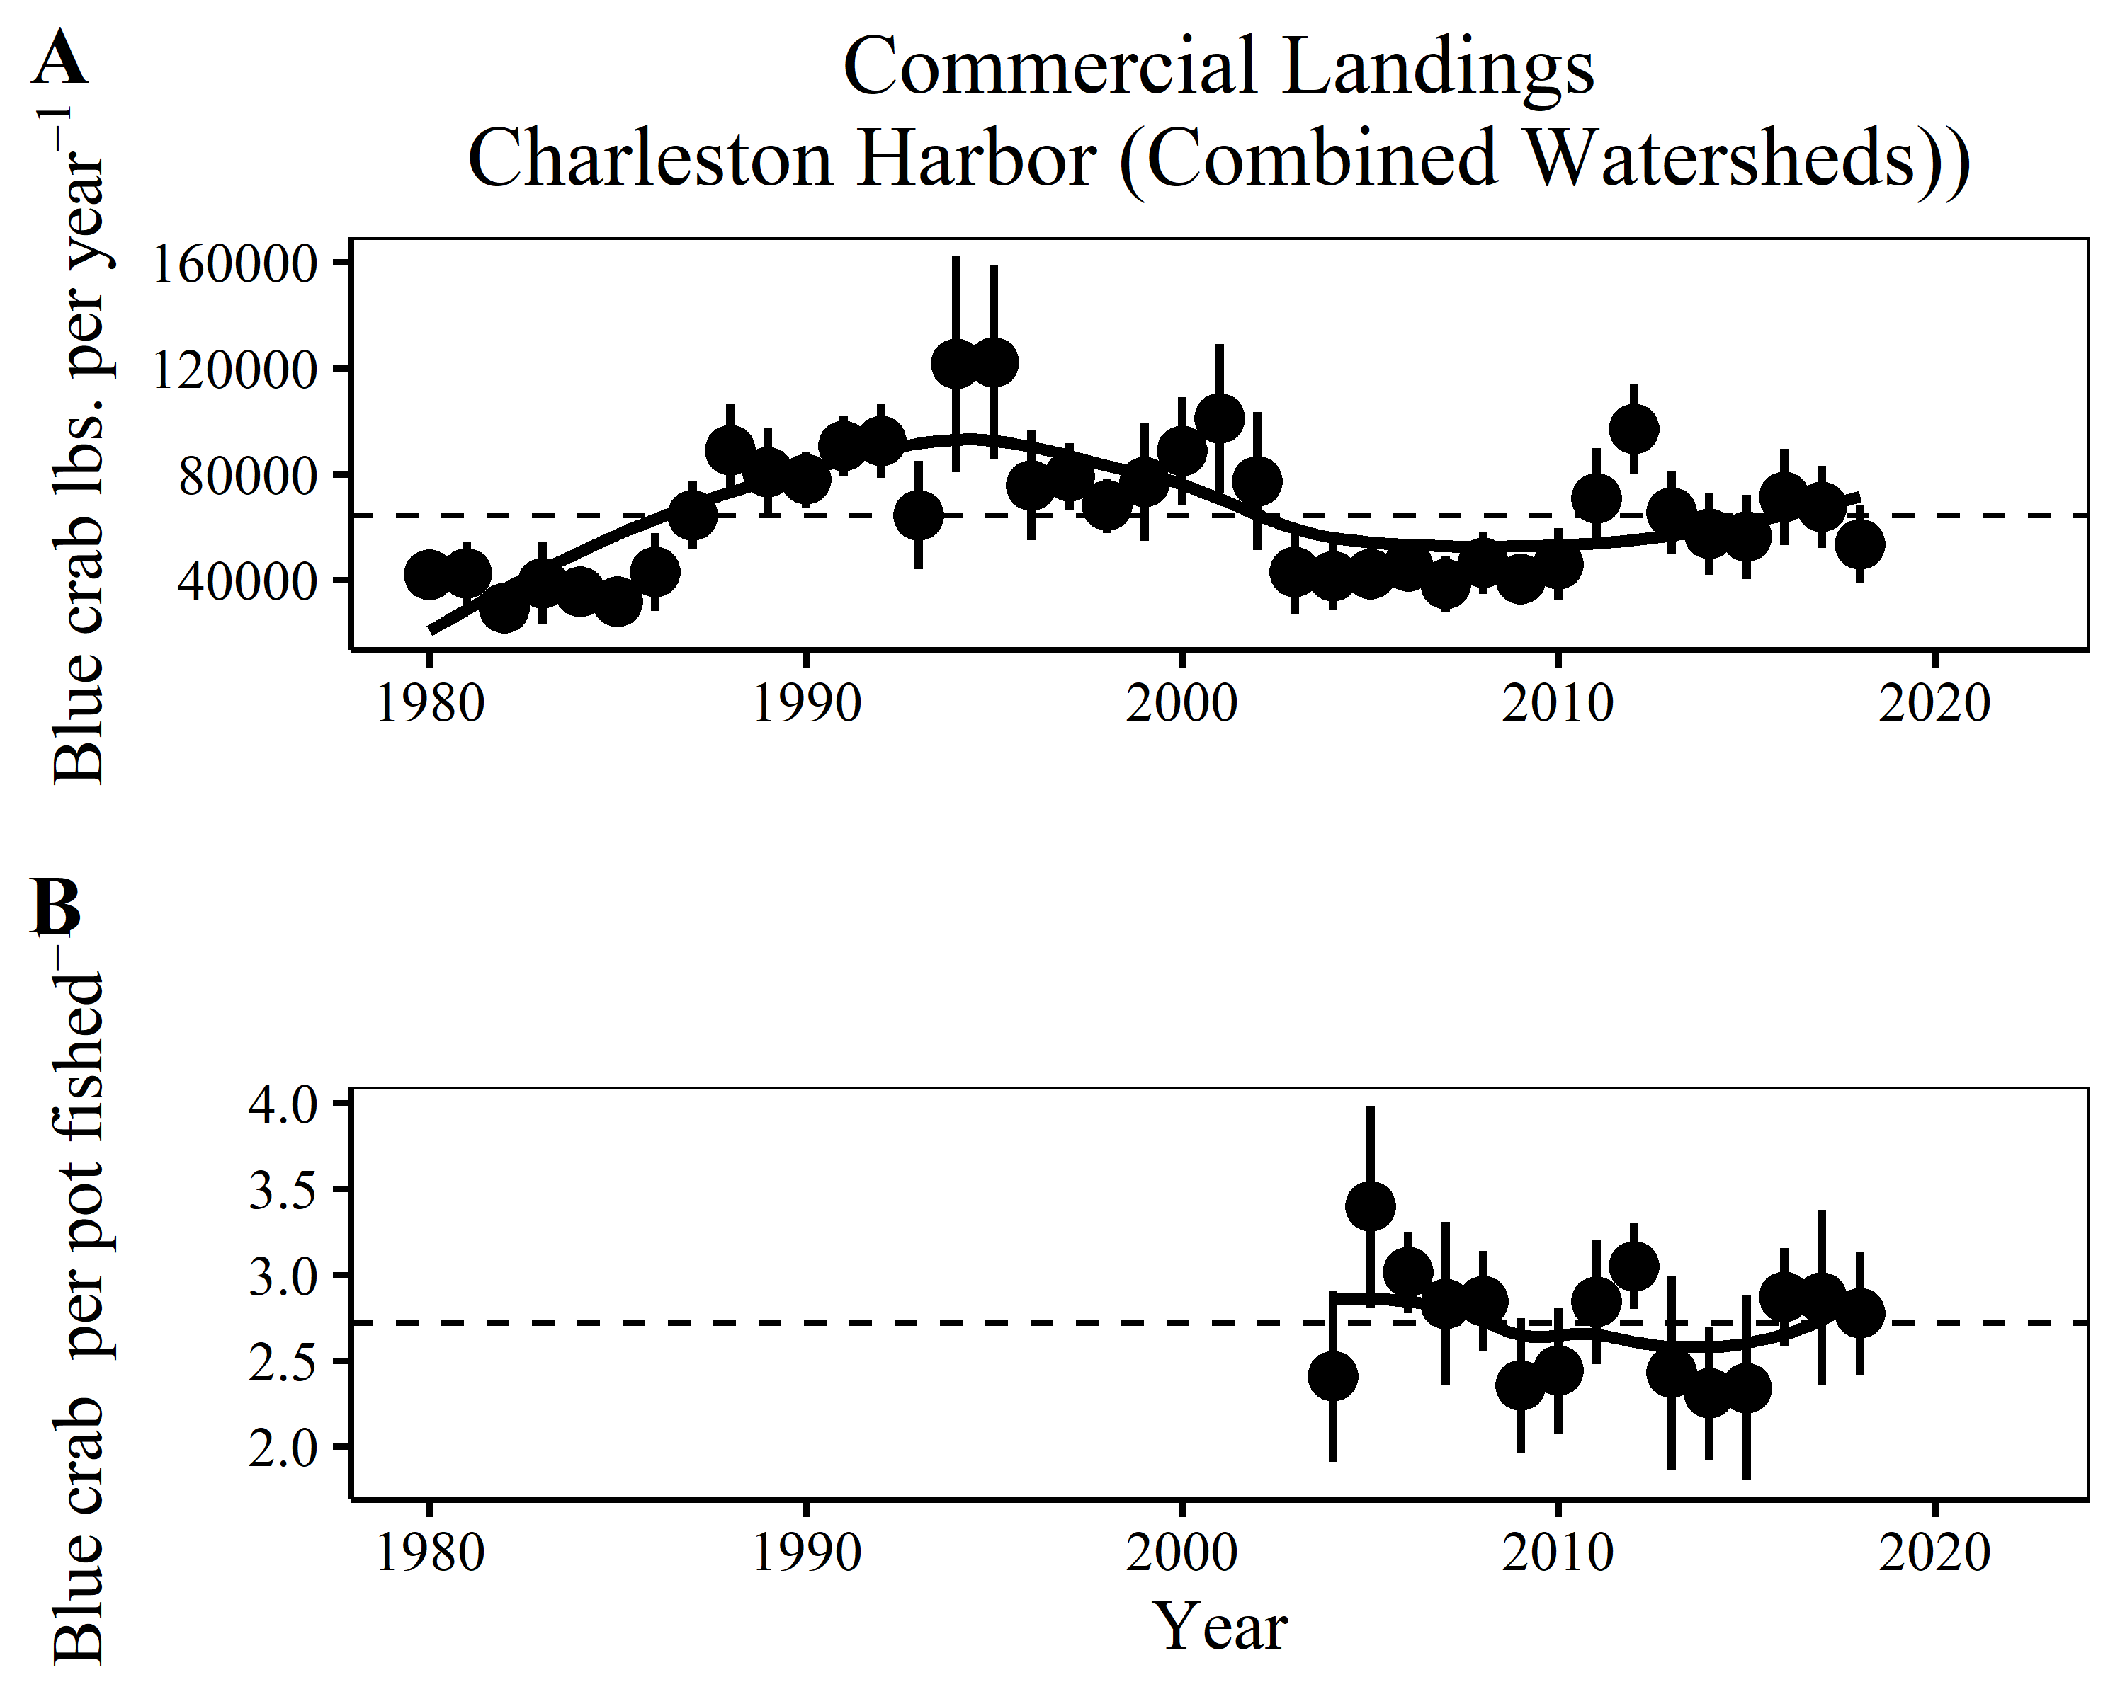

Objective 1 - This plot shows the point that there is high annual variability in blue crab catches and a potential decline in population starting around 2002. It should be mentioned that statewide initial analyses of the data have indicated a sharp decline but that when corrected for effort, and post implementation of proper reporting (2003-present), these data may not show the severe decline in populations that have been reported.

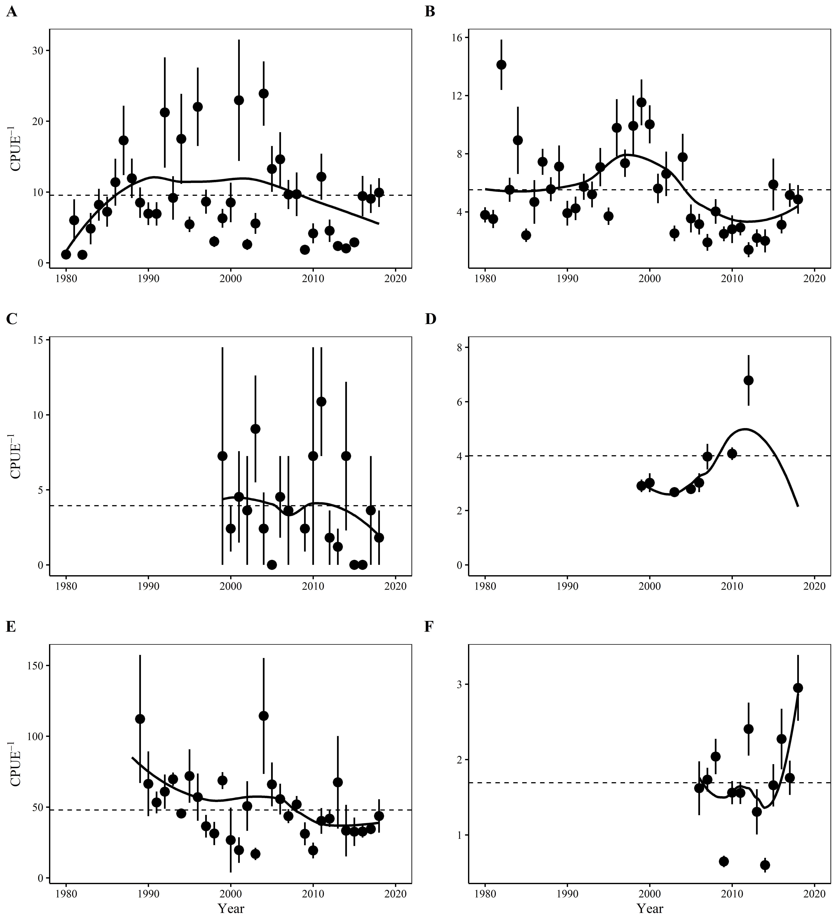

Objective 1 - …although this plot does show a decline in some of the more robust surveys (A, B, E), with disagreement from another robust survey (F) that is not long-term (>2005). The same high annual variabilty in the commercial landings are found in the fish-independent surveys. This plot could suggest different resiliency (? wrong word), and/or different responses of the population in different habitats. I’d love to add some sort of size/sex time series plot in

### Methods

### Discussion

Commercial landings (fig. 1) and survey abundance (fig. 2) time series show the high annual variablility of blue crab populations, but also may not agree totally on the decline in populations through the decade of the 2000’s.

The total pounds landed in the combined Charleston Harbor watersheds shows a trending decline from 2003 - 2010, but when these same landings data are corrected for effort in terms of number of pots pulled that trend is not observed. The year 2003 marks the first year of “trip ticket” reporting, in which all commercial blue crab license holders are required to report their catch. This is the same time frame (>2003) the Ashley and Cooper Rivers are included in commercial landings, whether that is due to not being actively fished for blue crab, underreported, or included in another reporting area. Time series data from the abundance surveys (fig 2) show a more severe decline in surveys occuring in tidal creek areas (figs 2B and 2D) than in open water areas (figs 2A, 2C, 2E) with data from the SCDNR Trammel Net survey not showing a decline but no data available for comparison before 2006. This suggests influence of habitat or environmental conditions on blue crab populations in particular areas of the estuary.

Of note: for commercial landings (fig. 1), and the longer abundance surveys (figs 2A and 2B), variability is increased when CPUEs are above the long-term mean - could this indicate less 0-catch events and do we care?

# Objective 2

Test the ability of a juvenile index, where juvenile abundance in one year predicts adult abundance in a following year

**Table 3:** Objective 2 - These are all relevant explanatory variables. Only one survey has explanatory relationships with its own lagged abundances. No juveniles from any survey predict abundances in later years. The realtionship between total CPUE and subadults with a 2-yr. may suggest that 1) the survey does not catch juveinles effectively or juveniles are not populating sampled micro-habitats.

**Table 4:** Objective 2 - This table shows the results of a dredge function run on the highest correlated variables (Figure 4), the total CPUEs (1-yr. lag) for the Harbor and Creek Trawl surveys (univariate corrs found Table 3). The multivariate model’s Radj^2 was lower than the univariate models. The multivariate was not compared to univariate models. A delta <2.0 from another model’s delta means the dredge sees no staistical difference outside of chance between the compared models. Population structure variables (Harbor Trawl mature males 1-yr lag, Creek Trawl immature males 1-yr lag) are statistically better models according to the dredge. Since the top scoring model is ranked highest, this summary indicates that none of the predictors improve model fit.

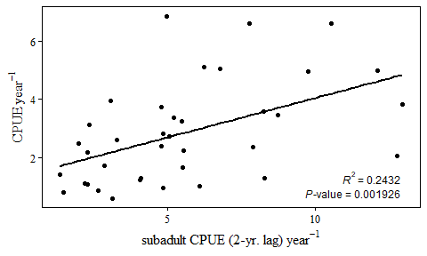

Objective 2 - Shows the potential to predict, but poor correlation. Prediction by subadult with a 2-yr lag suggests that either juveniles are underrepresented in sampling, or maybe they do not congregate until this size? THIS PLOT IS NOT NEEDED AND WOULD NEED CLEANUP

### Discussion

OLS regression models using all lifestages from all surveys with a 1- and 2-yr lag to predict all survey’s total CPUEs were constructed to find all explanatory relationships. The CRMS Creek Trawl survey is the most consistently responsive of the surveys when used in regression modeling. Fifteen significant relationships exist between total CPUEs from the Creek Trawl survey and several 1- and 2-yr.lagged lifestage variables (Table 3). The CRMS Harbor Trawl had one significant explanatory relationship with subadults from the same survey lagged 1-yr. The Trammel Net survey had one significant explanatory relatioship with mature females from the Harbor Trawl lagged 1-yr, which is the highest correlation (r2=0.36) of all the single regression models.  
Although there were several significant regression models constructed using fisheries independent survey life stage abundance CPUEs, no relationships correlate strong enough to be effective models. Using OLS single regression modeling, the six SCDNR fisheries independent surveys used to monitor blue crab populations in the Charleston Harbor watershed are ineffective predictors of their own abundance CPUEs. When these single variables were used to populate multiple regression OLS models, the adjusted R^2 values did not improve the correlations. Juvenile variables did not predict mean annual CPUEs.

# Objective 3

Explore predictive relationships between fisheries-independent abundance and commercial landings.

**Table 4:** Objective 3 - All significant relatioships of effort corrected Charleston Harbor watershed (Ashley, Cooper and Wando Rivers and Charlesotn Harbor) commercial Landings by lifestage variables from all surveys using OLS regression. Only variables from the Harbor and Creek Trawl surveys were related to these corrected landings. Multiple variables with consistent correlations through both surveys seem to suggest the surveys are effectively measuring the population, but there may be some other driver (habitat, environmental, fishing) outside of stock/population (proper term?) variables that affect blue crab abundance.

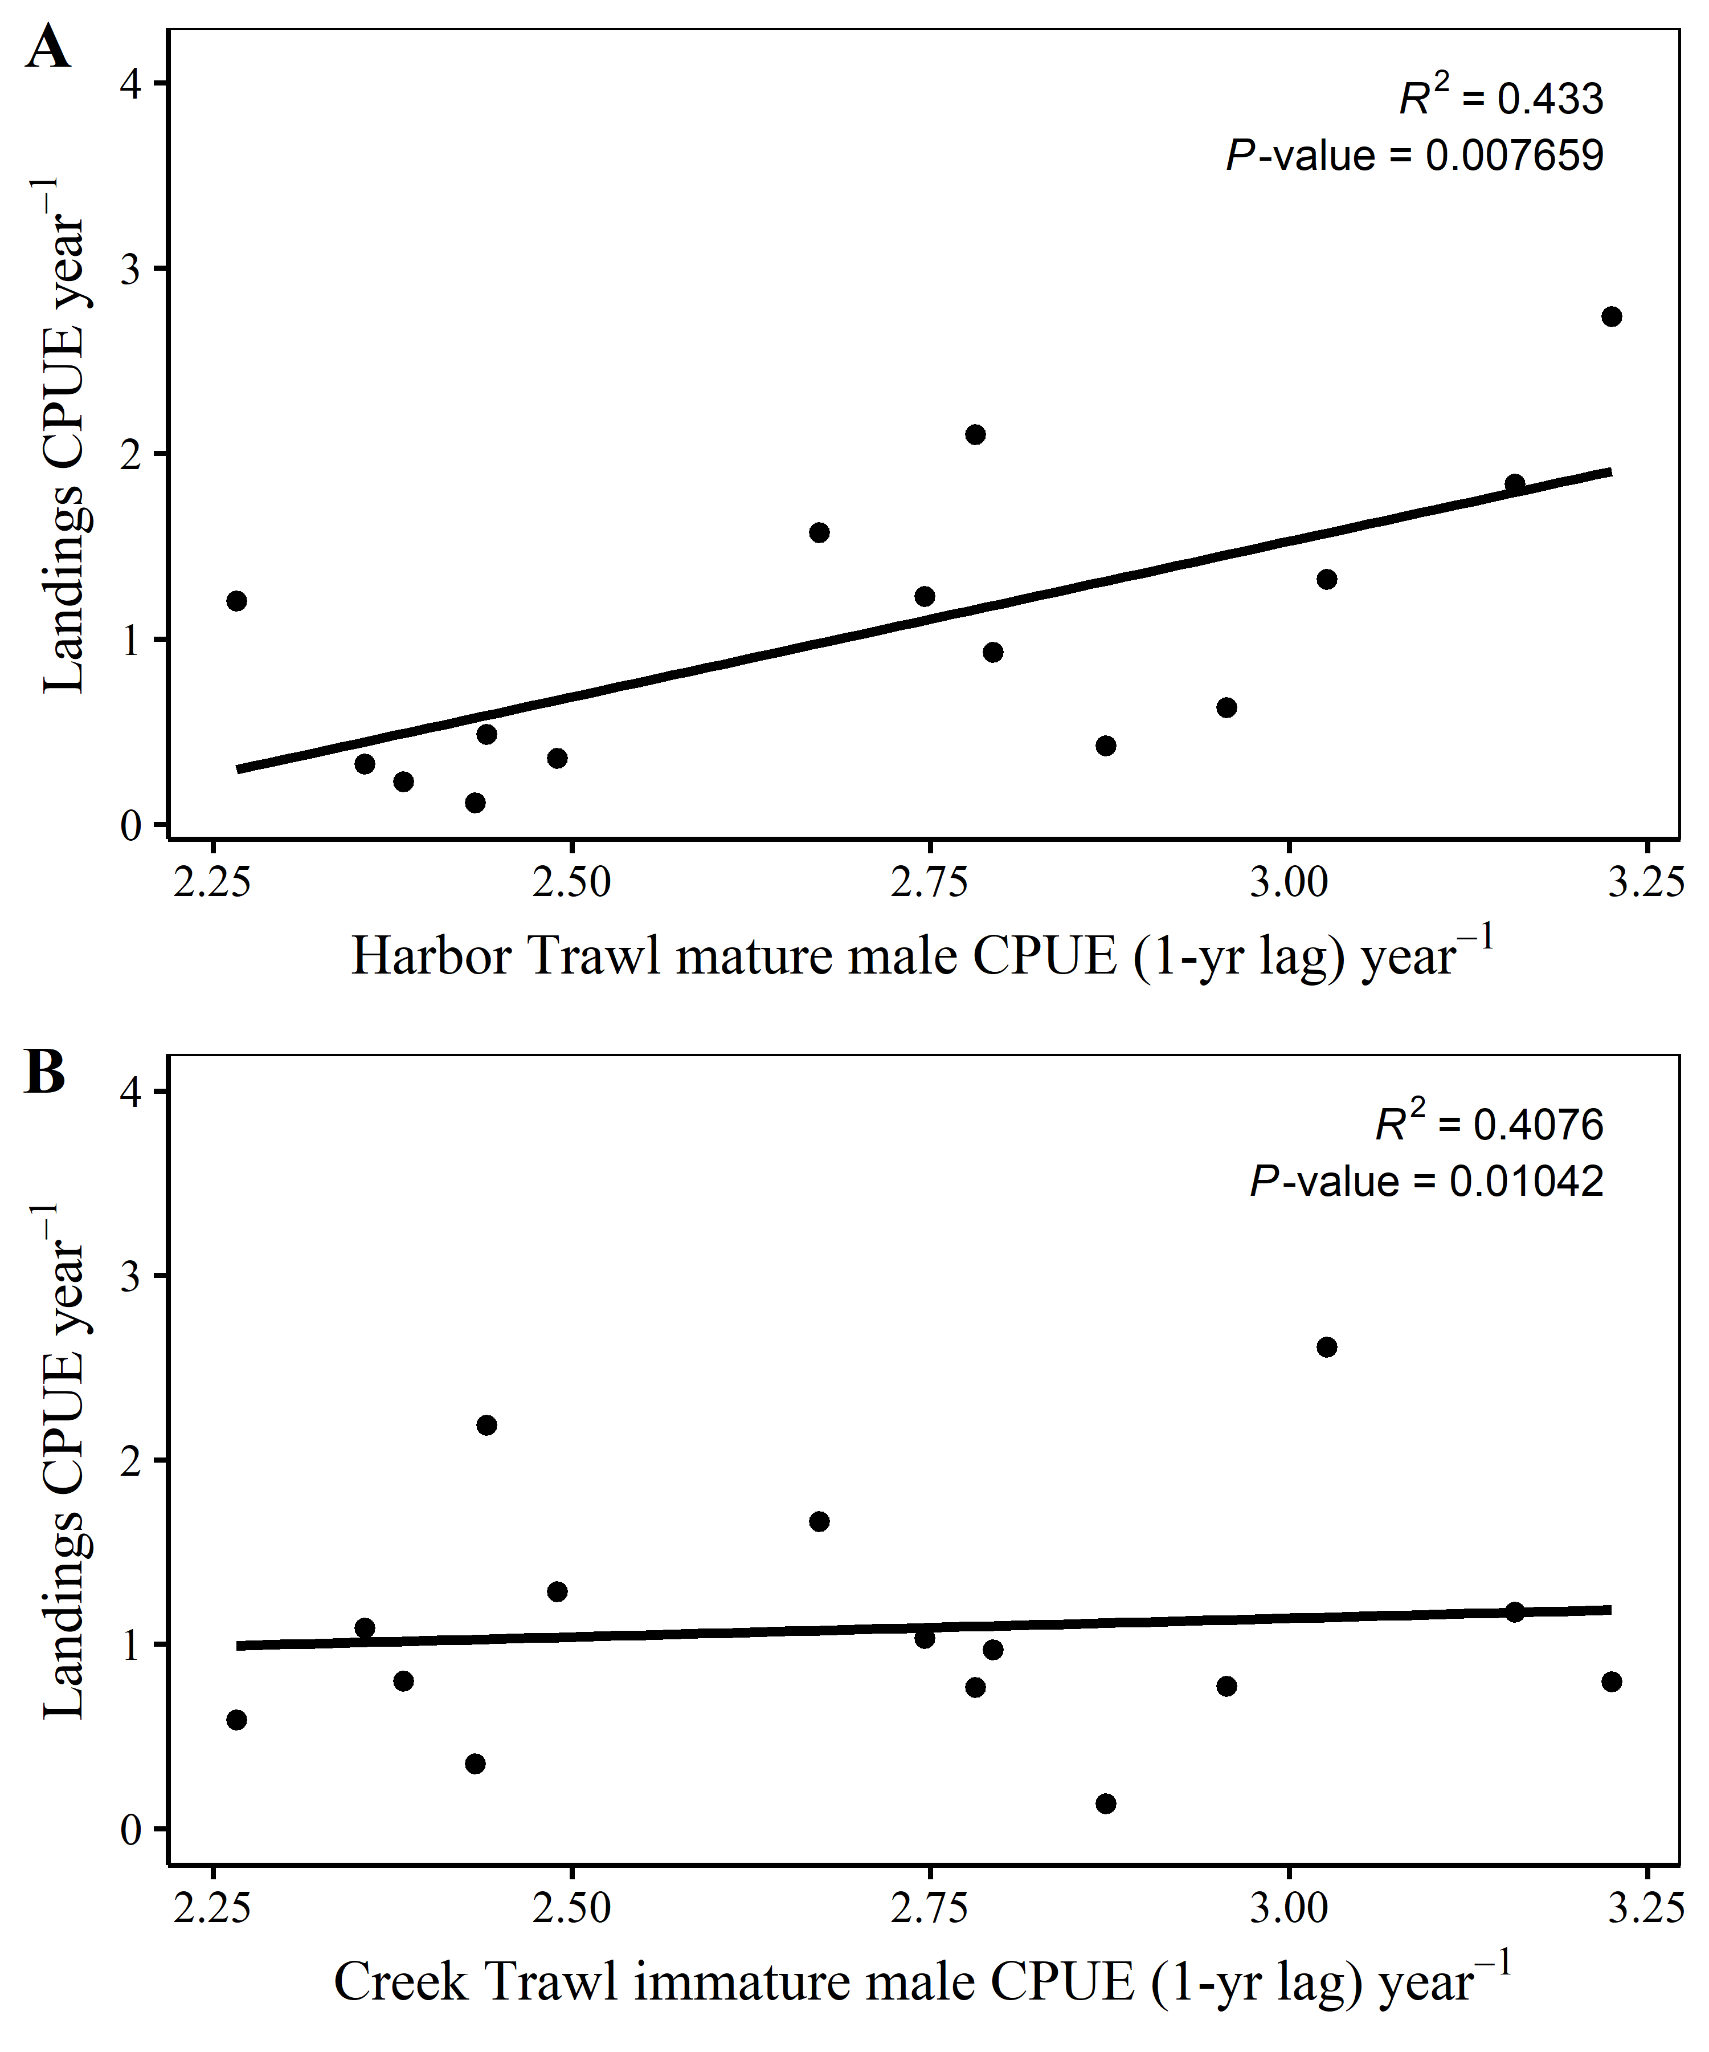

Ordinary Least Squares regression plots of select significant explanatory relatioships using lagged variables to Charleston Harbor watershed Landings CPUEs. Mean annual landings CPUE by Harbor Trawl mature males with a 1-yr lag (A), and mean annual landings CPUE by Creek Trawl immature males CPUE with a 1-yr. lag (B). Because the multiple regression relationships do not have as strong a correlation as some of the single, and are more illogical, I don’t think the table with multiple regression models is needed since their is no improvement in correlation.

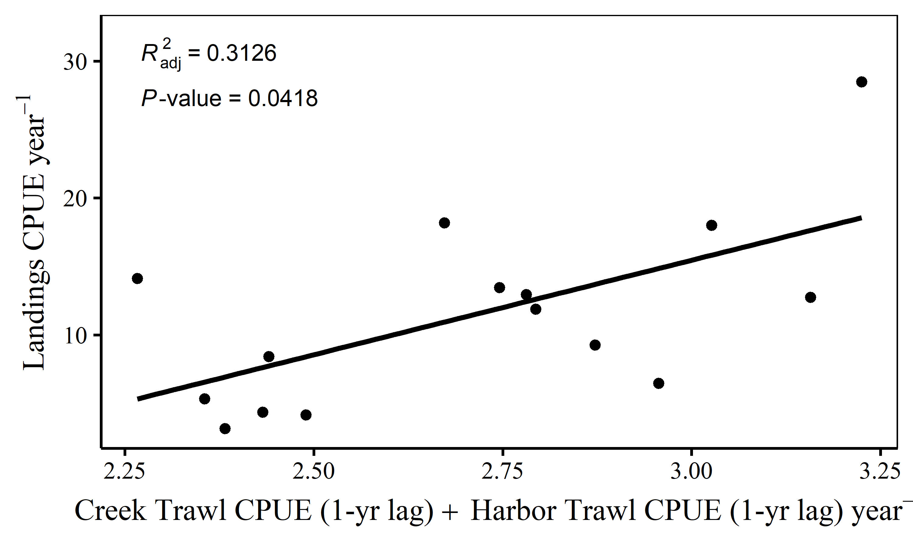

Objective 3 - This plot shows no model improvement if Total CPUEs are added together into a multiple regression model. The adj R^2 is not an improvement over the R^2 of the individual variables (See Table 4)

**Table 5:** Objective 3 - This table shows the results of a dredge function run on the highest correlated variables (Figure 4), the total CPUEs (1-yr. lag) for the Harbor and Creek Trawl surveys (univariate corrs found Table 4). The multivariate model’s Radj^2 was lower than the univariate models. The multivariate and univariate models were scored using AICc for small samples. A delta <2.0 from another model’s delta means the dredge sees no staistical difference outside of chance between the compared models. Mean annual population structure variables (Harbor Trawl mature males 1-yr lag, Creek Trawl immature males 1-yr lag) are statistically better models than mean annual total CPUE according to the dredge.

### Discussion

OLS regression models using all lifestages from all surveys with a 1- and 2-yr lag to predict Charleston Harbor watershed (Ashley River, Cooper River, Wando River and Charleston Harbor) landings CPUEs were constructed to find all explanatory relationships. All significant relationships are displayed in the following tables. The CRMS Creek Trawl is the most consistently responsive of the surveys when used in regression modeling. Nine significant relationships exist between mean annual Landings CPUE and several 1- and 2-yr.lagged lifestage variables from the CRMS Harbor and Creek Trawl surveys (Table 4). The CRMS Harbor Trawl survey’s mature males 1-yr. lag and the CRMS Creek Trawl survey’s immature male 1-yr. lag are the only variables with a coefficient of determination (r-squared) > 0.40. Multiple regression OLS models populated with these variables did not improve correlation.  
Only two fisheries independent life stage abundance CPUEs have significant relatioships with total landings (not effort corrected). The effects from these models have very small explanatory power over total landings. It should be mentioned that >2003 is when data from all 4 reporting areas (Ashley, Cooper, Wando Rivers and Charleston Harbor) and the effort-correction (pots pulled) begin.