# Outline for Chapter 1

Notes from MRK & SC outline mtg 2019-09-05

* Instructions from MRK
  + Outline of Chapter 1
  + Here are the time series
  + Here’s how they correlate
  + Here’s how they relate to each other

My thinking is 2 parts of Chapter 1 leading to a discussion

1. Survey catches
   1. What is the make-up of the catch of the surveys?
      1. determined by correlations of different size/sex CPUE variables and total CPUE of the survey
   2. Remarks on the coverage and “habitats” of the surveys
      1. Harbor trawl = longitudinal along a gradient
      2. Creek trawl = longitudinal along a gradient but also latitudinal through the tidal creeks
2. Prediction of landings CPUE using the surveys
   1. Discussion of landings vs. landings CPUE
3. Discussion of what lifestages our surveys cover and their explanatory power over landings
   1. Here’s what we’ve BEEN capturing through our surveys and what this long-term dataset shows, and this is how we can use the info at hand to predict landings
   2. Stay away from how to improve the surveys

Potential Chapter 1 workflow

* Time series trends for all surveys facet-wrapped with the several CPUE metrics
* Correlation of the variables within a survey
* Correlation of surveys
* Dredge results
* Scatterplots of final regression analyses
* Discussion

Still to do…

* Figure out how to show multiple regression scatterplots
  + Add p-value and r2 to plots
* Geom_hlines on time series
* Histos of size/class distibution

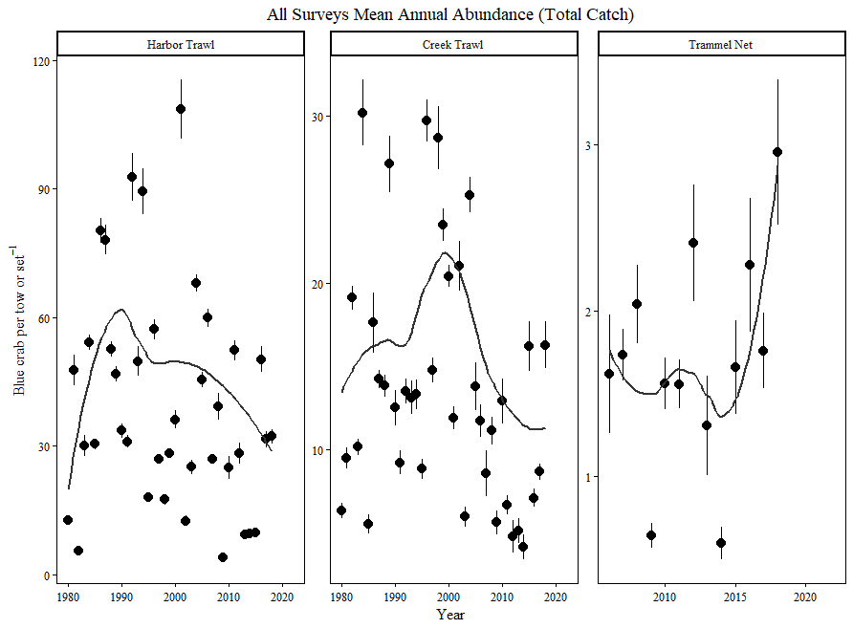

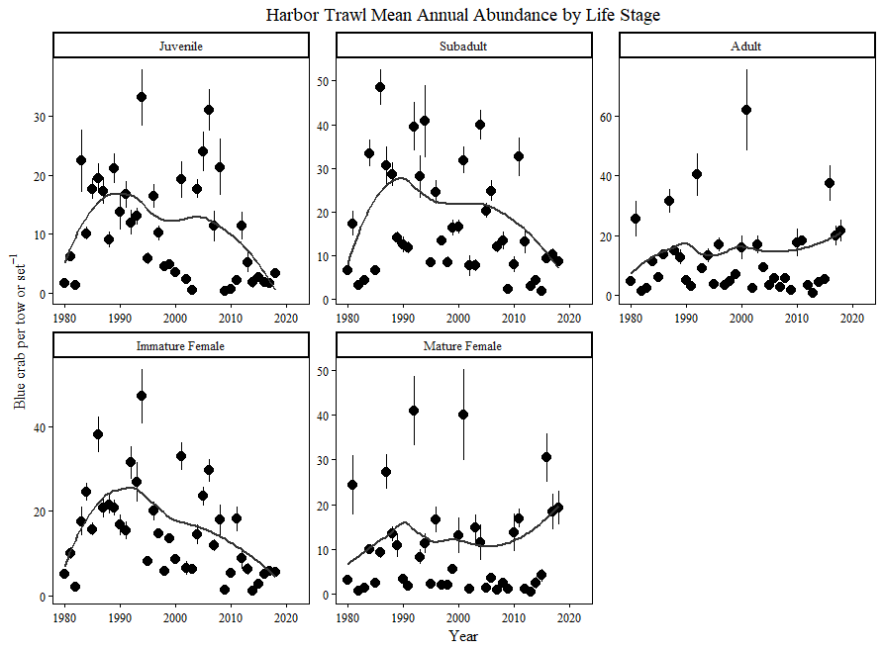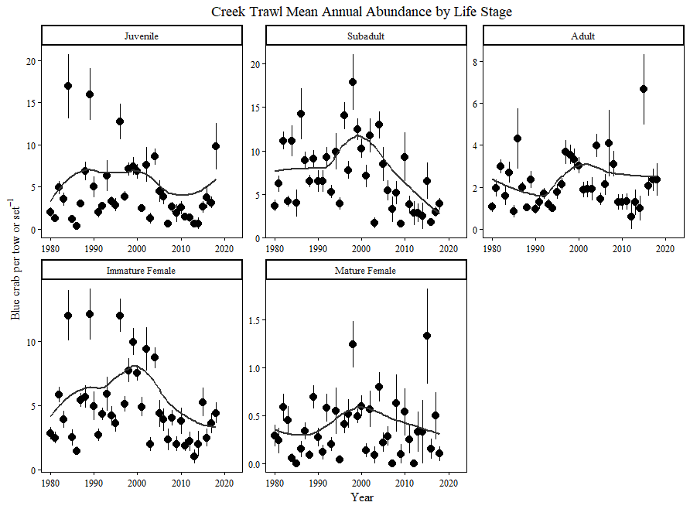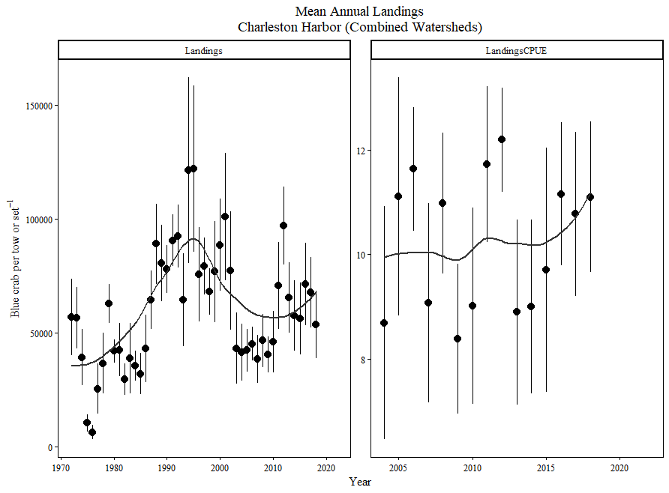

# Creek Trawl, Harbor Trawl & Trammel Net Surveys Catch Analyses

Figure 1. Kendall's Rank Correlation Coefficient for all Harbor Trawl CPUEs

* B90’s catch is dominated by immature females
  + - Correlation between B90 subadult and B90 Immature females = 0.74 R2. That is the highest correlation off all sex and maturity categories.
    - Correlation between B90 CPUE and B90 subadult = 0.83 R2. That is the highest correlation of any size and sex/maturity variable

Figure 3. Kendall Rank Correlation Coefficients for all Creek Trawl CPUEs

* T38’s catch is dominated by immature females, albeit these immature females are less influential on the creek trawl than immature females are on the harbor trawl.
  + - Correlation between T38 subadult and immature females = 0.77 R2. This is slightly higher than the juveniles and immature female correlation (0.72 R2)
    - Correlation between T38 CPUE and both subadults and immature females = 0.82 R2.

## T06 to come with fulfillment of data request

# Dredge

Integrated landings CPUEs for the Charleston Harbor Watershed seem to have a special predictive relationship when explained by the same year’s Harbor Trawl, Creek Trawl and Trammel Net Surveys’ total CPUEs, and by the Harbor Trawl and Creek Trawl Surveys’ subadult CPUEs with a lag (e.g. the abundances one year predict the landings of the next). The landings CPUE time series ranges from 2004-2018, which is the time limiting factor for all models except models incorporating the Trammel Net Survey, which range from 2006-2018. Any of the models, and dredges, sans Trammel Net Survey will have different summary statistics than models incorporating Trammel Net Survey variables due to the change in degrees of freedom after further filtering of the dataset.

An exploratory data dredge was performed in the open-source programming language R (MuMIn::dredge) with the purpose of model exploration using several of the size and sex/maturity variables of the explanatory surveys (Harbor Trawl, Creek Trawl and Trammel Net Survey) to predict Charleston Harbor mean integrated watershed landings CPUE. Ordinary Least Squares (OLS) multiple regression with no interaction was the model used to populate the dredge function. Interactive effects for all models were determined to be insignificant by post-exploratory modeling using OLS.

Relevant explanatory variables were determined by using the OLS bivariate modeling Shiny Application “shinycrab” built by Czwartacki. Models within a range of 2.00 AICc Δ from another model perform with no significant difference according to the dredge function. Traditional measures of model fit, including AICc and Akaike weight were not considered, as these are only exploratory analyses to uncover relationships between the variables.

An exploratory data dredge populated with survey specific Charleston Harbor abundance variables was used to predict Charleston Harbor mean integrated watershed landings CPUE. Ordinary Least Squares multiple regression with no interaction was used to feed the dredge. Variables found in the dataset used to feed the dredge were determined to be the most influential relationships between abundance and landings as determined by analyses using the Shiny Application “shinycrab” built by Czwartacki. Models within a range of 2.00 AICc Δ from another model perform with no significant difference according to the dredge function.

## Harbor Trawl

|  |  |  |  |  |  |  |  |  |  |  |  |
| --- | --- | --- | --- | --- | --- | --- | --- | --- | --- | --- | --- |
| Dependent Variable | Juveniles | Subadults | Subadults (Lag 1 yr.) | Adult | Immature Females | Mature Females | CPUE | p-value | R2 | Adj R2 | Dredge AICc Δ |
| Integrated |  |  | X |  |  | X |  | 0.006474 | 0.6 | 0.5272 | - |
| Charleston |  |  | X | X |  |  |  | 0.006744 | 0.597 | 0.5238 | 0.44 |
| Harbor |  |  |  |  | X |  |  | 0.006398 | 0.4474 | 0.4049 | 1.01 |
| Mean |  |  |  |  | X | X |  | 0.01267 | 0.5172 | 0.4367 | 2.81 |
| Annual |  |  |  | X | X |  |  | 0.01476 | 0.5047 | 0.4222 | 3.19 |
| Landings |  |  | X |  |  |  |  | 0.0204 | 0.349 | 0.2989 | 3.47 |
| CPUE |

Table 1: Select OLS regression analyses as suggested by MuMIn::dredge function for Harbor Trawl variables only. All models are multiple regression without interaction. Significant interaction between these variables were not found.

## Creek Trawl

|  |  |  |  |  |  |  |  |  |  |  |  |
| --- | --- | --- | --- | --- | --- | --- | --- | --- | --- | --- | --- |
| Dependent Variable | Juveniles | Subadults | Subadults (Lag 1 yr.) | Adult | Immature Females | Mature Females | CPUE | p-value | R2 | Adj R2 | Dredge AICc Δ |
| Integrated |  |  | X |  |  |  |  | 0.02055 | 0.3483 | 0.2982 | - |
| Charleston |
| Harbor |
| Mean |
| Annual |
| Landings |
| CPUE |

Table 2: Select OLS regression analyses as suggested by MuMIn::dredge function for Creek Trawl variables only

## Trammel Net Survey

|  |  |  |  |  |
| --- | --- | --- | --- | --- |
| Dependent Variable | CPUE | p-value | R2 | Dredge AICc Δ |
| Integrated | X | 0.02058 | 0.3762 | - |
| Charleston |
| Harbor |
| Mean |
| Annual |
| Landings |
| CPUE |

Table 3: Select OLS regression analyses as suggested by “shinycrab” app.R for Trammel Net CPUE

## Total Survey CPUEs ~ Mean Landings CPUE

|  |  |  |  |  |  |  |  |  |  |
| --- | --- | --- | --- | --- | --- | --- | --- | --- | --- |
| Dependent Variable | B90 | T06 | T06 + B90 | T38 | T38+B90 Subadults Lag | p-value | R2 | Adj R2 | Dredge AICc Δ |
| Integrated |  |  | X | X |  | 0.004269 | 0.6642 | 0.5971 | - |
| Charleston |  |  | X |  |  | 0.005645 | 0.5165 | 0.4725 | 0.41 |
| Harbor | X |  | X | X |  | 0.002889 | 0.7741 | 0.6988 | 0.42 |
| Mean |  | X | X | X |  | 0.002889 | 0.7741 | 0.6988 | 0.42 |
| Annual | X | X |  | X |  | 0.002889 | 0.7741 | 0.6988 | 0.42 |
| Landings | X |  |  |  |  | 0.02703 | 0.3231 | 0.2711 | 1.49 |
| CPUE |

Table 4: Select OLS regression analyses as suggested by MuMIn::dredge function for total CPUE variables only. Values in red reflect illogical models. All models are multiple regression without interaction. Significant interaction between these variables were not found.

## All Relevant Survey Vars ~ Mean Landings CPUE

|  |  |  |  |  |  |  |  |  |  |  |  |
| --- | --- | --- | --- | --- | --- | --- | --- | --- | --- | --- | --- |
| Dependent Variable | B90 Adult | B90 Immature Females | B90  Mature Females | B90  Subadult  Lag | T38 CPUE | T38 Subadult Lag | T38+B90 Subadults Lag | p-value | R2 | Adj R2 | Dredge AICc Δ |
| Integrated |  | X |  |  |  |  |  | 0.006398 | 0.4474 | 0.4049 | - |
| Charleston |  |  | X | X |  |  |  | 0.004123 | 0.5996 | 0.5328 | 0.47 |
| Harbor | X |  |  | X |  |  |  | 0.01276 | 0.6114 | 0.5054 | 0.58 |
| Mean |  |  | X |  |  |  | X | 0.005164 | 0.5842 | 0.515 | 0.79 |
| Annual | X |  |  |  |  |  | X | 0.006554 | 0.5674 | 0.4953 | 1.21 |
| Landings |  |  |  |  |  |  | X | 0.01234 | 0.3933 | 0.3466 | 1.53 |
| CPUE |  | X | X |  |  |  |  | 0.01267 | 0.5172 | 0.4367 | 1.76 |
|  | X | X |  |  |  |  |  | 0.01476 | 0.5047 | 0.4222 | 1.91 |

Table 5: Select OLS regression analyses as suggested by MuMIn::dredge function for all relevant variables. Values in red reflect illogical models. All models are multiple regression without interaction. Significant interaction between these variables were not found.

## Lagged Subadult CPUEs ~ Mean Landings CPUE

|  |  |  |  |  |  |  |  |
| --- | --- | --- | --- | --- | --- | --- | --- |
| Dependent Variable | B90 Subadults Lag | T38 Subadults Lag | T38+B90 Subadults Lag | p-value | R2 | Adj R2 | Dredge AICc Δ |
| Integrated | - | - | - |  |  |  | - |
| Charleston |  |  | X | 0.01234 | 0.3933 | 0.3466 | 0.10 |
| Harbor | X |  |  | 0.0204 | 0.349 | 0.2989 | 1.11 |
|  |  | X |  | 0.02055 | 0.3483 | 0.2982 | 1.14 |
|  | X | X |  | 0.04013 | 0.4149 | 0.3174 | 3.70 |
| Mean |
| Annual |
| Landings |
| CPUE |

Table 6: Select OLS regression analyses as suggested by MuMIn::dredge function for lagged subadult variables from Harbor Trawl and Creek Trawl surveys. All models are multiple regression without interaction. Significant interaction between these variables were not found. Model 1 of the dredge uses no variables and the AICc Δ suggests there is no difference in model performance between models 1-4.



