Chapter 1 Time Series  
All Abundance Surveys and Landings

Mean annual blue crab abundances from South Carolina Department of Natural Resources (SCDNR) fisheries independent population surveys and landings from fisheries dependent SCDNR landings data show high annual variability.

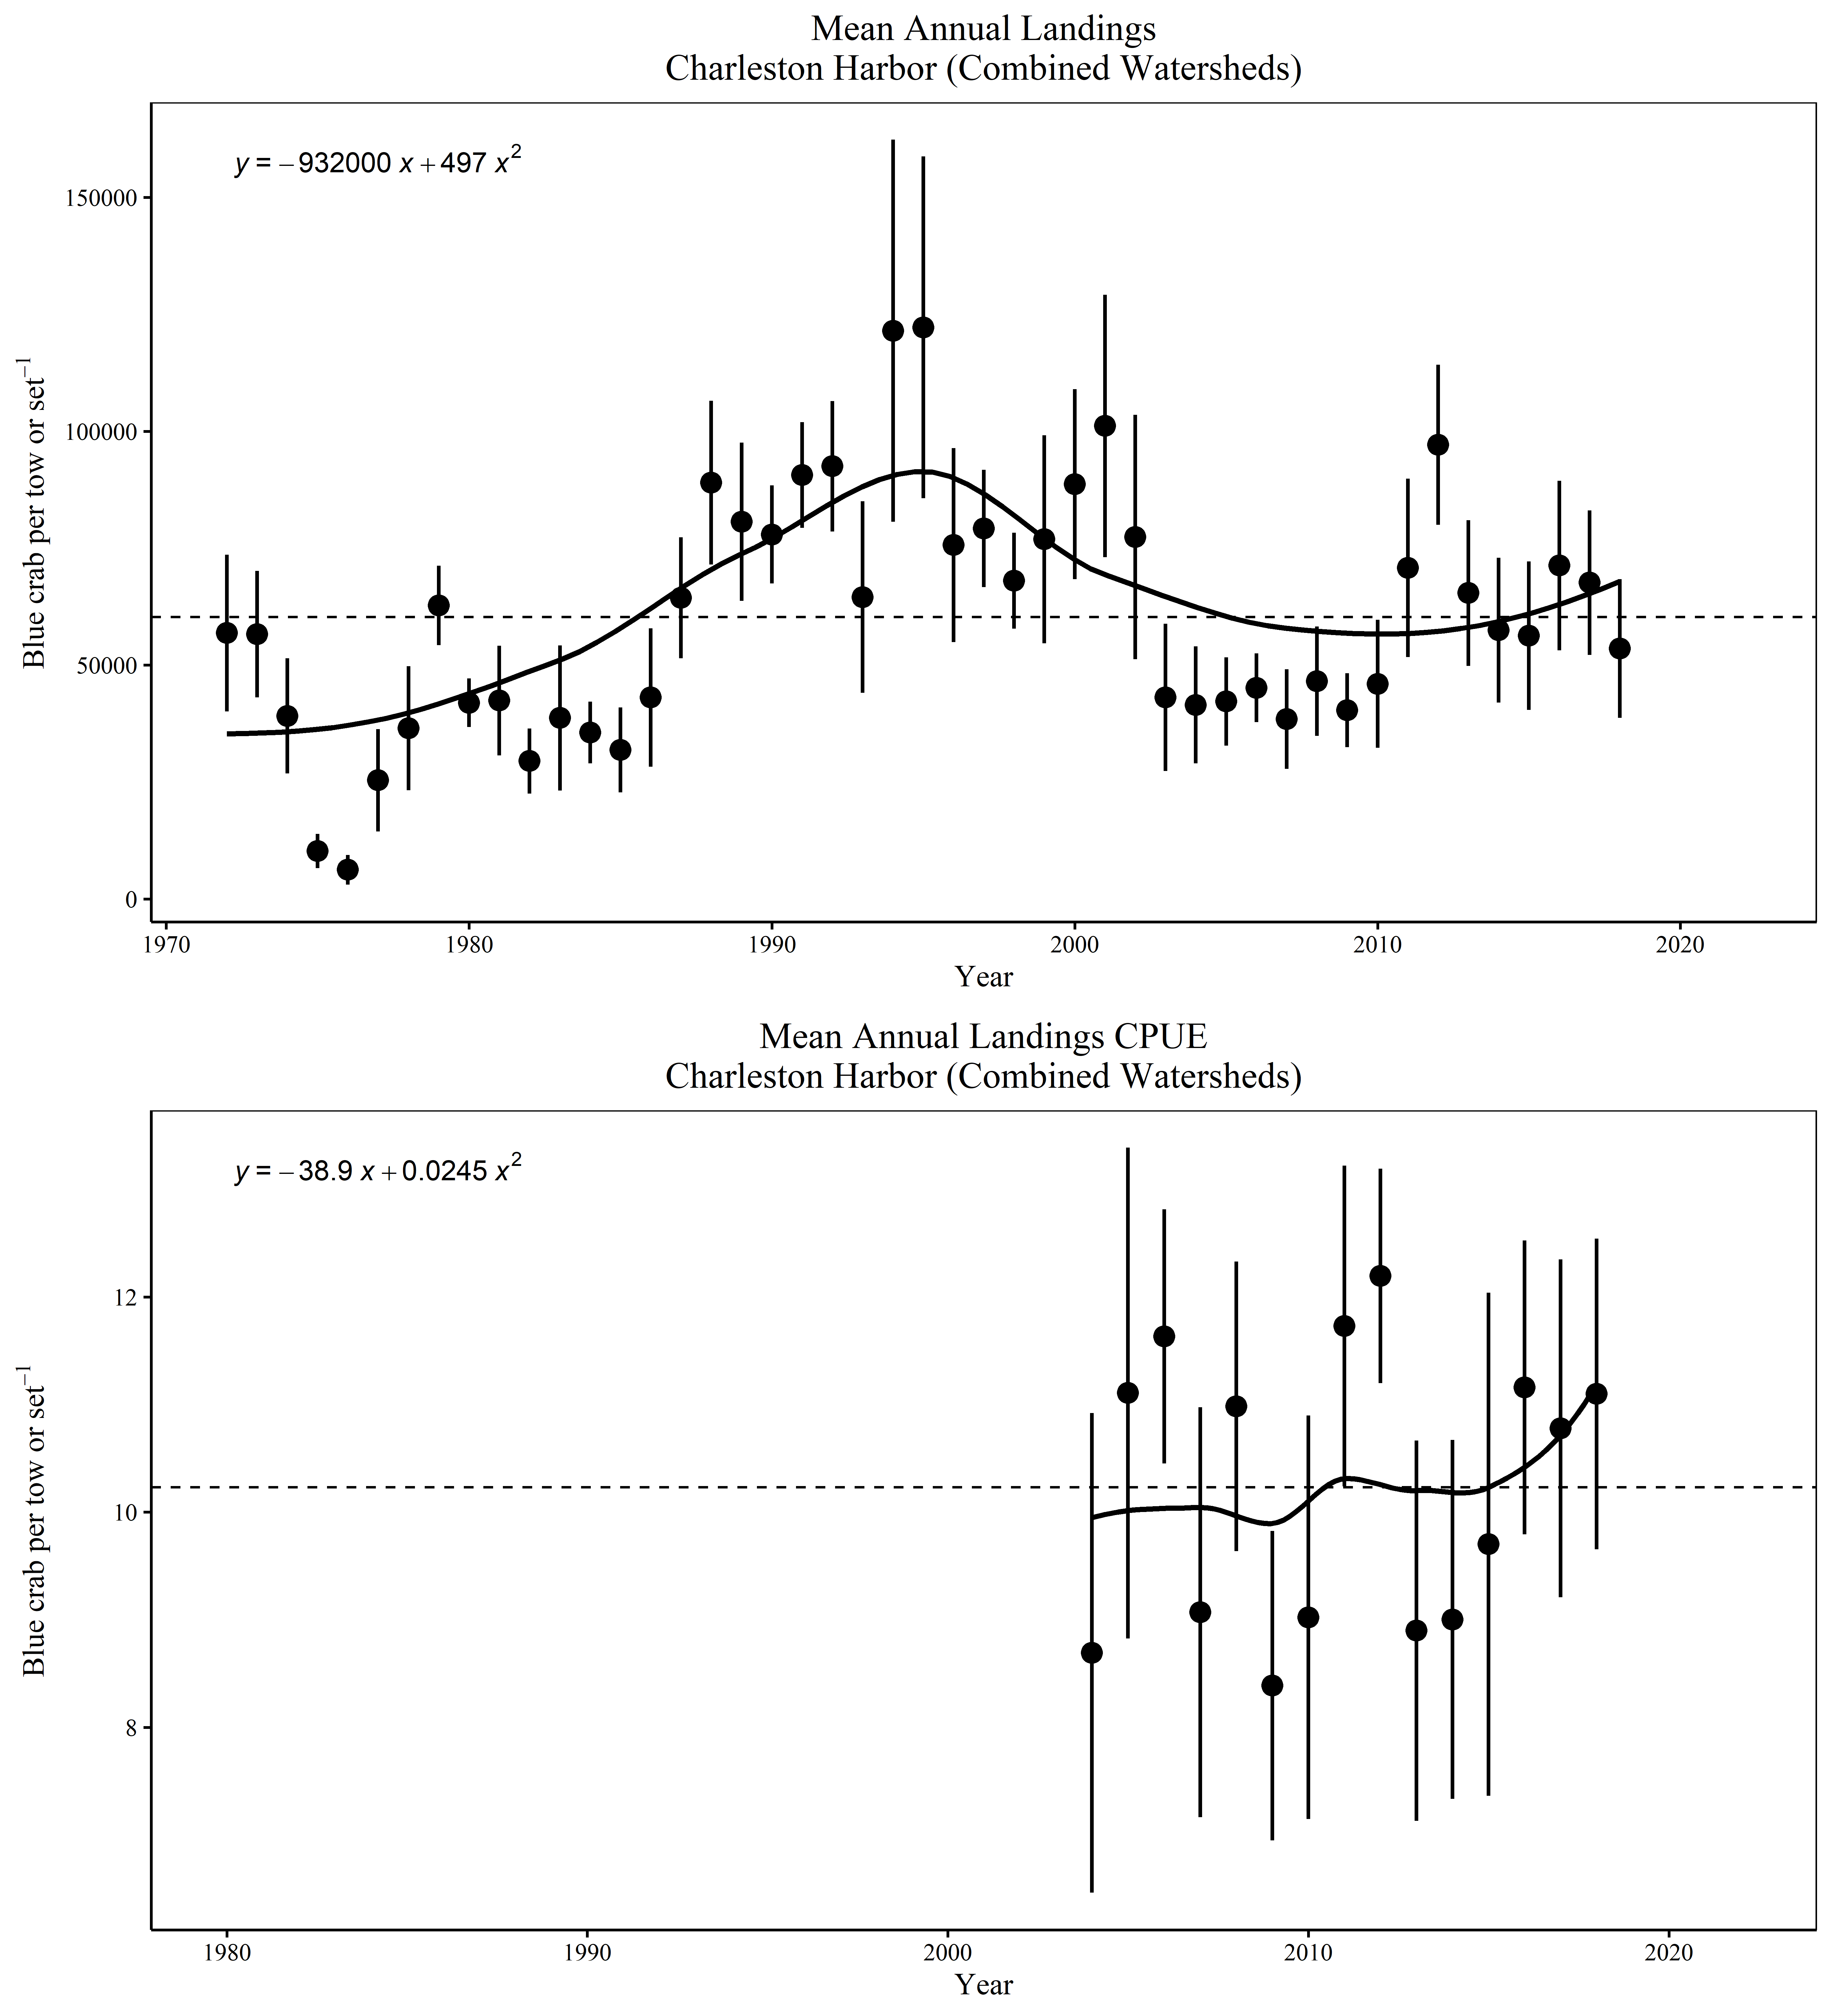

Total Annual blue crab Landings and total annual Landings CPUE (landings/number of pots pulled) (mean ± standard error) for all reporting areas within the Charleston Harbor watershed. All samples were collected within the Charleston Harbor watershed (Ashley, Wando and Cooper Rivers and Charleston Harbor).

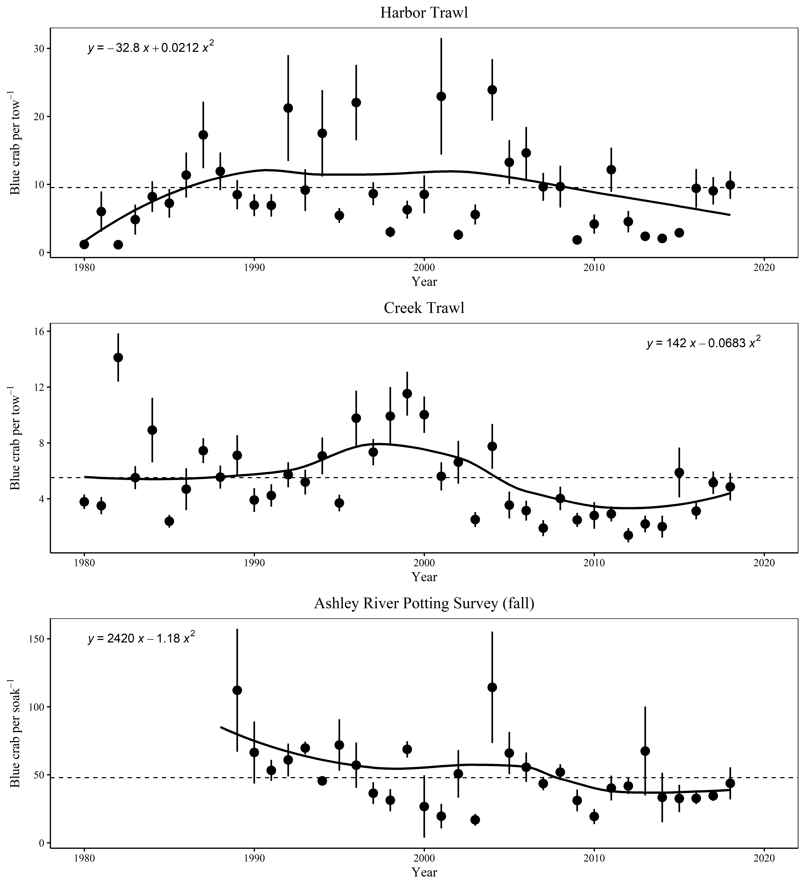

Annual blue crab (total catch) CPUE (mean ± standard error) from CRMS surveys. All samples were collected within the Charleston Harbor watershed (Ashley, Wando and Cooper Rivers and Charleston Harbor). Creek Trawl samples from May through September. Ashley Potting samples collected October and November. Harbor Trawl samples monthly.

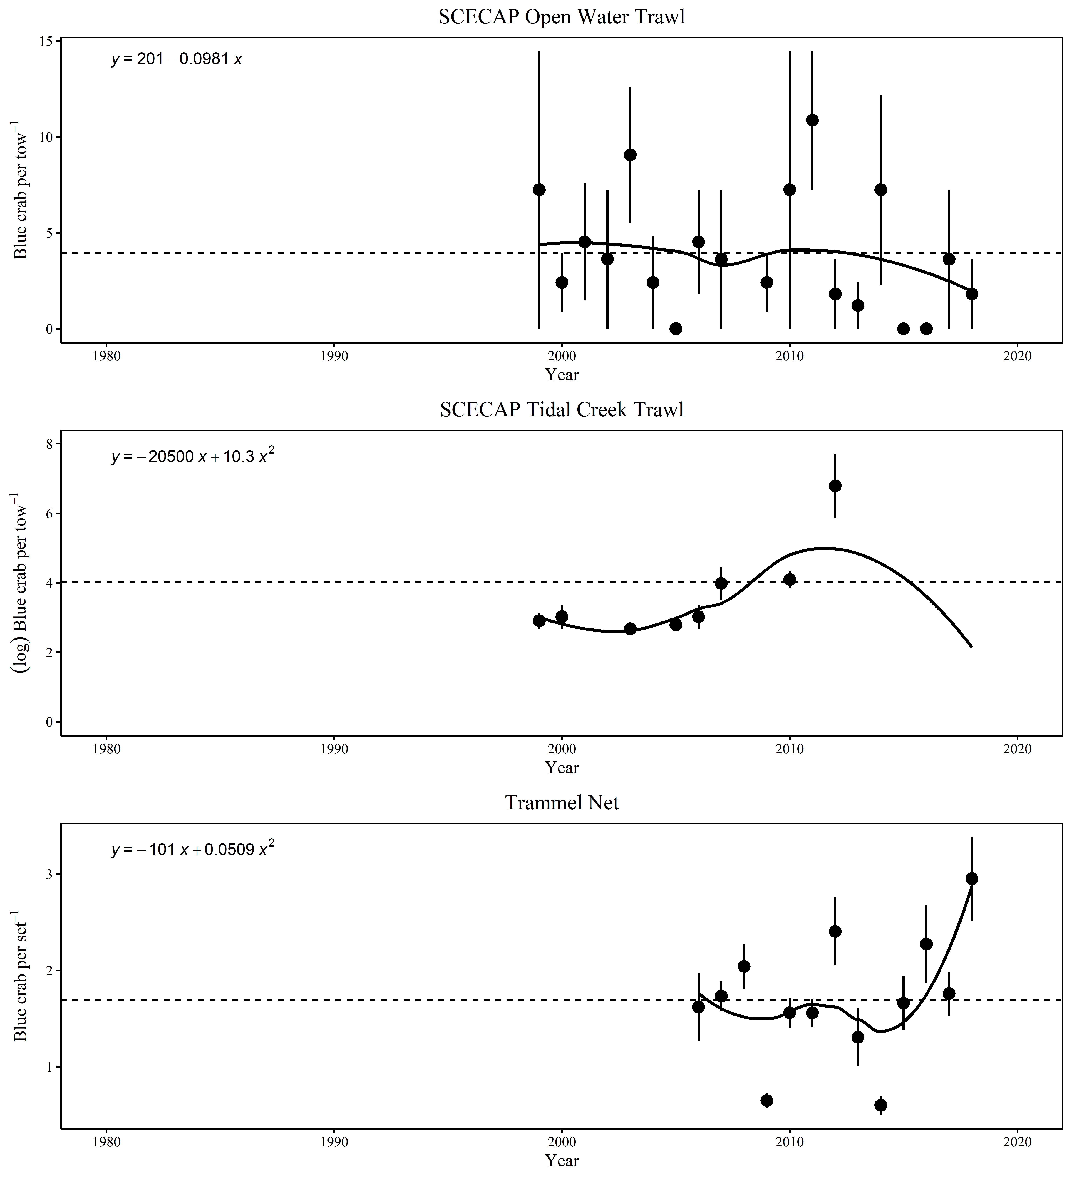

Annual blue crab (total catch) CPUE (mean ± standard error) from non-CRMS surveys. All samples were collected within the Charleston Harbor watershed (Ashley, Wando and Cooper Rivers and Charleston Harbor). SCECAP samples June through July. Trammel Net survey samples monthly.