Chapter 1

**Discussion** Mean annual blue crab abundances from South Carolina Department of Natural Resources (SCDNR) fisheries independent population surveys and landings from fisheries dependent SCDNR landings data show high annual variability.

## Landings Values Computation Methods

Landings are a sum of total pounds of landings accross all reporting areas in the Charleston Harbor watershed from 1972-2018. These data show crab landings reported in the Ashley River (2003-2018), Cooper River (2003-2018), Wando River (1974, 1978-2018) and Charleston Harbor (1972-2018). Landings from 2003 to 2018 are the only time period covering all 4 reporting areas. Standard error bars for these total sum landings show a sum total monthly range across all reporting areas.

The Landings04 data set is the Total Landings dataset subset to 2003-2018. 2003 was the first year for landings in the Ashley and Cooper Rivers, and the first first year for effort data.

Landings CPUE are landings with number of pots pulled as a metric of fishing effort. These mean annual data were computed as: $\overline{X}$ annual($\overline{x}$ monthly($Σ$ lbs month/year/watershed / $Σ$ pots pulled month/year/watershed)) or: Sum total monthly/Annual (ex. 01-1980) landings by watershed -> mean monthly/annual all watersheds -> mean annual all watersheds

### Questions

Should I plot number of pots pulled? I would like to stay away from talk of the fishery, as it would be distracting from the message of the chapter.

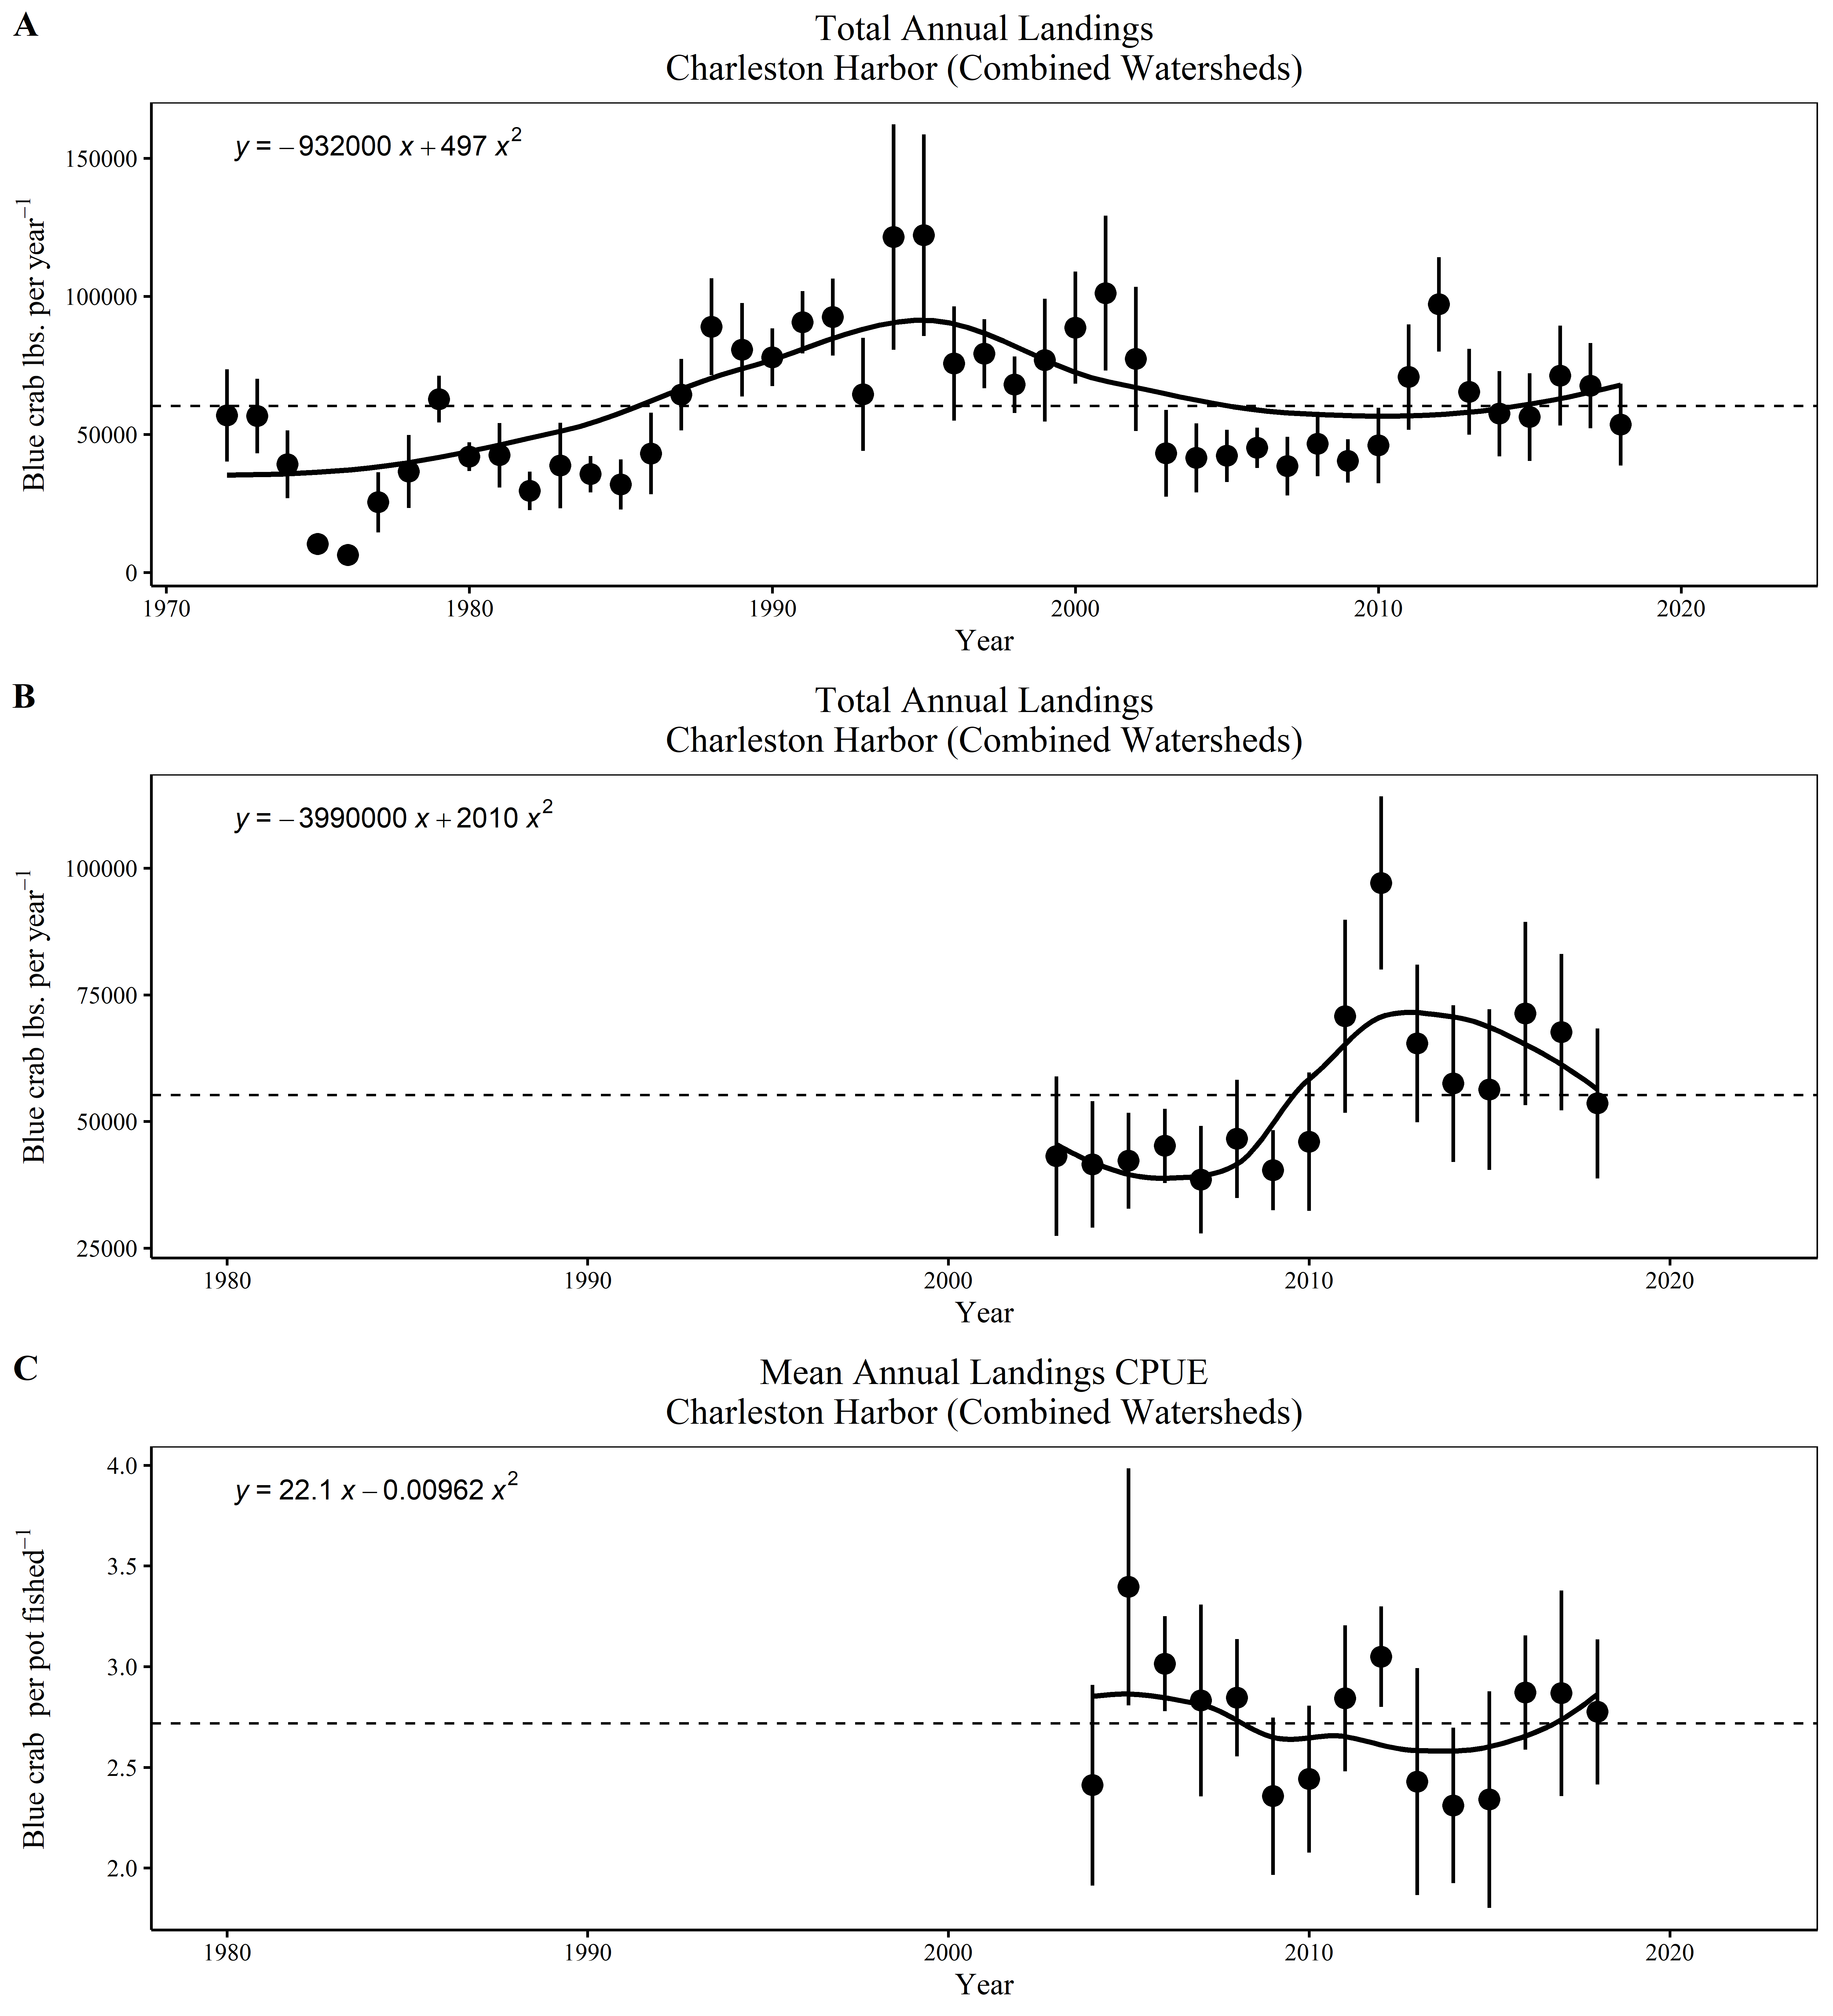

(A) Total annual blue crab Landings (mean ± standard error),(B) total annual blue crab landings (mean ± standard error) subset to 2004-2018, and (C) mean annual landings CPUE (mean ± standard error) for all reporting areas within the Charleston Harbor watershed (Ashley River, Wando River, Cooper River and Charleston Harbor)