Cloud Test Service User Guide

Create your account for CloudTestService 2

Start your Virtual Machines 2

Manage your Virtual Machines 5

Start your tests 9

# Create your account for Cloud Test Service

Please browse to <http://cloudtest.sh.intel.com> , and register your own account to use this service:

Click  to create a new account:

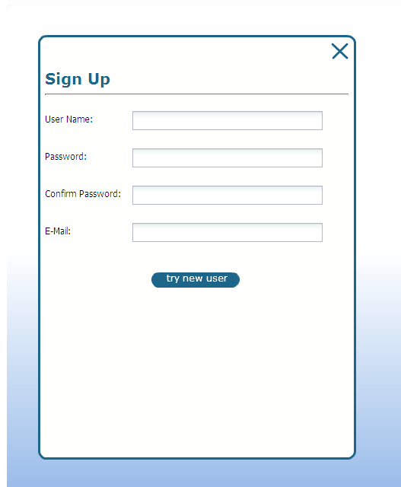

Just input your name (your CCR alias is recommended), and any sequence as the password. The email must be your Intel email address.

# Start your Virtual Machines

1. Logon to the Cloud Test Service with your just created account

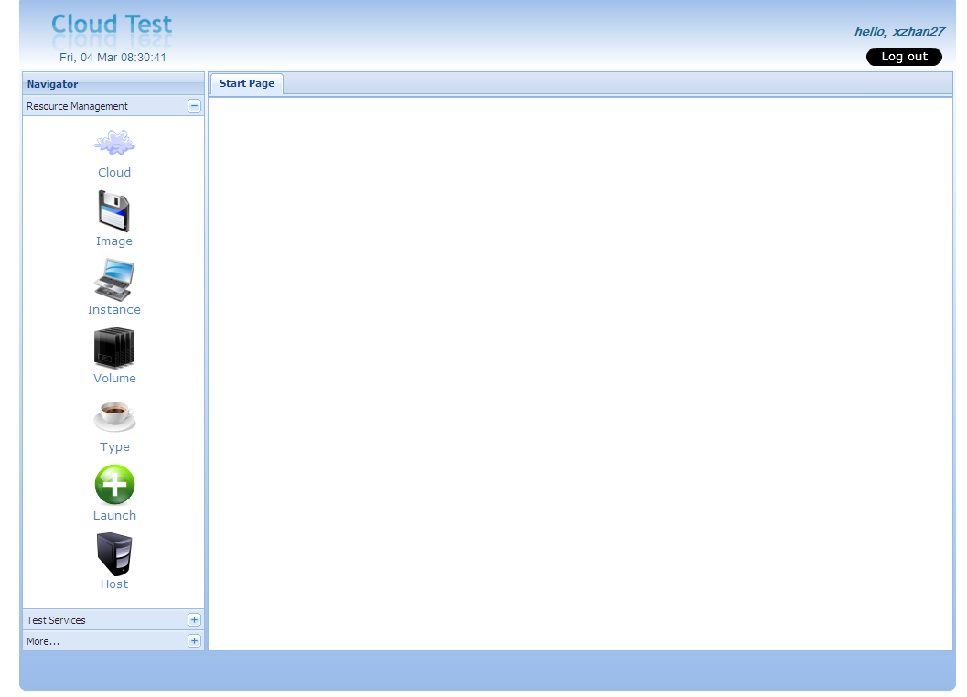

The main user interface of the service is typically Explorer style. All the available resources can be accessed in the left panel.

1. Expand the “Resource Management” tab on left, and click button

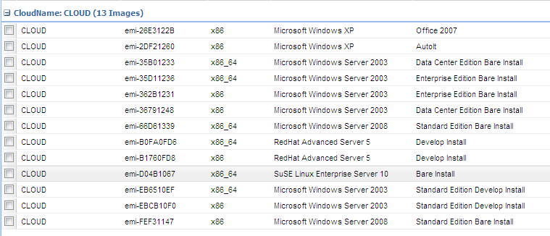

There’re now totally 13 virtual machine images installed. The configuration and installed software varies for the images. The last “comment” column describe the image’s basic information. For example, the “Develop Install” means this image is installed Intel C++ Compiler, and Visual Studio 2003(2005) (only for Windows Server 2003). However, the “Bare Install” means this images only has the basic tools such as JDK, SVN, and perl installed.

You can select whatever images to meet your requirements.

1. Select a suitable image, and click on the top right  to launch.
2. Now the setting is as below:

As the Cloud Test service is deployed on a physically isolated network, all the virtual machines’ IP address allocated are private. So there’s a gateway service configured to support external access inside Intel network. After the virtual machine is launched, the Cloud Test service will automatically setup the port mapping on the gateway to enable external access.

For a Windows virtual machine, please use below settings:

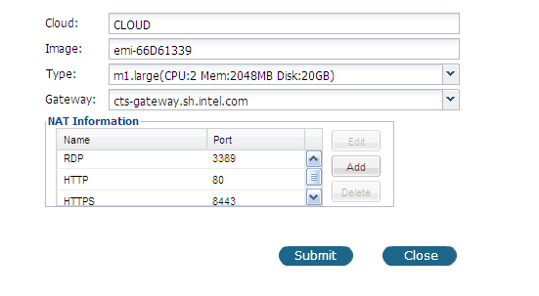

This will enable Remote Desktop pass-through, so that we can use Windows Remote Desktop client to access the virtual machine.

And for a Linux virtual machine, it looks like:

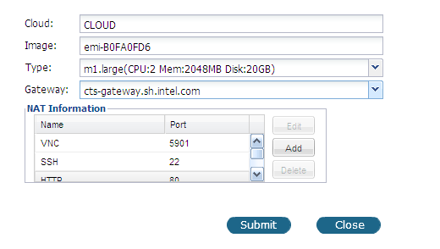

This will enable VNC and SSH pass-through, so that you can use any VNC or SSH client to access this virtual machine.

If you want any other ports accessible outside, just click  button, and use below setting:

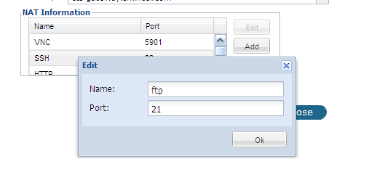

After the virtual machine is started, a port mapping will be created to pass-through the gateway, so that we can use any FTP client connect to the virtual machine. In next section, you will know how to get the mapped port to connect.

1. Click “Submit” to start the virtual machine, the page will be redirected to:

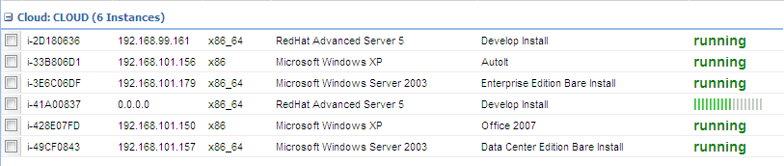

Please wait for the virtual machine ready, typically, you have to take 1 ~ 3 minutes before it’s ready. When the virtual machine is ready for service, the state will be displayed as

# Manage your Virtual Machines

1. After the virtual machine is started, you can find the way to connect by right click on the virtual machine, and select “Show Login Info”



For a Linux virtual machine, it typically shows as:

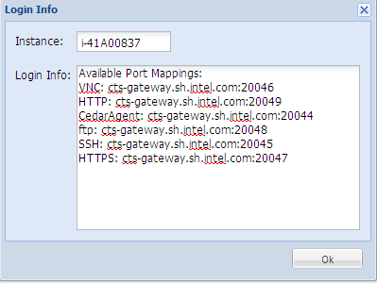

Now you can use vncviewer to open connection to cts-gateway.sh.intel.com:20046 to open the Linux desktop.

And you can use any ftp client to connect to the <ftp://cts-gateway.sh.intel.com:20048> to access the FTP service of the virtual machine.

Please note that the virtual machine images don’t have a FTP server configured, so please make sure to firstly install and configure a FTP server in the virtual machine before you access its service.

For a Windows virtual machine, it typically shows as:

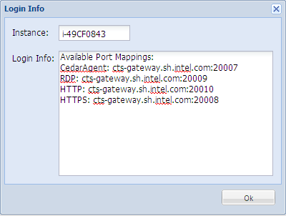

They you can use Windows Remote Desktop to connect to cts-gateway.sh.intel.com:20009 to open the display:

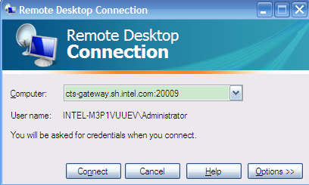

To login to Linux or Windows virtual machine, please use the password 123456 for the administrator and root account.

1. To terminate your virtual machine, just select it and click  button on top right of the instance view:

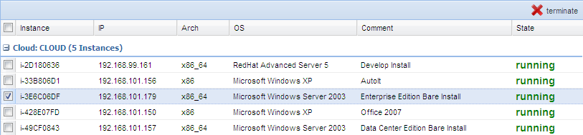

1. Cloud Test Service also supports networking based central storage called “volume”, any virtual machine can dynamically attach the volume for use. The volume can be viewed as an external pluggable hard disk for any virtual machines.

To create a volume, click 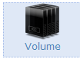to navigate to the Volume management view:

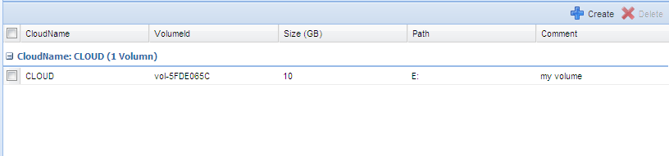

Click  to create a new volume:

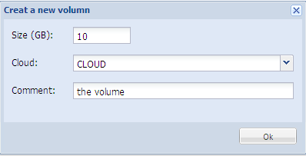

Select a cloud you want to create the volume in, input the volume size and your comment for this volume. Then click OK. A new volume will be created.

1. To attach this volume for your virtual machine, navigate to Instance management view, select a virtual machine, and right click to prompt the menu.



Select “Attach a New Volume” entry:

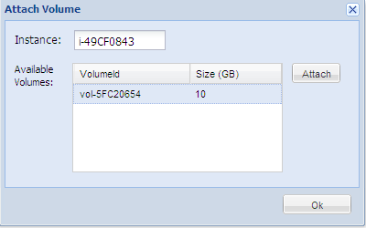

All available volumes will be listed in the dialog, and now select the volume we just created, and click “Attach” button:

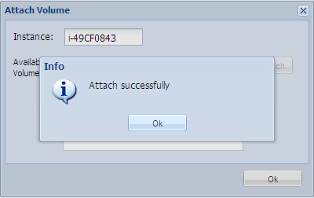

Click OK to close the dialogs, and login to your virtual machine, you will find there’s a new hard disk appears. On Windows, a new hard driver will be in the “My Computer”. On Linux, a new SCSI disk will be shown when executing “fdisk -l” command.

1. To detach the volumes of your virtual machine, navigate to Instance management view, select a virtual machine, right click to prompt the menu, and select “Show Attached Volumes”:

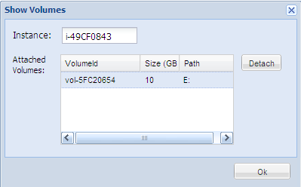

Select the volume you want to detach, and click “Detach” button. Then the volume will be detached, and the hard disk will disappear when you login to your virtual machine.

1. To destroy the volume, navigate to the Volume management view, select a volume and click 

# Start your tests