Prototype Link: https://dishcovery.4300showcase.infosci.cornell.edu/

P05:
For P04, we implemented SVD and saw a big increase in the relevance of our results and the similarity score. However, something that we needed to directly include, as mentioned in the TA and peer reviews, was explicitly displaying the latent dimensions. We did so in this iteration (P05) , improving our explainability by adding a “Why this result” section and including the top 3 query dimensions and the top 3 result dimensions, both positive and negative. We also added a brief tooltip for the similarity score, the tags, and the latent dimensions for further clarification, also as recommended in some of the peer reviews.
The “Why this result” section also included an explainability from the LLM as part of our RAG implementation. To incorporate RAG, we first prompted the LLM to modify the query, then used this modified query in our information retrieval system. When the user clicks ‘Why this result’, we call an LLM endpoint that retrieves the original and modified queries, selected restaurant’s metadata (categories, ambience tags, price, rating, etc), and a review excerpt of 900 characters, and asks the LLM to produce a 1–2 sentence explanation of why it matches the user’s query. This runs on-demand to keep latency/cost down. We made sure to take in TA feedback by ensuring that restaurant reviews were passed into the LLM. Another feature that we added is that, at the top of the results page before each of the recommended restaurant cards are shown, we have an AI summary of the restaurants that were recommended to the user and some supporting information about them. We also added a modified search query feature. For example, if someone searches up “Nashville cozy matcha delicious i want”, the LLM will rewrite the query and display the modified version as “Nashville cozy matcha,” providing more relevant results.
Additionally, we improved general features on our Restaurant Card based on peer feedback. We made the price range inclusive, displayed the restaurant addresses, and hover explanations to clarify why a tag was highlighted/unhighlighted. We addressed issues with “late night” conflicting with the displayed hours and also improved the loading time issues by caching our results so that they were not re-calculated when switching back and forth between cities.
Class concepts:
- Regex
  - We used regex text cleaning to strip punctuation, replace underscores, remove repetitive whitespace, extract the city name, and remove the city name from the query. We also ensured that everything was lowercased.
- Tokenizing
  - Tokens were generated by splitting on spaces after text normalization, both for the reviews and for the query.
- Stop word removal
  - We hardcoded a list of common stop words that don’t add much meaning, including articles, pronouns, and prepositions. This was then applied to the review text as well as the user queries. We also filtered queries further by removing certain query-specific stop words that do not add relevance, such as “want” and “looking”.
- Vector-space models
  - We represented each restaurant as a vector in a term-document matrix, where each row corresponds to a restaurant document (a concatenated string of its name, categories, ambiance tags, reviews, and such) and each column representing a vocabulary term. After, we reduce via SVD into a 100 latent dimension matrix. To score, we apply cosine similarity between the query vector and restaurant vectors. Cosine similarity works better here so that restaurants with more reviews, and hence longer documents, won’t necessarily get a large advantage over smaller businesses that might’ve had less reviews. Results are then ranked by descending cosine score and top results are returned.
- TF-IDF weighting
  - We used scikit-learn's TfidfVectorizer to help us balance out the terms a bit. We set min_df=2 to exclude highly specific terms that might only appear in one restaurant and used sublinear TF scaling to prevent highly repeated terms from being too dominating. We removed English stop words and used gram_range=(1, 2) to try and capture some two word phrases like "late night" or "dim sum." We also adapted a strategy to weigh different components of the restaurants separately (ex. reviews, category/cuisine, or ambiance) so we can properly tune the importance of different aspects.
- RAG
  - We first prompted the LLM to modify the query, then used this modified query in our information retrieval system. When the user clicks ‘Why this result’, we call an LLM endpoint that retrieves the original and modified queries, selected restaurant’s metadata (categories, ambience tags, price, rating, etc), and a review excerpt of 900 characters, and asks the LLM to produce a 1–2 sentence explanation of why it matches the user’s query. This runs on-demand to keep latency/cost down.
- Fuzzy Search
  - We implemented fuzzy search using Python’s difflib library to handle user typos by comparing query strings to entries in the corpus and returning the closest match based on a similarity ratio. A threshold of 0.75 ensures that minor misspellings are corrected while unrelated inputs are not inaccurately matched.
- SVD
  - We applied SVD on top of the TF-IDF matrix, reducing the vocabulary to 100 latent dimensions that capture co-occurrence patterns and semantic relationships rather than relying solely on exact term matches. This allowed us to group related concepts like cuisines, ambience, and dining contexts, significantly improving relevance and increasing similarity scores from roughly 0.06–0.11 with TF-IDF alone to 0.55–0.83 with TF-IDF+SVD.
Qualitative evaluation:
1. One change we made was adding explicit time-of-day filters. In our earlier prototype (e.g., P04), queries like “Tampa late night ramen” were not strictly filtered by the “late night” constraint. Instead, it was treated as a soft signal, so restaurants like Sekushi, despite closing at 6 pm, appeared as the second result as shown below:
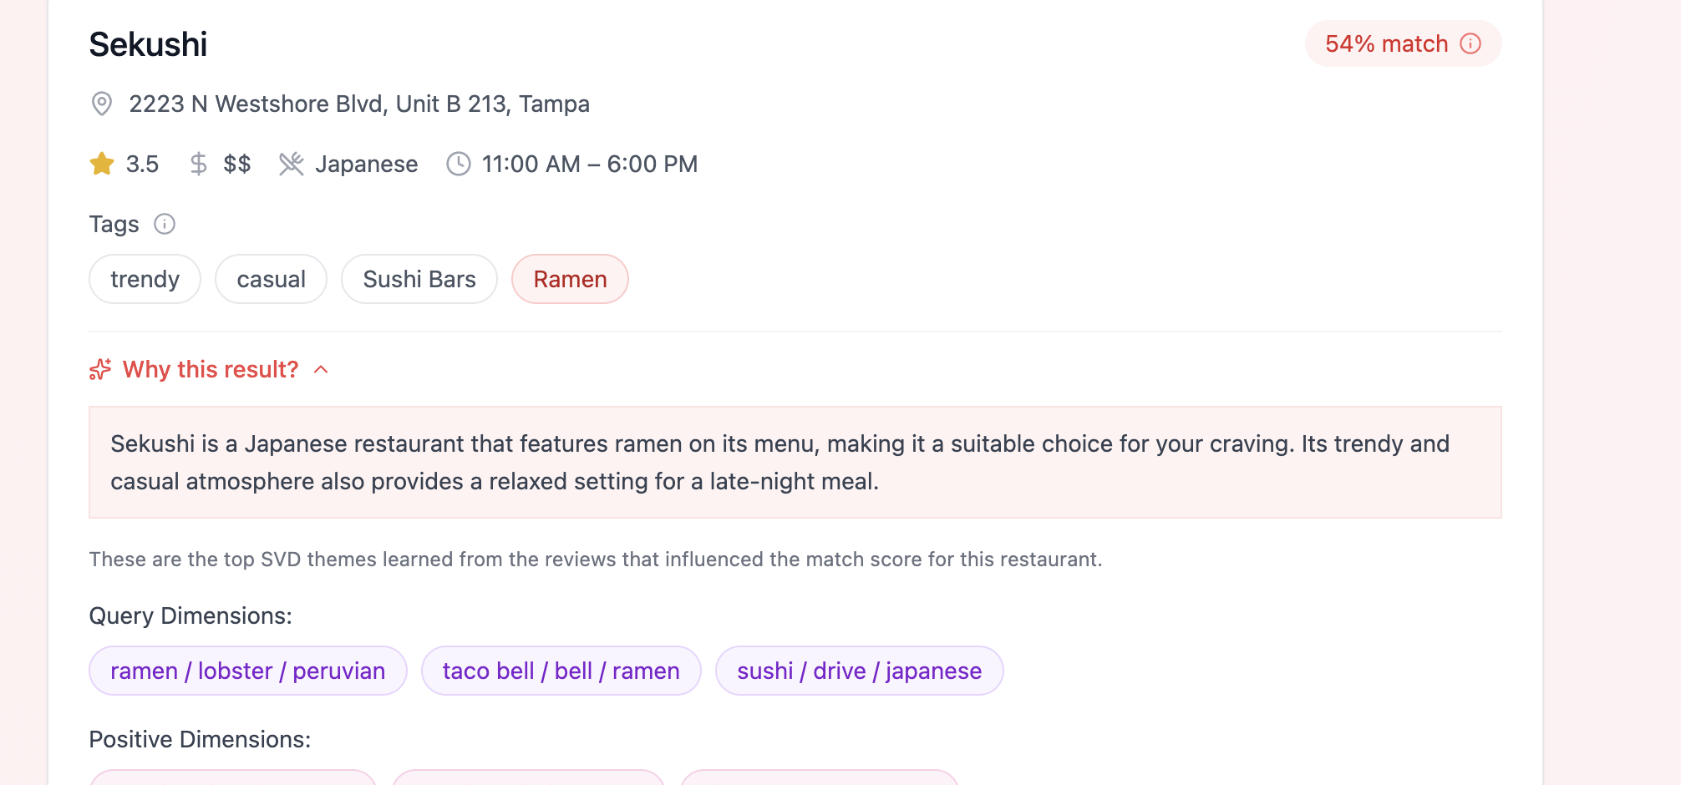
Now, with the updated system, “late night” is enforced as a hard filter (defined as 10 pm to 3 am). As a result, when searching for “Tampa late night sushi,” restaurants like Sekushi are excluded. The top results now all have closing times at or after 10 pm, making them better aligned with the user’s intent. These are the top 3 results:
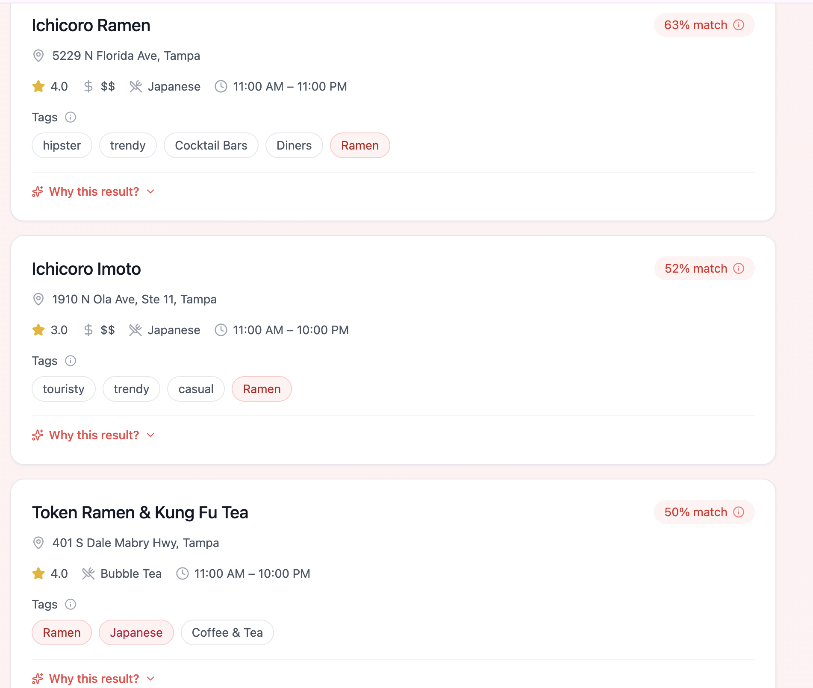
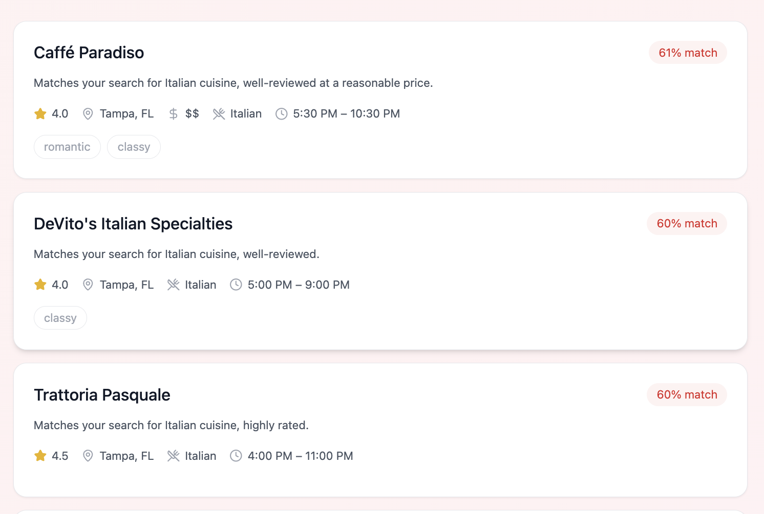
2. In our earlier prototypes, the queries were passed in directly to the IR pipeline after cleaning. Because of this, certain input and filler words were adding extra noise to the similarity matching and decreasing the accuracy of results. For example, if we search Tampa for “I kind of want Italian or maybe Mediterranean, something nice but not overly formal, good for a dinner date, somewhere in Tampa,” the top 3 options were previously all Italian.

After sending the query to be rewritten into a better and more compact search phrase, the top 3 results now provide both Italian and Mediterranean options. This makes them a lot more relevant to what the user actually wants with this query.
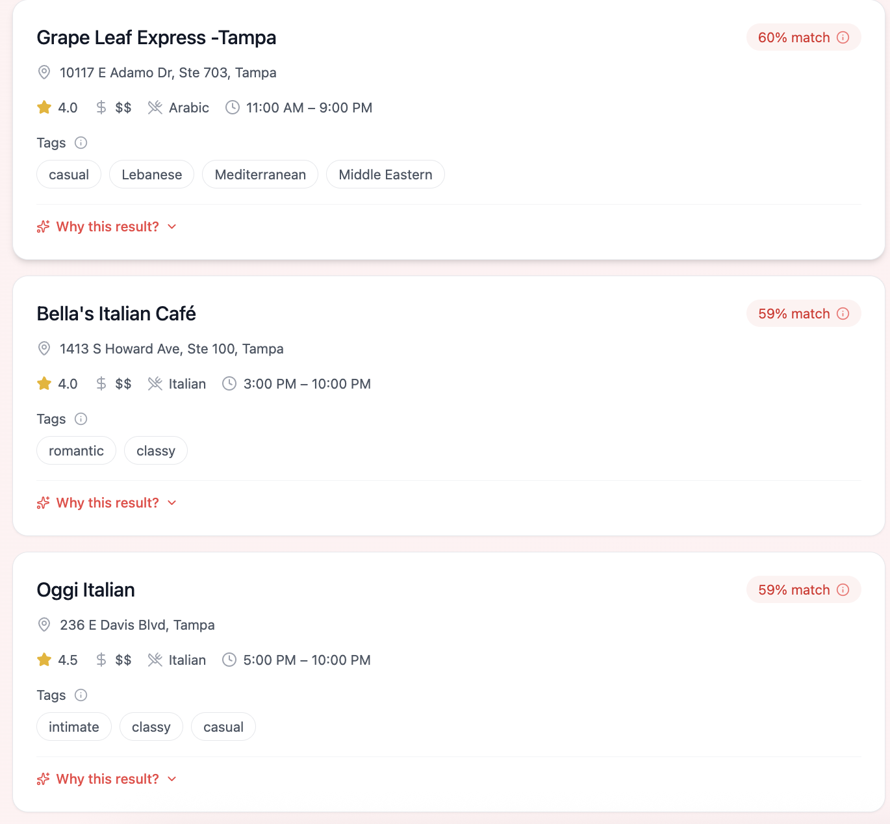
3. In our earlier prototype, the explanations for match scores were brief sentences that were mostly hard-coded to match the tags that are common between the user query and the responses. There were also no SVD dimension tags, so users had very limited visibility as to why certain themes were contributing to the results. When previously asked for “upscale dinner” in Nashville, with no price or star rating restrictions:
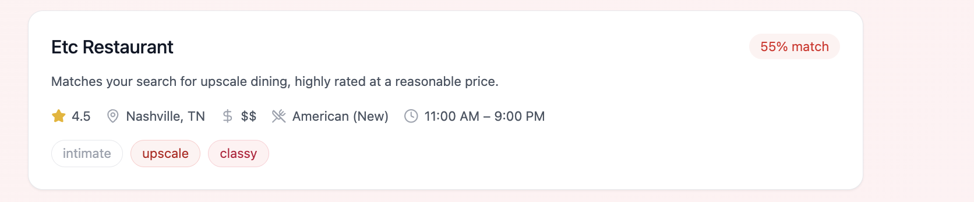
Now, there is a “Why this result?” explanation included, where users can view the LLM-generated explanation as well as the SVD dimensions that contributed to this result with the positive, negative, and query dimensions. These additions make the system a lot more interpretable.
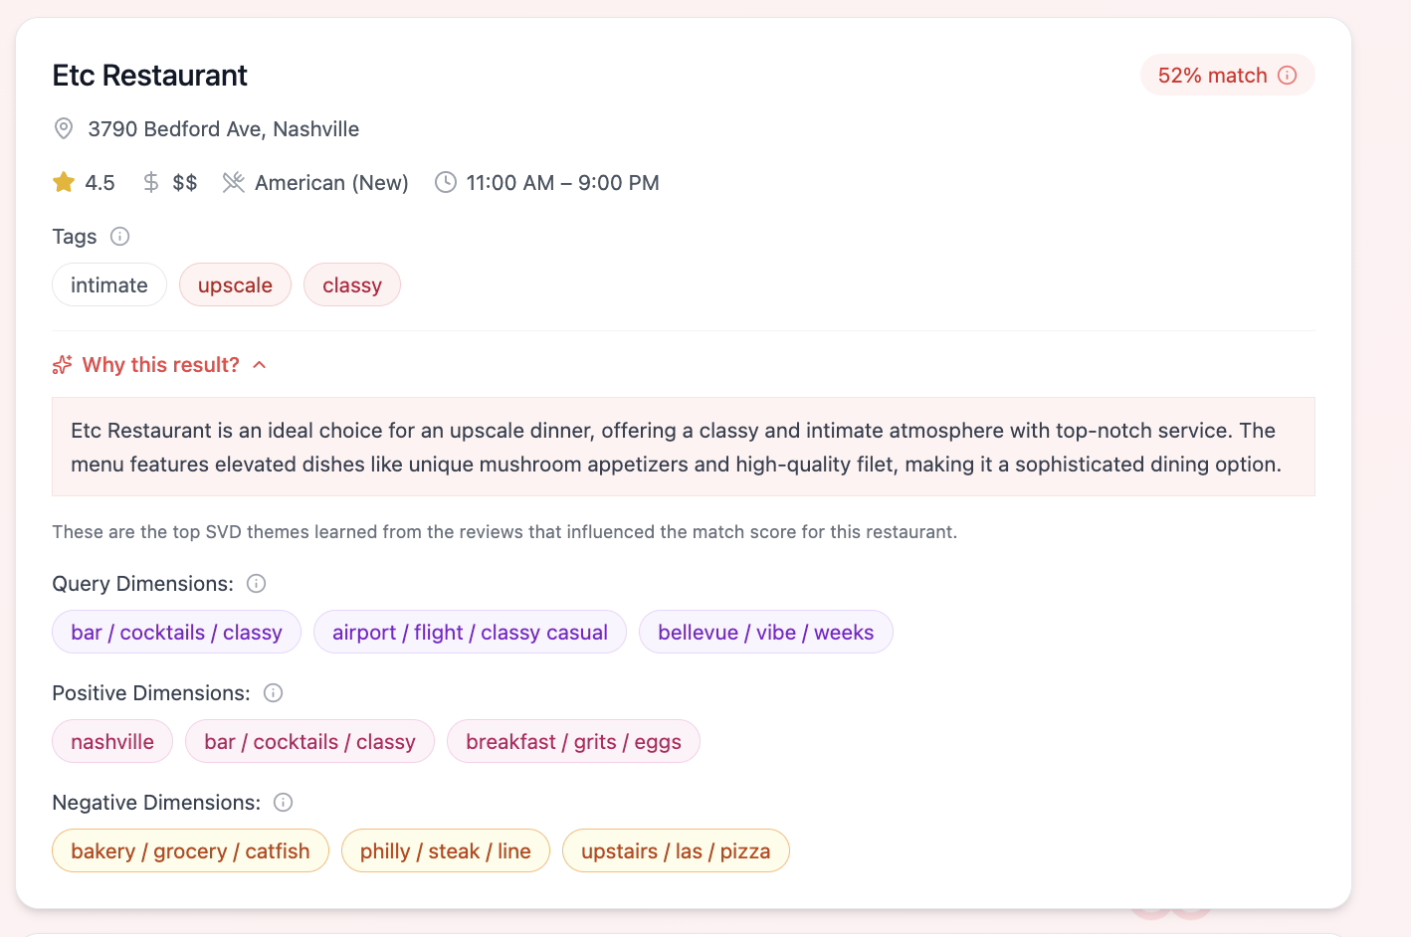

4. Previously, a non-optimal query from a user like “cozy matcha yum delicious i want” in Nashville was resulting in no results being found. If results were found, users would also have to read through each response to understand what options are available based on their needs.
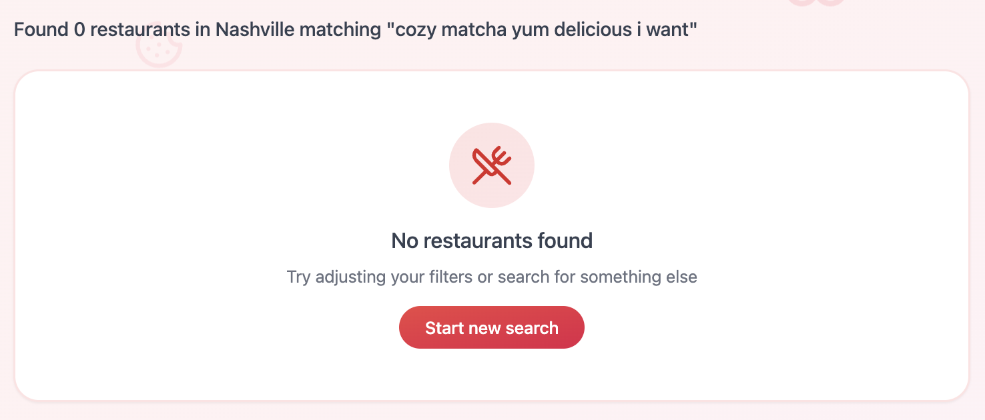
Now, the query is rewritten using the LLM, ensuring that it is optimized for relevant responses. Also, the information from the retrieved matches (including the old query, the new query, categories, ambience tags, ratings, hours, and match percentages) is provided to the LLM to create an AI overview of the options. This makes it a lot easier for users to quickly access information. The modified query is also illustrated in grey under the AI overview.
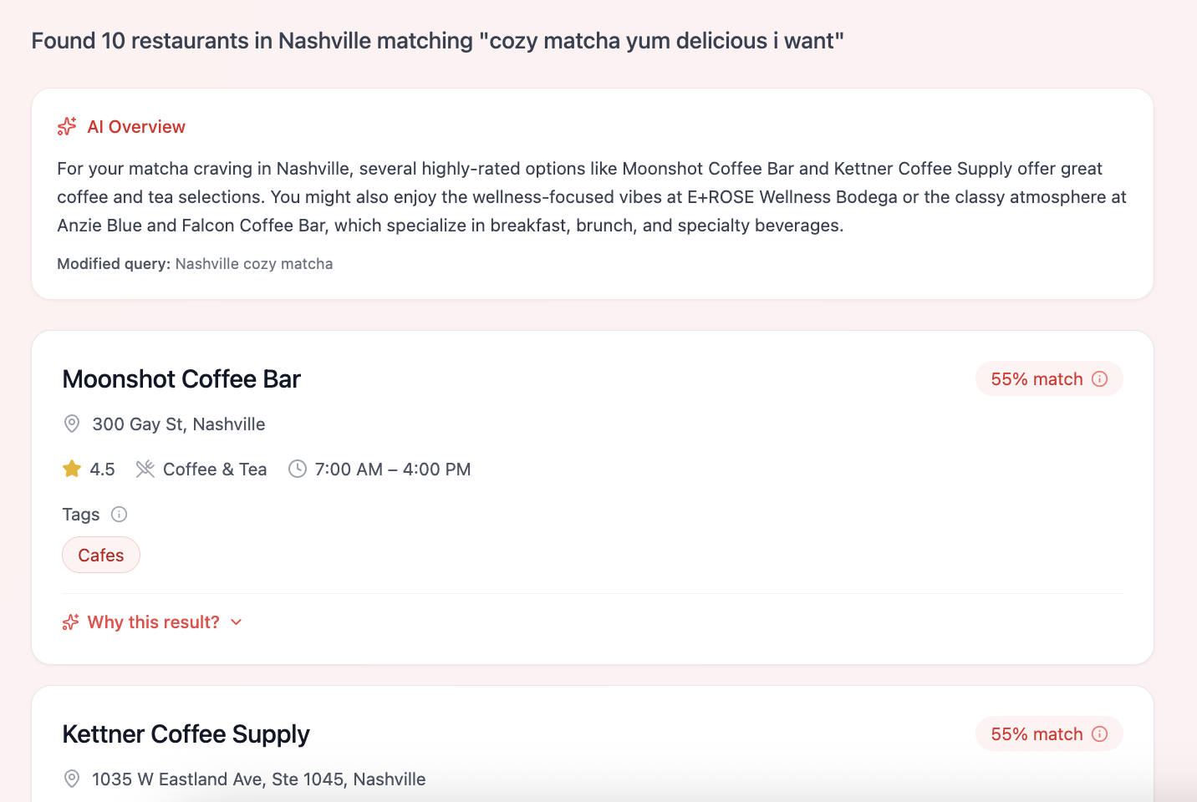

Known issues: explicitly list issues that remain unresolved, and select a few on which you would like feedback.
Some issues that remain unresolved are a limited number of features that allow users to engage with our project. Although users can type in a query, choose a city from a dropdown list, and adjust the price and ratings, there could be more visual aspects to our project. For example, we thought about including pictures of the restaurants, but since there are so many restaurants in our database and no pictures included, manually finding and adding images would have been difficult. Another idea that we had was to include the location of each restaurant on a map that the user could see to better understand where it is in the city they’re visiting. However, we did not get a chance to incorporate features like these. We instead focused more on improving the time taken to load the results, incorporating the RAG component, and refining the positive and negative, or overall latent dimensions.

