Game Design Proposal — Echobound
Student Name: 陈振宇 Date: May 31, 2026
An echolocation maze game built with Python + pygame
1.1 Design Ideas
One-sentence statement: You cannot see the maze — you can only hear it.
Echobound is a top-down maze game where the screen is almost entirely black. Instead of seeing the walls, the player presses a key to send out a sound wave that ripples outward, strikes nearby surfaces, and briefly lights up their outline before the world fades back into darkness. The whole game is about replacing sight with hearing: you build a mental map of a maze you have never actually seen, navigating by memory and by the fading echoes of your own pings. I wanted a mechanic that felt different from the usual maze game, and turning vision into an active, costly action — you have to decide when to 'look' — turned out to be a surprisingly tense idea to build around.
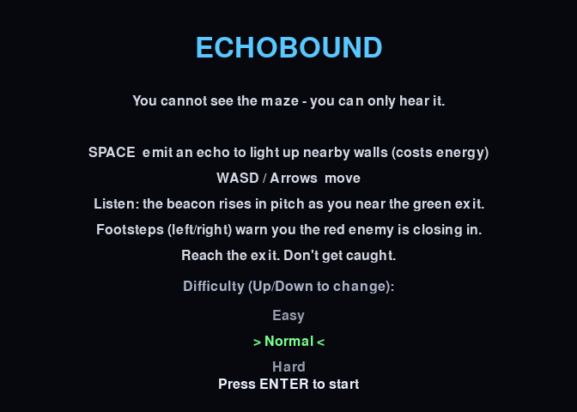
Figure 1 — The start menu, which doubles as the help screen, explaining the core idea and letting the player pick a difficulty (handled as a game-state machine, Lecture 1).
1.2 Game Elements
Background: The player is a lone diver exploring a flooded, lightless cave system. Light does not travel here, but sound does — so the only way to perceive the world is to listen to it.
Goal: Reach the green exit at the far corner of the maze. The exit is invisible until an echo reaches it, so the player must explore and memorise the layout to find their way out, then advance through progressively harder levels.
Gameplay: Arrow keys or WASD move the diver; SPACE emits an echo. Each echo is a ring of rays that expands outward, and only the walls near the expanding ring light up, so the ping reads like a sonar pulse sweeping the room. Pinging costs energy and has a short cooldown, so the player cannot simply spam it — they must ration their vision. Lit surfaces slowly fade to black, forcing a constant choice between spending an echo to refresh the picture and pressing forward into the dark. An enemy roams the maze and hunts the player by sound: every ping it hears reveals the player's location, so pinging is both how you see and how you give yourself away.
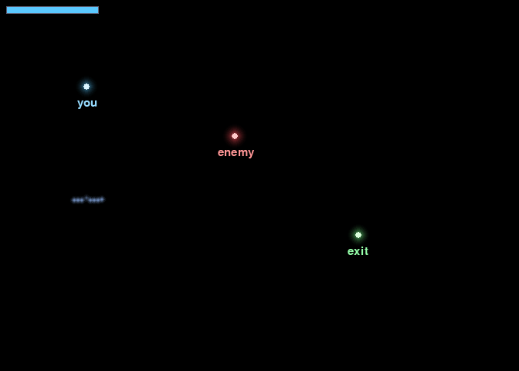
Figure 2 — The three key elements as they appear in play, each bloomed by an echo: the player (blue), the sound-hunting enemy (red), and the exit (green). The bar at top-left is the ping energy meter.
Multiple outcomes: (1) LEVEL CLEARED — the player reaches the exit and advances to a harder level. (2) CAUGHT — the sound-hunting enemy reaches the player, ending the run. The tension between needing to ping to see, and pinging attracting the enemy, is the core risk-reward loop.
1.3 Game Prototype (paper to digital)
The first prototype was on paper: a hand-drawn grid where I shaded in only the cells a 'reveal' would expose, to test whether navigating a mostly-hidden maze was fun or just frustrating. That paper test convinced me the reveal had to be a full 360° ring rather than a cone, and that lit areas needed to linger for a second or two so the player could act on them.
The digital prototype is a complete, playable Python + pygame program (source on GitHub, linked below). It is organised around the standard input → update → render game loop from Lecture 1, with each subsystem (maze, echo, enemy, audio) kept separate so they can be tuned independently. The prototype draws directly on algorithms from the course:
- Recursive Backtracker maze generation with braiding (Lecture 3) — carves a fully-connected maze with a depth-first stack, then opens a few extra walls to add loops and junctions.
- Expanding sonar wave-front via raycasting (Lecture 9) — each ping casts ~180 rays; each ray stops at the first wall it hits, and only walls near the ring's current radius light up, exactly the line-of-sight raycasting we studied for visibility.
- A* pathfinding (Lecture 4), used two opposite ways — the enemy chases the last spot it heard you ping, and a BFS shortest-path distance drives an exit 'beacon' tone that guides you (closer = higher pitch).
- Grid / AABB collision detection (Lecture 5) — both movement and the rays check whether a target cell is a wall before proceeding.
- Stereo panning with distance falloff (Lecture 7) — the enemy's footstep audio is panned left/right by its position relative to the player, so you hear which side it is approaching from.
- Soft radial glow with quadratic distance falloff (Lecture 10) — lit walls, the player and the enemy are drawn as light blooming out of darkness rather than flat dots.
- Frame-to-frame interpolation (Lecture 1) — the diver eases smoothly between grid cells instead of snapping.
All sound is generated procedurally with numpy (no asset files), and the audio layer degrades gracefully to silence if no audio device is available.

Figure 3 — A single echo. The player (blue glow) has just pinged; only the nearest walls bloom into light, brightest close to the player and fading with distance. Everything else stays black.
1.4 Game Testing (screenshots + description)
I ran the prototype and captured the states below, followed by a short account of how testing went.

Figure 4 — Pinging while moving. As the player walks and pings, the corridor they have travelled stays faintly remembered (older echoes are dimmer), while the path ahead remains unknown. This 'memory map' is what the game is built around.
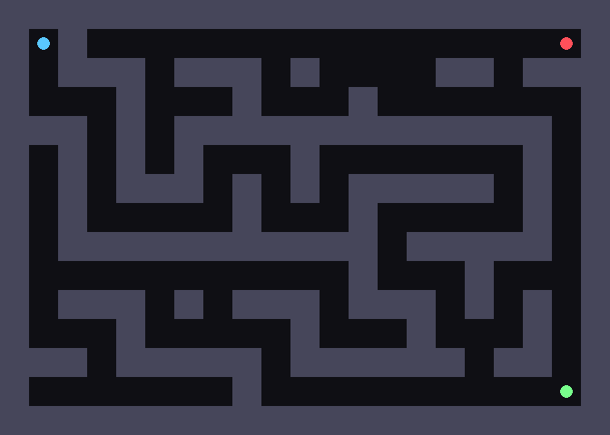
Figure 5 — Debug full-reveal view (not shown to the player). The complete generated maze with player (blue), enemy (red) and exit (green). Note the loops and junctions added by braiding. I used this view to verify every maze was fully connected and solvable.
Testing process: I first played the game myself, then had two classmates try it with no explanation beyond the controls. I watched where they got stuck, how often they pinged, and whether they understood that the enemy was tracking their sound. Each run took about three to five minutes, which felt like the right length for a single maze.
1.5 Feedback from Testing Sessions
- "It's too dark — after a few seconds I completely forget where the walls were." The echo faded too quickly to support memory.
- "I didn't realise the red thing was chasing me until it caught me." The enemy's threat was not communicated before it was too late.
- "I just spammed the ping key." With no cost on pinging, the intended risk-reward tension disappeared and the darkness stopped mattering.
- "Finding the exit felt random." Players wandered with no sense of direction toward the goal.
- "The maze is just one long corridor." The original generator produced few junctions, so there were no real navigation decisions.
- Positive: everyone agreed the echo-reveal moment felt striking and unlike other maze games, confirming the core idea was worth keeping.
1.6 Improvements from Feedback (algorithm and design)
Each piece of feedback led to a concrete algorithmic or design change, all of which are now implemented in the prototype:
- Fade too fast → lowered the per-frame fade rate so lit walls persist longer and the 'memory map' is actually usable; the fade now also scales with level for difficulty.
- Enemy too sudden → added stereo footstep audio (Lecture 7): the enemy emits a soft panned 'thud' whose left/right volume comes from its offset to the player and grows with proximity, so you hear it coming from a direction before it arrives.
- Ping spamming → added an energy cost and cooldown per ping, turning vision into a limited resource and restoring the intended tension.
- Exit feels random → added an exit 'beacon' tone whose pitch and frequency rise as the BFS path distance (Lecture 4) to the exit shrinks; the enemy and the exit now reuse the same pathfinding idea in opposite ways — one chases, one guides.
- One long corridor → added braiding to the Recursive Backtracker (Lecture 3): after carving the maze, a few interior walls between two passages are opened, adding loops and junctions so the player faces real choices. I considered a Sidewinder generator as an alternative bias and can A/B test it.
- Enemy felt omniscient → reworked the enemy to hunt by sound (it only knows the last cell where it heard a ping, and wanders when it loses the trail), which fits the echolocation theme far better than constant tracking.
- Added difficulty presets and a help/pause screen → Easy / Normal / Hard tune the enemy speed and fade rate (PCG parameter tuning, Lecture 8), and clearing a level advances to a deterministic, slightly harder maze (per-level seed, Lecture 8 / determinism).
Overall, testing mostly validated the core mechanic and redirected my effort toward feedback, pacing and fairness — making the darkness fair rather than merely punishing.
Game Demo Link (optional)
Source code available at: https://github.com/czy-source/echobound-by-Zhenyu_Chen
To play: clone or download the repository, then run pip install pygame numpy and python echobound.py (SPACE to ping, arrow keys / WASD to move, H to pause, R to restart; choose difficulty on the start menu). The repository README documents the controls and the algorithms used.

