Display and Control Devices

About This Chapter

This chapter introduces:

Emergency stop switch and indicators

Functions of the operation keyboard

Display area

Emergency Stop Switch and Indicators

Emergency Stop

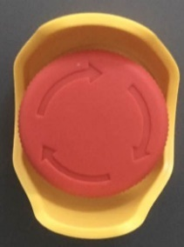 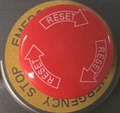

Emergency Stop

Emergency stop switches are installed at the entrance and exit of the equipment tunnel and on the operation keyboard.

In case of an emergency, press any emergency stop switch to immediately stop X-ray emitting and conveyer moving.

 Caution:

Emergency stop switches can be locked. To unlock an emergency stop swtich, turn the red button clockwise until it bumps up.

Power Indicator

 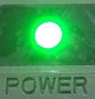

Power Indicator

Power indicators with signs above or under them are installed at the entrance and exit of the equipment tunnel and on the operation keyboard.

When the equipment is powered on, all the power indicators light up.

X-Ray Indicator

 

X-ray Indicator

Red X-ray indicators with signs above or under them are installed at the entrance and exit of the equipment tunnel and on the operation keyboard.

When X-rays are emitted, all the X-ray indicators light up.

Operation Keyboard

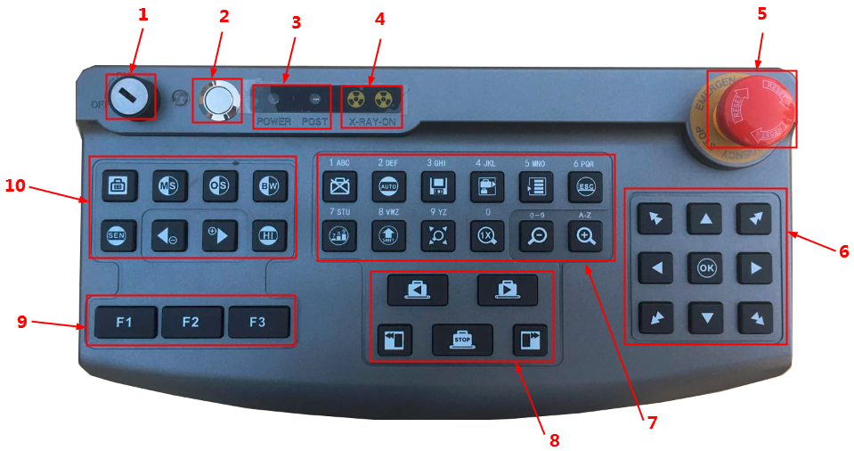Operation Keyboard

1 Key Switch

|  |  |
| --- | --- |
|  | The key switch can connect or disconnect the equipment safety interlock switch, and is used to prevent non-operators from operating the equipment.   * Before power-on, insert the key and turn it clockwise to the “ON” position. * If the safety interlock switch of the equipment works properly, the green indicator lights up. * Before power-off, turn the key counter-clockwise to the “OFF” position and the green indicator goes off. * Power off the system. |

 Caution:

The key can be removed only when it is in the ”OFF” position.

2 Power Button

|  |  |
| --- | --- |
|  | When the key switch is in the ”ON” position, press the power button to power on the system, when the power indicator lights up. |

3 Status Indicator

|  |  |
| --- | --- |
|  | The 3 indicators from top to bottom are: power indicator, keyboard communication indicator and punch clock indicator |

4 X-Ray Indicator

|  |  |
| --- | --- |
|  | When X-rays are emitted, the X-ray indicator lights up. When X-ray emitting stops, X-ray indicator goes off.. |

5 Emergency Stop

|  |  |
| --- | --- |
|  | In case of an emergency, press any emergency stop switch to stop X-ray emitting and conveyer moving. The emergency stop switches can be locked. To unlock a switch, turn the red button clockwise until it bumps up. |

6 Image processing Keys

|  |  |
| --- | --- |
|  | The black-and-white (B/W) key is used to enter/exit the black-and-white image state. The first press enters the black-and-white image state and the second press exits the state.  This key can also be used to input number *1*. For more instructions please refer to zoom in/out keys |
|  | The mineral stripping key is used to enable/disable the mineral stripping function. The first press enables the function and the second press disables the function. This key can also be used to input *2, a, b, c, A, B, C*. For more instructions please refer to zoom in/out keys. (Kind remind: For 5030A machine, it is no use.) |
|  | The organic stripping key is used to enable/disable the organic stripping function. The first press enables the function and the second press disables the function. This key can also be used to input *3, d, e, f, D, E, F*. For more instructions please refer to zoom in/out keys. (Kind remind: For 5030A machine, it is no use.) |
|  | Reverse color. Press to reverse/reverse back the image color.  This key can also be used to input *4, g, h, i, G, H, I*. For more instructions please refer to zoom in/out keys. |
|  | The Super enhancement key is used to enable/disable the Super enhancement function. The first press enables the function and the second press disables the function. This key can also be used to input *8, t, u, v, T, U, V*. For more instructions please refer to zoom in/out keys. |
|  | The high penetration key is used to enable/disable the high penetration function. The first press enables the function and the second press disables the function. This key can also be used to input *9, w, x, y, z, W, X, Y, Z*. For more instructions please refer to zoom in/out keys. |
|  | If you find a suspicious item when viewing images, press the mark key immediately after you see the whole image of the item on the screen. |
|  | Z789 is designed to highlight the suspicious organic material. Generally, explosives are likely to close to Z7 and drugs are likely to close to Z9. Press this key to active/turn off the function and switch among z7/z8/z9 (Kind remind: For 5030A machine, it is no use.) |
|  | Auto adaption. Press to auto zoom in/out the image to proper size. |
|  | Function not used yet |
|  | Functions of the zoom keys:   * Zooming in/out an image globally   These keys can also be used to switch between letter/number input. Enter system menu, press to switch between letter/number input, press to switch between capital/lower-case letters input. |



|  |  |
| --- | --- |
|  | The multi-absorptivity key is used to enable/disable the multi-absorptivity function. Press the key to enable the multi-absorptivity function, and press or to adjust the multi-absorptivity.  These keys are also used to input numbers and letters. Use to input *6, m, n, o, M, N,O*; and to input *7, p, q, r, s, P, Q, R, S*. For more instructions please refer to zoom in/out keys. |

7 Function Keys

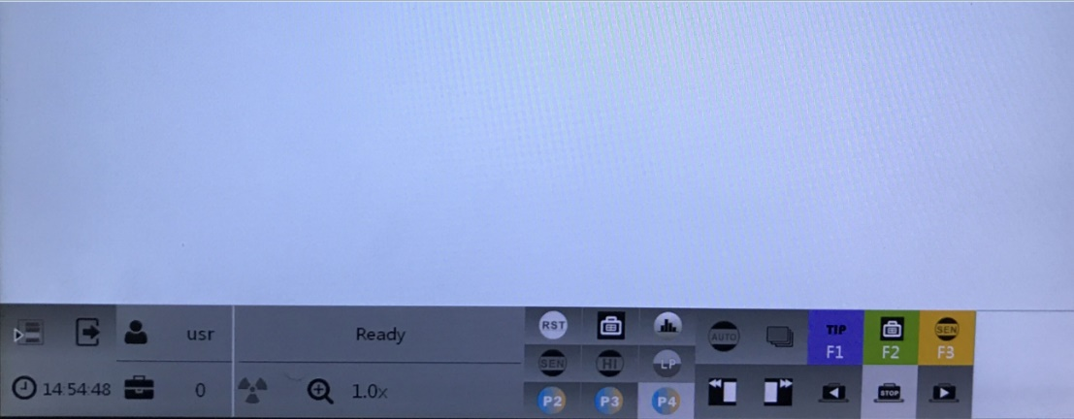

|  |  |
| --- | --- |
|  | System Menu  Press to enter system management interface |
|  | EXIT  Press to exit the current interface of status |
|  | Image management  Press to enter/exit image management interface.  This key is also used to input number *0*. For more instructions please refer to zoom in/out keys. |

8 Customizable Keys

|  |  |
| --- | --- |
|  | The functional keys can be configured with the **customer designed** functions. |

9 Conveyor Control Keys

|  |  |
| --- | --- |
|  | The transfer control keys are used to control the moving of the conveyer. |

10 Navigation keys

|  |  |
| --- | --- |
|  | Navigation keys are used to move the zoomed in images or recall the history image |

Display Area

Main Interface of the System

0 shows the XOIS main interface of the X-ray inspection system. 



XOIS Main Interface

The first picture of fig 4-5 is the screen display of major view (Top-view) and the second picture of fig 4-5 is the screen display of side-view. (Kind remind: For 5030A machine, it is no use.)

0 shows the functions of the function control area.

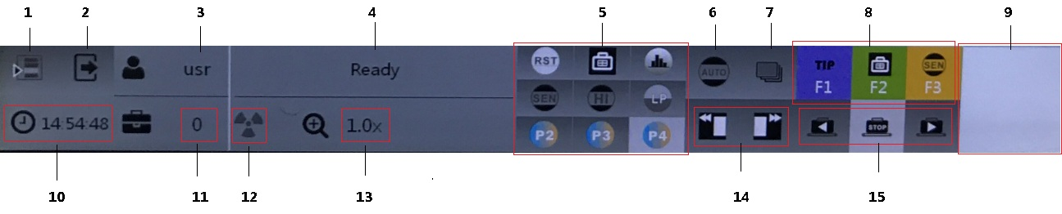

Status Panel of the System

Status Panel of the System

|  |  |
| --- | --- |
| 1. System menu | Click to enter system menu |
| 2. log off | Click to log off the current user |
| 3. User name | Displays the user name of the current user. |
| 4. System Status | Displays the current status of the equipment, including ready, scanning, reversing conveyor, auto backward, demo, management, failure.  The system status is described as follows:  Ready: An operator has logged into the system, the conveyer does not move, and the system is ready for inspection;  Scanning: X-rays are emitted to scan the inspected item;  Continuous scan: The conveyer is moving, the X-ray generator emits X-rays, and the image of the inspected item is displayed;  Rewind: In mono-direction scan mode, the conveyer is moving in the opposite direction of scanning;  Auto-backward: If there are still unscanned items on the conveyer when the system is powered off, the conveyer is automatically rewound next time the system is powered on;  Demo: The demonstration function is enabled through system settings and is being executed;  Image browsing: The queried image is opened and displayed on the screen.  Management: enter system management interface  Failure: The abnormal parts are collected to prompt the operator. |
| 5. Image Processing | The functions of the image processing are as follows  : back to default image processing status  : Reverse color.;  : histogram equalization.  : Super enhancement;  : High penetration;  : Low penetration;  : Pseudo color 2  : Mineral stripping;  : Low energy; |
| 6. Mark | Whether the image is marked |
| 7. Enforce emitting | The conveyer is moving, the X-ray generator emits X-rays, and the image of the inspected item is displayed; |
| 8. Customizable keys |  |
| 9. Navigation view | Displays the global view of the current screen. |
| 10. system time | Display the current time |
| 11. Image counter | Display the current baggage counter |
| 12. X-ray indicator | Lights up when X-ray is on |
| 13. Image zoom-in indicator | Indicates the ratio of the current image size to the original size. For image zoom-in operations, see section **错误!未找到引用源。**“Zooming in Images.” |
| 14. image recall | : recall image to earlier images  : to later images |
| 15. Conveyer status | Displays the current status of the conveyer with a red icon. |

Main Menu of the System

Right-click on the navigation view in the lower left corner of the screen or press  on the operation keyboard to display the main menu, as shown in 0:

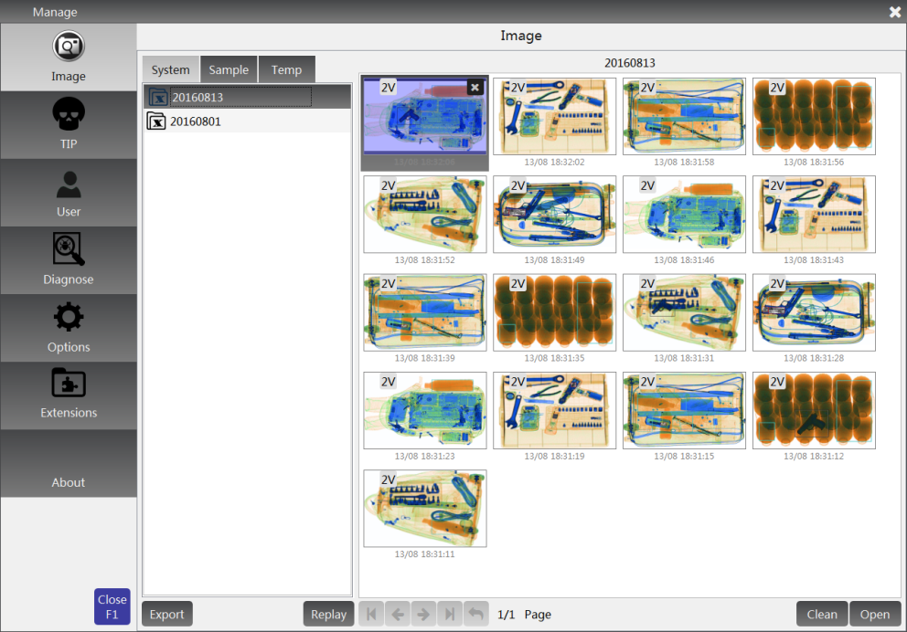

Main Menu Interface

 Note:

The menu commands available on the main menu very for system administrators, operators, and maintenance. 0 shows the main menu interface for administrators.