Activity Diagrams
Blockchain E-Commerce Platform

Each diagram separates actor actions from system and blockchain responsibilities using two swimlanes. A solid filled circle marks the start node and a ringed circle with a filled centre marks the end node. Diamonds are decision points and every branch is labelled.

Contents
- 1. Manage Cart
- 2. Browse Products
- 3. Checkout with All Payment Modes
- 4. Raise Dispute
- 5. Confirm Delivery
- 6. Resolve Escrow Dispute
- 7. Unstake Elixir
- 8. Stake Elixir
- 9. Manage Product Catalog
- 10. Update Fulfillment Stage
- 11. Manage Staking Tiers
- 12. Manage Subscription and Pay Fee
- 13. Transfer Currency P2P
- 14. Update Profile
- 15. Deposit RM
- 16. Swap Currency

1. Manage Cart
Swimlanes: Customer | System
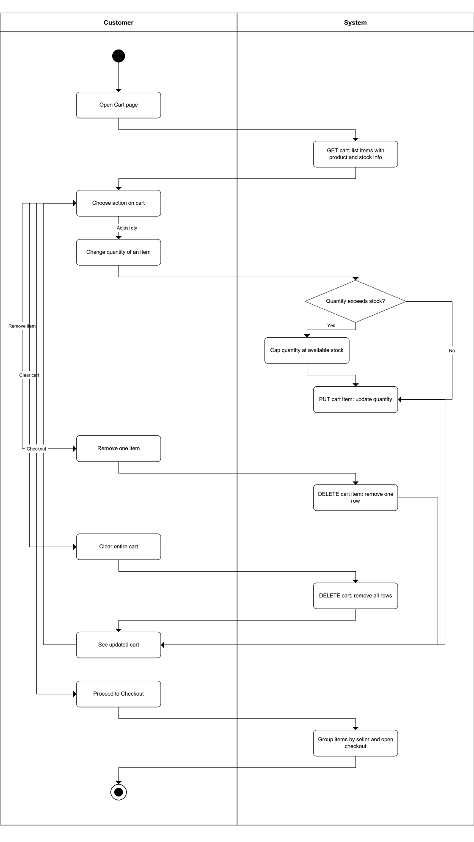

2. Browse Products
Swimlanes: Customer | System
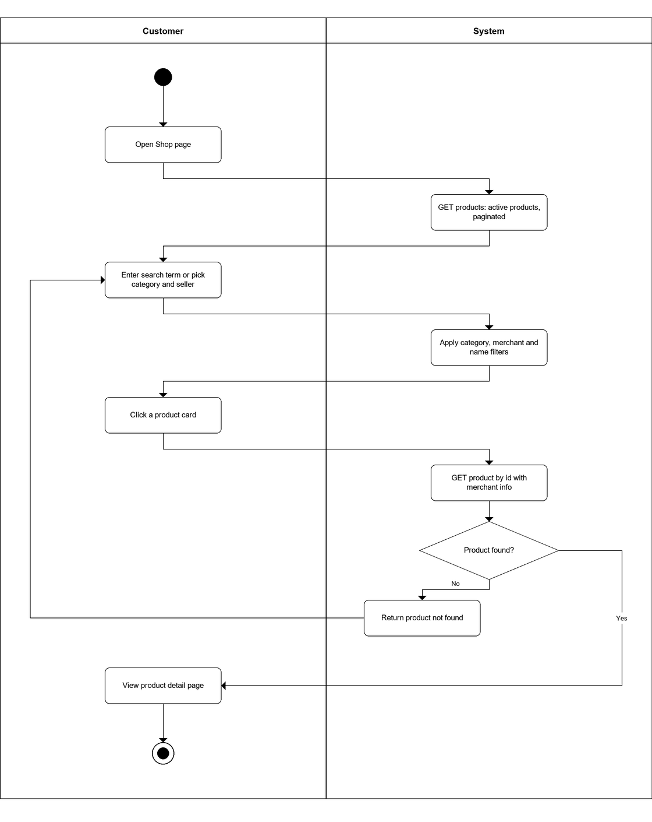

3. Checkout with All Payment Modes
Swimlanes: Customer | System and Blockchain
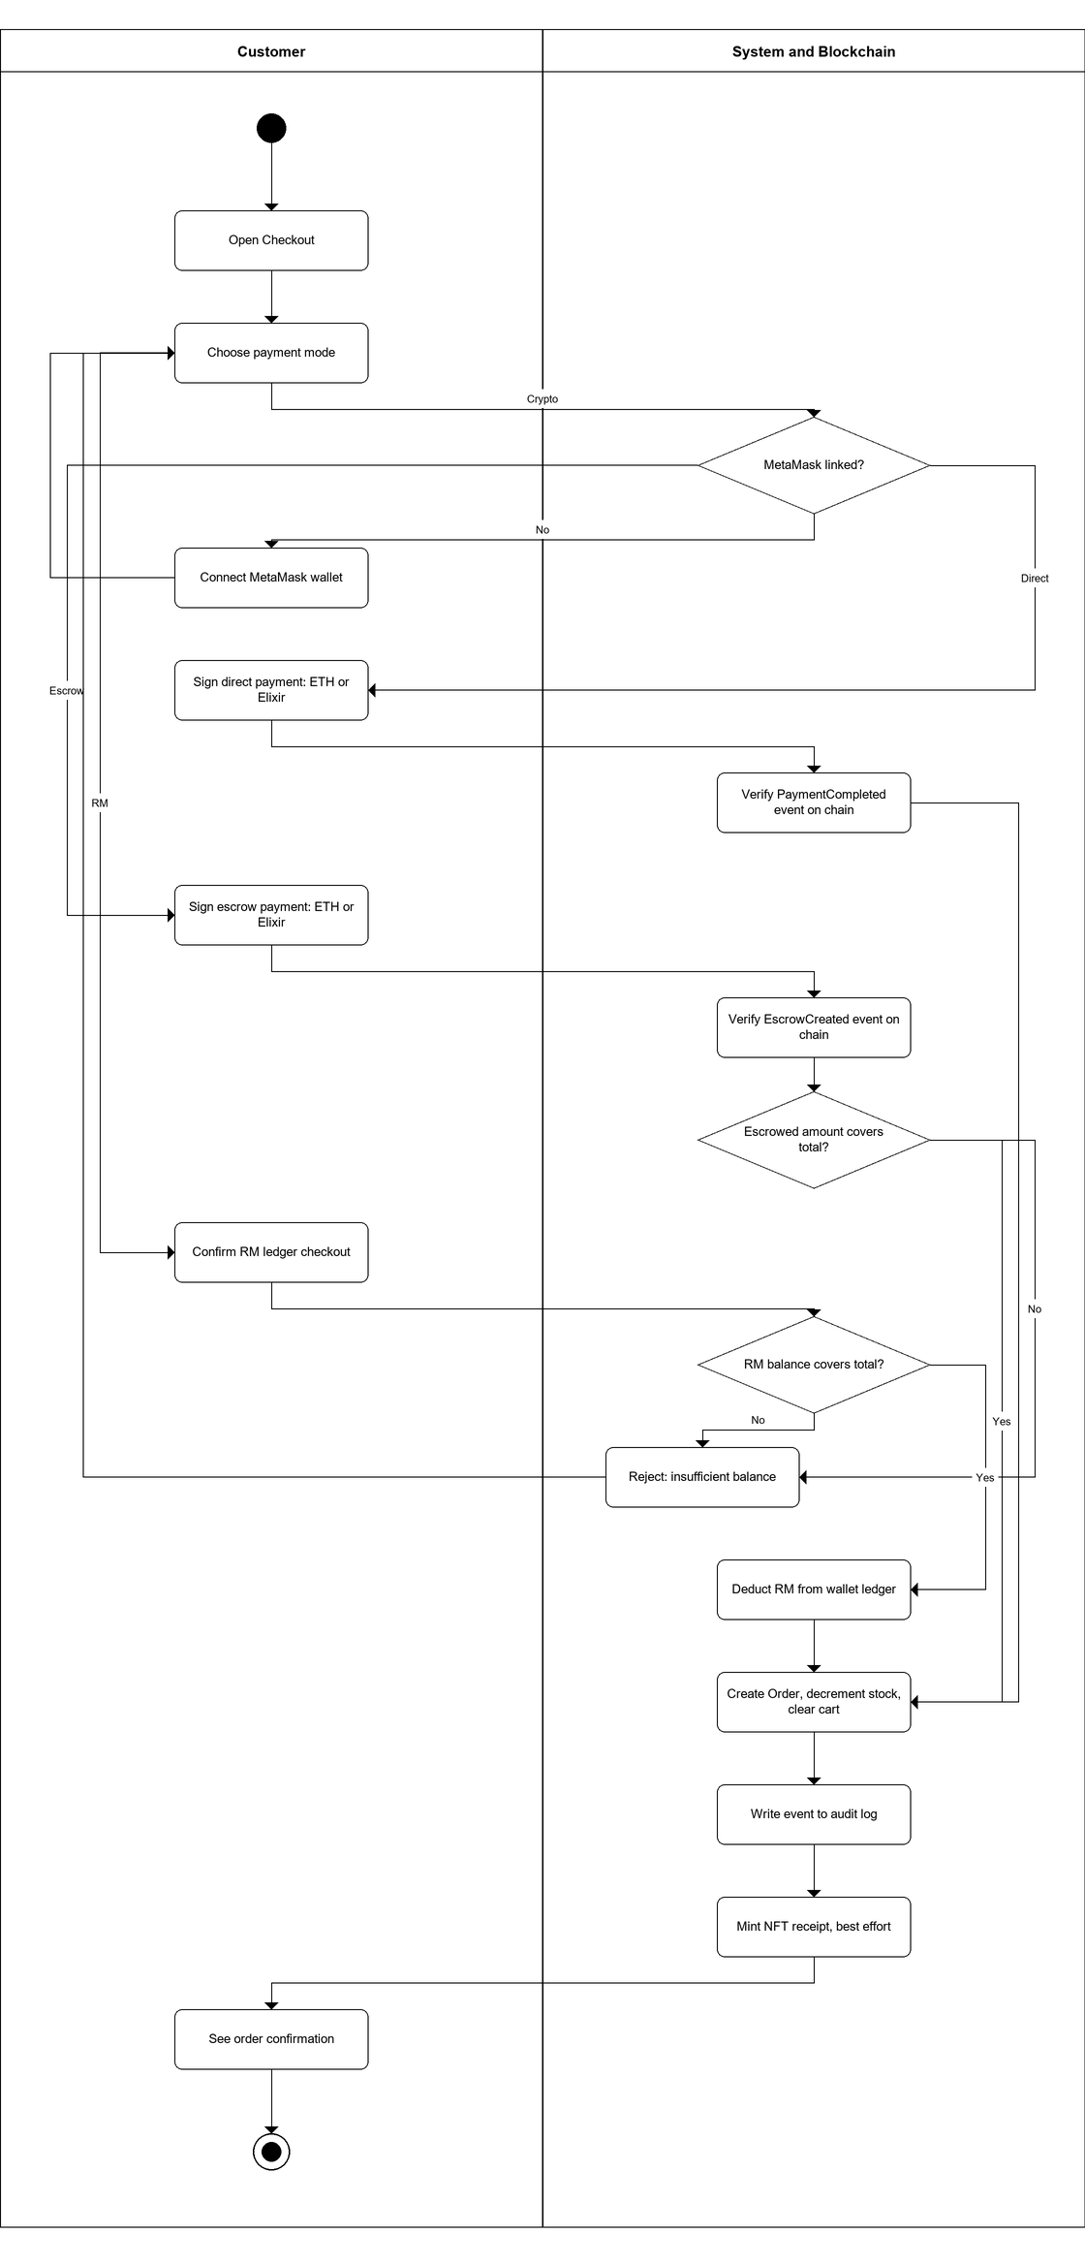

4. Raise Dispute
Swimlanes: Customer | System and Blockchain
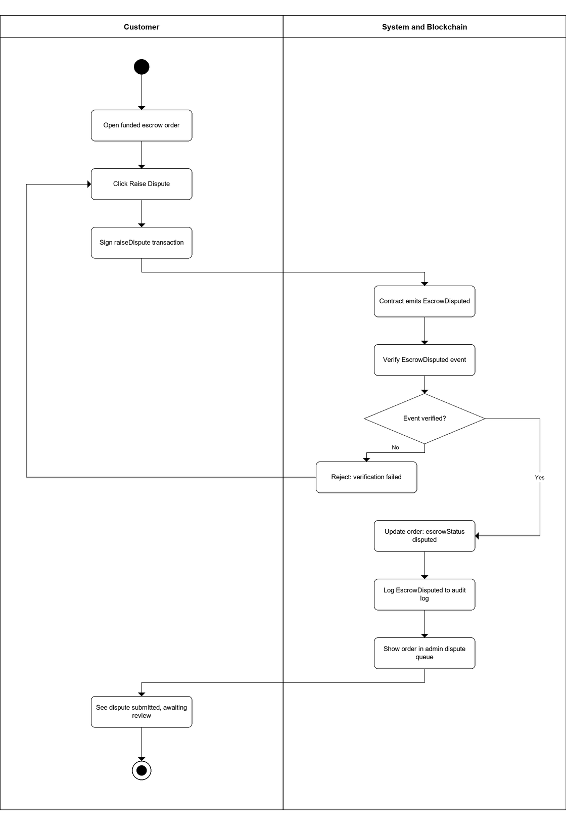

5. Confirm Delivery
Swimlanes: Customer | System and Blockchain
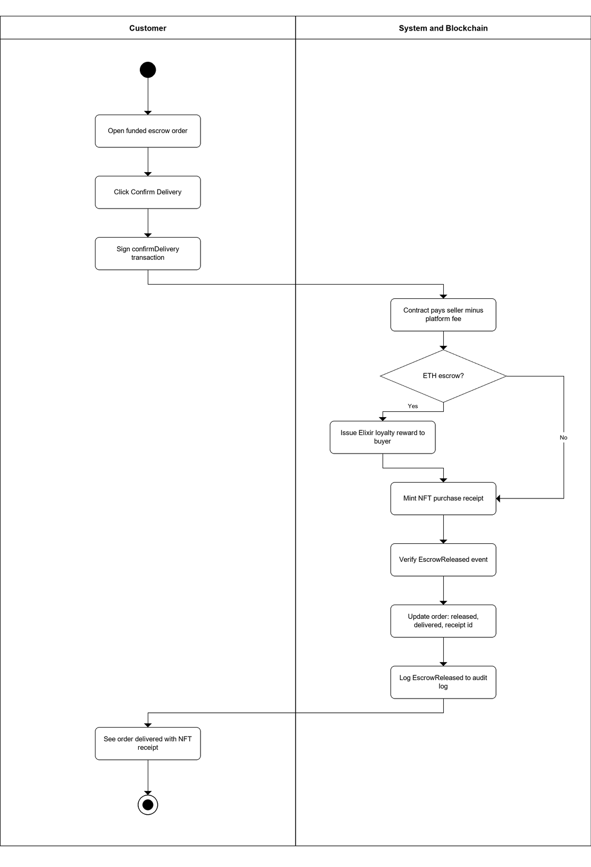

6. Resolve Escrow Dispute
Swimlanes: Admin | System and Blockchain
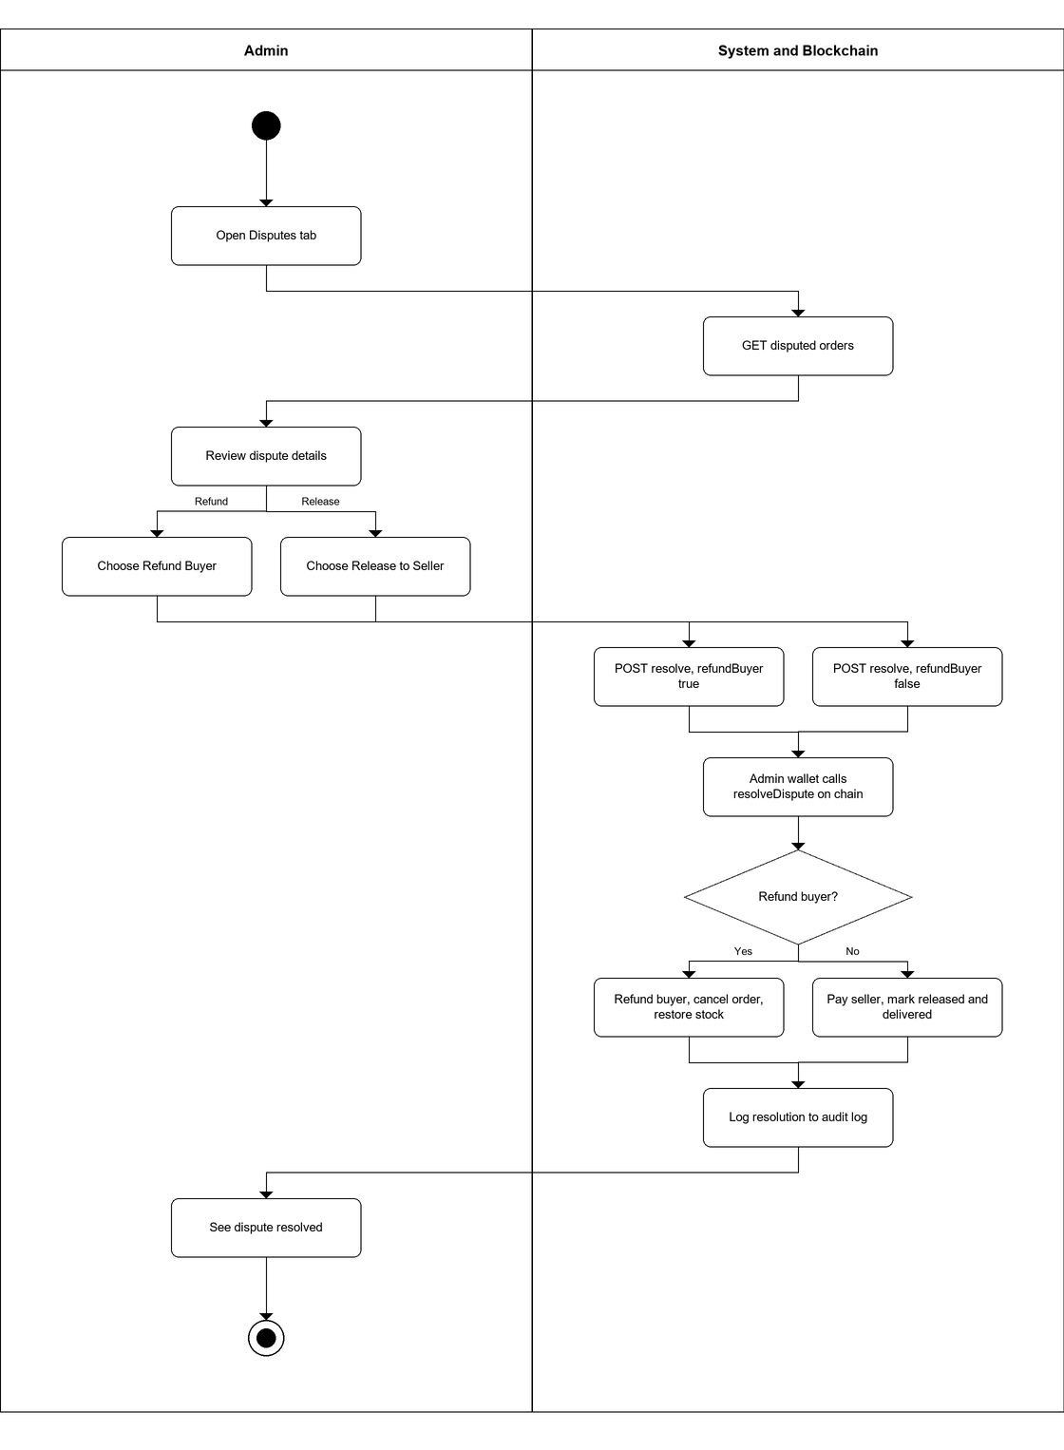

7. Unstake Elixir
Swimlanes: Customer | System and Blockchain
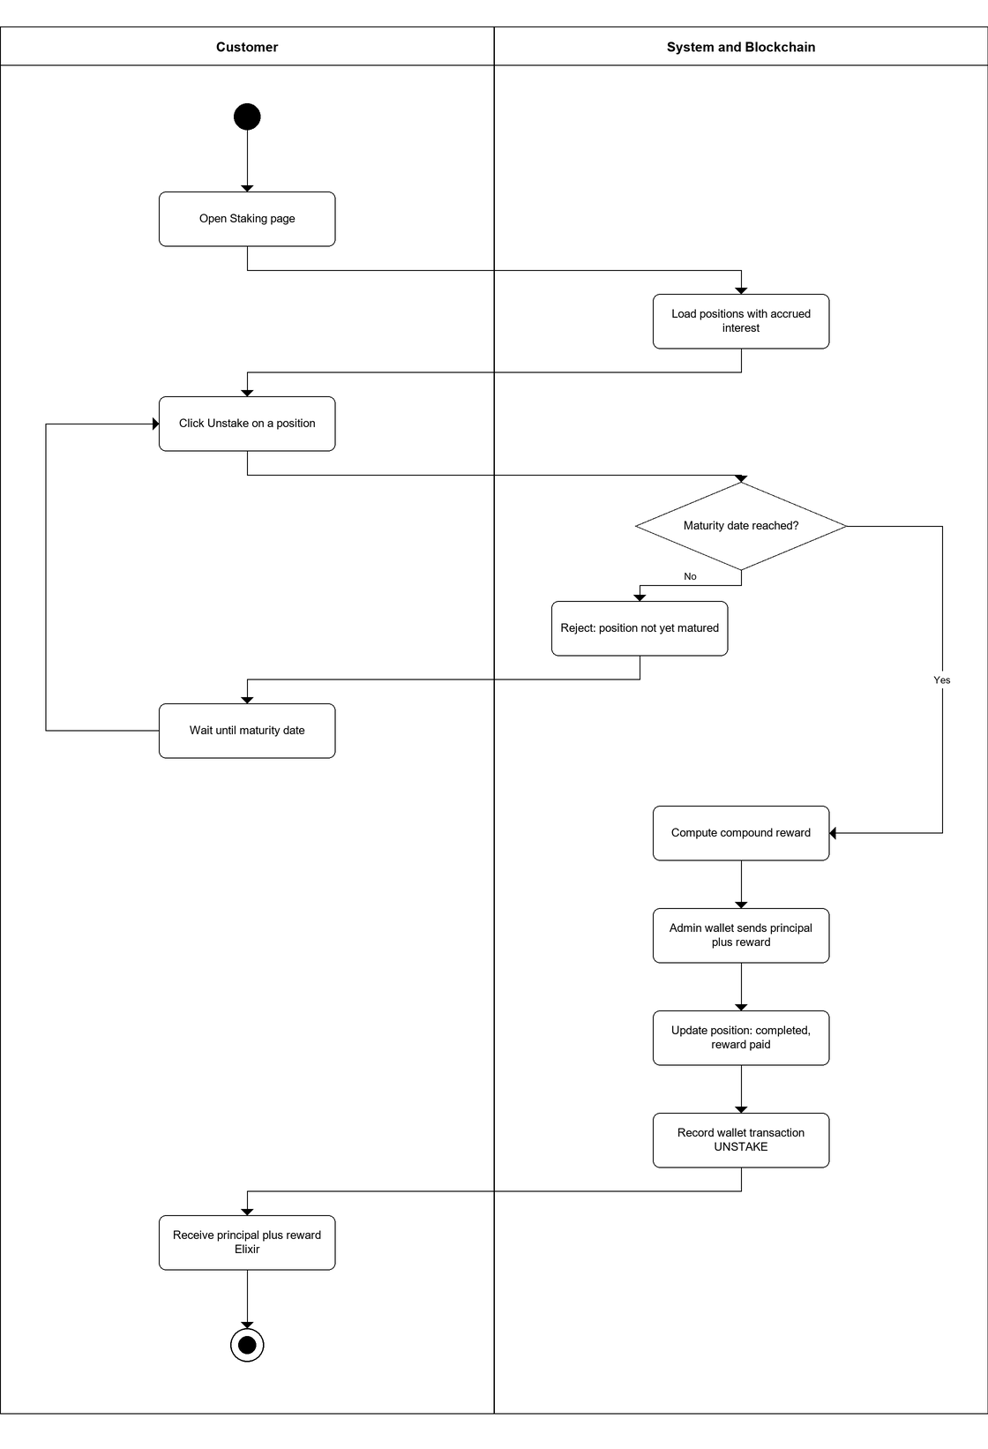

8. Stake Elixir
Swimlanes: Customer | System and Blockchain
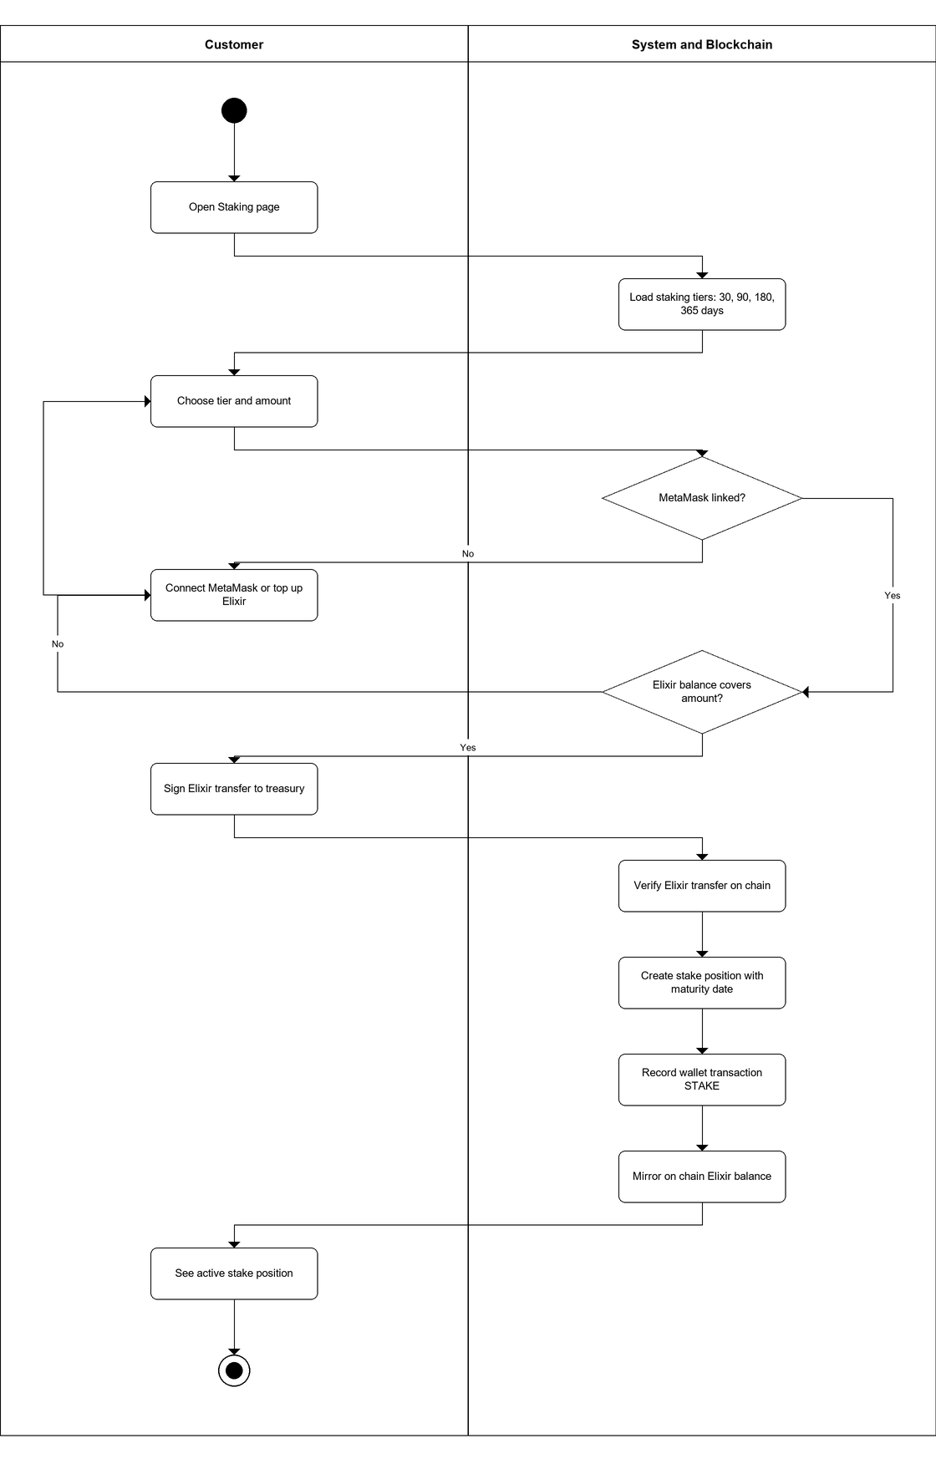

9. Manage Product Catalog
Swimlanes: Merchant | System
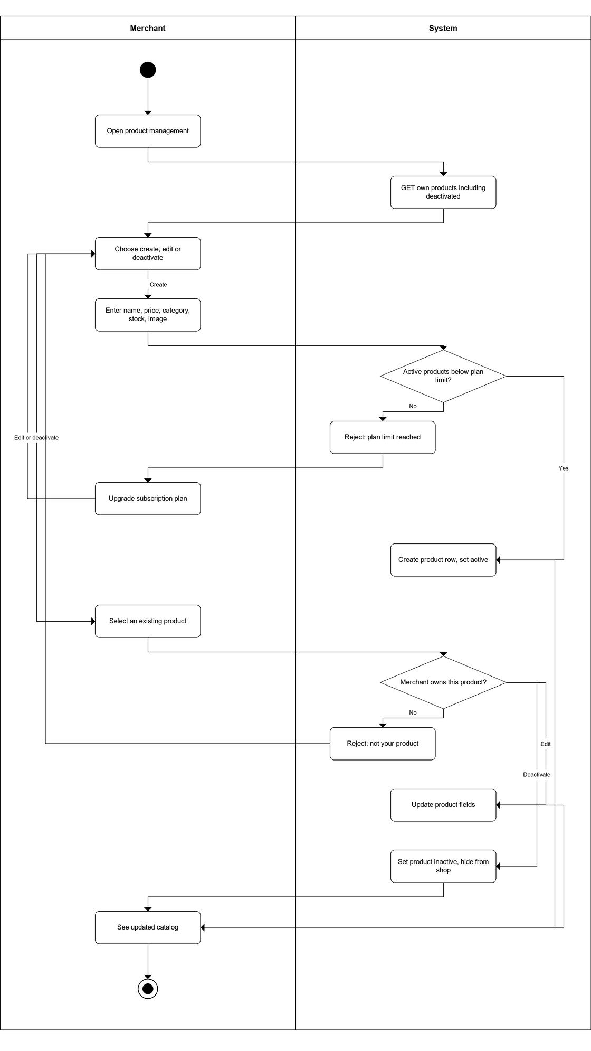

10. Update Fulfillment Stage
Swimlanes: Merchant | System
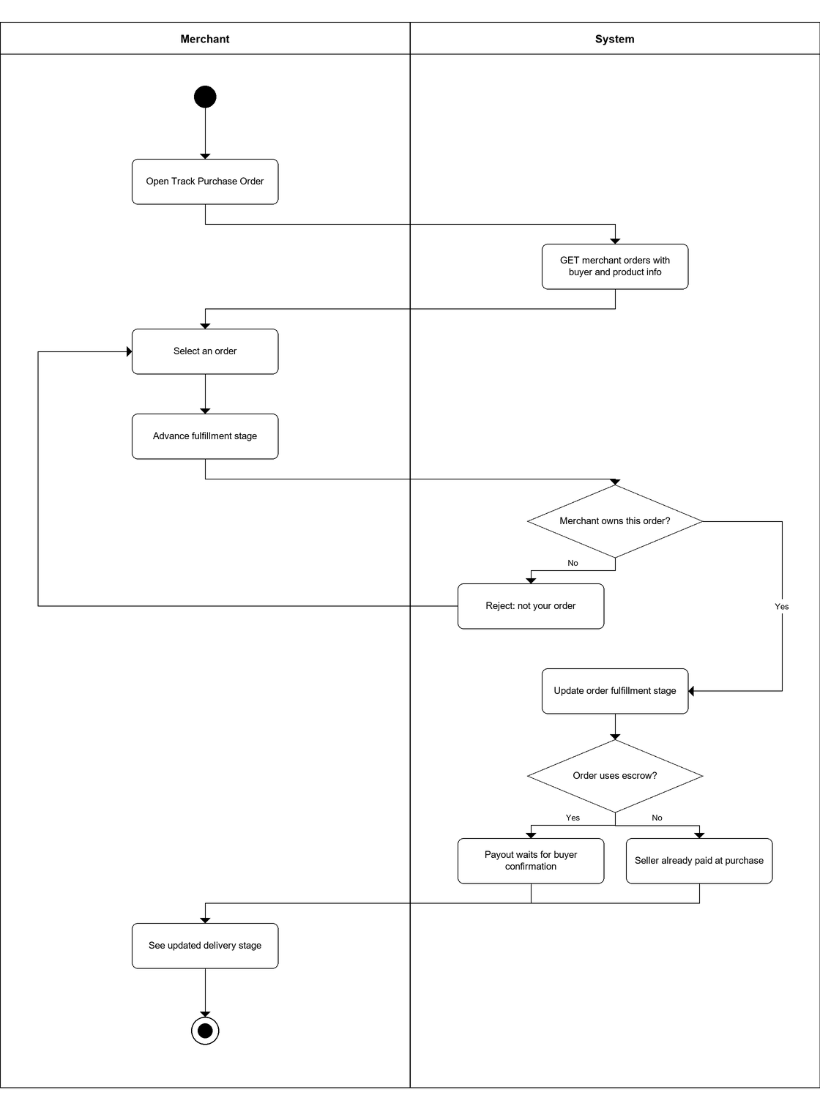

11. Manage Staking Tiers
Swimlanes: Admin | System
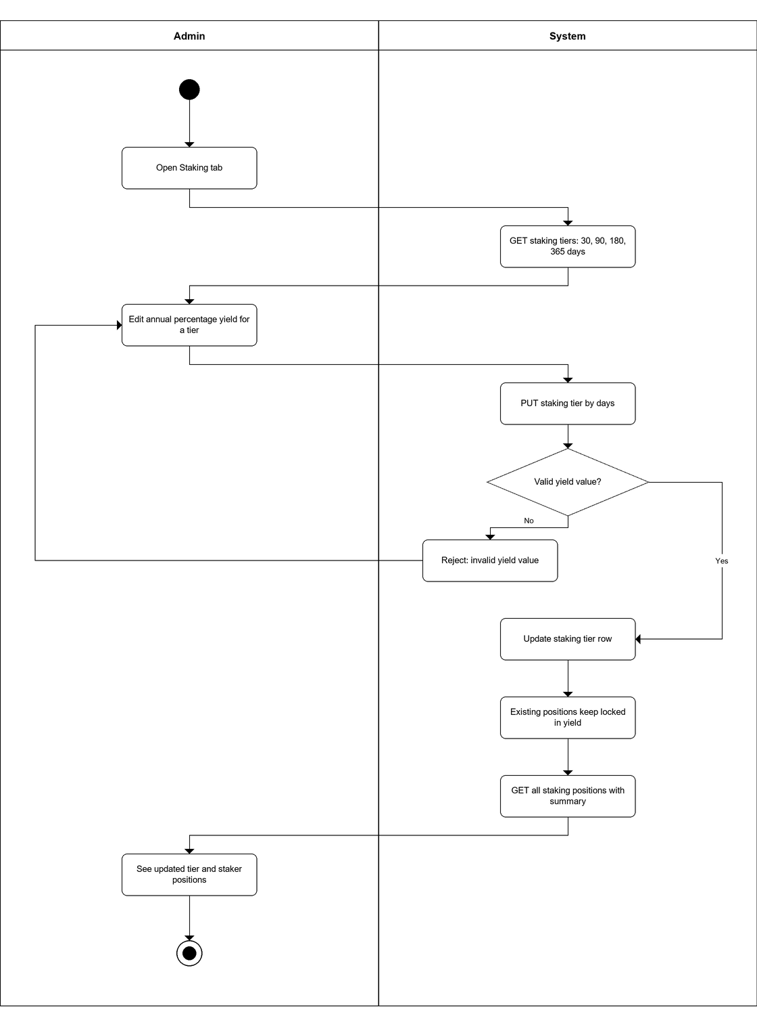

12. Manage Subscription and Pay Fee
Swimlanes: Merchant | System and Blockchain
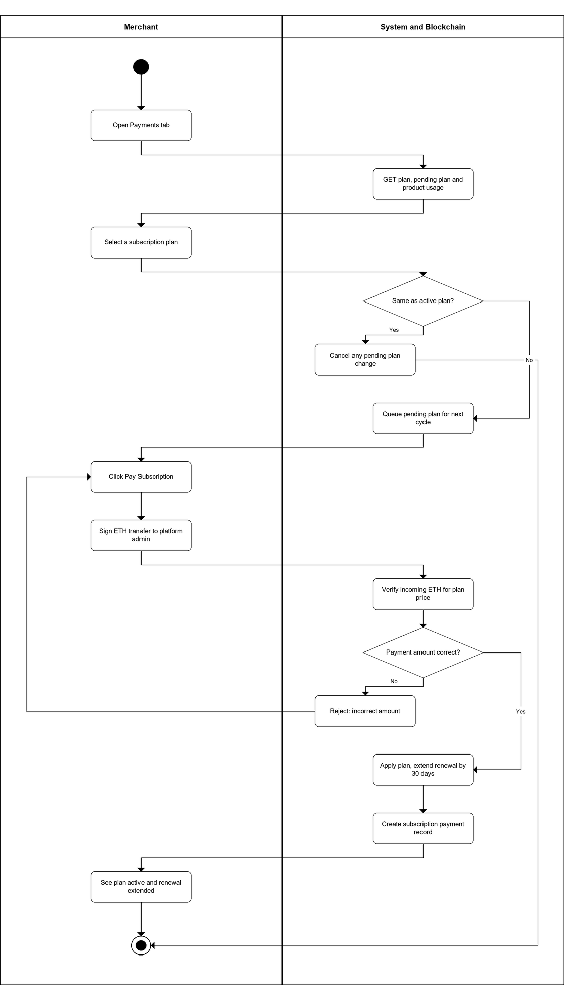

13. Transfer Currency P2P
Swimlanes: Customer | System and Blockchain
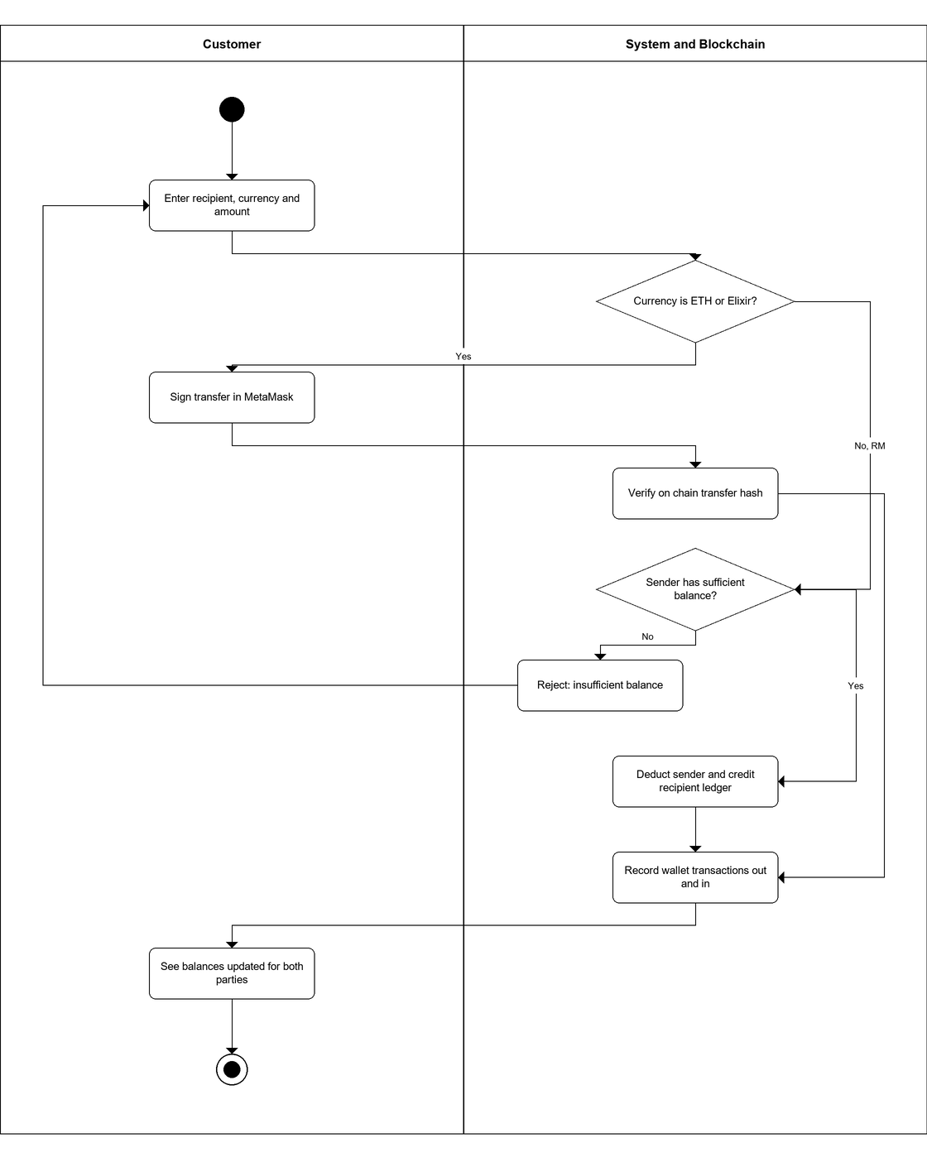

14. Update Profile
Swimlanes: Customer, Merchant or Admin | System
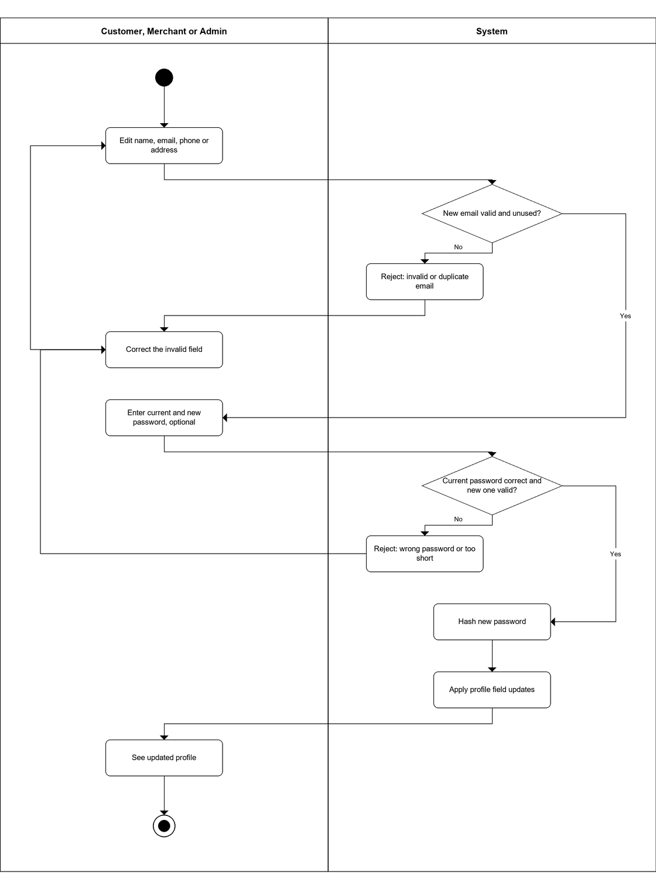

15. Deposit RM
Swimlanes: Customer | System
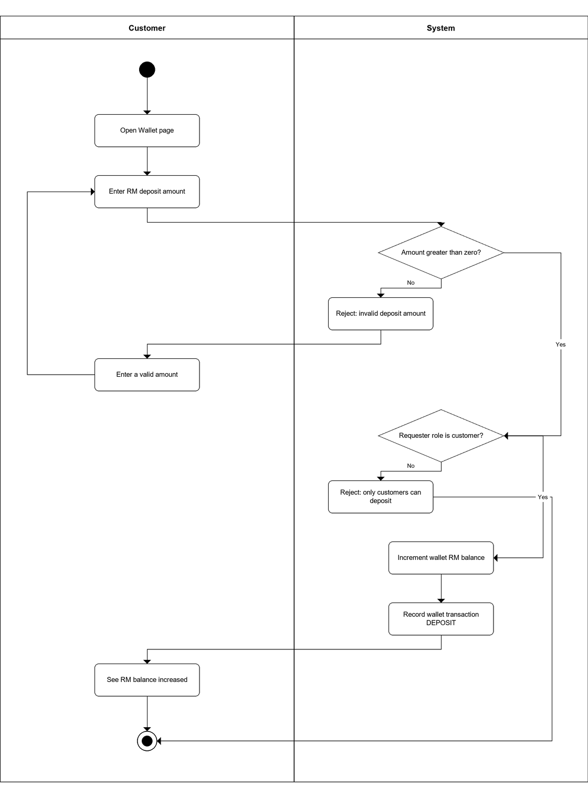

16. Swap Currency
Swimlanes: Customer | System and Blockchain
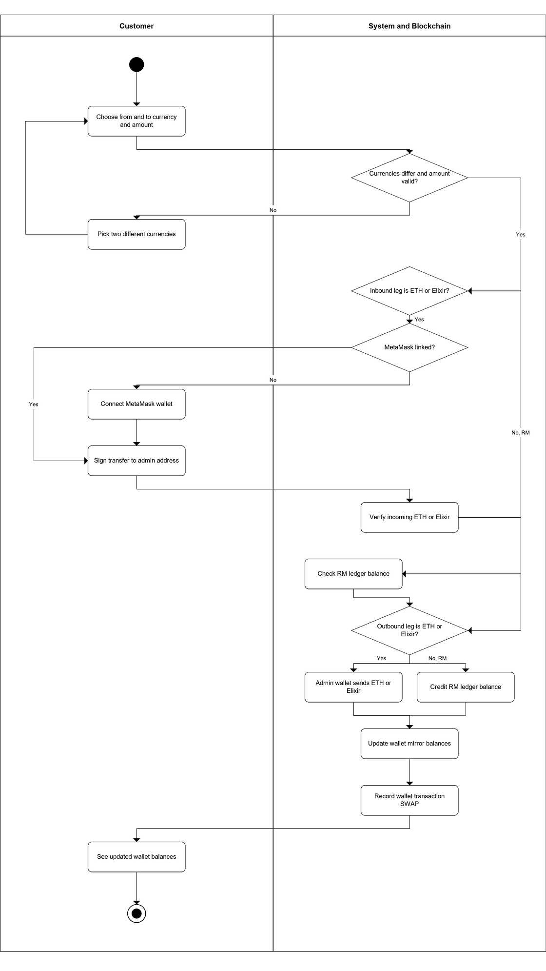

Database Schema Tables
Blockchain E-Commerce Platform — MySQL Tables and MongoDB Collection

Field-level layout of every table generated from the actual schema in backend/models/mysql.models.js (MySQL) and backend/models/blockchainLog.model.js (MongoDB). Each table lists the data type, field name, constraints, and description for every column.

Users Table
MySQL Table
The Users table is the foundation for the system that saves all user accounts, with a field called role that sets up the different types of users: customer, merchant, and admin. This allows for flexible user management while maintaining role-specific attributes, rather than creating one table for each user type. Role-specific attributes: customers hold a walletAddress and metamaskAddress used for on-chain payments; merchants additionally use the plan, pendingPlan, and planRenewsAt fields to manage their subscription tier; admins only rely on the base account fields and have no extra attributes, since their access is controlled entirely by the role value. Every wallet, order, product, cart, wallet transaction, stake position, and subscription payment record links back to this table through its id or userCode, making Users the central reference point for the rest of the schema.

Data Type | Field Name | Constraints | Description
uuid | id | Primary Key (PK) | Unique user identifier
string | userCode | Unique Key (UK) | U0001 style, auto-incremented user code
string | name | NOT NULL | User's full name
string | email | Unique Key (UK), NOT NULL | User's email address
string | phone | - | User's phone number
string | address | - | User's delivery / contact address
string | passwordHash | NOT NULL | Hashed password used for login
enum | role | NOT NULL | Account role: customer | merchant | admin
string | walletAddress | Unique Key (UK) | App-generated blockchain wallet address
string | metamaskAddress | Unique Key (UK), NULL | Linked MetaMask address, nullable, one per user
string | walletPrivateKey | - | Dev-only private key, never store real keys
boolean | isActive | NOT NULL | Whether the account is active
enum | plan | NULL | Merchant subscription plan: starter | pro | enterprise
enum | pendingPlan | NULL | Plan pending activation on next renewal
datetime | planRenewsAt | NULL | Next subscription renewal date
datetime | createdAt | NOT NULL | Record creation timestamp
datetime | updatedAt | NOT NULL | Record last update timestamp

Customer Wallet Table
MySQL Table
The Customer Wallet table holds the off-chain and mirrored on-chain balances for every customer, linked one-to-one to a Users record through the userCode reference field rather than the primary id. Only customer-role users receive a wallet row, created automatically at registration. RM is the authoritative fiat ledger balance managed entirely inside the database, while ETH and Elixir are refreshed mirrors of the customer's actual on-chain balances, meaning the blockchain remains the real source of truth for those two currencies. The walletAddress field ties the row back to the customer's blockchain wallet, and hideBalance is a UI preference flag rather than a financial attribute.

Data Type | Field Name | Constraints | Description
uuid | id | Primary Key (PK) | Unique wallet record identifier
string | userCode | Foreign Key (FK) | References Users.userCode
decimal | RM | NOT NULL | Off-chain fiat ledger balance (authoritative)
decimal | Elixir | NOT NULL | Mirrors on-chain LYT (Elixir) token balance
decimal | ETH | NOT NULL | Mirrors on-chain ETH balance
boolean | hideBalance | - | Whether the customer hides balances in the UI
string | walletAddress | Unique Key (UK) | Wallet address tied to this balance record
datetime | createdAt | NOT NULL | Record creation timestamp
datetime | updatedAt | NOT NULL | Record last update timestamp

Products Table
MySQL Table
The Products table stores every item listed for sale, each owned by a single merchant through the merchantId reference field. Rather than separating products by category into different tables, a single table covers all listings, with category stored as a plain attribute so merchants can group their own catalogue freely. priceEth and priceMyr are kept side by side so a product can be checked out in either currency without a live conversion lookup. isActive lets a merchant deactivate a listing (for example when out of stock or discontinued) without deleting the row, which preserves history for past orders and cart entries that still reference it.

Data Type | Field Name | Constraints | Description
uuid | id | Primary Key (PK) | Unique product identifier
uuid | merchantId | Foreign Key (FK) | References Users.id (merchant role)
string | name | NOT NULL | Product name
text | description | - | Product description
decimal | priceEth | NOT NULL | Price denominated in ETH
decimal | priceMyr | - | Price denominated in Malaysian Ringgit
string | category | - | Product category
int | stock | NOT NULL | Available stock quantity
string | imageUrl | - | URL of the product image
boolean | isActive | NOT NULL | Whether the product is active / listed
datetime | createdAt | NOT NULL | Record creation timestamp
datetime | updatedAt | NOT NULL | Record last update timestamp

Orders Table
MySQL Table
The Orders table is the central record of every purchase, referencing both the customerId and merchantId from Users so a single table can represent the transaction from either side. Rather than creating a separate table for every payment method, one paymentMode enum column (ETH_ONLY, TOKEN_ONLY, HYBRID, RM_ONLY, ETH_ESCROW, TOKEN_ESCROW) captures how the order was paid, and the escrow-specific fields (escrowId, escrowStatus) and receipt fields (receiptTokenId, receiptTxHash) are simply left null for orders that do not use those features. fulfillmentStage tracks the seller-controlled delivery progress (0-4), while onChainOrderId and txHash tie the row back to the EcommercePayment smart contract for on-chain verification.

Data Type | Field Name | Constraints | Description
uuid | id | Primary Key (PK) | Unique order identifier
bigint | onChainOrderId | - | Order id from the EcommercePayment smart contract
uuid | customerId | Foreign Key (FK) | References Users.id (as customer)
uuid | merchantId | Foreign Key (FK) | References Users.id (as merchant)
uuid | productId | Foreign Key (FK), NULL | Nullable, references Products.id
int | quantity | NOT NULL | Quantity ordered
decimal | totalPriceEth | NOT NULL | Total order price in ETH
enum | paymentMode | NOT NULL | ETH_ONLY | TOKEN_ONLY | HYBRID | RM_ONLY | ETH_ESCROW | TOKEN_ESCROW
decimal | ethPaid | - | Amount of ETH paid
bigint | tokensPaid | - | Amount of Elixir tokens paid
bigint | tokensEarned | - | Loyalty tokens earned from this order
string | txHash | - | On-chain transaction hash for the payment
enum | status | NOT NULL | pending | completed | cancelled
int | fulfillmentStage | NOT NULL | 0-4 fulfillment stage, seller-controlled
text | deliveryAddress | - | Delivery address for the order
bigint | escrowId | NULL | PurchaseEscrow contract id, if escrow was used
enum | escrowStatus | NULL | none | funded | released | refunded | disputed
boolean | deliveryConfirmed | - | Whether the customer confirmed delivery
datetime | deliveryConfirmedAt | NULL | Timestamp delivery was confirmed
bigint | receiptTokenId | NULL | PurchaseReceipt NFT token id
string | receiptTxHash | NULL | Transaction hash for the receipt mint
datetime | createdAt | NOT NULL | Record creation timestamp
datetime | updatedAt | NOT NULL | Record last update timestamp

Order Items Table
MySQL Table
The Order Items table breaks a single Orders row down into its individual line items, using orderId, productId, and merchantId reference fields to link each item back to its parent order, its product, and the merchant selling it. This design supports multi-product basket checkouts (used by the escrow and RM payment flows) without needing one Orders row per product. productName and unitPriceEth are stored as snapshots taken at purchase time, so historical order details stay accurate even if the merchant later renames or re-prices the product. Deleting an order cascades and removes its associated Order Items rows.

Data Type | Field Name | Constraints | Description
uuid | id | Primary Key (PK) | Unique order line item identifier
uuid | orderId | Foreign Key (FK) | References Orders.id, CASCADE delete
uuid | productId | Foreign Key (FK) | References Products.id
uuid | merchantId | Foreign Key (FK) | References Users.id (as merchant)
string | productName | NOT NULL | Product name snapshot at purchase time
int | quantity | NOT NULL | Quantity of this line item
decimal | unitPriceEth | NOT NULL | Unit price in ETH at purchase time
datetime | createdAt | NOT NULL | Record creation timestamp
datetime | updatedAt | NOT NULL | Record last update timestamp

Carts Table
MySQL Table
The Carts table holds each customer's pending selections before checkout, with customerId and productId reference fields linking a cart row to the customer who added it and the product being considered. Each row represents one product line with its own quantity, so a customer's full cart is simply every Carts row matching their customerId. Rows are removed once checkout completes and the corresponding Orders and Order Items records are created, keeping the cart table limited to active, not-yet-purchased selections.

Data Type | Field Name | Constraints | Description
uuid | id | Primary Key (PK) | Unique cart line item identifier
uuid | customerId | Foreign Key (FK) | References Users.id
uuid | productId | Foreign Key (FK) | References Products.id
int | quantity | NOT NULL | Quantity added to cart
datetime | createdAt | NOT NULL | Record creation timestamp
datetime | updatedAt | NOT NULL | Record last update timestamp

Wallet Transactions Table
MySQL Table
The Wallet Transactions table is a single, unified ledger for every kind of currency movement a user makes, rather than having a separate table for swaps, transfers, deposits, stakes, and unstakes. The type enum column (SWAP, TRANSFER_OUT, TRANSFER_IN, DEPOSIT, STAKE, UNSTAKE) distinguishes which activity a row represents, and fromCurrency/toCurrency plus fromAmount/toAmount are simply left null for whichever side does not apply to that type. userCode links each row back to the Users table, and counterparty records the other party's user code or address for peer-to-peer transfers, giving a complete audit trail of a user's financial activity in one place.

Data Type | Field Name | Constraints | Description
uuid | id | Primary Key (PK) | Unique wallet transaction identifier
string | userCode | Foreign Key (FK) | References Users.userCode
enum | type | NOT NULL | SWAP | TRANSFER_OUT | TRANSFER_IN | DEPOSIT | STAKE | UNSTAKE
enum | fromCurrency | NULL | ETH | ELIXIR | RM, nullable
enum | toCurrency | NULL | ETH | ELIXIR | RM, nullable
decimal | fromAmount | - | Amount debited from the source currency
decimal | toAmount | - | Amount credited to the destination currency
string | counterparty | NULL | Counterparty user code / address for transfers
string | txHash | NULL | On-chain transaction hash, if applicable
string | note | - | Optional free-text note
enum | status | NOT NULL | pending | completed | failed
datetime | createdAt | NOT NULL | Record creation timestamp
datetime | updatedAt | NOT NULL | Record last update timestamp

Stake Positions Table
MySQL Table
The Stake Positions table records every Elixir stake a customer opens, linked back to Users through the userCode reference field. Rather than a foreign key, tierDays is a plain integer that logically matches a days value in the Staking Tiers table, letting the tier's rate settings change over time without retroactively affecting stakes that already locked in their own apy and compoundFrequency at creation time. stakedAt and maturityAt define the lock-up window, and status (active | completed) together with rewardPaid tracks whether the position is still earning or has already been unstaked and paid out.

Data Type | Field Name | Constraints | Description
uuid | id | Primary Key (PK) | Unique stake position identifier
string | userCode | Foreign Key (FK) | References Users.userCode
decimal | amount | NOT NULL | Principal Elixir amount staked
int | tierDays | NOT NULL | Lock-up period selected, matches Staking Tiers.days
decimal | apy | NOT NULL | Annual percentage yield at time of staking
int | compoundFrequency | NOT NULL | Compounds per year, default 12
datetime | stakedAt | NOT NULL | Timestamp the stake was created
datetime | maturityAt | NOT NULL | Timestamp the stake matures / unlocks
decimal | rewardPaid | - | Reward amount paid out on unstake
enum | status | NOT NULL | active | completed
datetime | createdAt | NOT NULL | Record creation timestamp
datetime | updatedAt | NOT NULL | Record last update timestamp

Staking Tiers Table
MySQL Table
The Staking Tiers table holds the admin-configurable lock-up options that customers choose from when opening a stake, such as 30-day, 90-day, or 365-day tiers. It has no foreign key relationship to any other table; instead, it is referenced logically by Stake Positions through the matching days/tierDays values. This separation lets an admin update a tier's apy or label at any time without altering historical stakes, since each Stake Positions row already copied the tier's apy at the moment the stake was created. sortOrder simply controls the display order of tiers in the staking UI.

Data Type | Field Name | Constraints | Description
uuid | id | Primary Key (PK) | Unique staking tier identifier
int | days | Unique Key (UK) | Lock-up period in days
decimal | apy | NOT NULL | Admin-editable annual percentage yield
string | label | - | Display label for the tier
int | sortOrder | - | Display order in the staking UI
datetime | createdAt | NOT NULL | Record creation timestamp
datetime | updatedAt | NOT NULL | Record last update timestamp

Subscription Payments Table
MySQL Table
The Subscription Payments table records each fee a merchant (seller) pays to keep their plan active, linked back to Users through the sellerId reference field, with sellerCode kept as a denormalized copy for quick lookups. plan mirrors the plan enum on the Users table (starter | pro | enterprise) at the time of payment, so upgrading or downgrading later does not rewrite past payment history. periodStart and periodEnd define the billing cycle covered by that payment, and status (completed | failed) lets the platform decide whether to keep the merchant's plan active or revert it to pendingPlan on the Users table.

Data Type | Field Name | Constraints | Description
uuid | id | Primary Key (PK) | Unique subscription payment identifier
uuid | sellerId | Foreign Key (FK) | References Users.id (as seller)
string | sellerCode | - | Denormalized seller user code
enum | plan | NOT NULL | starter | pro | enterprise
decimal | amountEth | NOT NULL | Subscription fee paid, in ETH
string | txHash | - | On-chain transaction hash for the payment
datetime | periodStart | NOT NULL | Subscription period start date
datetime | periodEnd | NOT NULL | Subscription period end date
enum | status | NOT NULL | completed | failed
datetime | createdAt | NOT NULL | Record creation timestamp
datetime | updatedAt | NOT NULL | Record last update timestamp

Blockchain Logs Collection
MongoDB Collection
The Blockchain Logs collection is a MongoDB audit trail that records every significant on-chain event, such as completed payments, issued or redeemed tokens, escrow lifecycle changes, and receipt minting. Unlike the MySQL tables, it has no enforced foreign keys; instead, orderId, buyerAddress, and sellerAddress are plain string fields that happen to match values from the Orders and Users tables, forming an application-level reference rather than a database-level one. One flexible eventType field distinguishes the nine possible event kinds, and unused fields for a given eventType (for example issueReason on a payment event) are simply left empty, which is the main advantage MongoDB's schema-less documents give over a rigid relational table for this kind of event data.

Data Type | Field Name | Constraints | Description
objectid | _id | Primary Key (PK) | MongoDB document id
string | eventType | NOT NULL | PaymentCompleted | TokensIssued | TokensRedeemed | OrderCreated | EscrowCreated | EscrowReleased | EscrowDisputed | EscrowRefunded | ReceiptMinted
string | orderId | - | App-level reference to Orders.id (no enforced FK)
string | buyerAddress | - | App-level reference to Users.metamaskAddress
string | sellerAddress | - | App-level reference to Users.metamaskAddress
string | txHash | Unique Key (UK), sparse | On-chain transaction hash for the event
int | blockNumber | - | Block number the event was recorded in
string | sellerReceivesWei | - | Amount the seller receives, in wei
string | platformFeeWei | - | Platform fee taken, in wei
string | tokensEarned | - | Loyalty tokens earned from the event
string | paymentMode | - | Payment mode used for the related order
string | customerAddress | - | Customer wallet address for token events
string | tokensIssuedWei | - | Tokens issued, in wei
string | issueReason | - | Reason tokens were issued
string | tokensRedeemedWei | - | Tokens redeemed, in wei
string | productRef | - | Reference to the related product
string | notes | - | Free-text notes about the event
datetime | createdAt | NOT NULL | Record creation timestamp
datetime | updatedAt | NOT NULL | Record last update timestamp

User Interface Wireframes
Blockchain E-Commerce Platform — Customer, Seller and Admin Screens

Low-fidelity wireframes for every screen in the system, laid out from the actual React implementation so navigation labels, form fields, table columns, button text, staking tiers, payment modes and plan limits match the running application. Conditional states that change what the user can do — such as MetaMask connected versus disconnected, or the escrow lifecycle — are wireframed separately. Dashed callouts explain behaviour that is not visible from the static layout alone.

Contents
Authentication
- 1. Login
- 2. Register
Customer
- 3. Shop — Wallet Disconnected
- 4. Shop — Wallet Connected (Live ETH)
- 5. Shop — Single Seller Store View
- 6. Cart — Empty State
- 7. Cart — Items Grouped by Seller
- 8. Checkout — Crypto Locked (No Wallet)
- 9. Checkout — ETH Escrow Selected
- 10. Checkout — Payment Successful
- 11. Wallet — Balances, Swap & Transfers
- 12. Staking — Tiers, Calculator & Positions
- 13. Staking — Matured Position (Unstake)
- 14. Track Order — On-going / Completed
- 15. Track Order — Expanded Order + Escrow
- 16. Track Order — Escrow Outcome States
- 17. History — Unified Activity Feed
- 18. Profile — View Mode
- 19. Profile — Edit Mode & Password Change
Seller (Merchant)
- 20. Seller — Create / Manage Products
- 21. Seller — Update Fulfillment Stage
- 22. Seller — Revenue & Product Performance
- 23. Seller — Subscription & Plan Payment
Administrator
- 24. Admin — User Management
- 25. Admin — Staking Tiers & All Stakers
- 26. Admin — Subscription Revenue
- 27. Admin — Resolve Escrow Disputes

Authentication

1. Login
Route /login — shared entry point for all three roles.
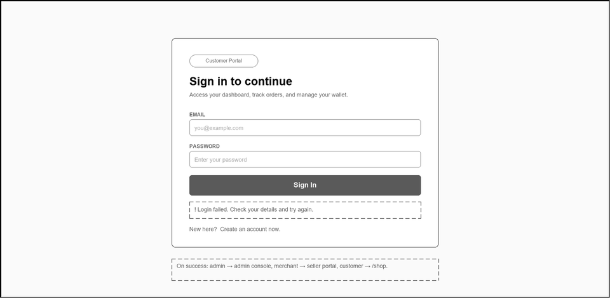

2. Register
Route /register — role is chosen at sign-up.
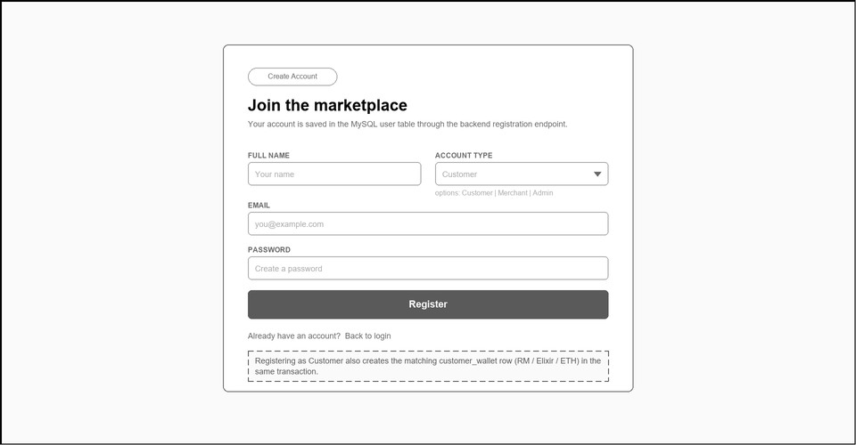

Customer

3. Shop — Wallet Disconnected
Route /shop — category pills, product grid, Connect MetaMask call to action.
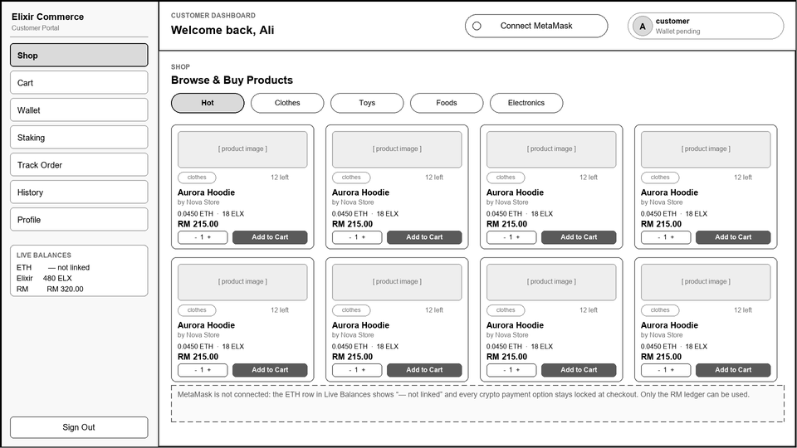

4. Shop — Wallet Connected (Live ETH)
Connected state: address chip, live ETH balance, crypto payments enabled.
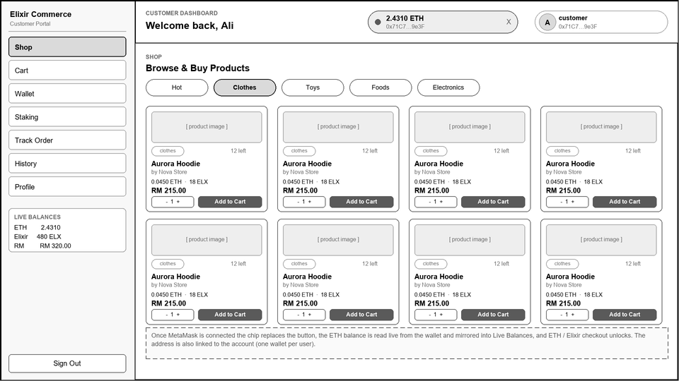

5. Shop — Single Seller Store View
Seller-filtered product grid.
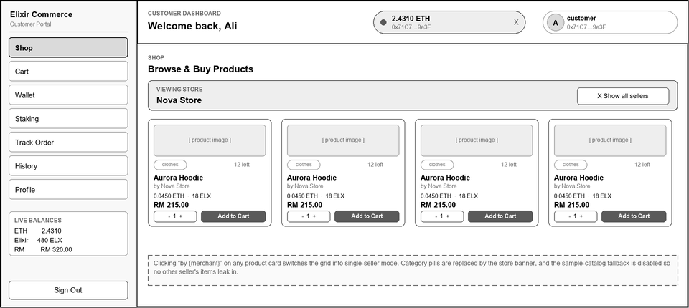

6. Cart — Empty State
Route /cart with no cart rows for the customer.
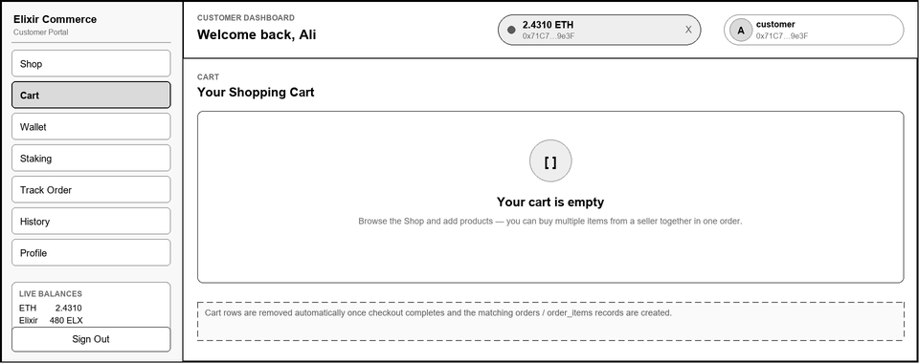

7. Cart — Items Grouped by Seller
Quantity steppers, per-store subtotal, per-store checkout.
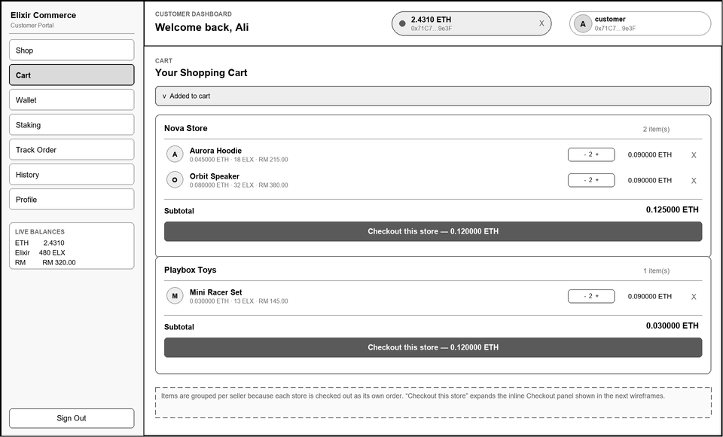

8. Checkout — Crypto Locked (No Wallet)
ETH / Elixir escrow disabled until MetaMask connects.
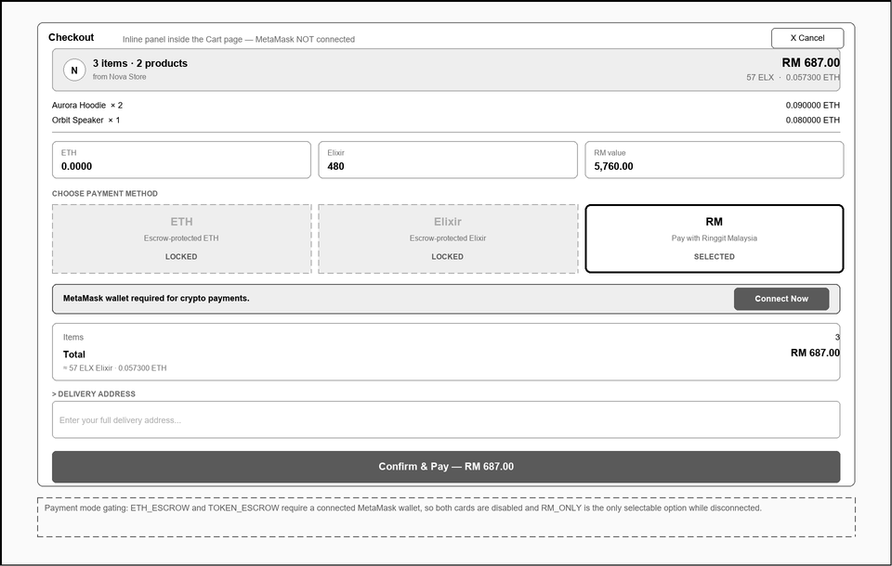

9. Checkout — ETH Escrow Selected
Wallet connected: escrow summary and loyalty reward preview.
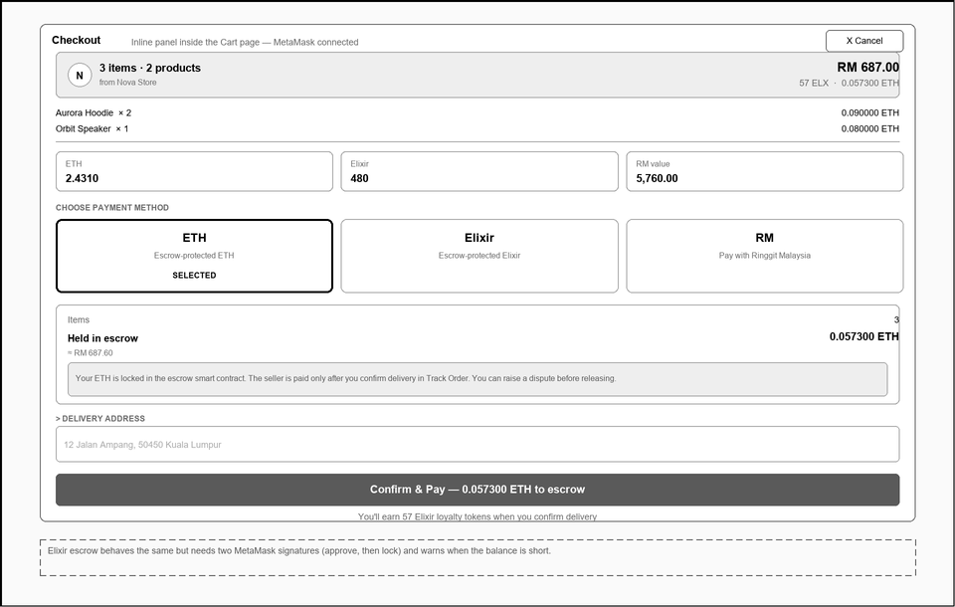

10. Checkout — Payment Successful
Confirmation state with on-chain transaction hash.
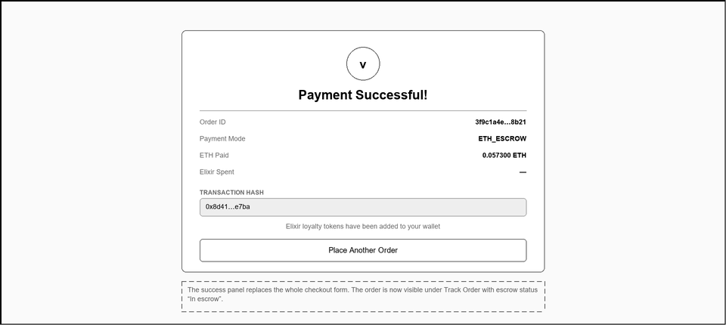

11. Wallet — Balances, Swap & Transfers
Route /wallet — three-currency balances, swap widget, RM deposit and peer transfer.
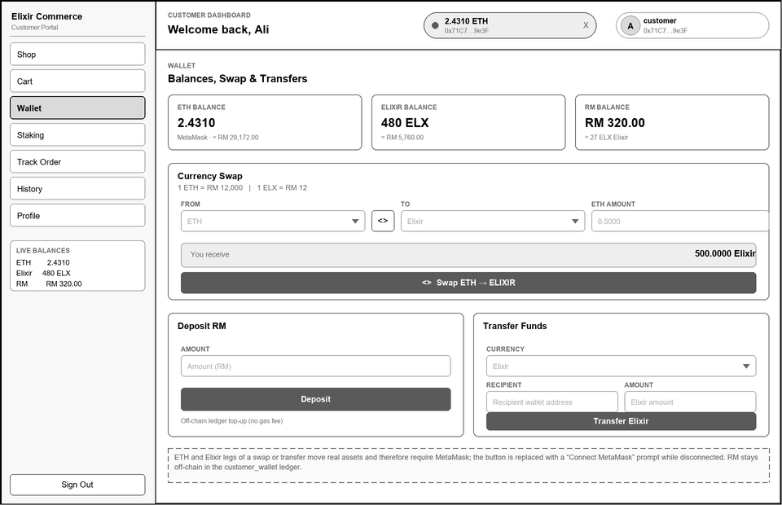

12. Staking — Tiers, Calculator & Positions
Route /staking — the new sidebar section: staking performance, APY tiers and compound-interest projection.
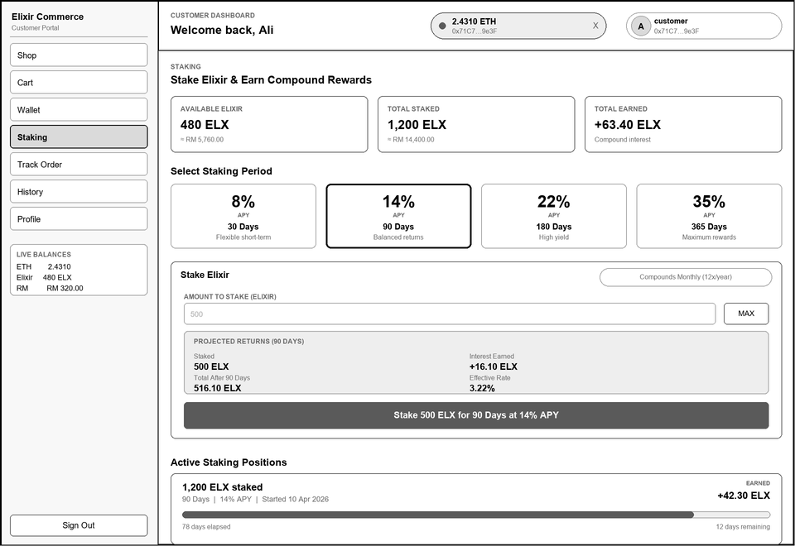

13. Staking — Matured Position (Unstake)
Mature position with claim action and the compound interest formula.
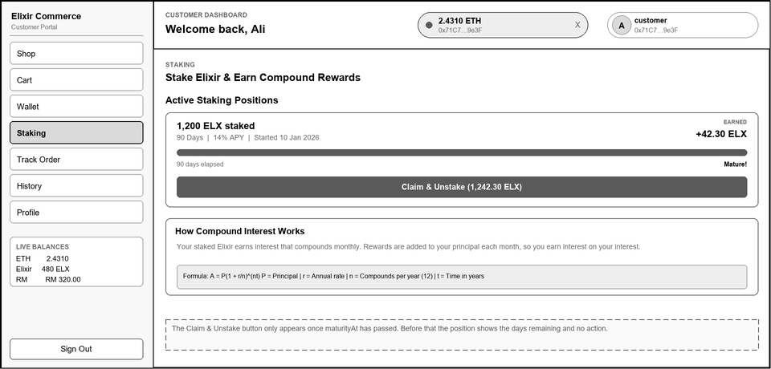

14. Track Order — On-going / Completed
Route /track-order — collapsed order list with stage badges.
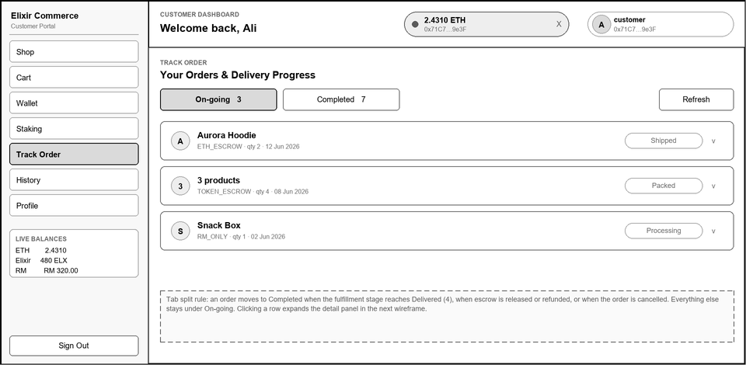

15. Track Order — Expanded Order + Escrow
Delivery timeline, order summary, escrow actions and on-chain audit log.
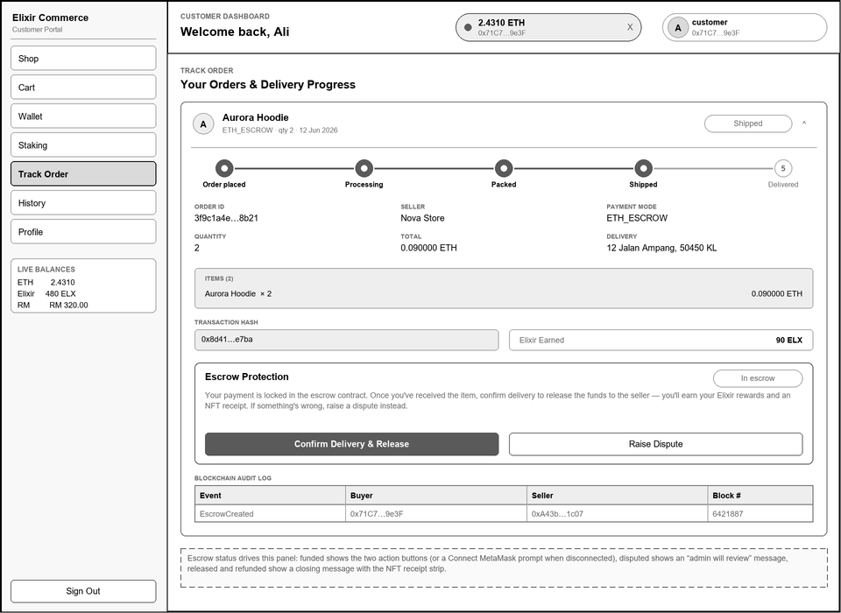

16. Track Order — Escrow Outcome States
Disputed, released and refunded escrow panels plus the minted NFT receipt strip.
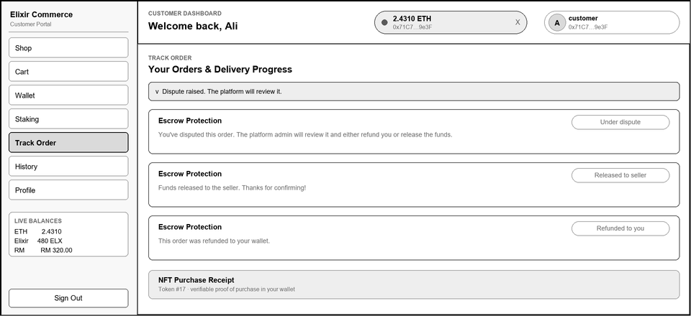

17. History — Unified Activity Feed
Route /history — filter pills over a merged order and wallet-transaction feed.
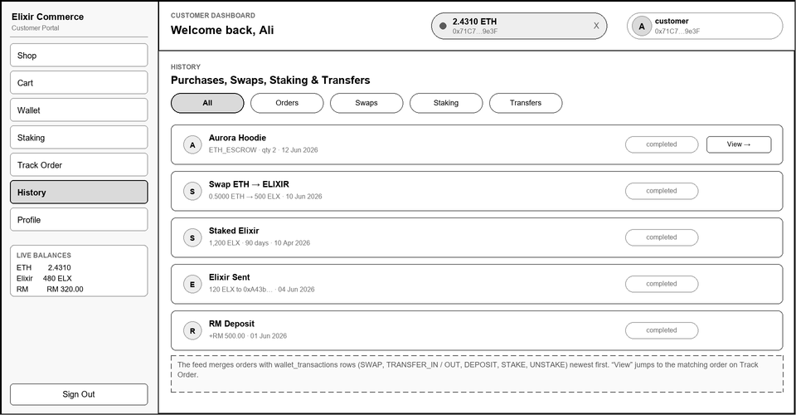

18. Profile — View Mode
Route /profile — account details beside wallet identity.
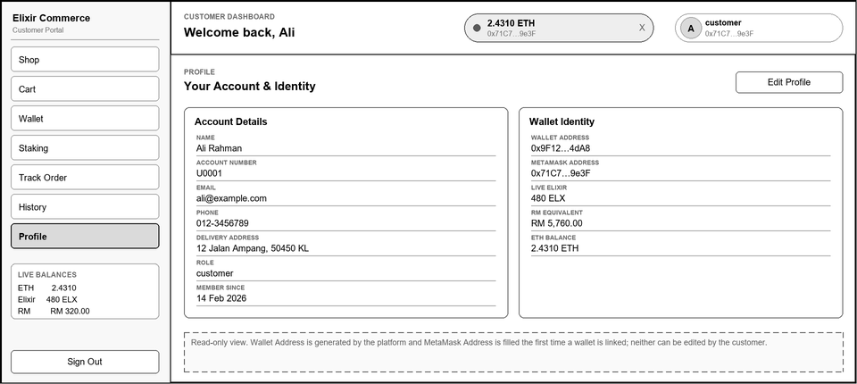

19. Profile — Edit Mode & Password Change
Editable account fields with an optional password change block.
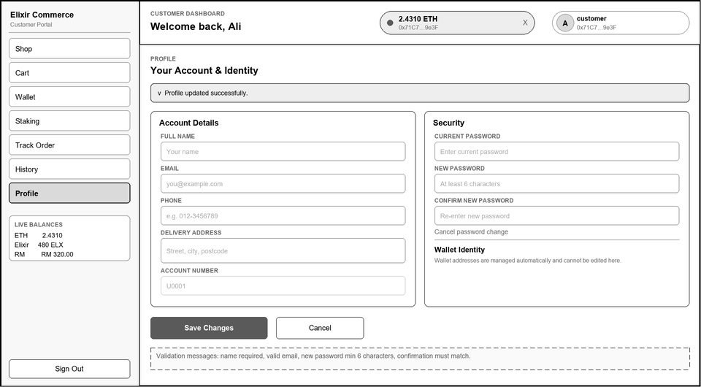

Seller (Merchant)

20. Seller — Create / Manage Products
Product form plus the seller's catalogue with Live / Hidden status.
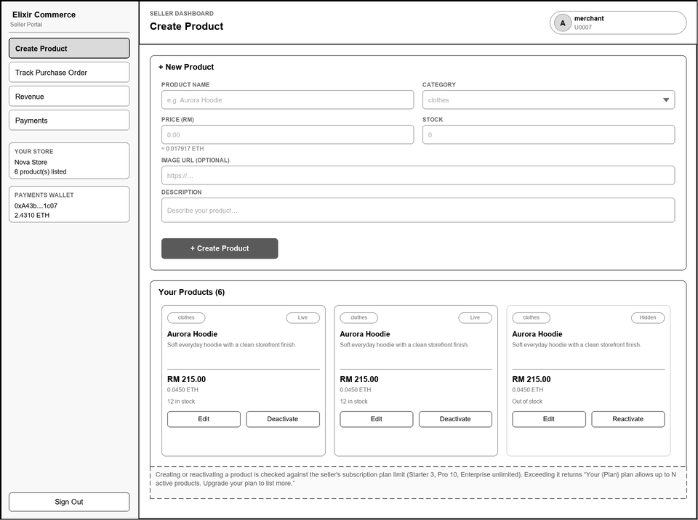

21. Seller — Update Fulfillment Stage
Per-order delivery timeline with Advance and direct stage selection.
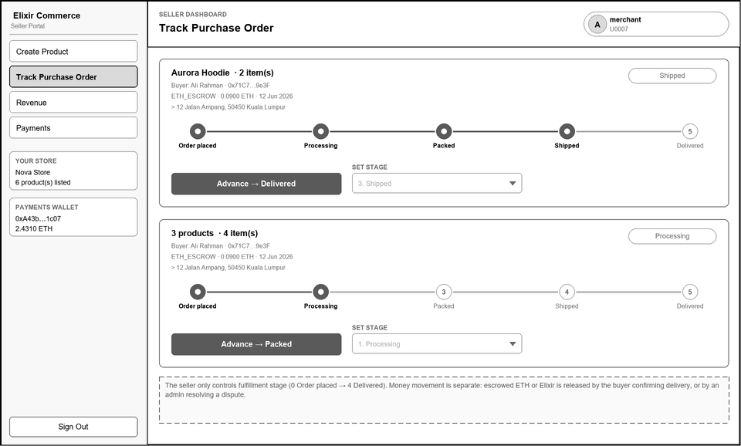

22. Seller — Revenue & Product Performance
Revenue tiles, per-product performance table and the delivery pipeline counters.
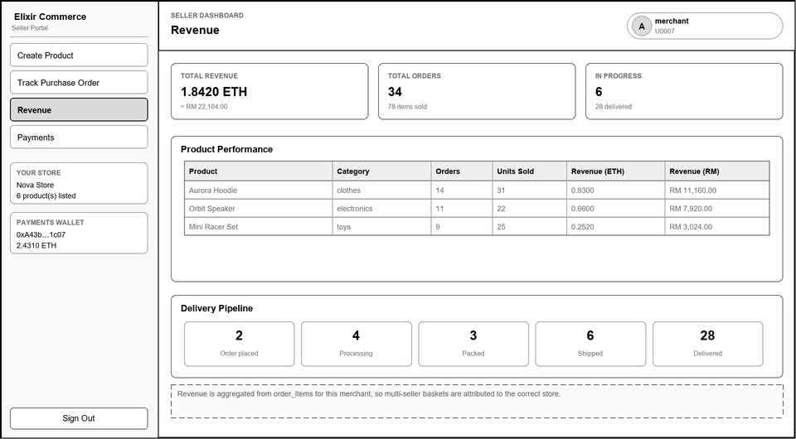

23. Seller — Subscription & Plan Payment
Current plan usage, plan switching and the monthly ETH renewal charge.
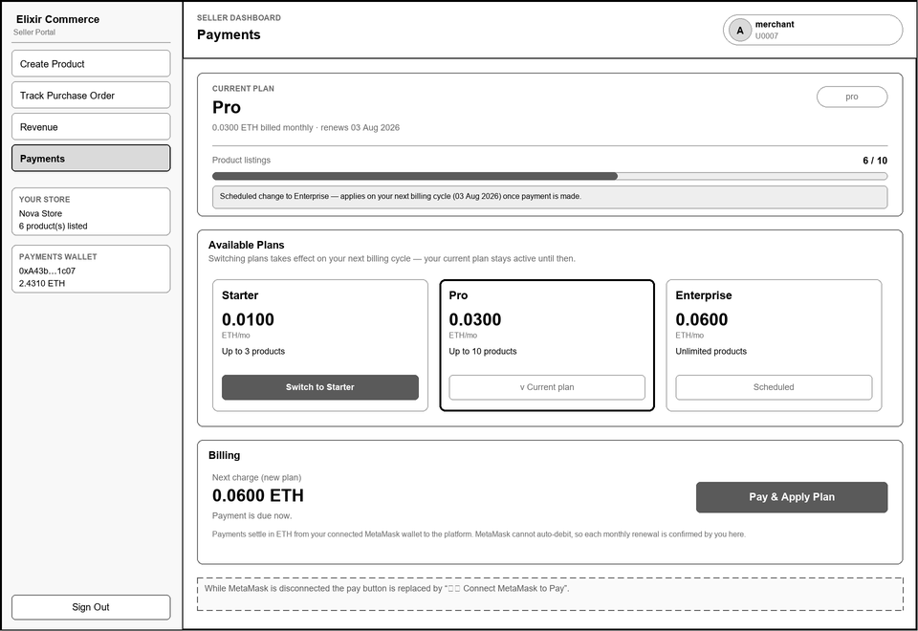

Administrator

24. Admin — User Management
Treasury tiles plus the searchable registry of every account.
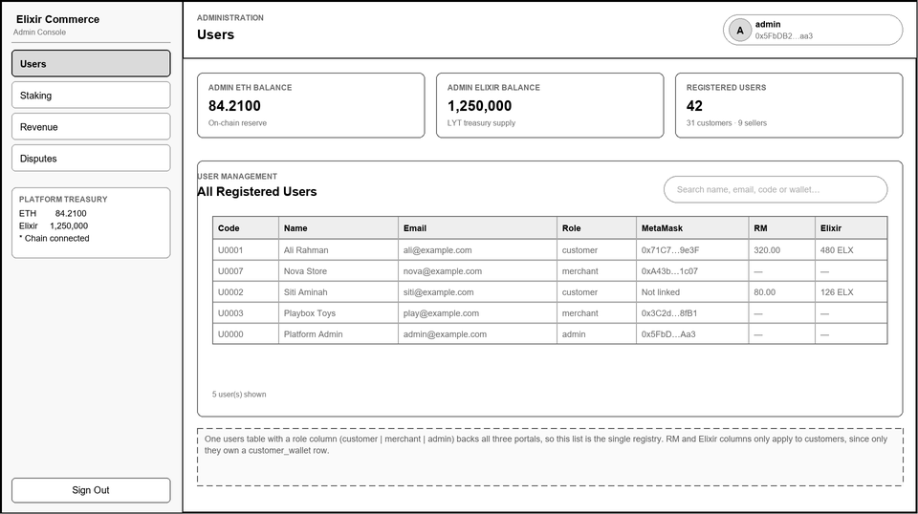

25. Admin — Staking Tiers & All Stakers
Editable APY per tier and the full staking position table.
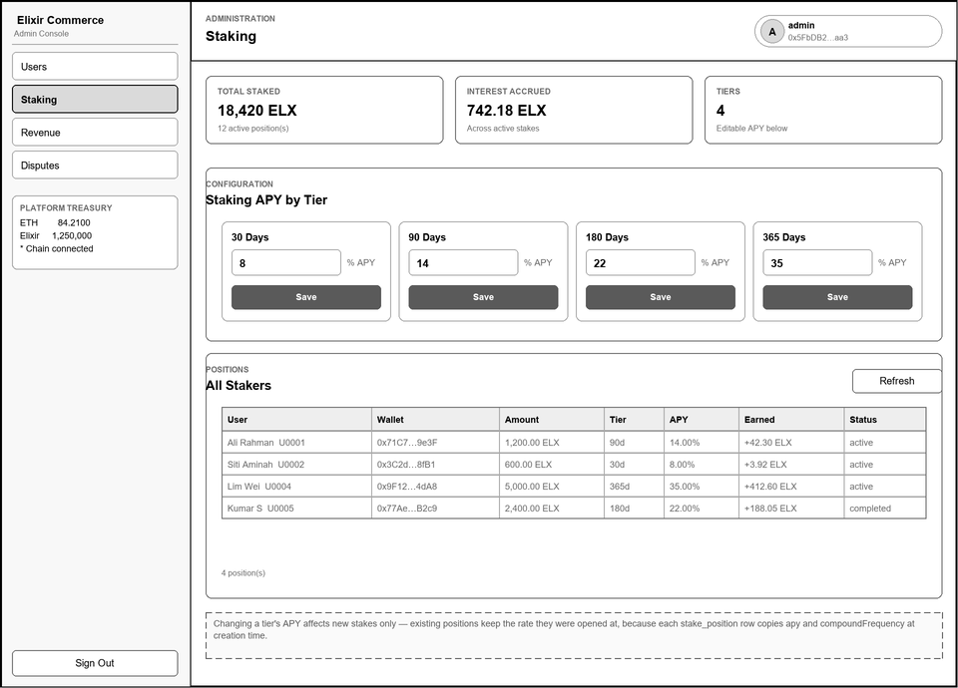

26. Admin — Subscription Revenue
Platform income from seller subscription plans, with a monthly trend and full payment ledger.
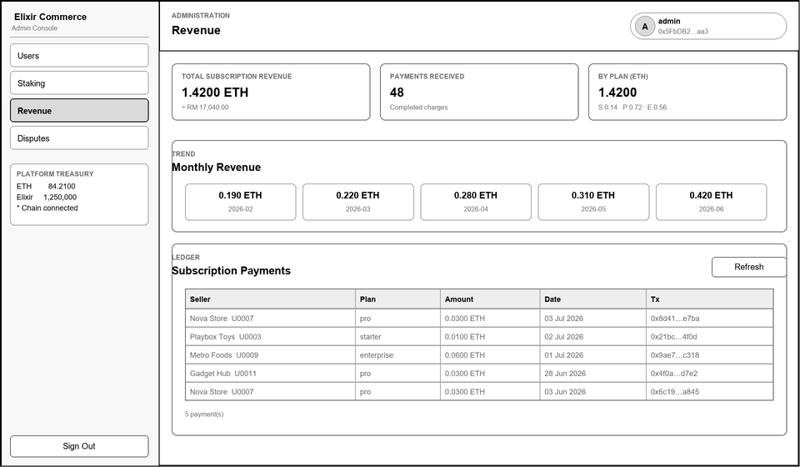

27. Admin — Resolve Escrow Disputes
Open disputes with the on-chain refund / release decision.
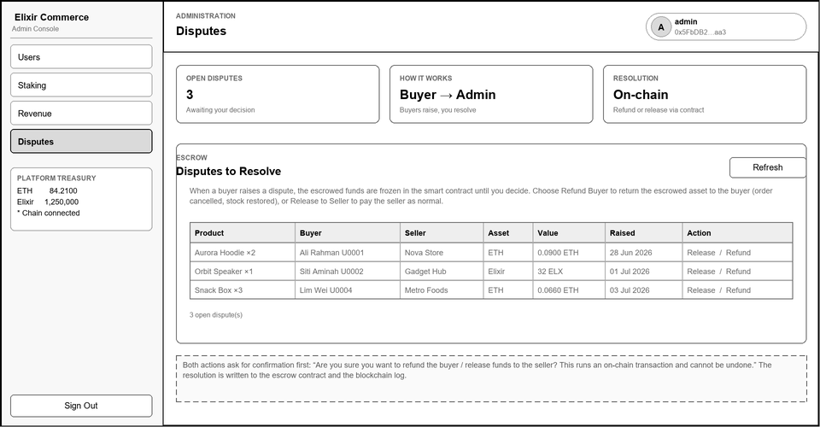

Test Cases
Blockchain E-Commerce Platform — Customer, Merchant and Admin Test Case Tables

Each table follows the TCNO / User Input / System Action / Expected Output / Actual Output / Result format, with Actual Output and Result left blank for the tester to complete during execution. Test cases are grouped by use case (see docs/usecase-specifications.md) so each row traces back to a specific Basic, Alternative, or Exception flow and the backend route it exercises.

Contents
Customer
- Table 1: Register Page Test Case
- Table 2: Login Page Test Case
- Table 3: Connect MetaMask Wallet Test Case
- Table 4: Shop Page Test Case
- Table 5: Cart Management Test Case
- Table 6: Checkout — ETH Payment Test Case
- Table 7: Checkout — Elixir Payment Test Case
- Table 8: Checkout — ETH Escrow Test Case
- Table 9: Checkout — Elixir Escrow Test Case
- Table 10: Checkout — RM Payment Test Case
- Table 11: Track Order & History Test Case
- Table 12: Confirm Delivery Test Case
- Table 13: Raise Dispute Test Case
- Table 14: Stake Elixir Test Case
- Table 15: Unstake Elixir Test Case
- Table 16: Currency Swap Test Case
- Table 17: Deposit RM Test Case
- Table 18: Transfer Currency Test Case
- Table 19: View NFT Purchase Receipts Test Case
- Table 20: Update Profile Test Case
Merchant
- Table 21: Manage Product Catalog Test Case
- Table 22: Plan Product Limit Enforcement Test Case
- Table 23: Track Purchase Order & Fulfillment Test Case
- Table 24: Subscription Plan & Payment Test Case
Admin
- Table 25: Admin User Management Test Case
- Table 26: Admin Staking Tier Management Test Case
- Table 27: Resolve Escrow Dispute Test Case
- Table 28: Admin Revenue Test Case
- Table 29: Treasury Balance & Audit Log Test Case

Customer

UC-C-01 Register
TCNO | User Input | System Action | Expected Output | Actual Output | Result
RG01 | Fill name, email, password; select role Customer; submit | System validates fields and creates a User + CustomerWallet row | Account created; JWT returned; user redirected to /shop
RG02 | Fill name, email, password; select role Merchant; submit | System creates a User row with role merchant (no CustomerWallet) | Account created; user redirected to Seller Portal
RG03 | Submit form with email already registered | System checks for a duplicate email before creating the row | HTTP 409 "Email already registered"; no new row created
RG04 | Submit form with the Name field left empty | System validates required fields before creating the row | HTTP 400 "Name, email and password are required"
RG05 | Click "Back to login" link | User is returned to the Login page | User is directed to the Login page
Table 1: Register Page Test Case

UC-C-02 Login
TCNO | User Input | System Action | Expected Output | Actual Output | Result
LG01 | Enter a registered email and correct password; click Sign In | System verifies the bcrypt password hash and signs a JWT | User is authenticated and redirected to the role's dashboard
LG02 | Enter a registered email with an incorrect password | System compares the password hash and rejects the mismatch | HTTP 401 "Invalid credentials"; user remains on Login page
LG03 | Enter an email that is not registered | System looks up the user by email and finds none | HTTP 401 "Invalid credentials" (same message as LG02)
LG04 | Submit the form with the Password field empty | System validates required fields | HTTP 400; user remains on Login page
LG05 | Click "Create an account now" link | User is directed to the Register page | User is directed to the Register page
Table 2: Login Page Test Case

UC-C-03 Connect MetaMask Wallet
TCNO | User Input | System Action | Expected Output | Actual Output | Result
MM01 | Click "Connect MetaMask" and approve the popup | MetaMask returns the address; backend links it via /api/auth/link-metamask | Wallet chip shows the address and live ETH balance; ETH/Elixir payments unlock
MM02 | Click "Connect MetaMask" and reject the popup | MetaMask cancels the connection request | No wallet is linked; the Connect MetaMask button remains visible
MM03 | Connect a MetaMask address already linked to another account | Backend detects the address is bound to a different user | HTTP 409 ADDRESS_IN_USE; frontend disconnects the wallet
MM04 | Connect a second MetaMask address while one is already linked to this account | Backend detects the account already has a different linked address | HTTP 409 ALREADY_BOUND_TO_USER; frontend disconnects the new wallet
MM05 | Connect the same MetaMask address that is already linked to this account | Backend finds the address already matches this account | Request succeeds with no changes; UI shows "already linked"
MM06 | Click the red ✕ disconnect button on the wallet chip | Frontend disconnects the MetaMask session (account link on the backend is unaffected) | Wallet chip is replaced by the "Connect MetaMask" button
Table 3: Connect MetaMask Wallet Test Case

UC-C-04 Browse / Search Products
TCNO | User Input | System Action | Expected Output | Actual Output | Result
SP01 | Open the Shop page with no filters applied | Frontend calls GET /api/products and renders active products | Product grid displays all active products
SP02 | Click the "Clothes" category pill | Frontend calls GET /api/products?category=clothes | Product grid updates to show only clothes-category products
SP03 | Type "hoodie" into the search box | Frontend calls GET /api/products?search=hoodie with a case-insensitive LIKE match | Product grid filters to products whose name contains "hoodie"
SP04 | Click "by {merchant name}" on a product card | Frontend switches to single-seller mode, filtering by merchantId | Product grid shows only that seller's products; store banner appears
SP05 | Click a product card to view its detail | Frontend calls GET /api/products/:id | Product detail view is displayed with full description and price
SP06 | Request a product id that does not exist | Backend cannot find a matching Product row | HTTP 404 returned; frontend shows a not-found state
Table 4: Shop Page Test Case

UC-C-05 Manage Cart
TCNO | User Input | System Action | Expected Output | Actual Output | Result
CT01 | Click "Add to Cart" on an in-stock product | Frontend calls POST /api/cart; backend creates or increments the cart row | Item appears in the cart; button briefly shows "Added ✓"
CT02 | Click "+" to increase a cart item's quantity beyond available stock | Backend caps the requested quantity at the product's stock level | Quantity is capped at stock; no error is raised
CT03 | Click "−" to reduce a cart item's quantity | Frontend calls PUT /api/cart/:id with the reduced quantity | Cart line item quantity decreases and subtotal updates
CT04 | Click the red ✕ remove button on a cart item | Frontend calls DELETE /api/cart/:id | Item is removed from the cart; subtotal recalculates
CT05 | Add a product from a second seller while items from a first seller are already in the cart | Cart groups items into separate per-seller sections | Cart displays two store sections, each with its own subtotal and checkout button
CT06 | Open the Cart page with no items added | Frontend detects an empty cart response | Empty state is shown: "Your cart is empty"
Table 5: Cart Management Test Case

UC-C-06a Checkout with ETH
TCNO | User Input | System Action | Expected Output | Actual Output | Result
CE01 | Select ETH payment mode with MetaMask connected and sufficient balance; confirm | MetaMask calls payWithETH; backend verifies the PaymentCompleted event | Order created with status completed; seller paid; buyer earns Elixir reward
CE02 | Select ETH payment mode while MetaMask is not connected | System blocks the crypto payment options | HTTP 400 "Connect your MetaMask wallet to pay with ETH"; ETH card is locked
CE03 | Confirm ETH payment with insufficient ETH balance in MetaMask | MetaMask rejects the transaction before it is broadcast | Transaction is not sent; user remains on the Checkout page with an error
CE04 | Submit a manipulated/unmined txHash to the backend | Backend re-reads the transaction receipt and fails to verify the PaymentCompleted event | HTTP 400 with the verification error message; no Order is created
Table 6: Checkout — ETH Payment Test Case

UC-C-06b Checkout with Elixir
TCNO | User Input | System Action | Expected Output | Actual Output | Result
CX01 | Select Elixir payment mode with sufficient Elixir balance; confirm | MetaMask calls payWithTokens; backend verifies the PaymentCompleted event | Order created with paymentMode TOKEN_ONLY; seller paid ETH from contract reserve
CX02 | Select Elixir payment mode with insufficient Elixir balance | Frontend shows an insufficient-balance warning before submission | "Insufficient Elixir balance ({n} available)" warning shown; payment blocked
CX03 | Select Elixir payment mode while MetaMask is not connected | System blocks the crypto payment options | Elixir card is locked; MetaMask connect prompt is shown
Table 7: Checkout — Elixir Payment Test Case

UC-C-06c Checkout with ETH Escrow
TCNO | User Input | System Action | Expected Output | Actual Output | Result
CS01 | Select ETH Escrow with a multi-product basket; confirm | MetaMask calls createEscrow; backend verifies EscrowCreated and checks the escrowed amount | Multi-item Order created with escrowStatus funded; stock decremented; cart cleared
CS02 | Confirm ETH Escrow where the escrowed amount is less than the basket total | Backend checks the escrowed amount covers at least 99% of the basket total | HTTP 400 "Escrowed ETH is less than the order total"; no Order created
CS03 | Confirm ETH Escrow while MetaMask is not connected | System blocks the escrow payment option | HTTP 400; ETH Escrow option is locked in the UI
CS04 | Confirm ETH Escrow with a basket containing items from two sellers | Frontend splits the basket into one escrow checkout per seller | Two separate escrow orders are created, one per seller
Table 8: Checkout — ETH Escrow Test Case

UC-C-06d Checkout with Elixir Escrow
TCNO | User Input | System Action | Expected Output | Actual Output | Result
CZ01 | Select Elixir Escrow; approve the token spend, then confirm the escrow lock | MetaMask requests an approve signature, then a createTokenEscrow signature | Two MetaMask prompts appear in sequence; Order created with escrowStatus funded
CZ02 | Confirm Elixir Escrow where the escrowed Elixir is less than the basket total | Backend checks the escrowed Elixir covers at least 99% of the basket total | HTTP 400; no Order created
CZ03 | Cancel the second MetaMask signature (the escrow lock) after approving the token spend | Frontend detects the second signature was never returned | Checkout is not completed; approved allowance remains but no funds are escrowed
Table 9: Checkout — Elixir Escrow Test Case

UC-C-06e Checkout with RM
TCNO | User Input | System Action | Expected Output | Actual Output | Result
CR01 | Select RM payment mode with sufficient RM balance; confirm | Backend opens a MySQL transaction, deducts RM, and creates the Order | Order created immediately with status completed; no MetaMask prompt required
CR02 | Select RM payment mode with insufficient RM balance | Backend checks the wallet's RM balance against the basket total | HTTP 400 "Insufficient RM balance. Need RM X, have RM Y."; transaction rolled back
CR03 | Confirm RM payment while MetaMask is disconnected | System allows the RM checkout to proceed without a wallet check | Order completes successfully with no MetaMask requirement
CR04 | Leave the Delivery Address field empty and click Confirm & Pay | Frontend/backend validates that a delivery address is required | Form does not submit, or backend rejects the request until an address is provided
Table 10: Checkout — RM Payment Test Case

UC-C-07 Track Order Status / History
TCNO | User Input | System Action | Expected Output | Actual Output | Result
TO01 | Open the Track Order page with at least one order placed | Frontend calls GET /api/orders/my and renders the order list with stage badges | Orders are split into On-going and Completed tabs with correct counts
TO02 | Click an order row to expand it | Frontend renders the 5-step delivery timeline and order summary | Timeline, summary grid, transaction hash and Elixir earned are displayed
TO03 | Open the History page and click the "Swaps" filter pill | Frontend filters the merged order/transaction feed to type SWAP only | Feed shows only swap transactions
TO04 | Open the History page with no activity recorded | Frontend detects an empty feed response | Empty state is shown: "No activity yet"
Table 11: Track Order & History Test Case

UC-C-08 Confirm Delivery
TCNO | User Input | System Action | Expected Output | Actual Output | Result
CD01 | Click "Confirm Delivery & Release" on a funded escrow order | MetaMask calls confirmDelivery; backend verifies EscrowReleased and updates the order | escrowStatus becomes released; fulfillmentStage set to 4; NFT receipt minted
CD02 | Click "Confirm Delivery & Release" while MetaMask is disconnected | System shows a Connect MetaMask prompt instead of the action buttons | "Connect MetaMask to manage escrow" button is shown; action is blocked
CD03 | Submit a txHash that fails on-chain event verification | Backend cannot decode an EscrowReleased event from the receipt | Order state remains unchanged; delivery is not marked confirmed
Table 12: Confirm Delivery Test Case

UC-C-09 Raise Dispute
TCNO | User Input | System Action | Expected Output | Actual Output | Result
RD01 | Click "Raise Dispute" on a funded escrow order | MetaMask calls raiseDispute; backend verifies EscrowDisputed and updates escrowStatus | Order's escrowStatus becomes disputed; order appears in the Admin Disputes queue
RD02 | Click "Raise Dispute" on an order that is not in a funded escrow state | System only exposes the dispute action for funded escrow orders | Raise Dispute button is not shown for that order
RD03 | Click "Raise Dispute" while MetaMask is disconnected | System shows a Connect MetaMask prompt instead of the action buttons | Dispute action is blocked until MetaMask is connected
Table 13: Raise Dispute Test Case

UC-C-10a Stake Elixir
TCNO | User Input | System Action | Expected Output | Actual Output | Result
ST01 | Select the 90-day tier, enter a valid Elixir amount, click Stake | MetaMask transfers Elixir to the treasury; backend verifies the transfer and creates a StakePosition | New active staking position appears with tierDays 90 and locked-in APY 14%
ST02 | Click "MAX" then Stake | Frontend fills the input with the full available Elixir balance before submitting | Amount field shows the full balance; stake is created for that full amount
ST03 | Enter a stake amount greater than the available Elixir balance | MetaMask rejects the transfer due to insufficient balance | Transaction fails before submission; no StakePosition is created
ST04 | Attempt to stake while MetaMask is disconnected | System blocks the staking action | Stake button is disabled or a Connect MetaMask prompt is shown
ST05 | Stake and observe the projected returns before confirming | Frontend computes A = P(1 + r/n)^(nt) client-side for the selected tier | Projected Returns card shows Staked, Interest Earned, Total, and Effective Rate
Table 14: Stake Elixir Test Case

UC-C-10b Unstake Elixir
TCNO | User Input | System Action | Expected Output | Actual Output | Result
UT01 | Click "Claim & Unstake" on a matured position | Backend computes the compound reward and sends principal + reward in LYT to the customer | Position status becomes completed; Elixir balance increases by principal + reward
UT02 | Attempt to unstake a position before its maturity date | Backend checks maturityAt against the current time | HTTP 400 "Not yet matured"; position remains active
UT03 | View an active, non-matured position | Frontend shows the elapsed/remaining days without an unstake action | Progress bar and "{n} days remaining" are shown; no Claim & Unstake button appears
Table 15: Unstake Elixir Test Case

UC-C-11 Swap Currency
TCNO | User Input | System Action | Expected Output | Actual Output | Result
SW01 | Swap ETH to Elixir with MetaMask connected and sufficient ETH | MetaMask sends ETH to the admin address; backend verifies it and pays out Elixir | ETH balance decreases; Elixir balance increases by the converted amount
SW02 | Swap RM to Elixir with sufficient RM balance | Backend deducts RM from the ledger and pays out Elixir from the admin wallet | RM balance decreases; Elixir balance increases; no MetaMask prompt for the RM leg
SW03 | Select the same currency for both From and To | System validates the two currencies must differ | HTTP 400; swap button remains disabled until a different currency is chosen
SW04 | Swap ETH to RM while MetaMask is disconnected | System blocks the on-chain leg of the swap | "Connect MetaMask to swap ETH." prompt is shown; swap is blocked
SW05 | Swap RM to ETH with insufficient RM balance | Backend checks the RM ledger balance before proceeding | HTTP 400; balances remain unchanged
Table 16: Currency Swap Test Case

UC-C-12 Deposit RM
TCNO | User Input | System Action | Expected Output | Actual Output | Result
DP01 | Enter a positive RM amount and click Deposit | Backend validates the amount and increments CustomerWallet.RM | RM balance increases by the deposited amount; DEPOSIT transaction recorded
DP02 | Enter 0 or a negative amount and click Deposit | Backend validates the amount is positive | HTTP 400; RM balance is unchanged
DP03 | Enter non-numeric text into the amount field | Backend rejects a non-numeric amount | HTTP 400; RM balance is unchanged
Table 17: Deposit RM Test Case

UC-C-13 Transfer Currency (P2P)
TCNO | User Input | System Action | Expected Output | Actual Output | Result
TR01 | Transfer Elixir to a valid recipient wallet address with sufficient balance | MetaMask sends the Elixir on-chain; backend verifies the txHash and records the transfer | Sender's Elixir balance decreases; TRANSFER_OUT / TRANSFER_IN rows recorded
TR02 | Transfer RM to a recipient with sufficient RM balance | Backend deducts from the sender's ledger and credits the recipient's ledger directly | Sender's RM decreases and recipient's RM increases; no on-chain transaction required
TR03 | Transfer an amount greater than the available balance | Backend/MetaMask checks the balance before sending | HTTP 400 or MetaMask rejection; no balance is moved
TR04 | Transfer ETH while MetaMask is disconnected | System blocks the on-chain transfer | "Connect MetaMask to transfer ETH." prompt is shown; transfer is blocked
Table 18: Transfer Currency Test Case

UC-C-14 View NFT Receipts
TCNO | User Input | System Action | Expected Output | Actual Output | Result
NR01 | Open the Receipts view after completing an escrow order with delivery confirmed | Frontend calls GET /api/escrow/receipts and reads PurchaseReceipt.receiptsOf on-chain | Minted receipt appears in the list with its token id
NR02 | Open the Receipts view with no MetaMask address linked | Backend has no address to query on-chain receipts for | Empty result is returned; no receipts are shown
Table 19: View NFT Purchase Receipts Test Case

UC-C-15 Update Profile
TCNO | User Input | System Action | Expected Output | Actual Output | Result
PR01 | Edit Name, Phone and Delivery Address; click Save Changes | Frontend calls PUT /api/auth/profile with the updated fields | "Profile updated successfully." toast appears; new values shown in view mode
PR02 | Change Email to an address already used by another account | Backend checks the new email is not used by another account | HTTP 409; email is not updated
PR03 | Enter a New Password without providing the correct Current Password | Backend verifies currentPassword before accepting a new one | HTTP 401; password is not changed
PR04 | Enter a New Password shorter than 6 characters | Backend validates the minimum password length | "New password must be at least 6 characters." error shown
PR05 | Enter mismatching New Password and Confirm New Password values | Frontend validates the two password fields match before submitting | "New password and confirmation do not match." error shown; form not submitted
PR06 | Clear the Name field and click Save Changes | Frontend validates the name field is not empty | "Name cannot be empty." error shown; form not submitted
Table 20: Update Profile Test Case

Merchant

UC-M-01a/b/d Manage Product Catalog
TCNO | User Input | System Action | Expected Output | Actual Output | Result
PC01 | Fill Product Name, Category, Price (RM), Stock; click Create Product | Backend validates required fields and checks the plan's product limit before creating the row | New product appears in "Your Products" with status Live
PC02 | Submit the Create Product form with the Product Name field empty | Backend validates name and priceEth are present | HTTP 400; product is not created
PC03 | Click "Edit" on an existing product, change the price, and save | Frontend calls PUT /api/products/:id after verifying ownership | Product's price is updated and reflected on the product card
PC04 | Click "Deactivate" on a Live product | Backend sets isActive to false (soft delete) via DELETE /api/products/:id | Product status changes to Hidden and disappears from the public Shop grid
PC05 | Click "Reactivate" on a Hidden product while under the plan's product limit | Backend re-runs the plan-limit check and sets isActive to true | Product status changes back to Live and reappears in the public Shop grid
PC06 | Attempt to edit a product belonging to a different merchant (e.g. via direct API call) | Backend verifies product.merchantId matches the requester | HTTP 403 "Not your product"; no changes applied
Table 21: Manage Product Catalog Test Case

UC-M-01c Check Plan Product Limit
TCNO | User Input | System Action | Expected Output | Actual Output | Result
PL01 | Create a 4th product on the Starter plan (limit 3) | Backend counts active products and compares to the Starter plan's limit of 3 | HTTP 403 PLAN_LIMIT_REACHED; "Your Starter plan allows up to 3 active products..." shown
PL02 | Create an 11th product on the Pro plan (limit 10) | Backend counts active products and compares to the Pro plan's limit of 10 | HTTP 403 PLAN_LIMIT_REACHED; product is not created
PL03 | Create a product while on the Enterprise plan (unlimited) | Backend finds productLimit is null for Enterprise and skips the cap check | Product is created successfully regardless of current product count
PL04 | Reactivate a Hidden product that would push the count over the plan limit | Backend re-runs the plan-limit check before reactivating | HTTP 403 PLAN_LIMIT_REACHED; product remains Hidden
Table 22: Plan Product Limit Enforcement Test Case

UC-M-02 Manage Purchase Orders / Fulfillment
TCNO | User Input | System Action | Expected Output | Actual Output | Result
PO01 | Open the "Track Purchase Order" tab with incoming orders present | Frontend calls GET /api/orders/merchant and renders one card per order | Orders are listed with buyer info, payment mode, and current fulfillment stage
PO02 | Click "Advance → Processing" on an order at stage Order placed | Frontend calls PUT /api/orders/:id/fulfillment with the next stage | Order's stage badge updates to Processing; timeline advances one step
PO03 | Select "4. Delivered" directly from the stage dropdown | Backend updates fulfillmentStage to 4 directly | Order timeline jumps straight to Delivered; Advance button becomes disabled
PO04 | Attempt to update the fulfillment stage of an order belonging to a different merchant | Backend verifies the order's merchantId matches the requester | HTTP 403 "Not your order"; stage is not changed
PO05 | Advance the stage on an ETH Escrow order that is still funded | System only updates the informational fulfillment stage, not the escrow payout | Fulfillment stage updates, but escrowStatus remains funded until the buyer confirms delivery
Table 23: Track Purchase Order & Fulfillment Test Case

UC-M-03 Manage Subscription
TCNO | User Input | System Action | Expected Output | Actual Output | Result
SB01 | Open the "Payments" tab | Frontend calls GET /api/subscription/me | Current plan, product usage, and renewal date are displayed
SB02 | Select the Enterprise plan card while currently on Pro | Frontend calls POST /api/subscription/change; backend sets pendingPlan | "Scheduled" tag appears on Enterprise; notice shows the change applies next billing cycle
SB03 | Select the currently active plan again after queuing a change | Backend clears the previously queued pendingPlan | Pending plan notice disappears; current plan remains unchanged
SB04 | Click "Pay & Apply Plan" with the correct ETH amount for the pending plan | MetaMask sends ETH to the platform; backend verifies the amount and applies pendingPlan | Plan becomes active; planRenewsAt extends by 30 days; SubscriptionPayment recorded
SB05 | Send an ETH amount that does not match the plan's price | Backend verifies the incoming ETH amount against the plan price | HTTP 400 "Incorrect amount"; plan is not changed
SB06 | Click "Pay / Renew" while MetaMask is disconnected | System replaces the pay action with a connect prompt | "Connect MetaMask to Pay" button is shown instead of the pay button
Table 24: Subscription Plan & Payment Test Case

Admin

UC-A-01/02 View Users & Platform Overview
TCNO | User Input | System Action | Expected Output | Actual Output | Result
AU01 | Open the "Users" tab | Frontend calls GET /api/admin/users and GET /api/admin/overview | User table and role-count tiles (customers/merchants/admins) are displayed
AU02 | Type a partial name into the search box | Frontend calls GET /api/admin/users?search={term} after a 300ms debounce | Table filters to users whose name, email, code, or wallet matches the term
AU03 | Search for a term that matches no user | Backend returns an empty result set | "No results for '{term}'." empty state is shown
AU04 | Attempt to open the admin Users API as a logged-in customer | Backend's requireRole("admin") middleware rejects the request | HTTP 403; user cannot view the admin user list
Table 25: Admin User Management Test Case

UC-A-04/04a Manage Staking Tiers
TCNO | User Input | System Action | Expected Output | Actual Output | Result
AS01 | Open the "Staking" tab | Frontend calls GET /api/admin/staking/tiers and GET /api/admin/staking/positions | Four tier cards (30/90/180/365 days) and the full stakers table are displayed
AS02 | Change the 90-day tier's APY from 14 to 16 and click Save | Frontend calls PUT /api/admin/staking/tiers/90; backend updates the StakingTier row | Tier's APY updates to 16%; note confirms existing positions keep their locked-in rate
AS03 | Enter a negative value into a tier's APY field and click Save | Backend validates the APY is a non-negative number | "Enter a valid APY." error shown; tier is not updated
AS04 | View a staking position opened before an APY change | System reads the apy value stored on the StakePosition itself, not the live tier value | Position continues to display the APY it was created with, unaffected by the tier update
Table 26: Admin Staking Tier Management Test Case

UC-A-05/06 View & Resolve Escrow Disputes
TCNO | User Input | System Action | Expected Output | Actual Output | Result
AD01 | Open the "Disputes" tab with at least one disputed order | Frontend calls GET /api/admin/escrow/disputes | Disputed order appears in the table with product, buyer, seller, asset, and value
AD02 | Click "Release to Seller" and confirm the dialog | Backend calls PurchaseEscrow.resolveDispute(escrowId, false); order is updated on success | Confirmation dialog appears; on confirming, escrowStatus becomes released, fulfillmentStage 4
AD03 | Click "Refund Buyer" and confirm the dialog | Backend calls PurchaseEscrow.resolveDispute(escrowId, true); stock restored on success | Order status becomes cancelled; product stock is restored; EscrowRefunded logged
AD04 | Click "Release to Seller" then dismiss/cancel the confirmation dialog | The native confirm dialog is dismissed before the API call is made | No on-chain call is made; dispute remains open
AD05 | Attempt to resolve a dispute while the admin wallet lacks contract owner permissions | The on-chain resolveDispute call reverts | HTTP 500; order state remains disputed and unchanged
Table 27: Resolve Escrow Dispute Test Case

UC-A-07 View Subscription Revenue
TCNO | User Input | System Action | Expected Output | Actual Output | Result
AR01 | Open the "Revenue" tab with subscription payments recorded | Frontend calls GET /api/admin/revenue | Revenue tiles, monthly trend, and the full payment ledger table are displayed
AR02 | Open the "Revenue" tab with no subscription payments recorded | Backend returns an empty payments list | "No revenue data" empty state is shown
AR03 | Click "↻ Refresh" on the Subscription Payments ledger | Frontend re-calls GET /api/admin/revenue | Ledger table reloads with the latest payment records
Table 28: Admin Revenue Test Case

UC-A-03/08 Treasury Balance & Blockchain Audit Log
TCNO | User Input | System Action | Expected Output | Actual Output | Result
AL01 | Leave the admin console open and wait 15 seconds | Frontend polls GET /api/admin/balance on a 15-second interval | Platform Treasury card refreshes with the current ETH and Elixir balances
AL02 | Disconnect the RPC/blockchain connection and check the Treasury card | Backend cannot reach the chain to read balances | Status indicator shows "Chain offline" instead of "Chain connected"
AL03 | Open the blockchain audit log filtered by eventType=EscrowCreated | Frontend calls GET /api/orders/blockchain/logs?eventType=EscrowCreated | Only EscrowCreated log entries are returned, most recent first
Table 29: Treasury Balance & Audit Log Test Case

UAT Preparation
Blockchain E-Commerce Platform — User Acceptance Testing Forms by Role

Each form lets a tester score every major feature area for a given role on a 0-5 scale (Excellent 5, Very Good 4, Fair 2-3, Poor 1-0), followed by two open feedback questions and a space for the developer's response. Testing categories are derived from the screens and use cases documented earlier in this file (usecase-specifications.md and the UI wireframes), so each row corresponds to a real, testable feature of the platform.

Contents
- 1. Customer UAT Preparation
- 2. Merchant (Seller) UAT Preparation
- 3. Admin UAT Preparation

1. Customer UAT Preparation
Name of the Tester:
Job Position:
Date:
Time Start: Time End:
Name of parameter/Testing Category | Excellent  (5) points | Very Good  (4) points | Fair  (2-3) points | Poor (1-0)  points
Account Registration and Login
Profile Management (Edit profile, Email, Password)
Connect MetaMask Wallet (Link wallet, Live ETH balance)
Browse and Search Products
Manage Cart (Add, Adjust Quantity, Remove)
Checkout with ETH / Elixir (Direct Payment)
Checkout with ETH / Elixir Escrow (Multi-item Basket)
Checkout with RM (Off-chain Ledger)
Track Order and Delivery Progress
Confirm Delivery and Raise Dispute
Stake Elixir and View Compound Interest
Unstake Elixir (Claim Matured Position)
Wallet: Currency Swap (ETH / Elixir / RM)
Wallet: Deposit RM and Transfer Currency (P2P)
View Purchase and Transaction History
View NFT Purchase Receipts
Overall Ease of Use and User Interface
1. What did you like the most about the app?
:
2. What should be improved?
:
Developer Response
:

2. Merchant (Seller) UAT Preparation
Name of the Tester:
Job Position:
Date:
Time Start: Time End:
Name of parameter/Testing Category | Excellent  (5) points | Very Good  (4) points | Fair  (2-3) points | Poor (1-0)  points
Account Registration and Login
Profile Management (Edit profile, Email, Password)
Connect MetaMask Wallet for Payments
Create New Product Listing
Edit Existing Product Details
Deactivate / Reactivate a Product
Plan Product Limit Enforcement (Starter / Pro / Enterprise)
Track Purchase Order and Buyer Details
Update Order Fulfillment Stage
View Revenue Dashboard and Product Performance
Manage Subscription Plan (Switch Plan)
Pay Subscription Fee in ETH
Overall Ease of Use and User Interface
1. What did you like the most about the app?
:
2. What should be improved?
:
Developer Response
:

3. Admin UAT Preparation
Name of the Tester:
Job Position:
Date:
Time Start: Time End:
Name of parameter/Testing Category | Excellent  (5) points | Very Good  (4) points | Fair  (2-3) points | Poor (1-0)  points
Account Login and Access Control
View All Registered Users and Search
View Platform Overview (User Counts by Role)
View Platform Treasury Balance (ETH / Elixir)
Manage Staking Tiers (Edit APY per Tier)
View All Staking Positions Across Platform
View and Resolve Escrow Disputes (Refund / Release)
View Subscription Revenue and Payment Ledger
View Blockchain Audit Log
Overall Ease of Use and User Interface
1. What did you like the most about the app?
:
2. What should be improved?
:
Developer Response
:

