ELEC5305 Acoustics Speech and Signal Processing

Controlled Comparison of Wiener Filtering and Spectral Subtraction for Speech Noise Reduction
Final Project Report
Zhizhong Chen
Student ID 530668932
The University of Sydney
Semester 2 2026
8 November 2026
Code and reproducibility materials
github.com/czz0806/elec5305-project-530668932
czz0806.github.io/elec5305-project-530668932

Contents
Abstract | 2
1 Introduction | 3
2 Literature Review | 3
3 Methods | 4
4 Results | 6
5 Discussion | 9
6 Limitations and Future Work | 10
7 Conclusion | 11
References | 11
Appendix A Reproducibility and Links | 11

Abstract
This project compares spectral subtraction and Wiener filtering in a controlled single-channel speech-enhancement benchmark. Eight aligned clean and noisy pairs from the Microsoft Deep Noise Suppression Challenge supplied eight real noise residuals. Each residual was remixed with clean speech at -5, 0, 5 and 10 dB, giving 32 paired conditions. Both methods used the same 32 ms short-time Fourier transform, 50 percent overlap and oracle noise-power estimate, isolating the spectral gain rule as the experimental variable. Performance was measured using global SNR improvement, segmental SNR and log-spectral distance. Wiener filtering achieved the larger SNR improvement in all 32 conditions, averaging 2.945 dB compared with 2.090 dB for spectral subtraction. Spectral subtraction produced the slightly lower mean log-spectral distance, 10.334 dB compared with 10.772 dB. The results therefore show a suppression-distortion trade-off: removing more error energy did not preserve the short-time spectrum most closely. Stationary or slowly varying backgrounds were easier than baby, birds, babble and wind noise. Because the oracle estimate is unavailable in deployment, this is an upper-bound algorithm comparison; practical noise estimation, a larger corpus and perceptual testing remain necessary.
Keywords: speech enhancement, Wiener filtering, spectral subtraction, STFT, DNS Challenge, SNR, log-spectral distance

1 Introduction
Additive background noise affects speech communication, recording quality and the reliability of downstream speech systems. A useful enhancement algorithm must suppress the unwanted component without removing speech harmonics, smearing transients or introducing artificial fluctuations. These goals compete because clean speech and noise overlap in both time and frequency. Modern deep models can learn complex mappings, but classical algorithms remain valuable because their assumptions, gain rules and failure modes can be inspected directly and reproduced with modest computation.
This project studies two established frequency-domain methods: spectral subtraction and Wiener filtering. Both begin with a short-time Fourier transform and estimate the clean spectrum from a noisy observation. Spectral subtraction removes an estimated noise spectrum and applies a floor to prevent negative or near-zero estimates. Wiener filtering applies a smooth gain based on the estimated proportion of speech power in each time-frequency bin. Because the front end and noise estimate can dominate performance, an uncontrolled comparison can confuse differences in the gain rules with differences in preprocessing or noise tracking.
The single research question is: How do Wiener filtering and spectral subtraction differ in noise reduction and speech distortion across several real-world noise types and input SNRs when both methods use the same STFT configuration and noise-power estimate? The investigation uses aligned DNS Challenge material, four controlled SNRs and three complementary objective measures. The emphasis is not on claiming a new state-of-the-art system. It is on reproducing two classical approaches, placing them in a credible research context and making a small controlled contribution by separating the gain-rule comparison from the noise-estimation problem.

2 Literature Review

2.1 Spectral subtraction
Boll's spectral-subtraction method estimates the spectral bias of additive noise during nonspeech activity and subtracts it from the noisy spectrum [1]. Its appeal is computational simplicity and an interpretable relationship between the estimated noise and the retained speech magnitude. The core weakness is that estimation errors vary independently across time-frequency bins. Hard subtraction can therefore leave isolated residual peaks, commonly described as musical noise, or remove low-energy speech components. Lim and Oppenheim placed spectral subtraction within a wider family of enhancement and bandwidth-compression methods and highlighted the central difficulty of estimating speech from a corrupted observation [2]. A spectral floor reduces extreme attenuation, but it also deliberately retains some noisy energy. The subtraction factor and floor therefore define a suppression-distortion trade-off rather than a universally optimal setting.

2.2 Wiener and statistical spectral estimation
The Wiener filter is the optimal linear minimum-mean-square-error estimator when the required second-order signal and noise statistics are known. In the short-time frequency domain, it scales each noisy coefficient according to an estimated local speech-to-noise power ratio [2]. A bin dominated by estimated speech receives a gain close to one, while a noise-dominated bin is attenuated. This smooth shrinkage avoids the explicit negative-power problem of direct subtraction. Ephraim and Malah showed that different statistical loss functions lead to related but distinct short-time spectral amplitude estimators [3]. Scalart and Filho later demonstrated the importance of a priori SNR estimation for stable speech enhancement [4]. These studies establish that the quality of noise and speech-power estimates is inseparable from the behaviour of the gain function.

2.3 Evaluation and research gap
Speech enhancement cannot be evaluated reliably with one number. Hu and Loizou compared objective measures against subjective judgements and separated speech distortion, background-noise distortion and overall quality [5]. Their results caution against treating a larger SNR as proof of better perceived speech. Global SNR is sensitive to total error energy but not to its spectral distribution. Segmental SNR limits domination by high-energy frames, while log-spectral distance directly measures frame-wise spectral deviation from a clean reference. The present project therefore reports all three and interprets disagreements between them rather than hiding them.
The DNS Challenge provides open speech and noise material and a common evaluation context for noise-suppression research [6]. Its synthetic test set includes aligned clean references, enabling controlled objective evaluation. Many educational comparisons apply different preprocessing, estimate noise differently for each method, or report only one example. The gap addressed here is narrower but testable: both algorithms receive exactly the same waveform, STFT and oracle noise-power estimate, and only their gain rules differ. This does not solve practical noise estimation; instead, it creates an upper-bound paired benchmark that makes the algorithmic contrast easier to interpret.

3 Methods

3.1 Dataset and controlled mixtures
Eight 10-second, 16 kHz, single-channel aligned clean/noisy pairs were selected from the DNS Challenge synthetic no-reverberation test material. The noise labels were traffic, babble, wind, vacuum, birds, bus, air conditioner and baby. For each file ID, the clean reference was subtracted from the aligned noisy recording to recover the original residual noise. DC means were removed, and the clean and residual signals were truncated to their common length. The residual was then scaled to each target SNR using the clean and noise energies before remixing. This produced 8 x 4 = 32 paired experimental conditions.
Noise | File ID | Target input SNRs | Duration | Sample rate
Traffic | 268 | -5, 0, 5, 10 dB | 10 s | 16 kHz
Babble | 147 | -5, 0, 5, 10 dB | 10 s | 16 kHz
Wind | 170 | -5, 0, 5, 10 dB | 10 s | 16 kHz
Vacuum | 192 | -5, 0, 5, 10 dB | 10 s | 16 kHz
Birds | 44 | -5, 0, 5, 10 dB | 10 s | 16 kHz
Bus | 101 | -5, 0, 5, 10 dB | 10 s | 16 kHz
Air conditioner | 17 | -5, 0, 5, 10 dB | 10 s | 16 kHz
Baby | 72 | -5, 0, 5, 10 dB | 10 s | 16 kHz

Table 1. Controlled DNS Challenge test material. Full filenames and provenance are documented in audio/SOURCE.txt.

3.2 Common short-time Fourier analysis
The noisy signal is modelled in the STFT domain as the sum of clean speech and noise. The index k denotes frequency and m denotes frame number.
All methods used a 32 ms periodic Hamming window, 50 percent overlap and an FFT length equal to the frame length. At 16 kHz this gives 512 samples per frame and a 256-sample hop. The modified spectra were reconstructed by inverse FFT and weighted overlap-add, with normalisation by the accumulated squared window. Keeping this analysis and synthesis chain identical prevents window choice from becoming a hidden confound.

3.3 Spectral subtraction
The oracle noise power spectral density P_N(k) was calculated as the mean squared magnitude of the recovered noise STFT over frames. Spectral subtraction used subtraction factor alpha = 1.0 and floor beta = 0.02. The noisy phase was retained.
The floor avoids negative estimates and limits isolated holes in the reconstructed spectrum. Parameters were fixed before the final comparison and were not retuned for individual noise types or SNRs.

3.4 Wiener filtering
For the Wiener method, speech power was estimated as the nonnegative difference between noisy power and the oracle noise power. A gain floor of 0.05 prevented complete nulling. The estimate and gain were then applied as follows.
With these definitions, both methods use the same oracle noise estimate but map it to the output magnitude differently. This is the intended independent variable in the experiment.

3.5 Evaluation measures and implementation
Global output SNR was calculated against the aligned clean reference, and SNR improvement was output SNR minus the measured input SNR. Segmental SNR used 20 ms frames with 50 percent overlap, active-frame selection and clipping to the interval -10 to 35 dB. Log-spectral distance used 32 ms frames, active-speech selection and an 80 dB magnitude floor. Lower LSD indicates a closer frame-wise magnitude spectrum. The main formulas are summarised below, where L denotes a log-magnitude spectrum.
The primary implementation is the MATLAB script code/run_final_project.m. It validates the required audio, creates all 32 mixtures, runs both algorithms, writes detailed and summary CSV tables, saves representative WAV files and exports the report figures. A separate Python implementation reproduces the same equations as a numerical cross-check. No model is trained, and no method is allowed to use different preprocessing. Results are descriptive because the small set of eight utterances is not sufficient for strong population-level statistical claims.

4 Results

4.1 SNR improvement across input levels
Wiener filtering achieved the greater SNR improvement in every paired condition. Averaged over all 32 cases, the improvement was 2.945 dB for Wiener filtering and 2.090 dB for spectral subtraction, a mean difference of 0.855 dB. Improvement decreased as the input SNR rose: at -5 dB the means were 3.408 and 2.374 dB, while at 10 dB they were 2.470 and 1.789 dB. The error bars in Figure 1 show substantial between-noise variation, so the overall ranking does not imply uniform absolute performance.
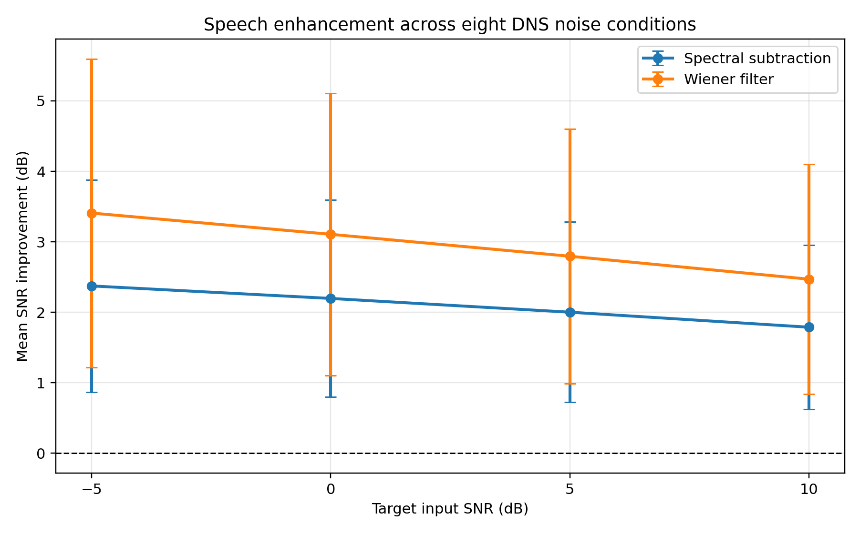
Figure 1. Mean global SNR improvement across eight DNS noise conditions. Error bars show one standard deviation across noise types.
Input SNR | SS output SNR | SS improvement | Wiener output SNR | Wiener improvement | SS LSD | Wiener LSD
-5 dB | -2.626 | 2.374 | -1.592 | 3.408 | 13.178 | 13.422
0 dB | 2.197 | 2.197 | 3.107 | 3.107 | 11.185 | 11.654
5 dB | 7.002 | 2.002 | 7.796 | 2.796 | 9.342 | 9.875
10 dB | 11.789 | 1.789 | 12.470 | 2.470 | 7.631 | 8.136
Overall mean | 4.590 | 2.090 | 5.445 | 2.945 | 10.334 | 10.772

Table 2. Mean global SNR and log-spectral distance by target input SNR. SS denotes spectral subtraction; LSD is lower when the enhanced spectrum is closer to clean speech.

4.2 Dependence on noise type
The heatmaps in Figure 2 expose the largest source of variability. Air-conditioner, bus and vacuum noise produced the strongest improvements for both methods, whereas baby, babble, birds and wind noise were more difficult. Averaged across input SNRs, Wiener improvement ranged from 0.685 dB for baby noise to 5.441 dB for bus noise. Spectral subtraction ranged from 0.442 to 3.685 dB. These patterns are consistent with the fixed long-term noise PSD being better matched to stationary or slowly varying backgrounds than to strongly nonstationary events.
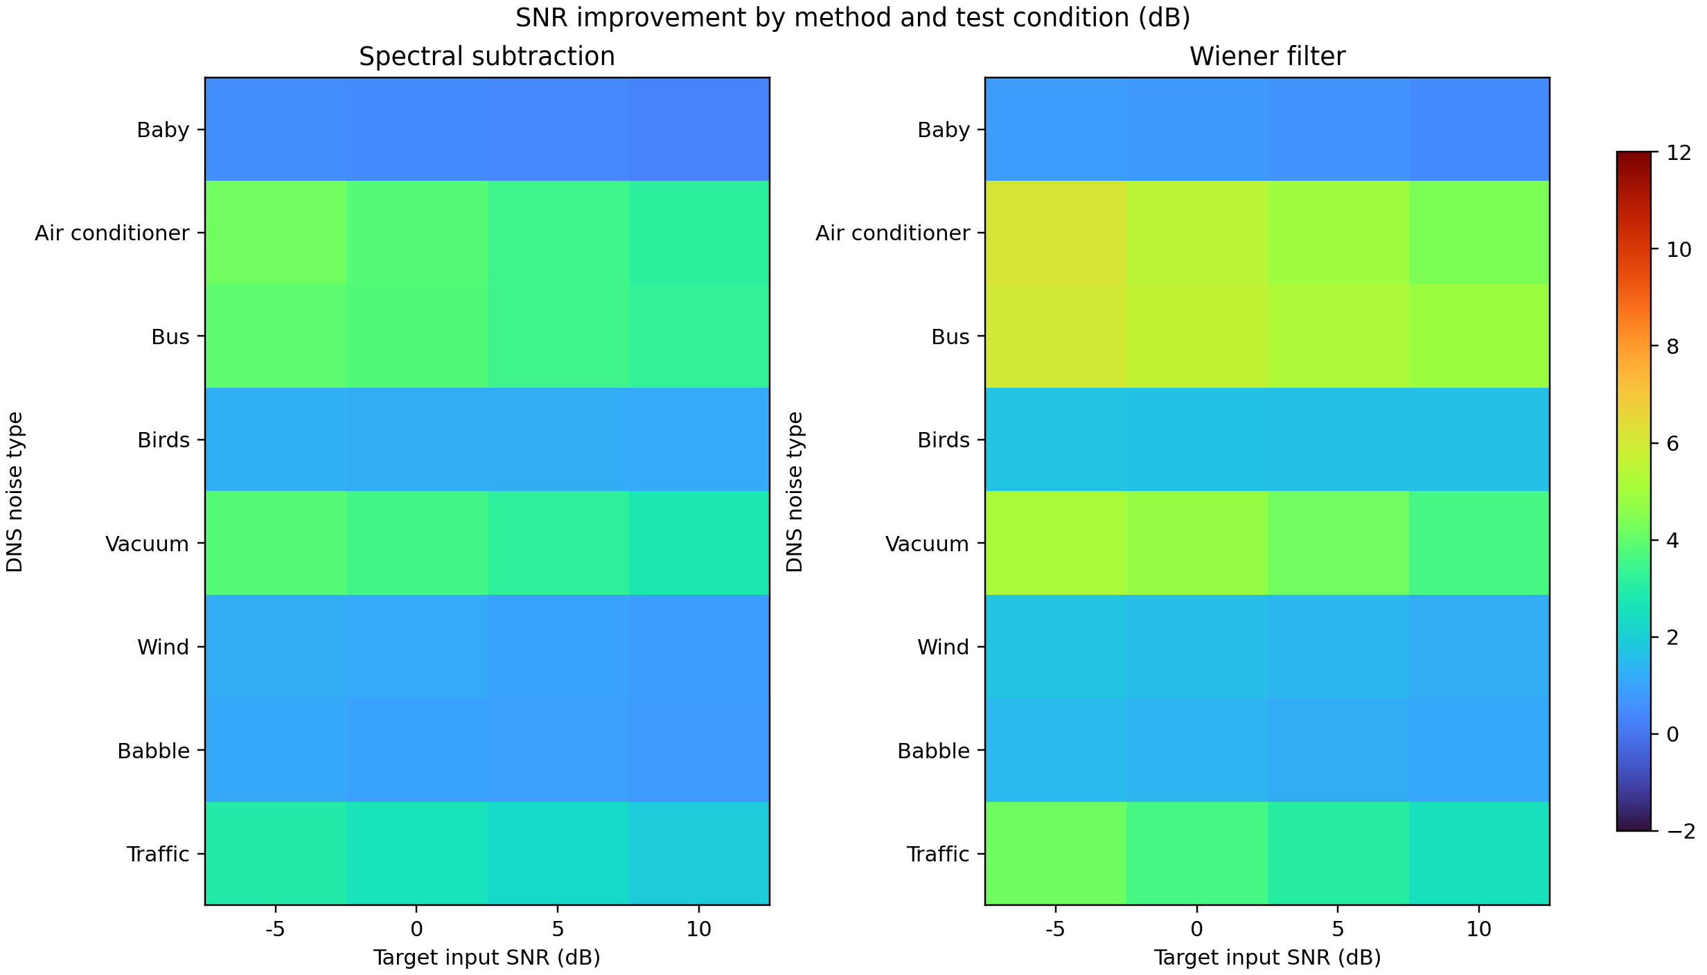
Figure 2. Global SNR improvement for all 32 test conditions. The common colour scale allows direct comparison between methods.
Noise type | SS improvement | Wiener improvement | SS LSD | Wiener LSD
Air conditioner | 3.685 | 5.220 | 11.649 | 10.865
Bus | 3.625 | 5.441 | 6.142 | 5.921
Vacuum | 3.333 | 4.427 | 14.174 | 13.643
Traffic | 2.441 | 3.331 | 12.531 | 12.682
Birds | 1.196 | 1.678 | 10.627 | 11.978
Wind | 1.058 | 1.493 | 8.938 | 9.428
Babble | 0.942 | 1.286 | 10.558 | 12.397
Baby | 0.442 | 0.685 | 8.053 | 9.261

Table 3. Metrics averaged over the four target SNRs for each noise type. All values are in dB.

4.3 Spectral distortion
Both enhancement methods reduced mean LSD relative to the noisy baseline when all conditions were pooled: the noisy mean was 11.628 dB, compared with 10.334 dB for spectral subtraction and 10.772 dB for Wiener filtering. The ordering is the reverse of global SNR. Spectral subtraction was lower by 0.438 dB overall, even though it removed less total error energy. LSD decreased sharply as input SNR improved for all signals. Noise-specific results were not universally beneficial: for baby and birds noise, both enhanced outputs had higher LSD than the noisy input, and Wiener filtering also increased LSD for wind. These cases demonstrate why a single average SNR result is insufficient.
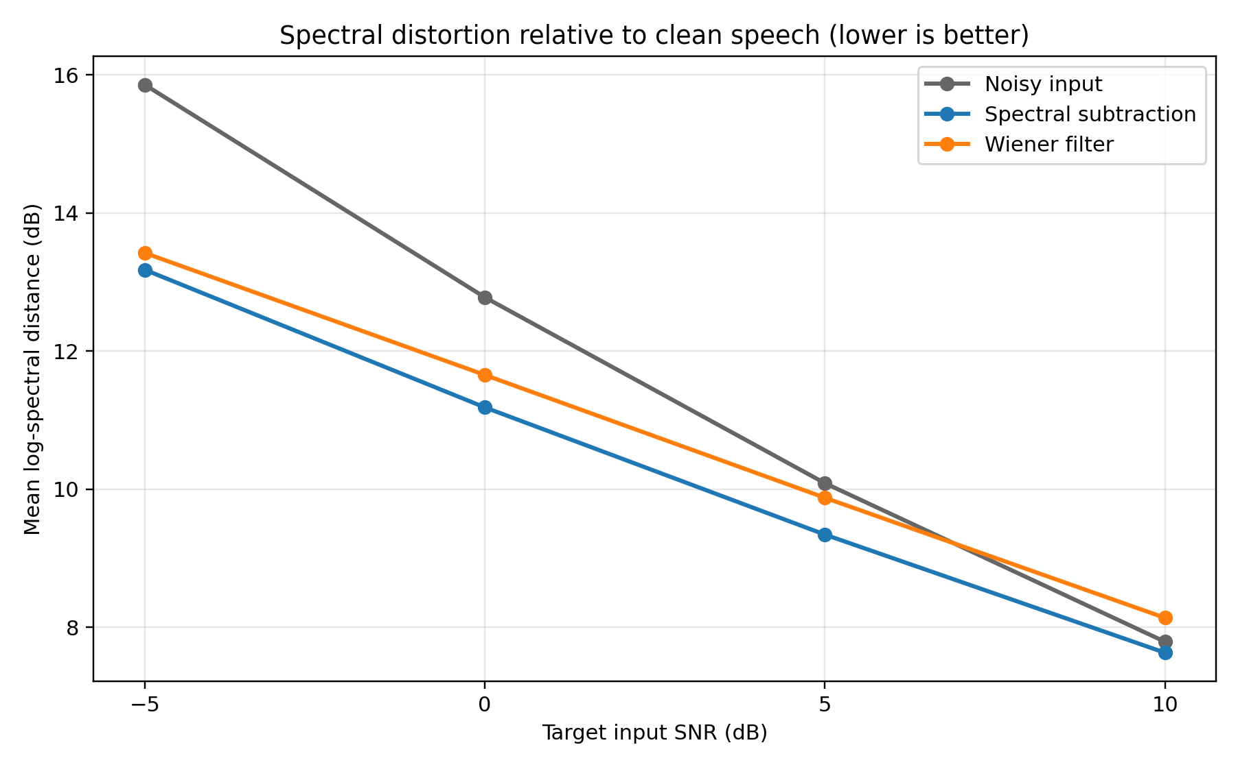
Figure 3. Mean log-spectral distance relative to clean speech. Lower values indicate less frame-wise spectral deviation.

4.4 Representative time-frequency behaviour
Figure 4 shows a 0 dB traffic condition. Both methods attenuate the broadband background while retaining the main speech bands. The Wiener output is visibly darker in many low-energy regions, consistent with its larger SNR improvement. The spectral-subtraction output retains more low-level structure, consistent with its less aggressive energy reduction and slightly lower overall LSD. These plots support the metric interpretation but are not a substitute for a formal listening test. Matching WAV files are supplied in results/final/audio_demo for direct comparison.
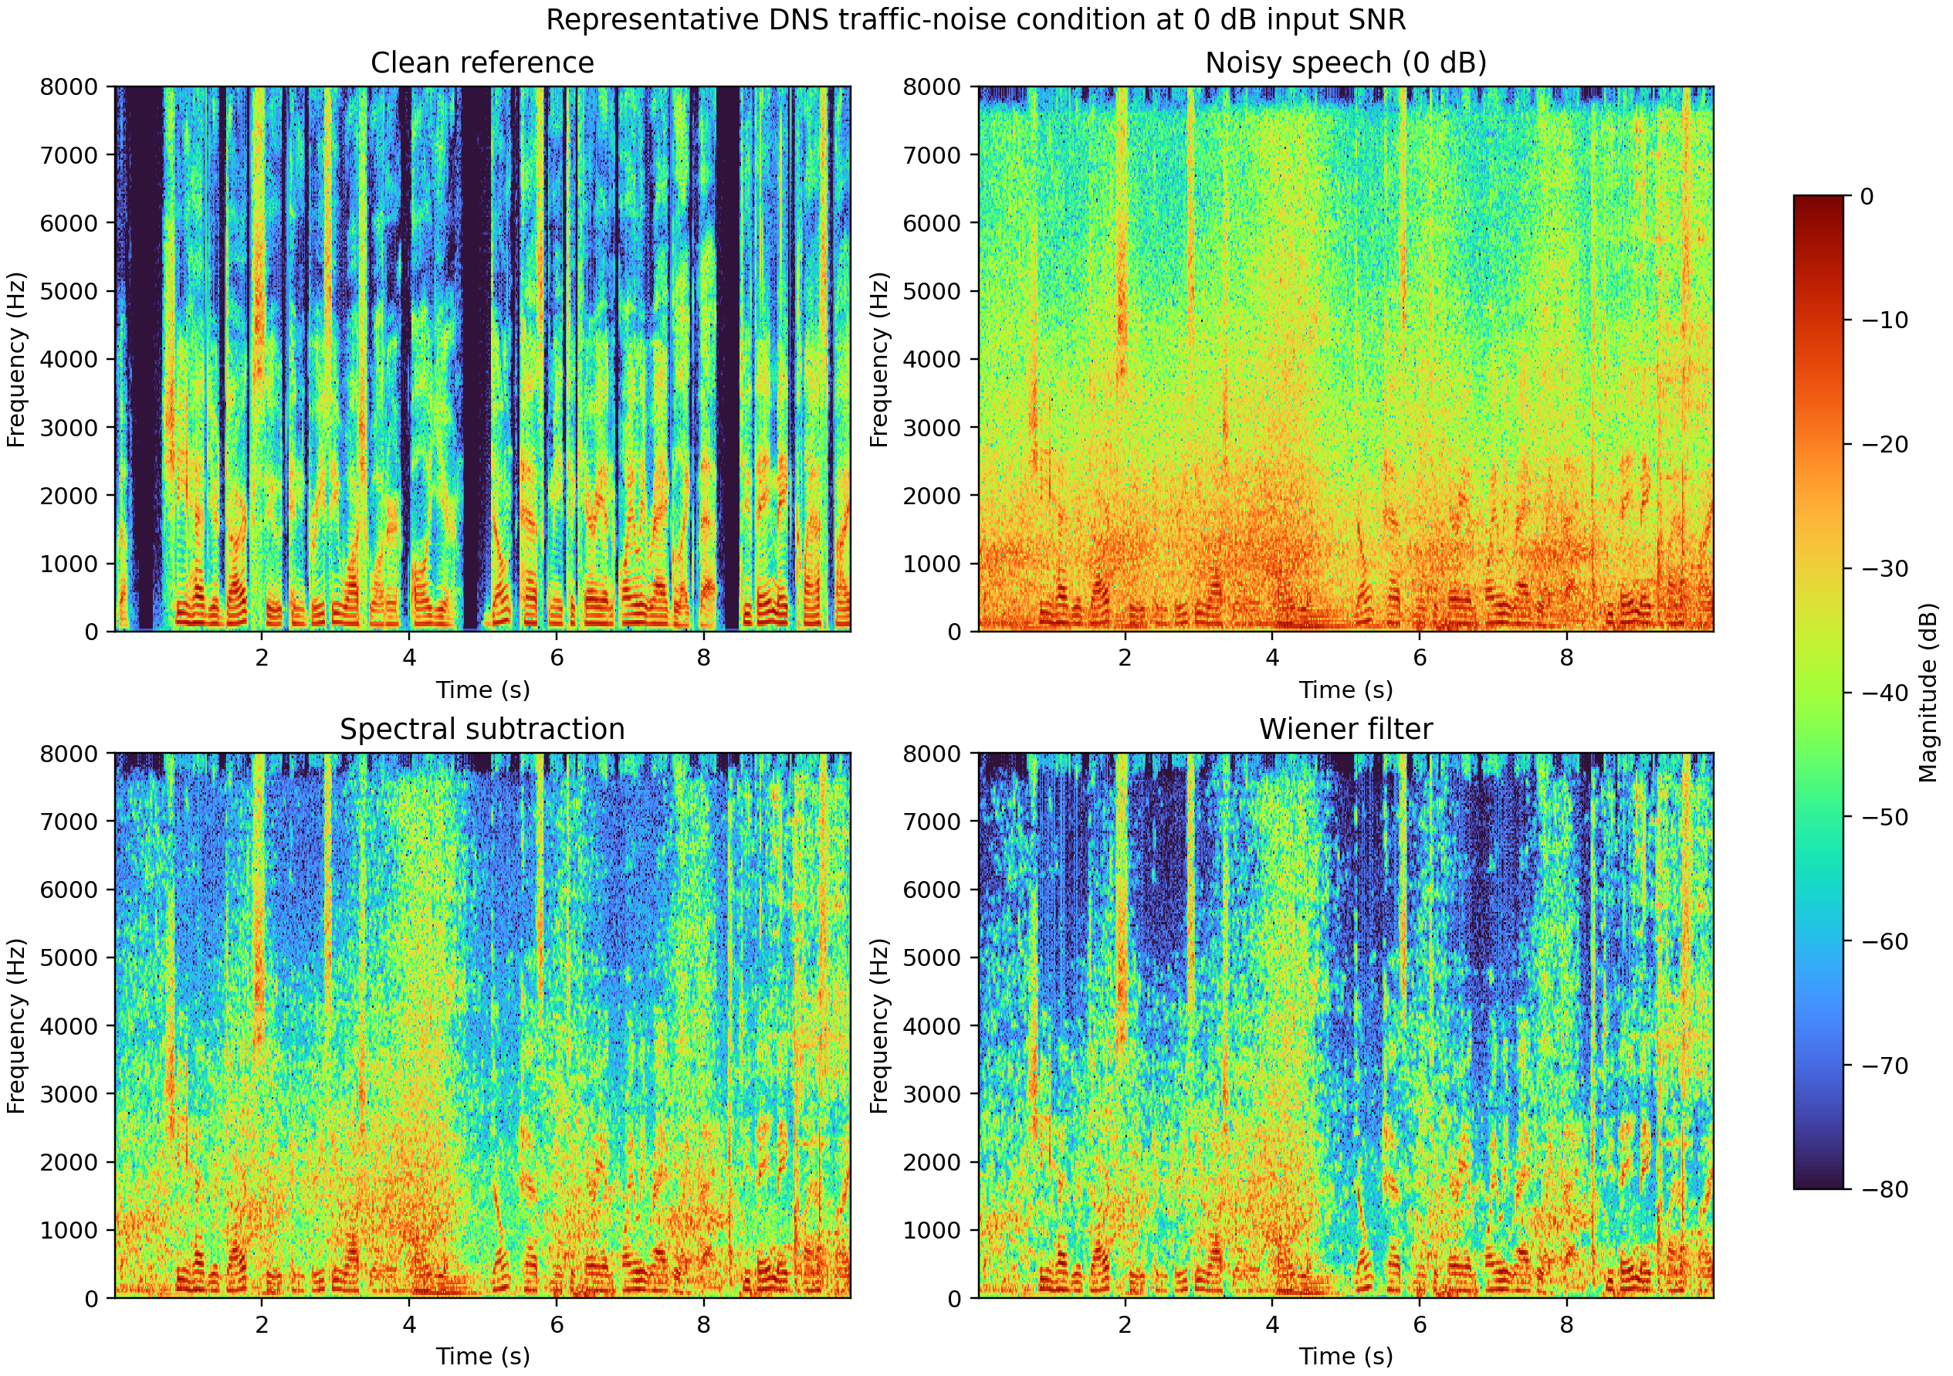
Figure 4. Clean, noisy, spectral-subtraction and Wiener spectrograms for the representative 0 dB traffic-noise condition. All panels use the same 80 dB colour range.

5 Discussion

5.1 Answer to the research question
Under a common oracle noise estimate, Wiener filtering was consistently stronger at reducing global squared error, while spectral subtraction preserved the log spectrum slightly more closely on average. The research question therefore does not have a one-dimensional winner. If the objective is maximum global SNR improvement with the tested parameters, Wiener filtering is preferred. If lower log-spectral deviation is prioritised, spectral subtraction has a small aggregate advantage. This is a substantive difference because it shows that the evaluation criterion changes the conclusion even when the dataset, front end and noise estimate are held fixed.

5.2 Why the methods differ
The implemented Wiener magnitude is more aggressive than direct power subtraction for many positive post-subtraction bins. Spectral subtraction retains the square root of the remaining power, whereas the Wiener method multiplies the noisy magnitude by a power ratio. For the same estimated noise power, this can produce a smaller output magnitude in uncertain bins. The stronger attenuation reduces total error energy and explains the SNR advantage, but it can also suppress weak speech components or alter the short-time spectral shape, which explains the slightly larger LSD. The gain floors moderate both behaviours but do not remove the fundamental trade-off.
The noise-type results further show that the oracle PSD is not equivalent to perfect time-varying noise knowledge. The experiment uses one average PSD per utterance. This representation is well suited to stationary air-conditioner, bus and vacuum backgrounds, but it cannot follow abrupt vocal or animal events. For baby, birds and babble noise, energy overlaps speech-like regions and changes rapidly. A fixed PSD then mistakes some noise for speech or some speech for noise. The result is limited SNR improvement and, in several conditions, increased spectral distance despite a nominal reduction in total error.

5.3 Relation to previous work
The findings are consistent with the classical literature rather than contradicting it. Boll's formulation emphasises spectral-bias removal and residual-noise control [1], while Wiener and statistical estimators emphasise smooth gains derived from local power ratios [2]-[4]. Hu and Loizou's evaluation study explains why noise reduction, speech distortion and overall quality should be examined separately [5]. The present project adds a compact paired benchmark: the first Feedback Two traffic case, where Wiener improved SNR by 3.597 dB and spectral subtraction by 2.622 dB, remains inside the final dataset, and the expanded 32-condition result shows that its ranking was not an isolated accident. At the same time, the LSD result prevents the preliminary SNR observation from being overgeneralised into a claim of universally better quality.

5.4 Practical significance
Classical methods remain useful when computation, interpretability or training data are limited. The final implementation processes each condition with fixed parameters and exposes every intermediate assumption. However, an engineer should not select a method from the 0.855 dB mean SNR gap alone. A practical decision also depends on whether speech distortion, residual noise, latency and intelligibility matter most. The demonstration audio and spectrograms make these trade-offs inspectable, but a deployment claim would require a causal noise estimator and human evaluation under the target listening conditions.

6 Limitations and Future Work
The strongest limitation is the oracle noise PSD. The exact residual noise is available only because the synthetic DNS pairs are aligned with clean references. This choice is valid for isolating gain rules but overestimates what a real system can know. Future work should replace it with a causal estimator based on initial noise-only frames, minimum statistics or recursive tracking, and should report the gap between oracle and estimated-noise performance.
The corpus is also small: eight utterances, one per noise label, cannot represent speaker, language or recording variability. A larger evaluation should sample multiple speakers and residuals per category, preserve a held-out tuning set and report confidence intervals or paired significance tests. Fixed parameters avoid per-condition overfitting, but they reveal only one point on each method's trade-off curve. Sweeping subtraction factor, spectral floor and Wiener gain floor would produce a Pareto analysis of suppression versus distortion.
Finally, global SNR, segmental SNR and LSD are intrusive engineering measures, not complete perceptual outcomes. No formal listening panel was conducted. Future work should add intelligibility and perceptual measures such as STOI and an appropriately licensed PESQ-style evaluation, followed by a small blinded listening test that separately rates speech distortion, residual noise and overall quality. Computational cost and real-time factor should also be measured once a causal implementation is available.

7 Conclusion
This project reproduced and compared Wiener filtering and spectral subtraction in a controlled multi-condition experiment. Across 32 tests, Wiener filtering produced the higher SNR improvement in every case and achieved a 2.945 dB overall mean, compared with 2.090 dB for spectral subtraction. Spectral subtraction produced the lower mean log-spectral distance, 10.334 dB compared with 10.772 dB. The central conclusion is therefore a measured trade-off rather than a universal winner: stronger error-energy suppression came with slightly greater spectral deviation. Stationary backgrounds were easier than nonstationary speech-like or animal sounds, and several nonstationary cases showed that processing can improve SNR while worsening spectral distance. The included MATLAB code, data provenance, CSV results, figures and audio examples make the analysis reproducible. A practical extension should focus first on causal noise estimation and perceptual validation.

References
[1] S. F. Boll, “Suppression of acoustic noise in speech using spectral subtraction,” IEEE Transactions on Acoustics, Speech, and Signal Processing, vol. 27, no. 2, pp. 113-120, 1979. doi: 10.1109/TASSP.1979.1163209.
[2] J. S. Lim and A. V. Oppenheim, “Enhancement and bandwidth compression of noisy speech,” Proceedings of the IEEE, vol. 67, no. 12, pp. 1586-1604, 1979. doi: 10.1109/PROC.1979.11540.
[3] Y. Ephraim and D. Malah, “Speech enhancement using a minimum mean-square error short-time spectral amplitude estimator,” IEEE Transactions on Acoustics, Speech, and Signal Processing, vol. 32, no. 6, pp. 1109-1121, 1984. doi: 10.1109/TASSP.1984.1164453.
[4] P. Scalart and J. V. Filho, “Speech enhancement based on a priori signal-to-noise estimation,” in Proceedings of ICASSP, vol. 2, 1996, pp. 629-632. doi: 10.1109/ICASSP.1996.543199.
[5] Y. Hu and P. C. Loizou, “Evaluation of objective quality measures for speech enhancement,” IEEE Transactions on Audio, Speech, and Language Processing, vol. 16, no. 1, pp. 229-238, 2008. doi: 10.1109/TASL.2007.911054.
[6] C. K. A. Reddy et al., “INTERSPEECH 2021 Deep Noise Suppression Challenge,” in Proceedings of Interspeech, 2021, pp. 2796-2800. doi: 10.21437/Interspeech.2021-1609.
[7] P. C. Loizou, Speech Enhancement Theory and Practice, 2nd ed. Boca Raton, FL: CRC Press, 2013. doi: 10.1201/b14529.
[8] Microsoft, “Deep Noise Suppression Challenge,” GitHub repository. Available: https://github.com/microsoft/DNS-Challenge. Accessed: 8 November 2026.

Appendix A Reproducibility and Links
The repository contains the working MATLAB implementation, eight aligned DNS pairs, detailed data provenance, all final metrics, summary tables, four report figures and four representative listening files. From the repository root, the complete experiment is run in MATLAB with run('code/run_final_project.m'). Results are written to results/final. The Python reference script is included to cross-check numerical outputs and is not required for the MATLAB submission.
GitHub repository: https://github.com/czz0806/elec5305-project-530668932
Project site and video section: https://czz0806.github.io/elec5305-project-530668932/#video-demonstration
Project video (4 min 40 s): https://youtu.be/TIqCp_KE7m0

Generative AI Acknowledgement
OpenAI ChatGPT and Codex were used to assist with code development, numerical cross-checking, document organisation and language editing. The source data, processing assumptions, metrics and generated outputs are disclosed in the repository so that the work can be inspected and reproduced. The author is responsible for reviewing the final submission and for complying with the University's academic-integrity and unit-specific AI requirements.

