Decimal values (exact and approximate).

What these notes are about. These notes are a summary of ideas which I discuss in lectures with my first year students. They are about ‘numbers’; specifically they are
about ‘real’ numbers, about the decimal values of those real numbers.

Introduction. We start by asking a simple looking question: what is the value of the square-root of 2? If we were calculating by hand then we might proceed by first noting that 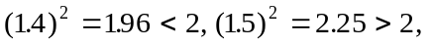and so 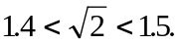 That would give us one decimal place accuracy for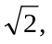and if we then wanted two decimal place accuracy we would obtainand so 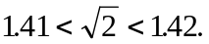 We could continue doing this by hand, getting increasing levels of accuracy, or (perhaps) eventually find an exact ‘terminating decimal value’ for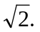

Our first important discovery is to realise that the latter cannot happen:

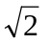 does not have a terminating decimal value

Really getting down to work. Suppose I said: the exact value of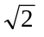is 1.4142135623237309504880168872421. Could that be true? No! Why not?
This should make it clear: try squaring some decimal numbers which do end
with the digit ‘1’:

You should realise an important point:

Every decimal number which ends in ‘1’ produces
- when squared -
another decimal number which also ends in ‘1’.

Claim 1. could not have a decimal value which ends in a ‘1’.

Proof. If it did, then we would have:

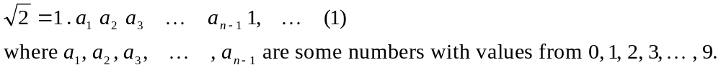

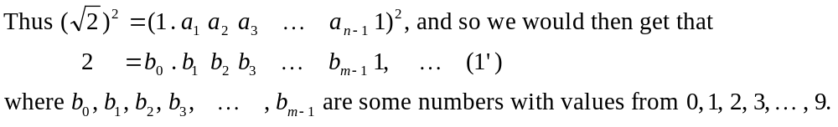

But that is impossible because the left hand side of 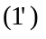 ends in 2, whereas the right hand side ofends in 1. Thus Claim 1 is established, and we move on immediately to:

Claim 2. could not have a decimal value which ends in 2.

Proof. If it did, then we would have:

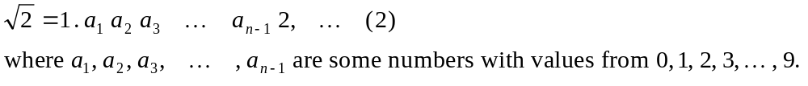

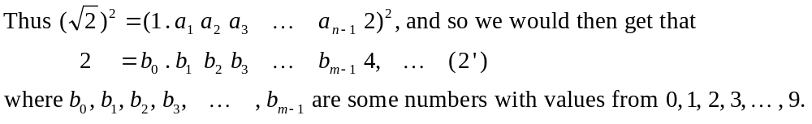

But that is impossible because the left hand side of 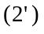 ends in 2, whereas the right hand side ofends in 4.

Speeding up. Seven other similar arguments show thatcould not have a decimal value which ends in 3, 4, 5, 6, 7, 8 or 9, and so we arrive at the following simple, but
by no means trivial assertion:

Theorem One: does not have a terminating decimal value.

Proof: Suppose thatdid have a terminating decimal value; then we would have:

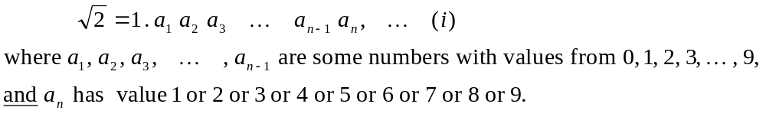

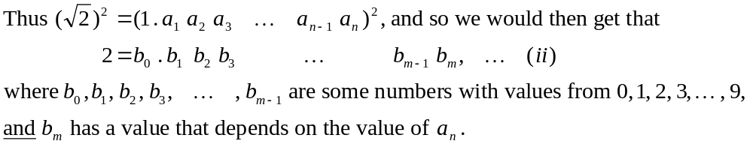

Now, how does the value of 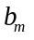 depend on the value of 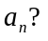 It’s simple:

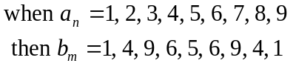

We see immediately that the r.h.s of (ii) never ends in a 2, which is what the l.h.s. of (ii) ends in. Thus (ii) is impossible, and so (i) is also impossible. We have proved what we have claimed, namely:does not have a terminating decimal value.

Taking stock. The argument you have just seen was a very simple one, but nevertheless it was a very powerful one. It is typical of the difference that there is between brute calculation on the one hand, and simple (but subtle) reasoning on the other. PROOF is the very stuff of which real Mathematics is made, and a mathematician, having proved something, immediately wants to prove as much as possible along similar lines; he/she immediately wants to ‘generalise’. So let’s start trying to generalise, by asking:

does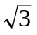have a terminating decimal expansion?

My calculator value for isthe decimal number 1.732050808, and Maple - if asked forto 20 places (including the 1 at the beginning) - gives 1.7320508075688772935.
Are any of those actually equal to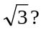 Of course they aren’t! And one can argue that
by the same sort of argument that we have already made. If the above three terminating decimal numbers were squared they would end in 4, 5 and 1 respectively, and since
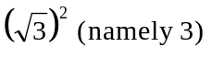ends in a 3, then none of the above decimal numbers could be equal to. However it’s not just that none of them is equal to, but just as in Theorem One (on Page 2) we can also argue:

Theorem Two: does not have a terminating decimal value.
Proof: You should write out a proof of this, following the same lines of argument that you have already seen with the proof of Theorem One. If you don't know what to do, or have some difficulty with it, then you simply must ask me about it.
What then about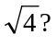 That’s of no real interest. Its value is 2, and nothing could be more terminating than that!!

And what about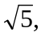does it have a terminating decimal expansion? As it happens it doesn’t, but that cannot (why not?) be immediately proved by the straightforward approach of the Proof of Theorem One. The same is true of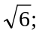 it too does not have a terminating decimal value, but once again the proof is not as straightforward as that of Theorem One.

Moving on to the numbers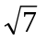and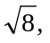you should be able to prove, in the same manner
as Theorem One’s proof, that neither of those has a terminating decimal expansion.
With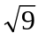we are back to the sort of thing that happened with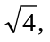 namely,has an exact value: 3. The same for 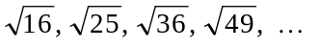(which have values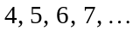 ).

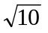doesn’t have a terminating decimal value, nor do any of these numbers:
and, of those numbers, certain ones can be proved to have no terminating decimal expansions by a proof which is simply the most general form of the proof which we saw with the proof of Theorem One. Which ‘certain ones’? Simply those which are like
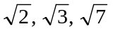and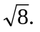 So here now is a general form of Theorem One:

Theorem Three: Let 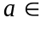N, and suppose that a ends in 2, 3, 7 or 8. Then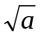does not have a terminating decimal expansion. (In words: if a positive whole number ends in 2, 3, 7 or 8, then its square-root cannot have an exact decimal value which comes to an end after a finite number of decimal places.)

Proof: (It is just like the proof of Theorem One, but with appropriate changes made to it.)
Suppose thatdid have a terminating decimal value. Then we would have:

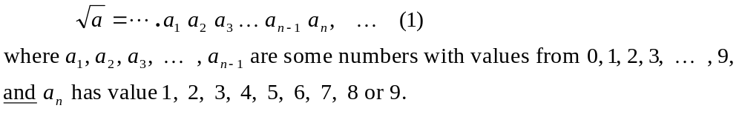

But then we would have:

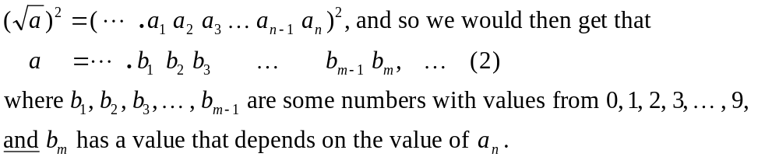

Now, how does the value of 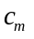 depend on the value of 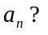 The dependence is this:

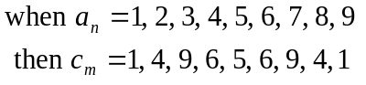

We see immediately that the right hand side of (2) never ends in 2, 3, 7 nor 8, which is what the left hand side of (2) ends in. Thus (2) is impossible, and so (1) is also impossible.

Thus we have proved Theorem Three: does not have a terminating decimal value.

That was an example of how a ‘generalisation’ can be made. One started with something that one had proved to be true, and then asked oneself: is there anything else of a similar nature that one can also prove to be true, along similar lines of argument?

Now we will see how yet another type of generalisation can be made. Above we looked at square-roots, and now we have a look at other kinds of ‘roots.’

Some more examples of numbers which do not have exact terminating decimal values:

First of all there are some obvious examples: numbers like 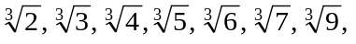
, though it requires a little more work to prove that these don’t have exact decimal values.

Question. Why does it ‘require a little more work’ to prove that the above cube-roots don’t have terminating decimal values? Why doesn’t the easy proof that we made up for (many) square-roots just carry over to cube-roots?

And just because cube-roots threw up a little hurdle for us shouldn’t prevent us from having a look at fourth-roots, and if we did have a look at them we would quickly come up with:

Theorem Four: Let N, and suppose that a ends in 2, 3, 4, 7, 8 or 9. Then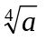does not have a terminating decimal expansion. (In words: if a positive whole number ends in 2, 3, 4, 7, 8 or 9, then its fourth-root cannot have an exact decimal value which comes to an end after a finite number of decimal places.)

I could continue in similar vein making similar statements for some fifth-roots, some sixth-roots, some seventh-roots, etc., but I wish to have a look at some other familiar numbers, which also do not have terminating decimal values.

What values do log-tables, or calculators, or Maple give for numbers like 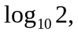
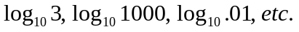 For the first,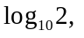 the values given by these are .3010, .3010299957 and (I’ll show you how to do this:) .301029995663981195213738894724.

Here, too, none of these is exact, though they are increasingly more accurate.

It is very easy to show that none of these is exact. Let’s look first at the log-table value: it happens to be .3010. Now, it is easy to argue that it (.3010) can’t be the exact value of 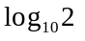: Suppose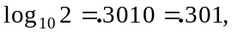then we would have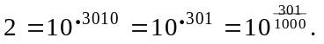 But that would lead to 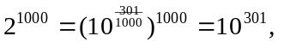and that is clearly impossible for any one of the following (equally acceptable, valid) reasons:

i. 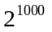 doesn't end in a 0 (what does it end in?), whereas 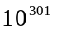does, and thus
could not be equal to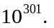

ii. couldn't equal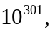 because if it did then we would have:
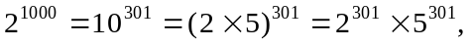and then dividing throughout by 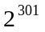we would
get that 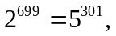which is clearly impossible since the first of these numbers is even
and the second of them is odd.

Thus cannot be equal to .3010.

Some simple problems for you to do. Look up log-tables, use your calculator or Maple, to produce values for 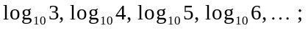prove that none of the values you come up with are exact values (apart from:
which have exact values 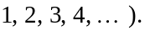

Summary of what we have done so far. We began by trying to find (hopefully) the exact values of certain numbers. A possible standard for exactness was the familiar ‘terminating decimal number.’ With that as our standard we found that while certain numbers do have exact terminating decimal values (e.g.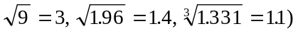
other numbers only have approximate terminating decimal values: 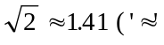is the notation for ‘is approximately’).

Perhaps we should adopt some other standard for exact values? That’s what we now do. In early Greek Mathematics the standard was rational numbers.

Formal definition: A rational number is a number r such that:
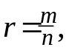
for some integers m and n, and 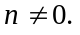

Examples of rational numbers:

Important note. It is not correct to say that “a rational number is a fraction.”

What − after all − is a ‘fraction’? It used to mean what we now call a rational number!!
But its meaning appears to have become altered to the extent that one finds that many people, when asked what ‘’ is, will say “oh, it’s a fraction.” But then every number would automatically be a fraction, since every number ‘x’ (let’s say) can be expressed as a ‘fraction’, simply by observing that: 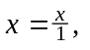or that 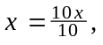… .

So, let us be clear about this: A rational number is not a ‘fraction’; rather it is
a rational fraction, meaning it is a ‘fraction’ in which both the ‘numerator’ and
(non-zero) ‘denominator’ are integers.

Of course a terminating decimal number is automatically a rational number:

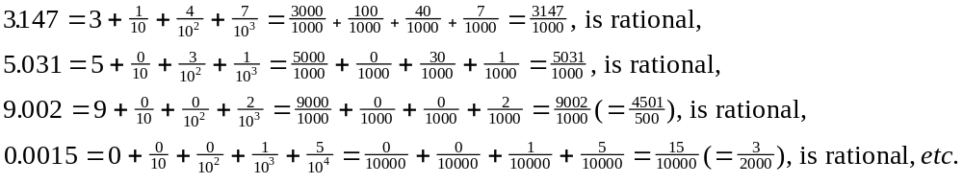

but not every rational number has a terminating decimal value. It is of interest to look at the decimal values of some rational numbers, and to record some impressions:

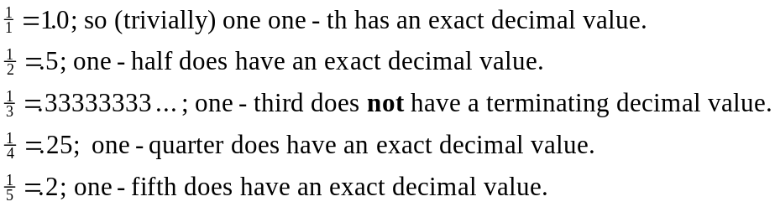

Some questions for you to think about:

1. Which rational numbers have terminating decimal values, and which ones don’t? Of
course above I have looked only at some rational numbers - with numerator fixed at 1 -
and only at those with denominators varying between 1 and 8. You need to think about
all sorts of other ones ... .
2. Also, of those rational numbers which don’t have terminating decimal values, which
ones:

i. appear to have ‘pure periodic expansions’ (e.g.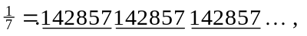 where
the block of digits 142857 is repeated)?
- appear to have ‘eventual periodic expansions’ (e.g.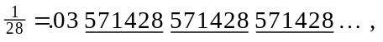
where there is an initial isolated block 03, followed by the block of digits 142857, which
is then repeated)?

We say that has a ‘periodic decimal expansion’, and we say the expansion has period 6 (meaning that the ‘block’ has 6 digits in it).

Of course you can use your hand, your calculator, or Maple to calculate decimal values (exact or approximate) for various rational numbers. The Maple command for an individual number is:

> evalf(1/7); # which would give as output
.1428571429

But a more useful command, if you want to see a lot of material all in one go is:

> seq([n, evalf(1/n)], n = 1..30); # ‘30’ is merely an example

for which the output will be:

[1, 1.], [2, .5000000000], [3, .3333333333], (and so on down as far as)
[20, .05000000000]

Now the big question to be thought about is this: many numbers - like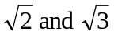for example - do not have exact terminating decimal values; might they have exact rational values? These are the kinds of questions pursued in a separate set of notes, on Rational and Irrational numbers.

Addition with the arrival of MapleV-Release5. A new command available in Maple is one for calculating the period of a rational number, but that is something which I will leave for a Maple class.

Simple questions can - and quite frequently do - lead to very important ideas very quickly.
Some actual or mental calculations would have been involved: the square-root of 2 is obviously between 1 and 2; but is it perhaps 1.3?, or 1.4? or … . Or is it perhaps between 1.6 and 1.7?
‘One’ if we were counting places after the decimal point, but it would be ‘two’ if we were taking into account all the digits. Maple - for example - in its ‘Digits’ setting, takes all the digits into account.
Maple calculated that number, with Digits set to 30. Better is to use the Maple command: > evalf(sqrt(2), 30); (or the Maple command: > evalf(2^(1/2), 30); )
Such a claim could not be established by mere computing alone. The best that a computer could have done is to perhaps have found the exact terminating decimal value of the square-root of 2 if it had such a value.
By a terminating decimal value we mean one that has a last digit. So, for example, 39.721, 999.9, .12121231, 56, 2, 1.414, 78120, etc., all have terminating decimal values, with last digits 1, 9, 1, 6, 2, 4 and 0. Note, however, the last digit of the decimals 3.1410, 3.1415900 - for example - would be considered to be 1 and 9 (and not 0).
Infinitely many, in fact.

